DATA MODEL & PERSISTENCE SPECIFICATION
Ontology and Knowledge Graph-Driven
Sustainability Principles Recommendation System
SEQ-09 | Version 0.2 | September 2026
Purpose
Define the V1 physical operational data model, persistence semantics, identifiers, constraints, transactions, portability rules and migration/backup expectations for SQLite local development and Supabase PostgreSQL hosted deployment, while preserving canonical repository/runtime separation.

Document control
Item | Value
Sequence | SEQ-09
Version | 0.2
Status | V1 physical persistence baseline
Date | September 2026
Upstream baseline | System Architecture Design v1.1 Final; Technical Interface Design v0.2; Interface Contract Registry v0.1; Data Flow Design v0.1 Final; Data Flow Registry v0.1; SEQ-06 Process Flow Specification v0.1; SEQ-07 Algorithm Specification v0.1
Change rule | This specification refines implementation detail without changing frozen recommendation semantics or V1 product scope.

Contents and reading order
- 1–3 define scope, source authority and persistence principles.
- 4–8 define identifiers, physical tables, JSON payloads, constraints and transaction/idempotency behavior.
- 9–12 define portability, migrations, retention/backup and runtime read/write patterns.
- 13–15 reconcile security handoff, deferred scope and acceptance.

1. Purpose and scope
SEQ-09 converts SEQ-05 logical stores and persistence events into a concrete V1 operational persistence design. It does not replace governed Excel repositories or compiled graph/embedding artifacts with database-managed ontology truth.

1.1 In scope
- Operational SQL tables, primary/foreign/unique/check constraints and indexes.
- Immutable/append-only semantics and atomic transaction boundaries.
- Portable SQLite and PostgreSQL type mapping.
- Idempotency persistence, version provenance and technical audit records.
- Persistence adapter behavior required by SEQ-08.

1.2 Out of scope
- Canonical repository schema — existing governed repositories remain authoritative.
- Graph/embedding runtime data as relational tables — compiled artifacts remain build outputs.
- Functional repository publication/rollback persistence — deferred beyond V1.
- Authentication provider implementation and detailed row-level access policy — SEQ-10.

2. Source baseline and data authority
Source | Persistence consequence
System Architecture Design v1.1 Final | Canonical knowledge separate from RecommendationEvent, RecommendationContextSnapshot, EducatorKitSnapshot and EducatorDecision.
Technical Interface Design v0.2 | Exact IDs/statuses/controlled values and idempotency/error behavior.
Data Flow Design v0.1 Final | Creation timing, mutability and consumers for persisted objects.
SEQ-08 Module Interface Specification v0.2 | PersistencePort is the only domain-facing operational write/read boundary.

3. Persistence principles
- Canonical/operational separation: runtime outputs never become ontology truth.
- Immutable snapshots: context and Kit snapshot rows are insert-only after commit.
- Append-only events/decisions: no overwrite of historical system or educator actions.
- Atomic completed recommendation: context snapshot and event commit together before RecommendationResult is returned.
- Portable SQL core: one logical schema supports SQLite and PostgreSQL; backend-specific optimizations remain adapter-local.
- Exact text preservation: educator Application Context and adaptation text are persisted exactly as used/saved.
- Version provenance: repository, graph, embedding/model, runtime, prompt/contract and interface versions are stored with the relevant historical record.
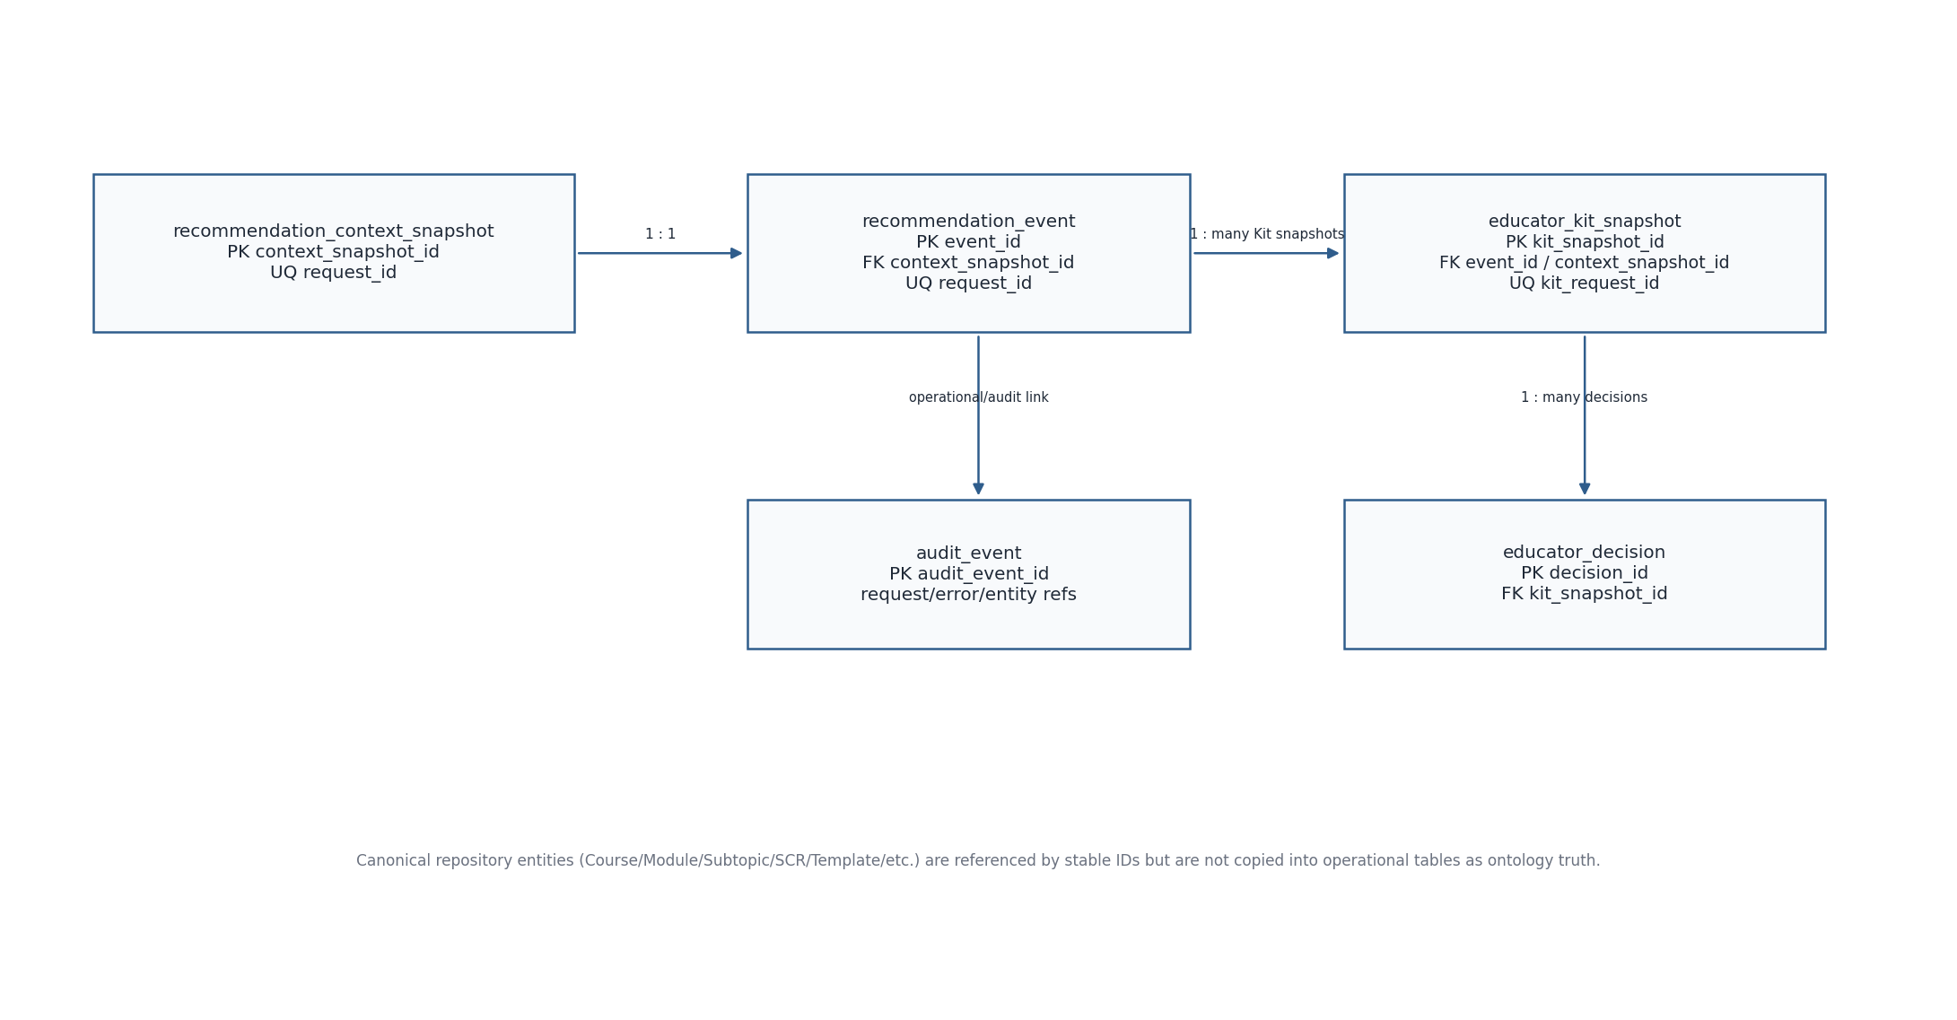
Figure 1. V1 operational physical data model

4. Identifier and timestamp conventions
Field family | Rule
Operational IDs | Opaque UUID strings generated server-side: context_snapshot_id, recommendation_event_id, kit_snapshot_id, educator_decision_id, audit_event_id. They must not imitate canonical repository ID formats.
Request IDs | Request_ID and Kit_Request_ID are opaque idempotency keys supplied/generated by application layer and protected by UNIQUE constraints.
Canonical IDs | Course_ID, Module_ID, Subtopic_ID, SCR_ID, Template_ID, Context_Candidate_ID and governed entity IDs are stored as text references; no operational FK is created to Excel/runtime artifacts.
Timestamps | Persist UTC. PostgreSQL uses timestamptz; SQLite uses ISO-8601 UTC text.
Hashes | SHA-256 canonical request payload hash is stored for idempotency conflict detection.

5. Physical table specification

5.1 recommendation_context_snapshot
Column | Type | Null | Constraint / purpose
context_snapshot_id | TEXT / varchar UUID | NO | PRIMARY KEY
request_id | TEXT | NO | UNIQUE; recommendation idempotency key
request_payload_hash | TEXT | NO | SHA-256 canonical normalized request representation
course_id | TEXT | NO | Canonical Course reference
module_id | TEXT | NO | Canonical Module reference
subtopic_id | TEXT | NO | Authoritative V1 technical anchor
application_context_source | TEXT | NO | CHECK EDUCATOR_ENTERED | ACCEPTED_SYSTEM_GENERATED
application_context_text | TEXT | NO | Exact accepted text used
accepted_context_candidate_id | TEXT | YES | Required only for ACCEPTED_SYSTEM_GENERATED
suggested_contexts_json | JSON/TEXT | NO | Final 0..2 candidates actually shown; default []
teaching_context_json | JSON/TEXT | NO | Reviewed teaching context; default {}
mechanism_profile_json | JSON/TEXT | YES | Positive and explicit-negative derived facets
evidence_state_json | JSON/TEXT | YES | Resolved graph/context/eligibility evidence snapshot
version_manifest_json | JSON/TEXT | NO | Repository/graph/model/runtime/interface versions
actor_scope_hash | TEXT | YES | Server-generated session/actor scope for access enforcement; not user-visible
created_at_utc | TIMESTAMPTZ/TEXT | NO | Immutable creation timestamp

5.2 recommendation_event
Column | Type | Null | Constraint / purpose
recommendation_event_id | TEXT | NO | PRIMARY KEY
request_id | TEXT | NO | UNIQUE; must match context snapshot request_id
context_snapshot_id | TEXT | NO | UNIQUE FK → recommendation_context_snapshot ON DELETE RESTRICT
recommendation_status | TEXT | NO | CHECK SUCCESS | ABSTAINED
primary_scr_id | TEXT | YES | Required iff SUCCESS
additional_scr_ids_json | JSON/TEXT | NO | Independent supported additional SCR IDs; default []
abstention_reason | TEXT | YES | Required iff ABSTAINED; controlled values only
why_this_fits | TEXT | YES | Trace-derived concise delivered explanation
trace_json | JSON/TEXT | YES | Structured persisted Explanation/Audit_Detail provenance
trace_available | BOOLEAN/INTEGER | NO | Derived/persisted convenience flag
created_at_utc | TIMESTAMPTZ/TEXT | NO | Append-only event time

5.3 educator_kit_snapshot
Column | Type | Null | Constraint / purpose
kit_snapshot_id | TEXT | NO | PRIMARY KEY
kit_request_id | TEXT | NO | UNIQUE Kit-generation idempotency key
kit_request_hash | TEXT | NO | SHA-256 canonical request hash
recommendation_event_id | TEXT | NO | FK → recommendation_event ON DELETE RESTRICT
context_snapshot_id | TEXT | NO | FK → recommendation_context_snapshot ON DELETE RESTRICT
selected_template_id | TEXT | NO | Canonical selected Stage-E Template_ID
requested_template_id | TEXT | YES | Non-null for explicit alternative request when applicable
kit_generation_status | TEXT | NO | CHECK READY | VALIDATION_FAILED for persisted snapshots
validation_status | TEXT | NO | CHECK PASS | FAIL
material_source_mode | TEXT | NO | CHECK USE_SYSTEM_SUGGESTION | USE_MY_MATERIAL
teaching_context_json | JSON/TEXT | NO | Effective teaching context used for this Kit
alternative_template_summaries_json | JSON/TEXT | NO | 0..2 summaries; default []
resolved_contract_json | JSON/TEXT | NO | Exact output-element contract + version
teaching_material_json | JSON/TEXT | NO | Resolved material/evidence with provenance
framework_context_json | JSON/TEXT | NO | Resolved active/excluded framework context
generation_provenance_json | JSON/TEXT | NO | Provider/model/prompt/runtime versions; no secret values
kit_payload_json | JSON/TEXT | NO | Structured generated Kit content
validation_json | JSON/TEXT | NO | Overall + element PASS/FAIL/NOT_APPLICABLE and reasons
actor_scope_hash | TEXT | YES | Session/actor scope for access enforcement
created_at_utc | TIMESTAMPTZ/TEXT | NO | Immutable snapshot timestamp

5.4 educator_decision
Column | Type | Null | Constraint / purpose
educator_decision_id | TEXT | NO | PRIMARY KEY
kit_snapshot_id | TEXT | NO | FK → educator_kit_snapshot ON DELETE RESTRICT
decision | TEXT | NO | CHECK USE_AS_SUGGESTED | ADAPT | CHOOSE_ALTERNATIVE | NOT_USE | SAVE_FOR_LATER
chosen_template_id | TEXT | YES | Required iff CHOOSE_ALTERNATIVE
adaptation_text | TEXT | YES | Required when an ADAPT decision saves an adaptation
decision_note | TEXT | YES | Optional educator note
actor_scope_hash | TEXT | YES | Session/actor scope if available
created_at_utc | TIMESTAMPTZ/TEXT | NO | Append-only action timestamp

5.5 audit_event
Column | Type | Null | Constraint / purpose
audit_event_id | TEXT | NO | PRIMARY KEY
occurred_at_utc | TIMESTAMPTZ/TEXT | NO | UTC event time
actor_type | TEXT | NO | PUBLIC_EDUCATOR | ADMIN | SYSTEM_SERVICE
event_type | TEXT | NO | Stable audit event code
request_id | TEXT | YES | Recommendation/Kit request correlation
entity_type | TEXT | YES | Operational/canonical resource type
entity_id | TEXT | YES | Opaque/canonical ID as applicable
outcome | TEXT | YES | SUCCESS/DENIED/ERROR/etc.
error_code | TEXT | YES | TechnicalError code if applicable
details_json | JSON/TEXT | YES | Sanitized metadata only; avoid raw educator/generated content and secrets

6. Integrity constraints
- SUCCESS requires primary_scr_id IS NOT NULL and abstention_reason IS NULL; ABSTAINED requires primary_scr_id IS NULL and a governed abstention_reason.
- ACCEPTED_SYSTEM_GENERATED requires accepted_context_candidate_id; EDUCATOR_ENTERED requires it to be NULL.
- Persisted Kit snapshot status is READY only when validation_status = PASS; VALIDATION_FAILED only when validation_status = FAIL.
- NO_ELIGIBLE_TEMPLATE produces no educator_kit_snapshot row because no generated Kit exists.
- CHOOSE_ALTERNATIVE requires chosen_template_id; ADAPT requires adaptation_text when the adaptation is actually saved.
- Foreign-key deletes are RESTRICT/NO ACTION; operational history is not cascaded away by normal application operations.

7. Transactions and idempotency
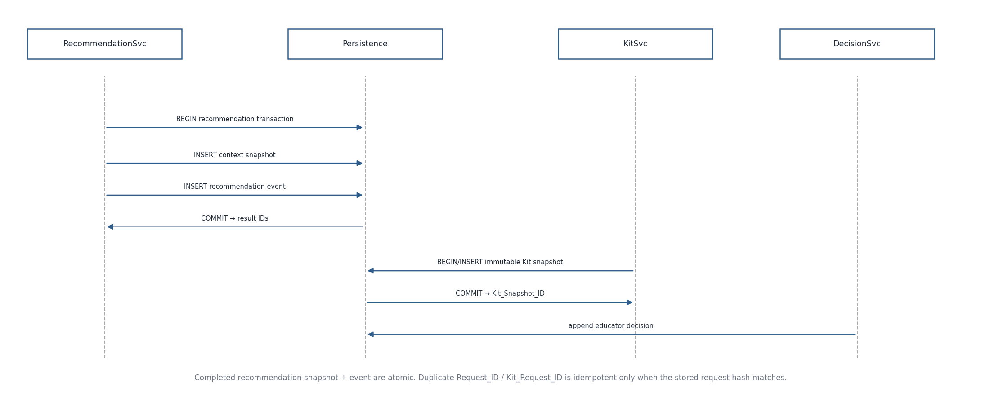
Figure 2. V1 persistence transaction boundaries
Recommendation transaction: validate idempotency key/hash, insert RecommendationContextSnapshot, insert RecommendationEvent, commit, then return RecommendationResult. A failure before commit returns TechnicalError and leaves no half-completed recommendation.
Kit transaction: validate Kit_Request_ID/hash, insert the immutable EducatorKitSnapshot for READY or VALIDATION_FAILED, commit, then return the Kit generation result. NO_ELIGIBLE_TEMPLATE is a domain result without snapshot creation.
Duplicate Request_ID/Kit_Request_ID with the same canonical payload hash returns the stored completed outcome. Reuse with a different hash is an idempotency conflict and must not execute a second semantic action.

8. JSON payload schemas and normalization
Payload | Persistence rule
suggested_contexts_json | Array of 0..2 exact displayed ContextCandidate records needed for provenance; internal resolver evidence may be summarized separately in evidence_state_json.
teaching_context_json | Keyed controlled fields; omit or null only according to SEQ-04 null rules; preserve Additional_Constraints exact text.
evidence_state_json | Structured mechanism facets, evidence paths/eligibility diagnostics and exact relevant version references needed for replay/audit.
version_manifest_json | Named version keys for repository bundle, graph manifest, embedding/model, runtime algorithm, interface contract and resolver versions.
trace_json | Structured educator Explanation plus Audit_Detail; no post-hoc generated prose.
kit_payload_json | Output-element-keyed structured Kit content; content-layer separation retained.
validation_json | Overall PASS/FAIL plus per Element_ID status PASS/FAIL/NOT_APPLICABLE and Failure_Reason.

9. Indexing and read patterns
Table | Required indexes
recommendation_context_snapshot | UNIQUE(request_id); INDEX(created_at_utc); optional INDEX(subtopic_id) for audit only.
recommendation_event | UNIQUE(request_id); UNIQUE(context_snapshot_id); INDEX(recommendation_status, created_at_utc); INDEX(primary_scr_id).
educator_kit_snapshot | UNIQUE(kit_request_id); INDEX(recommendation_event_id); INDEX(context_snapshot_id); INDEX(selected_template_id); INDEX(created_at_utc).
educator_decision | INDEX(kit_snapshot_id, created_at_utc); INDEX(decision).
audit_event | INDEX(occurred_at_utc); INDEX(request_id); INDEX(event_type, occurred_at_utc).

10. SQLite / PostgreSQL portability
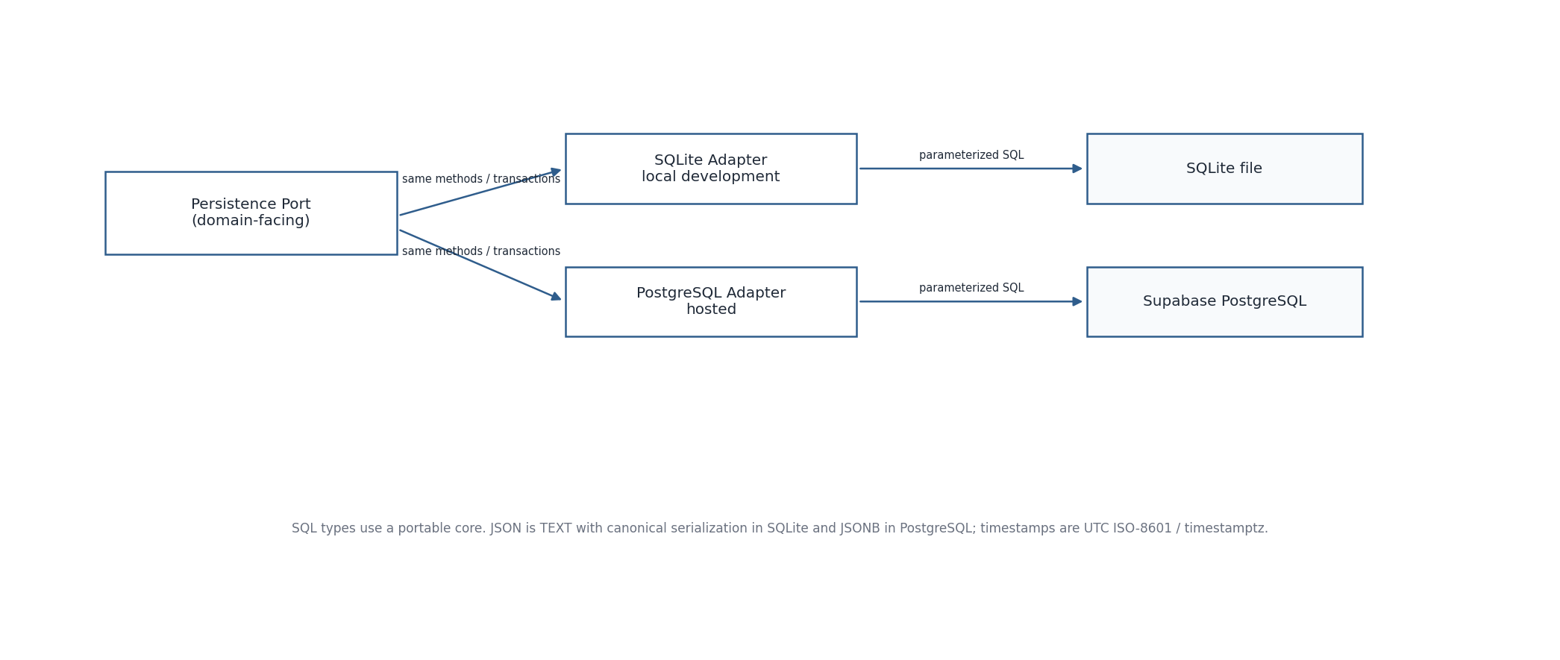
Figure 3. Persistence adapter portability
Logical type | SQLite | PostgreSQL
Operational ID / canonical ID | TEXT | text / varchar
UTC timestamp | TEXT ISO-8601 UTC | timestamptz
Boolean | INTEGER 0/1 | boolean
Structured JSON | TEXT containing canonical JSON | jsonb
Large text | TEXT | text
Foreign key | PRAGMA foreign_keys=ON | native FK
Transaction | BEGIN IMMEDIATE where write serialization needed | standard transaction with appropriate isolation

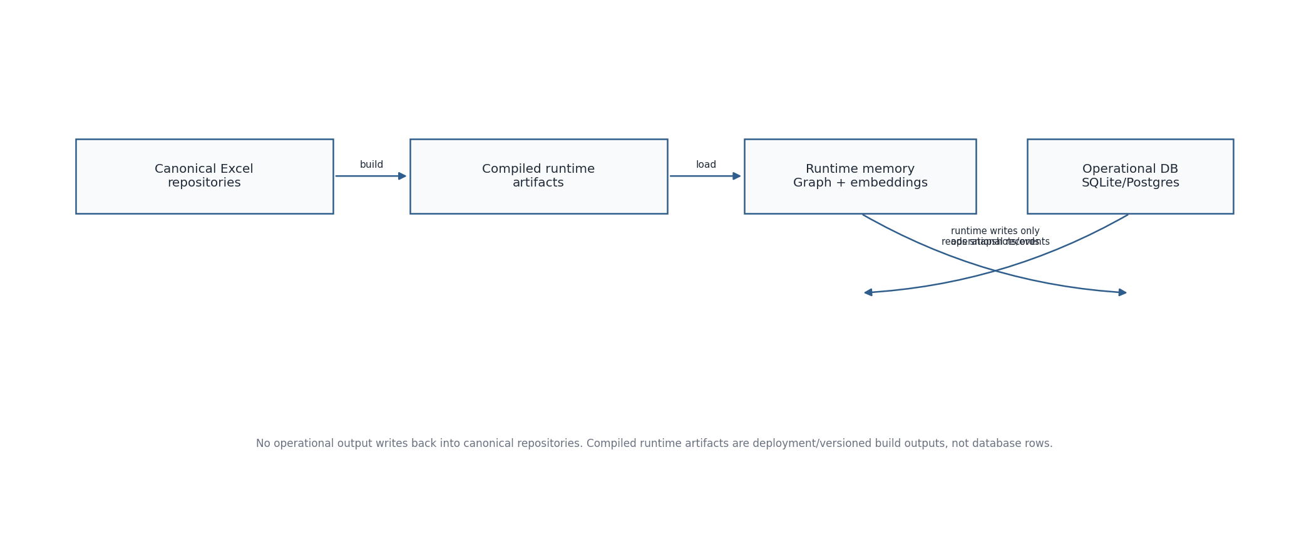
Figure 4. Canonical, compiled runtime and operational storage boundaries

11. Migrations, backup and recovery
- Maintain monotonically versioned SQL migration scripts in source control; never auto-alter production schema from Python object introspection.
- Record current schema_version in migration metadata controlled by the persistence adapter.
- SQLite local backup is file-level only while application is stopped or via SQLite backup API.
- Hosted PostgreSQL backup/restore follows deployment-provider capability; restoration is an operational procedure, not the deferred repository-release rollback UI.
- Migrations must preserve immutable historical snapshots/events; destructive migration requires explicit export/backup and review.

12. Retention and deletion behavior
V1 has no educator-facing delete-history workflow. Operational retention is configurable by deployment policy; no automatic purge is assumed by this specification. Where deletion is legally or operationally required, it is performed as a controlled maintenance action that respects linked records and audit requirements rather than by cascading UI deletes.
Raw temporary upload bytes, if educator material file upload is later enabled, are not part of this persistence model by default. Only the governed/extracted material used in the Kit and its provenance are retained inside the Kit snapshot unless a separate approved storage design is introduced.

13. Security handoff to SEQ-10
- actor_scope_hash is server-generated support metadata for session/actor authorization and must not expose raw session tokens.
- Database credentials remain server-side; no browser/direct client operational-table access is required for V1.
- audit_event details are sanitized and must not contain secrets or unrestricted raw educator/generated content.
- Hosted row-level access and role policies are defined in SEQ-10, not by exposing persistence tables directly to Streamlit clients.

14. Deferred persistence scope
- Repository candidate releases/publication history/activation rollback tables for functional Admin release management.
- Persisted PDF/export entities and export history.
- User accounts, educator saved-history ownership and cross-session retrieval model.
- Async job/queue tables.
- Automatic Kit repair attempt history.

15. Persistence acceptance checklist
- RecommendationContextSnapshot and RecommendationEvent commit atomically.
- All snapshots are immutable after commit; events/decisions are append-only.
- Unique idempotency keys and hashes prevent duplicate semantic execution.
- Canonical repository IDs are references only and operational data never writes back to canonical sources.
- SQLite and PostgreSQL adapters pass the same persistence contract tests.
- Hosted security rules can be applied without changing domain-facing PersistencePort signatures.

16. SEQ-06/SEQ-07 reconciliation verification
SEQ-09 was verified against all SEQ-06 process persistence points and SEQ-07 algorithm trace requirements. The four operational domain records plus sanitized audit event remain sufficient for V1; no new canonical or operational table is required solely by SEQ-06/07.
Requirement from SEQ-06/07 | Persistence coverage
PF-03/PF-04 / ALG-10–11 | Context snapshot + recommendation event already store completed outcome, trace/version/evidence payloads.
ALG-08/09 | Promotion path, raw/display rank, positive/negative facets and veto evidence remain JSON/provenance fields in snapshot/event rather than new tables.
PF-06–PF-08 / ALG-12–16 | EducatorKitSnapshot stores template, contract, material, framework, model/prompt and validation provenance.
PF-10 | EducatorDecision remains separate append-only record.
ALG-19 | request_id/kit_request_id + canonical request hash provide idempotency conflict detection.
PF-14 replay | Recorded version references remain sufficient; replay must not silently substitute latest assets.

- No schema expansion is required for text-only anchor routing, Admin release lifecycle, PDF history or automatic repair because those remain deferred.
Verification outcome: the specification remains semantically compatible after SEQ-06/07. Version 0.2 records this reconciliation and updates the upstream baseline; it does not redesign the frozen V1 behavior.

