SECURITY & ACCESS CONTROL SPECIFICATION
Ontology and Knowledge Graph-Driven
Sustainability Principles Recommendation System
SEQ-10 | Version 0.2 | September 2026
Purpose
Define the V1 trust boundaries, roles, authorization rules, secrets handling, input/output protections, provider and persistence safeguards, audit controls and security verification requirements for the public academic research prototype without expanding V1 administrative functionality.

Document control
Item | Value
Sequence | SEQ-10
Version | 0.2
Status | V1 security/access-control baseline
Date | September 2026
Upstream baseline | System Architecture Design v1.1 Final; Technical Interface Design v0.2; Interface Contract Registry v0.1; Data Flow Design v0.1 Final; Data Flow Registry v0.1; SEQ-06 Process Flow Specification v0.1; SEQ-07 Algorithm Specification v0.1
Change rule | This specification refines implementation detail without changing frozen recommendation semantics or V1 product scope.

Contents and reading order
- 1–3 define security scope, trust model and roles.
- 4–8 define authorization, persistence/secrets, input/output, external-generation and graph/admin controls.
- 9–12 define logging/privacy, availability/dependency controls and security verification.
- 13–15 provide incident handling, deferred scope and acceptance.

1. Purpose and scope
SEQ-10 protects the frozen V1 educator workflow and read-only/prototype Administration boundary. It assumes the application is an internet-accessible academic research prototype, not an enterprise identity platform.

1.1 In scope
- Public educator versus protected Admin trust boundaries.
- Server-side authorization before protected content/actions.
- Database/provider/model-registry secret isolation.
- Untrusted educator text/material and generated-output handling.
- SQL/XSS/prompt-injection/path/file-upload safeguards.
- Audit logging, rate/abuse controls, dependency hygiene and security test cases.

1.2 Out of scope
- Enterprise SSO, organizational RBAC hierarchy or multi-tenant institution administration.
- Functional repository publication, rollback or mutation authorization — those capabilities are deferred.
- Legal/compliance certification; deployment owner remains responsible for applicable policy.

2. Trust boundaries and threat model
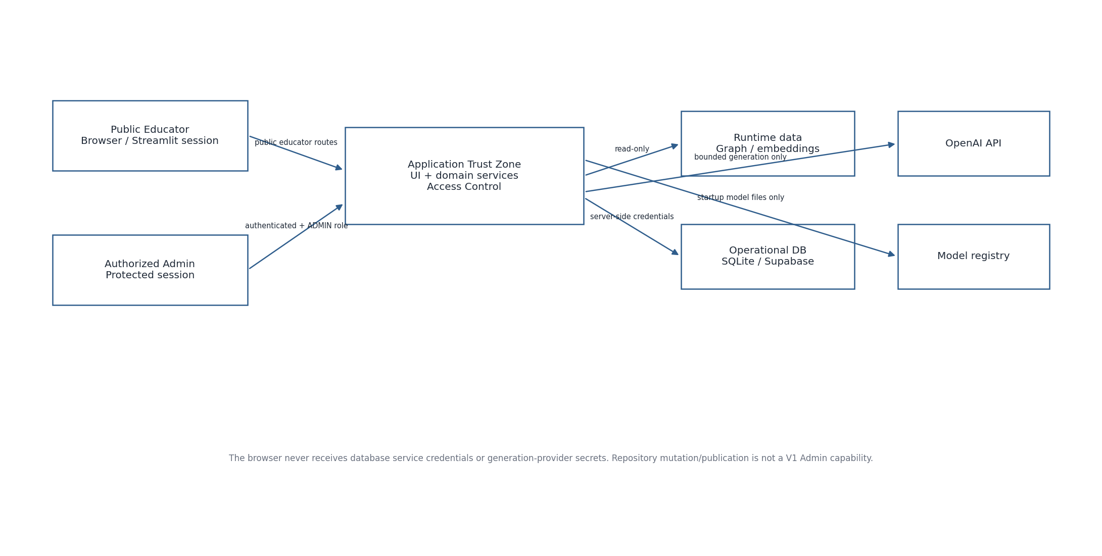
Figure 1. V1 security trust boundaries
Asset / boundary | Primary risks | V1 control direction
Public educator input | malformed input, prompt injection, abuse, sensitive/confidential text | Typed Pydantic/contract validation, size limits, treat all text/material as untrusted data, rate controls.
Admin UI | unauthorized access, privilege escalation | Authenticate configured admin identity/provider; check ADMIN role before rendering protected content.
Operational DB | SQL injection, ID guessing, data leakage | Server-only credentials, parameterized queries, default-deny direct client access, session/actor scope checks.
Generation provider | secret leakage, prompt injection, over-sharing data | Server-side key, bounded structured packet, minimum necessary data, no tool execution from model output.
Graph/runtime artifacts | tampering or stale/unverified artifacts | Version/checksum/config validation at startup; read-only in request path.
Logs/audit | content/secrets leakage | Redacted structured logs using IDs/codes, not raw prompts or credentials.

3. Roles and authorization model
Role | Authentication | Allowed V1 capabilities | Explicitly not allowed
PUBLIC_EDUCATOR | No account required unless deployment chooses otherwise; session-scoped application state | Browse active curriculum/help; context suggestions; generate recommendation; view current-session result/trace/Kit; PDF export; KG Explorer | Administration; repository mutation; direct DB/provider access; cross-session arbitrary snapshot lookup.
ADMIN | Authenticated through configured Access Control mechanism and assigned ADMIN role/allowlist | Protected Administration shell, read-only repository/runtime inspection and prototype/future workflow guidance | Upload/stage/build/publish/rollback/benchmark execution in V1.
SYSTEM_SERVICE | Server-side process identity | Load compiled artifacts, call persistence/provider adapters, append audit events | Interactive user capabilities.

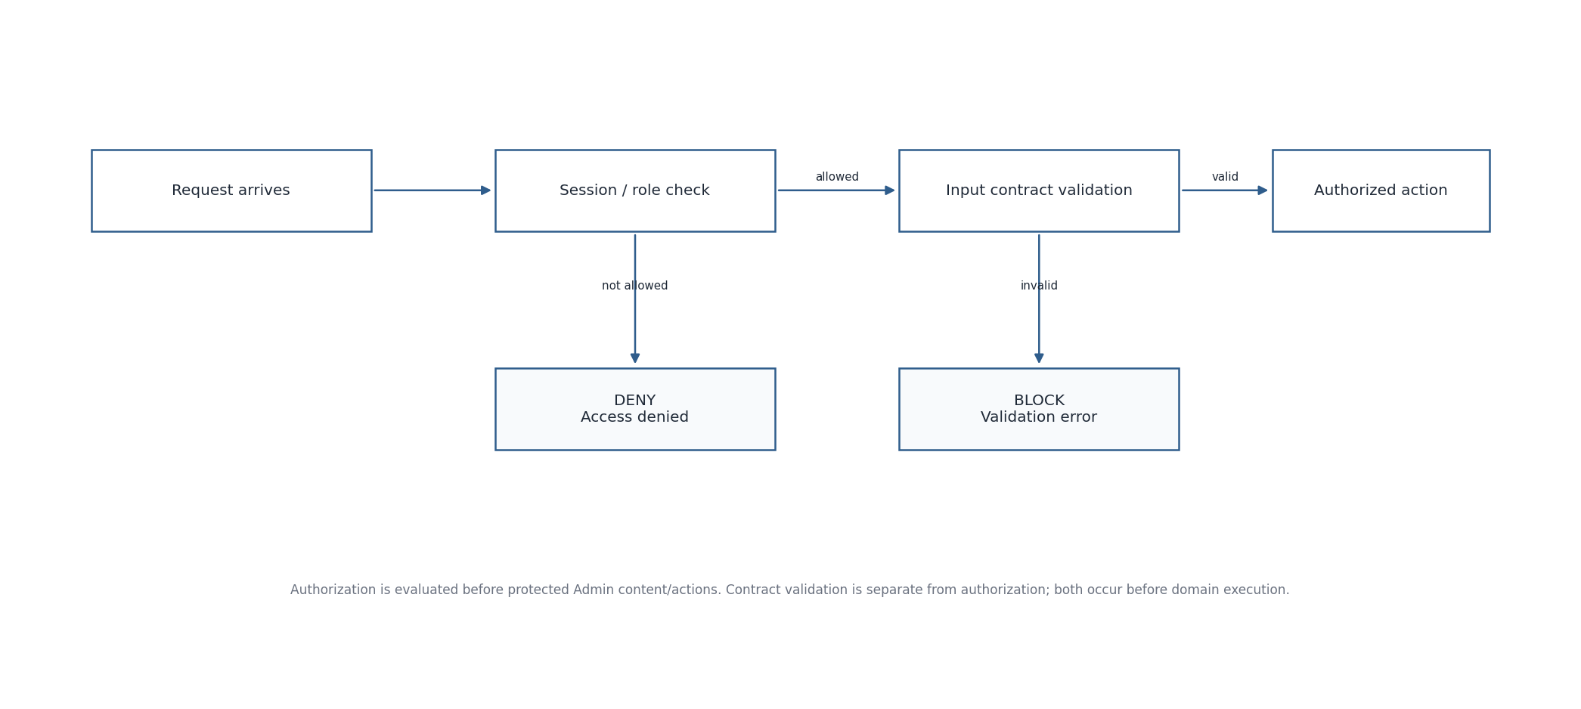
Figure 2. Authorization and contract-validation flow

4. Authorization policy
Action/resource | PUBLIC_EDUCATOR | ADMIN | SYSTEM_SERVICE
Curriculum/help reads | ALLOW | ALLOW | ALLOW
Recommendation/context/trace | ALLOW within current server session/actor scope | ALLOW for diagnostic use where UI exposes it | ALLOW
Kit generation/view/PDF/decision | ALLOW within current scope | ALLOW for diagnostic use where exposed | ALLOW
KG Explorer read-only | ALLOW | ALLOW | ALLOW
Admin shell / read-only repository inspection | DENY | ALLOW | ALLOW as internal support
Repository mutation/publication/build/rollback/benchmark execution | DENY | DENY in V1 | Deployment/build tooling only, outside Admin UI
Operational SQL/database API direct from browser | DENY | DENY | Server-side adapter only
External generation API credentials | DENY | DENY | Generation adapter only

For public educator routes with no account identity, access to persisted recommendation/Kit records is session/actor scoped by server-held state plus actor_scope_hash metadata. Opaque IDs are not treated as sufficient authorization by themselves.

5. Secrets and configuration
- OpenAI/API/provider keys, hosted database credentials and Admin authentication secrets are loaded from deployment environment/host secret storage (for example Streamlit secrets or environment variables) and never committed to source or serialized into snapshots.
- Only server-side adapters can access secrets. Secrets must not be echoed into UI errors, logs, trace JSON, generation provenance or PDF output.
- Configuration separates public non-secret values (model name/version, interface version) from secret credentials.
- Secret rotation must not require changing domain/interface contracts.

6. Input, query and rendering security
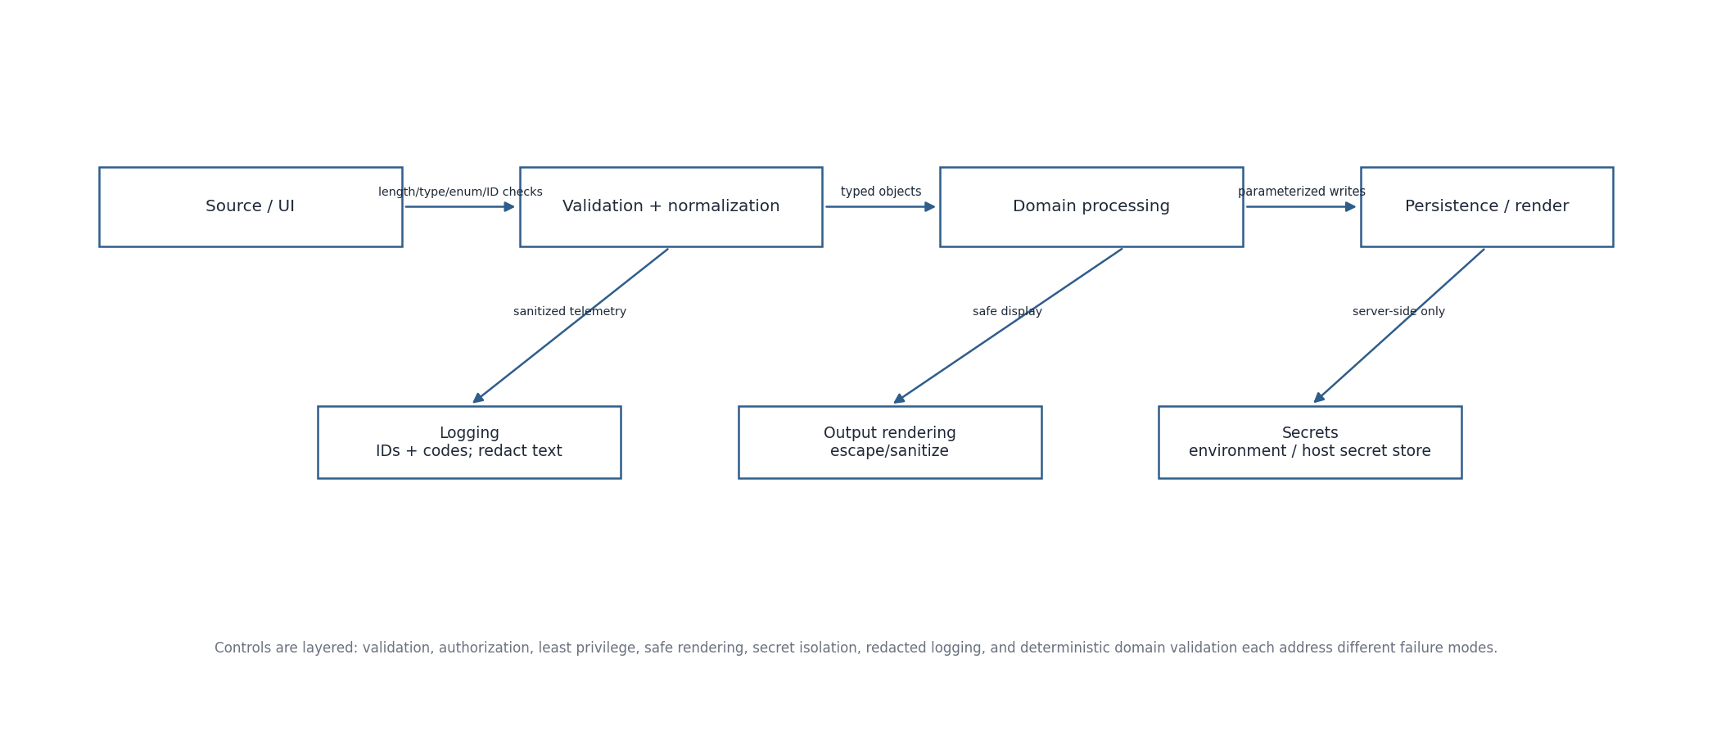
Figure 3. Layered input, processing, rendering and secret controls
Surface | Required controls
Canonical IDs / enums | Validate against expected format/controlled value and resolve existence where required; do not trust UI labels as keys.
Free text | Bound length; Unicode-safe normalization only where semantically appropriate; preserve exact text separately; no command/template evaluation.
SQL | Parameterized statements only; no string concatenation of educator text or IDs into SQL.
HTML/Streamlit rendering | Escape/sanitize educator and generated text; do not render raw model-provided HTML/JavaScript.
PDF rendering | Render from validated immutable Kit snapshot; disable/strip active content; sanitize filenames and external links.
Graph search/path | Resolve canonical endpoints; no arbitrary code/query-language execution from text.
File material if enabled | Configured non-executable types and size limit; never execute macros/scripts; extract text in isolated/temp path; discard temporary bytes unless separately approved.

7. External generation and prompt-injection boundary
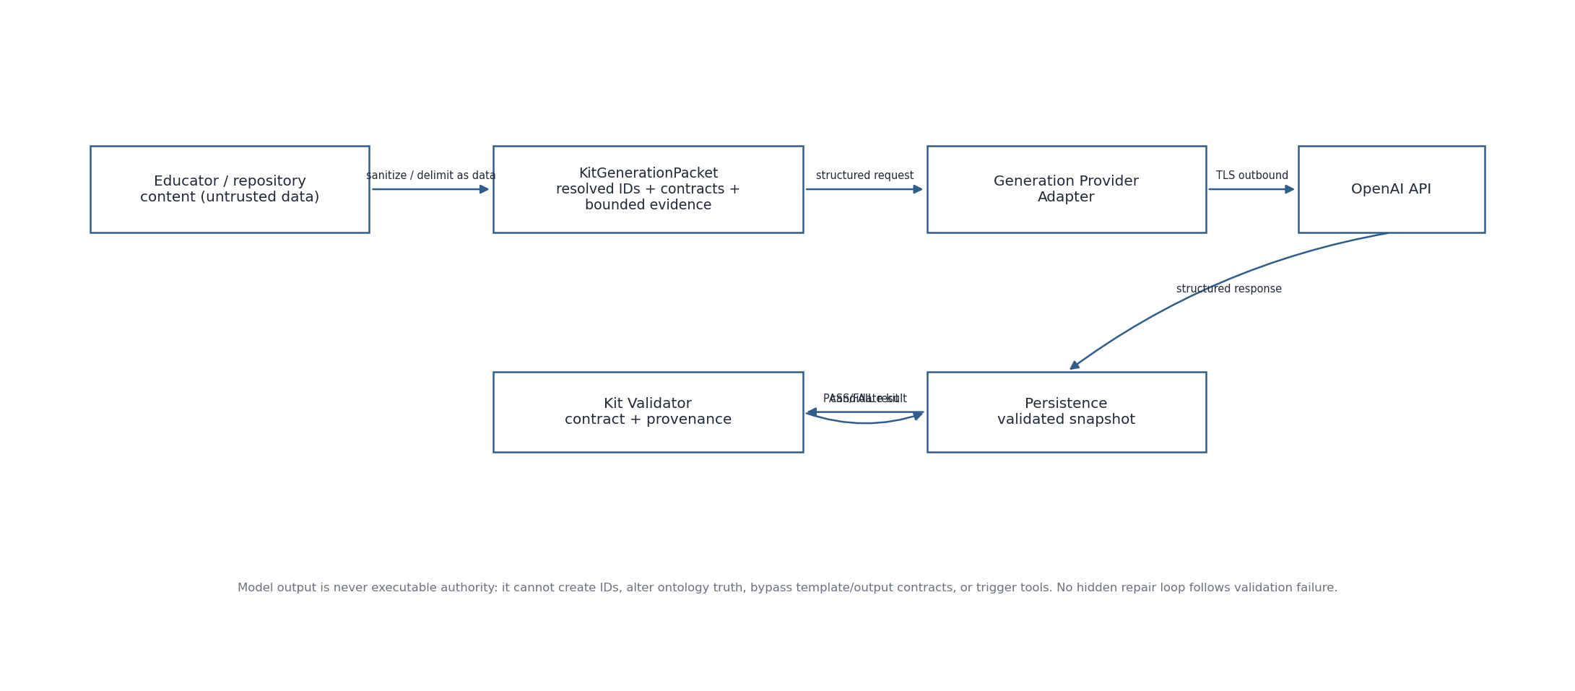
Figure 4. Bounded external-generation security boundary
- Educator text, teaching material and retrieved source excerpts are explicitly treated as data, not executable instructions that can override system/developer constraints.
- The generation request is assembled only after Template_ID, output contract, teaching material provenance and framework context are deterministically resolved.
- The model cannot choose/alter Course, Module, Subtopic, SCR_ID, Template_ID, framework eligibility or output-contract requiredness.
- Model output cannot directly trigger tools, database writes, network fetches, graph mutation or repository mutation.
- Candidate output is parsed/validated against the expected structured schema and the same output-element contract before a ready Kit snapshot is exposed.
- Provider/network failure returns TechnicalError; contract failure returns VALIDATION_FAILED; neither is silently converted to success.

8. Persistence and database security
- The application, not the browser, holds database credentials. Hosted operational tables are default-deny for direct anonymous/client access.
- If Supabase PostgreSQL is used, enable RLS/default-deny policies for anon/authenticated client roles; the server-side backend/service identity performs authorized operational reads/writes.
- Persistence adapters use parameterized queries, explicit transactions and foreign/check/unique constraints from SEQ-09.
- actor_scope_hash is a server-side authorization aid only; never store raw session cookies/tokens in operational tables.
- SQLite local files use restrictive filesystem permissions and are not served as static assets.
- Backups and database diagnostics are protected operational assets and must not be exposed through the public Streamlit app.

9. Knowledge Graph and Administration security
Area | Rule
KG Explorer | Read-only; all entity/relationship data comes from the active compiled governed graph/repositories. Search/path cannot mutate graph or invoke Recommendation Core.
Canonical IDs | Hidden from normal educator UI where not needed; may be retained internally/advanced audit. Hidden IDs are not themselves an authorization control.
Admin entry | Authorization check occurs before protected content is rendered. Unauthorized state shows a generic access-denied response.
Admin V1 scope | No functional repository write/upload/publish/rollback/benchmark execution endpoints exist in the public application. Future workflow descriptions are non-executable.

10. Logging, audit and privacy minimization
Data | Logging rule
Request/Event/Kit IDs | May be logged for correlation.
Error codes / component / timing | May be logged.
Educator Application Context / teaching constraints | Do not write full raw text to routine technical logs; exact text belongs only in governed operational snapshot where required.
Generated Kit content | Do not duplicate into routine logs; persisted Kit snapshot is the authoritative operational record.
Secrets / auth tokens / DB credentials | Never log.
Audit event details | Structured, minimal and sanitized; include actor type, action, resource ID, outcome and error code as needed.

The public UI should advise educators not to enter unnecessary personal, confidential or regulated information. The system persists only data required for recommendation/Kit provenance and configured operational audit.

11. Availability and abuse controls
- Disable Generate/Kit primary actions while a request is in flight; Request_ID/Kit_Request_ID idempotency prevents duplicate semantic execution.
- Apply configurable per-session/IP throttling to expensive recommendation and generation operations; exact quotas are deployment configuration, not contract constants.
- Bound input sizes, candidate counts, graph search result counts and PDF rendering payload sizes.
- Provider/model/database unavailability must fail explicitly without fallback to an unregistered backend.
- Time out external provider/network calls and surface retryable TechnicalError only when safe.

12. Supply-chain and deployment controls
- Pin Python dependencies in a reproducible lock/requirements file and review updates before deployment.
- Keep source repository private where intended; never commit secrets, local DB files or exported operational data.
- Validate compiled graph/embedding artifact versions/checksums before startup use.
- Use HTTPS for hosted application and all external provider/database connections.
- Run dependency vulnerability scanning and static secret scanning as part of release verification where tooling is available.

13. Security verification matrix
Test | Expected result
Unauthenticated Admin access | DENIED before protected content rendering.
PUBLIC_EDUCATOR calls deferred publication endpoint | No such functional endpoint / DENY.
SQL injection payload in free text | Stored/processed as text; parameterized SQL unaffected.
HTML/script in educator/model text | Escaped/sanitized; no script execution.
Prompt injection asking model to change SCR/Template_ID | No authority; deterministic IDs/contracts remain unchanged.
Duplicate Request_ID same hash | Return/reuse stored outcome; no duplicate event.
Duplicate Request_ID different hash | Reject idempotency conflict.
Guess another persisted snapshot ID | Denied unless current authorized/session scope allows it.
Provider unavailable | TechnicalError; no fallback provider/model.
Kit validation fails | VALIDATION_FAILED retained; no ready Kit/no hidden regeneration.
Graph runtime unavailable | Explicit unavailable state; no fake empty graph.

14. Incident and recovery behavior
- Security-relevant denial/failure can append sanitized audit_event records with correlation IDs.
- On suspected credential exposure, rotate affected secrets and restart/redeploy without changing domain contracts.
- On database compromise, disable affected deployment access, preserve required audit evidence, restore from controlled backup and verify integrity before reopening.
- On artifact tampering/version mismatch, fail startup/readiness rather than loading an unverified graph/model package.

15. Deferred security scope and acceptance

15.1 Deferred beyond V1
- Enterprise SSO/federation and institutional multi-tenant role hierarchy.
- Authenticated educator accounts and cross-session saved-history ownership model.
- Authorization for repository publication/build/rollback/benchmark execution.
- Persistent uploaded-file/object-storage security architecture if future product scope requires it.
- Fine-grained per-institution data isolation.

15.2 Acceptance checklist
- No secret is present in source-controlled configuration, snapshots, trace or logs.
- All protected Admin routes check authorization before rendering/action.
- No direct browser access to operational tables/provider credentials is required.
- Untrusted text cannot become executable code/HTML/tool authority.
- Persistence, generation and graph operations respect frozen SEQ-04/05 domain/error boundaries.
- Security controls do not introduce a new V1 repository mutation/publication capability.

16. SEQ-06/SEQ-07 reconciliation verification
SEQ-10 was verified against the finalized process branches and algorithm authorities. Existing controls cover the new formalization; no new V1 trust boundary is introduced by SEQ-06/07.
Process / algorithm risk | Verified control
PF-01/PF-02 / ALG-01/04 | Typed input validation, canonical ID resolution, bounded free text and no silent re-anchor.
ALG-07–09 | Weights/thresholds/config are server-side; client cannot alter candidate eligibility/promotion/negation rules.
PF-06 / ALG-12–16 | Untrusted content enters bounded generation packet as data; model has no authority over IDs/eligibility; output contract validation required.
PF-11 / ALG-17 | Graph endpoints canonicalized; read-only directed path query; no graph query language/code execution from educator text.
PF-12 / ALG-18 | Runtime artifact checksums/versions verified before load; invalid build fails closed.
ALG-19 | Idempotency keys/hashes mitigate duplicate expensive execution; conflicts are explicit.

- No functional V1 Admin mutation endpoint is introduced by the process or algorithm specifications.
Verification outcome: the specification remains semantically compatible after SEQ-06/07. Version 0.2 records this reconciliation and updates the upstream baseline; it does not redesign the frozen V1 behavior.

