TECHNICAL INTERFACE DESIGN
Ontology and Knowledge Graph-Driven
Sustainability Principles Recommendation System
SEQ-04 | Version 0.2 | September 2026
Document status
V1 implementation baseline. Exact typed logical contracts are defined here; physical persistence remains SEQ-09 and detailed security/access-control implementation remains SEQ-10.

Purpose
Define stable, implementation-ready interfaces between the educator UI, Recommendation Core, Educator Kit subsystem, Knowledge Graph Explorer, persistence, access control and external generation provider.

Document control
Item | Definition
Document | Technical_Interface_Design_v0.2.docx
Sequence | SEQ-04 — Technical Interface Design
Version / date | 0.2 / September 2026
Status | V1 implementation baseline
Companion registry | Interface_Contract_Registry_v0.1.xlsx
UI baseline | UI_Design_v0.3.docx + UI_Foundation_Decisions_v0.3.xlsx + UI_Data_Binding_Matrix_v0.3.xlsx + UI_Help_Content_Repository_v0.3.xlsx
Decision baseline | SEQ04_Decision_Register_v0.9.xlsx
Architecture baseline | System_Architecture_Design_v1.1.docx — reconciled V1 system/component architecture
Persistence boundary | Logical operational objects are defined; physical database schema is deferred to SEQ-09
Security boundary | Privileged access interface is identified; authentication, authorization and upload/security controls are deferred to SEQ-10

Contents and reading order
- 1. Purpose and scope; 2. Source baseline and supersession; 3. V1 interface architecture; 4. Shared contract conventions.
- 5. Interface registry; 6–10. Curriculum/Application Context, recommendation request, result and trace contracts.
- 11–13. Educator Kit generation, validation, snapshot, view and PDF export.
- 14. Knowledge Graph Explorer contracts; 15. Persistence and access-control boundaries; 16. Administration V1 boundary.
- 17–20. End-to-end sequences, errors/domain outcomes, cross-interface invariants, deferrals and implementation acceptance.
- Appendices A–B provide controlled values and an object-contract quick reference; the companion XLSX is the field-level registry.

1. Purpose and scope
This document defines the logical interface contracts required to implement the V1 research demonstrator. It converts the approved UI bindings and system architecture responsibilities into stable request, response, domain-outcome and provenance objects. The contracts are deliberately transport-neutral: a V1 Python implementation may use dataclasses or Pydantic models and in-process function calls without introducing REST endpoints, message queues or microservice boundaries.
The design covers the educator recommendation workflow, Application Context suggestion/acceptance, Recommendation Core handoff, result and explainability retrieval, Educator Kit generation and validation, snapshot rendering and PDF export, Knowledge Graph exploration, persistence boundaries, common technical errors and privileged access checks.
V1 authority rule
Curated repositories and their compiled runtime artifacts define semantic authority. Similarity scores, UI display text, generated content and free-form language do not create ontology truth, canonical relationships or recommendation eligibility.

1.1 In scope
- Typed logical inputs/outputs and required/optional field semantics.
- Domain outcomes versus technical errors, null behavior, idempotency and version provenance.
- V1 read/write responsibility across UI, Recommendation Core, Educator Kit, graph runtime and persistence.
- Reconciliation of later V1 decisions with earlier architecture/UI assumptions where they conflict.

1.2 Out of scope
- Physical SQL/PostgreSQL/SQLite table design and indexes (SEQ-09).
- Authentication protocol, credential/session implementation, file-upload security and secret management (SEQ-10).
- Algorithm pseudocode and exact ranking mathematics beyond the contract-visible invariants (later algorithm specification).
- Functional V1 repository onboarding/editing/publication/build/rollback/benchmark execution; those workflows are future/deferred.

2. Source baseline and supersession rules
The interface baseline is derived from the controlled architecture, repository designs, validated Recommendation Core behavior and the reconciled SEQ-03 UI artifacts. Where an earlier source describes functionality that was subsequently reduced or corrected for V1, the explicit rules in this document and the companion Interface Contract Registry take precedence for implementation.
Source / artifact | Role in SEQ-04
System_Architecture_Design_v1.1.docx | Reconciled system/component responsibilities, V1 scope boundaries and architecture-level interface paths.
UI_Design_v0.3.docx | Reconciled screen behavior, states, accessibility and V1 interaction scope.
UI_Data_Binding_Matrix_v0.3.xlsx | Field/source/UI-state mapping aligned to current interface contracts.
UI_Foundation_Decisions_v0.3.xlsx | UI decisions with superseded/deferred items retained for traceability.
UI_Help_Content_Repository_v0.3.xlsx | Governed user-facing static help after SEQ-04 reconciliation.
SEQ04_Decision_Register_v0.9.xlsx | Interface-level decisions and cross-interface reconciliation record.
Interface_Contract_Registry_v0.1.xlsx | Implementation registry of logical interfaces, object fields, enums, errors and deferred scope.

2.1 Explicit V1 supersessions
Earlier assumption | V1 interface baseline
Educator may directly select curated repository Application Contexts | Educator-facing options are own text or 0–2 system-generated alternatives. Repository contexts remain internal evidence/retrieval support.
Application Context source includes curated/repository-selected | Exactly EDUCATOR_ENTERED or ACCEPTED_SYSTEM_GENERATED.
Show more compatible curated contexts | Removed from V1. Broader internal retrieval remains permitted.
Kit exports PDF + HTML + Excel | In-app web/HTML view plus downloadable PDF only. Downloadable HTML/Excel deferred.
KG Explorer is a local-neighborhood graph | Complete active compiled governed graph remains explorable; focus/filter/lean loading are presentation strategies.
V1 Admin performs upload/build/publish/rollback/benchmark execution | V1 Admin is protected static/read-only/prototype only; operational lifecycle is future/deferred.
Text-only curriculum route is productized in V1 | V1 public workflow requires Course→Module→Subtopic; text-only anchor route deferred.

3. V1 interface architecture
V1 is a modular Python application, not a mandatory distributed system. The registered interfaces are logical contracts that separate authority and responsibility while allowing an in-process implementation. The same contracts can later be exposed through services without changing domain semantics. Figure 1 provides the interface-level boundary view used throughout the remaining contracts.
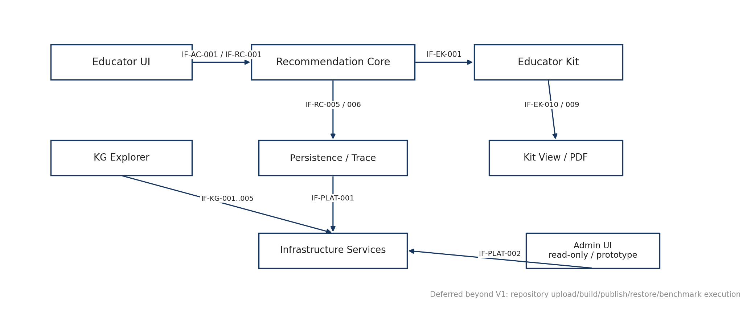
Figure 1. V1 logical interface architecture and responsibility boundaries
Educator UI
-> Input Adapter -> Recommendation Core -> RecommendationResult
-> Trace View reads persisted RecommendationEvent / ContextSnapshot
-> Accepted recommendation -> Pedagogy -> PKCR / Material / Framework -> Generator -> Validator -> EducatorKitSnapshot
-> Kit View / PDF Renderer read the immutable snapshot
Knowledge Graph Explorer -> read-only Graph Runtime
Protected Administration -> Access Check -> read-only/prototype V1 surfaces

3.1 Responsibility boundaries
Domain | Primary components | Contract authority
Educator UI | UI-01 / UI-02 / UI-03 / UI-04 | Collect/retain exact user state; display governed labels; never create semantic truth.
Recommendation Core | RC-03 through RC-11 | Normalize inputs, resolve controlled evidence, determine eligibility/ranking/promotion/negation, persist trace.
Educator Kit | EK-01 through EK-08 | Select pedagogy after accepted SCR, resolve contract/evidence/framework, generate/validate/snapshot/render.
Graph Runtime | RC-01 | Expose compiled governed graph for controlled runtime reasoning and separate read-only exploration.
Persistence | INF-04 | Store immutable snapshots/events and separate educator decisions; physical schema deferred.
Access Control | INF-05 | Gate protected Administration surfaces.
Generation Provider | INF-07 + EXT-04 | Generate bounded content from already-resolved inputs; never determine ontology/SCR/template eligibility.

4. Shared contract conventions

4.1 Identifiers and authority
- Canonical repository identifiers (Course_ID, Module_ID, Subtopic_ID, KCR_ID, KPR_ID, KFR_ID, SCR_ID, Template_ID and similar) remain stable semantic keys and are normally hidden in educator-facing UI.
- Operational identifiers (Request_ID, Kit_Request_ID, Context_Candidate_ID, Recommendation_Event_ID, Recommendation_Context_Snapshot_ID, Educator_Kit_Snapshot_ID) identify runtime activity/provenance and must not mimic canonical repository IDs.
- Readable labels never replace canonical IDs as join, lookup, persistence or request keys when a canonical ID exists.
- Generated Application Context candidate IDs are operational only and must never be written back as canonical Application_Context_ID values.

4.2 Time, versioning and reproducibility
- Operational timestamps are persisted in UTC. The UI may localize them for display.
- Recommendation and Kit provenance retains repository, runtime, model, contract, prompt and renderer versions where those versions affect reproducibility.
- Replay/audit must use the historical versions recorded for the event or clearly report their unavailability; it must not silently substitute current versions.

4.3 Nulls, empty collections and controlled unknowns
Null indicates legitimate absence or non-applicability. It must not be used as an informal substitute for a domain value. UNKNOWN, NOT_SPECIFIED and NO_PREFERENCE are permitted only where the relevant controlled teaching-context field explicitly supports them. Empty collections are valid for zero suggestions, no additional supported principles, no active framework items and no graph search/path result as defined by their domain status.

4.4 Domain outcomes versus technical errors
Separation rule
ABSTAINED, NO_COMPATIBLE_SUGGESTIONS, NOT_AVAILABLE, NO_MATCHES and NO_GOVERNED_PATH are valid domain outcomes. Infrastructure/runtime/provider failures use TechnicalError and must not be encoded as recommendation or graph domain statuses.

TechnicalError field | Requirement | Purpose
Error_Code | Required | Stable machine-readable code.
User_Message | Required | Safe actionable user-facing explanation.
Technical_Message | Optional | Diagnostic detail for logs/audit, not normal educator view.
Request_ID | Required when request-scoped | Correlates error to initiating action.
Retryable | Required boolean | Indicates whether retry is safe/reasonable.
Occurred_At | Required UTC timestamp | Operational audit.

4.5 Idempotency and duplicate-action control
Generate Recommendation uses Request_ID as an idempotency key. Kit generation uses Kit_Request_ID. A repeated request with the same idempotency identifier must not create duplicate RecommendationEvent or EducatorKitSnapshot records. The UI also disables consequential actions while processing, but backend idempotency remains required.

4.6 No-silent-fallback invariant
- No silent curriculum re-anchoring.
- No direct free-text-to-SCR shortcut in V1.
- No silent semantic-model substitution.
- No fabricated graph node, relationship, description or evidence path.
- No fresh LLM rationale when persisted recommendation trace is absent.
- No automatic hidden Kit repair/regeneration after validation failure.

5. Interface registry summary
The companion Interface_Contract_Registry_v0.1.xlsx is the field-level implementation source. The table below summarizes the V1 logical boundaries. Original architecture IDs are retained where they already existed; supplemental IDs identify SEQ-04 read/result/graph contracts that were previously implicit.
ID | Interface | Status | Primary path
IF-UI-001 | Curriculum Browse | Active | Educator UI -> governed curriculum repositories
IF-AC-001 | Application Context Suggestion | Active | Educator UI -> Application Context Resolver
IF-RC-001 | Educator Recommendation Request | Active | UI-01 -> RC-03 Input Adapter
IF-RC-002 | Normalized Recommendation Request | Active | RC-03 -> RC-10 Recommender
IF-RC-003 / 004 | Compiled Graph / Embedding Load | Active startup | Repository Build -> Graph Runtime / Semantic Engine
IF-RC-005 | Recommendation Result | Active | RC-10 -> Recommendation View
IF-RC-006 | Recommendation Trace | Active read | Evidence View -> persisted trace
IF-EK-001..007 | Educator Kit generation chain | Active | Accepted recommendation -> pedagogy/contract/material/framework/generator/validator/snapshot
IF-EXT-001 / 002 | Structured generation/provider API | Active | Kit Generator -> Generation Provider -> external API
IF-EK-008..011 | Kit load/view/PDF/educator decision | Active V1 profile | Persistence/renderer <-> Kit View
IF-KG-001..005 | KG load/search/entity/relationship/path | Active read | KG Explorer -> Graph Runtime
IF-PLAT-001 | Persistence Interface | Active logical | Functional domains -> persistence
IF-PLAT-002 | Privileged Access Check | Active | Protected UI -> access control
Deferred Admin interfaces | Publication/build/restore/benchmark execution | Deferred | Future V2/V3

6. Curriculum and Application Context interfaces

6.1 Mandatory curriculum hierarchy
The normal V1 route requires Course_ID, Module_ID and Subtopic_ID. Module must belong to the selected Course; Subtopic must belong to the selected Module. Subtopic is the authoritative technical anchor. Module and Course may be used internally only as controlled broader fallbacks when narrower evidence is insufficient.
V1 routing constraint
The public V1 interface does not offer a text-only anchor route. Educator free text is Application Context evidence and cannot silently replace the selected curriculum anchor.

6.2 ApplicationContextSuggestionRequest
Field | Type | Required | Rule
Request_ID | str | Yes | Unique request identifier.
Course_ID | str | Yes | Canonical selected Course.
Module_ID | str | Yes | Canonical selected Module; must belong to Course.
Subtopic_ID | str | Yes | Canonical selected Subtopic; authoritative anchor.
Application_Context_Text | str | No | If educator has already typed text, include it as application/mechanism evidence.

6.3 Suggestion resolver semantics
Suggestion discovery is not limited to two records and is not limited to records directly attached to the selected Subtopic. The selected Course/Module/Subtopic defines authoritative scope; the resolver may use controlled KCR/KPR/KFR expansion, governed relationships, repository Application Context evidence, mechanism/boundary evidence and controlled semantic fallback. Structural/mechanism/boundary compatibility establishes eligibility before semantic similarity ranks eligible candidates.
authoritative anchor + optional educator context text
-> controlled technical/mechanism evidence expansion
-> compatibility / boundary eligibility
-> broader eligible candidate pool
-> semantic ranking among eligible candidates
-> display strongest 0..2 SYSTEM-GENERATED alternatives

6.4 ApplicationContextSuggestionResponse
Field | Requiredness | Rule
Request_ID | Required | Echo/correlate request.
Suggestion_Status | Required | SUGGESTIONS_AVAILABLE or NO_COMPATIBLE_SUGGESTIONS.
Anchor | Required | Course_ID, Module_ID, Subtopic_ID used for generation.
Candidates[] | Required | 0..2 displayed ContextCandidate objects.

ContextCandidate field | Rule
Context_Candidate_ID | Runtime operational ID; not canonical repository truth.
Context_Title | Short readable title.
Application_Context_Text | Complete generated text that can be accepted as-is.
Display_Rank | 1..2.
Why_Suggested | Optional concise educator-facing rationale; no raw score exposure.
Internal_Provenance | Supporting repository context IDs/evidence, resolver version and generation method for audit only.

6.5 Acceptance and UI state
The Application Context text field is usable immediately. The educator may type before, during or after automatic suggestion evaluation. The UI retains the final 0–2 candidates actually shown and any accepted Context_Candidate_ID in session/request state so the Generate request is self-contained. Changing Course, Module or Subtopic clears stale candidates and any accepted generated candidate tied to the old anchor.
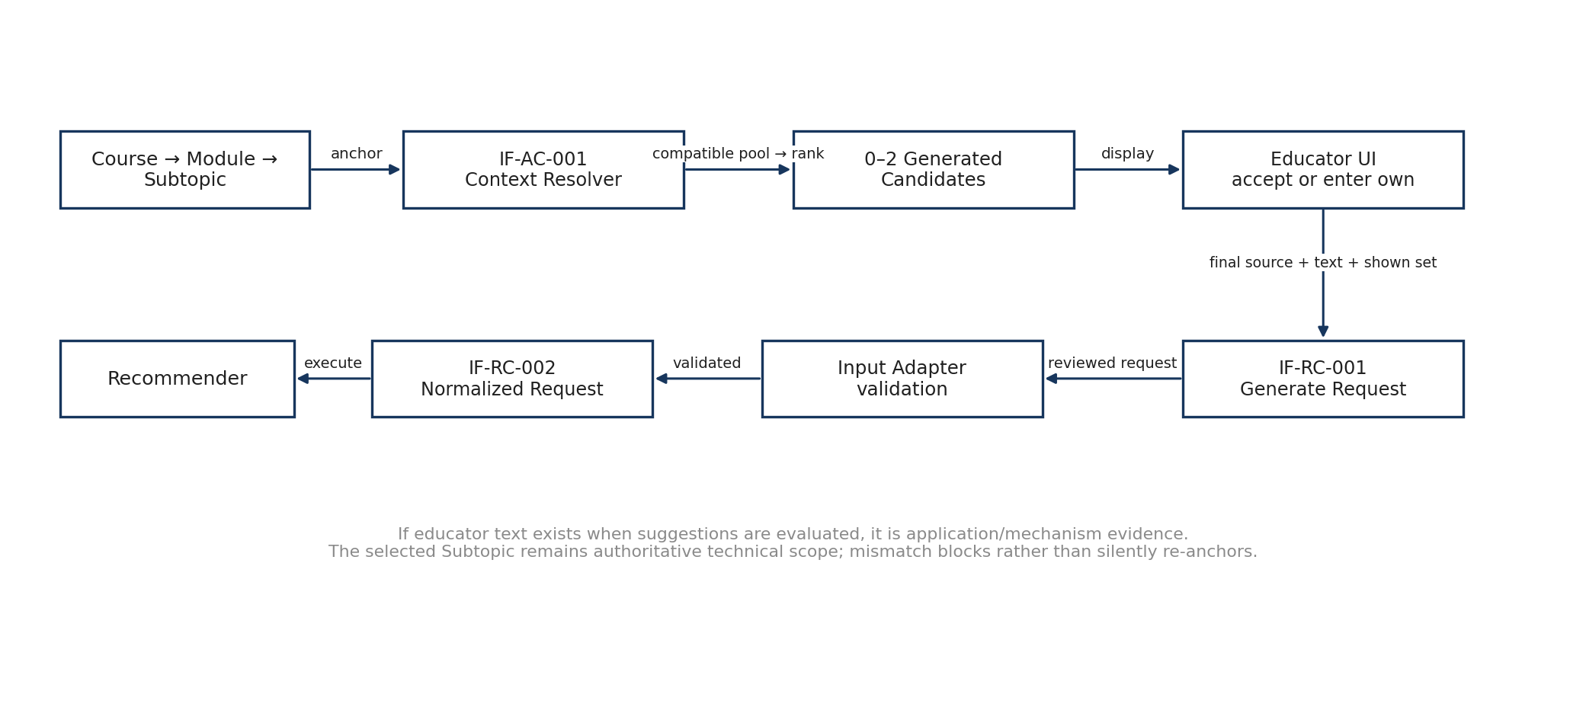
Figure 2. Application Context suggestion, acceptance and recommendation-request flow
Accepted path | Source value | Text | Accepted candidate ID
Educator enters own context | EDUCATOR_ENTERED | Exact educator text | null
Educator accepts generated alternative | ACCEPTED_SYSTEM_GENERATED | Exact candidate text | Context_Candidate_ID required

7. IF-RC-001 — Educator Recommendation Request
The Generate Recommendation action constructs a self-contained request from the reviewed UI state. The UI does not submit labels as authority and does not submit a separate Educator_Question field in V1.
Field / group | Requiredness | Contract rule
Request_ID | Required | Unique/idempotent Generate action ID.
Requested_At | Required | UTC timestamp.
Interface_Version | Required | Version of typed contract used.
Course_ID / Module_ID / Subtopic_ID | Required | Canonical hierarchy; Subtopic is authoritative technical anchor.
Application_Context_Source | Required | EDUCATOR_ENTERED or ACCEPTED_SYSTEM_GENERATED.
Application_Context_Text | Required | Exact final context used.
Accepted_Context_Candidate_ID | Conditional | Required only for accepted generated context; null for educator-entered.
Suggested_Context_Candidates_Shown[] | Required provenance | Final 0..2 candidates actually shown; empty list valid.
Teaching_Context | Optional field-by-field | Learner level, delivery, class size, time, assessment preference, access/resources and additional constraints.

7.1 Pre-execution validation
1. Course, Module and Subtopic are present and hierarchy-consistent.
2. Application_Context_Text is nonblank and Application_Context_Source is present.
3. ACCEPTED_SYSTEM_GENERATED requires a valid Accepted_Context_Candidate_ID from the current shown candidate set.
4. EDUCATOR_ENTERED requires Accepted_Context_Candidate_ID = null.
5. A material anchor/context mismatch blocks execution and returns correction guidance; the system does not silently re-anchor.
6. Duplicate Request_ID does not create duplicate recommendation execution.

7.2 IF-RC-002 — Normalized Recommendation Request
The Input Adapter converts the public request into an internal normalized object used by Recommendation Core. Normalization may derive mechanism/action/resource/boundary facets and other controlled features, but must preserve the original educator text and provenance separately. Normalized text/facets do not become canonical repository content.

8. RecommendationResult contract
Field | Condition / rule
Request_ID | Always returned for completed attempt.
Recommendation_Event_ID | Required for SUCCESS and ABSTAINED completed attempts.
Recommendation_Context_Snapshot_ID | Required for SUCCESS and ABSTAINED completed attempts.
Result_Created_At | UTC.
Recommendation_Status | SUCCESS or ABSTAINED only.
Primary_Recommendation | Exactly one for SUCCESS; null for ABSTAINED.
Additional_Supported_Principles[] | Only independently promoted/evidence-supported active SCRs; never similarity-only Top-N.
Abstention_Reason | Required iff ABSTAINED.
Trace_Available | Boolean; controls detailed trace action.
Can_Open_Educator_Kit | True only for successful accepted primary recommendation.

8.1 Primary recommendation payload
Field | Source / rule
SCR_ID | Canonical active SCR; retained internally/audit.
Sustainability_Concept | Canonical readable title from SCR repository.
Definition | Canonical definition from SCR repository.
Why_This_Fits | Concise trace-derived summary; not a fresh LLM explanation.

8.2 Abstention states
Abstention_Reason | Meaning | UI consequence
INSUFFICIENT_EVIDENCE | A sustainability mechanism may be plausible, but governed evidence is insufficient for a defensible recommendation. | No accepted SCR; no normal Kit action; offer change/clarification route.
NO_DEFENSIBLE_SUSTAINABILITY_MECHANISM | The current anchor/application evidence does not establish a defensible sustainability-relevant action/mechanism. | No accepted SCR; no Kit action; invite context clarification or curriculum review.

Status model
Technical/runtime/provider failure is never encoded as Recommendation_Status = ERROR. Such failures use TechnicalError.

9. Recommendation trace interface

9.1 Request and status
RecommendationTraceRequest uses Recommendation_Event_ID as the primary lookup key. The response returns the associated Recommendation_Context_Snapshot_ID and Trace_Status = AVAILABLE or NOT_AVAILABLE. NOT_AVAILABLE is a valid trace retrieval outcome; technical retrieval failures remain TechnicalError.

9.2 Educator-readable Explanation
- Curriculum anchor and its role in the decision.
- Application Context source, exact text used and meaningful action/mechanism interpretation.
- Supporting evidence for the accepted primary and any independently promoted secondary principles.
- Material boundary, guardrail and explicit negation/veto checks that constrained the decision.
- A concise decision summary derived from the persisted trace.

9.3 Audit_Detail
- Actual governed evidence paths with exact entity identifiers, relationship types and source-to-target direction.
- Candidate diagnostics/ranks/scores where needed for technical inspection.
- Promotion detail and independent supporting mechanism evidence for additional SCRs.
- Explicit-negative/negated facets and veto reasons kept separate from positive support.
- Repository, runtime, embedding-model and other relevant versions.
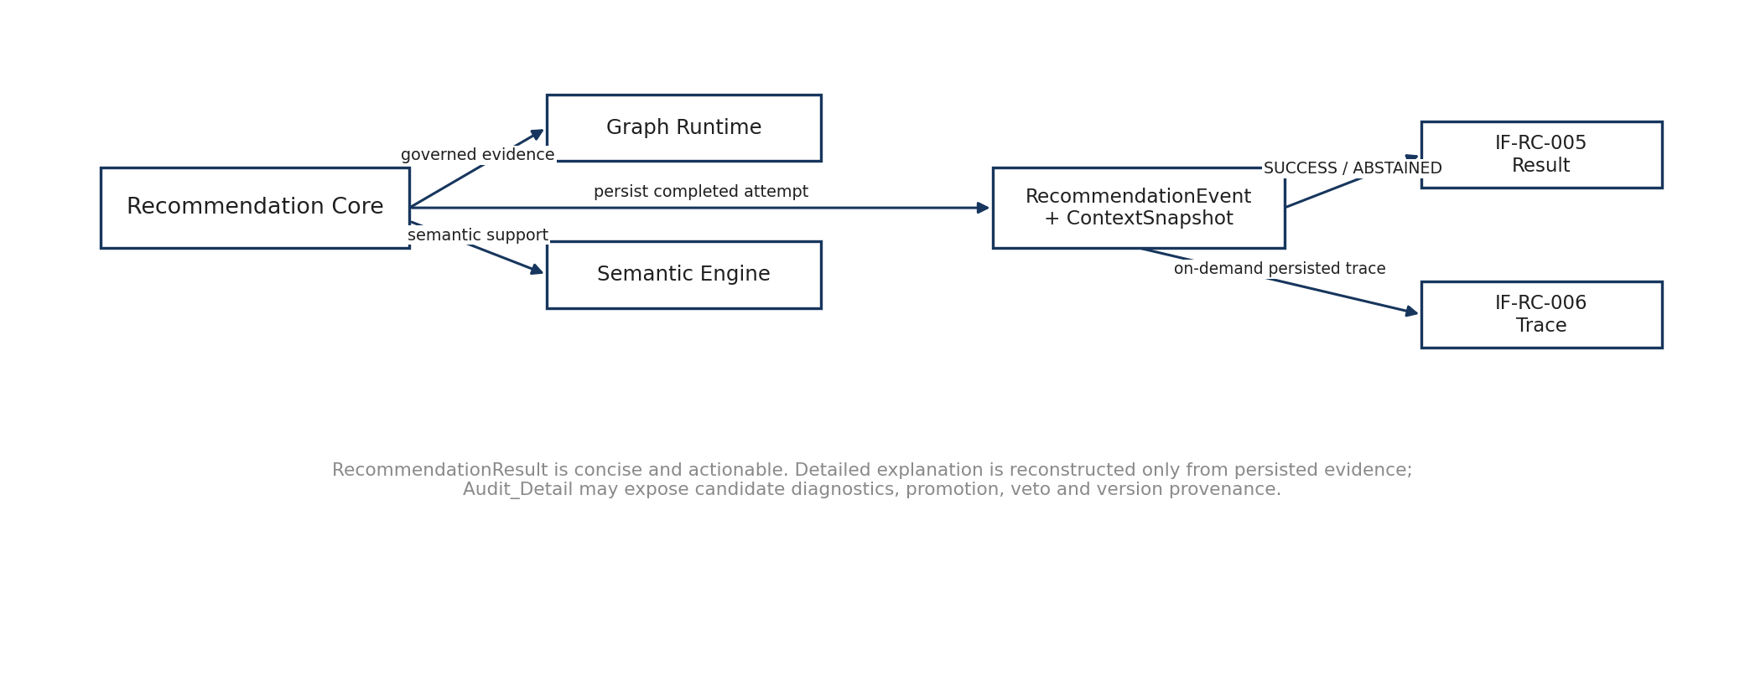
Figure 3. Recommendation result, persistence and trace-retrieval flow
Trace fidelity rule
A trace is persisted decision provenance, not a new graph query and not a post-hoc narrative. If trace data is absent, the system reports NOT_AVAILABLE and does not synthesize a plausible explanation.

10. Educator Kit interface architecture
The Kit subsystem starts only after a successful accepted sustainability recommendation. Teaching templates, framework mappings and generated content cannot create, rescue or change SCR eligibility.
accepted RecommendationEvent + ContextSnapshot
-> IF-EK-001 Pedagogy Selector
-> IF-EK-002 PKCR output contract
-> IF-EK-003 Teaching Material Resolver
-> IF-EK-004 Framework Context Resolver
-> IF-EK-005 bounded Kit Generation Packet
-> IF-EXT-001/002 generation provider
-> IF-EK-006 deterministic validation
-> IF-EK-007 immutable EducatorKitSnapshot

10.1 EducatorKitGenerationRequest
Field | Requiredness | Rule
Kit_Request_ID | Required | Unique/idempotent Kit generation action.
Recommendation_Event_ID | Required | Accepted recommendation authority.
Recommendation_Context_Snapshot_ID | Required | Exact context snapshot authority.
Requested_At / Interface_Version | Required | UTC and contract version.
Requested_Template_ID | Optional | Null for initial primary; alternative Template_ID only after explicit educator choice.
Teaching_Context_Update | Optional | Ordinary teaching changes may recontextualize Kit without rerunning SCR eligibility.
Material_Source_Mode | Required/default | USE_SYSTEM_SUGGESTION or USE_MY_MATERIAL; default system suggestion.
Educator_Material | Conditional | Required only for USE_MY_MATERIAL; upload/security transport deferred.

10.2 Primary versus alternatives
Initial Kit generation fully generates and validates only the primary teaching approach. Up to two materially distinct alternatives are returned as human-readable summaries. If the educator explicitly chooses an alternative, the system creates a new Kit_Request_ID, generates that selected Template_ID, validates it and creates a new immutable EducatorKitSnapshot. This explicit educator-triggered action is not an automatic repair loop.
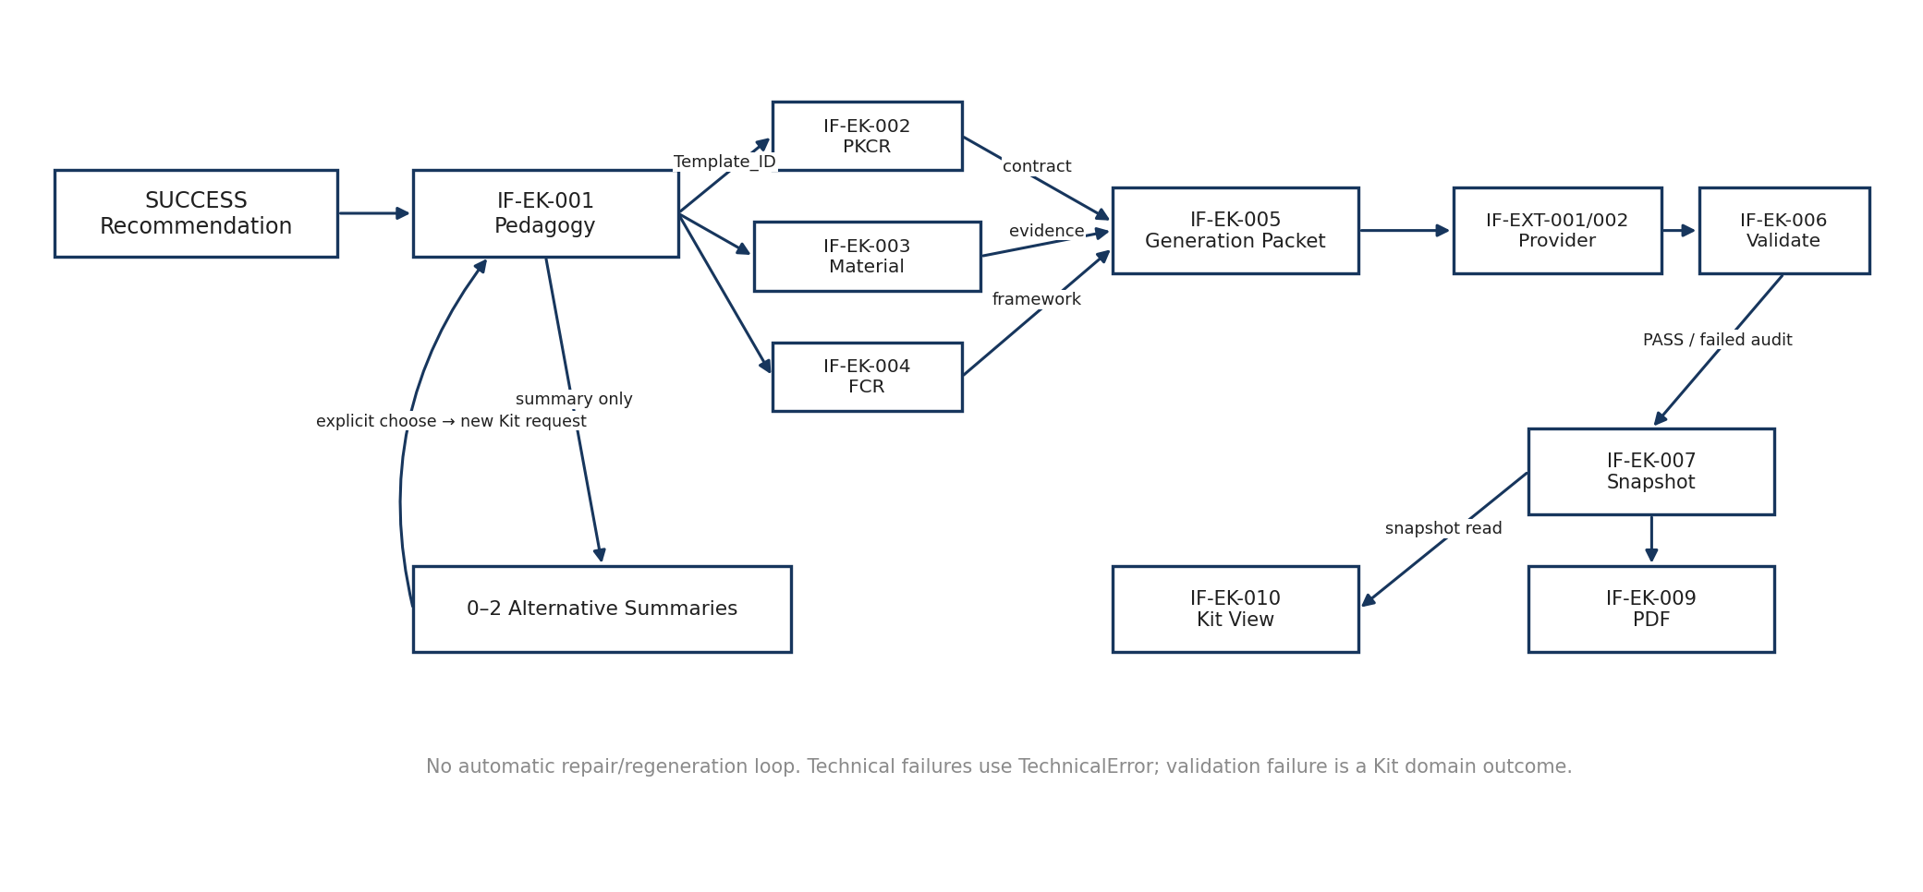
Figure 4. Educator Kit deterministic resolution, generation, validation and snapshot flow

10.3 Internal deterministic resolvers
Interface | Input | Output / rule
IF-EK-001 | Accepted recommendation + teaching context | One primary Template_ID + up to two distinct alternative summaries.
IF-EK-002 | Selected Template_ID + trigger state | Exact REQUIRED + triggered CONDITIONAL output elements; does not select template.
IF-EK-003 | SCR + template + context + material mode | Teaching material/evidence packet with explicit source/generated provenance.
IF-EK-004 | SCR + template + context | Framework Context Packet: ACTIVE_DIRECT / ACTIVE_CONTEXT; EXCLUDED retained in audit.
IF-EK-005 | Resolved contract + evidence + framework + context | Bounded generation packet.
IF-EXT-001/002 | Structured generation packet | Generated structured content; provider does not determine ontology truth or eligibility.

11. Kit generation result, validation and immutable snapshot

11.1 EducatorKitGenerationResult
Field | Rule
Kit_Generation_Status | READY | NO_ELIGIBLE_TEMPLATE | VALIDATION_FAILED.
Educator_Kit_Snapshot_ID | Present when a generated/failed snapshot is persisted as applicable; may be absent for NO_ELIGIBLE_TEMPLATE.
Primary_Teaching_Approach | Full generated/validated primary content for READY.
Alternative_Teaching_Approaches[] | 0..2 summaries, not full Kits until selected.
Validation_Summary | Overall and element-level validation summary.
Failure_Message | Optional user-facing domain failure explanation.

11.2 Validation contract
The validator receives the candidate Kit together with the same output-element contract and provenance packet used for generation. Overall PASS requires every REQUIRED and every triggered CONDITIONAL element to pass. Element results use PASS, FAIL or NOT_APPLICABLE.
Object | Fields / rule
KitValidationResult | Overall_Status (PASS|FAIL), Element_Results[], Validated_At, Validator_Version.
KitElementValidationResult | Element_ID, Status (PASS|FAIL|NOT_APPLICABLE), Output_Locator?, Failure_Reason? (required for FAIL).

11.3 Validation failure behavior
- The underlying sustainability recommendation remains visible/valid; a Kit-generation defect does not retune Recommendation Core.
- Failed element/reason and failed snapshot/audit provenance are retained.
- No incomplete or half-valid Kit is presented as Ready to use.
- No hidden automatic repair/regeneration occurs in V1.

11.4 EducatorKitSnapshot authority
EducatorKitSnapshot is immutable generated operational output. It contains selected Template_ID(s), resolved framework packet summary, applicability states, teaching evidence, generated output elements, contract/model/prompt/repository/runtime versions and validation. Educator decisions/adaptations are stored separately and never overwrite the canonical template or original system-generated snapshot.

12. Kit view and PDF export

12.1 EducatorKitViewRequest / Response
The normal in-app Kit view is a read operation keyed by Educator_Kit_Snapshot_ID. Kit_View_Status is AVAILABLE or NOT_AVAILABLE. Opening or refreshing the view must not call the generation provider, change template selection, re-resolve frameworks or mutate the snapshot.
Response section | Source / display rule
Primary Teaching Approach | Persisted snapshot; ready-to-use only after successful required validation.
Alternative Teaching Approaches | Persisted 0..2 summaries; explicit selection generates a new snapshot.
Student-facing content | Generated output elements, kept separate from educator-only expected reasoning.
Teaching Material & Evidence | Preserve real-source versus generated/scaffold provenance and locators.
Educator Guidance | Expected reasoning, assessment cues, limitations and triggered notes.
Framework Alignment | Compact resolved active summary; omit rather than fabricate when none.
Validation / Audit metadata | Concise normal status; deeper identifiers/versions/details in audit.

12.2 PDF export
Field | Rule
Educator_Kit_Snapshot_ID | Only domain input required for export.
File_Name | Safe deterministic file name.
Mime_Type | application/pdf.
Pdf_Content_or_Download_Handle | Rendered result.
Generated_At | UTC.
Renderer_Version | Retained/returned for export reproducibility.

Export invariant
The web Kit and PDF are rendered from the same immutable EducatorKitSnapshot. Export never regenerates teaching content or reruns recommendation, pedagogy selection or framework resolution. Downloadable HTML and Excel Kit exports are deferred beyond V1.

13. Knowledge Graph Explorer contract set
The Knowledge Graph Explorer is an independent read-only knowledge-inspection capability. The complete active compiled governed graph is the availability boundary. All valid curated nodes, relationships and governed entity details present in registered graph-participating repositories/runtime artifacts remain explorable. A lean initial rendering is permitted for performance/readability but must not reduce semantic availability.
Graph-source rule
Entity classes and relationship types are discovered from the active compiled graph/schema/runtime. The UI must not hard-code a small illustrative subset as the semantic catalogue.

13.1 IF-KG-001 — Load Complete Governed Graph
Response field | Rule
Graph_Status | AVAILABLE or UNAVAILABLE.
Graph_Version | Compiled graph version when available.
Compiled_Graph_Manifest_ID | Optional manifest reference.
Nodes[] | Lean identity payload: Entity_ID, Entity_Type, Display_Label, optional Status.
Relationships[] | Source_Entity_ID, exact Relationship_Type, Target_Entity_ID, optional Edge_Key.

The initial payload may keep node properties lean. Search, focus, expansion and inspection retrieve the governed details needed for deeper exploration. UNAVAILABLE is explicit; the UI does not render a misleading empty canvas when the graph runtime is unhealthy.

13.2 IF-KG-002 — Search Graph Entities
Search uses readable terms over registered entity types while retaining canonical IDs. Search_Status is MATCHES or NO_MATCHES. NO_MATCHES is a normal result and never causes the system to invent an entity.

13.3 IF-KG-003 — Inspect Graph Entity
Field | Rule
Entity_Status | FOUND | NOT_FOUND.
Entity_ID / Entity_Type / Display_Label | Canonical identity + readable label.
Authoritative_Description | Repository-derived; null/missing is shown as missing, never generated.
Properties | All governed fields relevant to that entity type; less common fields may appear under Advanced details.
Incoming_Relationships[] / Outgoing_Relationships[] | Exact compiled edges with source-to-target semantics.

13.4 IF-KG-004 — Inspect Graph Relationship
Relationship inspection preserves the exact compiled source entity, relationship type, target entity and direction. If governed relationship meaning/description is unavailable, the UI shows the exact type/direction and an explicit metadata gap rather than inventing a friendly semantic label. Visibility of an edge never by itself establishes recommendation eligibility.

13.5 IF-KG-005 — Find Directed Governed Path
Rule | V1 behavior
Endpoints | Canonical Start_Entity_ID and End_Entity_ID; both must resolve in active graph.
Direction | Follow stored source-to-target direction only.
Path selection | Return one shortest directed governed path by hop count.
Tie break | Deterministic stable traversal order (e.g. Relationship_Type -> Target_Entity_ID -> Edge_Key).
No path | Path_Status = NO_GOVERNED_PATH; valid domain outcome.
Display filters | Current canvas filters do not silently constrain backend path calculation.
Recommendation separation | Path is inspection only and never invokes/replaces Recommendation Core traversal.

13.6 Local graph UI state
Focus, back-to-previous-focus, fit, reset, expand/collapse, entity filters and relationship filters are presentation/navigation state rather than independent business-service interfaces. They may reuse graph-load/search/inspection functions as implementation requires. Filtering changes what is drawn, not canonical graph data or recommendation semantics.
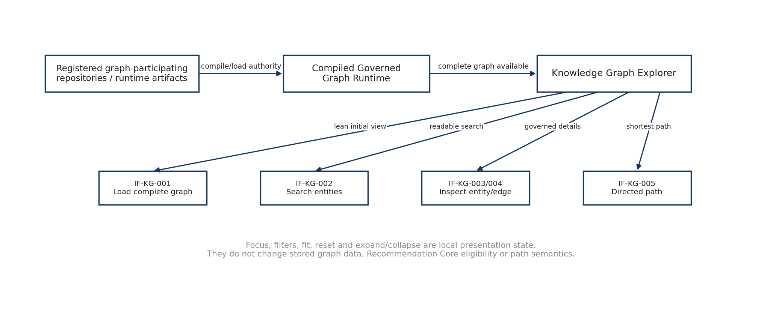
Figure 5. Knowledge Graph Explorer read-only interface flow

14. Persistence and privileged-access boundaries

14.1 IF-PLAT-001 — Persistence Interface
SEQ-04 defines persistence semantics at the logical object level. RecommendationContextSnapshot, RecommendationEvent, EducatorKitSnapshot and EducatorDecision are distinct operational records with separate mutability/authority. Exact SQL schemas, indexes, retention and transactional mapping remain SEQ-09.
Object | Mutability / purpose
RecommendationRequestDraft | Mutable working state before Generate/Update.
RecommendationContextSnapshot | Immutable per Generate/Update; exact resolved value plus provenance/source for every parameter.
RecommendationEvent | Immutable recommendation provenance: anchor, accepted SCR(s), evidence, scores, guardrails and versions.
EducatorKitSnapshot | Immutable selected templates, evidence/framework packet, generated elements, versions and validation.
EducatorDecision | Separate persistent educator action/adaptation; never overwrites original Kit/template.

14.2 IF-PLAT-002 — Privileged Access Check
Protected Administration content is rendered only after an authorization decision. AccessCheckResult distinguishes ALLOWED from DENIED. A denied user receives an explicit access-denied state and no partial protected content. Detailed authentication/session/role mechanics are deferred to SEQ-10.

15. Administration V1 boundary and future references
System V1 works only with existing curated repositories/runtime artifacts. Administration may provide a protected shell, static workflow guidance, and read-only repository/runtime inspection where practical. The following capabilities are not functional V1 interfaces: repository onboarding/edit persistence, workbook upload/staging, candidate diff/impact processing, candidate validation/build, release-gate orchestration, publish/activation, rollback/restore, and benchmark execution as a release workflow.
Capability | V1 | Future/deferred treatment
Read-only repository inspection | Allowed | Reuse authoritative repository bindings.
Static Add/Edit/Deprecate workflow guidance | Allowed prototype | No Save-to-Repository control.
Runtime/configuration status display | Optional read-only | Only if actual authoritative state exists.
Upload / stage candidate | Not functional | Future release-governance interface.
Candidate diff / validation / build | Not functional | Future release-governance interface.
Publish / activate / rollback | Not functional | Future persistence/release-control interface.
Run benchmark/regression from Admin | Not functional | Future validation orchestration interface.

The earlier publication/validation lifecycle remains useful as future-state design reference, but production V1 UI and interface bindings must not imply those actions are implemented.
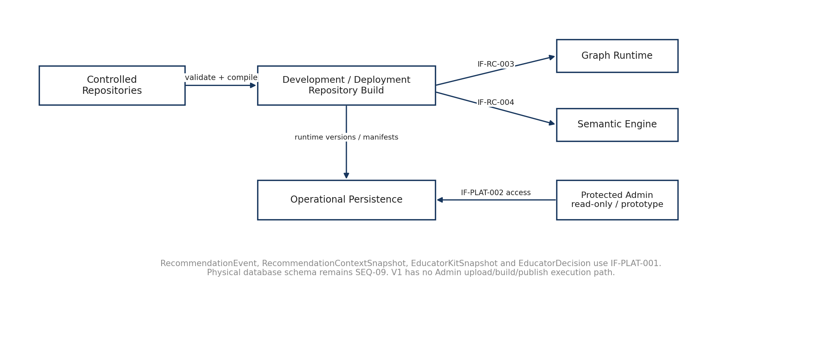
Figure 6. Repository build/runtime-load, persistence and protected-Administration boundary

16. End-to-end interface sequences

16.1 Normal educator recommendation sequence
1. UI loads governed Course options and retains Course_ID.
2. UI filters Modules by Course_ID; retains Module_ID.
3. UI filters Subtopics by Module_ID; Subtopic_ID becomes authoritative V1 technical anchor.
4. Application Context Resolver automatically evaluates suggestions using the anchor and optional already-entered educator context text; UI displays 0–2 generated alternatives.
5. Educator enters own context or accepts a generated candidate. UI retains source, exact text, final shown candidate set and accepted candidate ID where applicable.
6. Review/Generate creates idempotent EducatorRecommendationRequest and immutable RecommendationContextSnapshot.
7. Input Adapter validates hierarchy/context/mismatch and produces internal NormalizedRecommendationRequest.
8. Recommendation Core returns SUCCESS or ABSTAINED and persists RecommendationEvent/trace.
9. On SUCCESS the educator may open detailed trace or start Educator Kit generation.
10. Kit subsystem selects pedagogy, resolves output contract/material/framework, invokes bounded generation, validates and persists EducatorKitSnapshot.
11. Kit View reads the snapshot; PDF export renders on demand from the same snapshot.

16.2 Explicit alternative teaching approach sequence
READY primary Kit snapshot
-> educator chooses alternative Template_ID
-> new Kit_Request_ID
-> resolve contract/material/framework for chosen template
-> generate + validate
-> new immutable EducatorKitSnapshot

16.3 Graph exploration sequence
load lean complete graph identity
-> search / focus / filter locally
-> inspect entity/relationship details on demand
-> optional directed shortest-path query
-> reset/focus changes view only; no recommendation side effects

17. Error handling and domain-outcome matrix
Situation | Classification | Contract behavior
No compatible Application Context suggestion | Domain outcome | NO_COMPATIBLE_SUGGESTIONS; free-text remains available.
Material anchor/context mismatch | Blocking validation | Do not execute recommendation; return correction guidance.
No defensible sustainability mechanism | Recommendation abstention | ABSTAINED + NO_DEFENSIBLE_SUSTAINABILITY_MECHANISM.
Evidence insufficient | Recommendation abstention | ABSTAINED + INSUFFICIENT_EVIDENCE.
Trace missing | Domain outcome | Trace_Status = NOT_AVAILABLE; no synthesized rationale.
No eligible teaching template | Kit domain outcome | Kit_Generation_Status = NO_ELIGIBLE_TEMPLATE.
Kit output contract fails | Kit domain outcome | VALIDATION_FAILED; failed snapshot/audit retained; no ready Kit.
Graph search has no entity | Domain outcome | NO_MATCHES.
No directed governed path | Domain outcome | NO_GOVERNED_PATH.
Graph/model/provider/persistence unavailable | Technical failure | TechnicalError with retryability and request correlation where applicable.

18. Cross-interface invariants
- The selected Subtopic remains the V1 technical authority; educator Application Context supplies application/mechanism evidence and cannot silently replace the anchor.
- Eligibility is established before semantic ranking; similarity may rank eligible candidates but cannot create eligibility.
- Prerequisite/readiness relations do not automatically become topical recommendation evidence.
- Repository Application Context records may support retrieval/evidence but are not educator provenance in V1.
- Generated context and generated Kit content are operational output, not canonical ontology/repository truth.
- Framework mappings and pedagogical templates are downstream of accepted SCR eligibility and cannot rescue/create SCR relevance.
- Explicit negative/excluded evidence remains distinct from positive support and may veto unsupported secondary promotion.
- Additional sustainability principles appear only when independently evidence-supported.
- Knowledge Graph exploration may traverse broadly but is read-only and does not change Recommendation Core eligibility/ranking/guardrails.
- All Kit rendering/export is snapshot-derived; no view/export operation independently regenerates content.
- Failed Kit validation does not trigger hidden automatic repair and does not invalidate an otherwise accepted recommendation.
- Educator adaptations/decisions never overwrite canonical template data or the original generated Kit snapshot.

19. Deferred V2/V3 scope
Deferred capability | V1 replacement / rationale
Text-only anchor primary UI route | V1 requires explicit Course→Module→Subtopic; internal anchor-resolution foundation may remain for later productization.
Downloadable HTML Kit | In-app web Kit remains; no separate HTML download.
Kit Excel export | PDF-only downloadable export in V1.
Functional repository onboarding/edit UI | Controlled curated repositories remain source; V1 Admin may be static/read-only.
Upload/staging + candidate diff/build/publish | Future release-governance interfaces.
Rollback/restore UI | Future persistence/release-history semantics.
Benchmark execution from Admin | Future validation/test orchestration.
Automatic Kit repair/regeneration | Explicitly excluded; failed validation is persisted and surfaced.
Async job/queue APIs for Kit generation | V1 generation is synchronous; asynchronous orchestration may be introduced later without changing domain objects.

20. Implementation readiness and acceptance checklist
SEQ-04 is implementation-ready when production code and tests can demonstrate the following without introducing unregistered semantic shortcuts or unstated V1 capabilities.
☐ All public UI actions construct typed request objects using canonical IDs and exact educator text/provenance.
☐ Application Context suggestions show no more than two generated alternatives while allowing a broader controlled internal candidate pool.
☐ Generate is blocked for missing hierarchy/context or material anchor/context mismatch and is idempotent by Request_ID.
☐ RecommendationResult returns SUCCESS or ABSTAINED only; technical failures use TechnicalError.
☐ Trace retrieval never fabricates missing evidence and preserves actual relationship direction/type.
☐ Kit generation begins only from an accepted recommendation and fully generates only the primary approach initially.
☐ PKCR output-element contract controls completeness but never selects pedagogy.
☐ Kit validation uses deterministic overall/element statuses; failure is retained without hidden repair.
☐ Kit web view and PDF read exactly the persisted immutable snapshot.
☐ KG Explorer can inspect every valid compiled governed node/relationship type; initial lean rendering does not reduce availability.
☐ Path query returns one deterministic shortest directed governed path or NO_GOVERNED_PATH.
☐ V1 Admin does not expose functioning publication/build/rollback/benchmark controls.
☐ Version provenance is recorded wherever required for recommendation/Kit replay and audit.
☐ Physical persistence and security implementation remain consistent with later SEQ-09/SEQ-10 without changing these domain contracts.

Appendix A — Controlled values
Domain | V1 values
Application_Context_Source | EDUCATOR_ENTERED | ACCEPTED_SYSTEM_GENERATED
Application Context suggestion | SUGGESTIONS_AVAILABLE | NO_COMPATIBLE_SUGGESTIONS
Recommendation_Status | SUCCESS | ABSTAINED
Abstention_Reason | INSUFFICIENT_EVIDENCE | NO_DEFENSIBLE_SUSTAINABILITY_MECHANISM
Trace_Status | AVAILABLE | NOT_AVAILABLE
Material_Source_Mode | USE_SYSTEM_SUGGESTION | USE_MY_MATERIAL
Kit_Generation_Status | READY | NO_ELIGIBLE_TEMPLATE | VALIDATION_FAILED
Kit overall validation | PASS | FAIL
Kit element validation | PASS | FAIL | NOT_APPLICABLE
Educator_Decision | USE_AS_SUGGESTED | ADAPT | CHOOSE_ALTERNATIVE | NOT_USE | SAVE_FOR_LATER
Applicability_State | RECOMMENDED | RECOMMENDED_WITH_CONDITIONS | ADAPTATION_SUGGESTED | BOUNDARY_WARNING | HARD_BLOCK
Graph_Status | AVAILABLE | UNAVAILABLE
Graph search | MATCHES | NO_MATCHES
Graph entity inspection | FOUND | NOT_FOUND
Graph path | FOUND | NO_GOVERNED_PATH

Appendix B — Object-contract quick reference
Object | Key fields / purpose
ApplicationContextSuggestionRequest | Request_ID, Course_ID, Module_ID, Subtopic_ID, optional Application_Context_Text.
ContextCandidate | Context_Candidate_ID, title, exact generated text, display rank, optional Why_Suggested, internal provenance.
EducatorRecommendationRequest | Request metadata, canonical hierarchy, final Application Context source/text/candidate, shown suggestions, Teaching Context.
RecommendationResult | Event/snapshot IDs, SUCCESS|ABSTAINED, primary recommendation, additional supported principles, abstention reason, trace/Kit flags.
RecommendationTraceResponse | AVAILABLE|NOT_AVAILABLE, educator Explanation and technical Audit_Detail.
EducatorKitGenerationRequest | Kit_Request_ID, recommendation event/snapshot, optional requested alternative template, teaching context update, material mode.
EducatorKitGenerationResult | READY|NO_ELIGIBLE_TEMPLATE|VALIDATION_FAILED, snapshot ID, primary Kit, alternative summaries, validation.
KitValidationResult | Overall PASS|FAIL plus element PASS|FAIL|NOT_APPLICABLE and failure reason.
EducatorKitViewResponse | Snapshot-derived primary/alternatives, student content, educator guidance, evidence, framework alignment, validation/audit.
EducatorKitPdfExportResult | Snapshot ID, file name, application/pdf, content/download handle, timestamp, renderer version.
KnowledgeGraphLoadResponse | Graph status/version + lean complete node/relationship identity payload.
GraphEntityInspectResponse | Authoritative entity properties + exact incoming/outgoing relationships.
GovernedPathResponse | FOUND|NO_GOVERNED_PATH + one ordered deterministic shortest directed path when found.
TechnicalError | Error_Code, safe User_Message, optional Technical_Message, Request_ID, Retryable, Occurred_At.

The companion Interface_Contract_Registry_v0.1.xlsx contains the complete field-level registry, controlled-value catalogue, error/idempotency rules, SEQ-03 reconciliation crosswalk, deferred scope and main interface sequence. This document and that registry together form the SEQ-04 baseline.

