Verification & Validation Plan
SEQ-11 | Version 0.1 | Original Python implementation plan
  - Defines evidence, test layers and release gates before implementation changes are accepted.
Ontology and Knowledge Graph-Driven Sustainability Principles Recommendation System
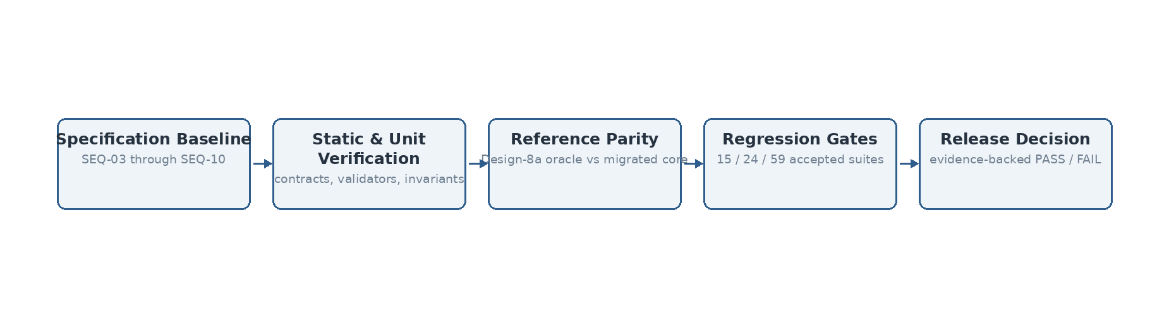
Figure 1. Verification and validation proceeds from frozen specifications to executable parity/regression evidence.

Source and design basis
This specification is implementation-facing and is subordinate to the previously frozen system design. It does not introduce Bolt.new or any alternate TypeScript deployment assumptions.
Authoritative input | Use in this sequence
System Architecture Design v1.1 Final | Component boundaries and V1 architecture invariants
Technical Interface Design v0.2 | Logical interface contracts and domain/technical outcome separation
Data Flow Design v0.1 Final | Data objects, transformations, persistence events and authority boundaries
SEQ-06 Process Flow Specification v0.1 | Behavioral ordering, branches and termination states
SEQ-07 Algorithm Specification v0.1 | Algorithm semantics and frozen Design-8a behavior
SEQ-08/09/10 v0.2 | Module ownership, persistence and security baseline
hybrid_runtime_v5.py | Accepted Design-8a reference implementation / parity oracle
Validation Benchmark Master Register v1.8 Lean | Accepted baseline gates and benchmark history

1. Purpose and V&V principles
The V&V plan separates verification (the implementation conforms to the specified design) from validation (the implementation continues to produce the accepted Design-8a recommendation behavior). Passing software tests is necessary but not sufficient: recommendation changes must also preserve the accepted benchmark safety and quality gates.
Principle | Rule
Gold isolation | Prediction code must not read gold labels or use benchmark answers as runtime evidence.
Coverage vs quality | Repository/anchor coverage is reported separately from recommendation quality.
Domain outcomes | Abstention, no path, no context and validation failure remain legitimate domain states rather than technical errors.
Parity before refactor | Behavioral refactoring below the recommendation-core boundary is blocked unless reference parity remains green.
Safety over aggregate gain | Forbidden promotions, unsupported inference or negation regressions fail acceptance even if aggregate recall rises.
Versioned evidence | Repository, algorithm, model and test-set versions are retained with every formal run.

2. Verification layers
Layer | Scope | Minimum evidence
V1 Static repository verification | Schemas, IDs, relationships, hierarchy, checksums | Repository validator report: zero errors
V2 Unit verification | Pure functions, validators, contract adapters | pytest unit suite PASS
V3 Integration verification | Repository compile, runtime load, facade behavior | integration suite PASS + compiled manifest
V4 Reference parity | Frozen v5a oracle vs migrated core | case-level decision/trace parity report
V5 Regression validation | Frozen accepted benchmark suites | accepted baseline gates preserved
V6 End-to-end V1 | UI → recommendation → persistence → Kit boundaries | workflow scenarios including domain failures
V7 Security verification | Access, secret isolation, malformed input, logging | SEQ-10 control tests PASS

3. Accepted Design-8a release gates
Gate | Accepted baseline / required condition
15-case regression | 15/15 legacy behavior preserved
Educator input suite | 24/24 end-to-end; Design-7.5b routing/context controls preserved
Generated-context quality | 4/4 accepted quality/off-scope-avoidance control
Forbidden promotions | 0
Promoted-vetoed overlap | 0
ALL59 strict end-to-end reference point | 30/46 recommendation-ready executions
ALL59 promoted precision / recall / F1 | 69.8% / 65.2% / 67.4% reference point
Top-1 path | Must remain the validated primary ranking path unless a separately approved design change is opened
The aggregate ALL59 values are reference acceptance evidence, not tuning targets to be optimized case-by-case. Any future algorithm change requires a separately versioned design decision and rerun of all applicable frozen gates.

4. Parity comparison policy
Same-language migration expects exact equality for categorical decisions and structured trace fields. Numeric semantic values may use an explicit tolerance only when backend/runtime numerical differences make bit-level equality inappropriate. A tolerance must never mask a threshold crossing that changes a decision.
Field class | Comparison
Exact decision fields | Resolution IDs, selected KCRs, scope status, primary SCR, promoted SCRs, abstention/status, vetoed SCRs: exact
Structured trace | Mechanism facets, promotion facets, negated facets, candidate trace: exact for current Python-to-Python migration
Numeric fields | Absolute tolerance declared by the harness; threshold-near deltas reviewed
Model identity | Backend/model name and version must match the intended run; no silent substitution

5. Test data governance
Frozen benchmark inputs and expected outcomes are test assets, not production knowledge. Gold labels are loaded only by evaluation code after prediction outputs have been frozen. Expert-review/ambiguity cases must not be force-tuned merely to match a gold ordering.

6. Entry and exit criteria
Milestone | Entry | Exit
SEQ-12 bootstrap | SEQ-03–10 frozen | Repository initializes cleanly; CI/test skeleton exists
SEQ-13 parity harness | Reference runtime available | Harness produces auditable case-level PASS/mismatch report
SEQ-14 repository pipeline | Current governed CSV bundle available | Validation PASS; deterministic graph/corpus manifest generated
SEQ-15 core migration | SEQ-13 harness green on smoke/reference subset | Migrated kernel callable through production service adapter; parity green on available cases
Implementation release | Full frozen benchmark artifacts available | All mandatory accepted Design-8a gates rerun and PASS

7. Current execution evidence
In the current build session the 19-file CSV repository bundle validated with 0 errors and 0 warnings (9,033 nodes; 10,347 relationships). The compilation pipeline completed. A three-case LSA smoke parity set covering recommendation, abstention and explicit-negation behavior passed 3/3, and the local pytest suite passed. This is implementation smoke evidence only; it does not replace the frozen MiniLM regression/ALL59 release suites.

