Git Repository & Project Skeleton
SEQ-12 | Version 0.1 | Original Python implementation plan
  - Bootstraps the original Python implementation structure, local Git history and CI-ready test seams.
Ontology and Knowledge Graph-Driven Sustainability Principles Recommendation System
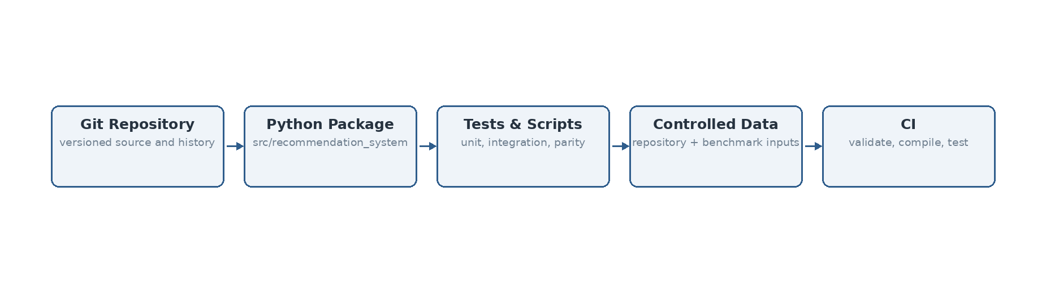
Figure 1. Repository skeleton keeps runtime code, reference oracle, governed data, tests and build artifacts distinct.

Source and design basis
This specification is implementation-facing and is subordinate to the previously frozen system design. It does not introduce Bolt.new or any alternate TypeScript deployment assumptions.
Authoritative input | Use in this sequence
System Architecture Design v1.1 Final | Component boundaries and V1 architecture invariants
Technical Interface Design v0.2 | Logical interface contracts and domain/technical outcome separation
Data Flow Design v0.1 Final | Data objects, transformations, persistence events and authority boundaries
SEQ-06 Process Flow Specification v0.1 | Behavioral ordering, branches and termination states
SEQ-07 Algorithm Specification v0.1 | Algorithm semantics and frozen Design-8a behavior
SEQ-08/09/10 v0.2 | Module ownership, persistence and security baseline
hybrid_runtime_v5.py | Accepted Design-8a reference implementation / parity oracle
Validation Benchmark Master Register v1.8 Lean | Accepted baseline gates and benchmark history

1. Repository identity and implementation direction
The repository is bootstrapped for the original implementation plan: Python services/domain modules, controlled CSV repositories, a Python recommendation runtime, NetworkX-compatible graph services, Pydantic contracts, pytest verification and later Streamlit/Cytoscape UI integration. No Bolt.new assumptions are introduced.

2. Bootstrap structure
recommendation-system-v1/
├── src/recommendation_system/
│ ├── contracts/
│ ├── core/
│ ├── parity/
│ ├── repository/
│ └── infrastructure/
├── reference/
│ ├── hybrid_runtime_v5.py
│ └── README_DESIGN8.md
├── data/
│ ├── repository/
│ └── benchmark/
├── tests/
│ ├── unit/
│ ├── integration/
│ └── parity/
├── scripts/
├── artifacts/
├── .github/workflows/ci.yml
├── pyproject.toml
├── .env.example
├── .gitignore
└── README.md

3. Dependency policy
Dependency | Role | Policy
Python 3.11+ | Primary implementation language | Baseline runtime; no platform-specific rewrite in SEQ-12–15
NumPy / scikit-learn | Reference numerical and LSA smoke backend | Required by frozen prototype and local parity smoke tests
sentence-transformers | Accepted MiniLM semantic backend | Optional install group; required for formal MiniLM parity/release run
NetworkX | Graph runtime/service implementation direction | Available to graph modules; recommendation reference currently retains its validated controlled adjacency logic
Pydantic | Typed request/domain contracts | Public service boundary validation
pytest | Unit/integration/parity verification | Required development gate
Streamlit / Cytoscape.js | Later V1 UI/explorer implementation | Optional UI dependency; not implemented in SEQ-12–15

4. Git controls
A local Git repository is initialized with one bootstrap commit. Generated compiled artifacts, parity reports, local databases, virtual environments and secrets are ignored. The `.env.example` contains names only; no secret values are committed.
Bootstrap commit: 348477e — “Bootstrap V1 implementation baseline through SEQ-15”.

5. CI baseline
The included GitHub Actions workflow is repository-agnostic infrastructure: checkout, Python setup, dependency install, smoke-case creation, repository validation, repository compilation and pytest. It does not publish artifacts or mutate canonical repositories.

6. Definition of done
Check | Status
Git repository initialized | PASS
Project package structure created | PASS
Reference runtime isolated | PASS
Controlled repository copied into data/repository | PASS
Unit/integration/parity test seams created | PASS
CI workflow created | PASS
Secrets excluded | PASS
Bolt.new-specific files introduced | NO

