Design-8a Reference Parity Harness
SEQ-13 | Version 0.1 | Original Python implementation plan
  - Creates an executable oracle-vs-candidate comparison gate before Recommendation Core refactoring.
Ontology and Knowledge Graph-Driven Sustainability Principles Recommendation System
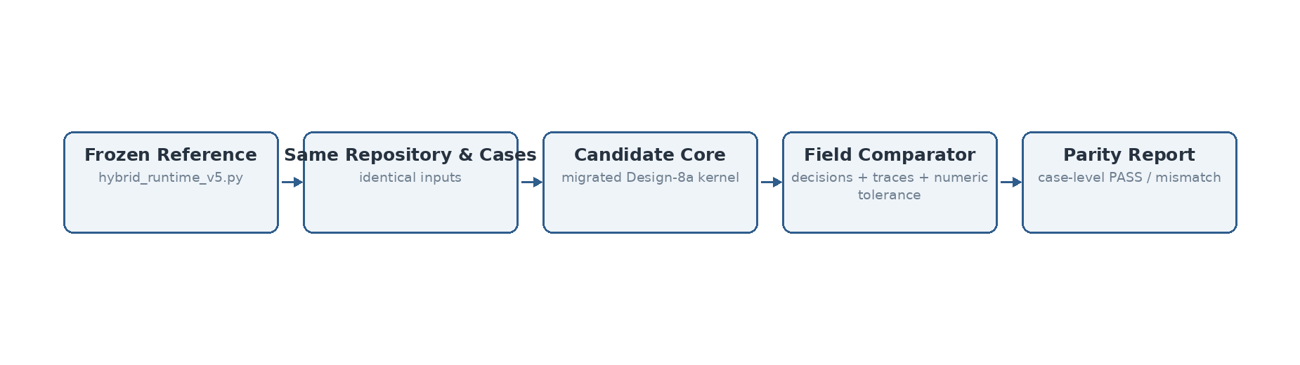
Figure 1. Reference and candidate receive identical repository/model/case inputs; discrepancies are emitted as case-level evidence.

Source and design basis
This specification is implementation-facing and is subordinate to the previously frozen system design. It does not introduce Bolt.new or any alternate TypeScript deployment assumptions.
Authoritative input | Use in this sequence
System Architecture Design v1.1 Final | Component boundaries and V1 architecture invariants
Technical Interface Design v0.2 | Logical interface contracts and domain/technical outcome separation
Data Flow Design v0.1 Final | Data objects, transformations, persistence events and authority boundaries
SEQ-06 Process Flow Specification v0.1 | Behavioral ordering, branches and termination states
SEQ-07 Algorithm Specification v0.1 | Algorithm semantics and frozen Design-8a behavior
SEQ-08/09/10 v0.2 | Module ownership, persistence and security baseline
hybrid_runtime_v5.py | Accepted Design-8a reference implementation / parity oracle
Validation Benchmark Master Register v1.8 Lean | Accepted baseline gates and benchmark history

1. Reference authority
`reference/hybrid_runtime_v5.py` is the frozen Design-8a / v5a behavioral oracle. The harness never reads gold labels during prediction. It compares reference output to the migrated candidate implementation using the same repository, semantic backend, model configuration and input cases.

2. Harness implementation
Component | Implementation
Reference loader | Loads frozen runtime directly from reference path without importing production core
Candidate loader | Calls RecommendationCoreService / migrated kernel
Input loader | CSV cases; identical dictionary payload passed to both engines
Exact fields | Resolution, selected KCRs/evidence, scope, primary/promoted SCRs, status, vetoed SCR IDs
Structured trace | Mechanism/promotion/negative facets and candidate trace payload
Numeric comparison | Explicit absolute tolerance for selected numeric fields
Output | JSON report with per-case PASS and mismatch detail

3. Current smoke parity set
Case | Purpose | Result
SMOKE_RECOMMEND | Normal mechanism-present recommendation path | PASS
SMOKE_ABSTAIN | No sustainability mechanism → abstention path | PASS
SMOKE_NEGATION | Explicit negation preserved as veto/exclusion evidence | PASS
The smoke suite runs on the deterministic LSA fallback backend so it can execute without downloading an external model. It establishes harness correctness and same-code migration parity. It is not a substitute for the accepted MiniLM benchmark suites.

4. Formal MiniLM parity gate
When the frozen benchmark case files/reference outputs are placed in `data/benchmark`, the same harness is run with `--backend sentence-transformer` and the accepted `sentence-transformers/all-MiniLM-L6-v2` model. The release comparison must preserve Design-8a gates defined in SEQ-11.
python scripts/run_parity.py \
--reference reference/hybrid_runtime_v5.py \
--repo data/repository \
--cases data/benchmark/<frozen_cases>.csv \
--output artifacts/parity_reports/design8a_minilm.json \
--backend sentence-transformer

5. Failure handling
A parity mismatch blocks refactoring acceptance. Investigation classifies differences as implementation defect, numeric/backend drift, test-asset/version mismatch, or an intentionally opened design change. Thresholds must not be tuned ad hoc to make one benchmark row pass.

6. Current status
Harness established and executable. Local three-case LSA smoke parity: 3/3 PASS. Full frozen MiniLM 15/24/59 suites were not rerun in this session because the underlying frozen case artifact was not available as a local executable input file; the benchmark register was available as authoritative historical evidence only. Full MiniLM parity therefore remains the pre-release gate rather than being falsely reported as completed.

