Repository Validation & Compilation Pipeline
SEQ-14 | Version 0.1 | Original Python implementation plan
  - Implements fail-closed validation and deterministic compilation of governed repository data into runtime artifacts.
Ontology and Knowledge Graph-Driven Sustainability Principles Recommendation System
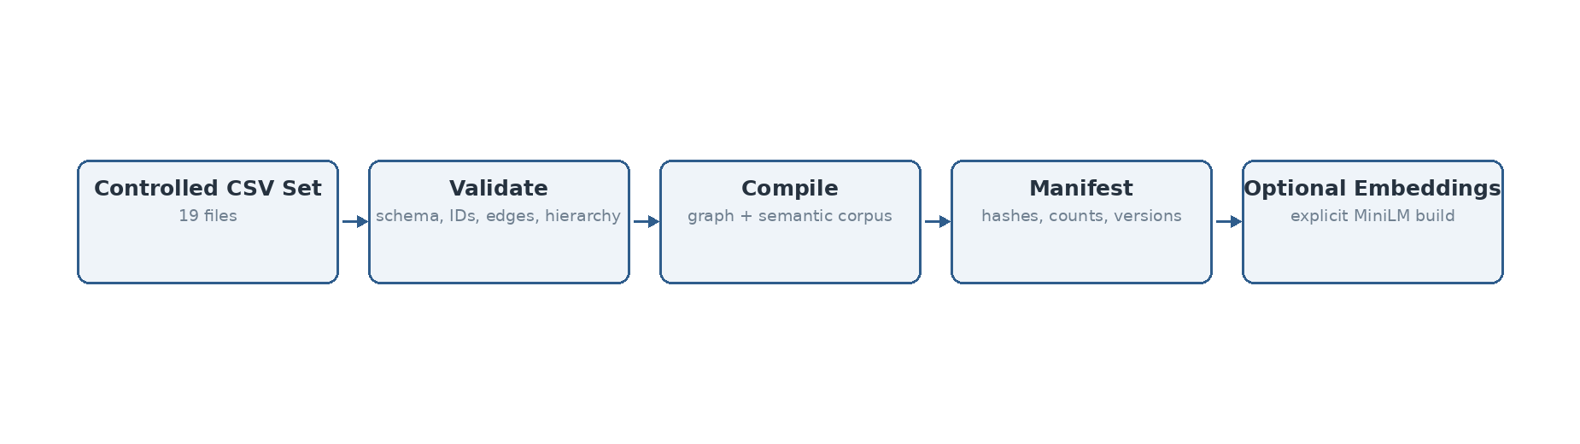
Figure 1. Development/deployment pipeline validates governed sources before producing immutable runtime artifacts.

Source and design basis
This specification is implementation-facing and is subordinate to the previously frozen system design. It does not introduce Bolt.new or any alternate TypeScript deployment assumptions.
Authoritative input | Use in this sequence
System Architecture Design v1.1 Final | Component boundaries and V1 architecture invariants
Technical Interface Design v0.2 | Logical interface contracts and domain/technical outcome separation
Data Flow Design v0.1 Final | Data objects, transformations, persistence events and authority boundaries
SEQ-06 Process Flow Specification v0.1 | Behavioral ordering, branches and termination states
SEQ-07 Algorithm Specification v0.1 | Algorithm semantics and frozen Design-8a behavior
SEQ-08/09/10 v0.2 | Module ownership, persistence and security baseline
hybrid_runtime_v5.py | Accepted Design-8a reference implementation / parity oracle
Validation Benchmark Master Register v1.8 Lean | Accepted baseline gates and benchmark history

1. Pipeline boundary
This is development/deployment tooling, not a V1 functional Admin publication workflow. Runtime outputs do not write back to canonical Excel/CSV repositories. Invalid repository input fails closed and does not silently load a partial graph.

2. Validator
Validation | Implemented rule
File presence | All 18 node CSVs plus relationships.csv required
Headers | Required ID/content/status/label fields asserted per repository
Node IDs | Nonblank, unique within file and globally unique across node repositories
Relationship endpoints | Every :START_ID and :END_ID must resolve to a governed node
Relationship types | Must be one of the governed relationship types currently compiled
Duplicate edges | Reported as warnings
Hierarchy typing | Course→Module, Module→Subtopic and Subtopic→KCR endpoint classes verified against governed ID schemes

3. Compiler outputs
Artifact | Contents
compiled_graph.json | All governed nodes with source properties plus typed directed edges
semantic_corpus.json | Deterministic searchable text for Course/Module/Subtopic/KCR/KPR/KFR/SCR/Application Context
manifest.json | UTC compile time, source SHA-256 hashes, byte sizes, node/edge counts, compiled artifact hashes and validation status
embeddings.npy + embedding_ids.json | Optional explicit MiniLM build; not silently produced/substituted
embedding_manifest.json | Model name, vector dimension and entity count when embedding build is requested

4. Current execution result
Measure | Observed
Files checked | 19
Governed node rows | 9,033
Relationships | 10,347
Validation errors | 0
Validation warnings | 0
Compilation | PASS
The current repository bundle therefore passes the implemented structural gate. This result validates the compiled CSV bundle used in this implementation step; it does not replace semantic/curatorial QA of repository content.

5. Commands
python scripts/validate_repository.py data/repository
python scripts/compile_repository.py data/repository artifacts/compiled
# Formal semantic artifact build when model is available:
python scripts/compile_repository.py data/repository artifacts/compiled \
--embeddings --model sentence-transformers/all-MiniLM-L6-v2

6. Future extension boundary
Publication staging, release activation, rollback and benchmark execution from the V1 Admin UI remain deferred. The compiler can later be wrapped by controlled deployment automation without changing canonical/runtime authority rules.

