Recommendation Core Migration With Parity
SEQ-15 | Version 0.1 | Original Python implementation plan
  - Migrates the frozen Design-8a kernel into the application package without altering accepted recommendation semantics.
Ontology and Knowledge Graph-Driven Sustainability Principles Recommendation System
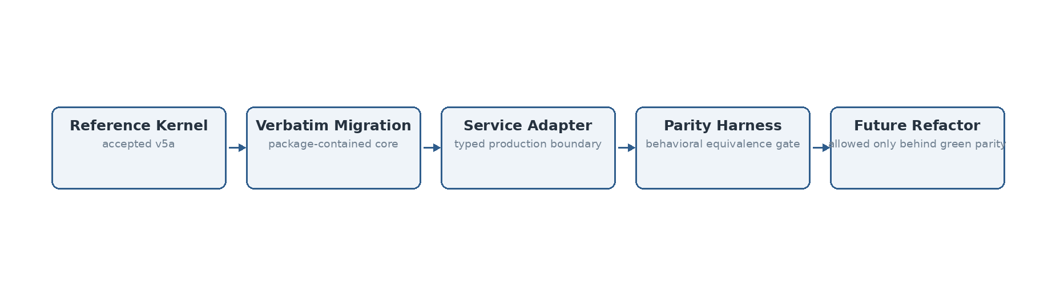
Figure 1. SEQ-15 chooses behavior-preserving migration first; structural refactoring is permitted only after parity remains green.

Source and design basis
This specification is implementation-facing and is subordinate to the previously frozen system design. It does not introduce Bolt.new or any alternate TypeScript deployment assumptions.
Authoritative input | Use in this sequence
System Architecture Design v1.1 Final | Component boundaries and V1 architecture invariants
Technical Interface Design v0.2 | Logical interface contracts and domain/technical outcome separation
Data Flow Design v0.1 Final | Data objects, transformations, persistence events and authority boundaries
SEQ-06 Process Flow Specification v0.1 | Behavioral ordering, branches and termination states
SEQ-07 Algorithm Specification v0.1 | Algorithm semantics and frozen Design-8a behavior
SEQ-08/09/10 v0.2 | Module ownership, persistence and security baseline
hybrid_runtime_v5.py | Accepted Design-8a reference implementation / parity oracle
Validation Benchmark Master Register v1.8 Lean | Accepted baseline gates and benchmark history

1. Migration strategy
The first production migration deliberately avoids rewriting the validated algorithm. The Design-8a kernel is copied verbatim into `src/recommendation_system/core/design8a_runtime.py`, while the original is retained under `reference/` as an independent oracle. A thin `RecommendationCoreService` provides the production-facing package boundary.
This is intentional: architectural modularization can proceed later behind the parity harness. It avoids combining behavior change, code reorganization and platform change in one step.

2. Preserved Design-8a behaviors
Behavior | Migration rule
Primary Top-1 ranking | Unchanged
Mechanism/full/context score weights | Unchanged reference configuration
Controlled scope/mismatch behavior | Unchanged
Curated context evidence | Preserved
Facet-local secondary discovery | Preserved
Specificity-aware lexical support | Preserved
Explicit-negation handling | Negative/excluded facets remain veto-only for secondary promotion
MERGED_INTO handling | Preserved
Gold isolation | Prediction code does not read gold labels
Trace fields | Raw rank, promoted rank, facet/veto provenance preserved

3. Production adapter
service = RecommendationCoreService(
repository_dir="data/repository",
backend="sentence-transformer",
model_name="sentence-transformers/all-MiniLM-L6-v2",
)
result = service.recommend(case)
The adapter is the point consumed by later facades/services. It exposes runtime version and semantic backend without allowing UI code to reach internal ranking modules or mutate algorithm configuration.

4. Parity evidence
Evidence | Result
Python syntax / import verification | PASS after migration
Repository validation prerequisite | PASS
Repository compilation prerequisite | PASS
LSA recommendation smoke parity | 3/3 PASS
pytest unit/integration/parity suite | PASS
Full frozen MiniLM regression/educator/ALL59 parity | Required before implementation release; not rerun in this session because frozen executable cases were not locally available

5. Refactor rule after SEQ-15
Subsequent extraction into separate Input Adapter, Mechanism Profiler, Context Resolver, Eligibility/Ranker, Promotion Engine and Negation Veto modules is allowed only in small increments. Each increment must leave the reference parity suite green. If a refactor requires changed output semantics, it is no longer a refactor and must reopen the algorithm/design decision process.

6. What SEQ-15 does not do
Not included | Reason
Bolt.new / TypeScript port | Explicitly outside the current original-plan implementation baseline
New ranking weights or thresholds | Would change Design-8a semantics
Design-8b behavior | Previously rejected experiment; Design-8a remains frozen baseline
V1 Admin publication workflow | Deferred by architecture
UI implementation | Later build stage; Recommendation Core is now package-callable

