PROJECT HANDOFF

Recommendation System
New-Chat Handoff
Ontology and Knowledge Graph-Driven Sustainability Principles Recommendation System
Purpose: To integrate sustainability principles into existing curricula.
Use this document at the start of the next Project chat
Attach this handoff plus the latest four SEQ-03 living artifacts. Treat the decisions below as continuation state, not as material to redesign from scratch. The immediate unfinished work is SEQ-03 Group D, with the Knowledge Graph Explorer requiring a complete visual redesign.

Item | Current state
Operational recommender | Frozen Design-8a + Repository v1.1
Current UI design sequence | SEQ-03
Completed UI groups | A. Foundation; B. Educator recommendation workflow; C. Educator Kit and explainability
Active UI group | D. Knowledge Graph and Administration
Remaining after D | E. Cross-cutting UI rules and final wireframes
V1 product posture | Academic research demonstrator/prototype; educator judgement remains authoritative

Critical continuation instruction
Do not reuse the earlier Group D wireframes as the visual direction. The user rejected them. Redesign Group D, especially the Knowledge Graph Explorer, using the user's arcmodel.io graph mockup and the OWID compute-graph design as explicit visual/interaction references.

1. What the new chat must know first
- This is a continuation of a long-running Master's research/prototype project, not a new design exercise.
- Preserve all frozen recommendation semantics. UI work must not alter Design-8a recommendation selection, traversal, eligibility, guardrails, ranking, promotion or negation rules.
- Normal educator UI must show readable labels, not internal canonical IDs. IDs are retained internally and may appear only in admin/audit when technically useful.
- Static/context help is externalized in UI_Help_Content_Repository_v0.1.xlsx and resolved through stable Help_Key values; do not hard-code long help text in Streamlit page logic.
- Every functional UI element must map to a governed repository field/runtime object in UI_Data_Binding_Matrix_v0.1.xlsx or be explicitly deferred to its owning later design sequence.
- Do not introduce arbitrary new canonical artifact names, IDs or repository structures without updating the System Component & Artifact Register.
- The user prefers technical, controlled, implementation-oriented design and dislikes superficial dashboard mockups.

2. Project and operational baseline
Area | Frozen / current baseline
Recommendation Core | Design-8a + Repository v1.1
Graph approach | Controlled hierarchical expansion; no unrestricted graph wandering for recommendation reasoning
Primary technical anchor | Selected Subtopic; Module/Course only controlled fallbacks when narrower evidence is insufficient
Related vs prerequisite | Related concepts support discovery; prerequisites indicate readiness/preparation
Similarity | Ranks already eligible candidates; never creates ontology truth or eligibility
Negation | Explicit negation/exclusion is veto/weakening evidence only; never positive promotion evidence
Multiple SCRs | Secondary SCR requires independent evidence-bearing mechanism facet
Educator Application Context | Educator-entered context supersedes system-generated/curated alternative on the main path
Embedding | sentence-transformers/all-MiniLM-L6-v2, 384d; published prototype must not silently fall back to LSA
Runtime KG | NetworkX MultiDiGraph in server RAM; repository authored in Excel, compiled via Pandas/Pydantic
Persistence | SQLite local; Supabase PostgreSQL hosted for events/snapshots/feedback/audit/publication metadata
UI | Streamlit/Python; Cytoscape.js for serious full-KG visualization
Generation | OpenAI API downstream only; cannot choose anchor, eligibility, guardrails, rank, final SCR or template

3. Validation state that should not be retuned casually
Validation set | Current state
Legacy 15 | 15/15 executable; Top-1 13/15; Top-3 15/15; strict E2E 14/15
CORE35 | 22/35 anchor-ready; Top-1 20/22; Top-3 19/22; no-SCR FP=0; unsupported=0
ALL59 Design-8a | 46 ready / 13 gaps; Top-1 38/46 = 82.6%; strict 30/46 = 65.2%; forbidden=0; unsupported=0
Educator routing D7.5b | 24/24 routing/E2E; recommendation 15/15; negatives 9/9; generated context 4/4
Benchmark caution | TC001 and TC005 are semantically plausible outputs; do not tune merely to match gold without expert review

Failure-analysis rule
When reviewing benchmark failures, classify them as anchor-resolution defect, repository coverage gap, traversal defect, eligibility defect, ranking defect, guardrail defect, repository semantic gap, benchmark ambiguity or robustness defect. Repository coverage gaps must not be 'fixed' by ranking changes.

4. Canonical repository / Educator Kit baseline
Artifact / layer | Current state
Semantic Repository | Workbook1_Lean_Semantic_Enhanced_v1.1(1).xlsx is the canonical V1 semantic source
Framework mapping | SCR_Framework_Mapping_Lean_v0.6_Complete_FullCF(1).xlsx — frozen
Pedagogy | SCR_Pedagogical_Repository_Lean_v1.0_FROZEN(1).xlsx — 295 templates, 16 types
Output contract | Template_Output_Element_Contract_Repository_Lean_v0.2_FROZEN.xlsx — 295 templates, 75 controlled elements, 5,013 rows
Framework Context Resolver | Framework_Context_Resolver_Repository_All295_v0.2_FROZEN.xlsx — 5,695 rows
Teaching Case & Evidence | Teaching_Case_Evidence_Repository_Lean_v0.2_OutputContract_Aligned.xlsx
Stage-F design | StageF_F0_Educator_Kit_Design_v1.0_FROZEN.xlsx

5. Downstream Educator Kit invariants
- Framework enrichment occurs only after SCR eligibility; it cannot create or rescue SCR relevance.
- Default pedagogy display: one Primary Teaching Approach plus up to two materially distinct alternatives.
- Applicability states: RECOMMENDED, RECOMMENDED_WITH_CONDITIONS, ADAPTATION_SUGGESTED, BOUNDARY_WARNING, HARD_BLOCK.
- HARD_BLOCK is reserved for genuine safety/legal/impossible-evidence/canonical-boundary conditions.
- Student-facing material and educator-only expected reasoning must remain visibly distinct.
- Every REQUIRED and triggered CONDITIONAL output-contract element must contain concrete ready-to-use content; no placeholders.
- External-source material must preserve source identity, date/version where material, URL/DOI/locator and learner use.
- No automatic V1 repair/regeneration loop after Kit validation failure; persist failure and reason.
- Educator actions: Use as suggested, Adapt, Choose alternative, Not use, Save for later.
- PDF, self-contained HTML and structured Excel exports are rendered from the same persisted immutable EducatorKitSnapshot.

6. SEQ-03 group structure — fixed
Group | Scope | Status
A. Foundation | Product identity, visual system, shell, Home, foundation KG/Admin shells, help, accessibility, data-binding principles | Retained
B. Educator recommendation workflow | Course → Module → Subtopic → Application Context → Teaching Context → Review → Generate | Designed / reviewed
C. Educator Kit and explainability | Recommendation Result, Why this recommendation?, Educator Kit, frameworks, evidence, validation, educator decisions, export | Designed / reviewed
D. Knowledge Graph and Administration | Full KG Explorer + Admin Overview + Repository Preparation/Publication + Validation & Benchmark | ACTIVE — redesign required
E. Cross-cutting UI rules and final wireframes | Final shared rules, states, responsive/accessibility consolidation, end-to-end wireframes | Not started

7. The four living SEQ-03 artifacts
Filename | Role
UI_Design_v0.1.docx | Primary UI specification: layout, behavior, states, accessibility, acceptance criteria and wireframes
UI_Foundation_Decisions_v0.1.xlsx | Stable A/B/C decisions and visual tokens; Group D/E append here
UI_Data_Binding_Matrix_v0.1.xlsx | Exact UI element → repository/runtime source → key/display/state/help/interface mapping
UI_Help_Content_Repository_v0.1.xlsx | Governed runtime context-sensitive help keyed by Help_Key

Latest combined A+B+C copies are in the SEQ03_GroupA_GroupB_GroupC package. Continue extending these same files; do not create parallel Group-D-only canonical documents.

8. Group A/B/C decisions that must carry forward

8.1 Foundation / visual system
Token / rule | Value
Background | #F7F8FA
Surface | #FFFFFF
Primary accent | #2F5D8C
Primary hover | #254A70
Primary text | #1F2937
Secondary text | #667085
Border | #D0D5DD
Success / warning / error / info | #2E7D32 / #8A5A00 / #B42318 / #315E9A
Focus | #2563EB
Radius | 8 px
Minimum control height | 44 px
Educator max width | 1160 px
Type | 32 / 24 / 20 / 16 / 14 px hierarchy
Spacing | 8 / 16 / 24 / 32 / 48 px
Theme | Light theme V1; minimal shadows; borders first

8.2 Group B — normal educator input
- Course, Module and Subtopic are all visibly mandatory in the normal hierarchy path.
- Course selection immediately shows governed Course details; Module then shows Module details; Subtopic confirms the preferred technical anchor.
- Final recommendation reasoning does not start from Course or Course+Module alone.
- Application Context screen has educator free text plus automatically shown top 1–2 compatible suggestions; no primary Browse/Suggest buttons.
- Show more compatible contexts is secondary progressive disclosure.
- Changing Course/Module/Subtopic invalidates downstream context suggestions and any accepted context tied to the old anchor.
- Teaching Context is optional field-by-field and affects pedagogy/Kit practicality, not sustainability eligibility.
- UI labels: Field/site visit possible?; Relevant data available for the activity?; Stakeholder interaction possible?; Lab/equipment available?.
- Resources and access is secondary/collapsed by default; detailed help explains what each field means and why it is asked.

8.3 Group C — result, explainability and Kit
- Result hierarchy: Use → Understand → Inspect/Audit.
- Show accepted Sustainability Principle in human-readable form; scores are not dominant.
- Why this recommendation? comes from persisted trace/evidence, not a new free-form explanation.
- No defensible sustainability mechanism is a valid abstention state; never force an SCR.
- Primary Teaching Approach + up to two materially distinct alternatives.
- Kit sections are driven by the selected Output Element Contract; do not force identical headings on all templates.
- Sustainability & Learning Framework Alignment is concise by default; raw resolver IDs remain in audit.
- Educator Kit validation is distinct from SCR validation.
- Exports preserve source links, provenance and student/educator-layer separation.

9. Group D — Administration plan agreed in this chat
V1 scope boundary
Repository Publication and Validation & Benchmark are functional V1 capabilities. Repository Preparation / Add / Edit / Deprecate is designed now but may remain static / demonstrative in V1, with controlled Excel workbooks remaining the actual authoring channel.

9.1 Administration navigation
Area | V1 intent
Overview | Functional: active release, runtime health, latest release gates, recent publication activity
Repository → Prepare / Edit | Mostly static/read-only prototype in V1; demonstrates Add/Edit/Deprecate/Change Set workflow
Repository → Publication | Functional: upload, stage, compare, validate, build, release-gate, publish
Validation & Benchmark | Functional: repository validation, recommendation regression, routing, Kit validation and release-gate evidence

9.2 Repository Preparation design
- UI authoring and Excel authoring are two preparation channels feeding the same governed release pipeline.
- Future functional preparation workflow: Add curriculum content; Edit existing content; Deprecate; Manage draft change sets.
- Adding a Course should guide Course → Modules → Subtopics → semantic preparation → relationship/constraint review → readiness review.
- Do not auto-create KCR/KPR/KFR for every new Subtopic. Search and reuse existing entities first; create a draft candidate only when no suitable entity exists.
- Recommendation readiness is separate from curriculum-record completeness. A Course can be structurally valid while some Subtopics remain semantically unready.
- Editing existing published content creates a draft copy/change; Save Draft never modifies active canonical data.
- Stable IDs survive ordinary edits. Material semantic replacement should be handled through deprecation/supersession rather than silently changing identity.
- Prefer deprecation over physical deletion for published canonical records.
- Relationship editing is governed by allowed relationship types; no arbitrary edge creation.
- High-impact edits must show dependency/impact review and determine which release gates become mandatory.

9.3 Repository Publication model
Publication invariant
Incremental input is allowed; publication is complete, versioned and atomic. Nothing edited through the UI or uploaded as Excel changes active runtime truth directly.

- Select change mode: Update selected repositories (default) or Replace complete repository release.
- Upload/stage changed registered workbooks. Uploaded files remain STAGED — NOT ACTIVE.
- Identify and compare current vs candidate: added, modified, deprecated and removed records; show dependent relationships.
- Validate candidate release: schema, controlled values, duplicate IDs, referential integrity, semantic/governance rules.
- Compile candidate runtime artifacts: tabular objects, NetworkX graph and embedding package.
- Run impact-based release gates/benchmarks required by the changed repository type.
- Review complete candidate release and explicitly Publish Release.
- Activate candidate only after runtime load/health verification; otherwise retain prior active release.

9.4 Publication / admin states to wireframe
State group | Required states
Access | No admin access / authorized administration
Staging | No candidate / upload in progress / file rejected / candidate staged
Change review | Changes detected / impact summary / unresolved destructive change
Validation | Running / passed / warnings / blocking errors
Build | Compiling / compilation failed / compiled successfully
Benchmark | Required / running / pass / regression detected
Publication | Ready / confirmation / publishing / success
Activation | Activation failed; previous active release retained
Recovery | Restore/rollback confirmation; history available
Empty/history | No validation history / no publication activity

10. Group D — Knowledge Graph Explorer redesign
Current status
The earlier Group D KG wireframe direction was rejected by the user as too weak/generic. Do not polish that version. Redesign the KG Explorer from first principles while preserving the frozen functional requirements.

10.1 User's preferred visual/interaction reference
Reference 1 — user's existing mockup/demo: https://github.com/raghuns-nit/arcmodel.io (course_examples.html / Knowledge Graph Instances)
Reference 2 — Our World in Data ETL compute graph design: https://docs.owid.io/projects/etl/architecture/design/compute-graph/
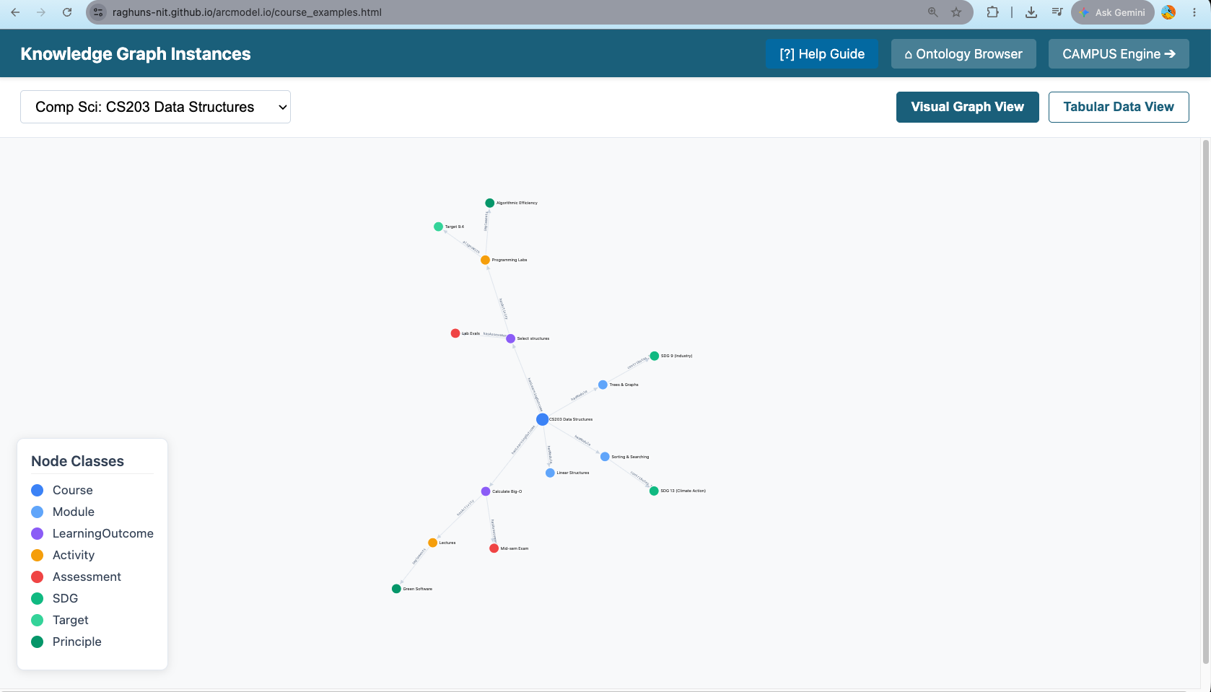
Figure H1. User-provided arcmodel.io Knowledge Graph Instances mockup — full graph canvas, top controls, view toggle and floating node-class legend.
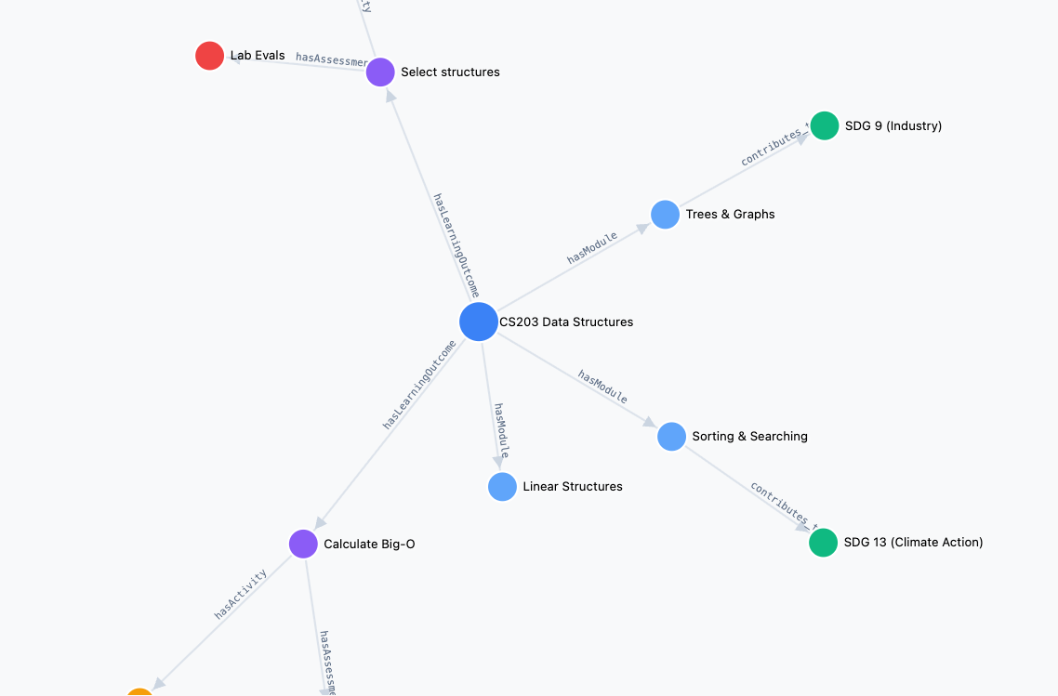
Figure H2. User-provided close view — readable node labels, typed edge labels and directional arrows.

10.2 What the redesigned KG Explorer must achieve
- It is a genuine graph-exploration surface, not a card dashboard with a small graph rectangle.
- Large, high-priority graph canvas dominates the page.
- Full governed KG remains explorable. Filtering/clustering/focus are display strategies, not architectural restrictions.
- Search any registered entity by readable text; entity types include Course, Module, Subtopic, KCR, KPR, KFR, Application Context, SCR, Guardrail and relevant framework/pedagogy entities where appropriate.
- Node-class legend must be immediately legible and visually connected to the graph. Use restrained class colors; color is not the sole identifier.
- Typed relationships are visible with direction and readable labels. Relationship inspection must explain semantics without implying recommendation eligibility.
- Selecting a node opens an inspector with authoritative label, type, definition/description, status and incoming/outgoing relationships.
- Support expand/collapse or neighbourhood focus, incoming/outgoing traversal, path exploration, fit-to-view, reset-to-complete-graph and back-to-previous-focus.
- Offer Visual Graph View and Tabular Data View; the tabular view is not a separate data model, just another representation of the same governed graph.
- Avoid an initial 9,000-node hairball. A complete graph is available, but the initial rendering can use meaningful clustering/level-of-detail and explicit 'complete graph / focused graph' state.
- Desktop/laptop is the reference layout. On smaller screens, preserve textual entity/relationship inspection even if advanced graph manipulation is reduced.
- Technology target remains Cytoscape.js inside Streamlit, behind the registered component boundary.

10.3 Visual direction to adopt
Element | Direction
Canvas | Near-full-width / near-full-height analytical canvas; graph is the product focus
Top bar | Compact global navigation, not a dashboard ribbon
Graph controls | Search + entity/relationship filters + scope/focus controls in a slim control band
View toggle | Visual Graph View / Tabular Data View, similar clarity to the user's mockup
Legend | Floating/docked Node Classes panel; collapsible if needed
Inspector | Right-side contextual drawer/panel when a node or relationship is selected
Edges | Light neutral lines with arrowheads; labels readable at useful zoom
Nodes | Class-aware restrained colors; label typography prioritized over decorative styling
Graph layout | Stable layouts where possible; focus transitions should preserve user orientation
OWID influence | Use graph structure and dependency readability, with clean whitespace and reduced UI chrome

10.4 What not to do
- Do not present KG Explorer as a small embedded diagram surrounded by large cards.
- Do not reduce the design to a local-neighbourhood-only explorer.
- Do not put Recommendation Core eligibility/ranking semantics into free exploration.
- Do not expose internal IDs as the primary node label.
- Do not make graph topology the only accessible representation.
- Do not use decorative gradients, excessive shadows or dashboard KPI tiles.

11. Immediate next task for the new chat
Start here
Do not regenerate all Group D artifacts immediately. First redesign and review the Knowledge Graph Explorer and Administration wireframe direction with the user. Once the visual/interaction direction is accepted, update the same four living SEQ-03 artifacts and create the final Group D wireframe package.

1. Review this handoff and the latest combined A+B+C artifacts.
2. Inspect the user's arcmodel.io KG screenshots/demo and the OWID compute-graph reference.
3. Propose a stronger Group D wireframe architecture: KG Explorer, Administration Overview, Repository Prepare/Edit (V1 static/read-only), Repository Publication, Validation & Benchmark and admin exceptional states.
4. Show the revised KG Explorer wireframe first or alongside a small coherent Group D set; prioritize graph-canvas quality over admin ornamentation.
5. After user accepts the direction, update UI_Design_v0.1.docx, UI_Foundation_Decisions_v0.1.xlsx, UI_Data_Binding_Matrix_v0.1.xlsx and UI_Help_Content_Repository_v0.1.xlsx, preserving all A+B+C content.
6. Post-execution review must compare Group D output against this handoff and earlier agreed requirements before declaring Group D complete.

12. Design / implementation boundaries to preserve
Boundary | Rule
UI vs interfaces | SEQ-03 defines fields/sources/states/behavior; exact typed request/response contracts belong to SEQ-04
UI vs persistence | Logical objects may be referenced; physical DB schema belongs to SEQ-09
Preparation vs publication | Preparation/editing creates draft state/change sets; only the publication pipeline can create active runtime truth
Explorer vs recommender | Explorer may traverse broadly; Recommendation Core remains controlled and evidence-gated
Generated content vs canonical repositories | Generated Kit text never writes back into canonical semantic/framework/pedagogy repositories
Help vs entity descriptions | Static guidance from Help repository; entity descriptions from authoritative repo/KG; recommendation rationale from trace

13. Current implementation sequence after SEQ-03
SEQ-03 is UI design only. Do not jump to production coding until the remaining design sequence is respected.
Sequence | Artifact / work
SEQ-04 | Technical Interface Design
SEQ-05 | Data Flow Design
SEQ-06 | Process Flow Specification
SEQ-07 | Algorithm Specification
SEQ-08 | Module Interface Specification
SEQ-09 | Data Model & Persistence
SEQ-10 | Security & Access Control
SEQ-11 | Verification & Validation Plan
SEQ-12 onward | Repository skeleton, Design-8a parity, repository compilation, Recommendation Core migration, infrastructure, Educator Kit services, UI, deployment and full release validation

14. Files to attach to the new chat
Priority | File
1 | Recommendation_System_New_Chat_Handoff_2026-09-23.docx
2 | SEQ03_GroupA_GroupB_GroupC/UI_Design_v0.1.docx
3 | SEQ03_GroupA_GroupB_GroupC/UI_Foundation_Decisions_v0.1.xlsx
4 | SEQ03_GroupA_GroupB_GroupC/UI_Data_Binding_Matrix_v0.1.xlsx
5 | SEQ03_GroupA_GroupB_GroupC/UI_Help_Content_Repository_v0.1.xlsx
6 | System_Architecture_Design_v1.0_Revised.docx
7 | System_Component_Artifact_Register_v0.3.xlsx (accepted governance baseline, if available in the Project)
8 | The two user-provided KG screenshots / arcmodel.io reference if the new chat does not retain the image context

15. Copy/paste starter for the new chat
Continue the Recommendation System project from the attached handoff. Treat this as a continuation, not a redesign from scratch. Read the handoff first, then the latest four SEQ-03 A+B+C artifacts. We are currently in SEQ-03 Group D — Knowledge Graph and Administration. Preserve all frozen Design-8a/repository/Stage-F rules and all Group A/B/C UI decisions. The previous Group D KG wireframes were rejected and must not be reused. Redesign the Knowledge Graph Explorer using my arcmodel.io Knowledge Graph Instances mockup/demo and the OWID ETL compute-graph page as visual/interaction references. The graph should be the main canvas, with readable node/edge semantics, search/filter/focus/path controls, a useful node-class legend, node/relationship inspection, full governed KG availability, and a Visual Graph View / Tabular Data View switch. For Administration, retain the agreed V1 split: Overview and Repository Publication + Validation & Benchmark are functional; Repository Prepare/Edit is designed now but may remain static/read-only in V1, with Excel still the actual authoring channel. Repository updates may be incremental at input, but every publication is a complete validated candidate release activated atomically. First propose/review the improved Group D wireframe direction before updating the four living SEQ-03 artifacts.

16. Final continuity checklist
- Do not change frozen recommendation logic while fixing UI.
- Do not silently invent interface fields/enums that belong to SEQ-04.
- Do not create duplicate canonical artifact names or temporary IDs.
- Do not drop Group A/B/C information when appending Group D.
- Do not call Group D complete until the user reviews the redesigned KG/Admin wireframes.
- After every artifact update, perform a cross-file review so UI Design, Foundation Decisions, Data Binding Matrix and Help Repository remain synchronized.

