Click on Manage Jenkins -> Manage Plugins

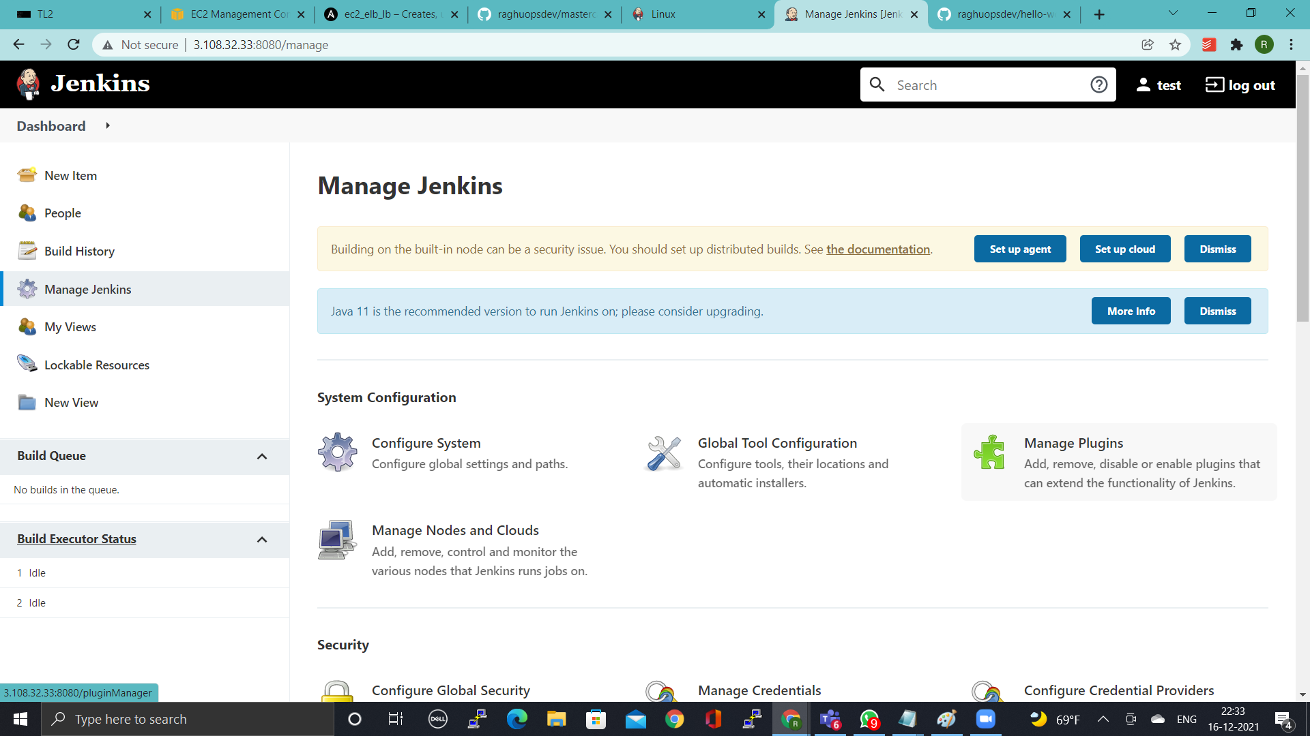

Click on **Available ->** select **Publish Over SSH** - > **Install without restart**

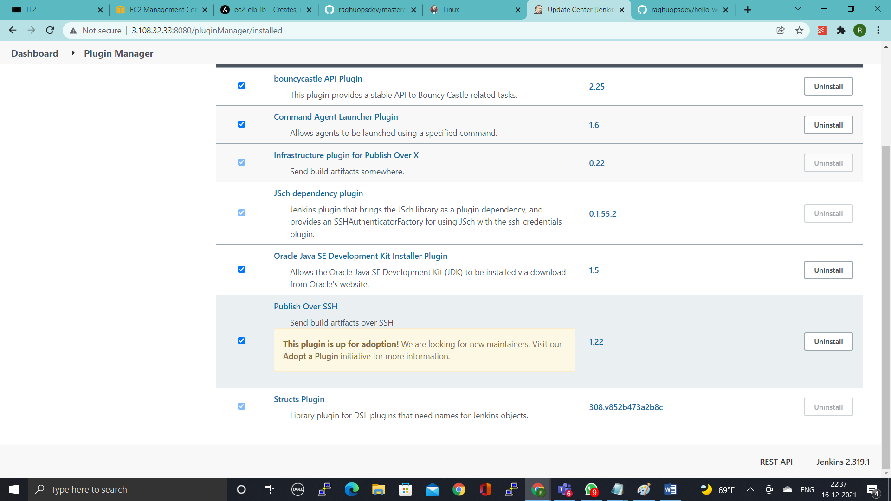

Click on **Manage Jenkins -> Configure Systems**

Configure SSH Server Name, Hostname & Username

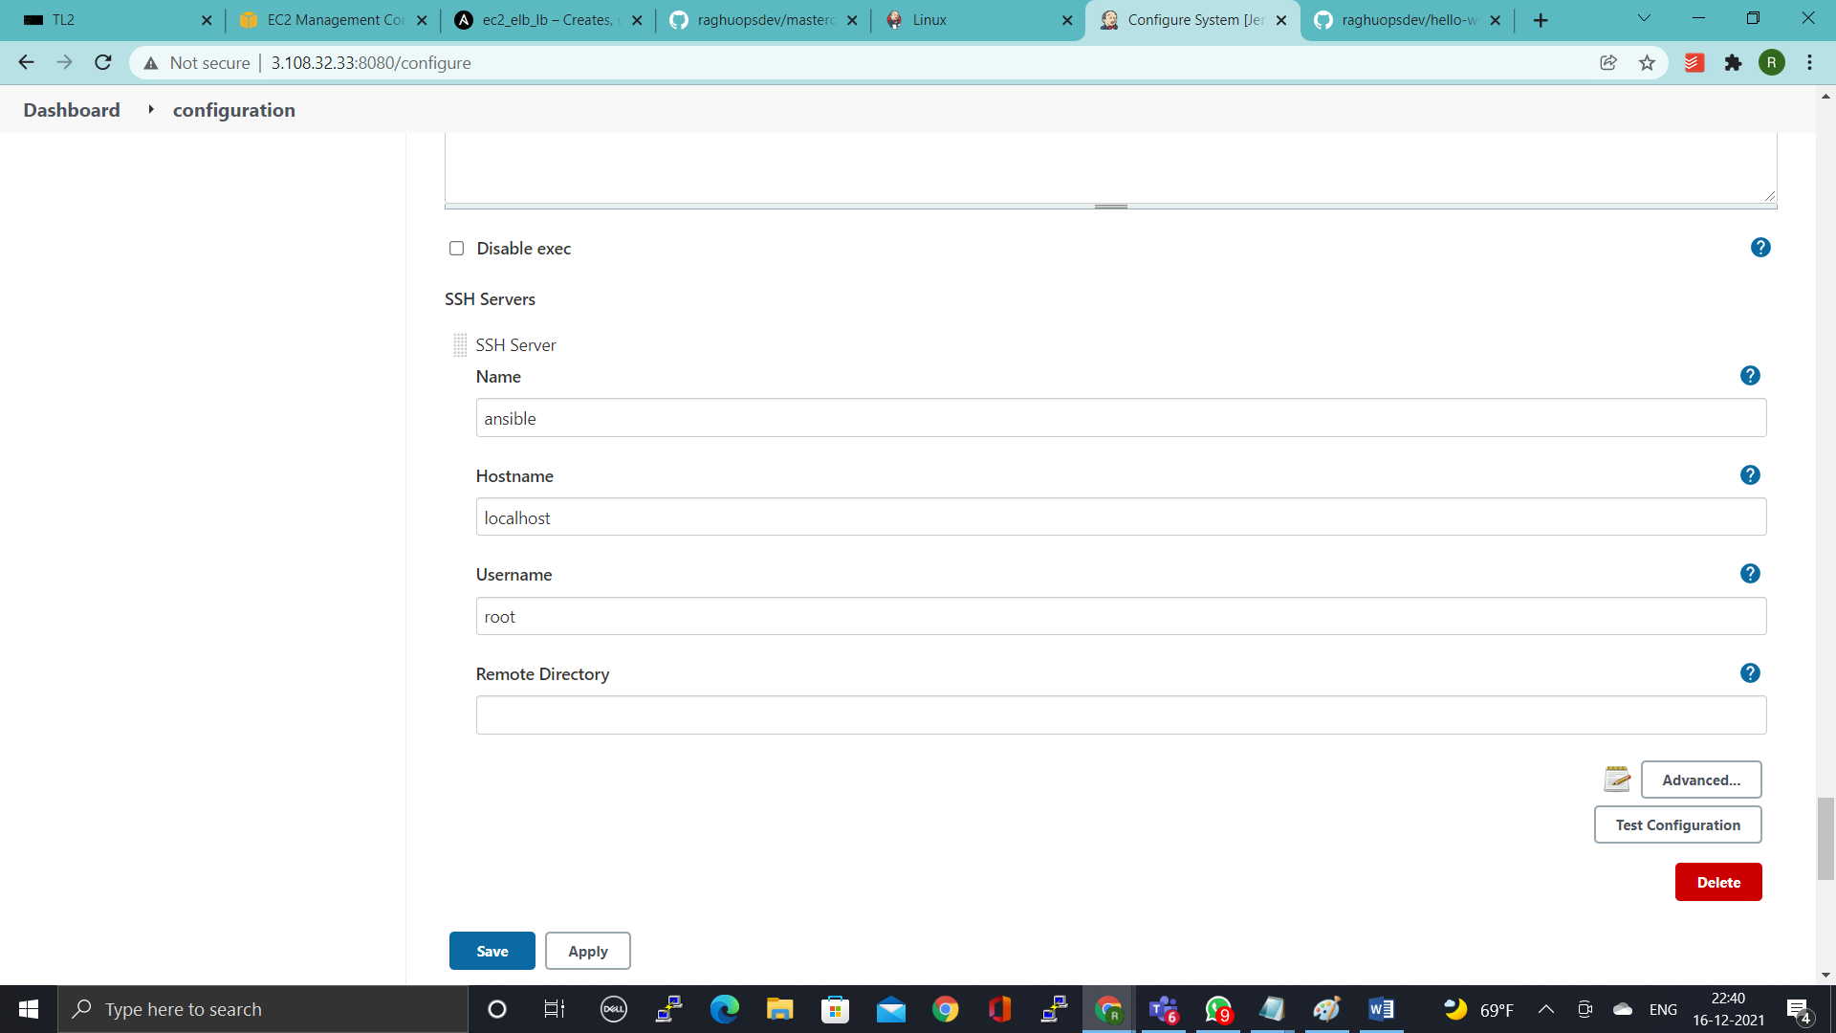

Setup either Password / Key, I used **Password**

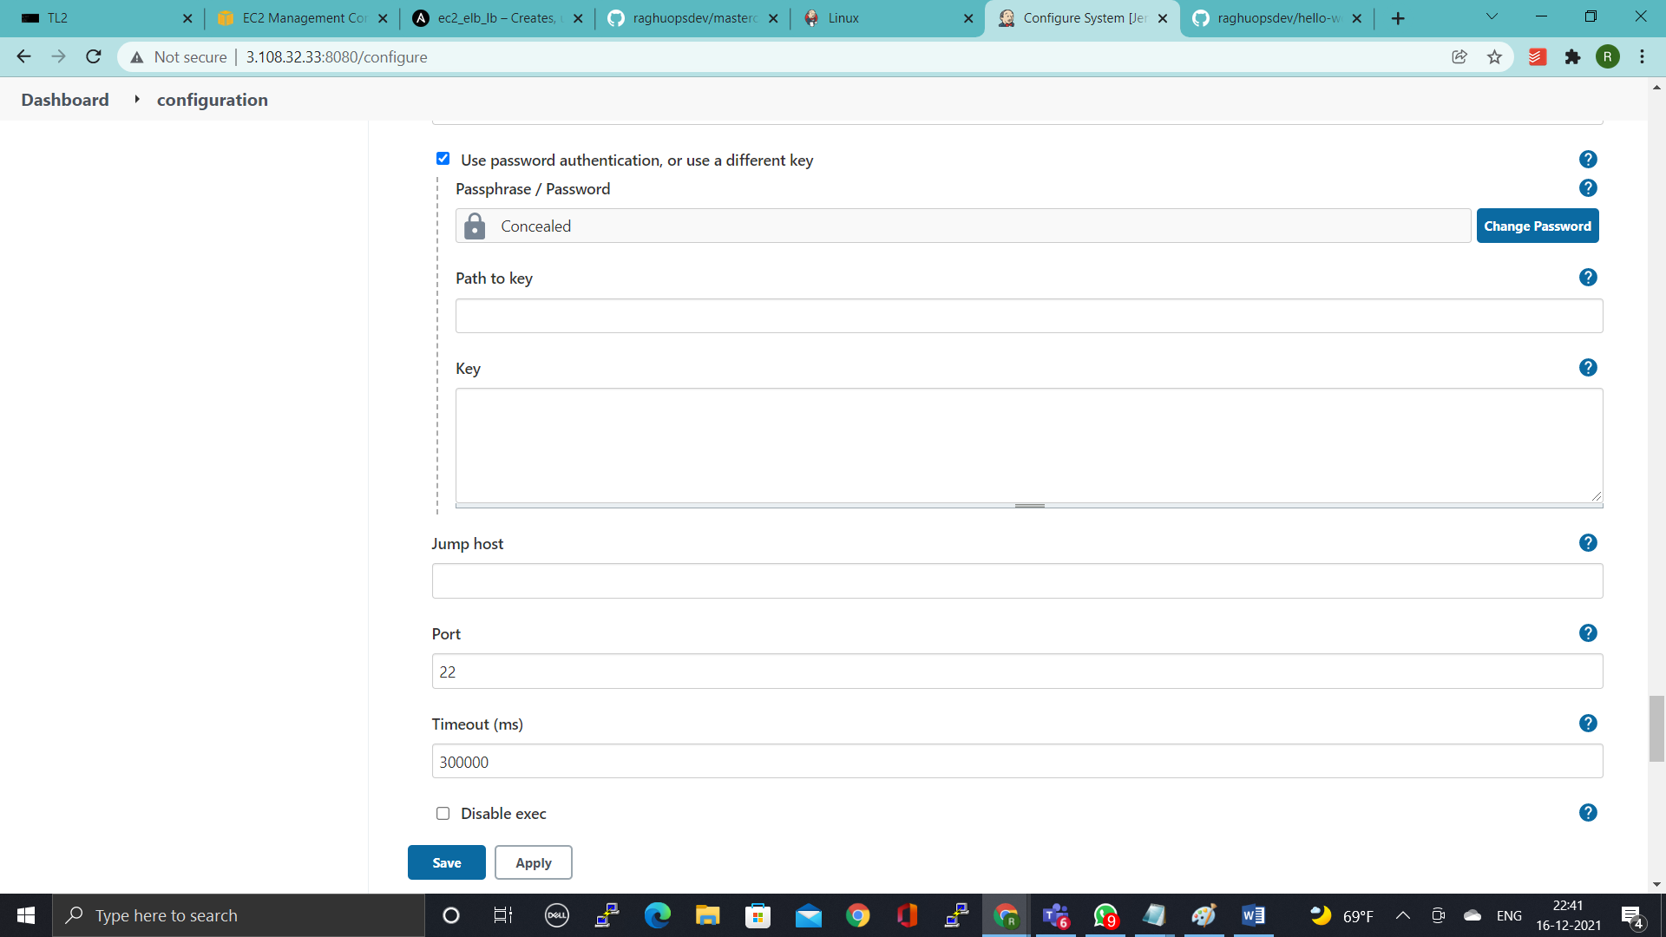

For Password you need to do few changes, add the following 2 entries to the sshd config

**# vi /etc/ssh/sshd_config**

PermitRootLogin yes

PermitRootLogin yes

**# service sshd restart**

**# vi /root/.ssh/authorized_keys**

Remove the selected text as shown below upto **ssh-rsa**

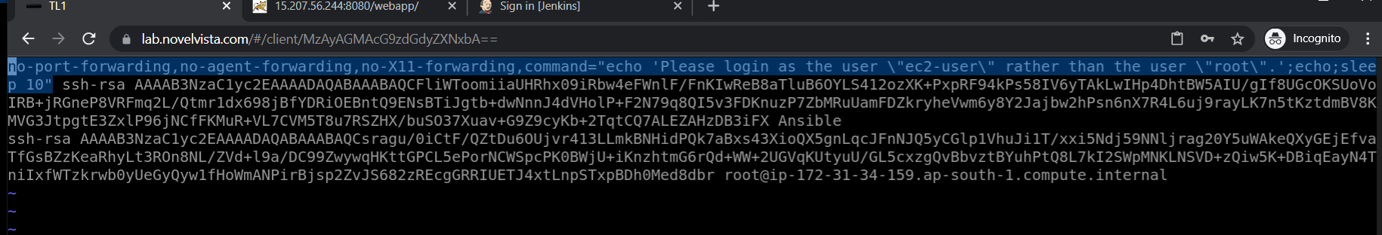

**Click on Test to see the Success**

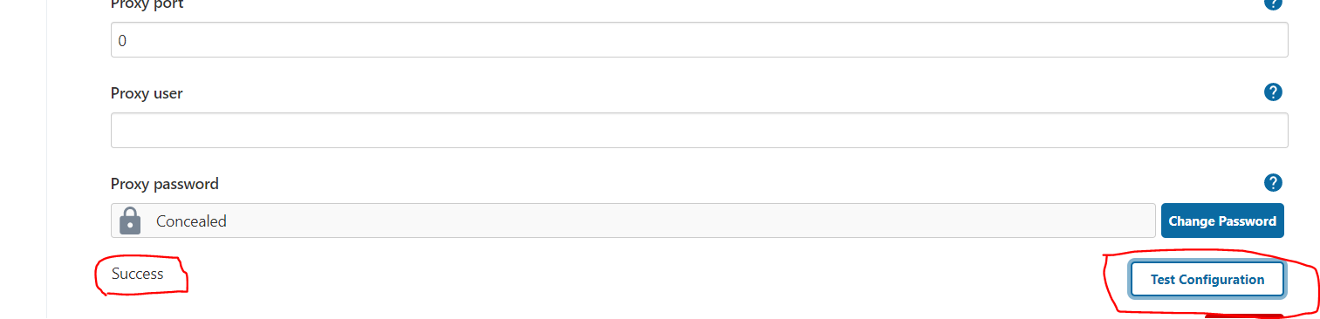

**Go to Dashboard**

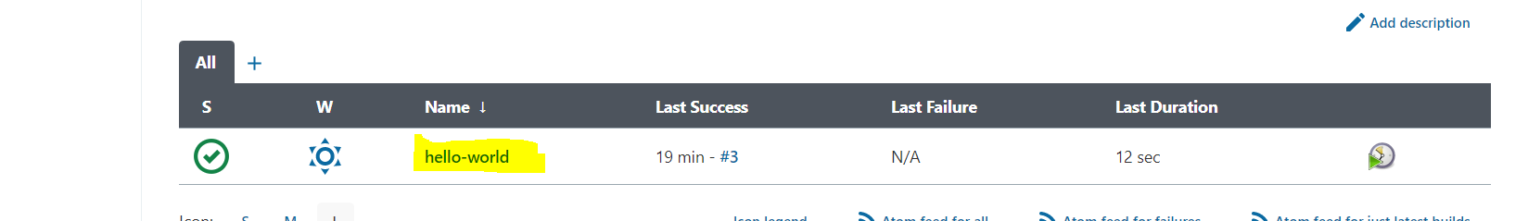

**Select Configuration**

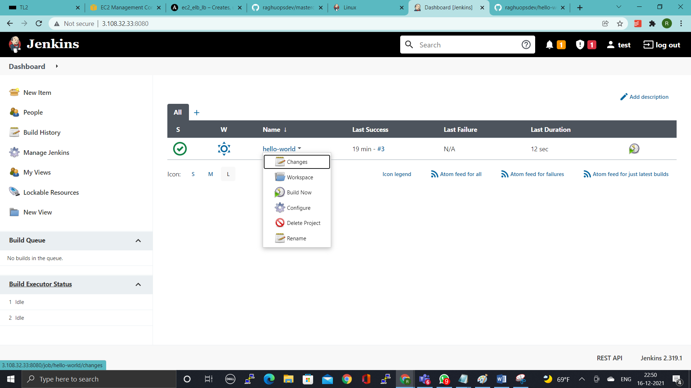

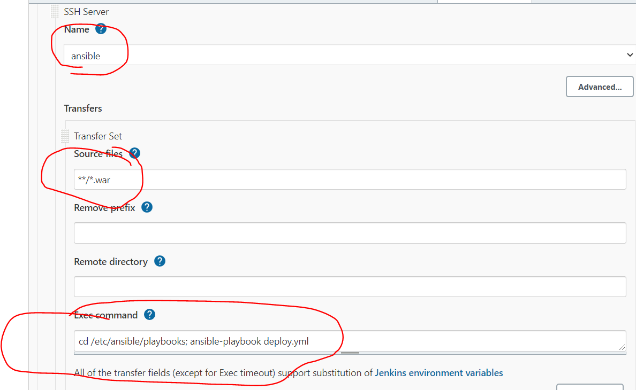

**Configure like above and Build the Job, you will see the Success**

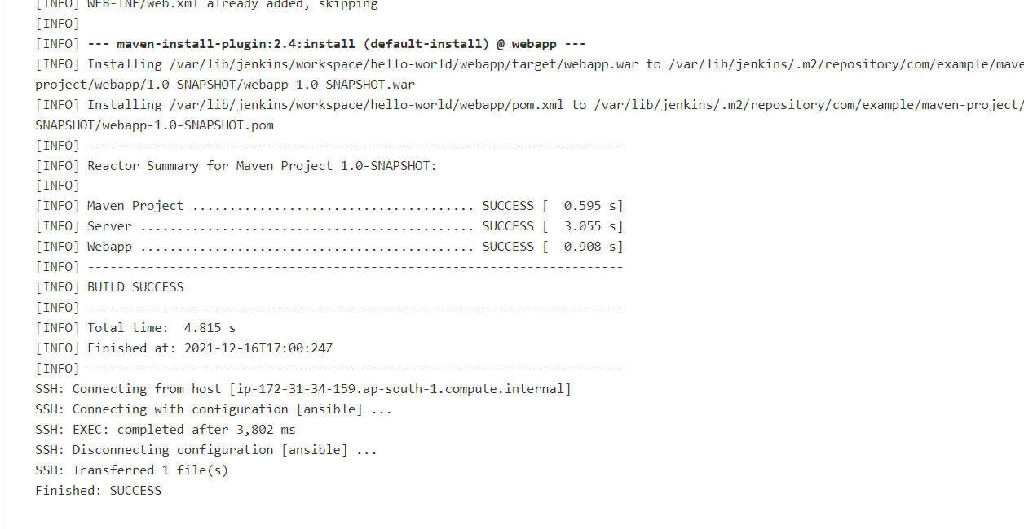

**Playbook has to be written you can select from Repo**

