Homework One
CS5592: Design and Analysis of Algorithms
Due: Monday, 09/12/2016, in class

- Use summation method to solve the following recurrence relation, assuming T(1) = O(1).
T(n) = 2T(n/2) + nlgn
- Use master method to determine and use theta (Θ) notation to represent asymptotic growth rate for each T(n) of the following recurrence relations. Assume T(n) is constant for n ≤ 4. You need to show clear steps to justify your answers.
(a) T(n) = 9T(n/2) + n3lgn
(b) T(n) = 9T(n/3) + n²
(c) T(n) = 6T(n/2) + n³
3 Given a sequence of n real numbers stored in a array, A[1], A[2], …, A[n]. We wish to find two numbers A[i] and A[j], where i < j, such that A[i] ≤ A[j] and their sum is the largest. That is,
A[i] + A[j] = Max {A[u] + A[v] | 1 ≤ u < v ≤.n, A[u] ≤ A[v]}
Please design a divide-and-conquer algorithm to solve the above problem. Please analyze the complexity of your algorithm. The complexity of your algorithm must be O(nlgn) or better.
- We wish to build a bridge over a river. As shown in the following figure, we use line segment AB as a reference which is perpendicular to the river. There are m suitable locations on the north bank of the river to hold the north end of the bridge. These m locations are on a same line perpendicular to AB and have distances, N[1] < N[2] < … < N[m], respectively, to the east of reference point A. On the south bank of the river, there are n suitable locations on the same line that have distances, S[1] < S[2] < … < S[n], respectively, to the east of reference point B. Now, we wish to select a location N[i], 1 ≤ i ≤ m, and a location S[j], 1 ≤ j ≤ n, such that d = |N[i] - S[j]| is minimized.
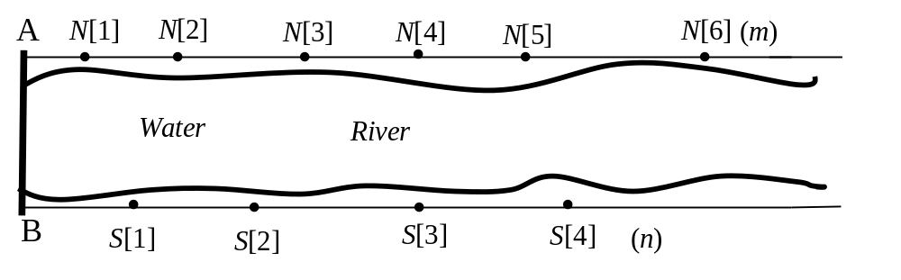
- Suppose we have chosen and fix S[j], 1≤ j ≤ n, to be the south end of the bridge. Please design a divide and conquer algorithm to choose north end N[i] such that d = |N[i] - S[j]| is minimized. Please use North-End (N[p..r], S[j], i, d) as the name of your algorithm. This algorithm will take sequence N[p..r], 1 ≤ p ≤ r ≤ n, and S[j] as input, and will output i and d such that d = |N[i] - S[j]| is the smallest, where p ≤ i ≤ r. Your algorithm should have complexity of O(lgm’) where m’ = r – p + 1, the size of N[p..r].

- The following is a divide and conquer algorithm that uses your algorithm in part (a). This algorithm takes segments N[p..r] and S[u..v] as input and computes a location N[i], u ≤ i ≤ v, and a location S[j], p ≤ j ≤ r, such that d = |N[i] - S[j]| is minimized. When we call this algorithm with p = 1, r = m, u = 1, v = n, we will find the answer to the problem in question.
North-and-South-end (N[p..r], S[u..v], i, j, d) //output N[i], S[j], and d = |N[i] - S[j]|
- if p > r //no north locations available.
- then d ← ∞
- return
- endif
- if u = v
- then j ← u
- North-End (N[p..r], S[j], i, d)
- return i, j, d
- else mid ← ⎣(u+v)/2⎦
- j1 ← mid
- North-End (N[p..r], S[j1], i1, d1)
- if N[i1] < S[j1]
- then North-and-South-end (N[p.. i1], S[u..mid-1], i2, j2, d2)
- North-and-South-end (N[i1+1.. r], S[mid+1..v], i3, j3, d3)
- else North-and-South-end (N[p.. i1-1], S[u..mid-1], i2, j2, d2)
- North-and-South-end (N[i1.. r], S[mid+1..v], i3, j3, d3)
- endif
- d ← max {d1, d2, d3}
- if d = d1
- then return i1, j1, d1
- else if d = d2
- then return i2, j2, d2
- else return i3, j3, d3
- endif
- endif
- endif
- End
Please establish a reasonable recurrence relation for the time complexity of this algorithm and prove that its complexity is O(nlgm).

5 (a) Prove that any full binary tree with n leaves has height ⎡lgn⎤ if all leaves are located in the bottom two levels.
(b) Prove that any full binary tree with n leaves has height Θ(lgn) if all leaves are located in the bottom 3 levels.

