**Advanced AIML Model Question Paper Probable Answer**

**Unit 5**

Q9-A.

**You have a user-item rating matrix where User A has rated Items 1, 2, and 3 with values of 5, 3, and 4, respectively. User B has rated Items 1, 3, and 4 with values of 2, 5, and 4, respectively. Using cosine similarity, calculate the similarity score between User A and User B.**

**What is Cosine Similarity?**

**Cosine similarity measures the cosine of the angle between two non-zero vectors in a multidimensional space. It evaluates how similar two vectors are irrespective of their magnitude. The formula is:**

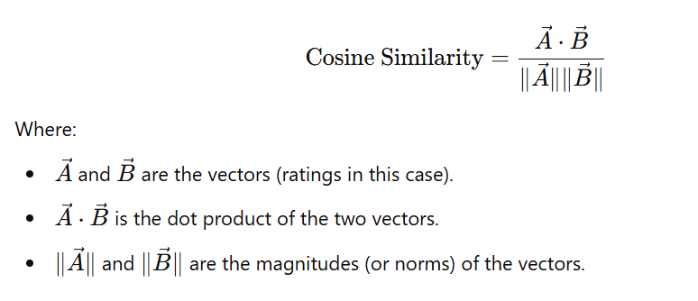

**Step-by-Step Calculation**

**Step 1: Representing the Ratings as Vectors**

**The ratings provided were:**

* **User A: Rated Items 1, 2, and 3 as 5, 3, and 4, respectively. Did not rate Item 4. This is represented as [5,3,4,0]**
* **User B: Rated Items 1, 3, and 4 as 2, 5, and 4, respectively. Did not rate Item 2. This is represented as [2,0,5,4]**

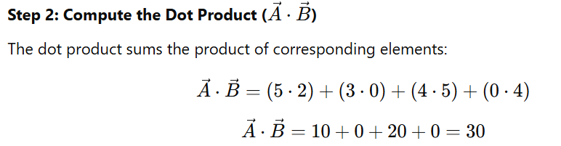

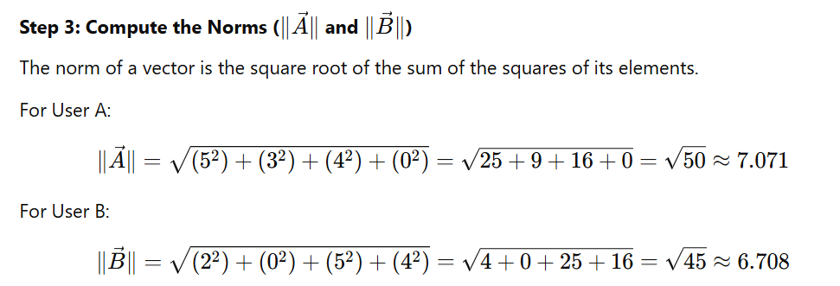

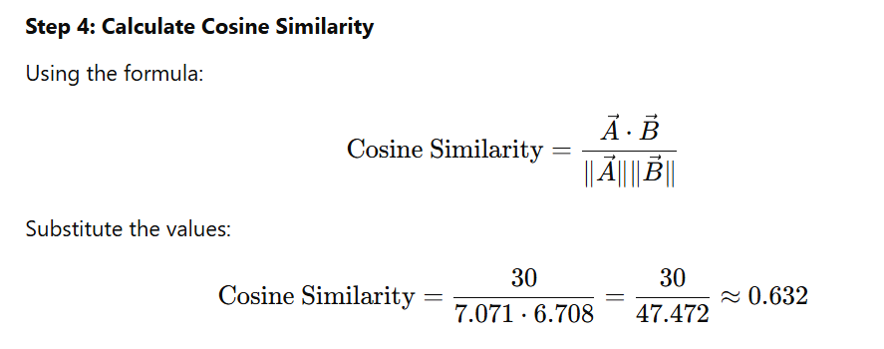

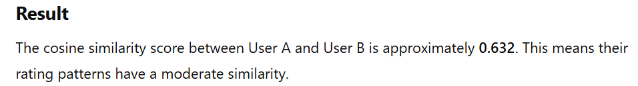

Q9-B.

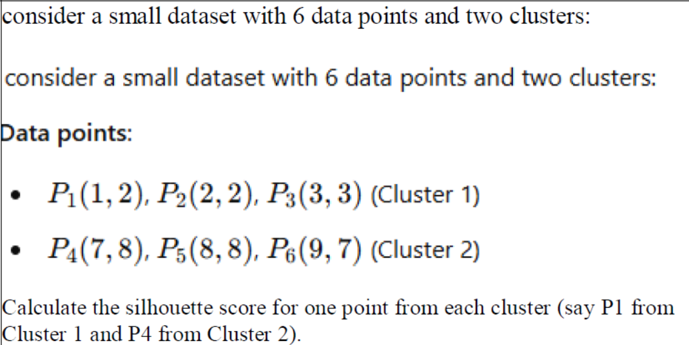

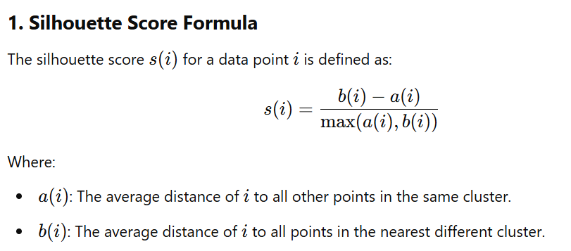

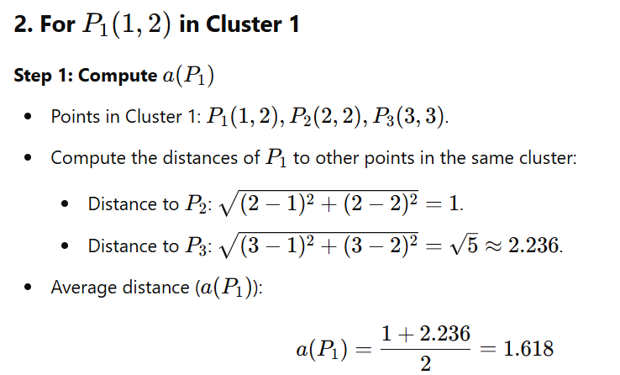

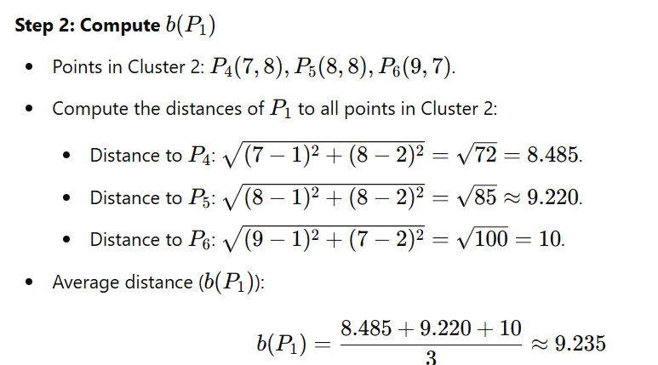

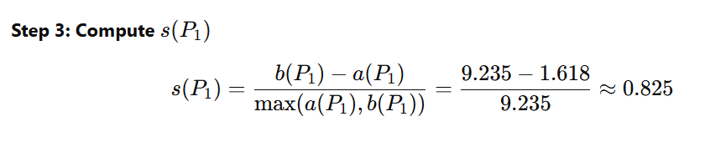

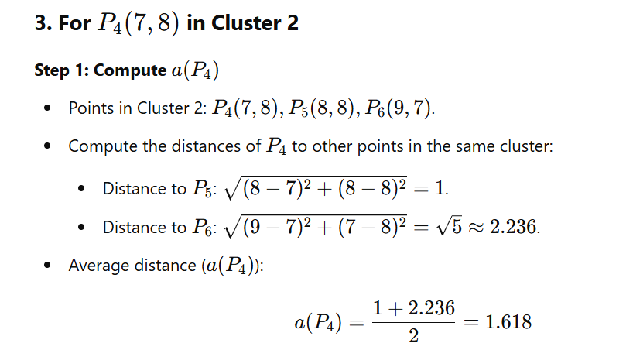

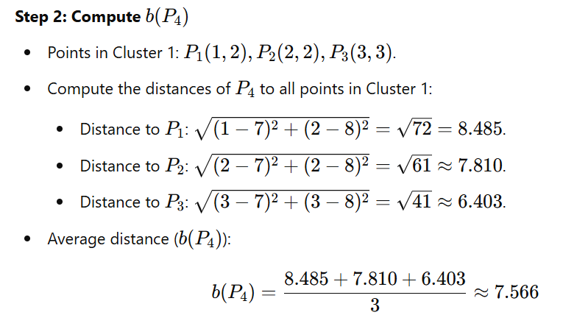

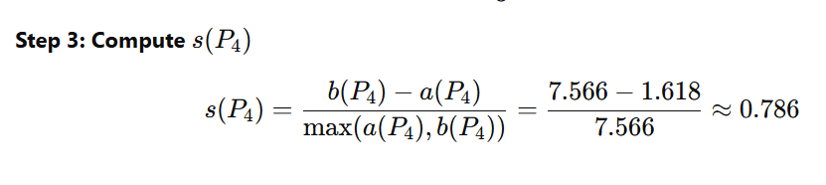

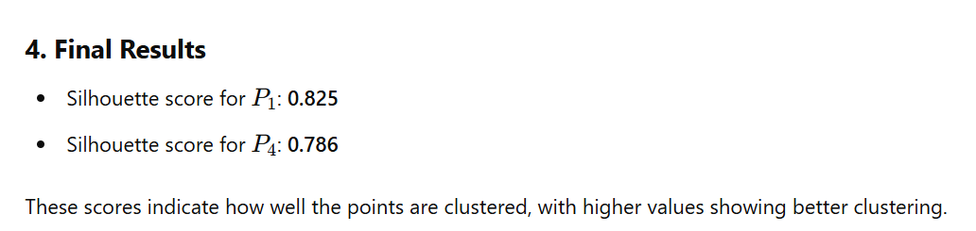

Q 10 A

How does the choice of distance metric impact the performance of clustering algorithms in unsupervised learning?

The choice of distance metric significantly impacts the performance of clustering algorithms in unsupervised learning because it determines how the similarity or dissimilarity between data points is calculated. Different distance metrics can result in vastly different clustering outcomes, as they influence how clusters are formed and how well they represent the data. Below are the key points on how the distance metric impacts clustering:

**1. Nature of the Data**

* **Euclidean Distance**: Works well for continuous, dense, and isotropic data (data that forms spherical or evenly distributed clusters). However, it may fail for data with varying scales or non-spherical clusters.
* **Manhattan Distance (L1 Norm)**: Suitable for high-dimensional data where features are independent or sparse. It is robust to outliers compared to Euclidean distance.
* **Cosine Similarity**: Measures the angle between vectors and is useful for text data, high-dimensional sparse data, or situations where the magnitude of the vector is less important than the direction.
* **Hamming Distance**: Effective for categorical or binary data where the focus is on matching attributes rather than numerical differences.

**2. Clustering Algorithm Sensitivity**

* **K-Means Clustering**: Relies heavily on Euclidean distance by default, which assumes clusters are spherical and equally sized. Using other metrics (e.g., cosine similarity) can alter its performance and applicability.
* **Hierarchical Clustering**: Flexible with distance metrics (e.g., Euclidean, Manhattan, or custom metrics). The metric determines the shape of dendrograms and how clusters merge.
* **DBSCAN**: A density-based algorithm that is sensitive to the distance metric. The choice of metric influences the density threshold, affecting the detection of clusters and noise points.
* **Spectral Clustering**: Often relies on similarity matrices (e.g., Gaussian or cosine similarity), where the metric defines the graph representation of data.

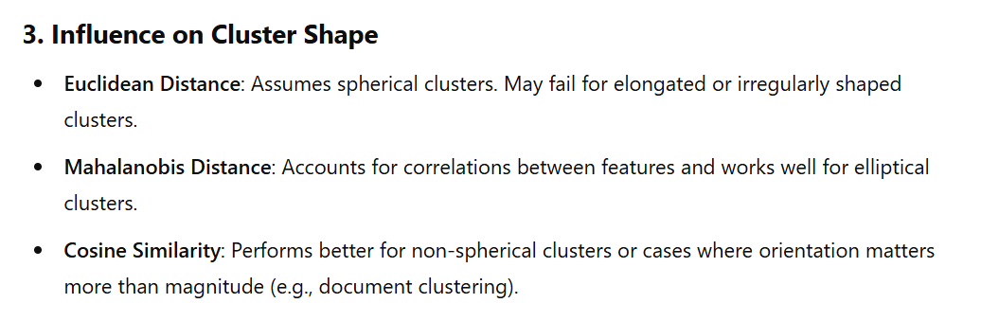

**4. Sensitivity to Feature Scaling**

Some metrics, such as Euclidean and Manhattan distances, are sensitive to feature scaling:

* If features are not normalized or standardized, features with larger scales dominate the metric.
* Metrics like cosine similarity or correlation distance are invariant to scaling and normalization, making them suitable for features with differing units.

**5. Impact on High-Dimensional Data (Curse of Dimensionality)**

* In high-dimensional spaces, distances (e.g., Euclidean) tend to converge, making it harder to distinguish points.
* Metrics like cosine similarity or Jaccard similarity are often more effective for high-dimensional data as they focus on relationships rather than absolute distances.

The choice of distance metric significantly impacts the performance of clustering algorithms in unsupervised learning because it determines how the similarity or dissimilarity between data points is calculated. Different distance metrics can result in vastly different clustering outcomes, as they influence how clusters are formed and how well they represent the data. Below are the key points on how the distance metric impacts clustering:

**1. Nature of the Data**

* **Euclidean Distance**: Works well for continuous, dense, and isotropic data (data that forms spherical or evenly distributed clusters). However, it may fail for data with varying scales or non-spherical clusters.
* **Manhattan Distance (L1 Norm)**: Suitable for high-dimensional data where features are independent or sparse. It is robust to outliers compared to Euclidean distance.
* **Cosine Similarity**: Measures the angle between vectors and is useful for text data, high-dimensional sparse data, or situations where the magnitude of the vector is less important than the direction.
* **Hamming Distance**: Effective for categorical or binary data where the focus is on matching attributes rather than numerical differences.

**2. Clustering Algorithm Sensitivity**

* **K-Means Clustering**: Relies heavily on Euclidean distance by default, which assumes clusters are spherical and equally sized. Using other metrics (e.g., cosine similarity) can alter its performance and applicability.
* **Hierarchical Clustering**: Flexible with distance metrics (e.g., Euclidean, Manhattan, or custom metrics). The metric determines the shape of dendrograms and how clusters merge.
* **DBSCAN**: A density-based algorithm that is sensitive to the distance metric. The choice of metric influences the density threshold, affecting the detection of clusters and noise points.
* **Spectral Clustering**: Often relies on similarity matrices (e.g., Gaussian or cosine similarity), where the metric defines the graph representation of data.

**3. Influence on Cluster Shape**

* **Euclidean Distance**: Assumes spherical clusters. May fail for elongated or irregularly shaped clusters.
* **Mahalanobis Distance**: Accounts for correlations between features and works well for elliptical clusters.
* **Cosine Similarity**: Performs better for non-spherical clusters or cases where orientation matters more than magnitude (e.g., document clustering).

**4. Sensitivity to Feature Scaling**

Some metrics, such as Euclidean and Manhattan distances, are sensitive to feature scaling:

* If features are not normalized or standardized, features with larger scales dominate the metric.
* Metrics like cosine similarity or correlation distance are invariant to scaling and normalization, making them suitable for features with differing units.

**5. Impact on High-Dimensional Data (Curse of Dimensionality)**

* In high-dimensional spaces, distances (e.g., Euclidean) tend to converge, making it harder to distinguish points.
* Metrics like cosine similarity or Jaccard similarity are often more effective for high-dimensional data as they focus on relationships rather than absolute distances.

**6. Domain-Specific Considerations**

* In bioinformatics, genetic sequence data may require metrics like Hamming or Jaccard distances.
* In image processing, perceptual metrics like Earth Mover's Distance (EMD) might be more meaningful.
* In natural language processing (NLP), cosine similarity or Jaccard similarity is often used due to the sparse nature of text embeddings.

**7. Performance Implications**

* **Computational Complexity**: Certain metrics (e.g., Euclidean) are computationally simpler, while others (e.g., Mahalanobis or EMD) may require more resources.
* **Interpretability**: The choice of metric impacts how results are interpreted. For example, cosine similarity is intuitive for text data but less so for continuous numerical data.

**Conclusion**

Choosing the appropriate distance metric requires a careful understanding of:

1. The nature of the data (e.g., categorical, continuous, high-dimensional, sparse).
2. The clustering algorithm being used.
3. The domain-specific requirements.

Improper choice of a metric can lead to poor clustering performance, whereas an appropriate metric enhances the algorithm’s ability to detect meaningful patterns.

Q 10 – B

What is the "curse of dimensionality," and how does it affect clustering algorithms, particularly in high-dimensional spaces?

The **curse of dimensionality** refers to a set of problems that arise when working with data in high-dimensional spaces. As the number of dimensions (features) increases, the data space becomes increasingly sparse, and many algorithms, including clustering algorithms, struggle to perform effectively. Below, we explore what the curse of dimensionality entails and its impact on clustering algorithms.

**1. Key Aspects of the Curse of Dimensionality**

**a. Sparsity of Data**

* In high-dimensional spaces, data points tend to become sparse and far apart from each other. This sparsity makes it difficult to identify meaningful patterns or relationships between points.

**b. Distance Measures Become Less Informative**

* Many clustering algorithms rely on distance metrics like Euclidean or Manhattan distances. In high dimensions:
  + Distances between points tend to converge, meaning the difference between the nearest and farthest points diminishes.
  + The relative importance of distances diminishes, making it hard to distinguish between clusters.

**c. Increased Computational Complexity**

* High-dimensional data leads to more computations for distance calculations and increases the complexity of clustering algorithms.

**d. Curse of Volume**

* The volume of the space increases exponentially with the number of dimensions, requiring exponentially more data to achieve the same density. This makes clustering less effective as data points become scattered.

**2. Impact on Clustering Algorithms**

**a. K-Means Clustering**

* **Distance Dependence**: K-Means relies on Euclidean distance to assign points to clusters. In high dimensions:
  + Centroids may not meaningfully represent clusters due to sparsity.
  + Data points may be almost equidistant from all centroids, leading to poor clustering results.
* **Interpretation**: Clusters might become meaningless as the algorithm struggles to distinguish between similar and dissimilar points.

**b. Hierarchical Clustering**

* **Agglomerative Methods**: Depend heavily on distance metrics. As distances lose meaning in high dimensions, the hierarchical structure can become arbitrary or misleading.
* **Scalability**: High-dimensional data increases the time complexity, making it infeasible for large datasets.

**c. DBSCAN (Density-Based Clustering)**

* **Density Threshold**: Defining a meaningful density threshold becomes challenging in high dimensions due to sparsity. Points might appear as noise because the concept of "density" becomes less reliable.
* **Neighborhood Definitions**: The choice of epsilon (radius) becomes sensitive and often ineffective in distinguishing meaningful clusters.

**d. Spectral Clustering**

* **Graph-Based Similarity**: High-dimensional data leads to difficulties in constructing similarity graphs. The similarity matrix may become dominated by noise or uniformity.

**3. Practical Implications**

**a. Dimensionality Reduction**

To mitigate the curse of dimensionality, dimensionality reduction techniques are often applied before clustering:

* **Principal Component Analysis (PCA)**: Reduces dimensions by projecting data onto principal components that capture the most variance.
* **t-SNE or UMAP**: Non-linear dimensionality reduction methods that are particularly effective for visualizing clusters in high-dimensional data.

**b. Feature Selection**

* Selecting only the most relevant features can improve clustering performance by removing redundant or irrelevant dimensions.

**c. Using Robust Metrics**

* **Cosine Similarity**: Often better than Euclidean distance for high-dimensional sparse data (e.g., text data).
* **Jaccard Similarity**: Useful for categorical or binary data.

**d. Sampling or Data Subset**

* Use smaller subsets of features or instances to reduce the dimensionality and mitigate sparsity issues.

**4. High-Dimensional Data-Specific Clustering Algorithms**

Certain algorithms are designed to work better in high-dimensional spaces:

* **Subspace Clustering**: Identifies clusters in subspaces of high-dimensional data rather than the full space.
* **Spectral Clustering**: Builds similarity graphs that capture relationships more effectively in high dimensions.
* **Density-Based Subspace Clustering (e.g., CLIQUE)**: Detects clusters within subspaces that are dense.

**5. Summary**

The **curse of dimensionality** impacts clustering algorithms by:

1. Reducing the meaningfulness of distance measures.
2. Increasing sparsity, making clusters less distinct.
3. Amplifying computational challenges.

**Mitigation Strategies**:

* Employ dimensionality reduction or feature selection.
* Use appropriate distance metrics.
* Choose clustering algorithms that can handle high-dimensional data, such as subspace or graph-based methods.

Addressing the curse of dimensionality is essential for achieving meaningful and efficient clustering results in high-dimensional spaces.

Unit 4

Q8-A. If a user has interacted with 3 items with ratings 4, 3, and 5 respectively, and the model predicts ratings of 4.2, 2.9, and 4.8, calculate the Mean Squared Error (MSE) between the predicted and actual ratings.

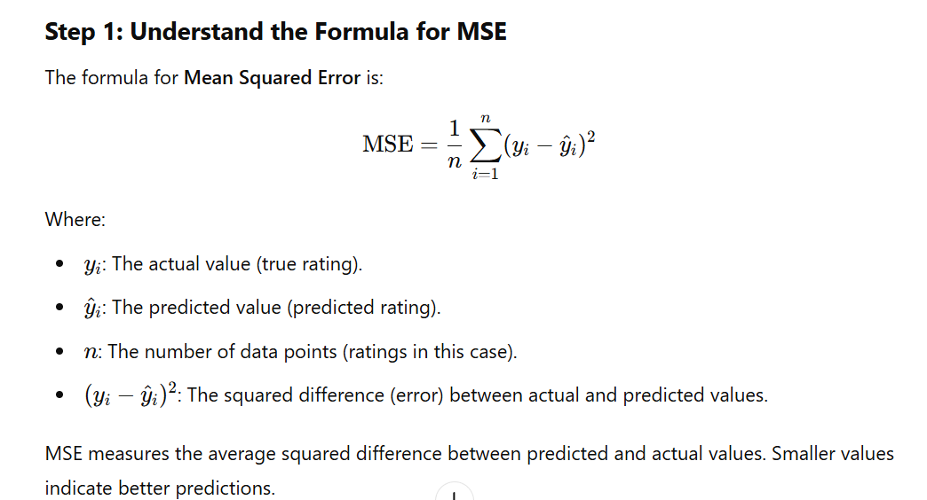

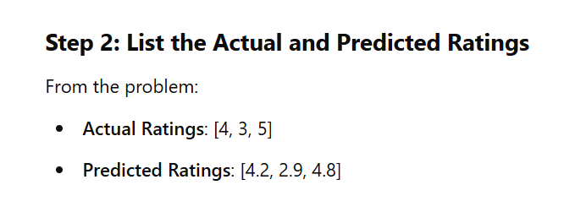

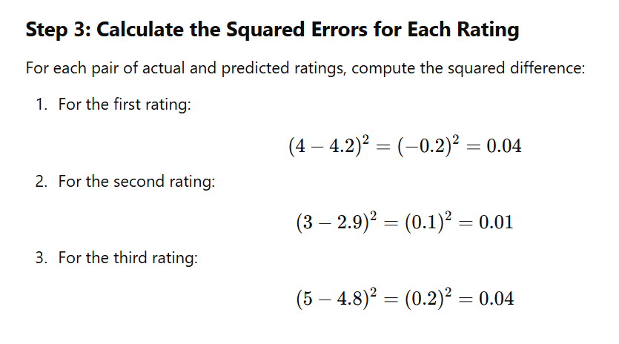

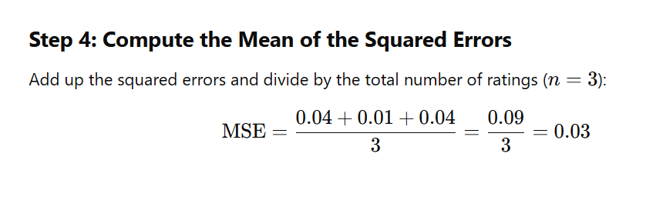

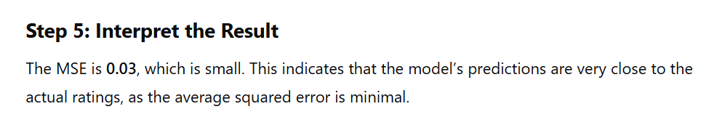

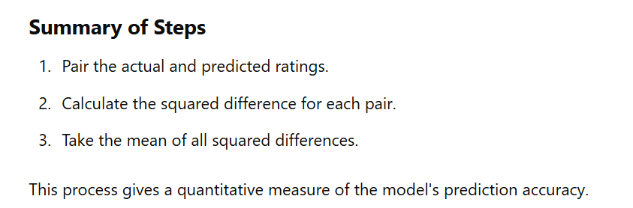

Q 8-B Describe a hybrid recommender system that combines collaborative filtering and content-based filtering. How can these two approaches be combined, and what are the potential challenges, such as data sparsity and scalability?

**Hybrid Recommender System**

A **hybrid recommender system** combines the strengths of **collaborative filtering (CF)** and **content-based filtering (CBF)** to provide better recommendations. The goal is to leverage the advantages of both methods while mitigating their individual weaknesses, such as **cold start**, **data sparsity**, and **scalability**.

**1. Collaborative Filtering (CF)**

* **How it works**: Uses interactions between users and items (e.g., ratings, purchases) to recommend items.
* **Strengths**:
  + Can recommend items without requiring item features.
  + Identifies trends from collective user behavior.
* **Weaknesses**:
  + Suffers from **cold start** (new users/items).
  + **Data sparsity** in user-item interaction matrices.
  + **Scalability** challenges with large datasets.

**2. Content-Based Filtering (CBF)**

* **How it works**: Uses item features (e.g., genre, description) and a user's history to recommend similar items.
* **Strengths**:
  + Works well for users with detailed histories.
  + Handles cold start for users (if item features are available).
* **Weaknesses**:
  + Struggles with new or unseen items (item cold start).
  + Limited diversity in recommendations (recommends similar items only).

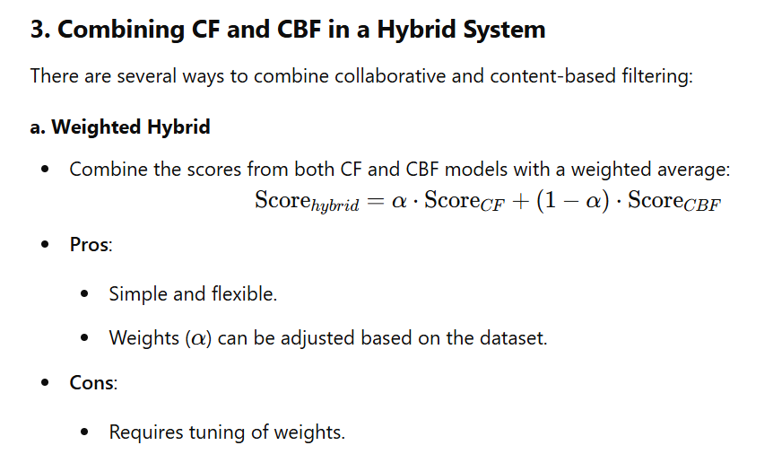

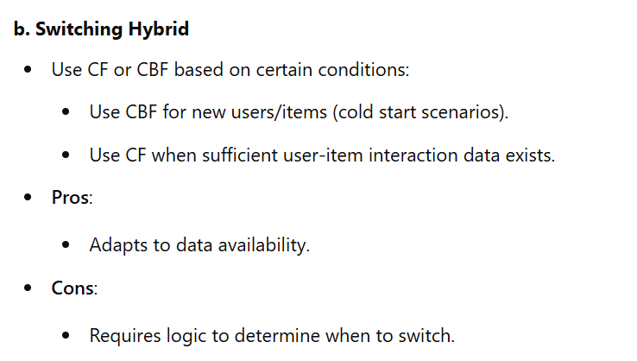

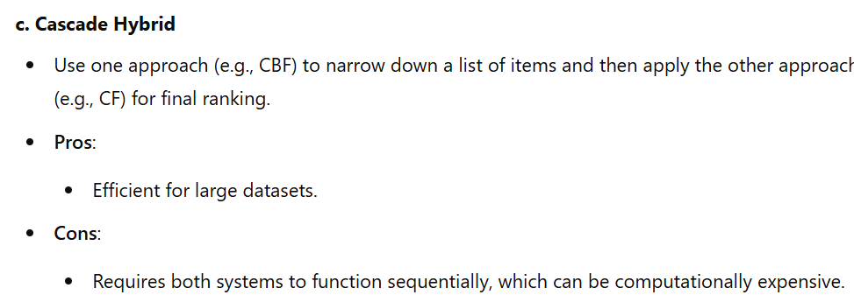

**d. Feature Augmentation**

* Use the output of one model to enhance the input of the other:
  + Use CF to generate latent factors (e.g., user/item embeddings) and feed them as features into a CBF model.
  + Use item features from CBF as additional input for CF models.
* **Pros**:
  + Combines latent information (CF) with explicit content data (CBF).
* **Cons**:
  + Computationally complex.

**e. Model-Based Hybrid**

* Use machine learning models (e.g., matrix factorization, neural networks) that integrate user-item interaction data (CF) and item features (CBF).
* Example: Factorization Machines or Neural Collaborative Filtering.
* **Pros**:
  + Unified framework.
  + Can handle large-scale datasets.
* **Cons**:
  + Requires substantial computational resources and expertise.

**4. Addressing Challenges**

**a. Data Sparsity**

* **Collaborative Filtering**:
  + CF struggles with sparse user-item interaction matrices.
  + Solution: Use matrix factorization techniques (e.g., SVD, ALS) or graph-based methods.
* **Hybrid Approach**:
  + Leverage item features (CBF) to mitigate sparsity.

**b. Cold Start**

* **Cold Start for Users**:
  + CF cannot recommend items for new users with no history.
  + Solution: Use CBF with available item features to provide initial recommendations.
* **Cold Start for Items**:
  + CBF struggles with new items that lack sufficient metadata.
  + Solution: Use CF to recommend items with similar interaction patterns.

**c. Scalability**

* **Collaborative Filtering**:
  + Real-time similarity computations (e.g., for KNN-based CF) are computationally expensive.
  + Solution: Use approximate nearest neighbor techniques or precompute recommendations.
* **Hybrid Approach**:
  + Use scalable algorithms (e.g., matrix factorization or deep learning).
  + Employ parallel computing or distributed systems (e.g., Spark).

**d. Diversity**

* Both CF and CBF can suffer from limited diversity.
* Solution: Add diversity constraints (e.g., include items from different categories) in the hybrid model.

**5. Advantages of a Hybrid System**

* Mitigates the weaknesses of CF and CBF.
* Improves accuracy and robustness of recommendations.
* Can handle cold start and sparsity better than standalone methods.
* Offers greater diversity in recommendations.

**Hybrid Recommender System**

A **hybrid recommender system** combines the strengths of **collaborative filtering (CF)** and **content-based filtering (CBF)** to provide better recommendations. The goal is to leverage the advantages of both methods while mitigating their individual weaknesses, such as **cold start**, **data sparsity**, and **scalability**.

Module 4

Q 7-A

Define maximum likelihood hypothesis derive an equation for ML hypothesis using Bayes theorem

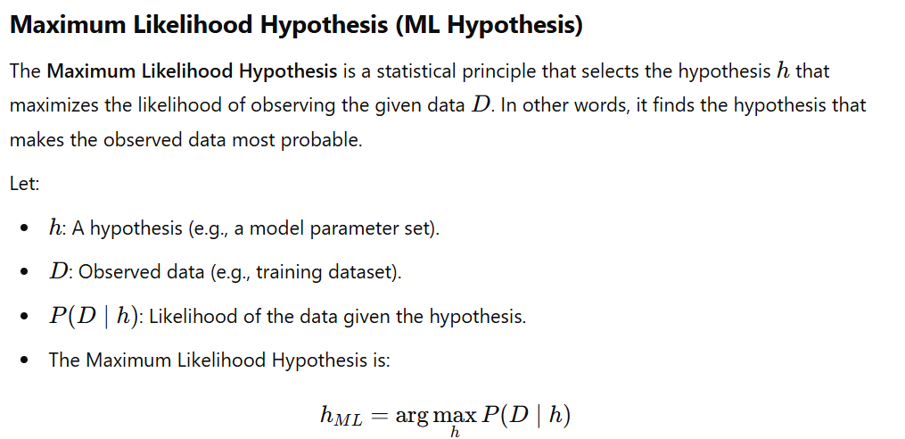

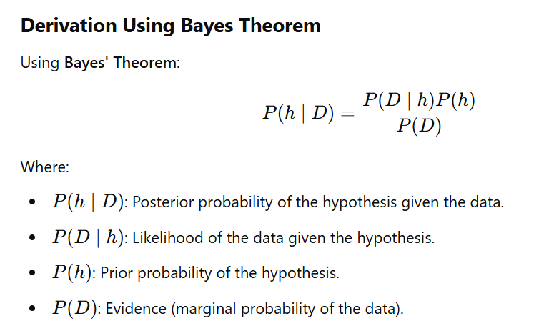

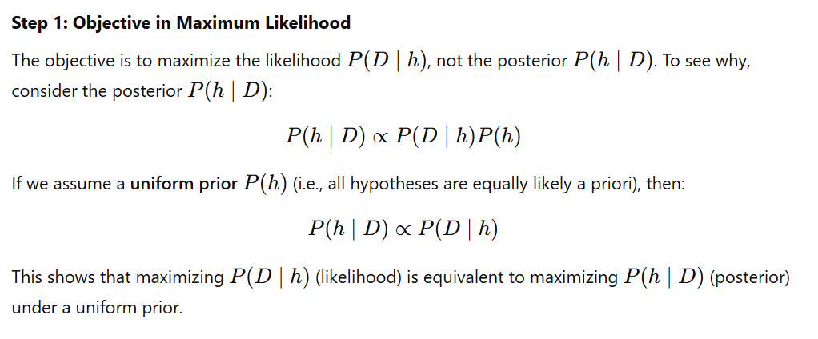

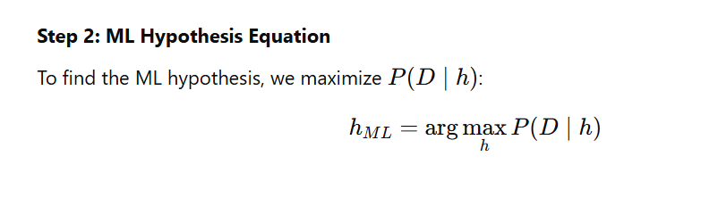

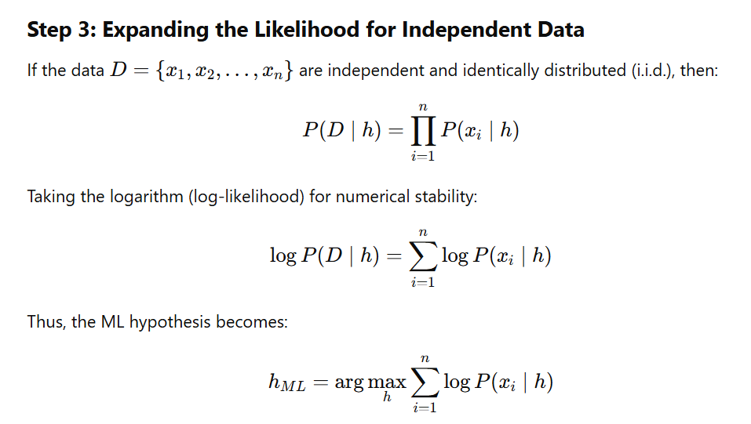

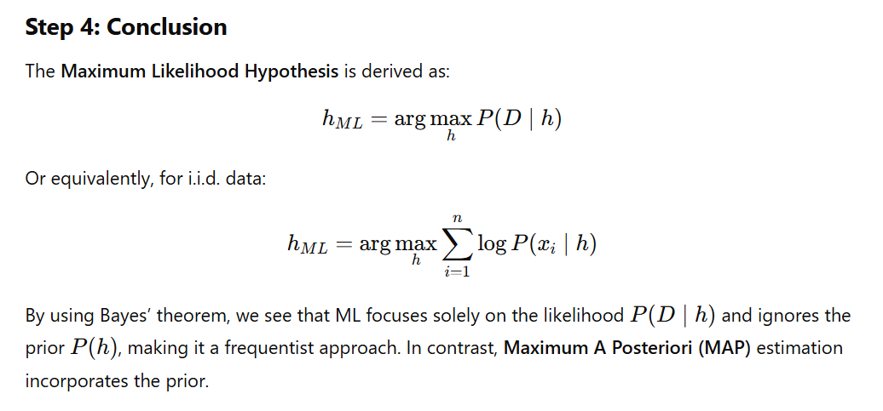

For further your understanding..

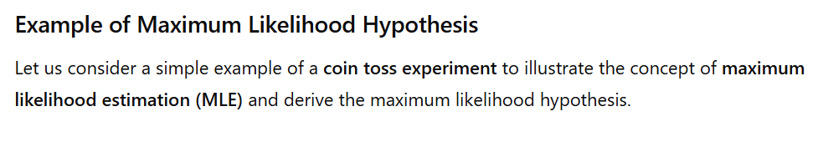

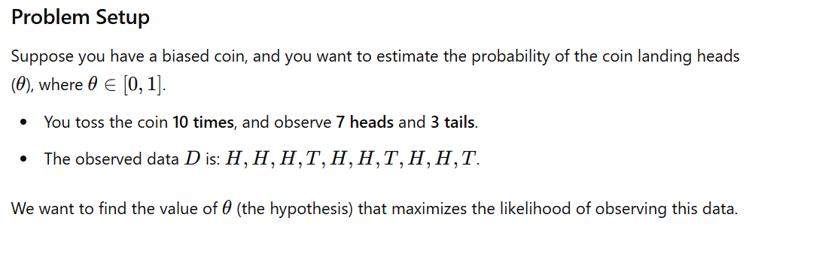

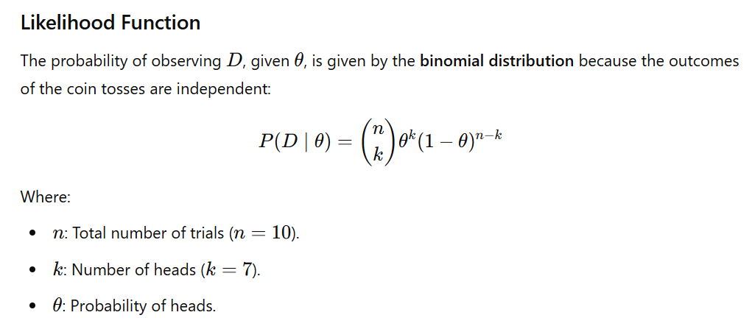

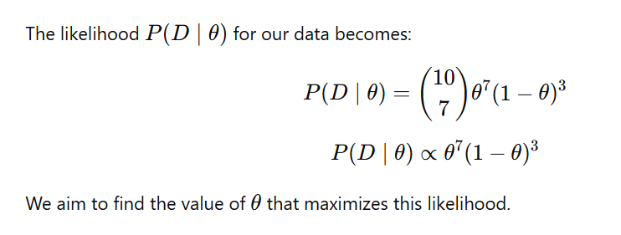

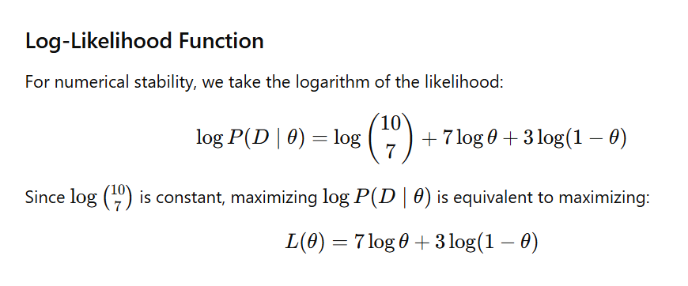

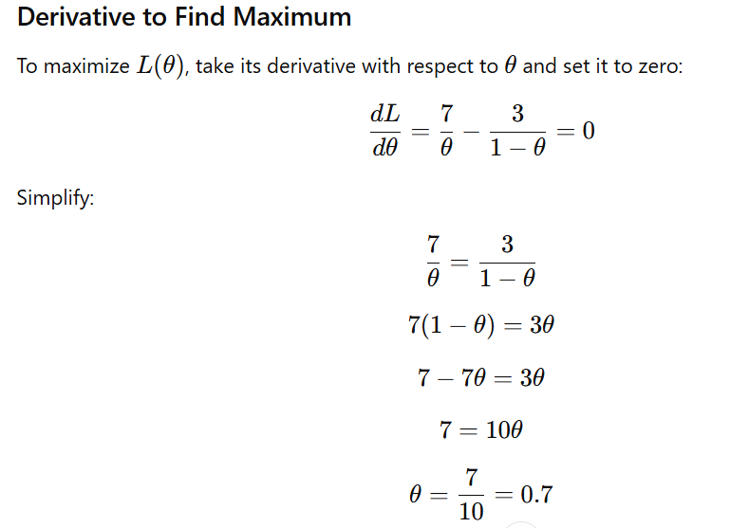

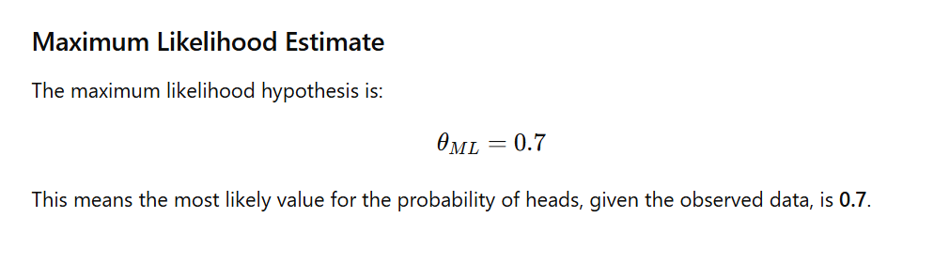

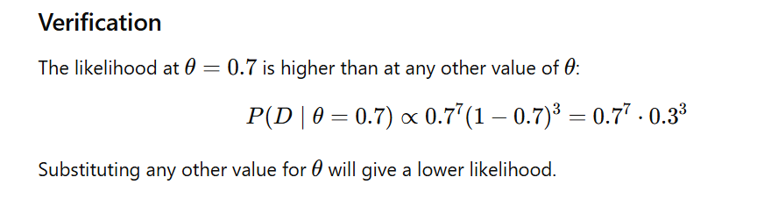

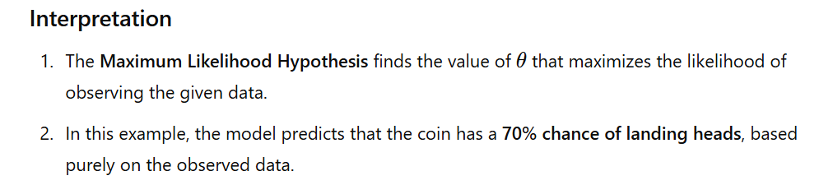

**Q7 – B.**

Given a user-item interaction matrix with 5 users and 4 items, how many latent factors would you need if you're using Singular Value Decomposition (SVD) for matrix factorization? Assume you choose 3 latent factors.

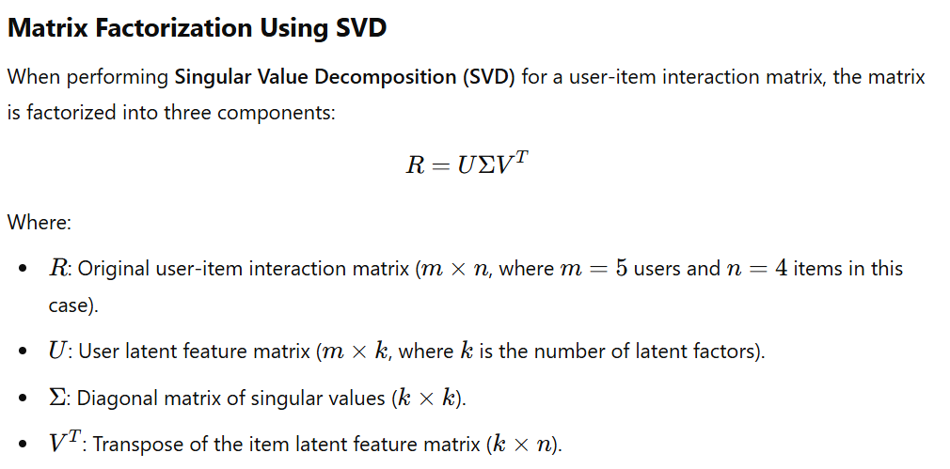

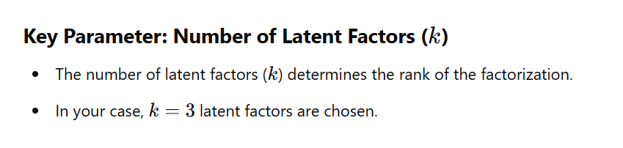

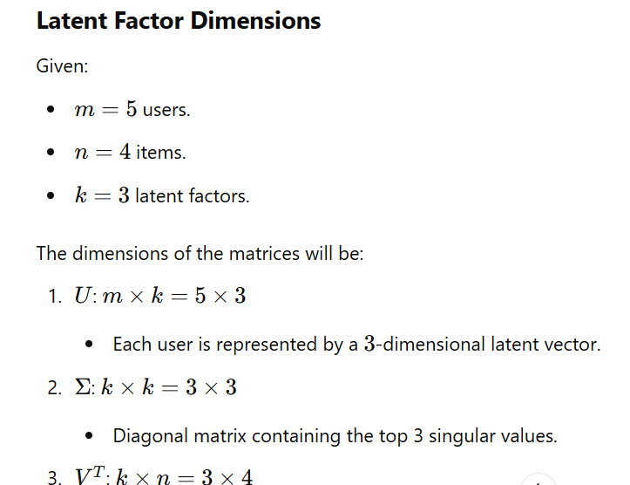

Each item is represented by a 3-dimensional latent vector.

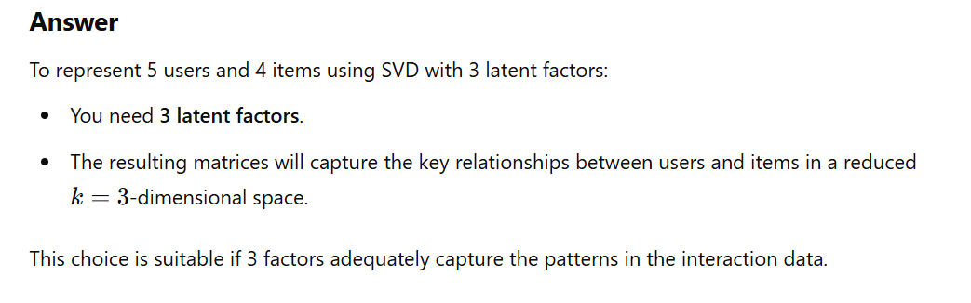

**Module 3**

**Q5-A**

**Design the perceptron that implement AND functions. Why is that a single layer perceptron can not be used to represent XOR function.**

**Designing a Perceptron for the AND Function**

**A perceptron is a simple binary classifier that computes a weighted sum of its inputs, applies a threshold (activation function), and outputs a binary result. The perceptron can represent linearly separable functions like the AND function.**

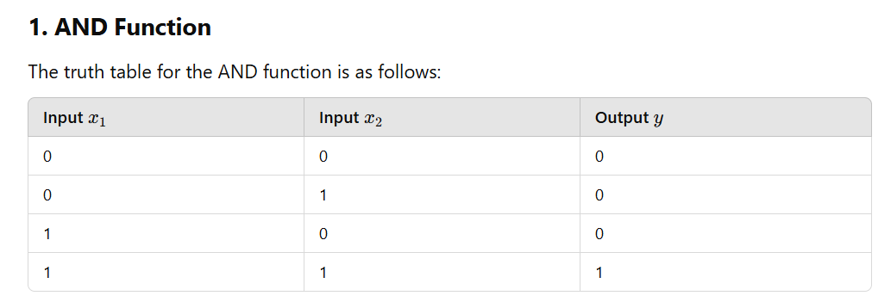

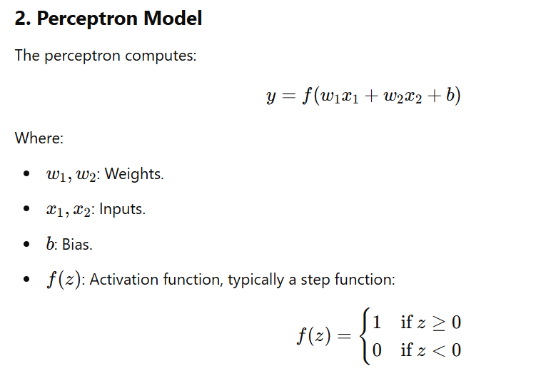

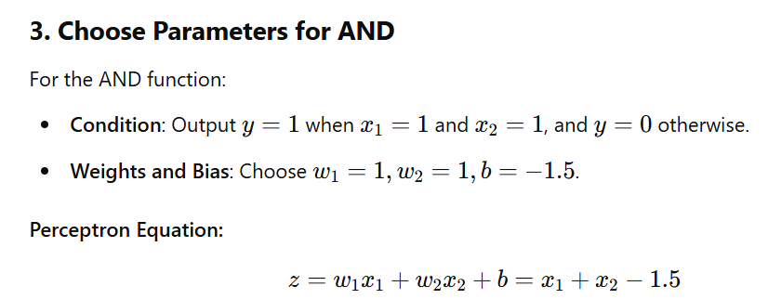

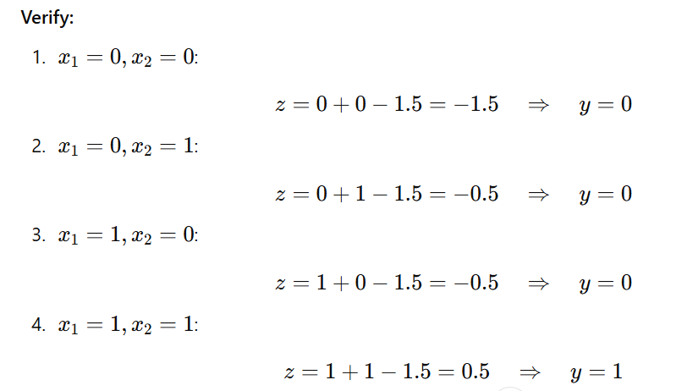

**The perceptron correctly implements the AND function.**

