1.0
Installing python in local system
Steps
Download python from browser , click Download Python | Python.org to open download page


Now search for python 3.12.6 and Click on go button

Now new page will open click on the python 3.12.6
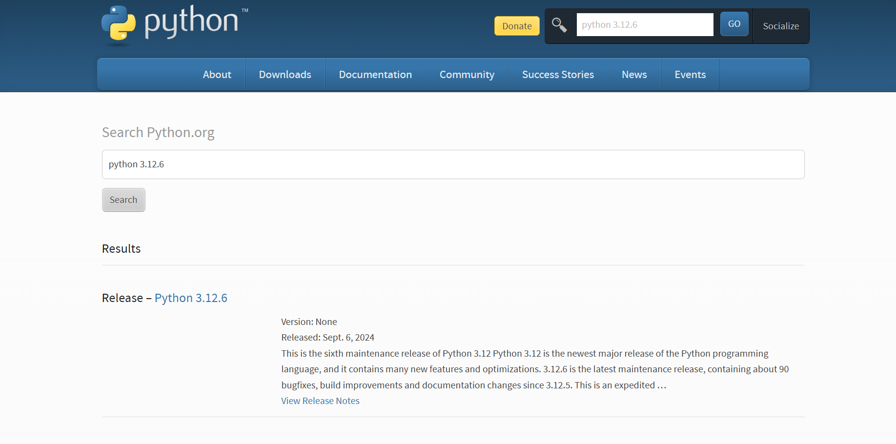

Scroll down until u see this files block click windows installer (64-bit)
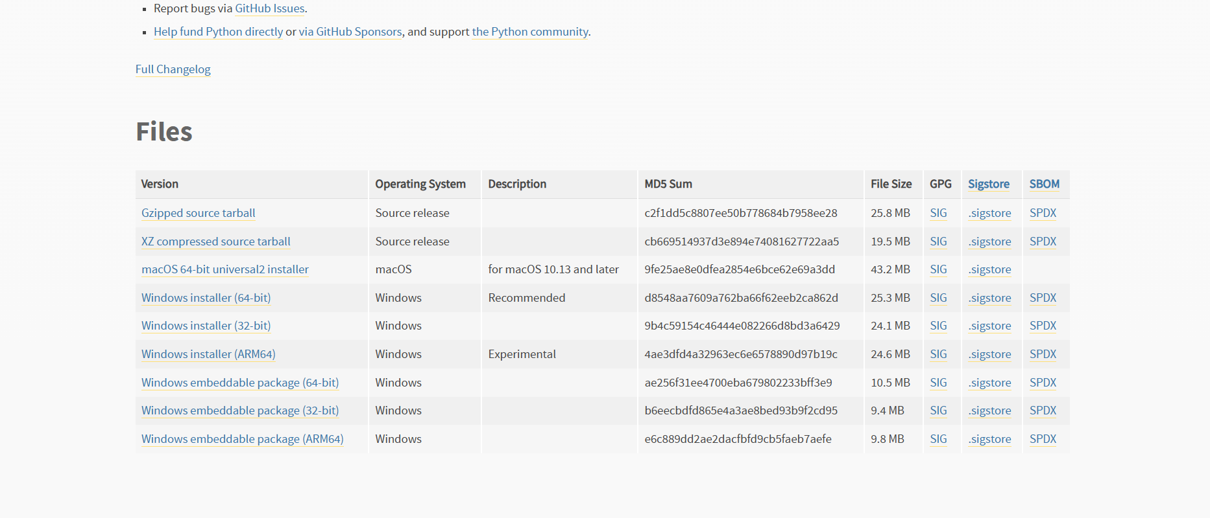

Now you can see python installer will start download wait until it completes

Now install the downloaded file

1.1
Setting path in environment

Search for IDLE 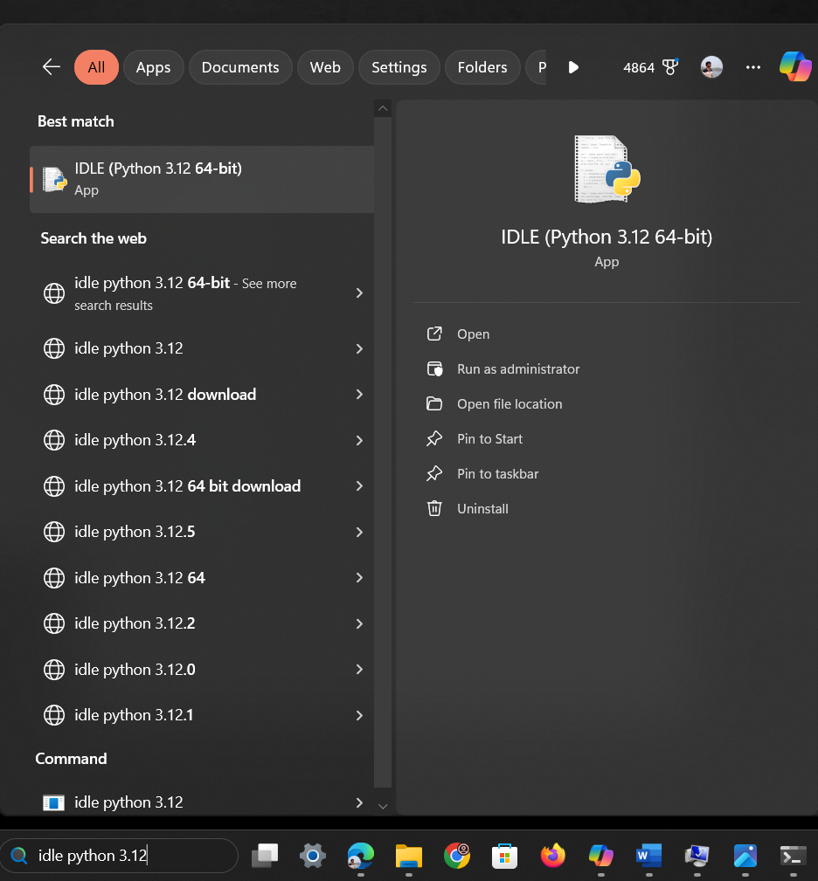

Click on file location
Copy the path

Now search for Edit the system environment variable

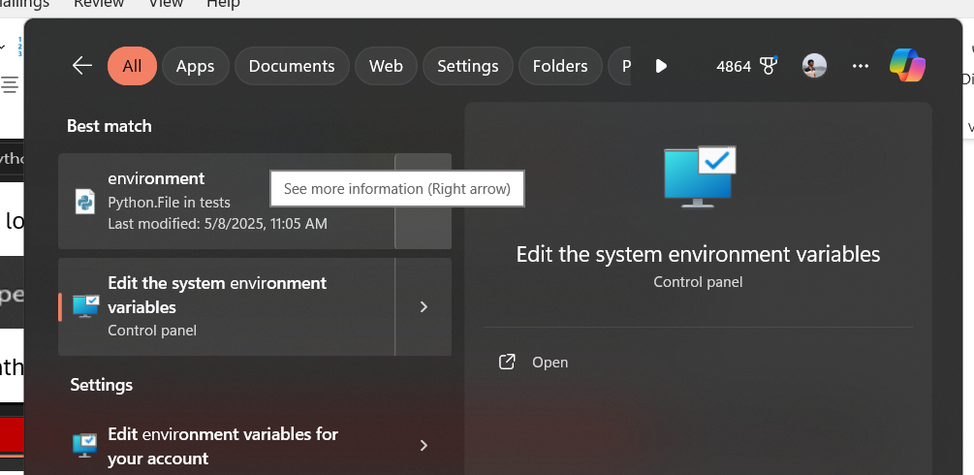
Open it
Now u can see this interface

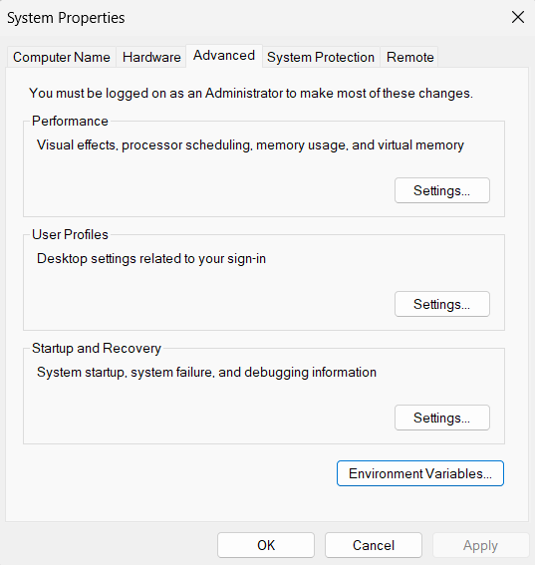
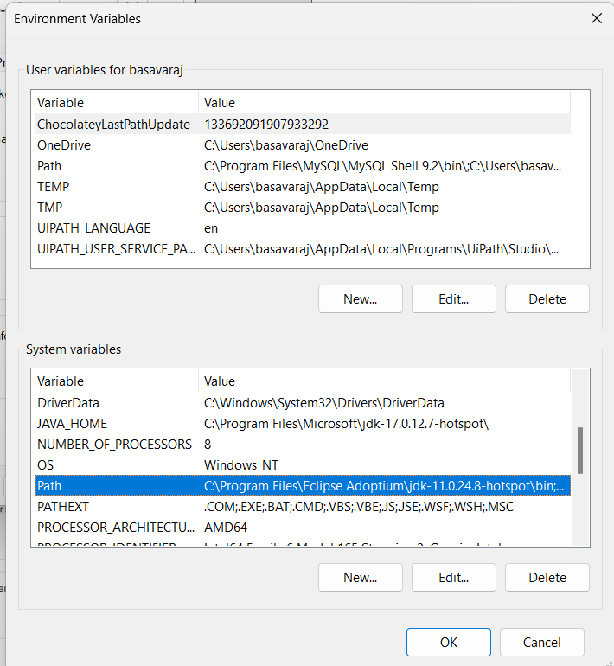
Click on environment variables

You can see Path below system variables , select it and click edit
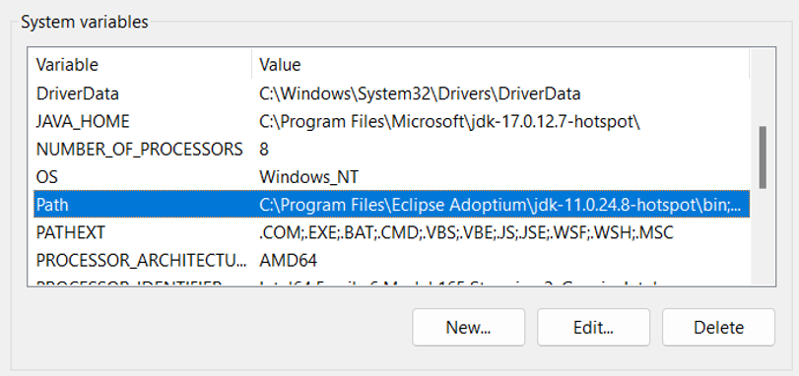
Click on New paste that copied address of python click ok
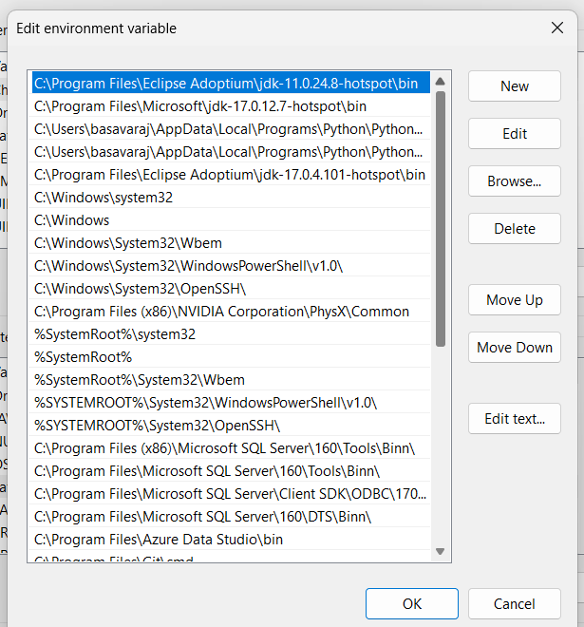

1.2
Verify Installation
Open command prompt inside it type command
Python –version
Output should show python with version
Like below image
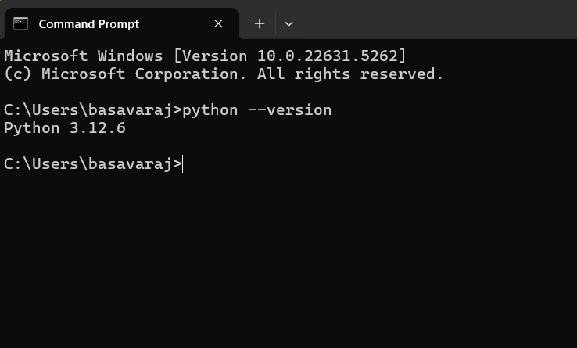

1.3 Downlaod Visual studio code
LinkDownload Visual Studio Code - Mac, Linux, Windows
Select the suitable OS
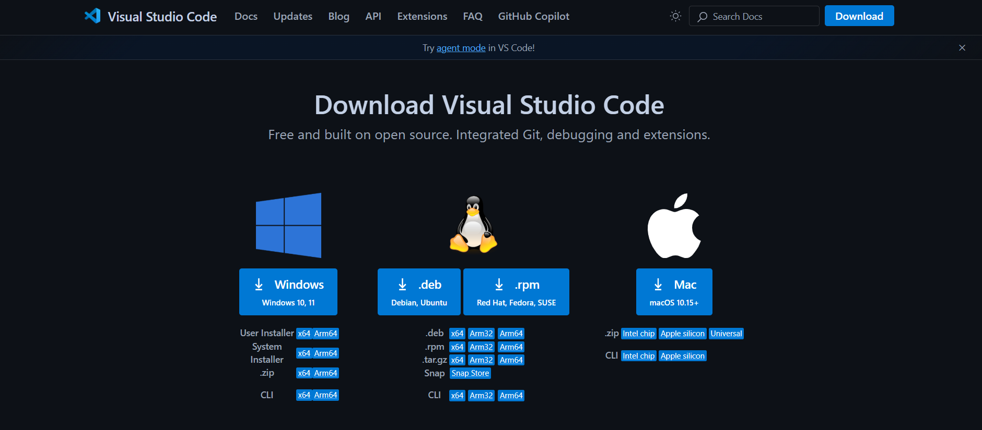

Before starting the Lab programs
Create folder
Open that folder in command prompt
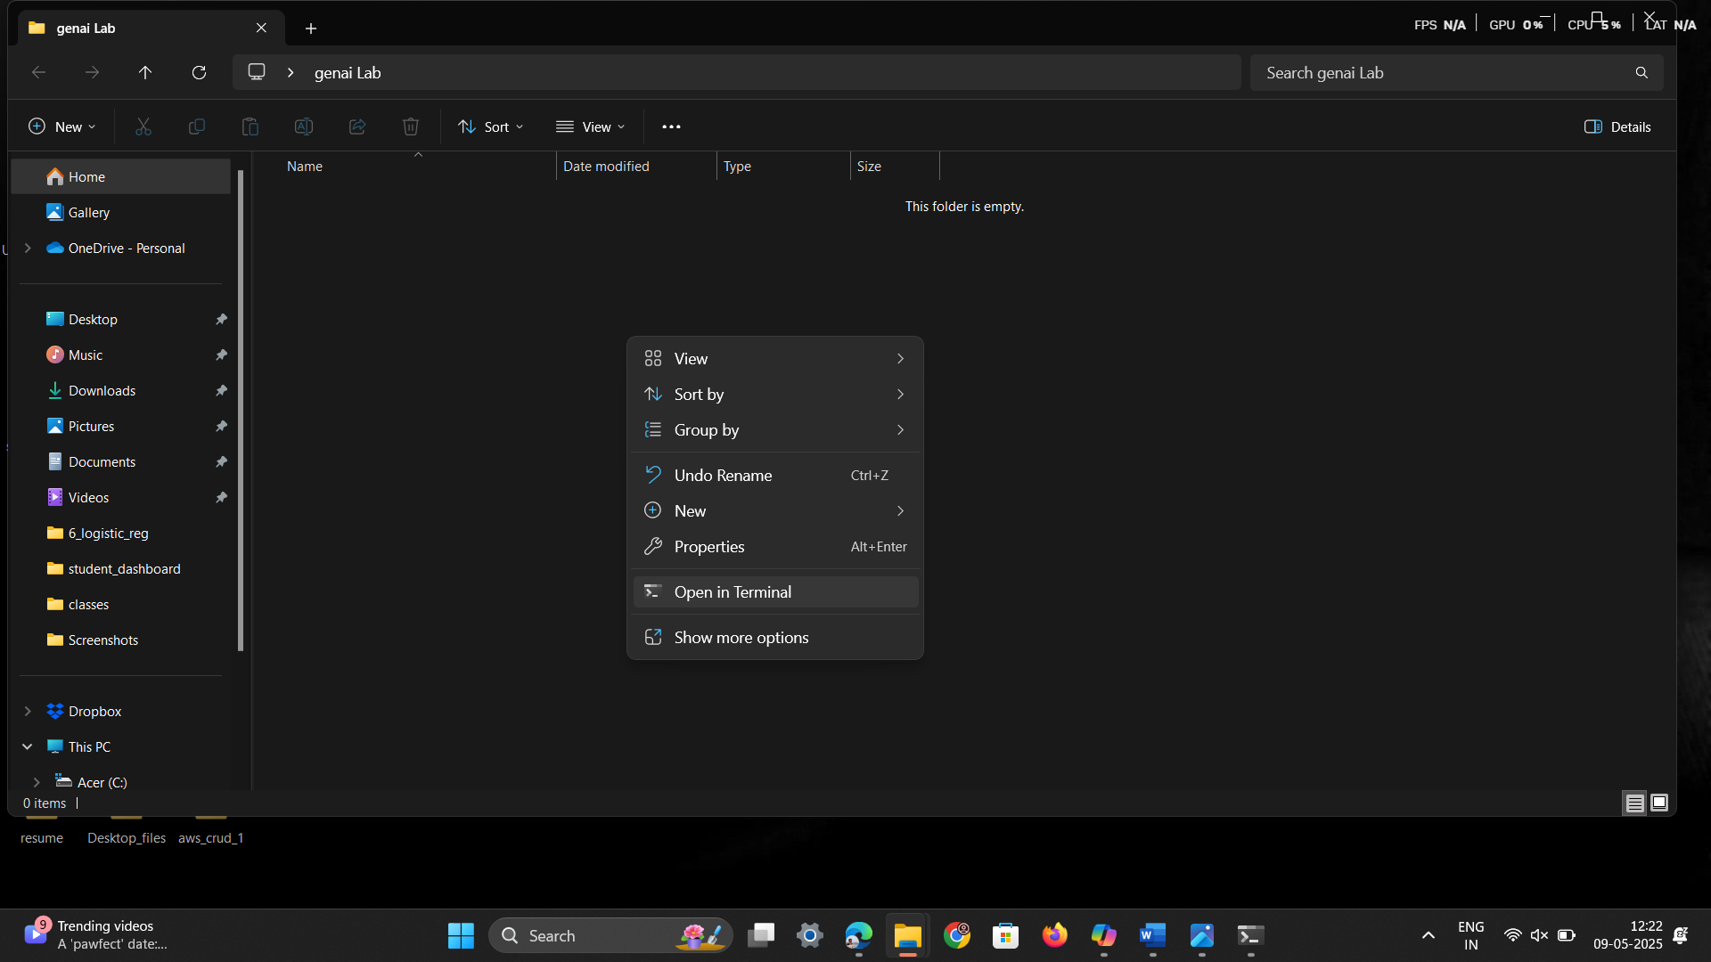

1.4 Create a Virtual Environment
Run the following command in your terminal or command prompt:
python -m venv myenv
Replace myenv with your preferred environment name.
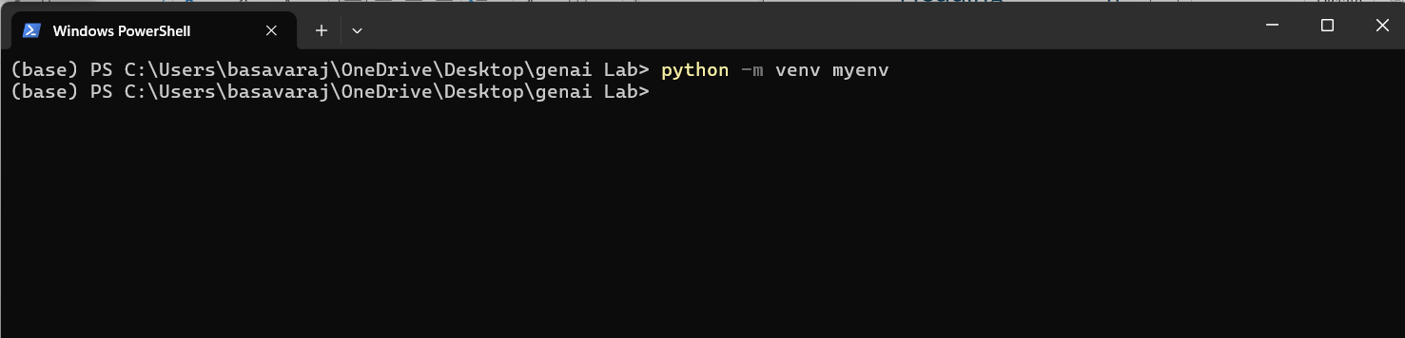
Now Virtual Environment file is created
1.5 Activate the Virtual Environment
Command myenv\Scripts\Activate
After running that command, you can see (myenv) our virtual environment is running
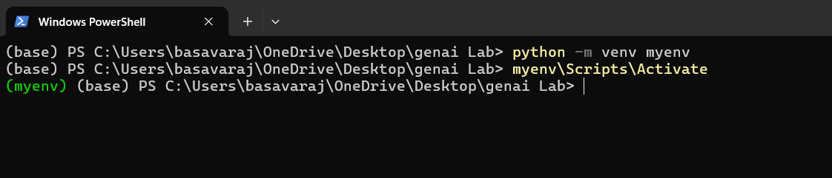
For first time u can see the error

To overcome this error
Open PowerShell, run as administrator
Handling Remote Execution Policy Restrictions (Windows)
Run this command Set-ExecutionPolicy Unrestricted -Scope CurrentUser
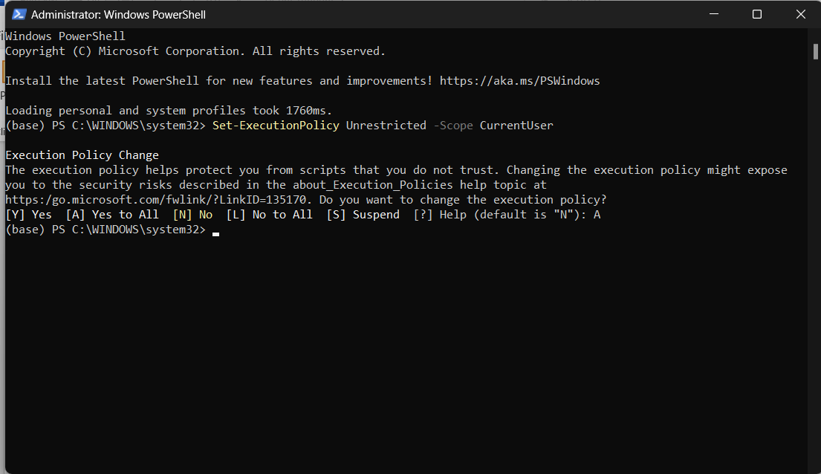
Now close the terminal open the folder open in terminal run activation command(myenv\Scripts\Activate)
Still face error
Try this command
Set-ExecutionPolicy RemoteSigned -Scope CurrentUser

Program -1

Open created folder in terminal , u can see that folder path in terminal
Type command code .
Folder will open in Vs code
Open terminal in vs code
Activate the virtual environment , command myenv\Scripts\Activate
Remember virtual environment should be activated inside that only u should install lib and run the programs
To check the activation check the below image (myven) should appear before the folder path
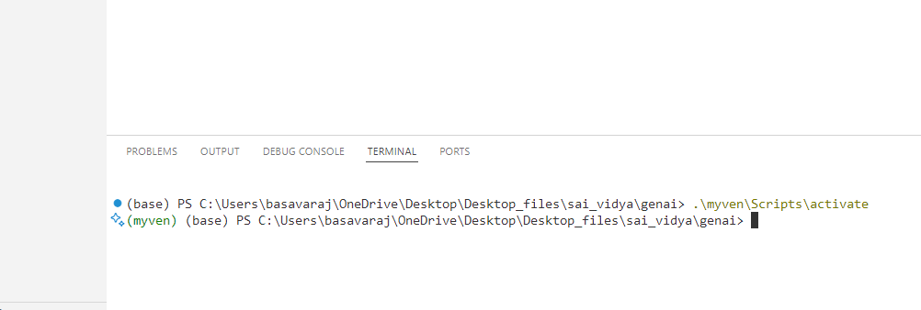

Click on new file name it as 1_program.py

Install the required libraries
To install run the below command in terminal
- pip install gensim numpy

Type the code

# Import required libraries

from gensim.models import Word2Vec
from gensim.parsing.preprocessing import STOPWORDS

# Step 1: Define corpus
corpus = [
'king is a strong man', 'queen is a wise woman', 'boy is a young man',
'girl is a young woman', 'prince is a young', 'prince will be strong',
'princess is young', 'man is strong', 'woman is pretty',
'prince is a boy', 'prince will be king', 'princess is a girl',
'princess will be queen'
]

# Step 2: Tokenize and remove stopwords
statements_listt = [sentence.split() for sentence in corpus]
documents = [[word for word in doc if word not in STOPWORDS] for doc in statements_listt]

# Show the cleaned documents
print("Cleaned Documents:")
print(documents)

# Step 3: Train the Word2Vec model
model = Word2Vec(documents, vector_size=3, window=3, min_count=1)

# Step 4: Vector operations
vector1 = model.wv['king']
vector2 = model.wv['man']

sum_vector = vector1 + vector2
diff_vector = vector1 - vector2

print("\nSum vector (king + man):", sum_vector)
print("Difference vector (king - man):", diff_vector)

# Step 5: Cosine similarity
similarity = model.wv.similarity('king', 'queen')
print(f"\nCosine Similarity between 'king' and 'queen': {similarity}")

# Step 6: Most similar words
similar_words = model.wv.most_similar('king', topn=5)
print("\nMost Similar words to 'king':", similar_words)

# Step 7: Analogy example
analogy_vector = model.wv['king'] - model.wv['man'] + model.wv['woman']
most_similar = model.wv.most_similar(positive=[analogy_vector], topn=1)
print("\nAnalogy Result (king - man + woman):", most_similar)

save the file
to run the code run the below code in terminal
python 1_program.py
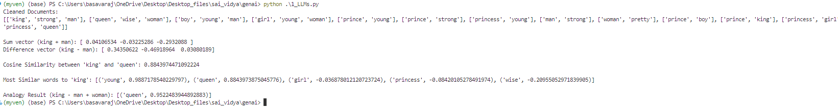
Output :
Cleaned Documents:
[['king', 'strong', 'man'], ['queen', 'wise', 'woman'], ['boy', 'young', 'man'], ['girl', 'young', 'woman'], ['prince', 'young'], ['prince', 'strong'], ['princess', 'young'], ['man', 'strong'], ['woman', 'pretty'], ['prince', 'boy'], ['prince', 'king'], ['princess', 'girl'], ['princess', 'queen']]

Sum vector (king + man): [ 0.04106534 -0.03225286 -0.2932088 ]
Difference vector (king - man): [ 0.34350622 -0.46918964 0.03080189]

Cosine Similarity between 'king' and 'queen': 0.8843974471092224

Most Similar words to 'king': [('young', 0.9887178540229797), ('queen', 0.8843973875045776), ('girl', -0.036878012120723724), ('princess', -0.08420105278491974), ('wise', -0.20955052971839905)]

Analogy Result (king - man + woman): [('queen', 0.9522483944892883)]

Program 2
Open created folder in terminal , u can see that folder path in terminal
Type command code .
Folder will open in Vs code
Open terminal in vs code
Activate the virtual environment , command myenv\Scripts\Activate
Remember virtual environment should be activated inside that only u should install lib and run the programs
To check the activation check the below image (myven) should appear before the folder path

Click on new file name it , 2_gen_ai_lab_embedding.py
Install the required libraries
To install run the below command in terminal
pip install gensim matplotlib scikit-learn pandas

Type the code
import gensim
from gensim.models import Word2Vec
import re
import pandas as pd
import matplotlib.pyplot as plt
from sklearn.decomposition import PCA

# Sample domain-specific corpus (Technology)
technology_corpus = [
"Artificial intelligence is transforming various industries.",
"Machine learning algorithms improve predictive analytics.",
"Cloud computing enables scalable infrastructure for businesses.",
"Cybersecurity is crucial for protecting sensitive data.",
"Blockchain technology ensures secure and decentralized transactions.",
"The Internet of Things connects smart devices seamlessly.",
"Big data analytics helps organizations make data-driven decisions.",
"Quantum computing has the potential to revolutionize cryptography.",
"Edge computing brings computation closer to data sources.",
"Natural language processing enhances human-computer interactions."
]

# Basic text preprocessing function (tokenization & lowercasing)
def simple_tokenize(text):
return re.findall(r'\b\w+\b', text.lower())

# Preprocess corpus manually
preprocessed_corpus = [simple_tokenize(sentence) for sentence in technology_corpus]

# Train Word2Vec model
model = Word2Vec(sentences=preprocessed_corpus, vector_size=50, window=5, min_count=1, workers=4)

# Select 10 domain-specific words
selected_words = ["ai", "machine", "cloud", "cybersecurity", "blockchain", "iot", "data", "quantum", "edge", "nlp"]
# Filter selected words to include only words present in model.wv
selected_words = [word for word in selected_words if word in model.wv]

# Extract word embeddings for selected words
word_vectors = [model.wv[word] for word in selected_words if word in model.wv]

# Reduce dimensionality using PCA
pca = PCA(n_components=2)
reduced_vectors = pca.fit_transform(word_vectors)

# Create DataFrame for visualization
df_embeddings = pd.DataFrame(reduced_vectors, columns=["x", "y"], index=selected_words)

# Plot embeddings
plt.figure(figsize=(10, 6))
plt.scatter(df_embeddings["x"], df_embeddings["y"], marker='o')

for word, (x, y) in zip(df_embeddings.index, reduced_vectors):
plt.text(x, y, word, fontsize=12)

plt.xlabel("PCA Component 1")
plt.ylabel("PCA Component 2")
plt.title("Word Embeddings Visualization (Technology Domain)")
plt.show()

# Function to get semantically similar words
def get_similar_words(word, top_n=5):
if word in model.wv:
return model.wv.most_similar(word, topn=top_n)
else:
return f"Word '{word}' not in vocabulary."

# Example usage
input_word = "technology"
similar_words = get_similar_words(input_word)
print(f"Top 5 words similar to '{input_word}':", similar_words)

To run this program , type below command in terminal
python 2_gen_ai_lab_embedding.py

Output image:
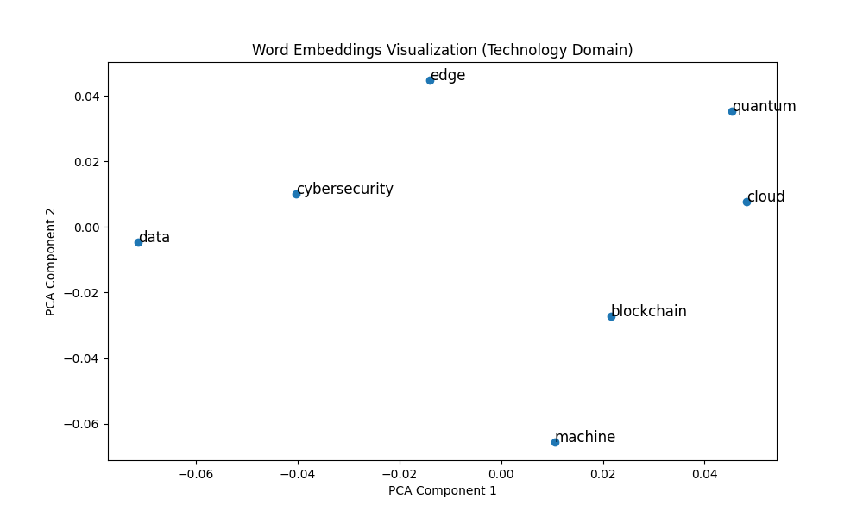

Program 3
Open created folder in terminal , u can see that folder path in terminal
Type command code .
Folder will open in Vs code
Open terminal in vs code
Activate the virtual environment , command myenv\Scripts\Activate
Remember virtual environment should be activated inside that only u should install lib and run the programs
To check the activation check the below image (myven) should appear before the folder path

Click on new file name it , 3_gen_ai_lab_embedding.py
Install the required libraries
To install run the below command in terminal
pip install gensim matplotlib scikit-learn pandas

Type the code
import gensim
from gensim.models import Word2Vec
import re
import pandas as pd
import matplotlib.pyplot as plt
from sklearn.decomposition import PCA

# Sample domain-specific corpus (Medical)
medical_corpus = [
"The patient was diagnosed with diabetes and prescribed metformin.",
"Hypertension can be managed with lifestyle changes and medication.",
"The MRI scan showed abnormalities in the brain tissue.",
"Patients with asthma should avoid exposure to allergens.",
"The new drug showed promising results in clinical trials.",
"Surgery was performed to remove the tumor successfully.",
"Doctors recommend regular exercise to prevent cardiovascular diseases.",
"The vaccine helps in boosting the immune response against infections.",
"Genetic factors play a significant role in the onset of Alzheimer's disease.",
"Antibiotics should be used responsibly to prevent resistance."
]
# Basic text preprocessing function (tokenization & lowercasing)
def simple_tokenize(text):
return re.findall(r'\b\w+\b', text.lower())

# Preprocess corpus manually
preprocessed_corpus = [simple_tokenize(sentence) for sentence in medical_corpus]
print("preprocessed corpus")
print(preprocessed_corpus)

# Train Word2Vec model
model = Word2Vec(sentences=preprocessed_corpus, vector_size=50, window=5, min_count=1, workers=4)

# Extract word embeddings for visualization
words = list(model.wv.index_to_key) # Get vocabulary words
print("vocabulary words")
print(words)
word_vectors = [model.wv[word] for word in words] # Get corresponding embeddings
print("word vectors")
print(word_vectors)

# Reduce dimensionality using PCA
pca = PCA(n_components=2)
reduced_vectors = pca.fit_transform(word_vectors)

# Create DataFrame for visualization
df_embeddings = pd.DataFrame(reduced_vectors, columns=["x", "y"], index=words)

# Plot embeddings
plt.figure(figsize=(10, 6))
plt.scatter(df_embeddings["x"], df_embeddings["y"], marker='o')

for word, (x, y) in zip(df_embeddings.index, reduced_vectors):
plt.text(x, y, word, fontsize=12)

plt.xlabel("PCA Component 1")
plt.ylabel("PCA Component 2")
plt.title("Word Embeddings Visualization (Medical Domain)")
plt.show()

#3 d plot
# Import necessary libraries
import matplotlib.pyplot as plt
from mpl_toolkits.mplot3d import Axes3D # Import for 3D plotting
from sklearn.decomposition import PCA

# ... (rest of your code)

# Perform PCA with 3 components
pca = PCA(n_components=3) # Change n_components to 3
reduced_vectors = pca.fit_transform(word_vectors)

# Create DataFrame for visualization
df_embeddings = pd.DataFrame(reduced_vectors, columns=["x", "y", "z"], index=words) #add z

# Plot embeddings in 3D
fig = plt.figure(figsize=(10, 8)) # Adjust figure size if needed
ax = fig.add_subplot(111, projection='3d') # Create a 3D subplot

ax.scatter(df_embeddings["x"], df_embeddings["y"], df_embeddings["z"], marker='o')

for word, (x, y, z) in zip(df_embeddings.index, reduced_vectors):
ax.text(x, y, z, word, fontsize=10) # Adjust fontsize if needed

ax.set_xlabel("PCA Component 1")
ax.set_ylabel("PCA Component 2")
ax.set_zlabel("PCA Component 3") # Add z-axis label
ax.set_title("Word Embeddings Visualization (3D)")

plt.show()

Run the code
Command
python 3_gen_ai_lab_embedding.py
Output
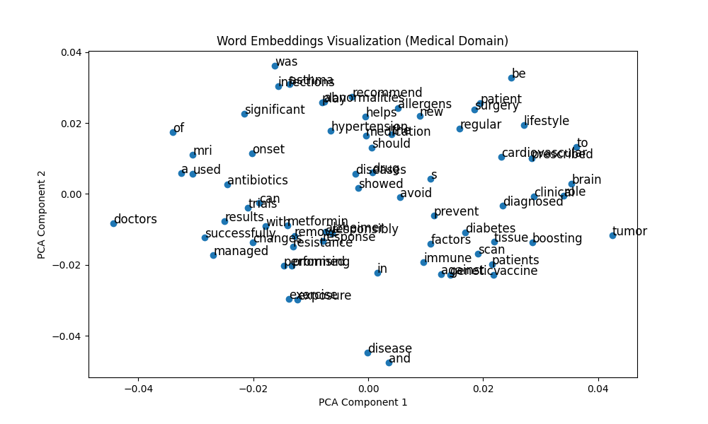

Program 4
Open created folder in terminal , u can see that folder path in terminal
Type command code .
Folder will open in Vs code
Open terminal in vs code
Activate the virtual environment , command myenv\Scripts\Activate
Remember virtual environment should be activated inside that only u should install lib and run the programs
To check the activation check the below image (myven) should appear before the folder path

Click on new file name it , 4_gen_ai_lab_embedding.py
Install the required libraries
To install run the below command in terminal
pip install gensim matplotlib scikit-learn pandas
Type the code
import gensim
from gensim.models import Word2Vec
import re
import pandas as pd
import matplotlib.pyplot as plt
from sklearn.decomposition import PCA

# Sample domain-specific corpus (Technology)
technology_corpus = [
"Artificial intelligence is transforming various industries.",
"Machine learning algorithms improve predictive analytics.",
"Cloud computing enables scalable infrastructure for businesses.",
"Cybersecurity is crucial for protecting sensitive data.",
"Blockchain technology ensures secure and decentralized transactions.",
"The Internet of Things connects smart devices seamlessly.",
"Big data analytics helps organizations make data-driven decisions.",
"Quantum computing has the potential to revolutionize cryptography.",
"Edge computing brings computation closer to data sources.",
"Natural language processing enhances human-computer interactions."
]

# Basic text preprocessing function (tokenization & lowercasing)
def simple_tokenize(text):
return re.findall(r'\b\w+\b', text.lower())

# Preprocess corpus manually
preprocessed_corpus = [simple_tokenize(sentence) for sentence in technology_corpus]

# Train Word2Vec model
model = Word2Vec(sentences=preprocessed_corpus, vector_size=50, window=5, min_count=1, workers=4)

# Select 10 domain-specific words
selected_words = ["ai", "machine", "cloud", "cybersecurity", "blockchain", "iot", "data", "quantum", "edge", "nlp"]

# Extract word embeddings for selected words
word_vectors = [model.wv[word] for word in selected_words if word in model.wv]
# Filter selected words to include only words present in model.wv
selected_words = [word for word in selected_words if word in model.wv]
# Reduce dimensionality using PCA
pca = PCA(n_components=2)
reduced_vectors = pca.fit_transform(word_vectors)

# Create DataFrame for visualization
df_embeddings = pd.DataFrame(reduced_vectors, columns=["x", "y"], index=selected_words)

# Plot embeddings
plt.figure(figsize=(10, 6))
plt.scatter(df_embeddings["x"], df_embeddings["y"], marker='o')

for word, (x, y) in zip(df_embeddings.index, reduced_vectors):
plt.text(x, y, word, fontsize=12)

plt.xlabel("PCA Component 1")
plt.ylabel("PCA Component 2")
plt.title("Word Embeddings Visualization (Technology Domain)")
plt.show()

# Function to get semantically similar words
def get_similar_words(word, top_n=5):
if word in model.wv:
return [w[0] for w in model.wv.most_similar(word, topn=top_n)]
else:
return []

# Function to enrich a GenAI prompt
def enrich_prompt(prompt):
words = simple_tokenize(prompt)
enriched_words = []
for word in words:
enriched_words.append(word)
similar_words = get_similar_words(word, top_n=2)
enriched_words.extend(similar_words)
return " ".join(enriched_words)

# Example usage
original_prompt = "Explain the impact of AI on businesses."
enriched_prompt = enrich_prompt(original_prompt)

print("Original Prompt:", original_prompt)
print("Enriched Prompt:", enriched_prompt)

# Function to compare outputs from a GenAI model
def generate_response(prompt):
# Placeholder function to simulate a GenAI response
return f"Generated response for: {prompt}"

original_response = generate_response(original_prompt)
enriched_response = generate_response(enriched_prompt)

print("\nOriginal Response:", original_response)
print("Enriched Response:", enriched_response)

Run the program
Command python 4_gen_ai_lab_embedding.py

Output


Program 5
Open created folder in terminal , u can see that folder path in terminal
Type command code .
Folder will open in Vs code
Open terminal in vs code
Activate the virtual environment , command myenv\Scripts\Activate
Remember virtual environment should be activated inside that only u should install lib and run the programs
To check the activation check the below image (myven) should appear before the folder path

Click on new file name it , 5_gen_ai_lab_embedding.py
Install the required libraries
To install run the below command in terminal
pip install gensim matplotlib scikit-learn pandas
Type the code
import gensim
from gensim.models import Word2Vec
import re
import pandas as pd
import matplotlib.pyplot as plt
from sklearn.decomposition import PCA
import random

# Sample domain-specific corpus (Technology)
technology_corpus = [
"Artificial intelligence is transforming various industries.",
"Machine learning algorithms improve predictive analytics.",
"Cloud computing enables scalable infrastructure for businesses.",
"Cybersecurity is crucial for protecting sensitive data.",
"Blockchain technology ensures secure and decentralized transactions.",
"The Internet of Things connects smart devices seamlessly.",
"Big data analytics helps organizations make data-driven decisions.",
"Quantum computing has the potential to revolutionize cryptography.",
"Edge computing brings computation closer to data sources.",
"Natural language processing enhances human-computer interactions."
]

# Basic text preprocessing function (tokenization & lowercasing)
def simple_tokenize(text):
return re.findall(r'\b\w+\b', text.lower())

# Preprocess corpus manually
preprocessed_corpus = [simple_tokenize(sentence) for sentence in technology_corpus]

# Train Word2Vec model
model = Word2Vec(sentences=preprocessed_corpus, vector_size=50, window=5, min_count=1, workers=4)

# Function to get semantically similar words
def get_similar_words(word, top_n=5):
if word in model.wv:
return [w[0] for w in model.wv.most_similar(word, topn=top_n)]
else:
return []

# Function to generate a short paragraph using similar words

def generate_paragraph(seed_word):
similar_words = get_similar_words(seed_word, top_n=5)
if not similar_words:
return f"No similar words found for '{seed_word}'."

paragraph = f"In a world driven by {seed_word}, innovations continue to shape our future. "
paragraph += "With advancements in " + ", ".join(similar_words[:-1]) + f", and {similar_words[-1]}, "
paragraph += "society is witnessing a technological revolution that transforms industries and improves daily life."

return paragraph

# Example usage
seed_word = "intelligence"
generated_paragraph = generate_paragraph(seed_word)

print("Seed Word:", seed_word)
print("Generated Paragraph:", generated_paragraph)

Run the program
Command python 5_gen_ai_lab_embedding.py

Output
Seed Word: intelligence
Generated Paragraph: In a world driven by intelligence, innovations continue to shape our future. With advancements in computing, edge, of, connects, and devices, society is witnessing a technological revolution that transforms industries and improves daily life.
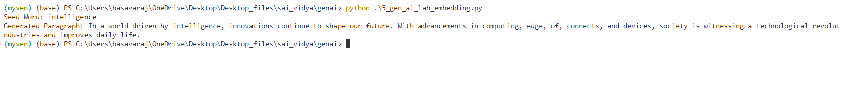

Program 6
Open created folder in terminal , u can see that folder path in terminal
Type command code .
Folder will open in Vs code
Open terminal in vs code
Activate the virtual environment , command myenv\Scripts\Activate
Remember virtual environment should be activated inside that only u should install lib and run the programs
To check the activation check the below image (myven) should appear before the folder path

Click on new file name it , 6_gen_ai_lab_embedding.py
Install the required libraries
To install run the below command in terminal
pip install torch torchvision torchaudio
pip install transformers
pip install tf-keras

Type the code

from transformers import pipeline

# Load pre-trained sentiment analysis pipeline
sentiment_pipeline = pipeline("sentiment-analysis")

# Function to analyze sentiment
def analyze_sentiment(text):
result = sentiment_pipeline(text)
return result[0]

# Example sentences for sentiment analysis
sentences = [
"I love the new AI advancements, they are truly revolutionary!",
"The new software update is frustrating and full of bugs.",
"Customer service was amazing, very helpful and responsive.",
"I'm disappointed with the product quality, not what I expected.",
"This experience has been wonderful, highly recommend!"
]

# Analyze sentiment for each sentence
for sentence in sentences:
sentiment_result = analyze_sentiment(sentence)
print(f"Sentence: {sentence}\nSentiment: {sentiment_result}\n")

Run the program
Command python 6_gen_ai_lab_embedding.py
Output
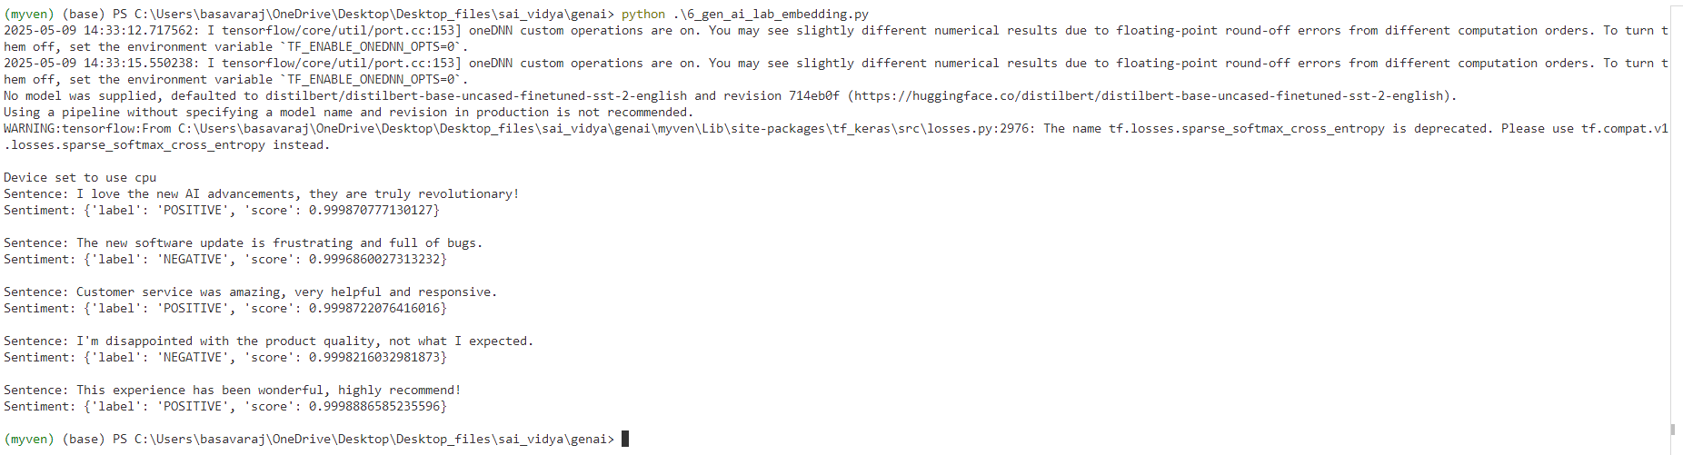

Program 7
Open created folder in terminal , u can see that folder path in terminal
Type command code .
Folder will open in Vs code
Open terminal in vs code
Activate the virtual environment , command myenv\Scripts\Activate
Remember virtual environment should be activated inside that only u should install lib and run the programs
To check the activation check the below image (myven) should appear before the folder path

Click on new file name it , 7_gen_ai_lab_embedding.py
Install the required libraries
To install run the below command in terminal
pip install torch torchvision torchaudio
pip install transformers
pip install tf-keras

Type the code
from transformers import pipeline

# Load pre-trained summarization pipeline
summarization_pipeline = pipeline("summarization")

# Function to summarize text
def summarize_text(text, max_length=100, min_length=30):
summary = summarization_pipeline(text, max_length=max_length, min_length=min_length, do_sample=False)
return summary[0]['summary_text']

# Example passage for summarization
long_text = (
"Artificial intelligence is rapidly transforming various industries, "
"enabling automation, improving efficiency, and enhancing decision-making processes. "
"With the rise of machine learning and deep learning models, businesses can now process large amounts of data "
"more effectively, uncover hidden patterns, and gain valuable insights. "
"However, ethical concerns, data privacy, and bias in AI algorithms remain significant challenges. "
"As technology advances, organizations and policymakers must collaborate to ensure responsible AI development and deployment."
)

# Obtain summarized text
summary_result = summarize_text(long_text)
print("Original Text:", long_text)
print("Summarized Text:", summary_result)

Run the program
Command python 7_gen_ai_lab_embedding.py
Output
Original Text: Artificial intelligence is rapidly transforming various industries, enabling automation, improving efficiency, and enhancing decision-making processes. With the rise of machine learning and deep learning models, businesses can now process large amounts of data more effectively, uncover hidden patterns, and gain valuable insights. However, ethical concerns, data privacy, and bias in AI algorithms remain significant challenges. As technology advances, organizations and policymakers must collaborate to ensure responsible AI development and deployment.
Summarized Text: Artificial intelligence is rapidly transforming various industries, enabling automation, improving efficiency, and enhancing decision-making processes . As technology advances, organizations and policymakers must collaborate to ensure responsible AI development and deployment .
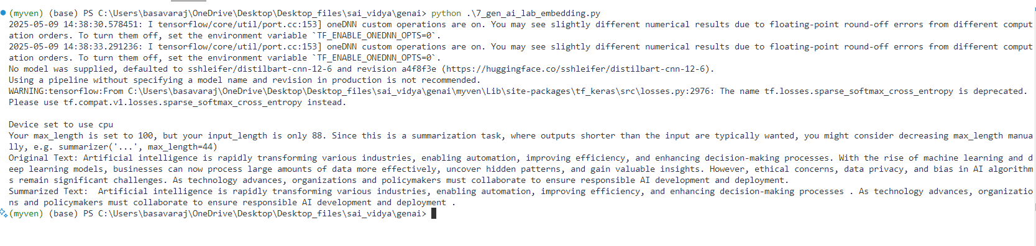
Program 8
Open created folder in terminal , u can see that folder path in terminal
Type command code .
Folder will open in Vs code
Open terminal in vs code
Activate the virtual environment , command myenv\Scripts\Activate
Remember virtual environment should be activated inside that only u should install lib and run the programs
To check the activation check the below image (myven) should appear before the folder path

Create sample.txt file inside the same folder
Type this text inside the txt file
Climate change is a long-term alteration of temperature and typical weather patterns in a place. It could refer to a particular location or the planet as a whole. Climate change may cause weather patterns to be less predictable. These unexpected weather patterns can make it difficult to maintain and grow crops in regions that rely on farming because expected temperature and rainfall levels can no longer be relied on. Climate change has also been connected with other damaging weather events such as more frequent hurricanes, floods, downpours, and winter storms. The melting of glaciers, rising sea levels, and shifting wildlife populations are all effects of climate change.

Click on new file name it , 8_gen_ai_lab_embedding.py
Install the required libraries
To install run the below command in terminal
pip install langchain langchain-community cohere python-dotenv
Type the code
import os
from langchain_core.prompts import PromptTemplate
from langchain_community.llms import Cohere

# Set your Cohere API key
os.environ["COHERE_API_KEY"] = "Your_cohere_api_key"

# Path to your local file
file_path = "sample.txt" # Change this to the correct local path if needed

# Read the file content
try:
with open(file_path, "r", encoding="utf-8") as file:
document_text = file.read()

print("📄 File loaded successfully!\n")
print(document_text[:500]) # Show first 500 characters

except FileNotFoundError:
print(f"❌ File not found: {file_path}")
exit(1)
except Exception as e:
print(f"⚠️ An error occurred: {e}")
exit(1)
# Load Cohere model
llm = Cohere(model="command", cohere_api_key=os.environ["COHERE_API_KEY"])
# Define prompt template
prompt = PromptTemplate(
input_variables=["input_text"],
template="Summarize this text:\n\n{input_text}"
)
# Format and generate response
formatted_prompt = prompt.format(input_text=document_text)
response = llm.invoke(formatted_prompt)
print("\n📝 Summary:\n", response)

Run the code
Command python 8_gen_ai_lab_embedding.py

Output
📄 File loaded successfully!
Climate change is a long-term alteration of temperature and typical weather patterns in a place. It could refer to a particular location or the planet as a whole. Climate change may cause weather patterns to be less predictable. These unexpected weather patterns can make it difficult to maintain and grow crops in regions that rely on farming because expected temperature and rainfall levels can no longer be relied on. Climate change has also been connected with other damaging weather events such
C:\Users\basavaraj\OneDrive\Desktop\Desktop_files\sai_vidya\genai\8_gen_ai_lab_embedding.py:31: LangChainDeprecationWarning: The class `Cohere` was deprecated in LangChain 0.1.14 and will be removed in 1.0. An updated version of the class exists in the :class:`~langchain-cohere package and should be used instead. To use it run `pip install -U :class:`~langchain-cohere` and import as `from :class:`~langchain_cohere import Cohere``.
llm = Cohere(model="command", cohere_api_key=os.environ["COHERE_API_KEY"])
📝 Summary:
Climate change refers to the long-term alteration of temperature and weather patterns, which has a range of effects including unpredictable weather patterns, extreme weather events, melting glaciers, rising sea levels, and shifting wildlife populations.

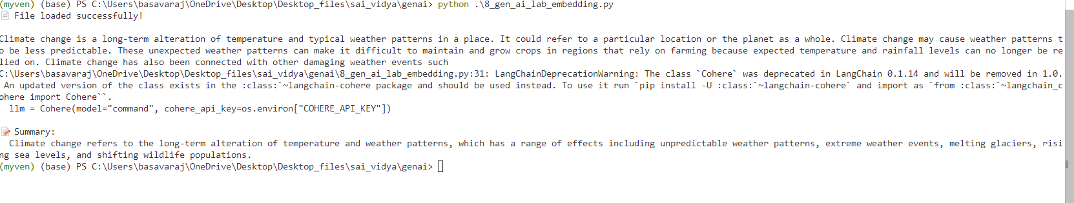

Program 9
Open created folder in terminal , u can see that folder path in terminal
Type command code .
Folder will open in Vs code
Open terminal in vs code
Activate the virtual environment , command myenv\Scripts\Activate
Remember virtual environment should be activated inside that only u should install lib and run the programs
To check the activation check the below image (myven) should appear before the folder path

Create sample.txt file inside the same folder
Type this text inside the txt file
Climate change is a long-term alteration of temperature and typical weather patterns in a place. It could refer to a particular location or the planet as a whole. Climate change may cause weather patterns to be less predictable. These unexpected weather patterns can make it difficult to maintain and grow crops in regions that rely on farming because expected temperature and rainfall levels can no longer be relied on. Climate change has also been connected with other damaging weather events such as more frequent hurricanes, floods, downpours, and winter storms. The melting of glaciers, rising sea levels, and shifting wildlife populations are all effects of climate change.

Click on new file name it , 9_gen_ai_lab_embedding.py
Install the required libraries
To install run the below command in terminal
pip install wikipedia-api pydantic
pip install wikipedia
Type the code
from pydantic import BaseModel
import wikipedia
import re

def extract_info(page_content: str, keyword: str) -> str:
"""Extract relevant information based on keyword search."""
pattern = re.compile(rf'({keyword}.*?)\n', re.IGNORECASE)
match = pattern.search(page_content)
return match.group(1) if match else "Not Available"

class InstitutionInfo(BaseModel):
name: str
founder: str
founded_year: str
branches: str
employees: str
summary: str

def fetch_institution_details(institution_name: str) -> InstitutionInfo:
try:
page = wikipedia.page(institution_name)
content = page.content

founder = extract_info(content, "Founder")
founded_year = extract_info(content, "Founded")
branches = extract_info(content, "Campuses|Branches|Locations")
employees = extract_info(content, "Employees|Staff")
summary = " ".join(page.summary.split(".")[:2]) # First two sentences

return InstitutionInfo(
name=institution_name,
founder=founder,
founded_year=founded_year,
branches=branches,
employees=employees,
summary=summary
)
except wikipedia.exceptions.PageError:
return InstitutionInfo(
name=institution_name,
founder="Not Available",
founded_year="Not Available",
branches="Not Available",
employees="Not Available",
summary="No information found on Wikipedia."
)

if __name__ == "__main__":
institution_name = input("Enter Institution Name: ")
result = fetch_institution_details(institution_name)
print(result.model_dump_json(indent=4))

Run the program
Command python 9_gen_ai_lab_embedding.py
It as for institute name, enter the institute name
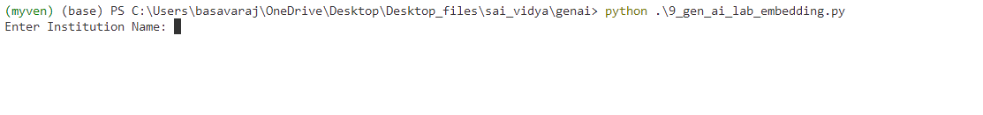
Output
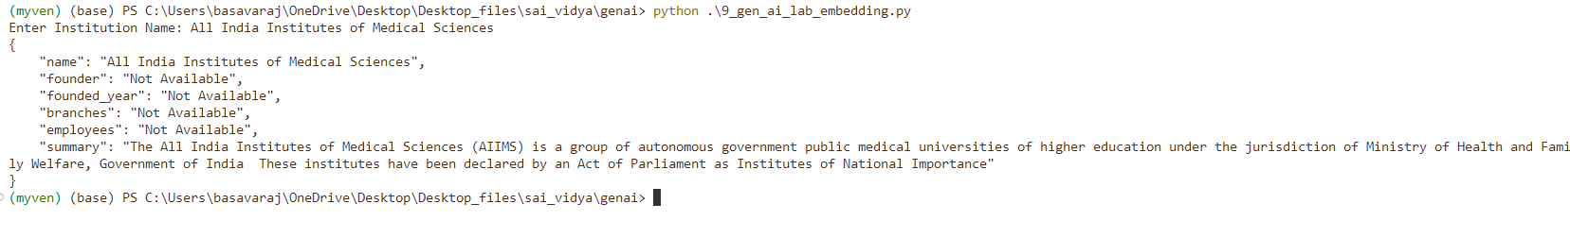

Program 10
Open created folder in terminal , u can see that folder path in terminal
Type command code .
Folder will open in Vs code
Open terminal in vs code
Activate the virtual environment , command myenv\Scripts\Activate
Remember virtual environment should be activated inside that only u should install lib and run the programs
To check the activation check the below image (myven) should appear before the folder path


Click on new file name it , 9_gen_ai_lab_embedding.py
Install the required libraries
To install run the below command in terminal
pip install streamlit PyPDF2 requests langchain langchain-community langchain-openai python-dotenv
Paste the IPC_186045_removed_removed (1).pdf file inside the same folder
Create .env file
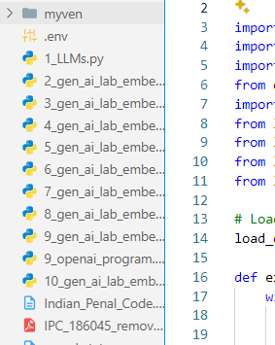

inside the .env file add your openai api key like below
OPENAI_API_KEY=your_api_key
Now type the program inside created , 9_gen_ai_lab_embedding.py file
Code:
import os
import requests
import PyPDF2
from dotenv import load_dotenv
import streamlit as st
from langchain_openai import ChatOpenAI, OpenAIEmbeddings
from langchain_community.vectorstores import FAISS
from langchain.text_splitter import CharacterTextSplitter
from langchain.chains import RetrievalQA

# Load environment variables from .env
load_dotenv()

def extract_text_from_pdf(pdf_path):
with open(pdf_path, "rb") as file:
reader = PyPDF2.PdfReader(file)
text = "\n".join([page.extract_text() for page in reader.pages if page.extract_text()])
return text

def download_and_extract_ipc():
pdf_path = "IPC_186045_removed_removed (1).pdf"

if not os.path.exists(pdf_path):
url = "https://www.indiacode.nic.in/repealedfileopen?rfilename=A1860-45.pdf"
response = requests.get(url, stream=True)
if response.status_code == 200:
with open(pdf_path, "wb") as file:
for chunk in response.iter_content(chunk_size=1024):
file.write(chunk)
st.success("IPC PDF downloaded successfully.")
else:
st.error("Failed to download the IPC PDF.")
return None

text = extract_text_from_pdf(pdf_path)

if text.strip():
with open("Indian_Penal_Code.txt", "w", encoding="utf-8") as f:
f.write(text)
return text
else:
st.error("No extractable text found in the PDF.")
return None

@st.cache_resource(show_spinner="Embedding IPC text...")
def create_retriever(text):
text_splitter = CharacterTextSplitter(chunk_size=1000, chunk_overlap=200)
texts = text_splitter.split_text(text)
embeddings = OpenAIEmbeddings()
vector_store = FAISS.from_texts(texts, embeddings, normalize_L2=True)
return vector_store.as_retriever(search_type="similarity", search_kwargs={"k": 3})

def main():
st.title("📘 IPC Chatbot")
st.write("Ask anything about the Indian Penal Code (1860).")

openai_key = os.getenv("OPENAI_API_KEY")
if not openai_key:
st.error("OpenAI API key not found. Please set it in your .env file.")
return

if "retriever" not in st.session_state:
text = download_and_extract_ipc()
if not text:
return
retriever = create_retriever(text)
st.session_state.retriever = retriever

llm = ChatOpenAI(model_name="gpt-3.5-turbo")

qa_chain = RetrievalQA.from_chain_type(llm=llm, retriever=st.session_state.retriever)

user_input = st.text_input("Enter your query:")
if user_input:
with st.spinner("Searching..."):
response = qa_chain.invoke(user_input)
st.markdown("**Bot:** " + response["result"])

if __name__ == "__main__":
main()

Run the program
Command streamlit run 10_gen_ai_lab_embedding
Output
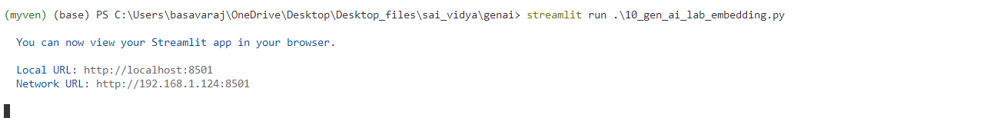
New stremlit page will open in browser that is IPC chatbot like below image
Ask chatbot about any ipc question

