n8n
n8n (pronounced "en-eight-en" or "nodemation") is a low-code workflow automation platform that allows users to connect various applications, databases, and APIs to automate repetitive tasks. It is often described as a more flexible and developer-friendly alternative to tools like Zapier or Make.
Key Features
- Visual Workflow Builder: Uses a drag-and-drop interface where you connect "nodes" (representing different apps or functions) to create automated sequences.
- Extensive Integrations: Supports over 400 pre-built integrations with popular tools like Google Sheets, Slack, GitHub, and various CRM systems.
- AI-Native Capabilities: Features built-in support for LangChain, allowing users to build AI agents and integrate LLMs directly into their workflows.
- Self-Hosting & Data Privacy: Unlike many cloud-only competitors, n8n can be self-hosted on your own servers, providing total control over your data and infrastructure.
- Developer-Friendly: While it offers no-code functionality, it also allows for custom JavaScript or Python code within nodes to handle complex logic.
Why People Use It
- Cost Control: It follows a "fair-code" model; self-hosting often allows for unlimited executions without the per-task fees common in other platforms.
- No Vendor Lock-in: Its publicly available source code and self-hosting options ensure you aren't tied to a single provider's pricing or platform changes.
- Complex Logic: It can handle sophisticated multi-step workflows, loops, and conditional branching that simpler tools might struggle with.

Hands-on
Pre-requisites:
- Register and login to n8n I,e n8n.io/
- API-Keys of the LLM mode’s
- API-Keys of third party web services

Practical 1 - Basic-LLM-0
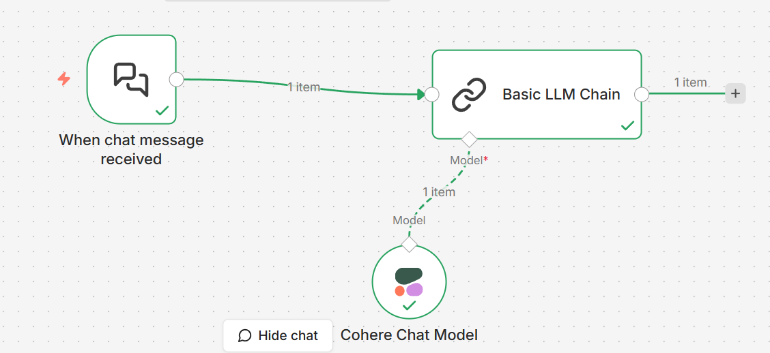

Nodes
  - Chat Trigger Node – Chat – On new chat event
  - Basic LLM Chain Node – Basic LLM Chain
  - Cohere Chat Model node – Click on Model – select cohere chat model
Set Up credentials
Enter API-Key of Cohere
  - Open chat and enter prompt
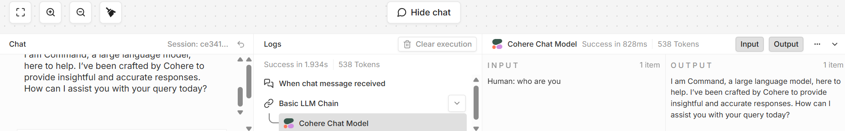

Practical 2 - openweathermap-1

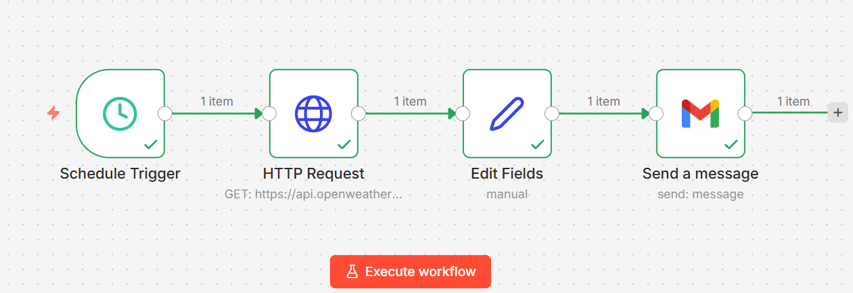
Nodes
  - Schedule Trigger
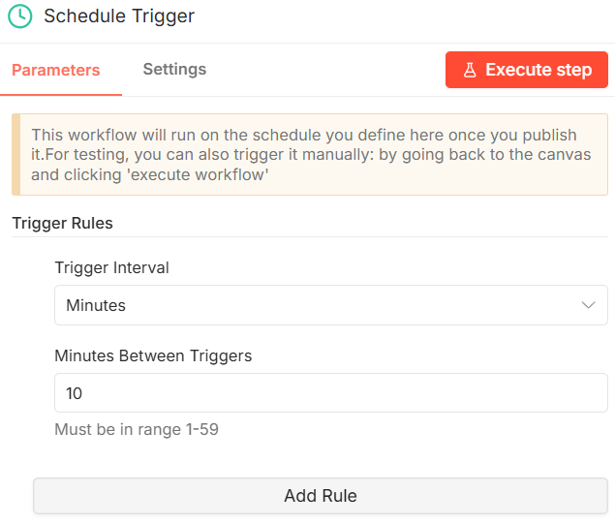

  - Http Request :: URL - https://api.openweathermap.org/data/2.5/weather?q=bangalore&&units=metric&appid=384db1ce93218e20fd384d3016372238
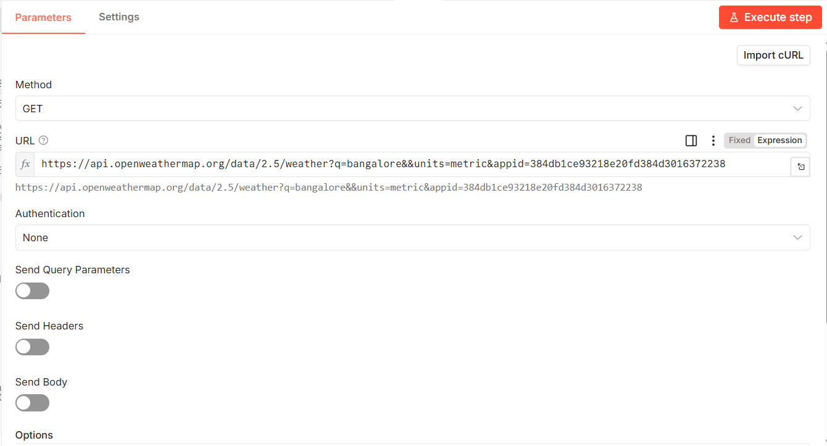

  - Edit Fields
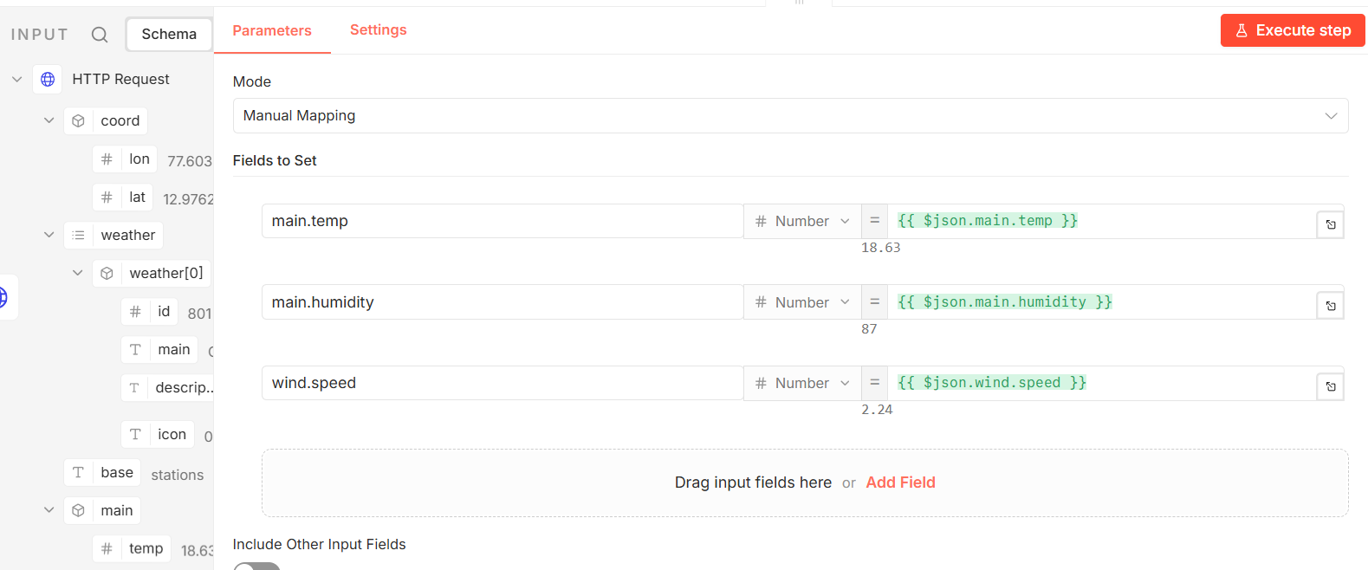

  - Send a message
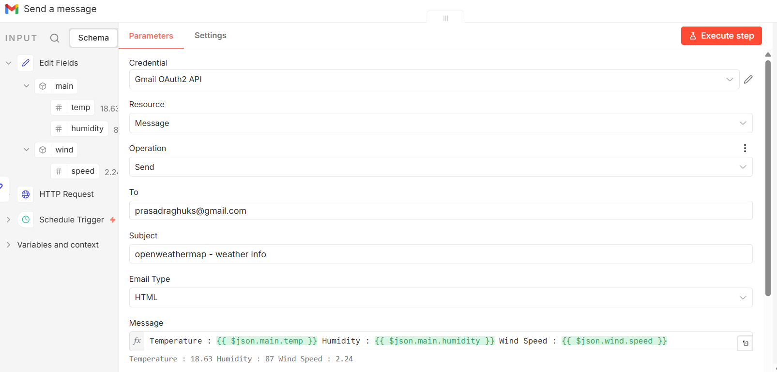
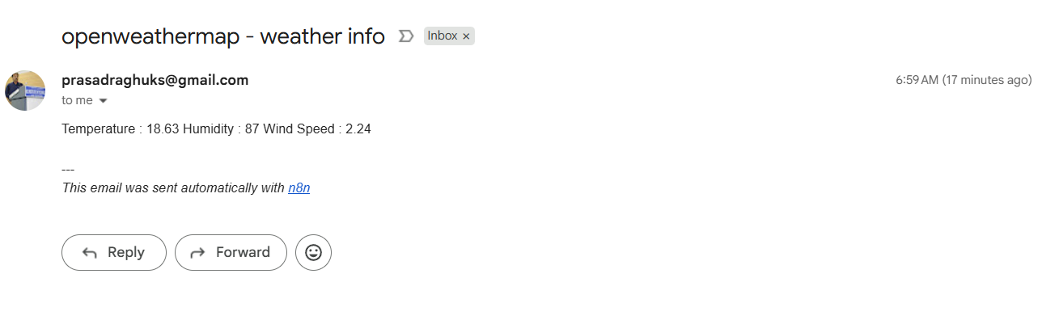
Practical 3 - DailyNewsAggregator-2

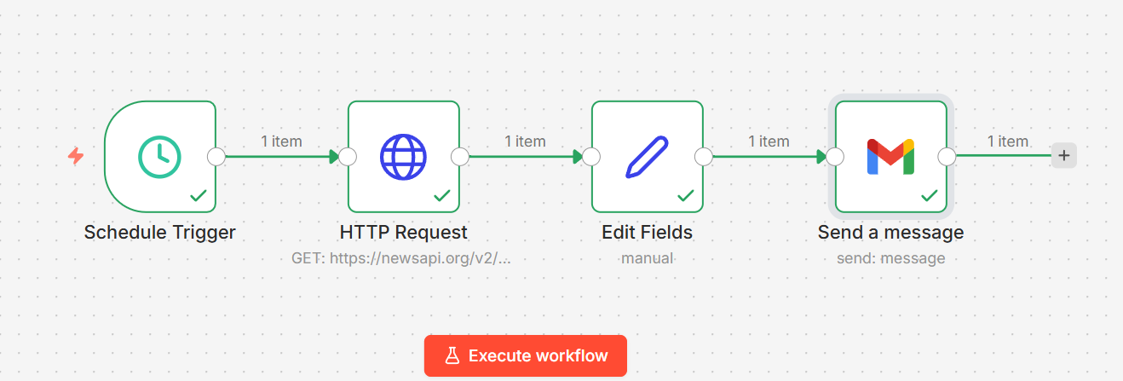

Nodes:
- Scheduler Trigger

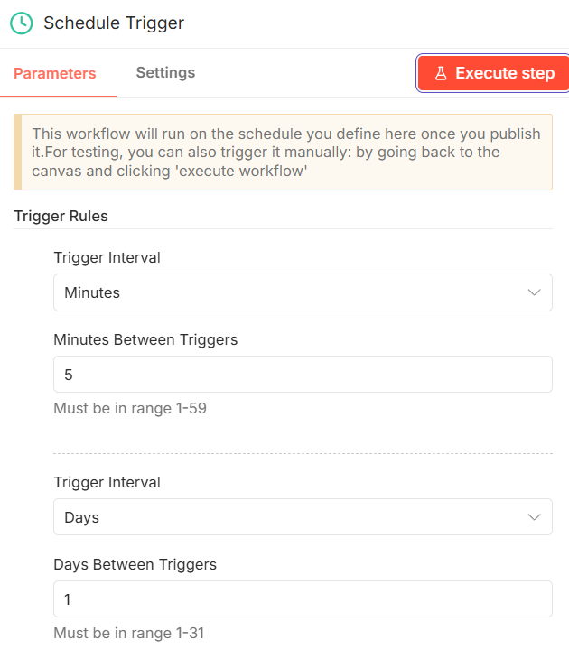
- Http Request

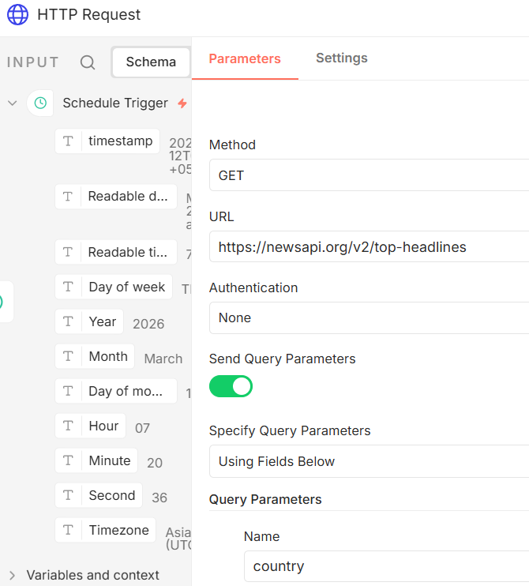

URL : https://newsapi.org/v2/top-headlines
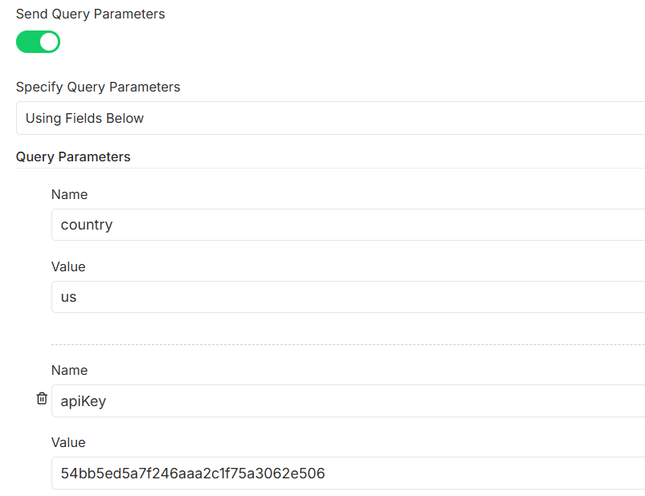
- Edit Fields
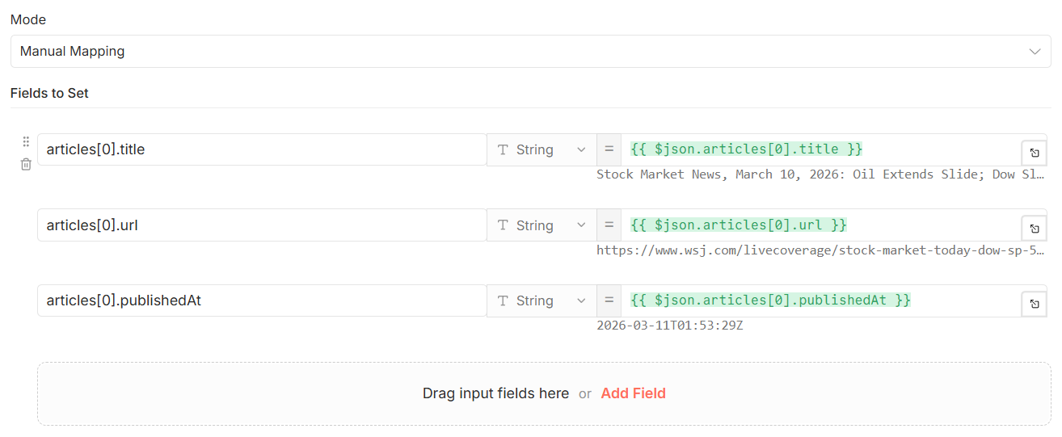
- Send a message
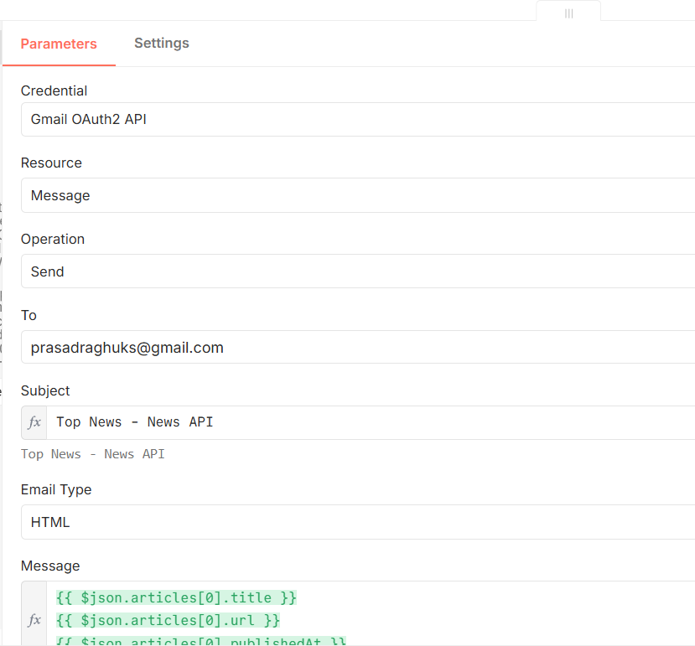
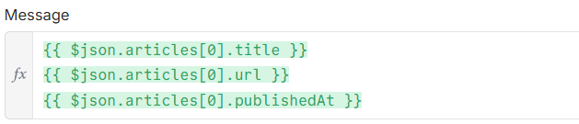
Execute Workflow
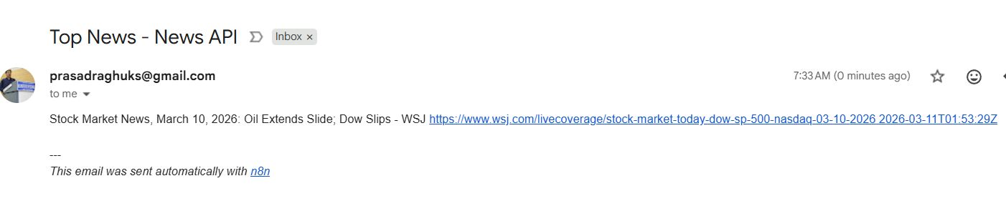

Practical 4 - Stock-3

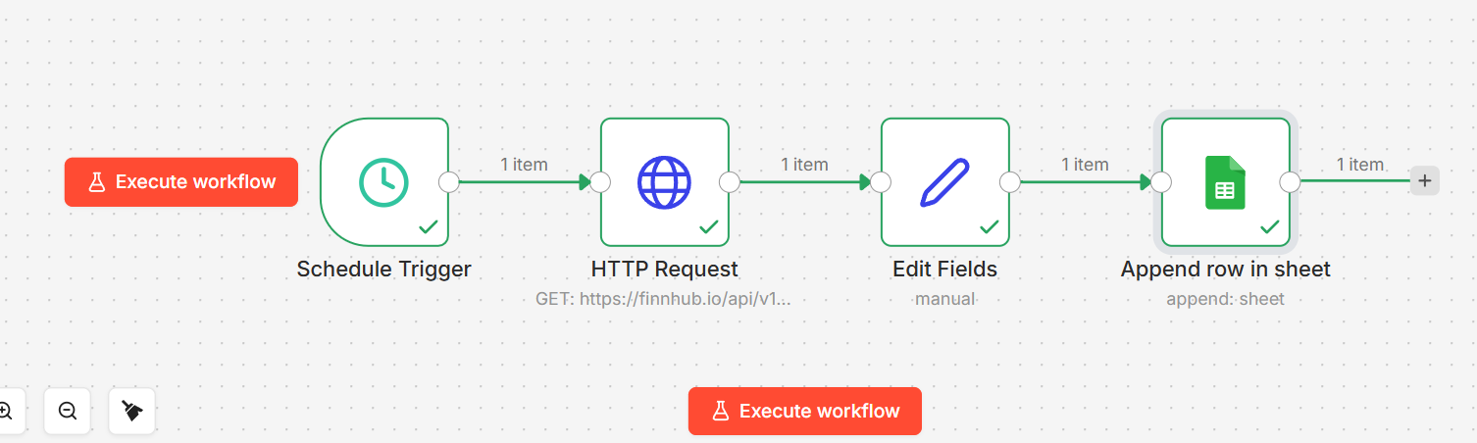

- Execute Workflow

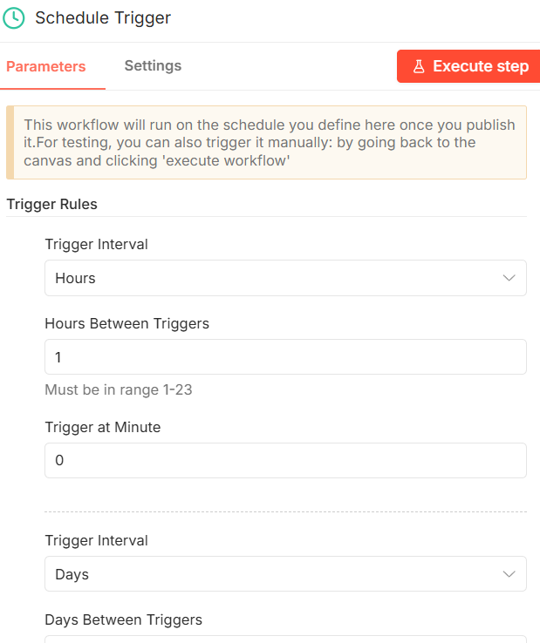

- Http Request
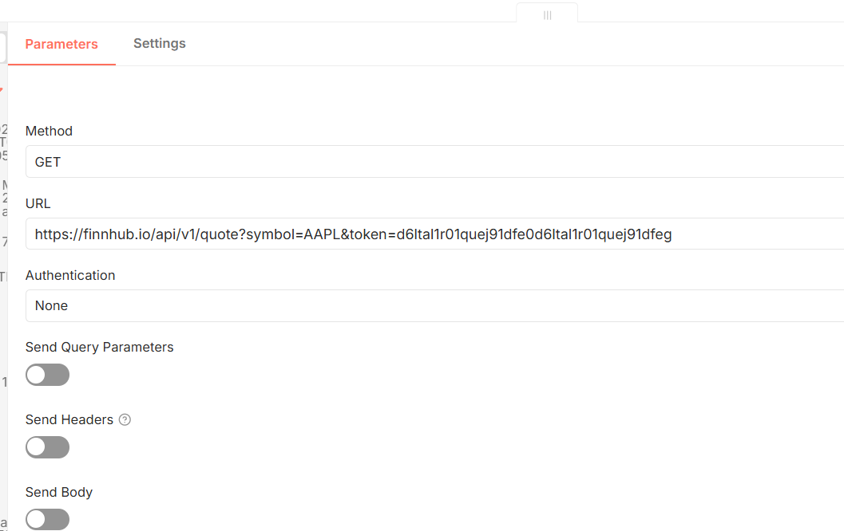

URL :

https://finnhub.io/api/v1/quote?symbol=AAPL&token=d6ltal1r01quej91dfe0d6ltal1r01quej91dfeg

- Edit Fields

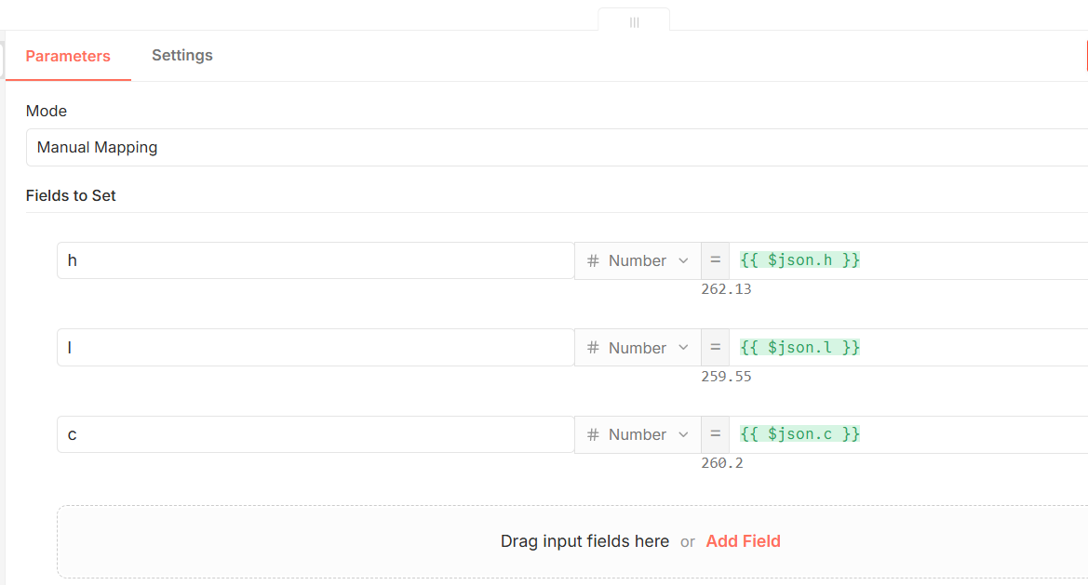

- Append Row in Sheet

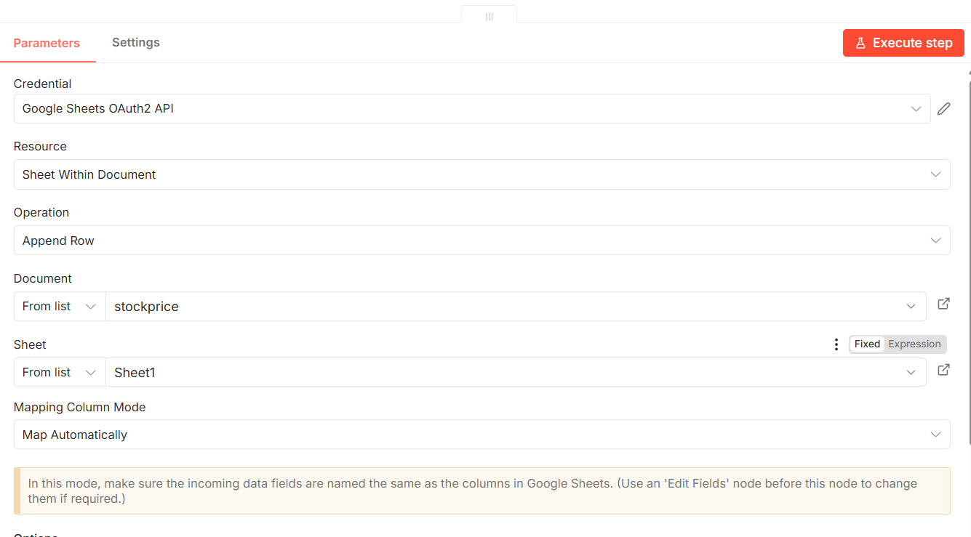

- Out put
