Module 11 – Pricing and Support
Topic : Introduction to Pricing and Support
decorative graphic for pricing and support module
As you learn about fundamentals of the AWS Cloud, two key questions might arise: "What does it cost for our business to operate in the cloud?" and "What support is available if I need assistance with these services or products?" In this section, you dive into the answers to those questions. This portion of the training offers a high-level overview of the Amazon Web Services (AWS) pricing and support landscape, including information on basic concepts of AWS pricing, resources for AWS support, and some practical strategies for optimizing cost in the AWS Cloud.

In this lesson, you will learn how to do the following:

Describe how AWS has services and options for pricing and support.

In the previous video, you learned about the different pricing and support concepts that will be covered in this section of the training.

AWS pricing, AWS support, and cost optimization

In these next lessons, you will learn about essential pricing concepts, tools, and strategies for effectively tracking and controlling your AWS spending.

graphic with text AWS Pricing
In the first section, you learn about key pricing concepts. You are also introduced to tools like the AWS Billing Dashboard, AWS Budgets, and AWS Cost Explorer to help you track, manage, and forecast AWS costs.

support icon with text support
In the next section, you learn about options for support. This section provides information on AWS Support plans and other resources, including the AWS Marketplace and AWS Partner Network.

graph with text cost optimization
The final section applies concepts to the real world by thinking about cost optimization. This section provides a practical example to help you efficiently manage cloud costs and optimize AWS service expenses.
Topic : AWS Pricing Concepts
In this lesson, you will learn how to do the following:
- Describe the key concepts of AWS pricing.
- Identify the driving factors of cost.
AWS offers customers a pay-as-you-go approach for pricing for the vast majority of our cloud services. With AWS, customers pay only for the individual services they need, for as long as they use them, and without requiring long-term contracts or complex licensing. In this lesson, you learn more about the three key concepts of AWS pricing. You also learn about the primary elements that drive customer cost.
Key concepts of AWS pricing
To review the three key concepts of how you pay for AWS services, review each of the following cards.

Pay as you go
With pay as you go, you can adapt to changing business needs and reduce the risk of overprovisioning or missing capacity.

Save when you commit
For certain services, such as Compute services on AWS, Savings Plans offer savings over On-Demand prices when you commit to a 1-year or 3-year plan.

Pay less by using more
With AWS, you can realize important savings as your usage increases. For some services, pricing is tiered, meaning the more you use, the less you pay.
Driving factors of cost
The pricing of AWS services varies based on several factors, such as service category or type, configuration, AWS Region, and which pricing model you choose. Refer to the pricing tab on a service's webpage for details on its specific pricing factors.
There are three fundamental drivers of cost with AWS: compute, storage, and outbound data transfer. These driving factors impact AWS service categories in different ways. To learn how compute, storage, and outbound data transfer drive cost at AWS, expand each of the following factors.
Compute
For compute resources, you pay by a certain span of time, like by the hour or by the second. Unless you've made a reservation for which the cost is agreed upon beforehand, you pay from the time you launch a resource until the time you stop the instance.
Storage
You can choose from a broad portfolio of storage solutions with deep functionality for storing, accessing, protecting, and analyzing data. Pricing for storage largely depends on how much storage you have provisioned or how much you are using.
For some storage options, such as Amazon Simple Storage Service (Amazon S3), storage cost is tiered. This means you can optimize storage costs based on how frequently and quickly you need to access data. With Amazon S3, consider the following six cost components when storing and managing customer data:
- Storage pricing
- Request and data retrieval pricing
- Data transfer and transfer acceleration pricing
- Data management and analytics pricing
- Replication pricing
- The price to process your data with Amazon S3 Object Lambda
To learn more about Amazon S3 pricing, choose the following link and navigate through the pricing tabs: Amazon S3 Pricing.
Data transfer
In most cases, there is no charge for inbound data transfer or for data transfer between AWS services within the same Region. There are some exceptions, so be sure to verify data transfer rates before beginning.
Outbound data transfer is aggregated across services and then charged at the outbound data transfer rate. The more data you transfer, the less you pay per gigabyte. For data storage and transfer, you typically pay per gigabyte.
AWS pricing scenario
Let's apply these AWS pricing concepts and drivers of cost to a possible scenario. Use Amazon Elastic Compute Cloud (Amazon EC2), a service in the compute category, as an example.
An AWS customer decides to provision an EC2 instance for their nonprofit organization. To learn how this customer's EC2 instance might be impacted by the driving cost factors of compute, storage, and data transfer, review each of the following.
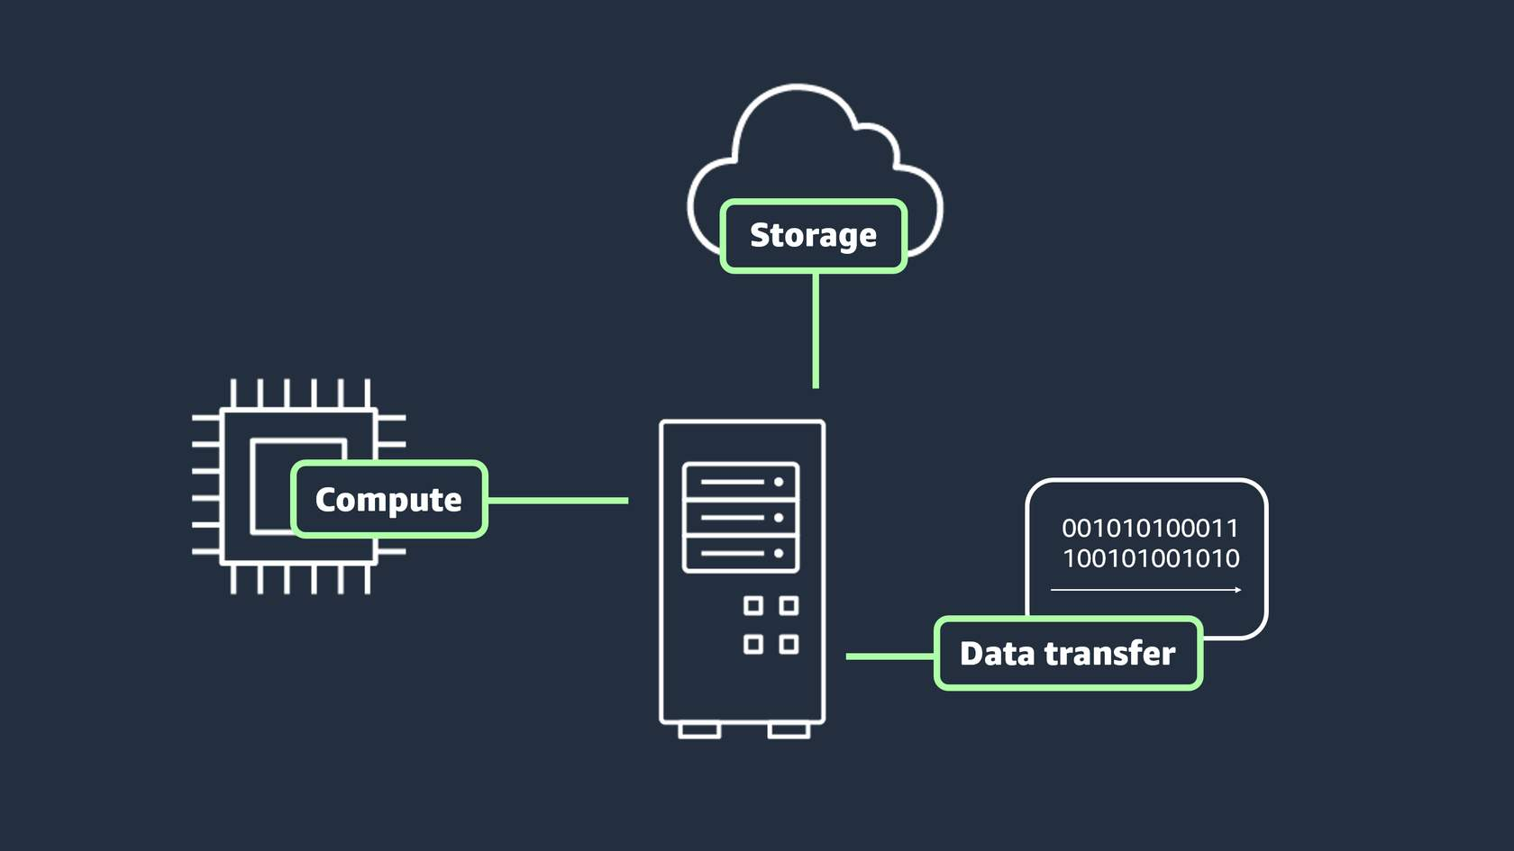
Compute
Example:
The organization built their own application that processes and manages online donations. There are over 500 types of EC2 instances that they can choose from to run that application. Each type of EC2 instance has a different quantity of CPU and memory, both of which are compute factors of Amazon EC2. Based on their requirements, they chose to use t4g.nano instance, which provides the lowest price while still meeting their needs.
Storage
Example:
The organization's donation processing application requires storage, so they configure their EC2 instance with Amazon Elastic Block Store (Amazone EBS). Price will be impacted by the amount of capacity configured.
Data transfer
Example:
The organization's donation processing application will transfer data from their EC2 instance to another solution to run analytics. This transfer would be considered outbound data transfer. Price will be impacted by capacity and which internet source or AWS Region the data is being transferred to.
For the chart associated with the cost of data transfer out, navigate to the following webpage and scroll to "Data Transfer": Data transfer on Amazon EC2.
As noted, these three factors impact each service category and AWS service differently. Please refer to the pricing tab of a service's webpage to learn how these factors impact price.
Topic : AWS Pricing and Billing Services
In this lesson, you will learn how to do the following:
- Identify the key benefits and use cases of AWS Organizations, AWS Billing Dashboard, AWS Budgets, and AWS Cost Explorer.
- Identify the key benefits and use cases for the AWS Pricing Calculator.
In this lesson, you learn about specific AWS services that you can use to manage and optimize AWS costs. First, you will cover the concept of consolidated billing in AWS Organizations. Then, you will learn about some services that you can use to view, track, and forecast expenses.
AWS pricing and billing services
You learned about various AWS pricing and billing services and tools. These services are purpose-built to help you forecast, track, manage, and view your AWS costs. When you are first starting out with the AWS Cloud, they can be hard to tell apart. To help you differentiate the services, let's review these services and their key uses cases.

AWS Organizations
AWS Organizations provides centralized management and governance of your AWS environment. Using AWS Organizations, you can create, group, and manage accounts. You can also apply security policies at the account level and consolidate billing with multiple accounts using a single payment method.
Use cases:
- Consolidate multiple AWS accounts into one central organization.
- Implement organization-wide policies.
To learn more about AWS Organizations, refer to the AWS Organizations User Guide.

AWS Billing and Cost Management dashboard
The AWS Billing and Cost Management dashboard centralizes cost management, showing current charges, usage, forecasts, and detailed breakdowns. It also provides tools to manage payments, view invoices, set budgets, and consolidate billing.
Use cases:
- Use helpful visualizations and billing reports of monthly AWS spend.
- Set up and manage payment methods.
To learn more about the AWS Billing and Cost Management dashboard, refer to the AWS Billing User Guide.

AWS Budgets
AWS Budgets helps set custom budgets and sends alerts when costs, usage, or Savings Plans and Reserved Instances (RIs) utilization or coverage exceed defined thresholds.
Use cases:
- Set up alerts for when projected costs exceed predefined thresholds.
- Forecast future expenses based on current usage trends.
To learn more, refer to Managing your costs with AWS Budgets.

AWS Cost Explorer
AWS Cost Explorer helps visualize, analyze, and manage AWS costs and usage with interactive graphs, reports, and forecasts. It provides insights into spending patterns, trends, and Reserved Instance recommendations.
Use cases:
- Analyze historical spending trends to identify cost-saving opportunities.
- Forecast future AWS costs based on current usage patterns to budget effectively.
To learn more, refer to Analyzing your costs and usage with AWS Cost Explorer.

AWS Pricing Calculator
Another helpful tool is the AWS Pricing Calculator. The AWS Pricing Calculator is a web-based planning tool that you can use to create estimates. You input specific configurations such as instance types, storage options, and data transfer volumes. Then, based on your configurations, you receive a detailed cost breakdown to help you budget for your AWS resource allocation.
Use cases:
- Estimate potential costs before deployment.
- Compare costs of different AWS services and configurations.
To learn more, refer to Generating estimates with AWS Pricing Calculator.
Topic: AWS Support Plans
In this lesson, you will learn how to do the following:
- Describe and differentiate between AWS Support plans.
- Identify additional technical support options available at AWS.
- Identify self-support options for AWS services.
AWS has a number of comprehensive support options that you can use to keep your cloud experience as seamless as possible. In this lesson, you gain insights into the different support plans available, including Basic, Develop, Business, and Enterprise plans. You also learn about other resources, such as additional technical assistance, AWS documentation, and more. By the end of this lesson, you will have a solid understanding of which support plan and assistance options best align with your organization's requirements.
Types of AWS support
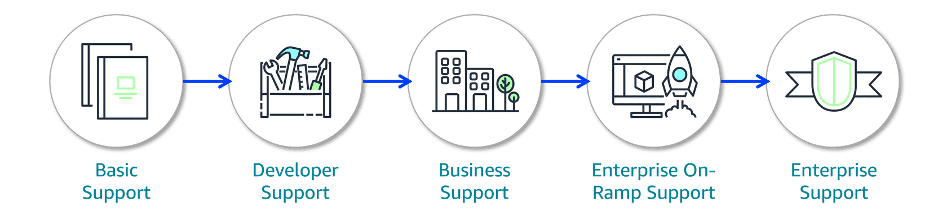
AWS offers a range of support plans tailored to meet the needs of different customers, from those just getting started to large enterprises with complex requirements. Each plan builds onto the previous one, adding more advanced tools, personalized support, and faster response times to help you get the most out of your AWS experience. To learn more about which plan is right for you, refer to Compare AWS Support Plans.
To review the differences between the plans, refer to the following table.
Basic Support | Developer Support | Business Support | Enterprise On-Ramp Support | Enterprise Support
Included for all AWS customers | Recommended for experimenting or testing in AWS | Recommended minimum tier for production workloads in AWS | Recommended for production and business critical workloads in AWS | Recommended for business critical and mission critical workloads in AWS
Includes access to documentation, whitepapers, and AWS re:Post | Response times:• < 24 hours for general guidance• < 12 hours when systems impaired | Response times:• Includes previous plan response times• < 4 hours when production system impaired• < 1 hour when production system is down | Response times:• Includes previous plan response times• < 30 minutes when business-critical system is down | Response times:• Includes previous plan response times• < 15 minutes when business- or mission-critical system is down
Core AWS Trusted Advisor checks | Core AWS Trusted Advisor checks | Full set of AWS Trusted Advisor checks | Full set of AWS Trusted Advisor checks | Full set of AWS Trusted Advisor checks and prioritized recommendations by AWS account team
Technical Account Management not included | Technical Account Management not included | Technical Account Management not included | A pool of technical account managers (TAMs) provide proactive guidance | A designated TAM provides consultative architectural and operational guidance
A technical account manager (TAM) is included with the Enterprise On-Ramp and Enterprise Support plans. The TAM serves as your primary AWS contact, offering expert guidance on using AWS services, optimizing architectures, managing costs, and connecting you with AWS programs and experts. For example, if you're building an app using multiple AWS services, your TAM can advise on the best integration approach.
Additional resources for your cloud journey
In addition to AWS Support plans, AWS also provides access to other teams, resources, and documentation that you can use to support your cloud journey. To learn more about these resources, review the following five types below the image.
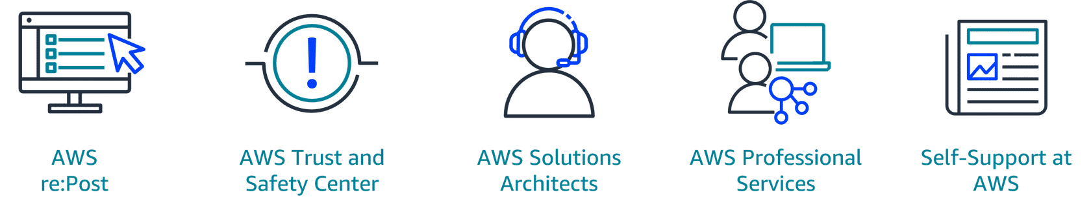
AWS re:Post
AWS re:Post is a community-driven, question-and-answer platform where users can seek help, share knowledge, and find solutions related to AWS services and technologies.AWS re:Post also houses AWS Knowledge Center. AWS Knowledge Center contains articles and videos covering the most frequently asked questions and requests from AWS customers. To learn more about AWS re:Post, refer to AWS re:Post. To learn more about AWS Knowledge Center, refer to AWS Knowledge Center.
AWS Trust and Safety Center
The AWS Trust and Safety Center provides information on how to report activity or content on AWS that you suspect is abusive. To learn more about this service, refer to AWS Trust and Safety Center.
AWS solutions architects
For Business and Enterprise Support customers, AWS solutions architects (SAs) provide architectural guidance, best practice recommendations, and help in designing scalable and secure applications.
AWS Professional Services
AWS Professional Services is a consulting service that offers deeper, project-based support. They help with complex migrations, security audits, performance tuning, and more. To learn more about this service, refer to AWS Professional Services.
Self-support at AWS
AWS also provides extensive documentation and self-support resources that you can use to research, answer a question, or troubleshoot an issue. Documentation includes user guides for AWS services, SDK guides, blog posts, and whitepapers for specific solutions.
To learn more about these resources, refer to AWS documentation.
In this lesson, you will learn how to do the following:
- Identify the key services and benefits of AWS Marketplace.
- Describe the role of the AWS Partner Network and identify the key benefits of being an AWS Partner.
In this lesson, you dive into two critical components of the AWS landscape: the AWS Marketplace and the AWS Partner Network (APN). Whether you are looking to find specialized software solutions or you are seeking to enhance your own company’s offerings through partnership with AWS, understanding these components is an important part of your learning journey.
AWS Marketplace and AWS Partner Network
AWS Marketplace
The AWS Marketplace is a digital catalog that includes thousands of software listings from independent software vendors. You can use AWS Marketplace to find, test, and buy software that runs on AWS. For each listing in AWS Marketplace, you can access detailed information on pricing options and reviews from other AWS customers. Solutions and services offered in the AWS Marketplace include the following:

- Software as a service (SaaS):
  - Business applications such as project management tools
  - Marketing tools such as customer engagement platforms
  - Collaboration tools such as file sharing services
- Machine learning (ML) and AI:
  - Prebuilt models for image recognition, natural language processing, and more
  - ML algorithms for training custom models
- Data and analytics:
  - Business intelligence platforms for visualization and reporting
  - Data integration tools
You can also explore software solutions by industry and use case. For example, suppose your company is in the healthcare industry. In AWS Marketplace, you can review use cases that software helps you to address, such as implementing solutions to protect patient records or using machine learning models to analyze a patient’s medical history and predict possible health risks.
To explore more offerings and find the right fit for your business, refer to AWS Marketplace.
AWS Partner Network
The AWS Partner Network (APN) is a global community that uses AWS technologies, programs, expertise, and tools to build solutions and services for customers. Together, partners and AWS provide innovative solutions, solve technical challenges, and deliver customer value.
You can work with AWS Partners to create or use specialized solutions that are tailored to your unique business needs. For example, a retail company might use AWS to host their website. They could then work with an AWS Partner who specializes in advanced analytics and machine learning to improve customer personalization on that website. To learn more about working with AWS Partners, refer to Engage with AWS Partners.
You can also become an AWS Partner. There are many benefits to becoming a partner, including the following:

- Funding benefits: As businesses join the AWS Partner Network and participate in specific programs available to AWS Partners, they can unlock various funding benefits to help build, market, and sell with AWS. To learn more, refer to AWS Partner Funding.
- AWS Partner events: AWS Partner events include webinars, virtual workshops, and in-person learning opportunities. You can use AWS Partner events to network with other partners, learn more about new or current offerings, and collaborate with AWS experts. To learn more, refer to AWS Partner Events.
- AWS Partner Training and Certification: Take advantage of unique, partner-centered offerings from AWS Training and Certification. From certification to a specific service or learning objective, the AWS Partner training portfolio has numerous opportunities to upskill your cloud knowledge. To learn more, refer to AWS Partner Training

Topic: Cost Optimization

In this lesson, you will learn how to do the following:

Describe techniques for cost optimization.

By now, you have a solid idea of the fundamentals of AWS pricing and support. In this lesson, you apply some of the concepts you learned, reviewing how these services and ideas work together in real life. You explore a hypothetical example to learn about some helpful cost optimization techniques, and you review an architectural diagram that describes how these techniques work from a cloud architectural perspective.

Cost optimization architecture diagram

Let's review the solutions discussed in the video. The following architecture diagram demonstrates a few different ways for optimizing costs in the cloud. To learn more about this architecture focused on cost optimization, review each of the four AWS services below.

architecture diagram
Amazon EC2
One way to optimize cost with Amazon EC2 instances is to rightsize your resources. This means that you analyze and adjust your resources to meet the needs of your workload. Services such as AWS Compute Optimizer can help rightsize your compute resources.

Also, using Spot Instances can help optimize for cost. Spot Instances work well for workloads that are tolerant to interruptions. Spot Instances use spare Amazon EC2 capacity for a significant discount compared to On-Demand instances.

Auto scaling
Another way to help optimize cost with compute resources is auto scaling. When demand drops, AWS Auto Scaling will automatically remove any excess resource capacity, so you avoid overspending. Application load balancing also helps distribute traffic across EC2 instances.

Amazon RDS
Rightsizing is an important piece of cost optimization in your Amazon Relational Database Service (Amazon RDS) instances. Amazon RDS can scale storage using storage autoscaling which prevents over- or underprovisioning.

Read replicas scale capacity horizontally, meaning your resources won't need to a scale up into a larger instance. Instead of scaling the primary instance, read replicas are used to store data and can be used for heavy read workloads which in turn reduces the strain on the primary instance. Similarly, using something like Amazon Elasticache for caching can also reduce the load on your primary instance and optimize for cost.

Amazon S3
Using the right storage class is key to optimizing cost in the cloud.

For example, you might use S3 Glacier Deep Archive as a low-cost storage tier ideal for data that is accessed once or twice a year. For data with unknown or changing access patterns, S3 Intelligent-Tiering is a great choice.

You can also use VPC endpoints to help optimize for cost as well, as using VPC endpoints for Amazon S3 access can help reduce data transfer costs.

Topic: Module Summary
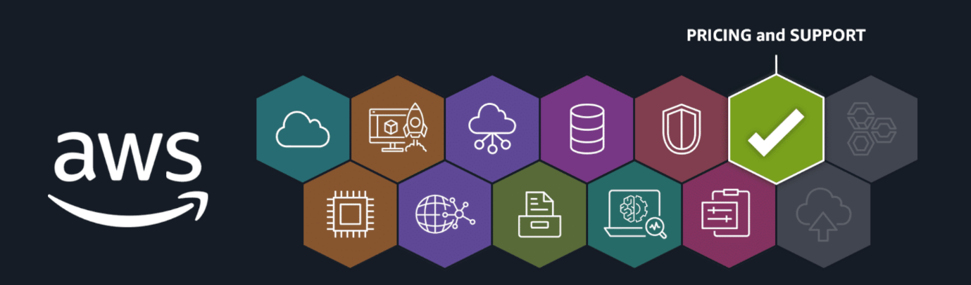
Recap and next steps
In the last few lessons, you learned about AWS pricing concepts and AWS support options. You covered fundamental pricing concepts and services. You also learned the difference between AWS Support Plans and other technical assistance resources. Finally, you applied these concepts to a real-world application by thinking about how to optimize for cost in the AWS Cloud.
Next in your AWS Cloud Practitioner learning journey, you will consider the basic principles, strategies, and services for migrating resources to the cloud.
Resources
To learn more about the material covered in this module, choose the resource links contained in the following table.
Resource link | Description
Amazon S3 Pricing | The Amazon S3 Pricing page outlines costs for storage, requests, data transfer, and additional features, along with details on AWS Free Tier for new customers.
Amazon EC2 On-Demand Pricing | The Amazon EC2 On-Demand Pricing page details the costs for EC2 instances, including pricing for instance types, data transfer, and additional features with no long-term commitments.
What is AWS Organizations? | The AWS Organizations User Guide explains how to centrally manage multiple AWS accounts, automate account creation, apply governance policies, and simplify billing and resource sharing.
AWS Billing Console | The AWS Billing Console provides a centralized platform for managing and understanding AWS charges, offering tools to view and download invoices, monitor discounts and credits, and analyze spending trends across multiple accounts.
AWS Budgets | AWS Budgets provides tools to create custom budgets for tracking and managing AWS costs, usage, and Reserved Instance or Savings Plan use. It also helps prevent overspending by offering alerts and automated actions.
AWS Cost Explorer | AWS Cost Explorer provides tools to visualize, analyze, and manage AWS costs and usage, with customizable reports and cost forecasting to optimize cloud spending.
AWS Pricing Calculator Documentation | The AWS Pricing Calculator is a free, web-based tool that helps customers create detailed cost estimates for AWS services, so they can plan and manage their cloud expenditures effectively.
AWS re:Post | AWS re:Post is a community-driven, question-and-answer platform provided where users can seek help, share knowledge, and find solutions related to AWS services and technologies.
AWS Trust and Safety Center | The AWS Trust and Safety Center offers guidance on reporting abuse, protecting applications, and following best practices for digital messaging on AWS.
AWS Professional Services | The AWS Professional Services page highlights how AWS experts help organizations accelerate cloud adoption with tailored guidance across industries and technologies.
Welcome to AWS Documentation | The AWS Documentation page provides comprehensive technical resources, including guides, API references, tutorials, and best practices across AWS services.
AWS Marketplace | The AWS Marketplace is a digital catalog where customers can discover, purchase, and manage third-party software, data, and services with flexible pricing options.
Engage with AWS Partners | The AWS Partners page helps you discover how AWS Partners can help you accelerate your cloud journey.
Funding Benefits for AWS Partners | The AWS Partner Funding page outlines funding benefits, including credits and discounts, to support AWS partners in developing, marketing, and selling solutions based in AWS.
AWS Partner Events | The AWS Partner Events page lists upcoming webinars, workshops, and in-person events for IT professionals, developers, and business leaders, with options to filter by date, location, and topic.
AWS Partner Training and Certification | The AWS Partner Training page offers courses, certifications, and resources to help AWS Partners build cloud skills across various roles and enhance their expertise.

