Module 12 – Migrating to AWS Cloud

Topic : Introduction to Migration
Decorative image with migrating at the module titl
In this lesson, you will learn how to do the following:

Describe cloud migration.

Identify three phases of large cloud migrations.

Cloud migration refers to the process of moving your organization's digital assets, IT resources, applications, and databases from on-premises infrastructure to the AWS Cloud. This involves strategic planning, implementation, and ongoing management to achieve a smooth and successful transition. It is not typically a one and done type of move. With large migrations, companies might migrate in phases or stages.

Three phases of the migration process

AWS helps guide companies through the migration process, which can be divided into three sequential phases. From the first phase to the last, there are AWS services and tools to support your migration. Although this is not an exhaustive list of every AWS migration service, these core migration services will help get you on your way.

To learn more about the migration phases, review each of the numbered descriptions below the graphic.

1. Assess
In this phase, you build the business case for the migration and assess your readiness. One of the services used in this phase is the Migration Evaluator.

2. Mobilize
In this phase, you prepare the organization and mobilize the resources needed for the migration. Two services you might use in this phase are AWS Application Discovery Service and the AWS Migration Hub.

3. Migrate and modernize
In this phase, you use your strategy, plan, and the best practices to migrate and modernize. Tools to support you include AWS Application Migration Service and AWS Database Migration Service (AWS DMS). If you are transferring data, you might use AWS DataSync, AWS Transfer Family, and the AWS Snow Family.

While AWS Migration Hub helps you mobilize your resources, you can use it as a one-stop place to also manage during the migrate and modernize phase. You will learn more about Migration Hub and the other migration services in the next lesson.

Topic : AWS Cloud Adoption Framework

In this lesson, you will learn how to do the following:
- Describe the AWS Cloud Adoption Framework.
- Identify the six perspectives of the AWS CAF.
In this lesson, you will explore the AWS Cloud Adoption Framework (AWS CAF) and the six perspectives to remember as you get started.
Improve your cloud readiness
When you migrate to the AWS Cloud, there are critical planning tasks, many groups of stakeholders, and best practices to consider. With so much to take into account, it can seem overwhelming to even know where to start. That's where the AWS CAF can help.

AWS CAF
The AWS CAF is a framework that brings AWS experience and best practices to companies preparing to migrate to the AWS Cloud. The framework provides tools to help accelerate the migration journey, organize resources, and align management during the transition.
Benefits: AWS CAF provides benefits for migrations to reduce business risk and improve sustainability and corporate transparency. Companies can grow revenue by creating new products and services in their cloud transformation. They can also reduce operational costs, increase productivity, and improve customer experience in their new cloud environment.
Use cases: You can use AWS CAF to migrate technology like legacy infrastructure and applications. You can also use it to migrate and optimize business processes, operations, and even create new business models with the move to the cloud.
Functional and business-related stakeholders
There are several groups of stakeholders and various parts of the business to consider in your migration planning and readiness.
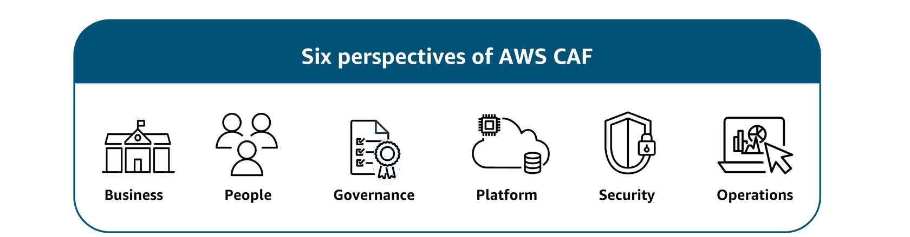

Business
The Business perspective makes sure that IT aligns with business needs and that IT investments link to key business results.
Use the Business perspective to create a strong business case for cloud adoption and prioritize cloud adoption initiatives. Make sure that your business strategies and goals align with your IT strategies and goals.
The following are common Business perspective roles:
- Business managers
- Finance managers
- Budget owners
- Strategy stakeholders

People
The People perspective supports development of an organization-wide change management strategy for successful cloud adoption.
Use the People perspective to evaluate organizational structures and roles, assess new skill and process requirements, and identify gaps. This helps prioritize training, staffing, and organizational changes.
The following are common People perspective roles:
- Human resources
- Staffing
- People managers

Governance
The Governance perspective focuses on skills and processes to align IT strategy with business strategy. This perspective helps you maximize business value and minimize risks.
Use it to understand how to update the staff skills and processes necessary to maintain business governance in the cloud. Manage and measure cloud investments to evaluate business outcomes.
The following are common Governance perspective roles:
- Chief information officer (CIO)
- Program managers
- Enterprise architects
- Business analysts
- Portfolio managers

Platform
The Platform perspective includes principles and patterns for implementing new solutions in the cloud and migrating on-premises workloads to the cloud.
Use a variety of architectural models to understand and communicate the structure of IT systems and their relationships. Describe the architecture of the target state environment in detail.
The following are common Platform perspective roles:
- Chief technology officer (CTO)
- IT managers
- Solutions architects

Security
The Security perspective makes sure that the organization meets security objectives for visibility, auditability, control, and agility.
Use AWS CAF to structure the selection and implementation of security controls that meet the organization’s needs.
The following are common Security perspective roles:
- Chief information security officer (CISO)
- IT security managers
- IT security analysts

Operations
The Operations perspective helps you to enable, run, use, operate, and recover IT workloads to the level agreed upon with your business stakeholders.
Define how day-to-day, quarter-to-quarter, and year-to-year business is conducted. Align with and support the operations of the business. AWS CAF helps these stakeholders define current operating procedures and identify the process changes and training needed to implement successful cloud adoption.
The following are common Operations perspective roles:
- IT operations managers
- IT support managers

Topic : Seven Migration Strategies

In this lesson, you will learn how to do the following:
- Describe the seven migration strategies.
When a company migrates to the AWS Cloud, they have many options. There are seven migration strategies to help them reach their goals. The company may choose certain strategies depending on its specific needs and application types, where the company starts, and the company’s future plans. In this lesson, you will explore the seven migration strategies, also known as the seven Rs.
Seven migration strategies
The most common paths to the cloud
When customers are migrating applications to the cloud, they can use seven common migration strategies. The decision on which strategy depends on factors such as the complexity of existing applications, business goals, time constraints, and available resources. Often, organizations will use a combination of these strategies across their application portfolio. By carefully considering each option and aligning it with specific applications and objectives, organizations can create a tailored migration plan that maximizes the benefits of cloud adoption while minimizing risks and disruptions.
To learn more about the migration strategies, review each of the seven strategies below.
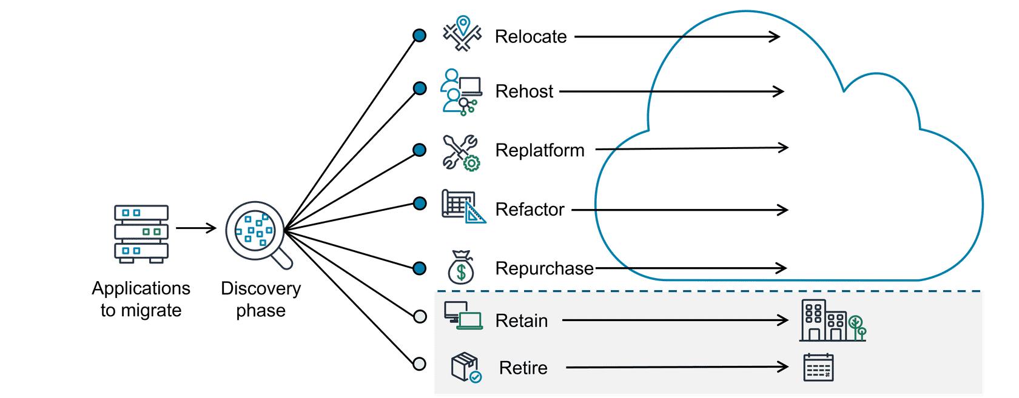
Relocate
Relocating is changing the hosting location to the cloud. This could be if applications are already virtual machines (VMs) or containers running on premises and then moving to the cloud.
Rehost
Rehosting, also known as lift-and-shift, involves moving applications without changes.
In a scenario of a large legacy migration, in which the company is looking to implement its migration and scale quickly to meet a business case, the majority of applications are rehosted.
Replatform
Replatforming, also known as lift, tinker, and shift, involves making a few cloud optimizations to realize a tangible benefit. Optimization is achieved without changing the core architecture of the application.
Refactor
Refactoring, also known as re-architecting, involves reimagining how an application is architected and developed by using features built for the cloud. Refactoring is driven by a strong business need to add features, scale, or improve performance that would otherwise be difficult to achieve in the application’s existing environment.
Repurchase
Repurchasing involves moving from a traditional license to a software-as-a-service (SaaS) model.
For example, a business might choose to implement the repurchasing strategy by migrating from a customer relationship management (CRM) system to a new sales force software.
Retain
Retaining consists of keeping applications that are critical for the business in the source environment. This might include applications that require major refactoring before they can be migrated or work that can be postponed until a later time.
Retire
Retiring is the process of removing applications that are no longer needed.

Topic: Migration Services and Tools
In this lesson, you will learn how to do the following:
- Identify AWS migration tools and resources.
- Describe Migration Evaluator and when to use it.
- Describe AWS Application Discovery Service and when to use it.
- Describe AWS Migration Hub and when to use it.
- Locate AWS Migration and Modernization Competency Partners
No matter where you are in the migration process, you have many AWS services and resources you can use to support your migration journey. In this lesson, you will identify four migration services and locate additional resources to help support you after this training.
Assess phase
In the Assess phase, it is important to have the right tools to build the business case for your migration. That's where Migration Evaluator can help.

Migration Evaluator
The Migration Evaluator is a migration assessment service that helps you create a business case for AWS Cloud planning and migration. It does this with a data driven approach, analyzing your current state, target state, and developing a migration readiness plan with projected cloud costs.
Benefits: The benefits include removing the guesswork when migrating. It provides visibility into multiple cost-effective cloud migration scenarios. It also gives insights on reusing existing software licensing, which can further reduce costs.
Use cases: You can use Migration Evaluator to conduct broad-based discovery, take a snapshot of your current on-premises footprint to fine-tune licensing, view server dependencies, and gain visibility into multiple migration scenarios. You can also use it to estimate and reduce your cloud costs.
Mobilize phase
Let's look at two services that you might use in the Mobilize phase for discovery and planning.

Application Discovery Service
The Application Discovery Service discovers on-premises server inventory and connections. It gathers configuration, performance, and connection details for both servers and databases to create a detailed migration plan.
Benefits: With Application Discovery Service, you get a comprehensive snapshot of your on-premises inventory. You also can integrate discovery data with other services like Migration Hub and protect the data Application Discovery Service collects.
Use cases: You can use the AWS Application Discovery Service to conduct discovery and inventory, map the connections and dependencies, and generate a migration plan.
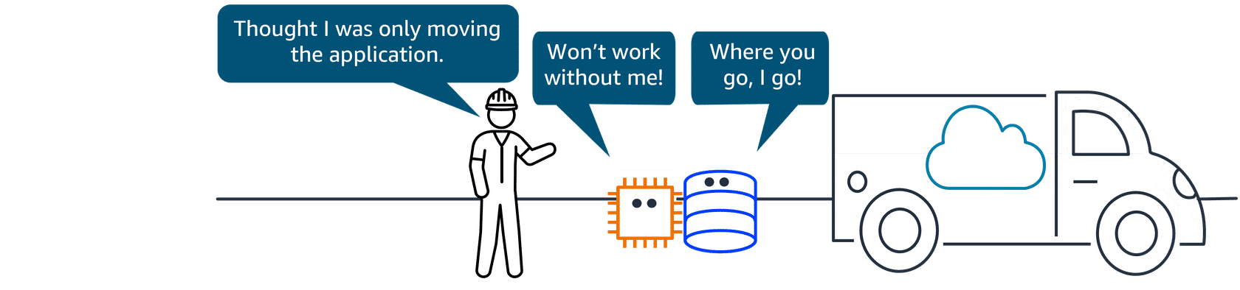

Migration Hub
The Migration Hub is a centralized hub to take you from discovery, assessment, planning, and execution of your migration. It provides tools, guidance, and automated recommendations to collaborate with your team and track your migration.
Benefits: With the Migration Hub, you have one location to go for your migration and, expert guidance in the form of prescriptive journey templates. Another benefit is cost savings because there is no charge to use Migration Hub.
Use cases: You can use Migration Hub for migration assessment and planning and migration completion and collaboration with teams. You can also use it for modernization efforts like fast-tracking application refactoring.
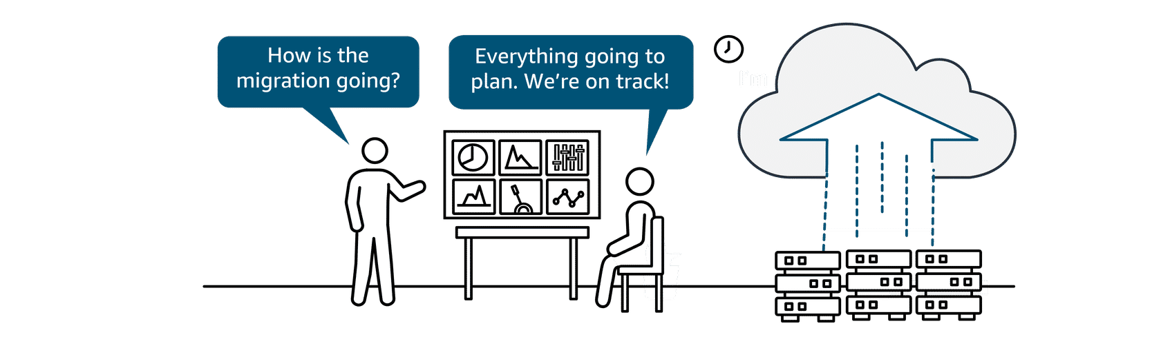
Migrate and modernize phase
As you start moving resources to the cloud, you might continue to use Migration Hub to track your progress. You can also use Migration Hub during migration to modernize your applications. In following lessons, you will explore database and data migrations. But first, let's look at another service that focuses on your application migration, Application Migration Service.

Application Migration Service
Application Migration Service is a tool to move and improve your on-premises and cloud-based applications. It helps customers streamline, expedite, and reduce the cost of migrating and modernizing applications.
Benefits: The benefits include support to migrate from any source infrastructure that runs a supported operating system (OS). It makes it possible to modernize your applications during migration. You can maintain normal business operations during the application replication process and also reduce costs by using one tool for a wide range of applications.
Use cases: You can use the Application Migration Service for on-premises applications running on physical servers or infrastructure, cloud-based applications, or moving between AWS Regions. You can also use it to modernize applications.
Migration resources
AWS Migration and Modernization Competency Partners
When migrating to the AWS Cloud, if you need help and expertise, you don't have to go it alone. You can work with the AWS Competency Partner Program. You can search for AWS Migration and Modernization Service Partners who specialize in specific phases of the migration or the type of help you need. To learn more, refer to AWS Migration and Modernization Competency Partners

Topic : Database Migrations

In this lesson, you will learn how to do the following:
- Describe the challenges and considerations of migrating databases.
- Describe the benefits and use cases of AWS Database Migration Service (AWS DMS).
- Describe the benefits and use cases of AWS Schema Conversion Tool (AWS SCT).
Migrating databases
Services to plan, migrate, and, if needed, convert
Migrating your database to the cloud can provide an opportunity to redesign and improve your database architecture. Because legacy systems and requirements change over time, you might also consider whether to migrate to an AWS managed database service or an open source database to reduce licensing costs. It is fairly simple to migrate data from one server to another when both are using the same database engine, known as homogeneous migration. Going to a different engine, or heterogeneous migration, is more complex and might require changes in your application. The good news is, whether your migration is homogenous (from same type of database to same type) or heterogenous (from one type of database to a different type), there are AWS services to support you.
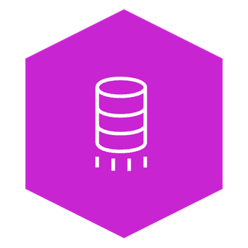
AWS DMS
The AWS Database Migration Service (AWS DMS) makes it possible to quickly and securely migrate databases and perform ongoing data replication tasks for live databases and data warehouses. It provides a way to plan, assess, convert, and migrate databases even with data warehouses in one central tool.
Benefits: AWS DMS provides benefits for migrating databases including maintaining high availability and low downtime during the migration process. It supports homogenous and heterogenous migrations. It also makes it possible to migrate terabyte sized databases at a low cost.
Use cases: You can use AWS DMS to move to managed databases, remove licensing costs, replicate ongoing changes in your database, and improve integration with data lakes.
If you want to change from a commercial database to an open source database during your migration, there are a few important logistics. When the databases you are migrating have different source and target engines, you need to consider how to recreate existing resources, like the database schema, in the target. A schema defines the structure and organization of data inside the database and acts like a blueprint for things like table structures, field types, and relationships between items. It can be time consuming to recreate everything manually. That's where AWS Schema Conversion Tool (AWS SCT) can help.
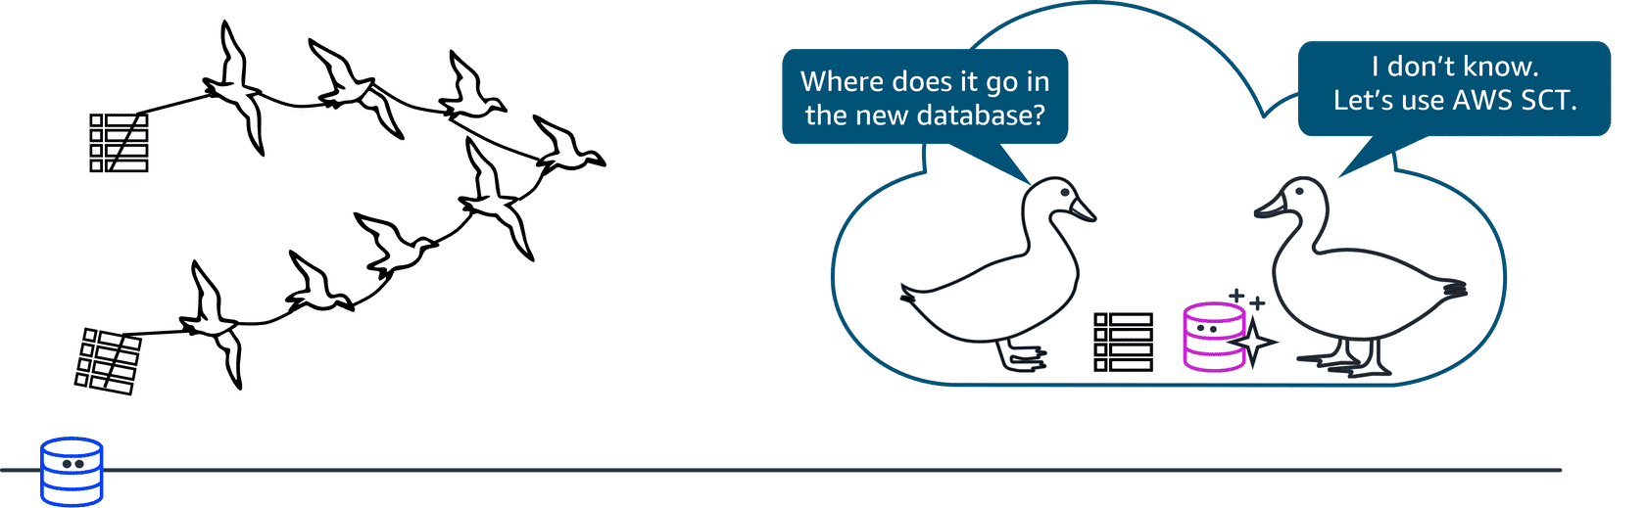

AWS SCT
AWS SCT makes it possible to convert database schemas and code objects (like stored procedures, views, and functions) from one database engine to another. AWS SCT can even give you estimates of how big of an effort a conversion is, which helps with planning.
Benefits: AWS SCT provides benefits to simplify database migrations by automating schema analysis, recommendations, and conversion at scale. It is compatible with popular databases and analytics services as source and target engines. It can save weeks or months of manual time and resources, which are typically required in conversions.
Use cases: You can use AWS SCT to move from commercial databases to open source databases. You can also use it for migrating large data warehouse workloads and modernizing or updating database schemas in place.
Topic: Transferring Data Online
In this lesson, you will learn how to do the following:
- Identify services for online or offline transfer data to the AWS Cloud.
- Describe the benefits and use cases of AWS DataSync.
- Describe the benefits and use cases of AWS Transfer Family.
In this lesson, you will learn about services to transfer online data.
Transferring data to and from the AWS Cloud
Online data transfer
Several AWS services facilitate online data transfer to the AWS Cloud. In the last lesson, you learned that AWS Database Migration Service (AWS DMS) transfers the database and its data to the AWS Cloud. In this lesson, you will identify services that can help with the considerations of online transfer for other types of data and files.
In this lesson, you will review three services:
- AWS DataSync
- AWS Transfer Family
- AWS Direct Connect
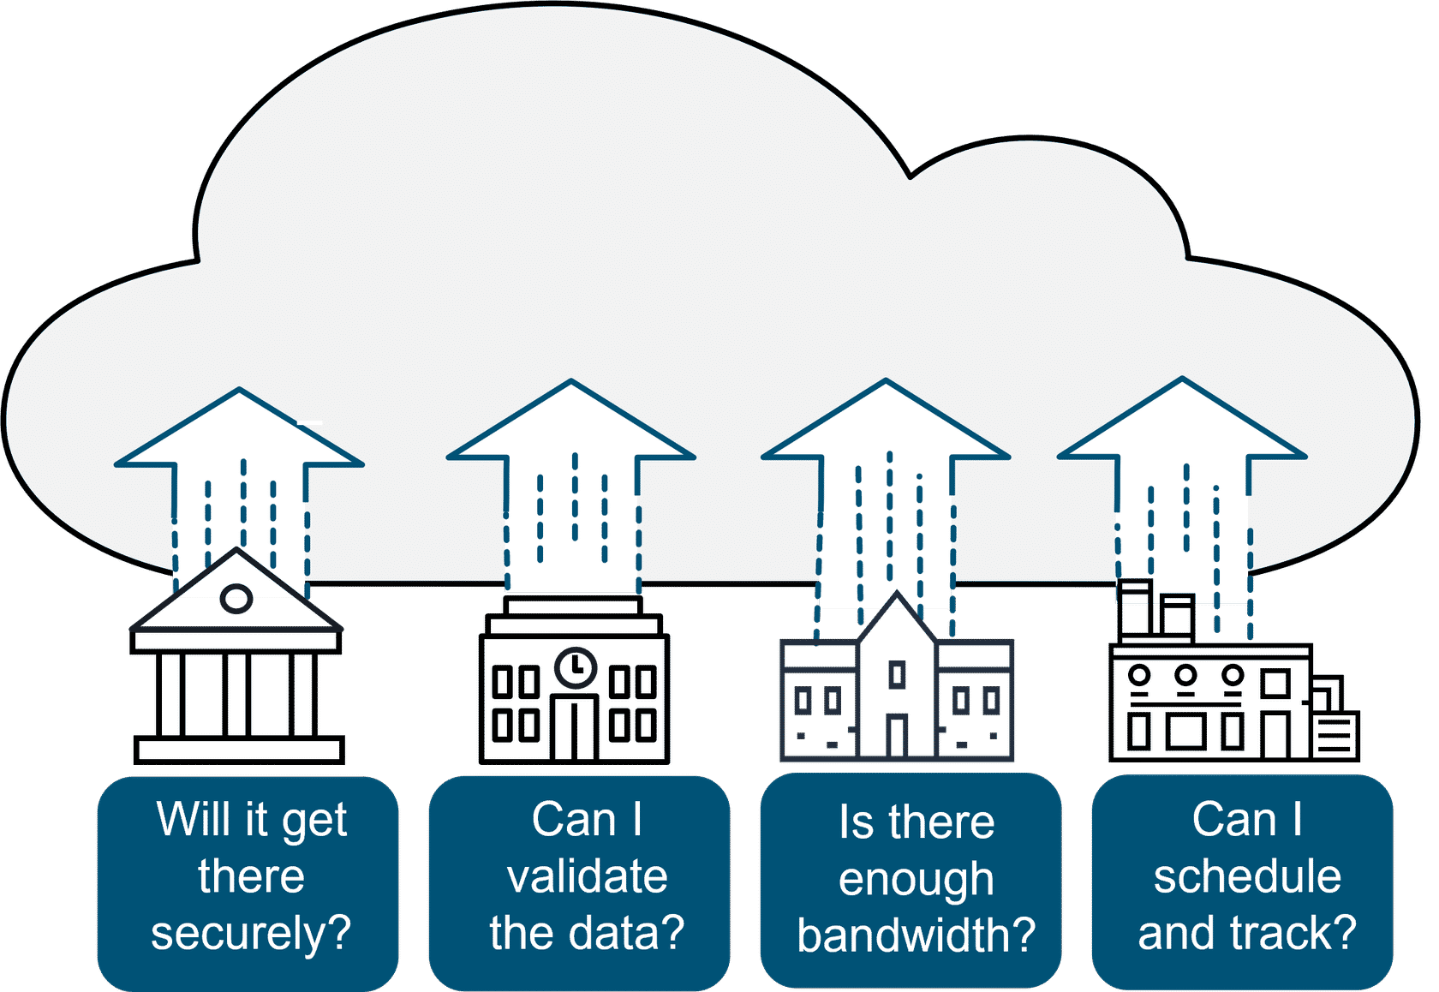
When you migrate data to the AWS Cloud, there are a few considerations to keep in mind. You need to ensure security (will it get there safely), data validation (will it get there in one piece), scheduling (when is the best time). You would also confirm bandwidth requirements. For the majority of data migration workloads, AWS DataSync will do the job.
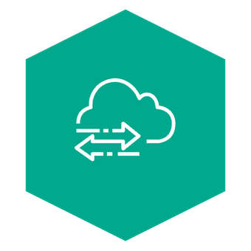
AWS DataSync
AWS DataSync is specifically designed for automating and accelerating data transfer. DataSync simplifies and accelerates moving large amounts of data between on-premises storage and AWS storage services like Amazon Simple Storage Service (Amazon S3). It automates many aspects of the transfer process, including running instances, encryption, and network optimization.
Benefits: The benefits include streamlining and accelerating secure data migrations. DataSync manages data movement workloads with bandwidth throttling, migration scheduling, task filtering, and task reporting. It also provides rapid data replication.
Use cases: You can use DataSync to migrate your data, archive your cold data, and manage hybrid data workflows.
The next service provides fully managed support for file transfers into and out of Amazon S3. It supports many different transfer protocols. A transfer protocol is a set of rules or standards that govern the way data is moved from one location to another.

AWS Transfer Family
The AWS Transfer Family makes it possible to seamlessly manage and share data with simple, secure, and scalable file transfers. This service provides fully managed support for secure file transfers over FTP, Secure File Transfer Protocol (SFTP), File Transfer Protocol Secure (FTPS), and other protocols. It helps you transfer files directly into and out of AWS storage services like Amazon S3 and Amazon EFS.
Benefits: The benefits include simplifying the process of setting up and managing file transfers and reducing the need for complex infrastructure management. The Transfer Family provides secure data transfer with encryption and authentication, to ensure data integrity and confidentiality. It is built to scale and streamline workflows.
Use cases: You can use the Transfer Family to modernize and manage your file transfers, simplify data sharing with your workforce and partners, and integrate transactional business data into a unified data lake.
You might remember Direct Connect from the networking module. With the bandwidth of a dedicated connection, it is also a great solution for moving your data online to the AWS Cloud when migrating.

Direct Connect
AWS Direct Connect is a service that makes it possible for you to establish a dedicated private connection between your network and virtual private cloud (VPC) in the AWS Cloud. Because it is your dedicated connection, it is a fast, reliable, and secure way to transfer your data or files.
Benefits: Direct Connect helps reduce network costs and increase amount of bandwidth.
Topic : Transferring Data Offline
In this lesson, you will learn how to do the following:
- Describe AWS Snowball Edge device use cases.
- Describe Snowball Edge device benefits.
In this lesson, you will review a service for transferring data offline, when AWS DataSync doesn't meet your requirements for transferring data online.
Alternatives for data migration
Transferring data offline
Many customers prefer online migrations, but there are some customers who need to transfer data offline. An example would be if bandwidth is limited, or in remote locations with no internet and Direct Connect is not an option. Or, in cases with large data volumes, sending petabytes of data over the internet would take longer than simply sending a physical device. In the following section, you will review AWS Snowball Edge Storage Optimized devices.
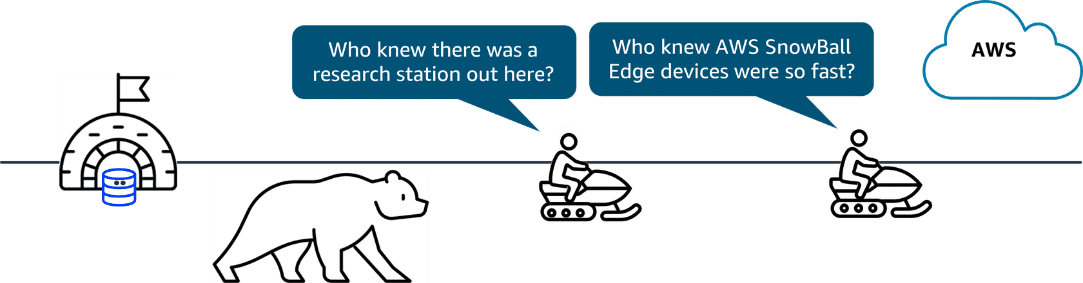
Alternatives for data migration

Snowball Edge Storage Optimized devices
AWS Snowball Edge Storage Optimized devices are a great solution for offline data migration where connecting to the internet might not be an option. These devices deliver high performance NVMe storage, making it possible to simplify multi-petabyte data migrations from on-premises locations to AWS.
Benefits: The benefits include delivering better compute performance and larger storage capacity with gigabytes of data per second for data migration workloads with offline requirements.
Use cases: You can use Snowball Edge devices for data migration when offline migration is required. They can also be used for edge computing when a secure, rugged device is needed.

Topic: Module Summary
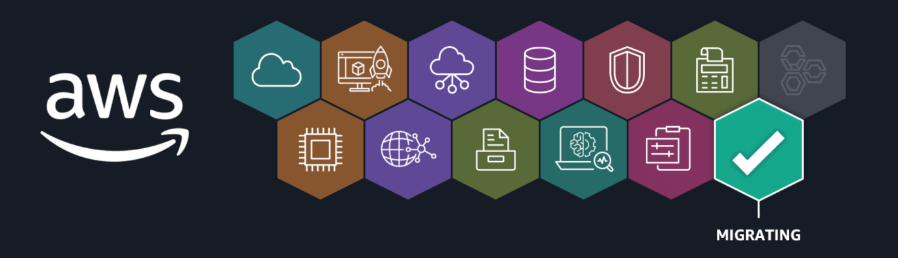
Recap and next steps
In this migration module, you identified the AWS Cloud Adoption Framework (AWS CAF), the seven migration strategies, and migration services to migrate applications, databases, and data.
Resources
To learn more about the material covered in this module, choose the resource links in the following table.
Resource link | Description
Three Phases of Migration | In performing a large-scale migration, there are typically three phases: assess, mobilize, and the last phase, migrate and modernize.
AWS Cloud Adoption Framework | AWS CAF is a framework that brings AWS experience and best practices to companies preparing to migrate to the AWS Cloud. The framework provides tools to help accelerate the migration journey, organize resources, and align management during the transition.
Seven Migration Strategies (7 Rs) | When migrating to the cloud, there are seven common migration strategies that customers can choose to implement. They are relocate, rehost, replatform, refactor, repurchase, retain, and retire.
Migration Evaluator | The Migration Evaluator is a migration assessment service that helps you create a business case for AWS Cloud planning and migration. It does this with a data-driven approach, analyzing your current state and target state, and developing a migration readiness plan with projected cloud costs.
AWS Application Discovery Service | Application Discovery Service discovers on-premises server inventory and connections. It gathers configuration, performance, and connection details for both servers and databases to create a detailed migration plan.
AWS Application Migration Service | Application Migration Service is a tool to migrate and improve your on-premises and cloud-based applications. It helps customers simplify, expedite, and reduce the cost of migrating and modernizing applications.
AWS Migration Hub | Migration Hub is a centralized hub to take you from discovery to assessment, planning, and implementation of your migration. It provides tools, guidance, and automated recommendations to collaborate with your team and track your migration.
AWS Database Migration Service (AWS DMS) | AWS DMS makes it possible to quickly and securely migrate databases to the AWS Cloud. It provides a way to plan, assess, convert, and migrate databases even with data warehouses in one central tool.
AWS Schema Conversion Tool (AWS SCT) | AWS SCT is a service that makes it possible to convert database schemas and code objects (like stored procedures, views, and functions) from one database engine to another.
AWS DataSync | DataSync is specifically designed for automating and accelerating secure data migrations. DataSync manages data movement workloads with bandwidth throttling, migration scheduling, task filtering, and task reporting. It also provides rapid data replication.
AWS Transfer Family | Transfer family makes it possible to seamlessly manage and share data with simple, secure, and scalable file transfers. This service provides fully managed support for secure file transfers over SFTP, FTPS, FTP, and others. It helps you transfer files directly into and out of AWS storage services like Amazon S3 and Amazon EFS.
AWS Direct Connect | Direct Connect is a cloud service that you can use to establish a private, dedicated network connection between your on-premises network and AWS.
AWS Snow Family | AWS Snowball Edge Storage Optimized devices are a great solution for offline data migration where connecting to the internet might not be an option. Snowball Edge Storage Optimized devices deliver high performance storage, and make it possible to simplify multi-petabyte data migrations from on-premises locations to AWS.

