Module 13: Well Architectured Solutions

Topic : Introduction
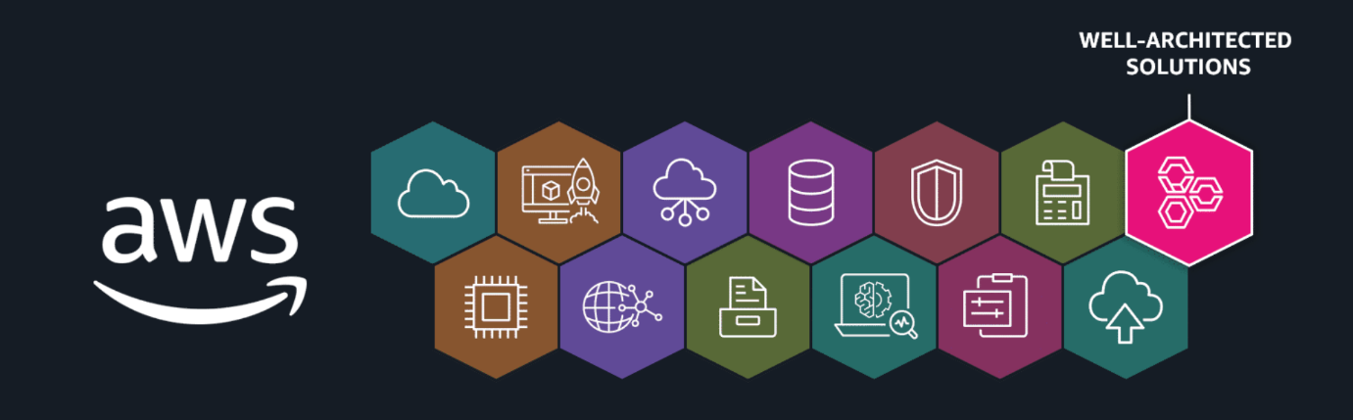
Before we cross the finish line, let’s take a quick pause and appreciate how far you’ve come. You’ve been introduced to a wide range of AWS services, learned how to piece them together, and gained a strong foundation for building in the cloud. But you are not done yet. With only a few topics left, it’s time to level up your understanding even further. In this next section, we will highlight a few more AWS services—ones designed for development, business applications, end-user computing, and Internet of Things (IoT) solutions. Plus, you will be introduced to a powerful resource that helps you assess whether your cloud architecture is functional, efficient, secure, and built to last: the AWS Well-Architected Framework.

Topic : AWS Specialized Services

In this lesson, you will learn how to do the following:
- Identify key AWS services used to develop, deploy, and troubleshoot applications.
- Identify key AWS services used to meet business application needs.
- Identify key AWS services used for end-user computing.
- Identify key AWS services used for IoT device management.
Types of services
AWS services are purpose-built for specific use cases. In the following section, you will learn more about the following four types of specialized AWS services:
- Development services
- Business application services
- End-user computing services
- IoT services
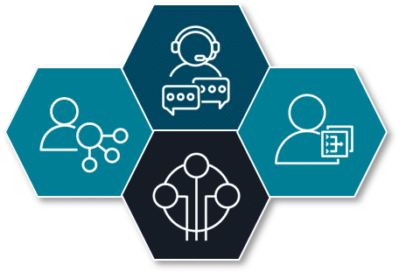
Development services
AWS offers several services to help developers automate CI/CD pipelines, monitor and debug applications, build GraphQL APIs, and deploy web and mobile applications on AWS. Let's examine these services in a bit more detail.


AWS CodeBuild
CodeBuild is a fully managed continuous integration service that compiles source code, runs tests, and produces software packages for deployment. It automatically scales to meet demand, and you only pay for the build time that you use.

AWS CodePipeline
CodePipeline is a fully managed CI/CD service that automates the build, test, and deploy phases of your release process. This helps developers streamline software release workflows and reliably deliver new features and fixes without needing to provision servers.
CI/CD pipelines automate the integration, testing, and deployment of code changes to help provide quick and reliable software delivery.

AWS X-Ray
X-Ray is a powerful tracing, debugging, and performance analysis tool that helps developers visualize application behavior. With X-Ray, developers can quickly identify performance bottlenecks, troubleshoot issues, and optimize applications for better efficiency and reliability.

AWS AppSync
AWS AppSync is a fully managed GraphQL service. With AWS AppSync, developers can create a single GraphQL API that can securely access, manipulate, and combine data from multiple data sources. This helps developers connect frontend applications with backend data.
With GraphQL, a query language for APIs, clients request only the specific data they need.

AWS Amplify
Amplify helps you streamline the process of developing, deploying, and managing secure and scalable full-stack applications on AWS. With Amplify, developers can quickly add features, like authentication, APIs, storage, and hosting, with minimal infrastructure management.
Full-stack applications are software systems that involve both frontend (user interface) and backend (server-side) development.
Business application services
These services are ideal for managing business application needs such as customer service operations and email promotions. Let's review a couple of examples.



Amazon Connect
Businesses can use this AI-powered contact center service to efficiently set up and operate a scalable customer service call center. Amazon Connect provides capabilities for call routing, recording, and analytics while integrating seamlessly with other AWS services.

Amazon Simple Email Service (Amazon SES)
Amazon SES is a scalable and cost-effective email service provider that can be integrated into any application for reliable, high-volume email automation. It helps businesses optimize the delivery of transactional and marketing emails, resulting in enhanced customer engagement.
End-user computing services
In modern businesses, IT departments often need to provide remote access to resources like virtual desktops and applications. Let's explore some AWS services that can be used to set up these environments for employees.


Amazon AppStream 2.0
AppStream 2.0 is a fully managed service that streams applications from the cloud directly to any compatible device. This includes software-as-a-service (SaaS) applications and applications converted from desktop to SaaS without code revisions. This provides instant access to powerful software without the need for high-end local hardware.
In SaaS, applications are hosted on the cloud and accessed through the internet, without the need for local installation or maintenance.

Amazon WorkSpaces
WorkSpaces is a fully managed cloud-based desktop computing service. With WorkSpaces, employees can securely access their work environment from any device with an internet connection. Employees can perform the same tasks as if they were on a physical office computer, while companies can benefit from cost-efficiency and easy administration.

Amazon WorkSpaces Secure Browser (formerly Amazon WorkSpaces Web)
WorkSpaces Secure Browser is a fully managed remote enterprise browser. It provides a protected environment for employees to access private websites, SaaS applications, and the public internet. With WorkSpaces Secure Browser, IT departments don't need to manage specialized client software, infrastructure, or VPN connections.
IoT services
Internet of Things (IoT) is a network of connected physical devices embedded with sensors and software that collect and exchange data over the internet. These devices can be monitored and controlled remotely to improve efficiency, provide new services, and enhance quality of life.
Let's explore an AWS service specifically designed for IoT management.


AWS IoT Core
AWS IoT Core is a managed cloud service used to securely connect physical devices with cloud applications. It helps you create efficient IoT solutions by streamlining the complex process of ingesting, processing, and acting on device data. Device connections and data are secured with mutual authentication and end-to-end encryption, and you can choose from several communication protocols.
Some IoT solutions include the following:
- Smart security cameras – Home monitoring that sends alerts to your phone
- Smart pet feeders – A pet feeder that you can control remotely
- Smart irrigation systems – A rain machine that adjusts watering based on weather and soil conditions
Topic : AWS Well-Architected Framework
In this lesson, you will learn how to do the following:
- Recall the importance of continuous improvement and optimization in cloud architecture.
- Explain the six key pillars of the AWS Well-Architected Framework.
- Describe the AWS Well-Architected Tool (AWS WA Tool).
To help you design cloud solutions that are not just functional but also optimized, AWS offers the Well-Architected Framework. It gives you a structured approach to building secure, high performing, resilient, and efficient architectures aligned with best practices.
Key takeaways: Well-Architected Framework pillars
To review the pillars of the Well-Architected Framework, see descriptions under each of the following flashcards.
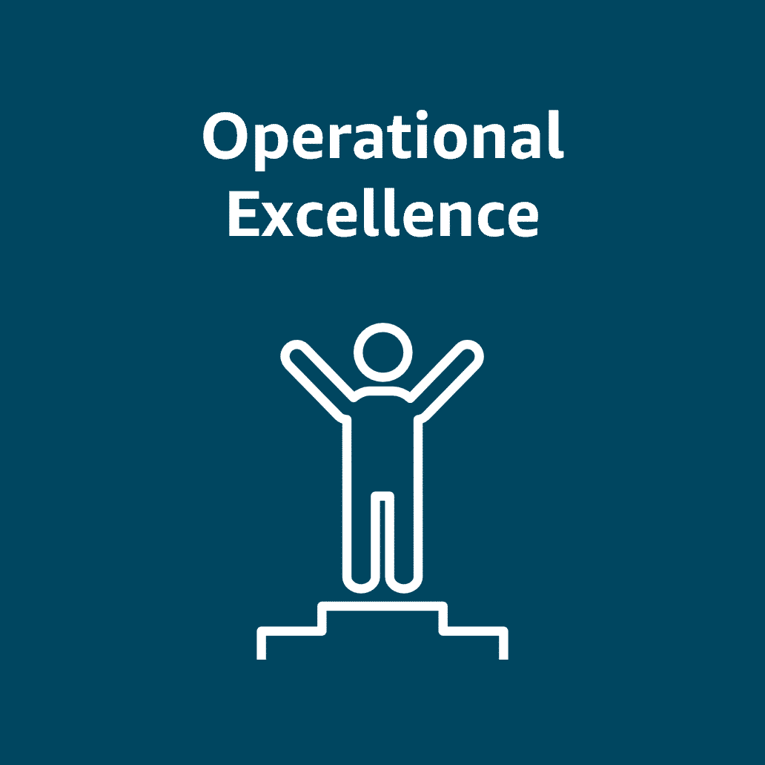
Operational Excellence: Focuses on operations, monitoring, automation, and continuous improvement
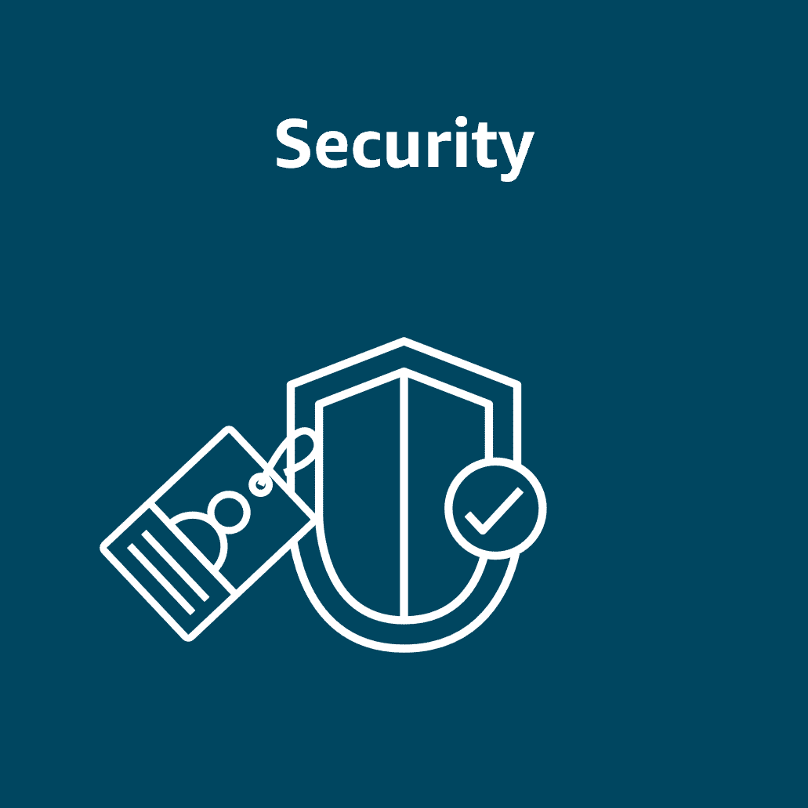
Security: Protects systems and data through best practices like least privilege and data integrity
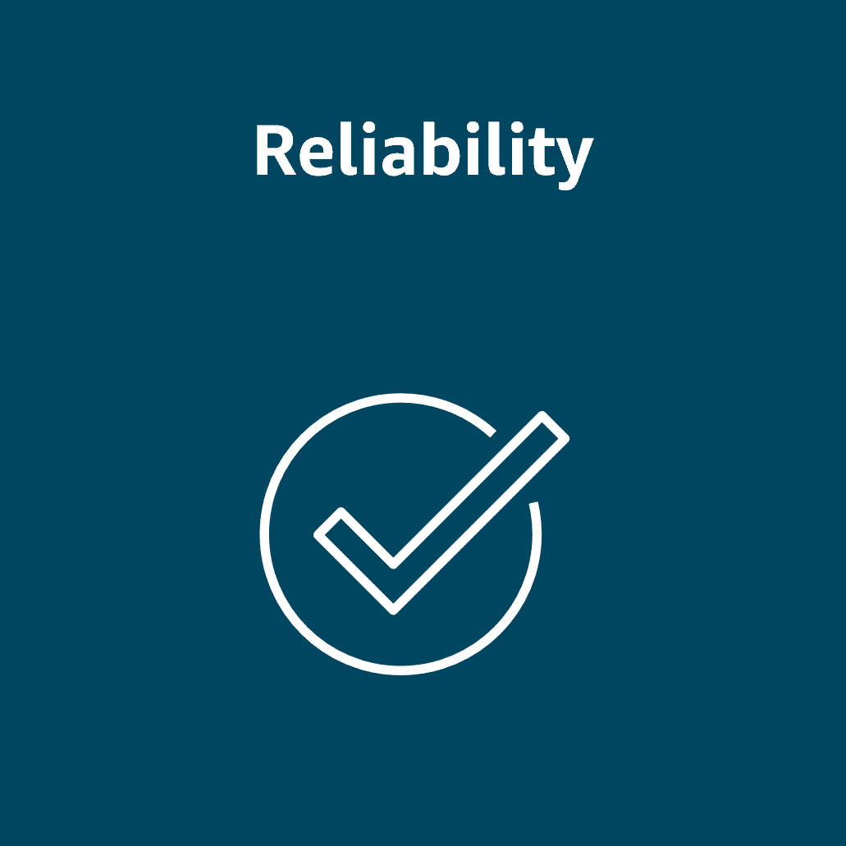
Reliability: Emphasizes recovery planning and system adaptability to meet changing demands
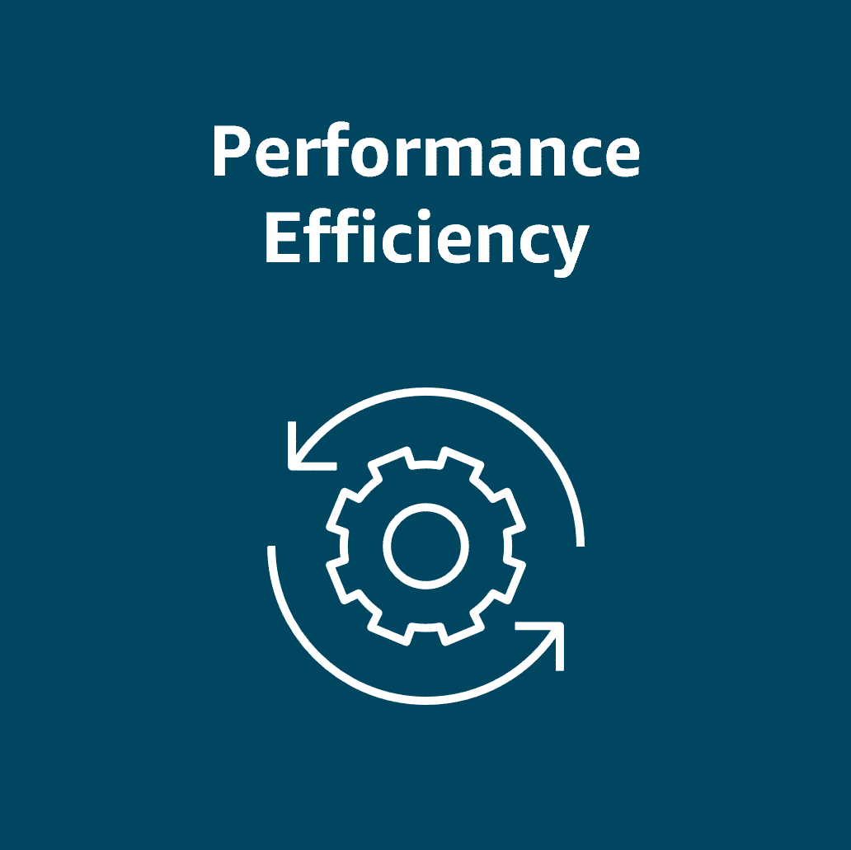
Performance Efficiency: Encourages using the right resources for the job and adjusting as needs evolve
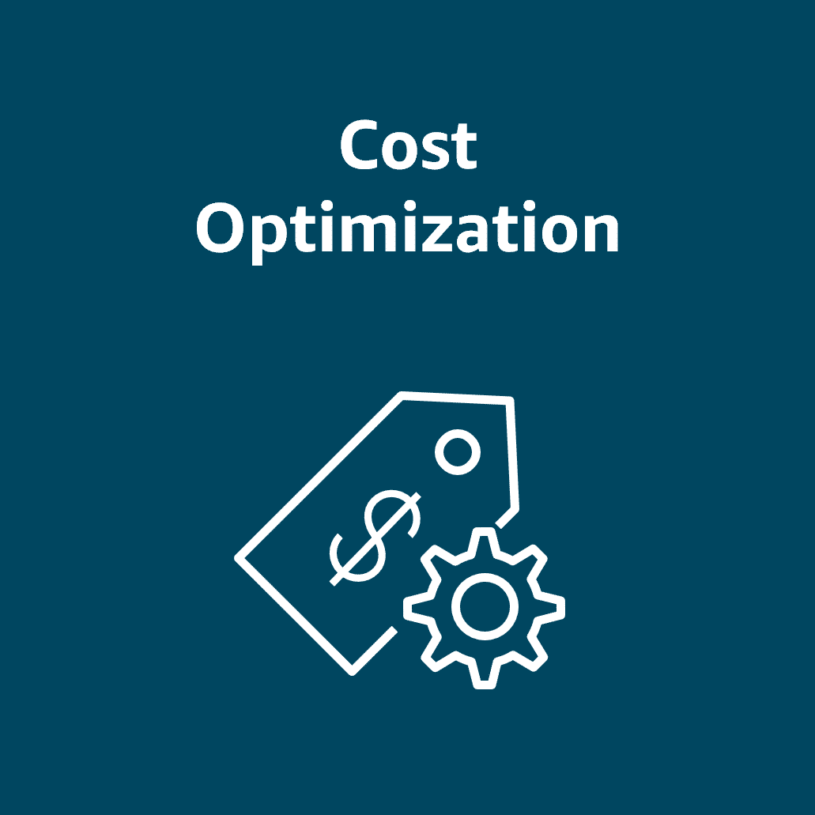
Cost Optimization: Helps control and reduce costs through smart provisioning and resource management
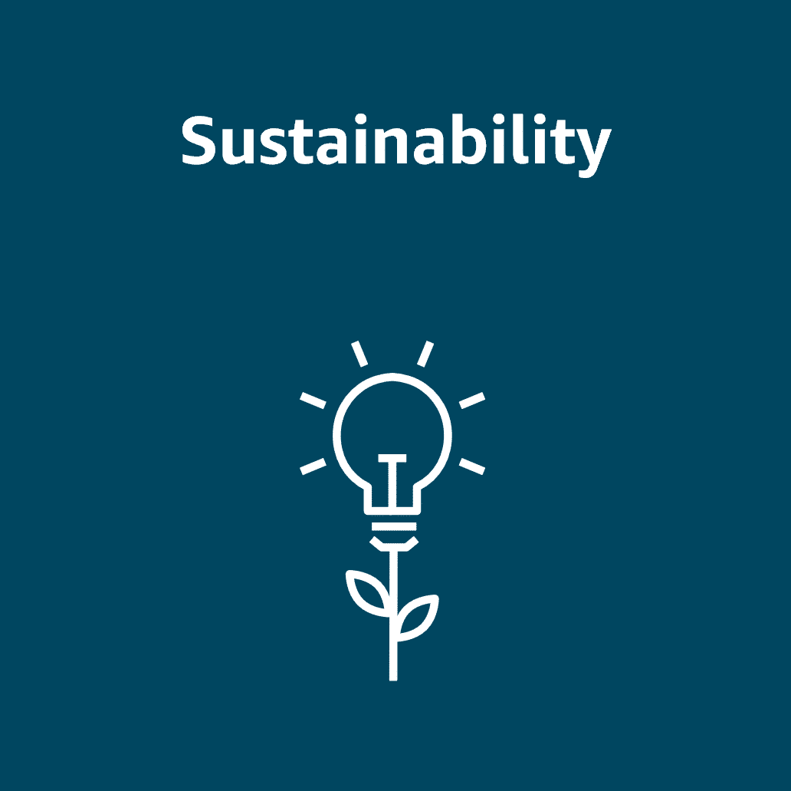
Sustainability: Promotes energy-efficient design and environmentally conscious resource usage

AWS Well-Architected Tool
The AWS Well-Architected Tool (AWS WA Tool) is a free service that helps assess and improve cloud workloads based on the six key pillars: Operational Excellence, Security, Reliability, Performance Efficiency, Cost Optimization, and Sustainability. It offers workload reviews, milestone tracking, and custom lenses for tailored evaluations and improvement plans. Integrated with AWS services like AWS Identity and Access Management (IAM) and APIs, it supports team collaboration and continuous progress tracking. The AWS WA Tool is ideal for architects, engineers, and compliance teams, and it promotes consistent, actionable, and well-documented architecture reviews.
Optimizing a cloud architecture
Imagine you own a bustling online florist business, with orders flowing in during peak times like Valentine’s Day or Mother’s Day. Behind the scenes, the cloud architecture needs to be just as resilient and efficient as the operations. Let’s use the Well-Architected Framework to optimize the system for reliability, performance, security, cost savings, and sustainability.
To learn more about this architecture, review each of the following seven steps.
STEP 1
Starting architecture
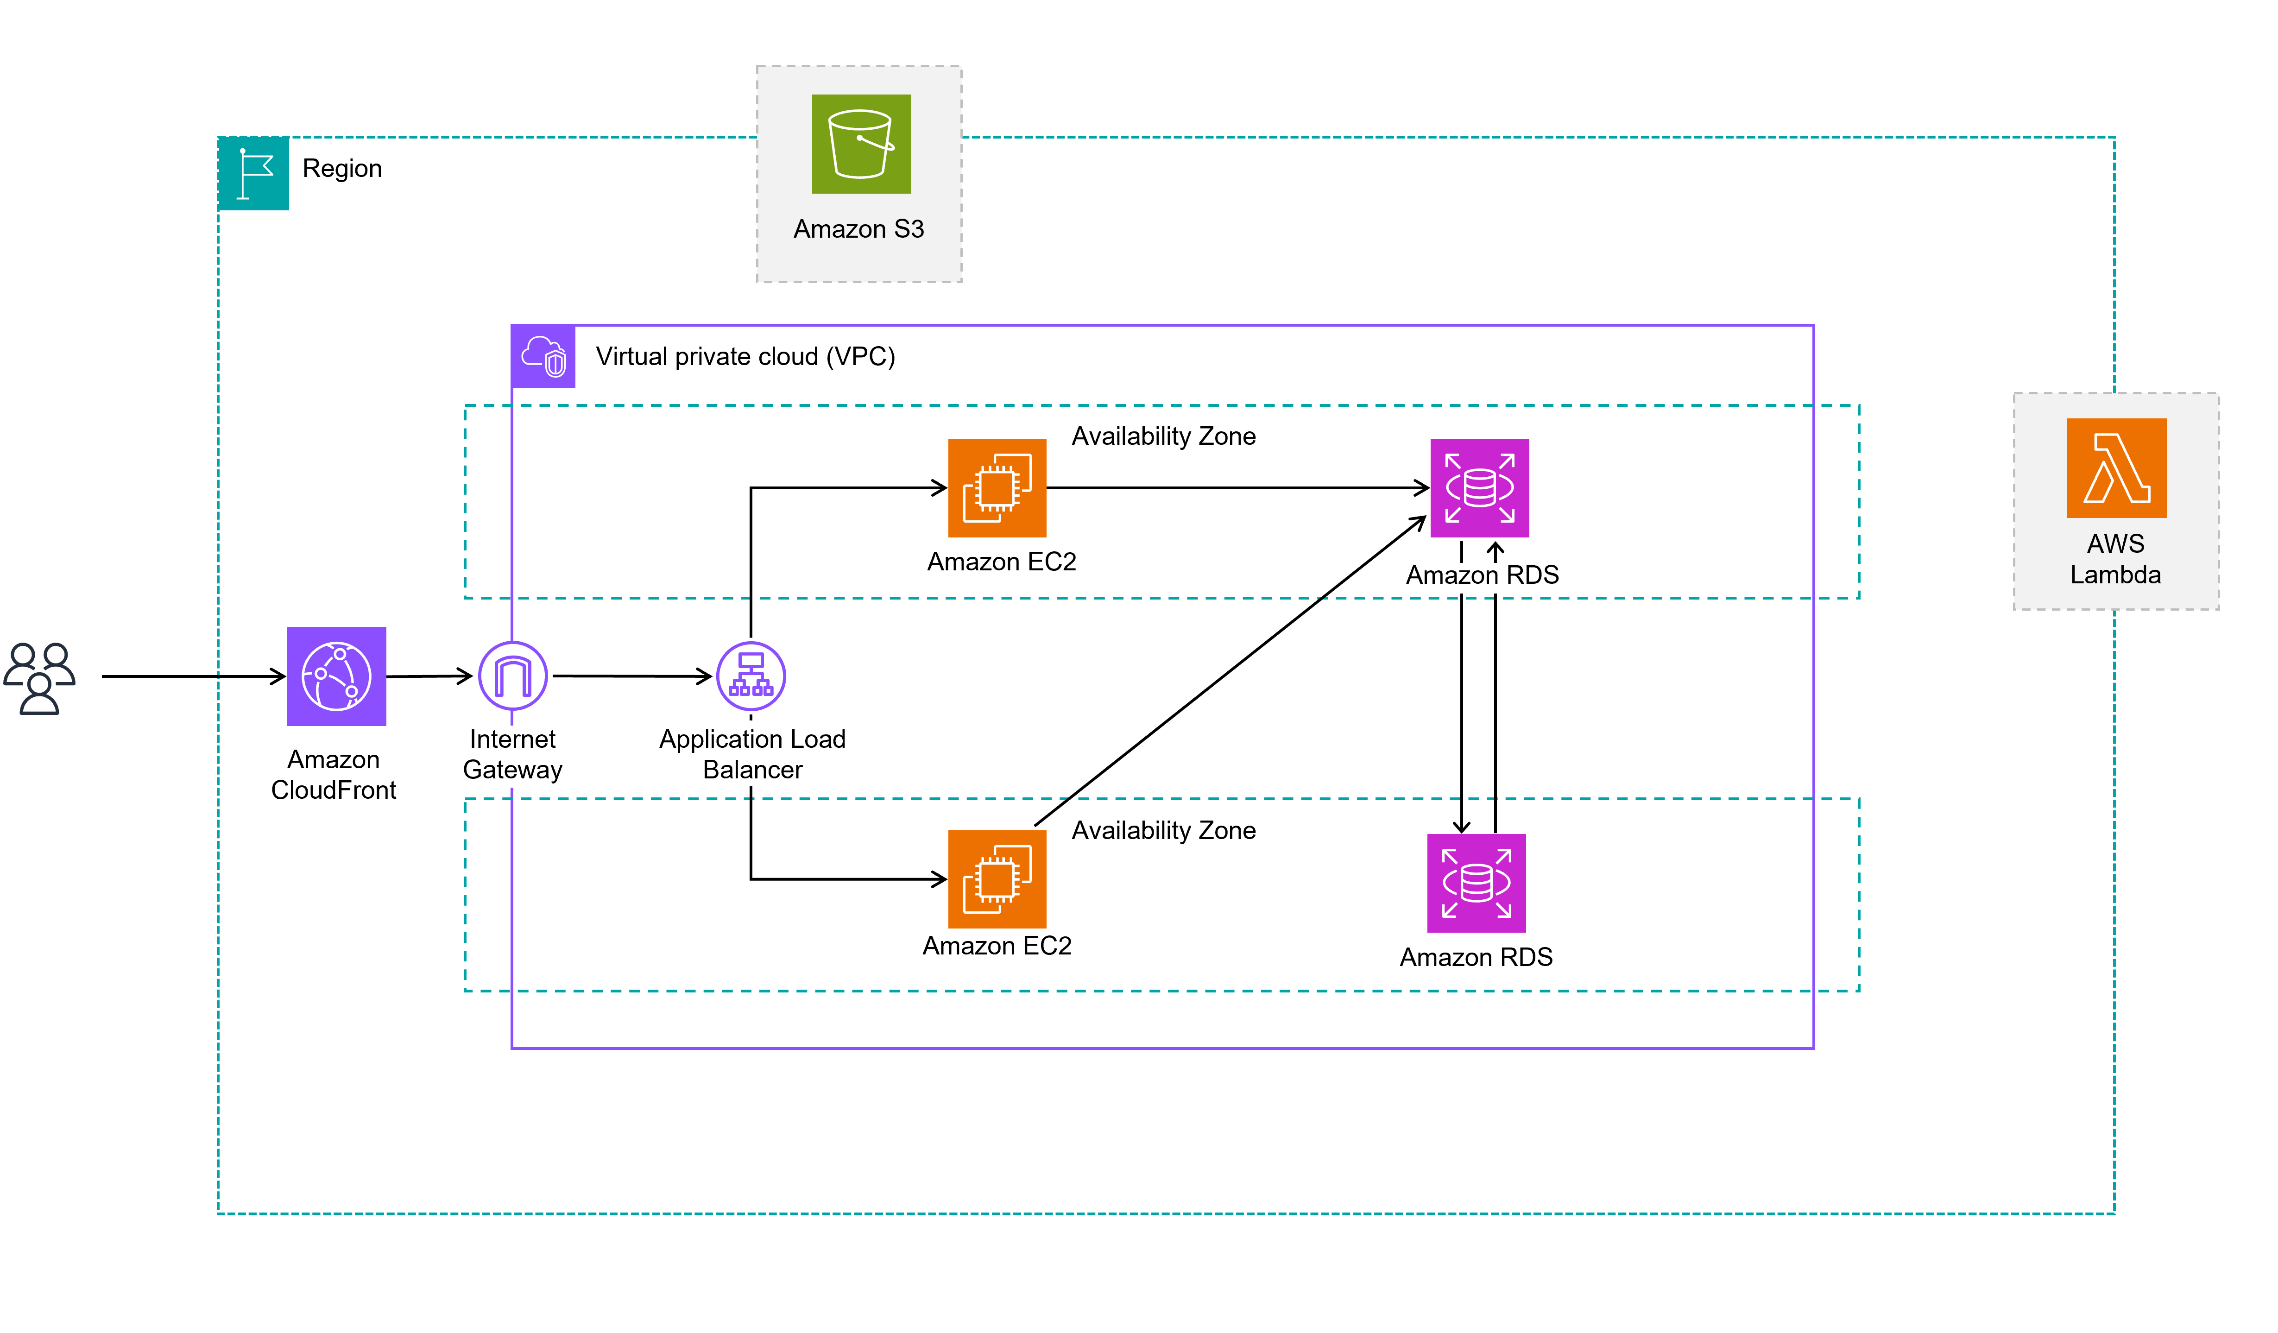
Let’s look at your current setup. You have a classic ecommerce architecture. It includes Amazon Elastic Compute Cloud (Amazon EC2) instances for the website and Amazon Relational Database Service (Amazon RDS) databases to handle orders and customer data. It also has an Amazon Simple Storage Service (Amazon S3) bucket full of product images. It’s functional, but let's evaluate how well it's scaling and handling traffic—especially during busy times.
STEP 2
Operational Excellence
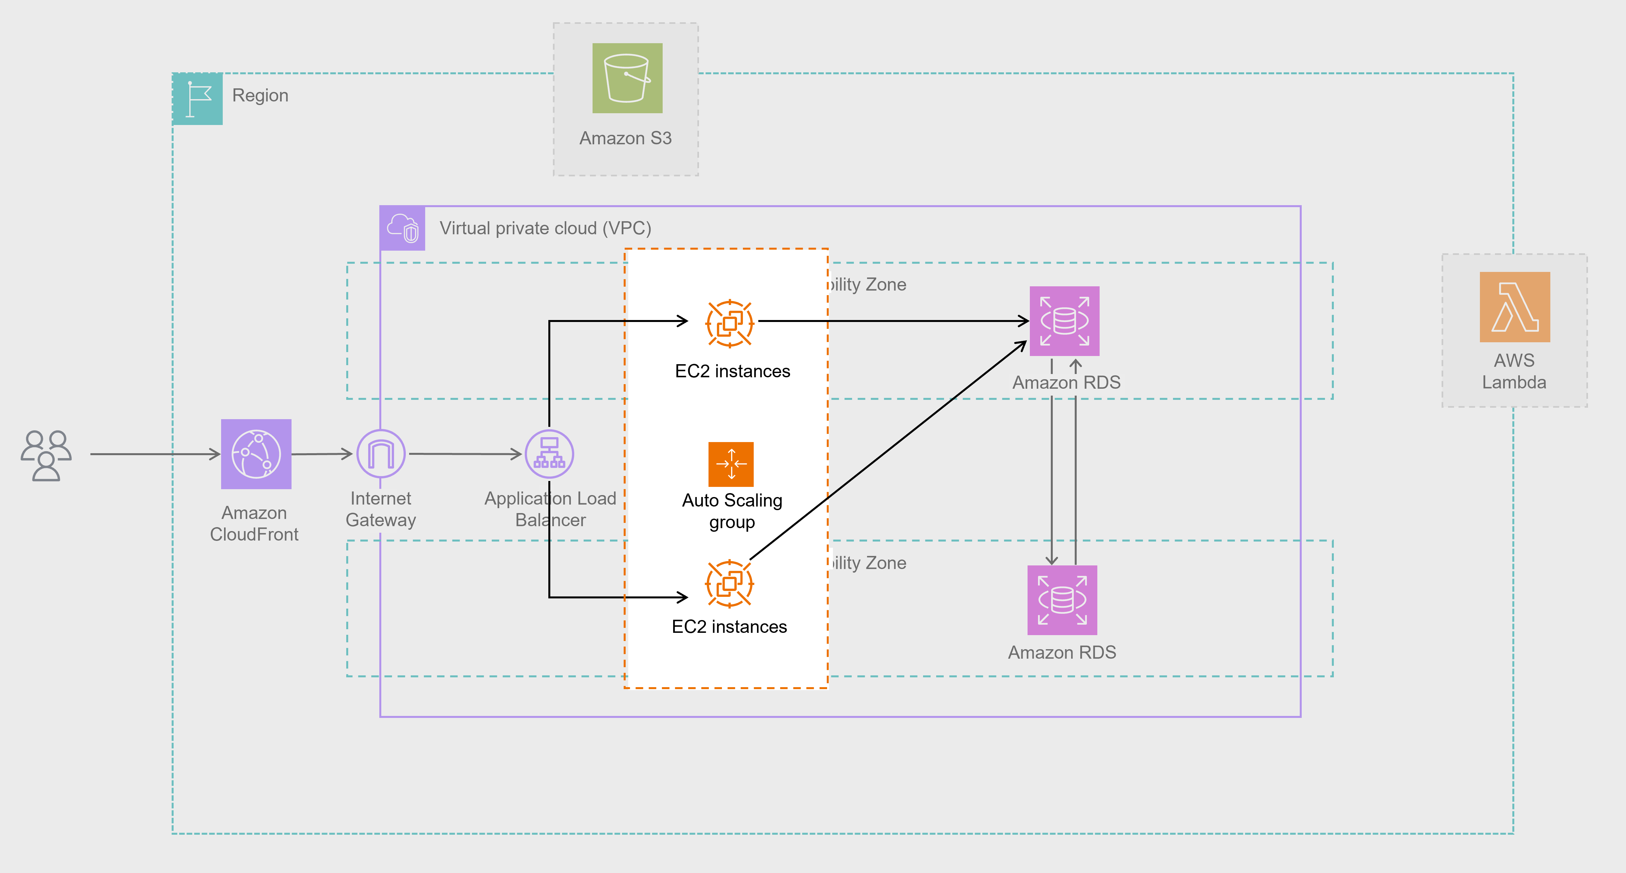
Your business is running smoothly, but what happens if an EC2 instance crashes during a rush of orders? To be truly resilient, you can automate scaling with EC2 Auto Scaling. Additionally, to make day to day operations more reliable and efficient, you can use infrastructure as code and implement self healing mechanisms like auto-rollback. These practices help your system adapt during high-demand periods as well as operate efficiently over time.
Enhancement: EC2 Auto Scaling
STEP 3
Security
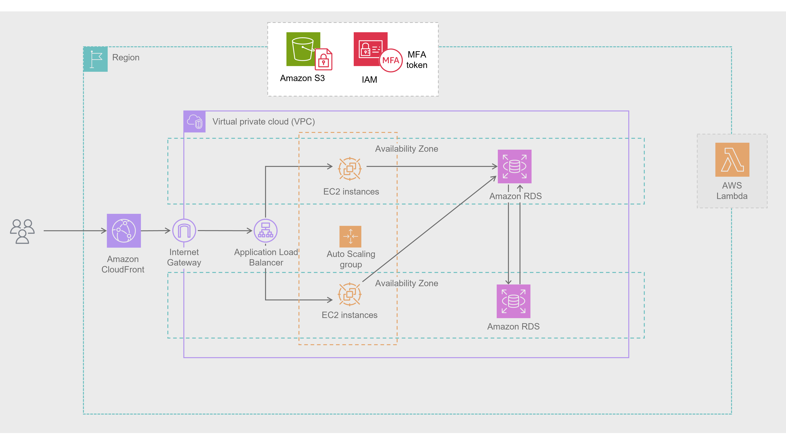
You’ve already got a secure foundation with an Amazon Virtual Private Cloud (Amazon VPC), but there’s more to do. Ask yourself: Are your EC2 instances regularly patched? Do your IAM policies follow the principle of least privilege? Protecting customer data—like names, addresses, and payment info—requires strong encryption for data at rest and in transit, along with fine-grained access controls. Strengthening these layers builds trust with your customers and safeguards sensitive information.
Enhancement: Strengthening encryption and IAM policies
STEP 4
Reliability
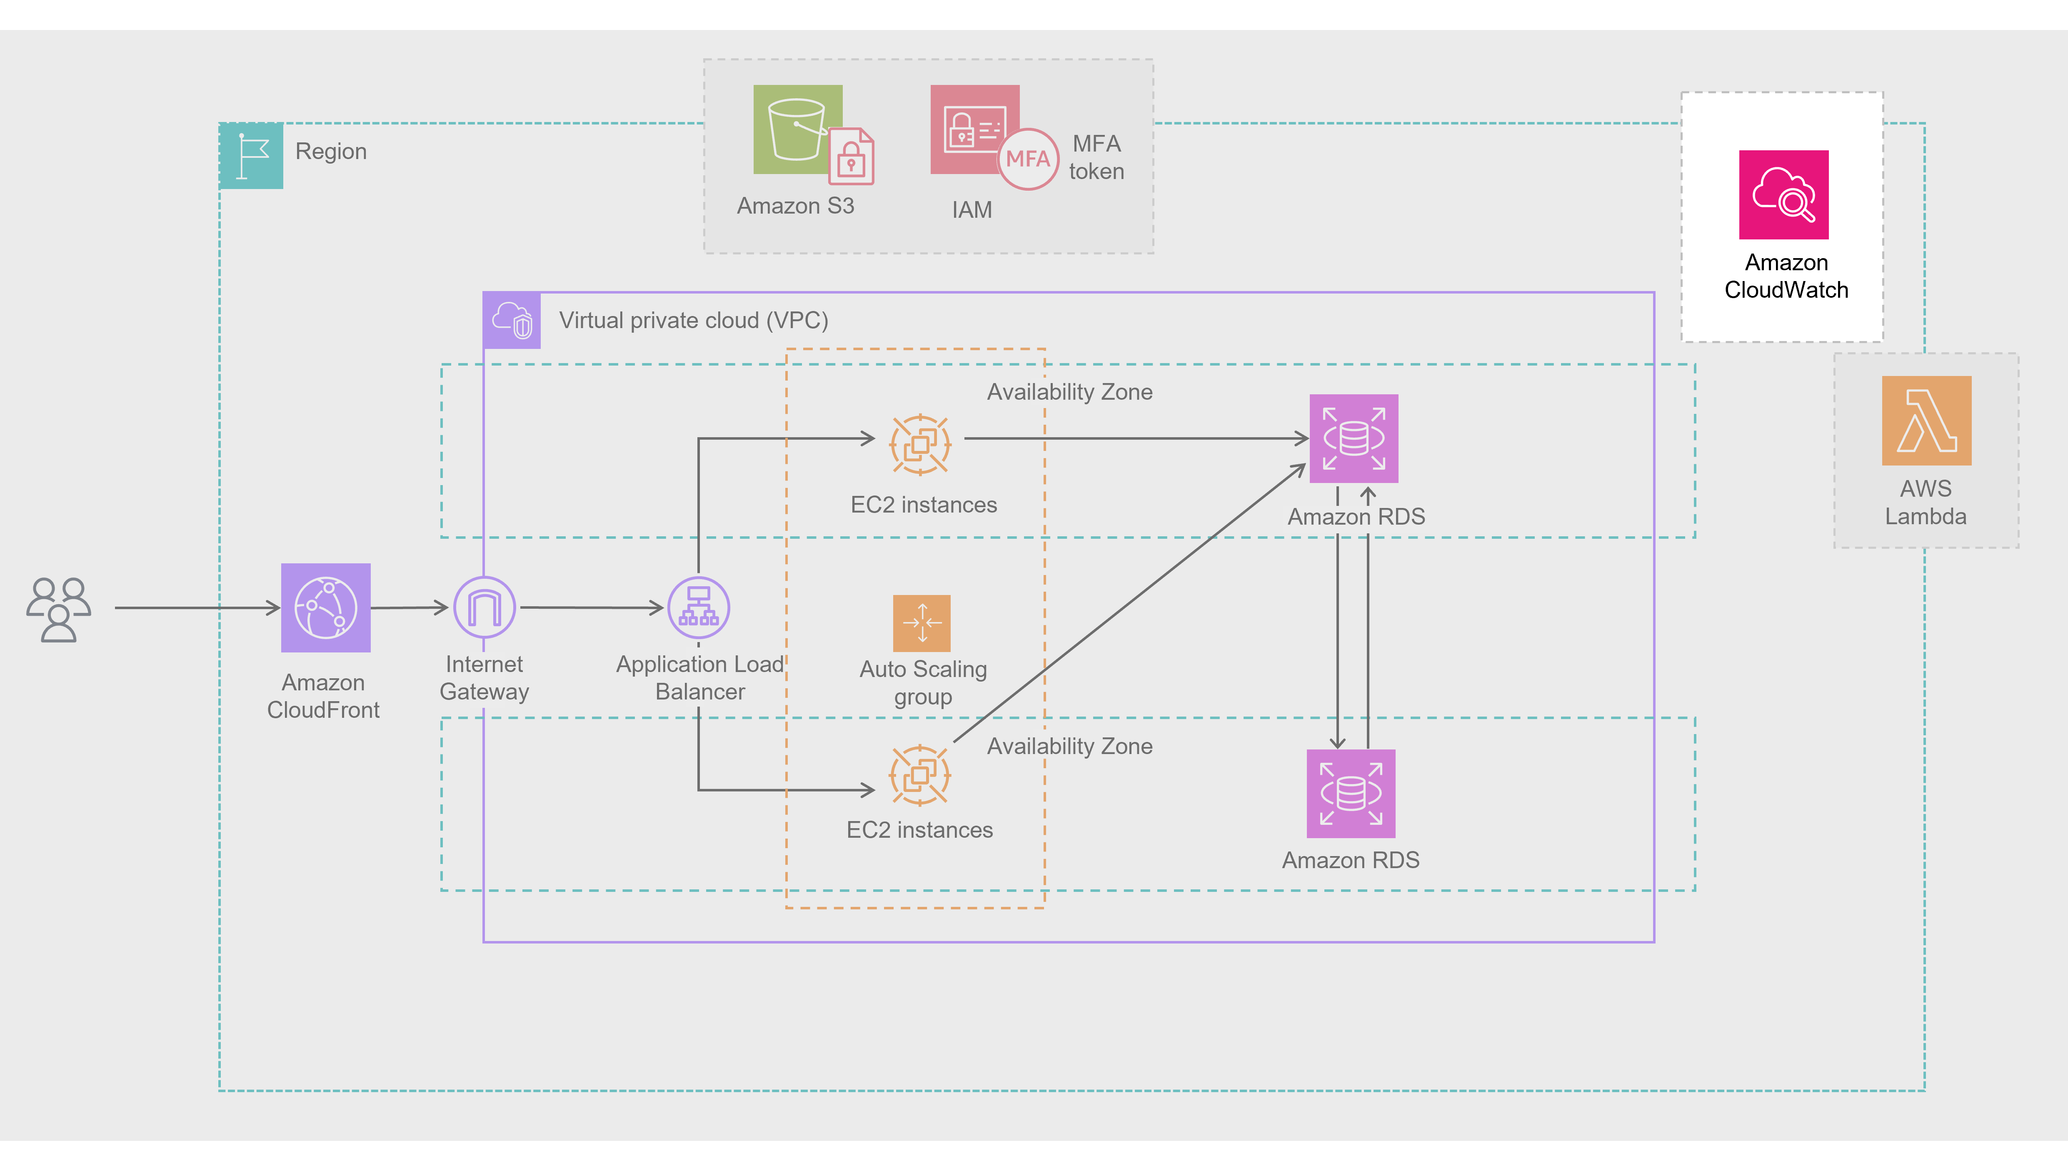
During busy seasons, availability is everything. You’ve already taken a great step by deploying resources across multiple Availability Zones, but you can increase reliability even further. Use Amazon CloudWatch to monitor your system’s health and set up automated recovery actions.
Enhancement: Amazon CloudWatch
STEP 5
Performance Efficiency
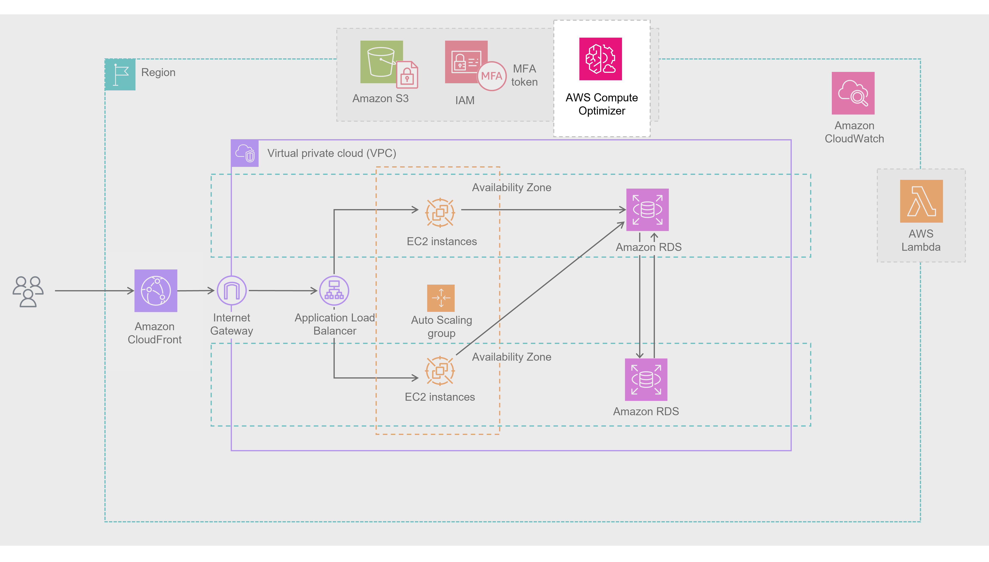
As your business scales, your system should scale with it. Are your EC2 instances and RDS instances rightsized for your workload? AWS Compute Optimizer can help make sure you’re not wasting resources or underprovisioning your infrastructure. You’re already using AWS Lambda for event-driven tasks like image processing, which is great for flexible scaling. Make sure those functions are rightsized, too. And with Amazon CloudFront, you can already deliver product images quickly to global customers for a smooth, fast shopping experience.
Enhancement: AWS Compute Optimizer
STEP 6
Cost Optimization
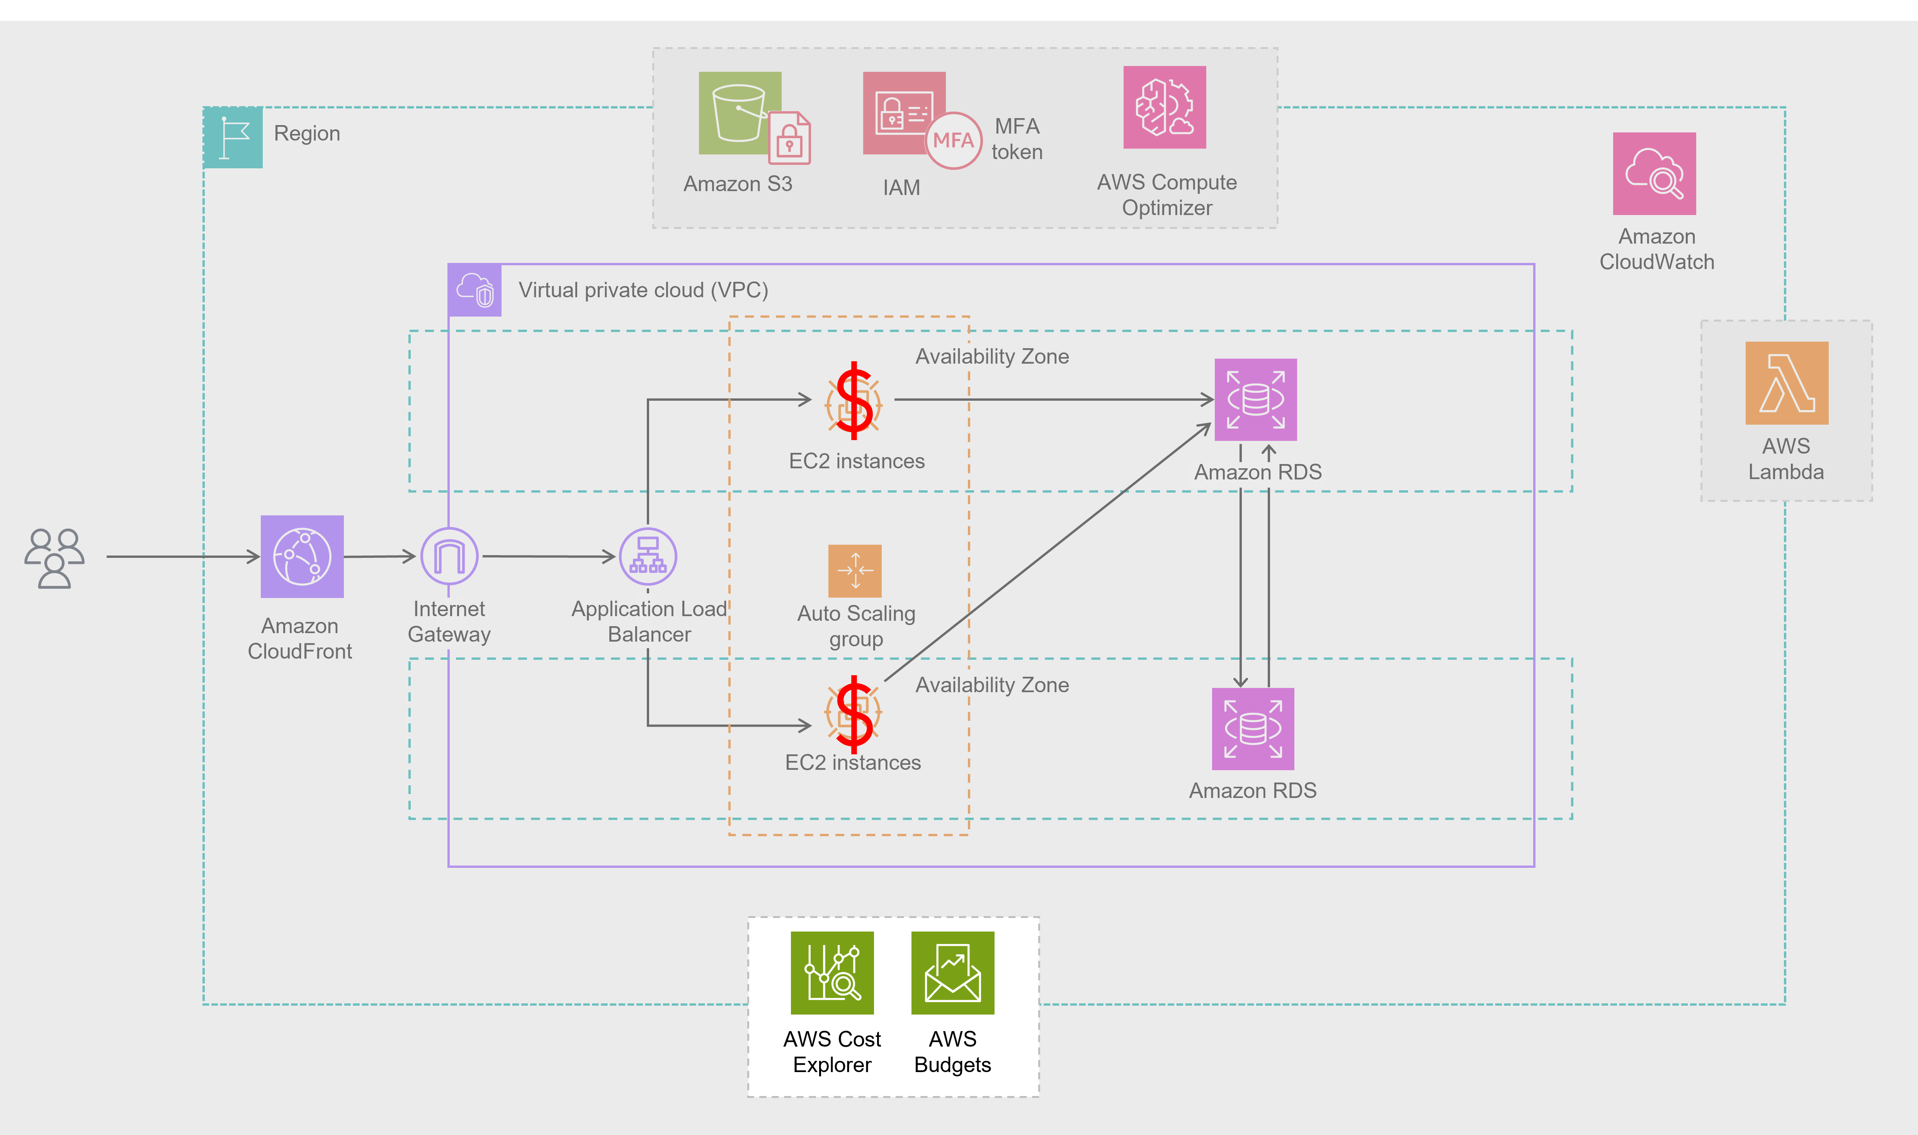
You're currently using On-Demand EC2 instances, which are great to start with, but switching to Spot Instances for variable traffic and Savings Plans for steady workloads can cut costs significantly. Track and manage your cloud spending in real time with AWS Budgets and AWS Cost Explorer. These tools help you make smart, cost-effective decisions while maintaining performance and reliability.
Enhancement: Savings Plans, AWS Budgets, AWS Cost Explorer
STEP 7
Sustainability
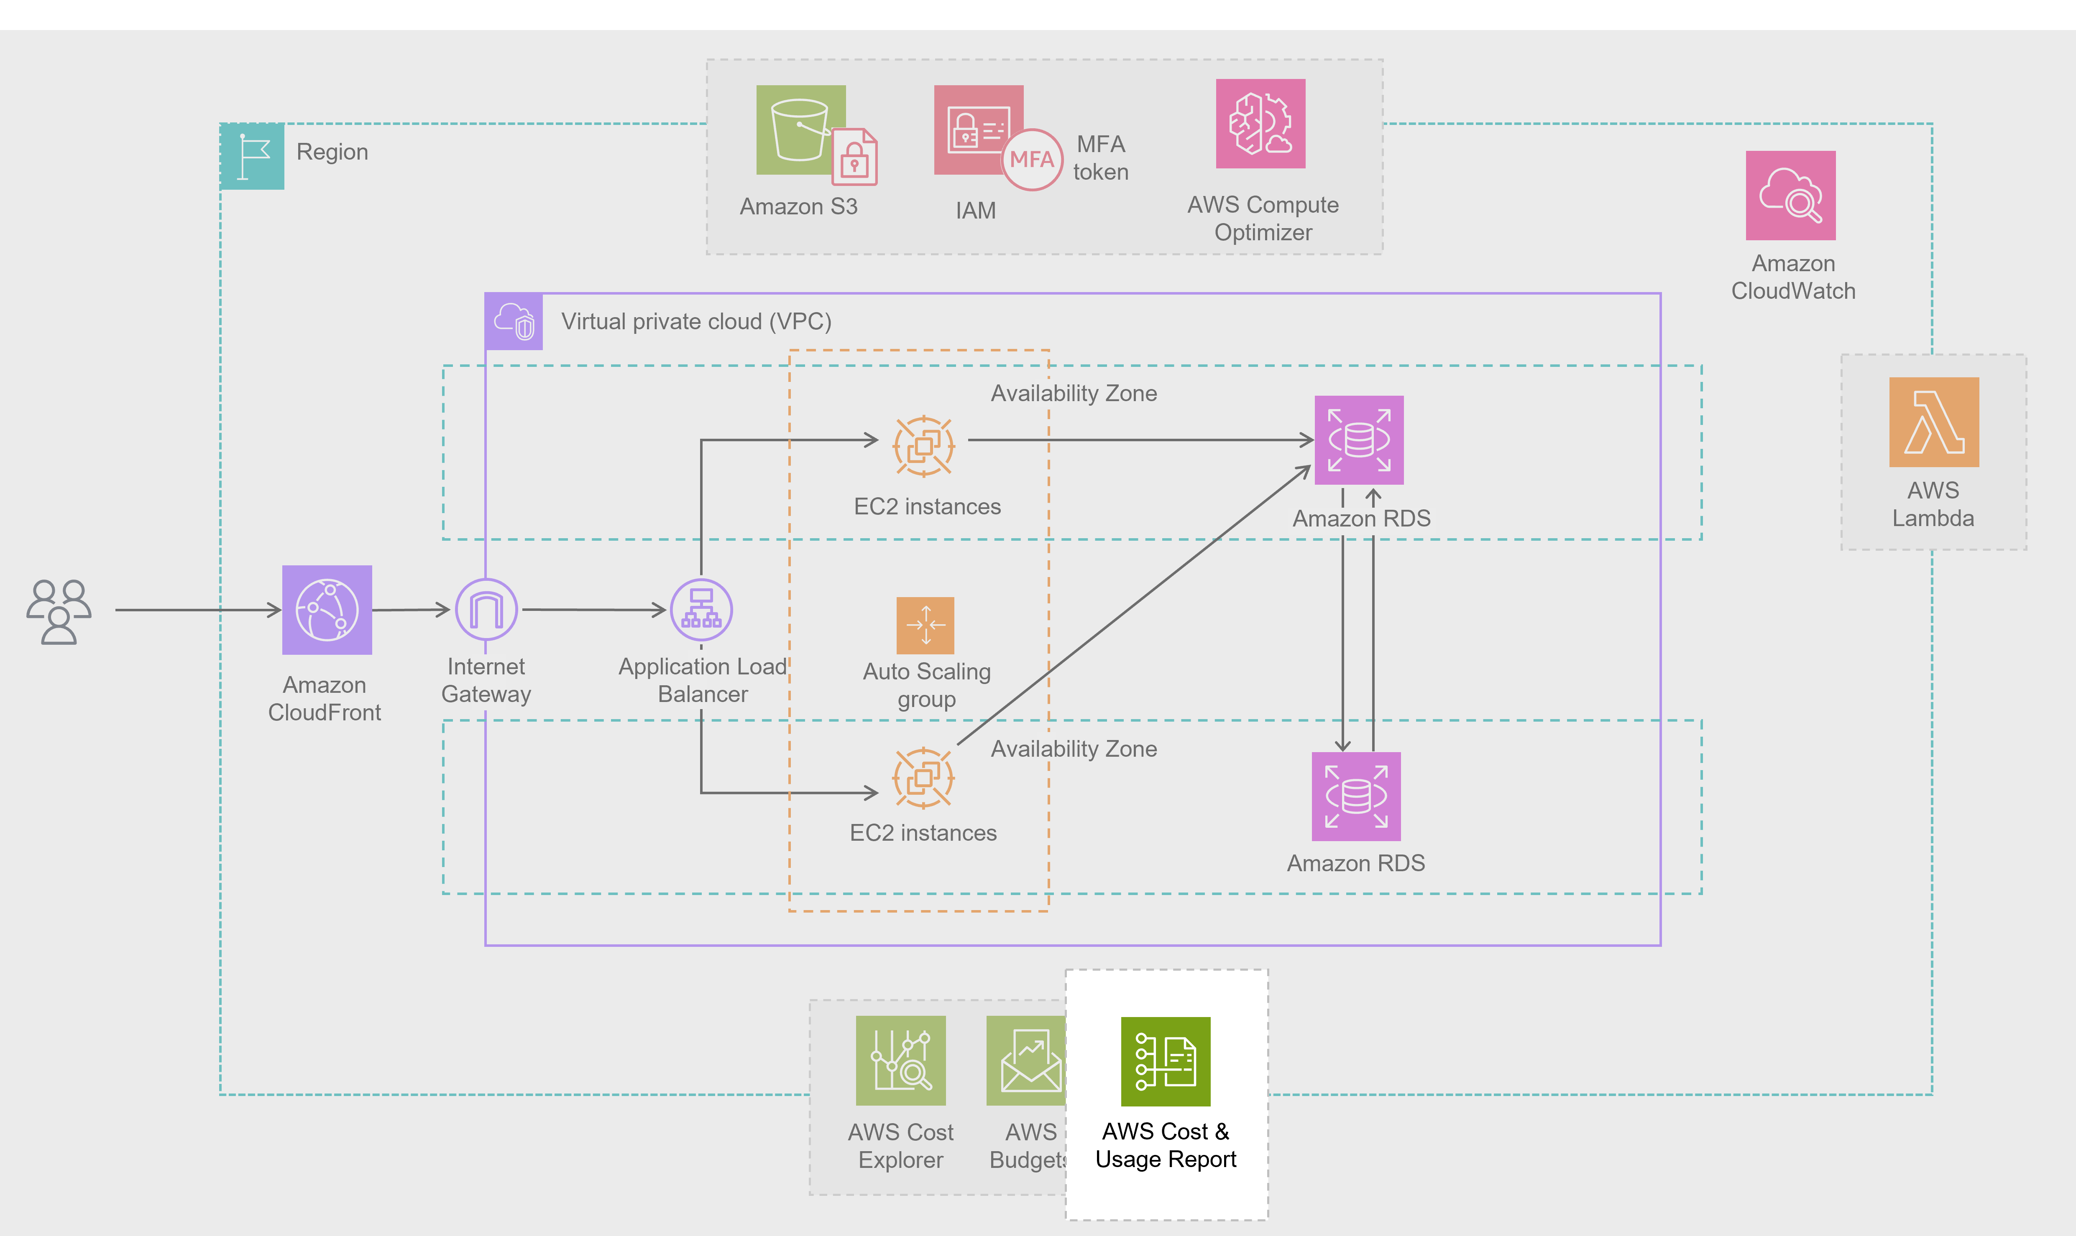
Your use of serverless and elastic resources already reduces your environmental footprint. To go further, continue optimizing workloads to minimize resource waste. Doing so benefits both the planet and your bottom line—proving that environmentally conscious decisions can also be business-smart.
Enhancement: AWS Cost & Usage Report
Topic : Specialized Use Cases
In this lesson, you will learn how to do the following:
- Explain how real-life companies combine specialized AWS services to meet specific business needs.
Specialized use cases architecture diagrams
Delivering customer solutions by combining specialized AWS services
Let's review the solutions discussed in the video. The following architecture diagrams demonstrate how you can combine AWS services together in different ways to solve for specific business problems.
Serverless web backend monitored by X-Ray
This is a typical serverless web backend with X-Ray monitoring the environment. To review the components of this solution, review each of the three numbered markers below the diagram.
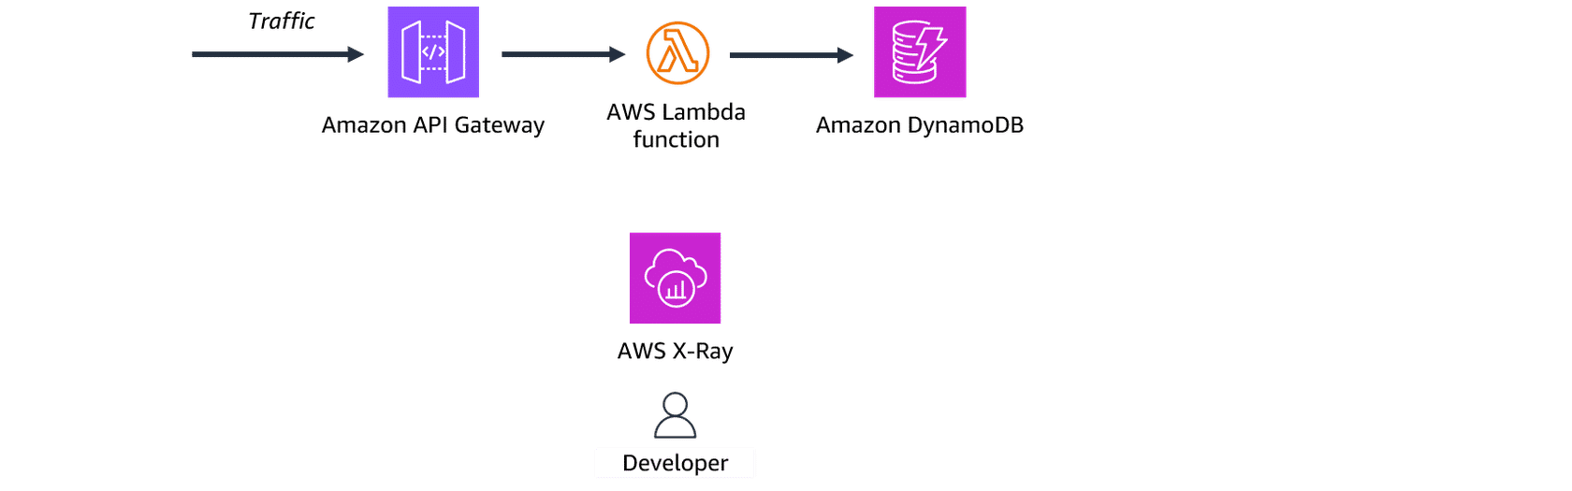
1. Receive traffic
An Amazon API Gateway receives and validates HTTP requests.
2. Trigger Lambda function
The API Gateway triggers a Lambda function that sends requests to Amazon DynamoDB.
3. Monitor traffic
X-Ray traces requests through API Gateway, Lambda, DynamoDB and back to the client. This helps developers troubleshoot any problems.
Serverless static website with contact form
This serverless setup demonstrates a static website with a contact form hosted on Amazon S3. To review the components of this solution, review each of the three numbered markers below the diagram.
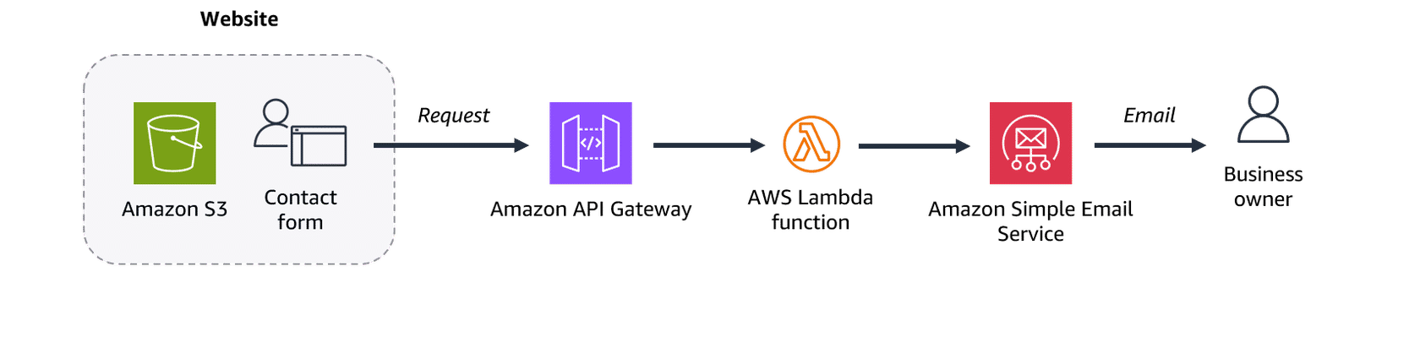
1. Accept customer input
Customers submit questions using a contact form housed on a static Amazon S3 website.
2. Receive request
An API Gateway receives and validates the contact form request.
3. Send email
The API Gateway then invokes a Lambda function that sends an email to the business owner using Amazon SES.
Customer support with callback option
This customer support solution provides an alternate channel and callback option so customers can avoid long wait times. To review the components of this solution, review each of the three numbered markers below the diagram.
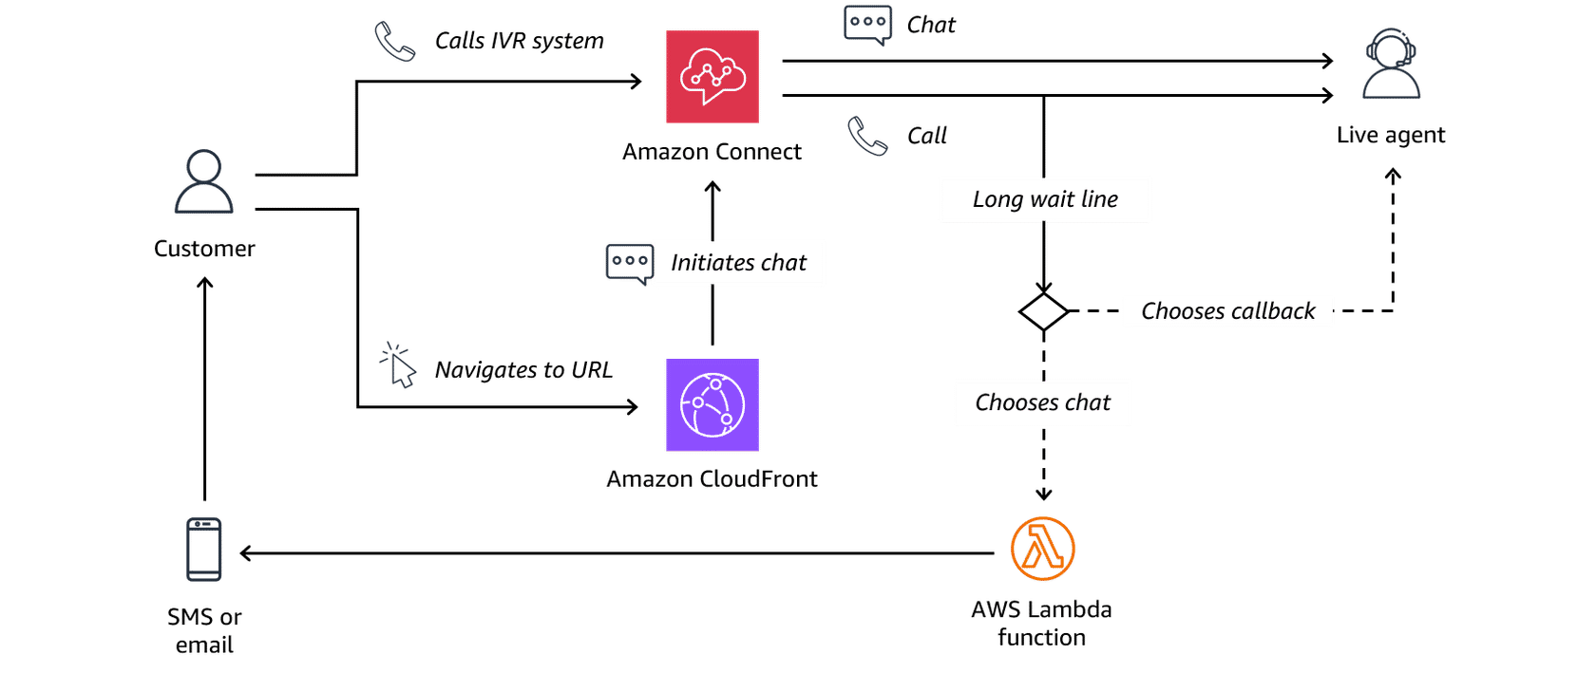
1. Initiate contact
A customer calls or texts a customer support center. Calls are placed into the Amazon Connect interactive voice response (IVR) system. Text messages are routed to Amazon Connect from CloudFront.
2. Connect to agent
Amazon Connect tries to connect the customer with a live agent.
3. Provide options
For calls with long wait lines, customers can choose to receive an agent callback or they can switch to text through a Lambda function.
Topic: Module Summary
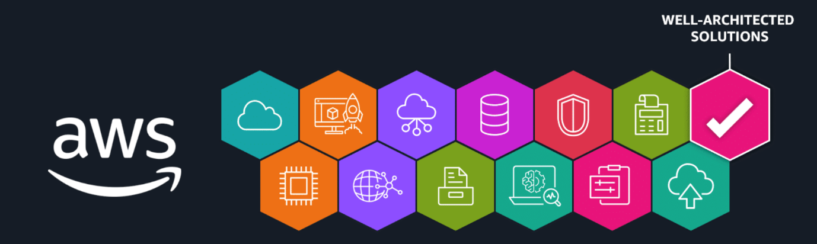
Recap and next steps
In this module, you explored AWS purpose-built services for development, business, and customer support. You examined the AWS Well-Architected Framework and learned about its six pillars: Operational Excellence, Security, Reliability, Performance Efficiency, Cost Optimization, and Sustainability. You also discovered how the AWS Well-Architected Tool helps assess and enhance workloads, so you can align with best practices. Finally, you learned about serverless architectures, highlighting how services like API Gateway, Lambda, and DynamoDB provide scalable, efficient solutions with minimal infrastructure.
Before you go, join Morgan, Alan, and Rudy for a few final thoughts, some encouragement, and a well-earned celebration of everything you’ve accomplished!
Resources
To learn more about the material covered in this module, choose the resource links contained in the following table.
Resource link | Description
AWS CodeBuild | Build scripts for compiling, testing, and packaging your code.
AWS CodePipeline | Automate and monitor CI/CD pipelines.
AWS X-Ray | Monitor and debug applications.
AWS AppSync | Connect applications to multiple data sources using a single GraphQL API request.
AWS Amplify | Quickly develop, deploy, and manage full-stack applications on AWS.
Amazon Connect | Manage customer service operations with artificial intelligence.
Amazon SES | Use automation to send large volumes of transactional and marketing emails.
Amazon AppStream 2.0 | Stream cloud-based and desktop applications to users on compatible devices.
Amazon WorkSpaces | Provide employees with secure virtual desktops.
Amazon WorkSpaces Secure Browser | Provide employees with secure access to web-based applications and sites.
AWS IoT Core | Securely connect devices with cloud applications to create IoT solutions.
AWS Well-Architected | The AWS Well-Architected Framework provides a structured approach to designing and operating secure, high performing, resilient, and efficient infrastructure for applications and workloads on AWS, guided by six key pillars.
AWS Well-Architected Framework | This website is the official documentation for the AWS Well-Architected Framework.
What is AWS Well-Architected Tool? | The AWS Well-Architected Tool provides a consistent process for measuring your architecture using AWS best practices.
AWS Architecture Center | The AWS Architecture Center provides reference architectures and best practices for building secure, efficient, and scalable solutions on AWS.
AWS Architecture Blog | The AWS Architecture Blog shares technical insights and best practices for building effective solutions on AWS.

