Module 8 – AI/ML and Data Analytics

Topic : Introduction to AI and Machine Learning

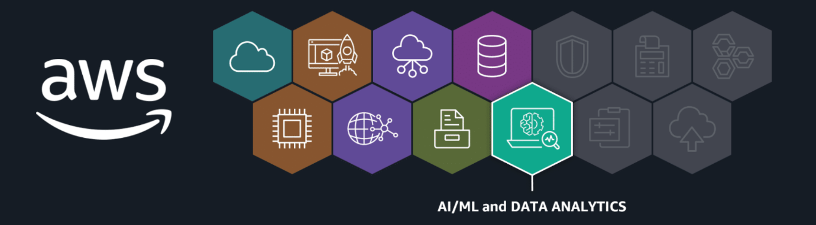
From e-commerce to medical research, high-quality data is used to analyze past events and innovate for the future. AI/ML and data analytics are two fields heavily involved in these processes. In the following lessons, you will learn how AWS Artificial intelligence and machine learning (AI/ML) solutions can help you predict future trends and automate processes. And you will learn how AWS solutions can be used to analyze historical trends and derive insights from data.
In this lesson, you will learn how to do the following:
- Define artificial intelligence (AI) and its subset machine learning (ML).
Let's start with some fundamentals. In the following video, you'll learn the basics of AI and its subset, machine learning.
Key concepts
Let's review a couple of key definitions for artificial intelligence and machine learning. You will build on these concepts in the following lessons.
AI
- Artificial Intelligence is a broad field focused on the development of intelligent computer systems capable of performing humanlike tasks.

ML
- Machine learning is a type of AI for training machines to perform complex tasks without explicit instructions. Machine learning training finds the patterns hidden in vast amounts of historical data to produce an ML model. This ML model can then be applied to new data to make predictions or decisions based on the patterns it's learned.
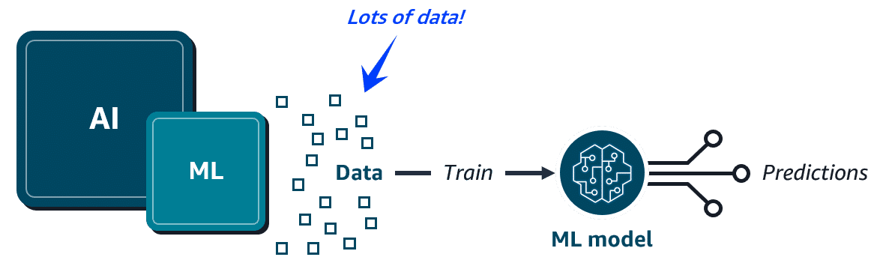

Topic : AI/ML AWS

In this lesson, you will learn how to do the following:
- Identify common business use cases for AI/ML.
- Identify the three tiers of AI/ML solutions offered by the AWS AI/ML stack.
Key concepts
AI/ML helps solve for many common business use cases. At AWS, solutions for these common use cases, and others, are offered through the AWS AI/ML stack.
Common ML business use cases
- ML models power the Amazon.com e-commerce recommendations engine. But, ML can solve for lots of other business use cases, such as the following:
  - Predict trends, such as future stock prices.
  - Make decisions, like routing callers to the right department.
  - Detect anomalies, such as bank fraud.
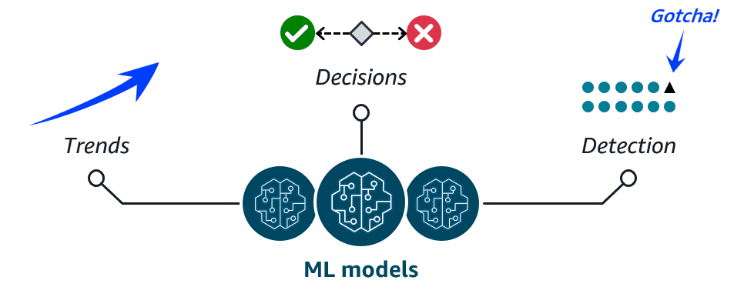
AWS AI/ML solutions
- The AWS AI/ML stack is composed of the following three tiers of solutions:
  - AI services - pre-built models that are already trained to perform specific functions
  - ML services - a more customized approach with Amazon SageMaker AI where you build, train, and deploy your own ML models with fully managed infrastructure
  - ML frameworks and infrastructure - a completely custom approach to building models using purpose-built chips that integrate with popular ML frameworks


Topic : AWS AI/ML Solutions
In this lesson, you will learn how to do the following:
- Describe the benefits and purpose of the services contained in each tier of the AWS AI/ML stack.
Let's examine the three tiers of the AWS AI/ML stack in more detail. You can think of the tiers as a progression from pre-built, easily deployable managed solutions to highly customized solutions that require more skill to implement.

Tier 1: Pre-built AWS AI services
The AWS AI services tier is made up of pre-built models that are already trained to perform specific functions. These ready-to-use, managed services can help you quickly solve for a variety of business use cases. In the next section, you will learn about the following three groups of AWS AI services:
- Language services
- Computer vision and search services
- Conversational AI and personalization services

Language services
AWS AI language services are great for when you need to interpret text or speech and transform it into something meaningful. Let's examine how these services solve for some common use cases.


Amazon Comprehend
Amazon Comprehend uses natural language processing to extract key insights from documents. It develops these insights by recognizing key phrases, language, sentiment, and other common elements in documents.
Use cases: Content classification, customer sentiment analysis, and compliance monitoring

Amazon Polly
Amazon Polly converts text into lifelike speech. It supports multiple languages, different genders, and a variety of accents.
Use cases: Virtual assistants, e-learning applications, and accessibility enhancements for visually impaired users

Amazon Transcribe
Amazon Transcribe converts speech into text. It supports multiple languages and offers features such as speaker identification, custom vocabulary, and real-time transcription.
Use Cases: Customer call transcription, automated subtitling, and metadata generation for media content.

Amazon Translate
Amazon Translate is a text translation service. This service is ideal for global communication because it supports real-time and batch text translation across multiple languages.
Use cases: Document translation and multi-language application integrations
Computer vision and search services
These services are ideal for answering questions and gathering insights from various types of content sources such as documents, images, videos, and more. Let's look at some examples.


Amazon Kendra
Amazon Kendra uses natural language processing to search for answers within large amounts of enterprise content. Because it understands the context of a query, it can return more precise and relevant answers than just a list of documents with matching keywords.
Use cases: Intelligent search, chatbots, and application search integration

Amazon Rekognition
Amazon Rekognition is a video analysis service. It can identify objects, people, text, scenes, and activities within images and videos stored in Amazon Simple Storage Service (Amazon S3).
Use cases: Content moderation, identity verification, media analysis, and home automation experiences

Amazon Textract
Amazon Textract detects and extracts typed and handwritten text found in documents, forms, and even tables within documents.
Use cases: Financial, healthcare, and government form text extraction for quick processing
Conversational AI and personalization services
With these services, users can interact with your apps through text and voice conversations. You can also present your customers with product recommendations personalized just for them. Let's explore these services.


Amazon Lex
With Amazon Lex, you can add voice and text conversational interfaces to your applications. This service uses both natural language understanding (NLU) and automatic speech recognition (ASR) to create lifelike conversations.
Use cases: Virtual assistants, natural language search for FAQs, and automated application bots

Amazon Personalize
With Amazon Personalize, you can use historical data to build intelligent applications with personalized recommendations for your customers.
Use cases: Personalized streaming, product, and trending recommendations
Tier 2: ML services
The ML services tier provides a more customized approach for customers who want a bit more control over their ML solutions without having to manage infrastructure. SageMaker AI is a key offering in this tier.


Amazon SageMaker AI
With this fully managed service, you can build, train, and deploy your own ML models without worrying about infrastructure. The SageMaker AI integrated development environment (IDE) provides simplified access control and transparency over your ML projects. You can track model training experiments, visualize data, and debug and monitor your workflows all within one environment. SageMaker AI even offers access to hundreds of pre-trained models that you can deploy in a few quick steps.
Key benefits of SageMaker AI
To learn more about key SageMaker AI benefits, review each of the following flashcards.
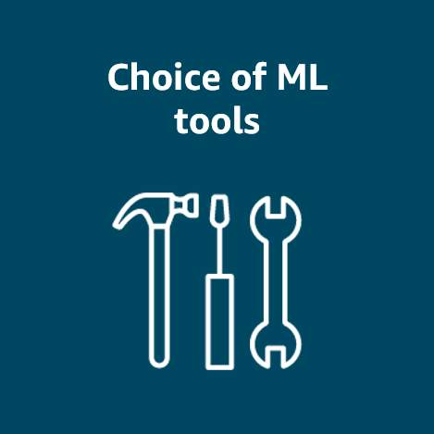
Choice of ML tools
Increase innovation with different tool choices. Data scientists can use the IDE, and business analysts can use the no-code interface.

Fully managed infrastructure
Focus on ML model development while SageMaker AI provides you with high-performance, cost-effective infrastructure.
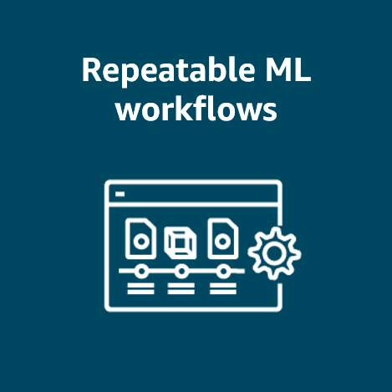
Repeatable ML workflows
Automate and standardize your MLOps practices and governance across your enterprise to support transparency and auditability.
Tier 3: ML frameworks and infrastructure
Some organizations have highly specialized needs that require complete control over the ML training process. They can use in-house expertise, ML frameworks, and AWS infrastructure to develop their own ML solutions.

Core components

ML frameworks
An ML framework is a software library or tool that provides experienced ML practitioners with pre-built, optimized components for building machine learning models. AWS supports ML frameworks like PyTorch, Apache M-X Net, and TensorFlow.

AWS ML infrastructure
AWS ML infrastructure, such as ML-optimized Amazon Elastic Compute Cloud (Amazon EC2) instances, Amazon EMR, and Amazon Elastic Container Service (Amazon ECS), can support these custom solutions. These services provide high performance and flexibility for advanced ML workloads.
Topic : Introduction to Generative AI on AWS
In this lesson, you will learn how to do the following:
- Describe deep learning and its subset, generative AI.
- Identify the types of generative AI solutions offered by AWS.
Key concepts
Let's review some key generative AI concepts that are important for understanding this emerging technology.
Deep learning
- Deep learning (DL) is a subset of machine learning where models are trained using layers of artificial neurons that mimic the human brain. Each layer of these neural networks summarizes and feeds information to the next layer until a final model is produced.
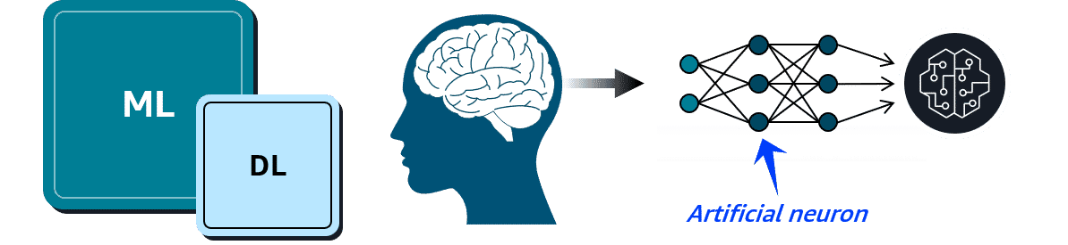
Generative AI
- Generative AI is a type of deep learning powered by extremely large ML models known as foundation models (FMs). FMs are pre-trained on vast collections of data. While traditional ML models are trained to perform singular tasks, FMs can be adapted to perform multiple tasks.
- Large language models (LLMs), are a popular type of FM trained to use human language. Foundation models can also be used to create videos, images, music, and more.
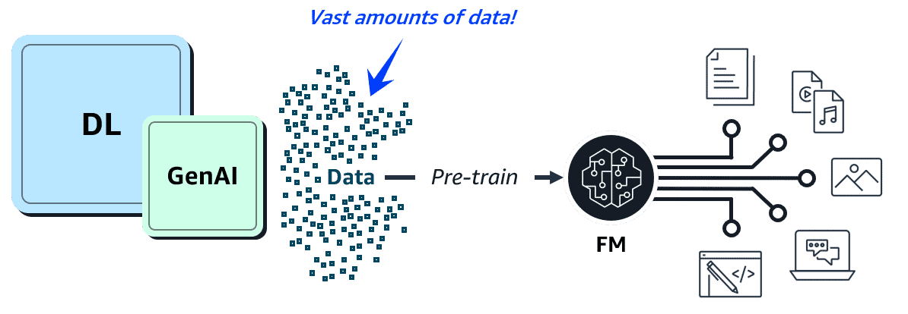
Generative AI on AWS
- AWS offers the following types of generative AI solutions:
  - Amazon SageMaker JumpStart—An ML hub with FMs and pre-built ML solutions deployable with a few clicks
  - Amazon Bedrock—A fully managed service for adapting and deploying FMs from Amazon and other leading AI companies
  - Amazon Q—An interactive AI assistant that can be integrated with a company's information repositories



Topic : AWS Generative AI Solutions

In this lesson, you will learn how to do the following:
- Describe the benefits and purpose of the generative AI services offered by AWS.
Let's examine a few AWS generative AI solutions in more detail. This includes Amazon SageMaker JumpStart for accelerating model development and Amazon Bedrock for deploying high-performing FMs through a single API. Amazon Q integrates with your existing information repositories to answer questions and helps generate insights and new content.


Amazon SageMaker JumpStart
SageMaker JumpStart is a machine learning hub within SageMaker AI that accelerates the process of building, training, and deploying ML models. SageMaker JumpStart offers a library of pre-built ML solutions across various domains such as computer vision, NLP, and tabular data. These pre-trained models can be fine-tuned to suit your specific needs and deployed with just a few clicks.

Common use cases for SageMaker JumpStart
To learn more about some common SageMaker JumpStart use cases, review each of the following flashcards.
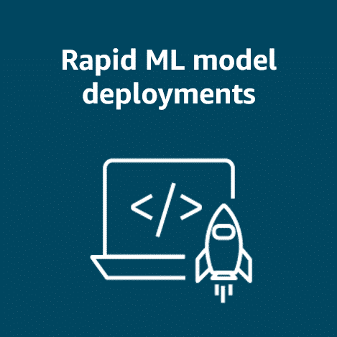
Rapid ML model deployments
Quickly deploy pre-trained models without extensive ML expertise.

Custom fine-tuned solutions
Fine-tune pre-trained FMs with your domain-specific data.
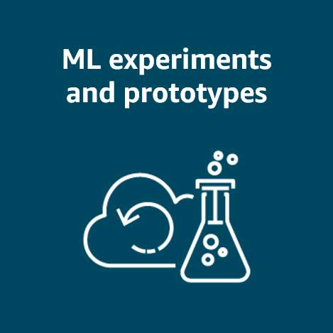
ML experiments and prototypes
Compare performance for different models before committing to a specific approach.

Amazon Bedrock
Amazon Bedrock is a fully managed service that was specifically designed for working with large foundation models and building generative AI applications. It provides access to FMs from Amazon and leading AI startups, such as Claude and Stable Diffusion, all through a single unified API. With Amazon Bedrock, you can quickly experiment with FMs, fine-tune them with your own data, and seamlessly integrate them into your AWS applications.

Common use cases for Amazon Bedrock
To learn about some common Amazon Bedrock use cases, review each of the following flashcards.
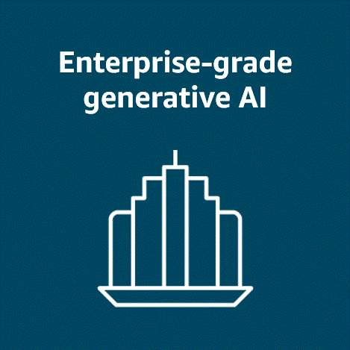
Enterprise-grade generative AI
Build production-ready generative AI applications with enterprise-level security, privacy, and scalability.

Multimodal content generation
Create applications that can generate multiple content types, such as text and images.

Data Analytics with AWS

Topic : Introduction to Data Analytics
In this lesson, you will learn how to do the following:
- Describe the benefits and purpose of ETL data pipelines.
- Define data analytics.
Key concepts
Both AI/ML and data analytics are supported by good data. Let's review ways in which data is prepared and used by analysts.
Data pipelines for ETL processes
- Both AI/ML and traditional data analytics need clean and accessible data in a format that's usable by analytics tools and AI algorithms. ETL processes are used for this purpose. With ETL, you perform the following steps:
  - Extract the data from various sources and store it.
  - Transform it into a consistent, usable format for downstream tools to consume.
  - Load it into a destination system, like a data warehouse or analytics platform.
Data pipelines are automated assembly lines used to make the ETL process efficient and repeatable. AWS has a suite of integrated services so you can build your own data pipelines.
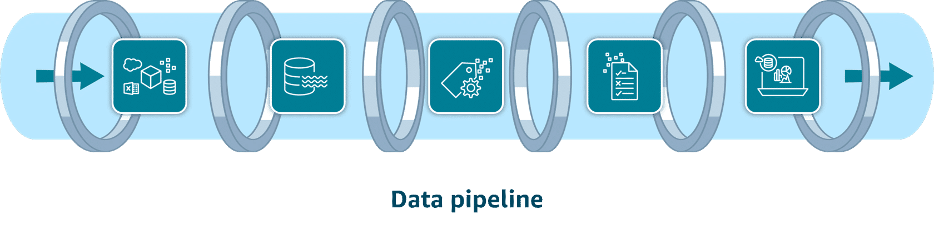
Data analytics
- Data analytics is when analysts transform raw historical data to uncover valuable insights and trends. This traditional data analysis can apply to important use cases, such as the following:
  - Loan companies explaining lending decisions to customers.
  - Medical researchers analyzing clinical trial data through hypothesis testing.
  - Insurance companies making their risk assessment models transparent for regulators.
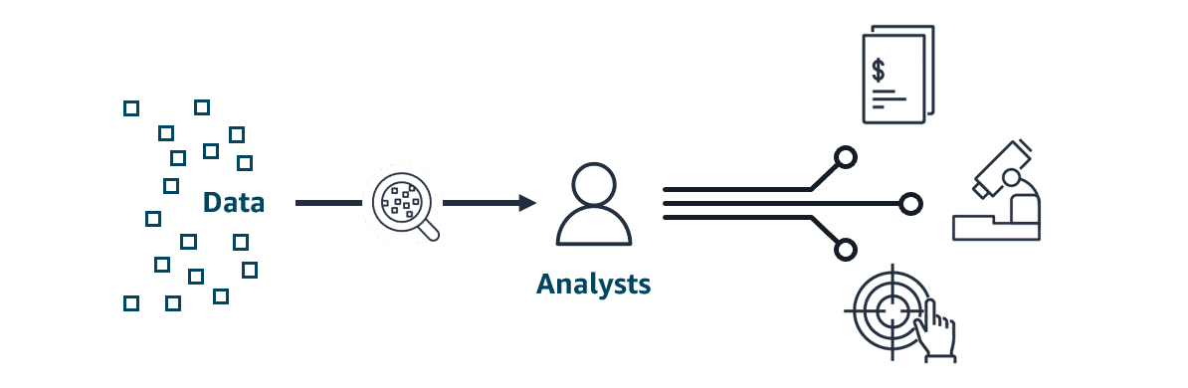

Topic : Data Pipelines on AWS

In this lesson, you will learn how to do the following:
- Describe the AWS services used in each phase of a typical AWS data pipeline.
AWS data pipeline services
Let's dive a bit deeper into the AWS services used in a typical AWS data pipeline.
Data ingestion services
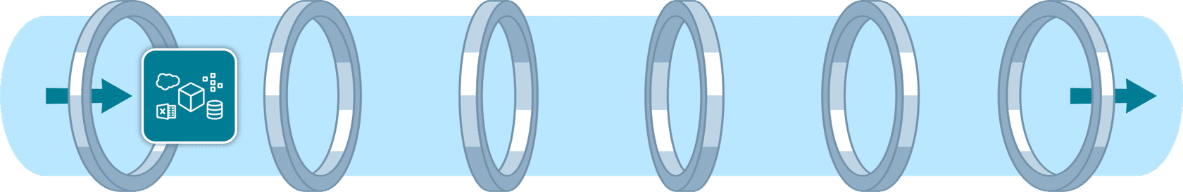
Data ingestion involves moving data from source systems into your chosen storage solution. Use real-time ingestion when the data is needed immediately. Use batch ingestion when some latency is tolerable.

Amazon Kinesis Data Streams
You can use Kinesis Data Streams for real-time ingestion of terabytes of data from applications, streams, and sensors. This serverless service even provides automatic provisioning and scaling in on-demand mode.

Amazon Data Firehose
Firehose is an option for data ingestion in near real-time. This fully managed service provides automatic provisioning and scaling. It also delivers data within seconds to data lakes, warehouses, and analytics services.
Data storage services

Data can come from many different sources. To gain insights, data is commonly consolidated into a single location. There are two storage options for this. Flexible data lakes store vast amounts of raw data. Alternatively, the more structured data warehouses are optimized for business intelligence.

Amazon S3
Amazon S3 is a popular choice for data lakes. This object storage service can securely house virtually any amount of structured or unstructured data. Amazon S3 is also fully elastic, automatically scaling as you add and remove data.

Amazon Redshift
Amazon Redshift is a fully managed data warehouse service that can store petabytes of structured or semistructured data. With the scalability and pay-as-you-go pricing model, organizations can cost-effectively analyze large datasets.
Data cataloging services

Cataloging your data with metadata provides an inventory of your organization's data.

AWS Glue Data Catalog
AWS Glue Data Catalog provides a centralized, scalable, and managed metadata repository that enhances data discovery. It improves the overall efficiency of data pipelines by delivering metadata to various data stores and analytics services.
Data processing services

Data processing services clean and transform your data so it's ready to be analyzed.

AWS Glue
AWS Glue is a fully managed ETL service that makes data preparation simpler, faster, and cost effective. AWS Glue ETL jobs can use the AWS Glue Data Catalog to access metadata about data sources, which can help inform transformations defined in the ETL script.

Amazon EMR
Amazon EMR is ideal for large-scale data processing and organizations with existing big data expertise. It automatically handles infrastructure provisioning, cluster management, and scaling. Amazon EMR supports popular big data frameworks like Apache Spark, Apache Hadoop, and Apache Hive.
Data analysis and visualization services

Queries and visualization tools help you to develop important insights about your data.

Amazon Athena
With Athena, you can run SQL queries to analyze data in relational, nonrelational, object, and custom data sources. This fully managed serverless service can access data hosted on Amazon S3, on premises, or even in multi-cloud environments. It offers a cost-effective solution for data analysis because you only pay for the queries you run.

Amazon Redshift
Amazon Redshift is a fully managed data warehouse solution. Its columnar storage and massively parallel processing architecture make it ideal for analyzing large datasets. You can use it to perform complex SQL queries on large datasets for frequent, high-performance analytical workloads.

Amazon QuickSight
With QuickSight, both technical and non-technical users can quickly create modern interactive dashboards and reports from various data sources without managing infrastructure. Amazon Q in QuickSight provides natural language queries so business analysts and users can build, discover, and share meaningful insights in seconds.

Amazon OpenSearch Service
With OpenSearch Service, you can search for relevant content through precise keyword matching or natural language queries. Unified dashboards provide real-time data visualization as you analyze and monitor logs, traces, and metrics for various applications.

Module Summary
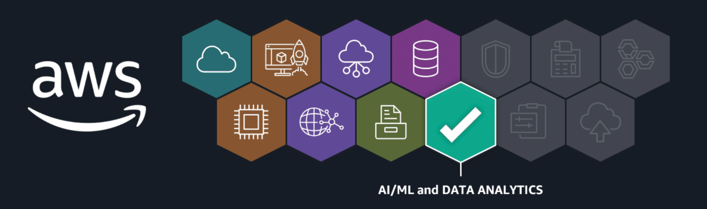
Recap and next steps
AI/ML and data analytics are two fields that use high-quality data to analyze past events and innovate for the future. In the previous lessons, you learned how AWS AI/ML solutions help to predict future trends and automate processes. And you learned how AWS solutions can be used to analyze historical trends and develop insights from data.
Resources
To learn more about the material covered in this module, choose the resource links contained in the following table.
Resource link | Description
Amazon Comprehend | Use natural language processing to extract key insights from documents.
Amazon Polly | Convert text into lifelike speech.
Amazon Transcribe | Convert speech into text.
Amazon Translate | Translate text into multiple languages.
Amazon Kendra | Use natural language processing to intelligently query enterprise content.
Amazon Rekognition | Identify objects and activities in images and videos.
Amazon Textract | Detect and extract typed and handwritten text in documents.
Amazon Lex | Add voice and text conversational interfaces to applications.
Amazon Personalize | Add personalized customer recommendations to applications.
Amazon SageMaker AI | Build, train, and deploy your own ML models without worrying about infrastructure.
Amazon SageMaker JumpStart | Deploy pre-trained ML solutions, like computer vision, NLP, and tabular data, with just a few clicks.
Amazon Bedrock | Fine-tune and seamlessly integrate large FMs from Amazon and leading AI startups into your AWS applications with a single API.
Amazon Q Business | Answer questions and solve problems using the data and expertise found in your company's information repositories.
Amazon Q Developer | Accelerate development with code recommendations.
Amazon Kinesis Data Streams | Ingest terabytes of streaming data in real time.
Amazon Data Firehose | Ingest and deliver data within seconds to multiple consumers, such as data lakes and warehouses.
Amazon S3 | Store virtually limitless amounts of all types of data using this popular data lake choice.
Amazon Redshift | Store petabytes of structured or semistructured data in this data warehouse service. Analyze large datasets stored in the warehouse using complex SQL queries.
AWS Glue Data Catalog | Provide metadata to various analytics services with this centralized repository.
AWS Glue | Process data by using the AWS Glue Data Catalog as a reference.
Amazon EMR | Process big data workloads by using popular frameworks like Apache Spark.
Amazon Athena | Analyze various data sources hosted anywhere with a single SQL query.
Amazon QuickSight | Visualize data by creating interactive dashboards with or without expertise.
Amazon OpenSearch Service

