Module 2: Introduction to Amazon EC2


Compute refers to the processing power needed to run applications, manage data, and perform calculations. In the cloud, this power is available on-demand. You can access it remotely without owning or maintaining physical hardware. Essentially, compute in the cloud means creating virtual machines with a cloud provider to run applications and tasks over the internet. In the following lessons, you will gain a thorough understanding of Amazon Elastic Compute Cloud (Amazon EC2), a powerful compute service from AWS, as you explore its flexibility, cost-effectiveness, and scalability.
In this lesson, you will learn how to do the following:
- Describe how compute resources are provisioned and managed in the cloud.
- Compare the benefits and challenges of using virtual servers to managing physical servers on premises.
- Identify the concept of multi-tenancy in Amazon EC2.
In this lesson, you will get an overview of Amazon EC2. You will learn about provisioning and managing virtual servers to host your applications and business resources.

Amazon EC2
Amazon EC2 is more flexible, cost-effective, and faster than managing on-premises servers. It offers on-demand compute capacity that can be quickly launched, scaled, and terminated, with costs based only on active usage.
The flexibility of Amazon EC2 allows for faster development and deployment of applications. You can launch as many or as few virtual servers as needed and configure security, networking, and storage. You can also scale resources up or down based on usage, such as handling high traffic or compute-heavy tasks.
Key takeaways: Comparing on-premises and cloud resources
When designing infrastructure for your business, selecting the right resources can significantly affect your efficiency, flexibility, and overall costs. Review the key differences between on-premises and cloud resource management.
Challenges of on-premises resources
Imagine that you're responsible for designing your company's infrastructure to support new websites. With traditional on-premises resources, you must purchase hardware upfront, wait for delivery, and handle installation and configuration. This process is time-consuming, costly, and inflexible because you're locked into a specific capacity that might not align with changing demands.
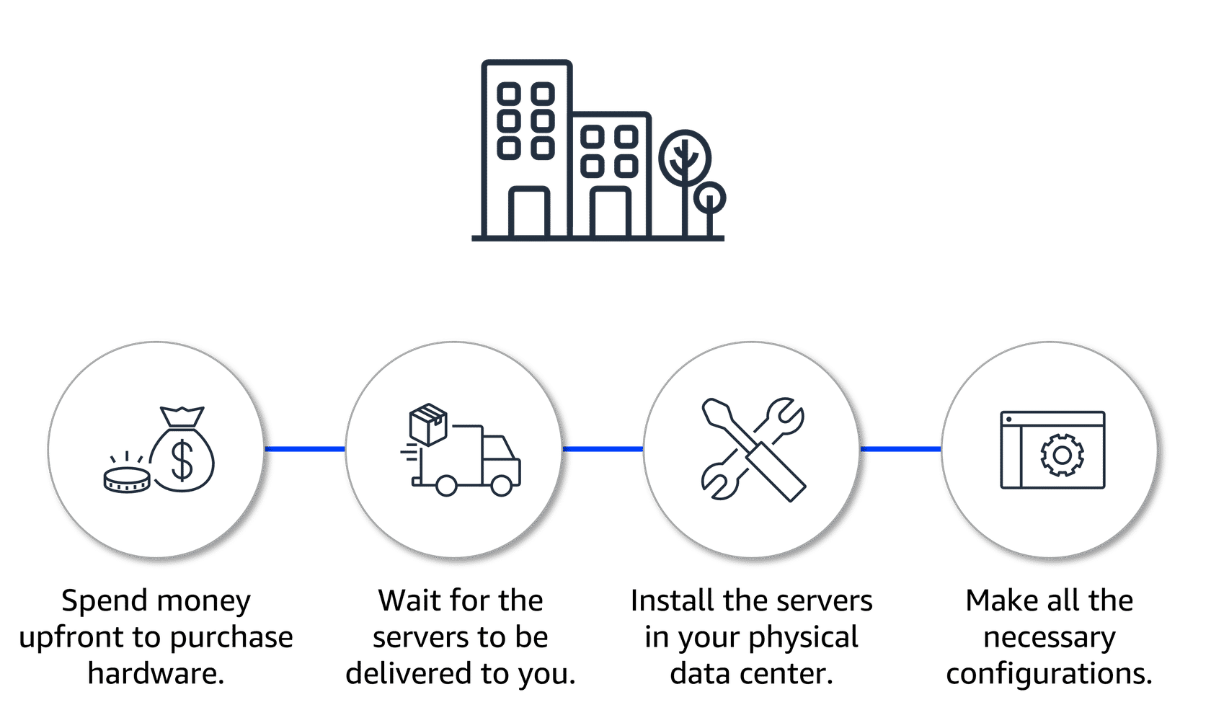
Benefits of using Cloud Resources
In contrast, with Amazon EC2, you can quickly launch, scale, and stop instances based on your needs without the delays and upfront costs associated with traditional on-premises resources.
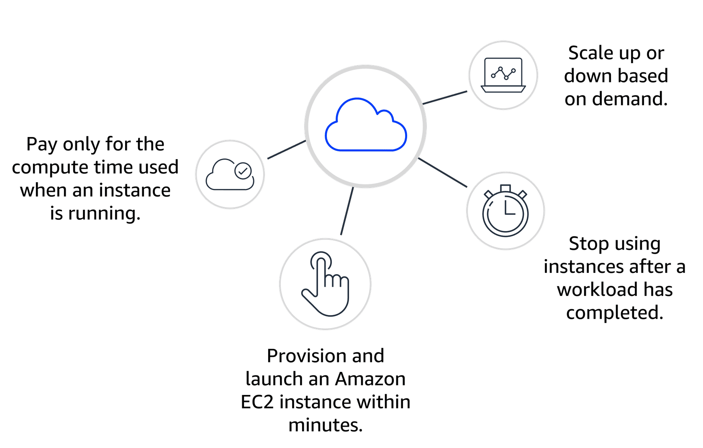
How Amazon EC2 works
You’ve learned that AWS manages complex infrastructure, offering on-demand compute capacity that’s available whenever you need it. You can request EC2 instances and have them ready to use within minutes. But how do you actually get started?
Accessing on-demand compute capacity
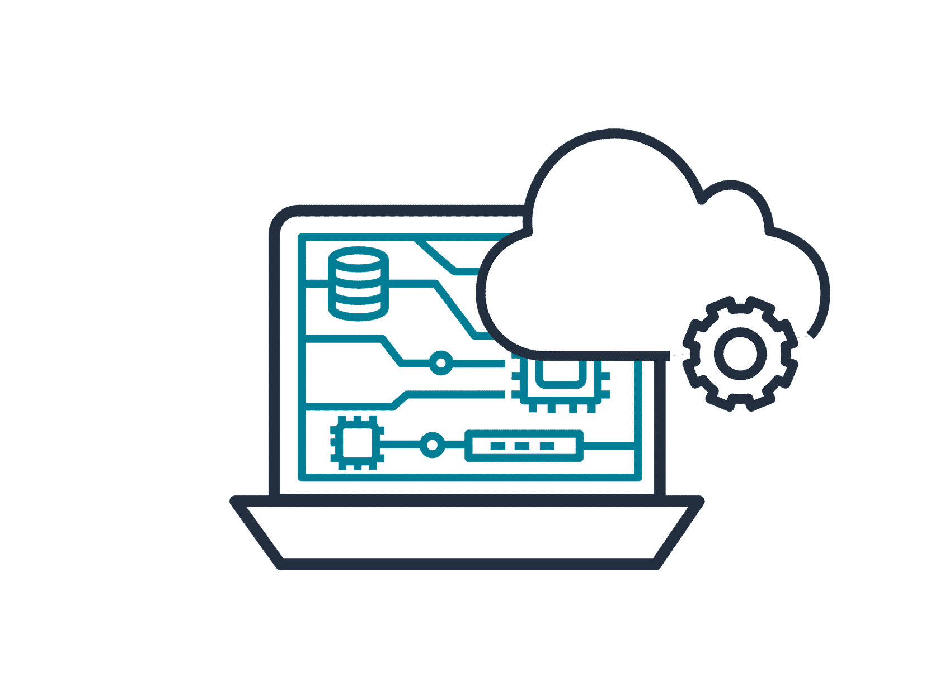
With Amazon EC2, you can quickly launch, connect to, and use virtual instances in the cloud. Here's an overview of how the process works.
Launch an instance

When launching an EC2 instance, you start by selecting an Amazon Machine Image (AMI), which defines the operating system and might include additional software. You also choose an instance type, which determines the underlying hardware resources, such as CPU, memory, and network performance.
Connect to the instance
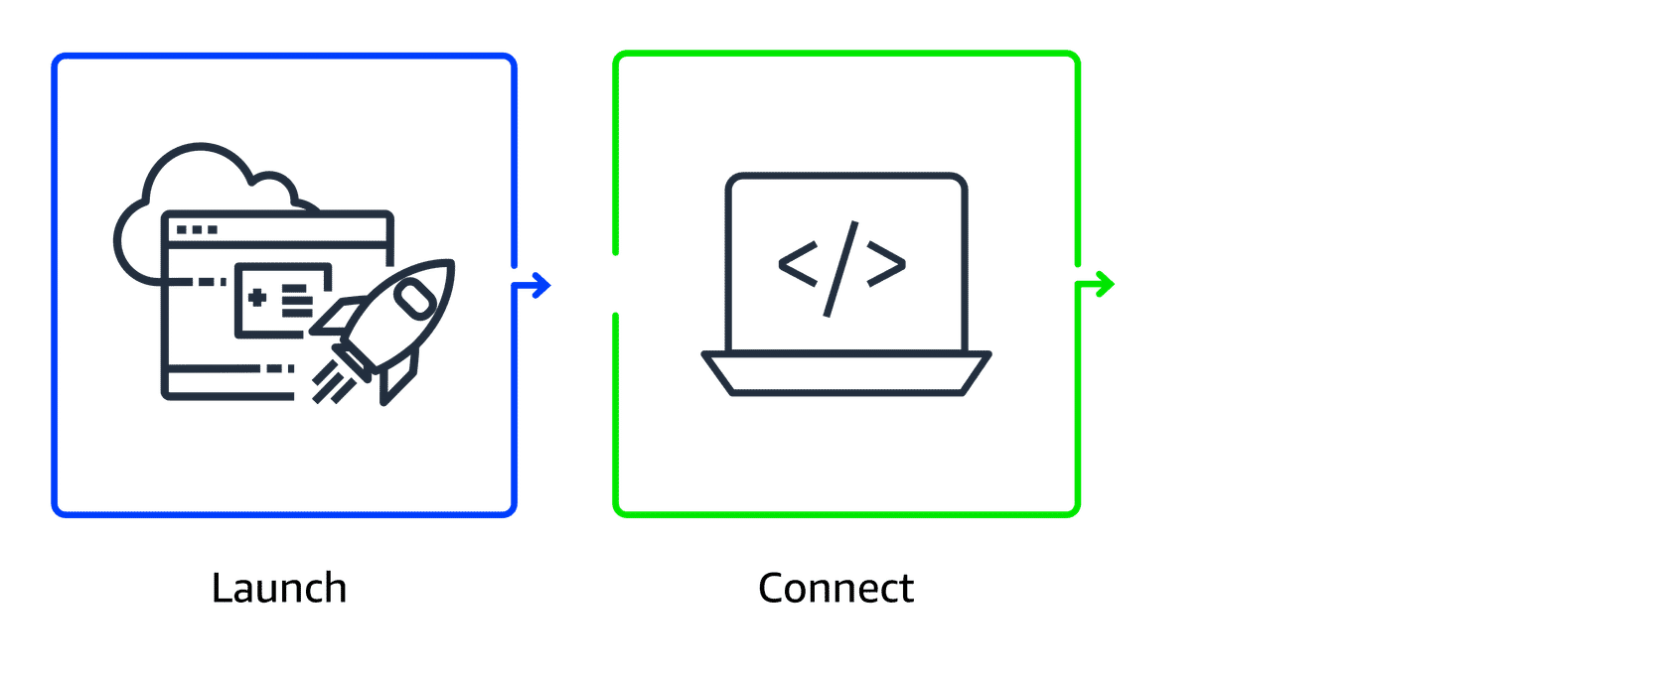
You can connect to an EC2 instance in various ways. Applications can interact with services running on the instance over the network.
Users or administrators can connect using SSH for Linux instances or Remote Desktop Protocol (RDP) for Windows instances. Alternatively, AWS services like AWS Systems Manager offer a secure and simplified method for accessing instances.
Use the instance
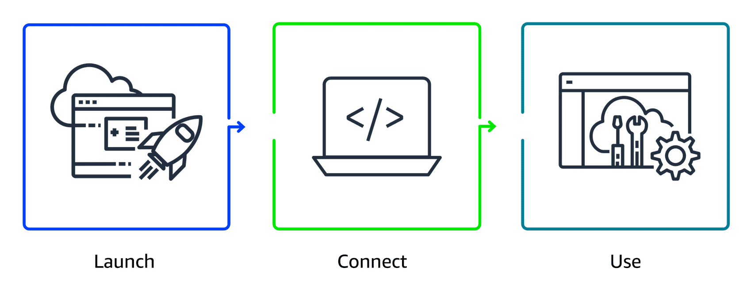
After you are connected to the instance, you can begin using it to run commands, install software, add storage, organize files, and perform other tasks.

How to Provision AWS Resources
In this lesson, you will learn how to do the following:
- Explain how to use the AWS Management Console, the AWS Command Line Interface (AWS CLI), and the AWS SDK to interact with AWS services.
- Describe the customer and AWS responsibilities regarding virtual machines.
- Explain the differences between managed and unmanaged services.
In AWS, tasks such as launching an EC2 instance, stopping an instance, or modifying instance settings are done through API requests. APIs provide predefined methods to interact with, manage, and configure AWS resources efficiently. In this lesson, you will learn about the three main ways to call AWS APIs.
Key takeaways: Interacting with AWS services
All interactions with services are powered by APIs. You can access these APIs through three primary methods: the AWS Management Console, the AWS CLI, or the AWS SDK. Let's review these methods.
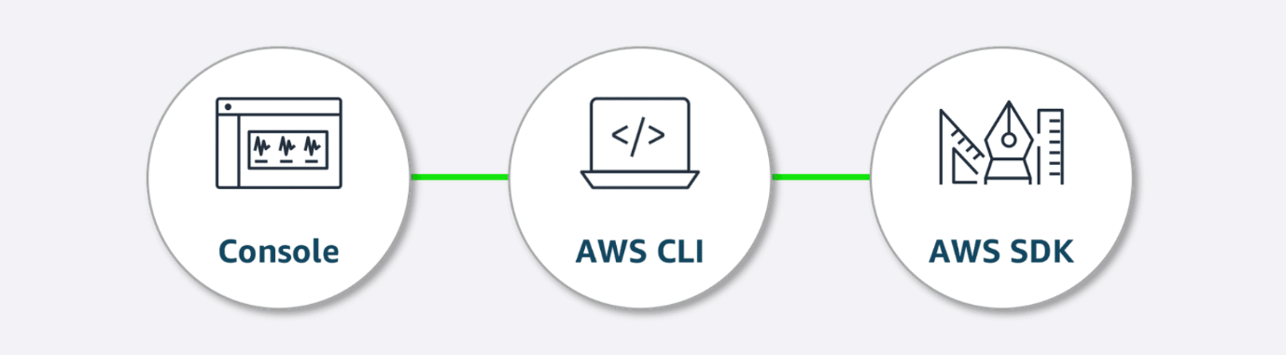
- AWS Management Console: The AWS Management Console is a web interface for managing AWS services, offering quick access to services, search functionality, and simplified workflows. With the mobile app, you monitor resources, view alarms, and check billing, supporting multiple logged-in identities at once. Good for: Users who prefer a visual, easy-to-use interface for managing and configuring AWS services
- AWS CLI: With the AWS CLI, you manage multiple AWS services directly from the command line across Windows, macOS, and Linux. You can automate tasks through scripts, such as launching EC2 instances.
Good for: Advanced users and developers who need to automate tasks, script actions, and manage AWS resources efficiently from the command line
- AWS SDK: The AWS SDK simplifies integrating AWS services into your applications by providing APIs for various programming languages. AWS offers documentation and sample code for languages like C++, Java, and .NET to help you get started.
Good for: Developers looking to integrate AWS services into their applications using language-specific APIs
Compute and shared responsibility
The AWS Shared Responsibility Model outlines the division of duties between the customer and AWS. AWS handles the security of the cloud (hardware and infrastructure), whereas the customer is responsible for security in the cloud (applications, data, and access control).
An unmanaged service like Amazon EC2 requires you to perform all of the necessary security configuration and management tasks. When you deploy an EC2 instance, you are responsible for configuring security, managing the guest operating system (OS), applying updates, and setting up firewalls (security groups). You will learn more about managed and unmanaged services later.
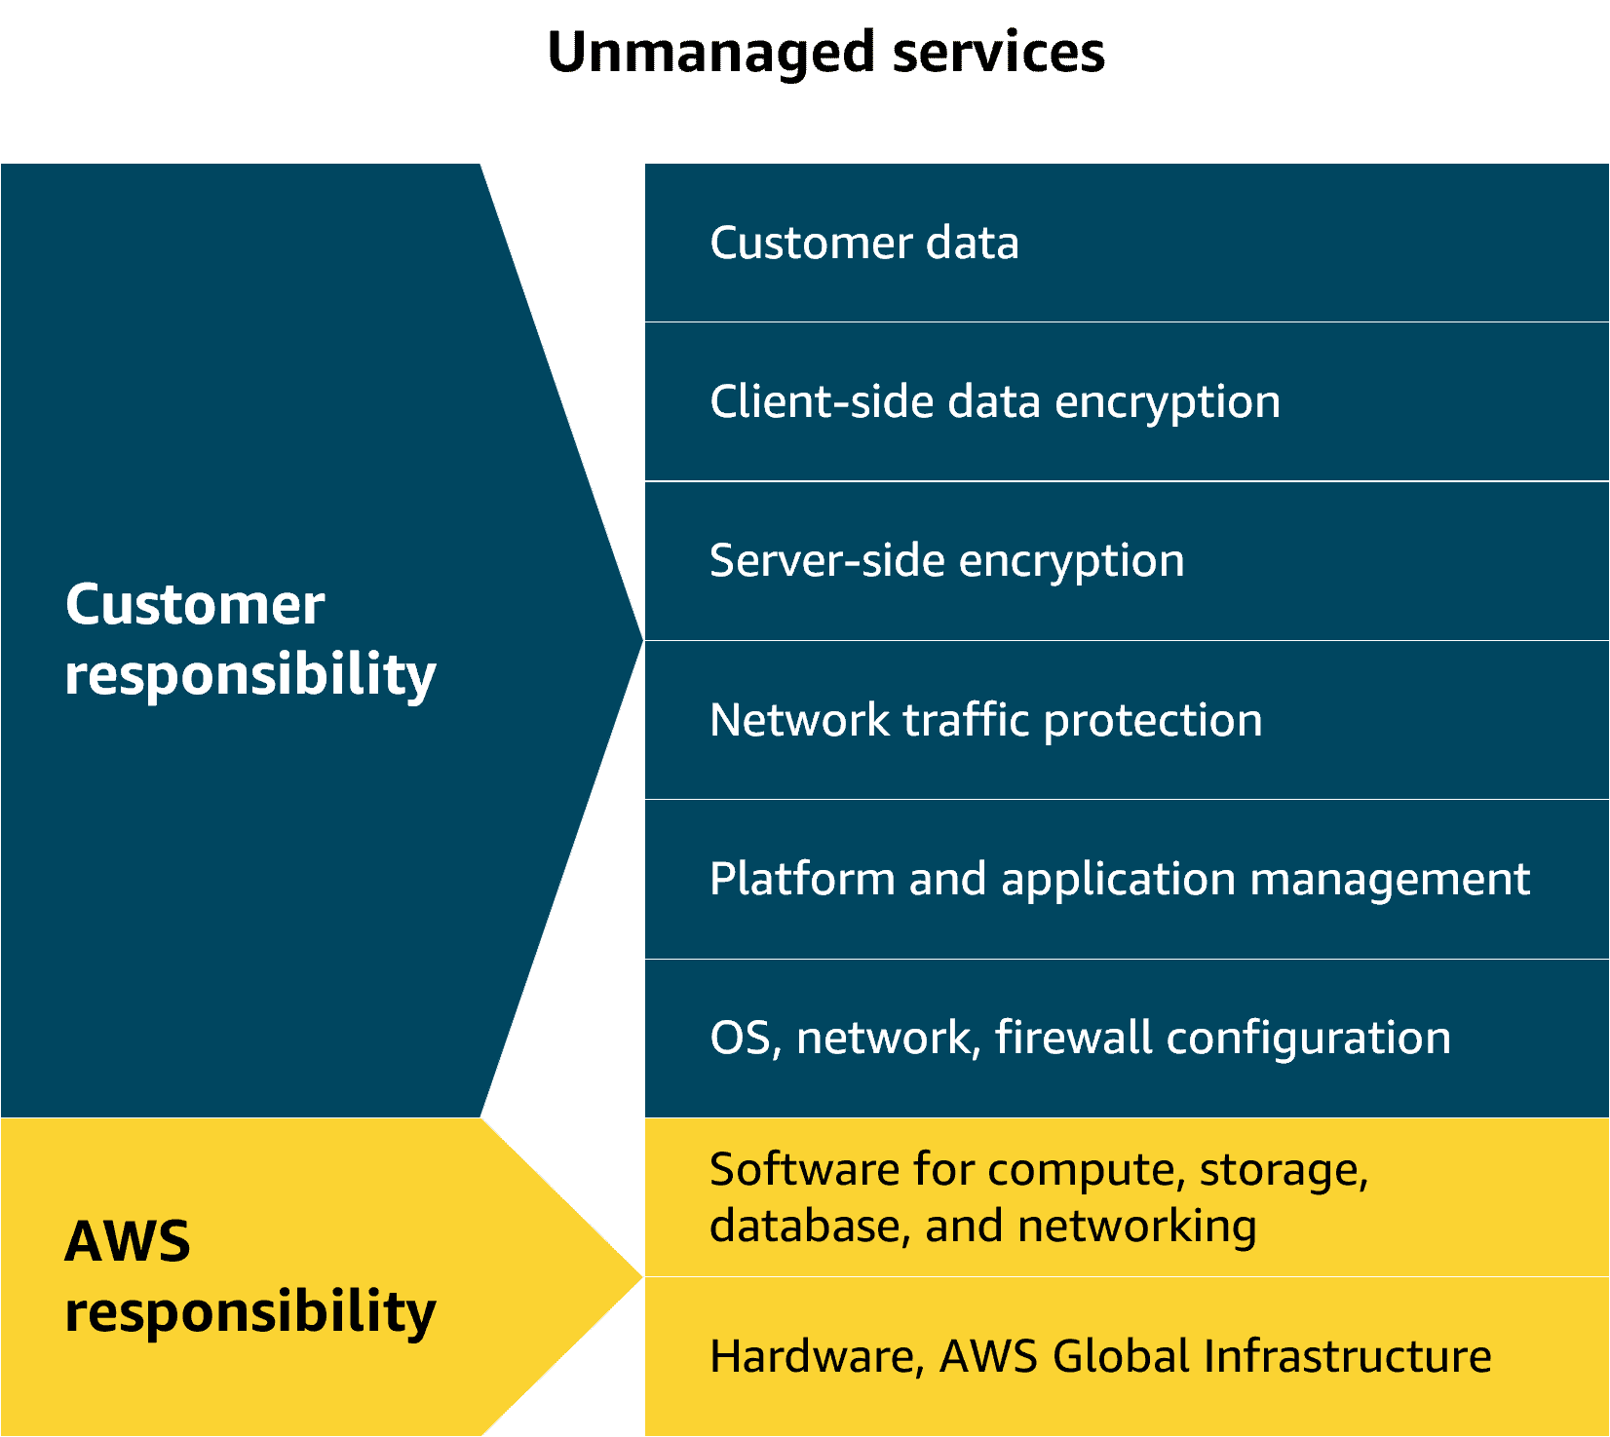
Customer and AWS responsibilities in the AWS Shared Responsibility Model.
Completed

Demo: Launching an Amazon EC2 Instance
In this lesson, you will learn how to do the following:
- Identify the key configurations needed when setting up an EC2 instance.
- Explain how an AMI maintains consistency and efficiency when scaling applications.
Amazon EC2 demonstration
If you're eager to understand how Amazon EC2 works, this is your chance to see it in action! In this demo, you learn about the basic steps of launching an EC2 instance. By the end of this demo, you will have a fully functional EC2 instance.
Amazon Machine Images
In the previous demo, you got a quick introduction to AMIs. AMIs are pre-built virtual machine images that have the basic components for what is needed to start an instance. Now, let's explore AMIs in more detail.
AMI components
An AMI includes the operating system, storage setup, architecture type, permissions for launching, and any extra software that is already installed. You can use one AMI to launch several EC2 instances that all have the same setup.
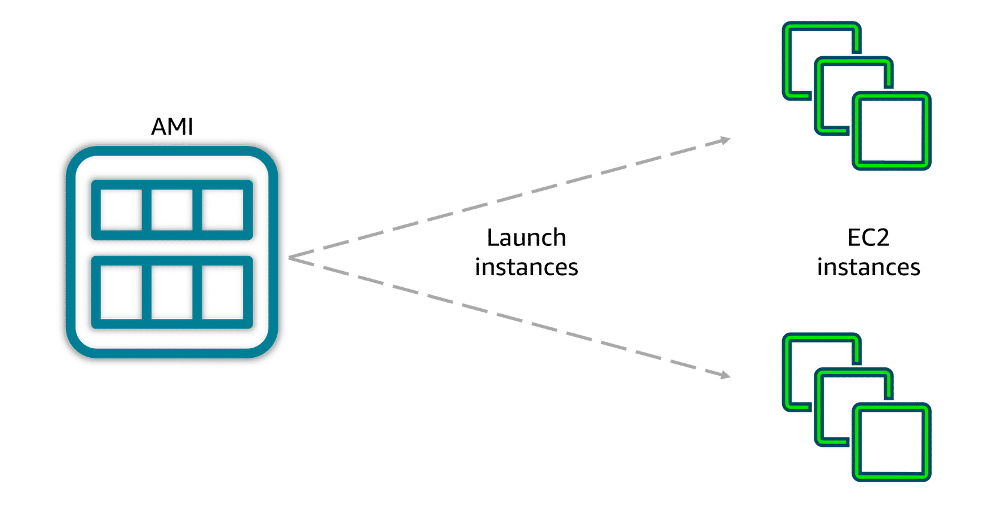
Three ways to use AMIs
AMIs can be used in three ways. First, you can create your own by building a custom AMI with specific configurations and software tailored to your needs. Second, you can use pre-configured AWS AMIs, which are set up for common operating systems and software. Lastly, you can purchase AMIs from the AWS Marketplace, where third-party vendors offer specialized software designed for specific use cases.

AMIs provide repeatability through a consistent environment for every new instance. Because configurations are identical and deployments automated, development and testing environments are consistent. This helps when scaling, reduces errors, and streamlines managing large-scale environments.
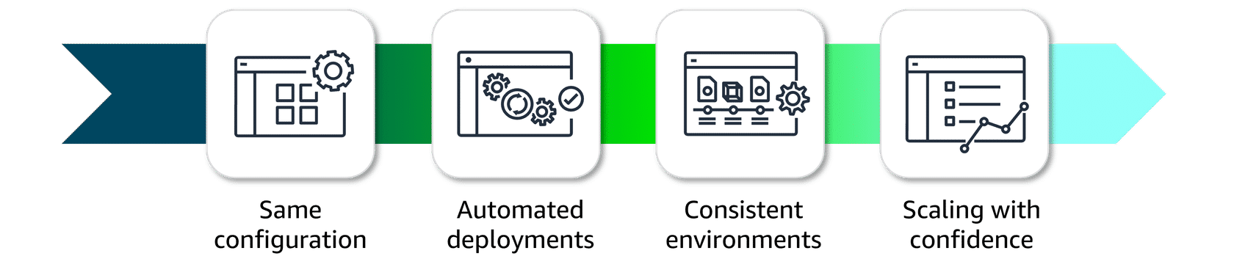

Amazon EC2 Pricing
In this lesson, you will learn how to do the following:
- Explain the available Amazon EC2 pricing options.
- Describe when to use each pricing option based on specific use cases.
- Describe Amazon EC2 Capacity Reservations and Reserved Instance (RI) flexibility.
In this lesson, you will learn about the pricing options for Amazon EC2. This information will help you find the most cost-effective solution for your workloads—whether you're just getting started or aiming to maximize savings on long-term usage.
Key takeaways: AWS pricing options
By understanding the different Amazon EC2 pricing options, you can make more informed decisions and optimize your costs based on your specific usage needs. To review the AWS pricing options, review each of the following.
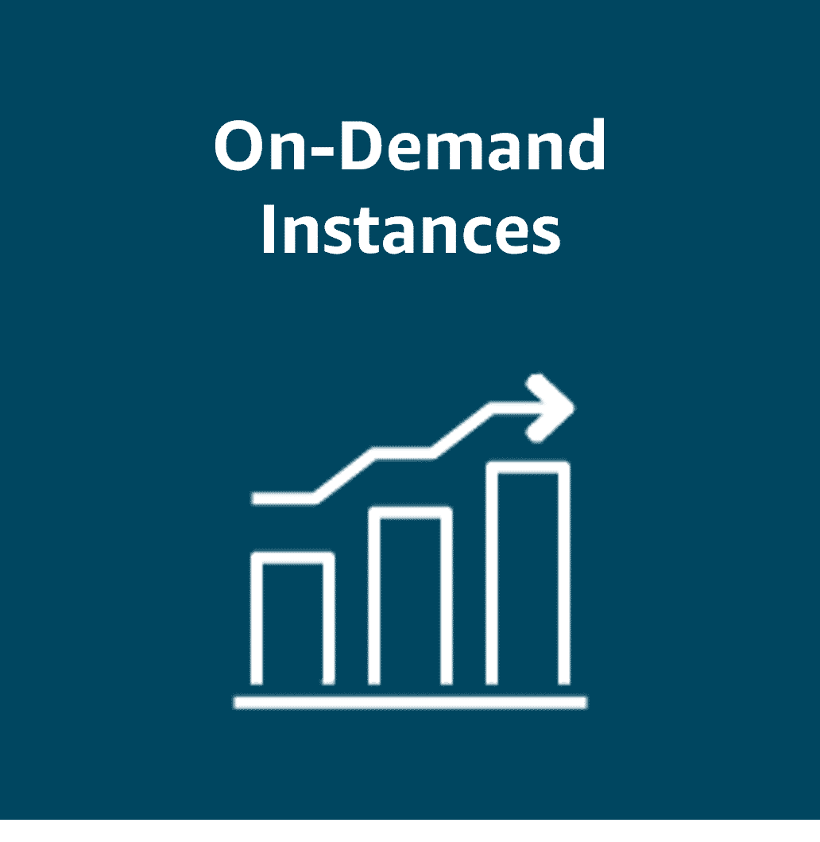
On-Demand Instances:
Pay only for the compute capacity you consume with no upfront payments or long-term commitments required.
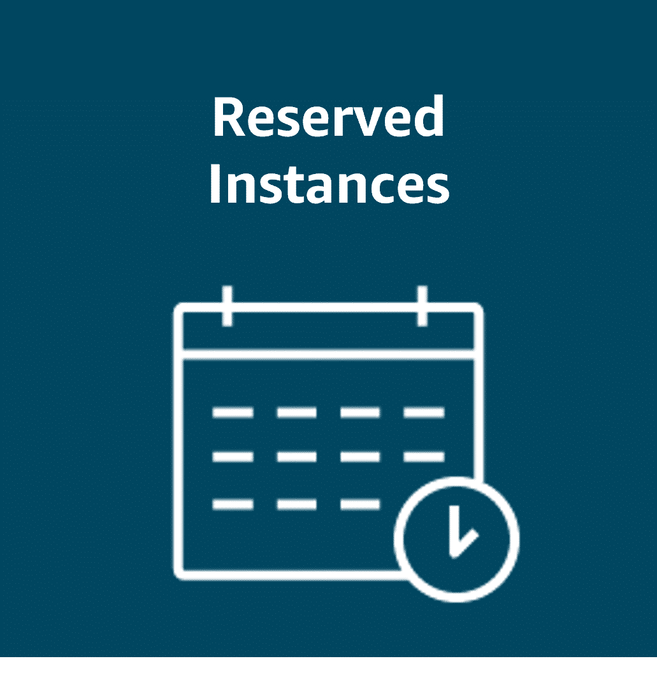
Reserved Instances:
Get a savings of up to 75 percent by committing to a 1-year or 3-year term for predictable workloads using specific instance families and AWS Regions.

Spot Instances:
Bid on spare compute capacity at up to 90 percent off the On-Demand price, with the flexibility to be interrupted when AWS reclaims the instance.

Savings Plans:
Save up to 72 percent across a variety of instance types and services by committing to a consistent usage level for 1 or 3 years.
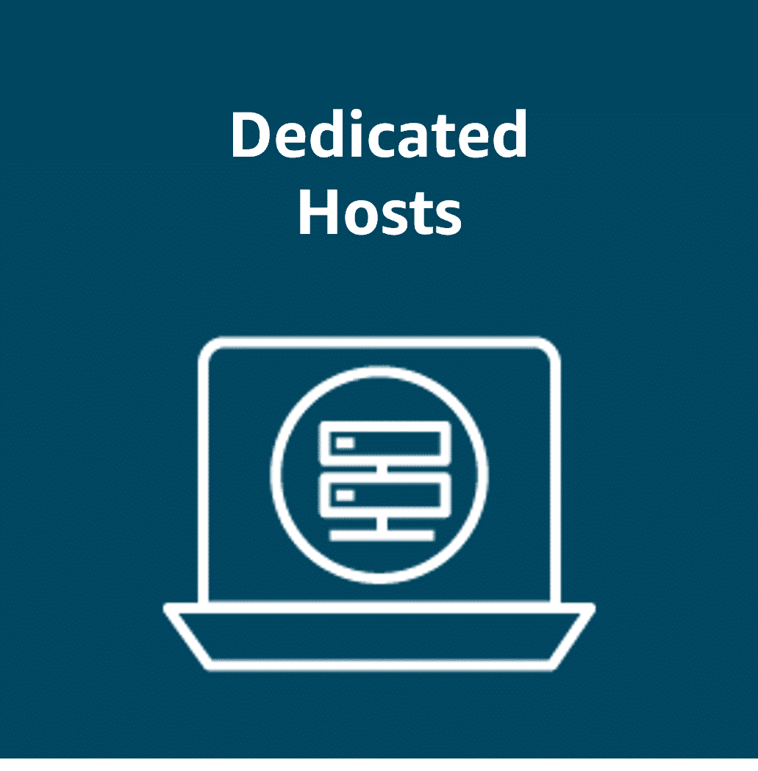
Dedicated Hosts:
Reserve an entire physical server for your exclusive use. This option offers full control and is ideal for workloads with strict security or licensing needs.

Dedicated Instances:
Pay for instances running on hardware dedicated solely to your account. This option provides isolation from other AWS customers.
Dedicated Instances
Dedicated Hosts provide exclusive use of physical servers, offering full control over instance placement and resource allocation. This makes them ideal for security- or compliance-driven workloads. But what if you don’t need that level of control?
You could use Dedicated Instances, which offer physical isolation from other AWS accounts while still benefiting from the flexibility and cost savings of shared infrastructure.
The key difference is that Dedicated Instances provide isolation without you choosing which physical server they run on. Dedicated Hosts give you an entire physical server for exclusive use, providing complete control over instance placement and resource allocation.
Ultimately, the right choice depends on your specific workload requirements and the level of control you need over your infrastructure.
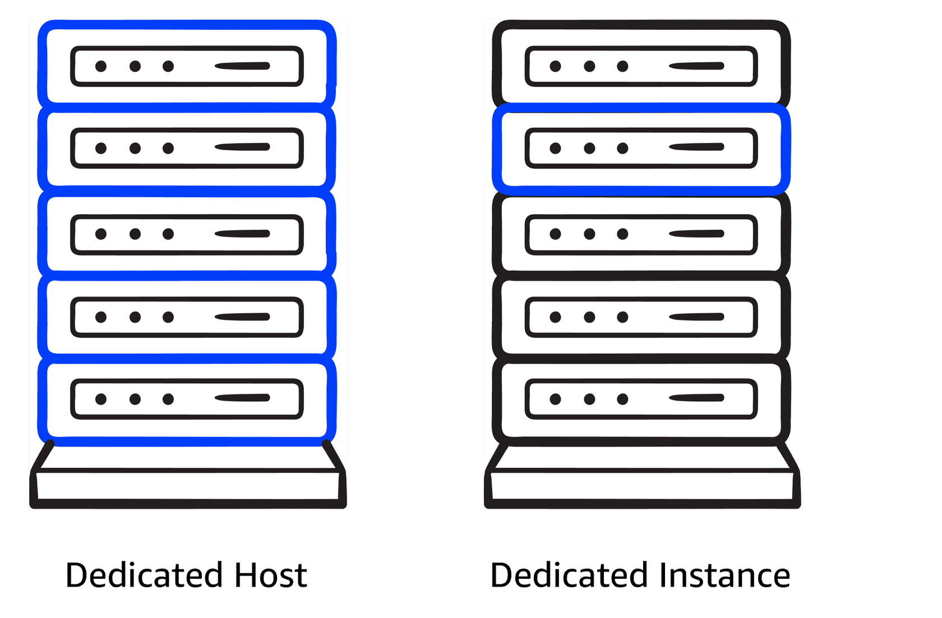
Dedicated Hosts offer exclusive use of a server with full control, whereas Dedicated Instances provide isolation without server control.
More about cost optimization
To optimize costs and resource allocation, AWS offers a range of pricing options including Savings Plans, Amazon EC2 Capacity Reservations, and Reserved Instances (RIs). Each of these is tailored to meet different workload and capacity needs.
- Savings Plans: Good for: Predictable workloads
Savings Plans offer discounts compared to On-Demand rates in exchange for a commitment to use a specified amount of compute power (measured per hour) over a one-year or three-year period. They provide flexible pricing for Amazon EC2, AWS Fargate, AWS Lambda, and Amazon SageMaker AI usage, regardless of instance type or AWS Region. Payment options include All upfront, Partial upfront, or No upfront.
For more information, refer to What are Savings Plans?
- Capacity Reservations: Good for: Critical workloads with strict capacity requirements
With Amazon EC2 Capacity Reservations, you reserve compute capacity in a specific Availability Zone for critical workloads. Reservations are charged at the On-Demand rate, whether used or not. You only pay for the instances you run. This is ideal for strict capacity requirements for current or future business-critical workloads.
For more information, refer to Reserve compute capacity with EC2 On-Demand Capacity Reservations.
- Reserved Instance flexibility: Good for: Steady-state workloads with predictable usage RIs offer up to 75 percent savings over On-Demand pricing by applying discounts across instance sizes and multiple Availability Zones within a Region. When you purchase a Reserved Instance (RI), AWS automatically applies the discount to other instance sizes within the same family based on the instance size footprint. It also applies the discount across multiple Availability Zones for enhanced resource distribution and fault tolerance. For more information, refer to How Reserved Instance discounts are applied.

Auto Scaling and Load Balancing
In this lesson, you will learn how to do the following:
- Recognize the concepts of scalability and elasticity as they apply to AWS.
- Describe how AWS can help businesses adjust compute capacity based on varying demands.
If you've ever tried to access a website that wouldn't load and kept timing out, it might have been overwhelmed by more requests than it could handle. In this lesson, you will explore how scalability helps you manage fluctuating demand by adjusting compute capacity.
Key takeaways
Scalability is about a system’s potential to grow over time, whereas elasticity is about the dynamic, on-demand adjustment of resources.
Scalability Scalability refers to the ability of a system to handle an increased load by adding resources. You can scale up by adding more power to existing machines, or you can scale out by adding more machines. Scalability focuses on long-term capacity planning to make sure that the system can grow and accommodate more users or workloads as needed.

Elasticity Elasticity is the ability to automatically scale resources up or down in response to real-time demand. A system can then rapidly adjust its resources, scaling out during periods of high demand and scaling in when the demand decreases. Elasticity provides cost efficiency and optimal resource usage at any given moment.
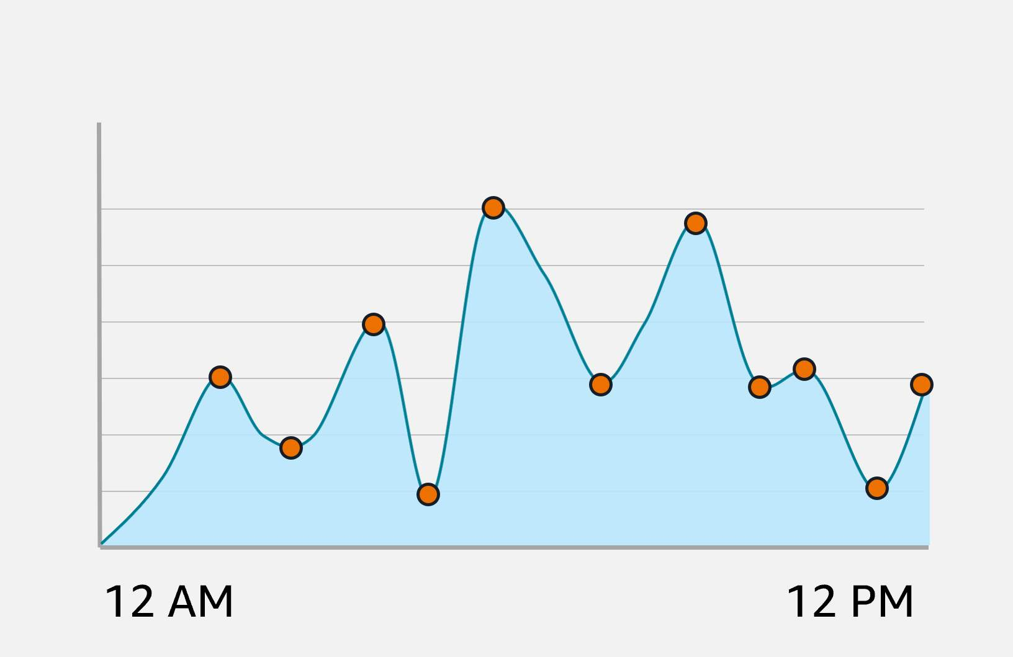

Amazon EC2 Auto Scaling Amazon EC2 Auto Scaling automatically adjusts the number of EC2 instances based on changes in application demand, providing better availability. It offers two approaches. Dynamic scaling adjusts in real time to fluctuations in demand. Predictive scaling preemptively schedules the right number of instances based on anticipated demand.
Example: Amazon EC2 Auto Scaling
With EC2 Auto Scaling, you maintain the desired amount of compute capacity for your application by dynamically adjusting the number of EC2 instances based on demand. You can create Auto Scaling groups, which are collections of EC2 instances that can scale in or out to meet your application’s needs.
An Auto Scaling group is configured with the following three key settings.
- The minimum capacity defines the least number of EC2 instances required to keep the application running. This makes sure that the system never scales below this threshold. It's the number of EC2 instances that launch immediately after you have created the Auto Scaling group. In this example, the minimum capacity is four EC2 instances.
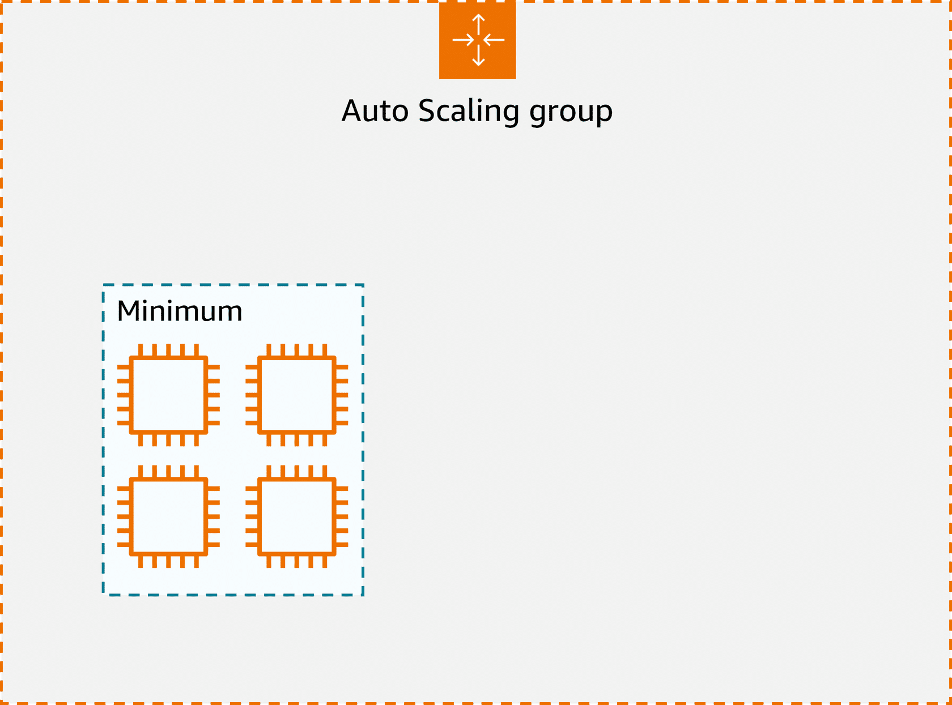
- The desired capacity is the ideal number of instances needed to handle the current workload, which Auto Scaling aims to maintain. If you do not specify the desired number of EC2 instances in an Auto Scaling group, the desired capacity defaults to your minimum capacity. In this example, the desired capacity is six EC2 instances.
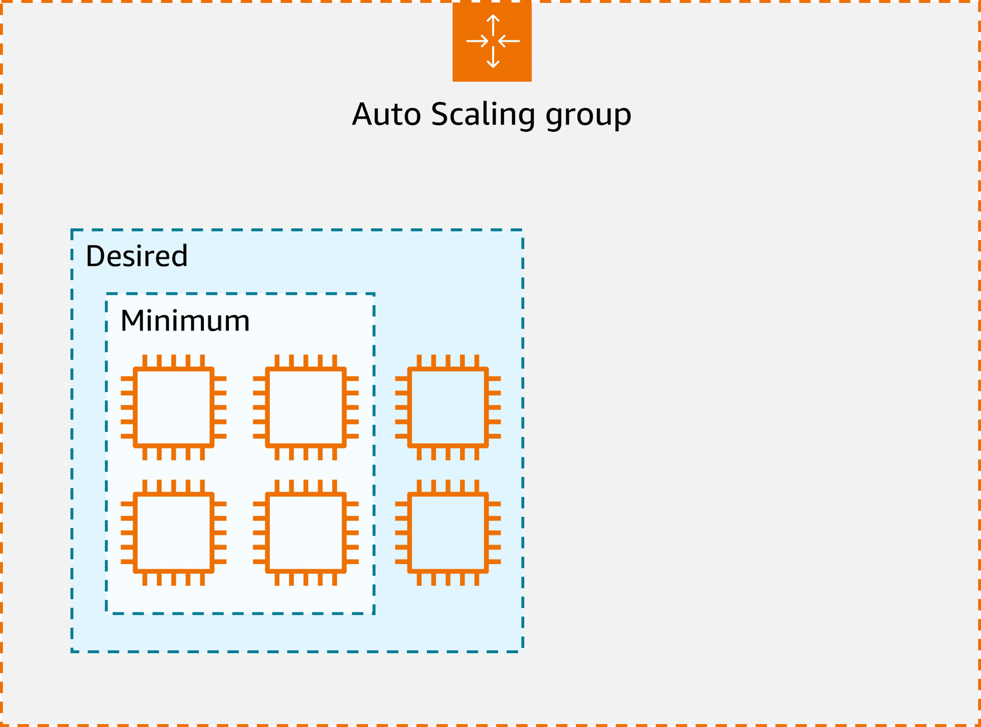
- The maximum capacity sets an upper limit on the number of instances that can be launched, preventing over-scaling and controlling costs. For example, you might configure the Auto Scaling group to scale out in response to increased demand.
In this example, a maximum of 12 EC2 instances can be launched. Amazon EC2 Auto Scaling will scale between the minimum and maximum number of instances.
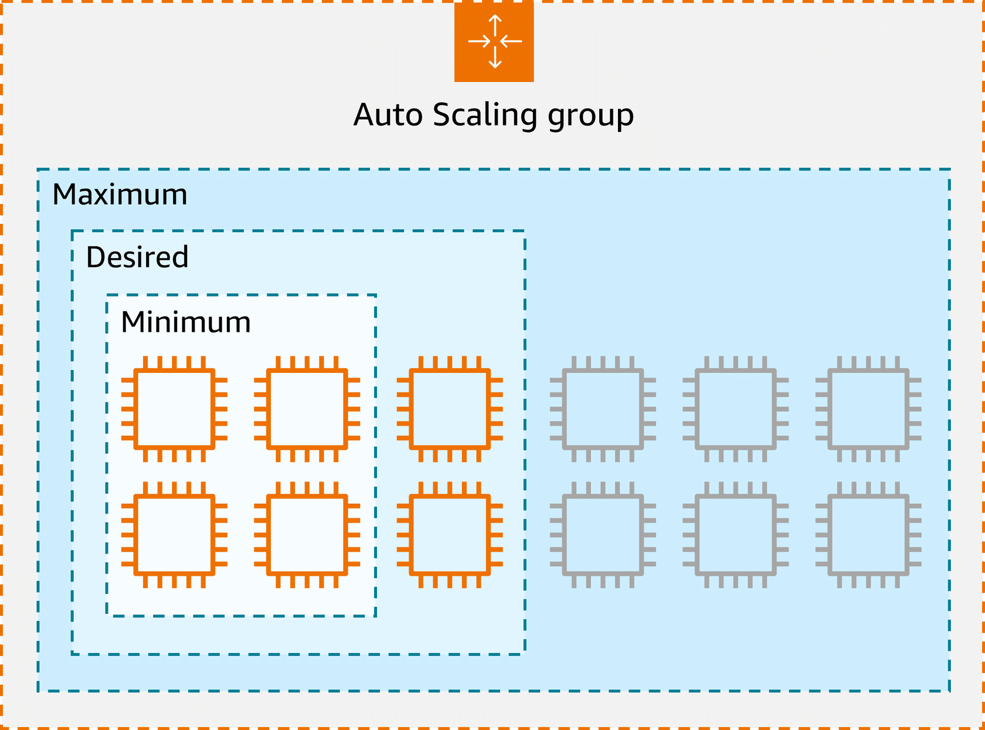
Because Amazon EC2 Auto Scaling uses EC2 instances, you pay for only the instances you use, when you use them. This gives you a cost-effective architecture that provides the best customer experience while reducing expenses.

Directing Traffic with Elastic Load Balancing
In this lesson, you will learn how to do the following:
- Describe the challenge of traffic distribution and scalability in AWS environments.
- Recognize the benefits of Elastic Load Balancing (ELB) in AWS.
- Explain the relationship between Amazon EC2 Auto Scaling and ELB in managing AWS resources.
Spreading workloads improves the performance of your applications by preventing any single resource from having to handle the full workload on its own. In this lesson, you will learn how ELB simplifies traffic distribution and management for AWS applications.

Elastic Load Balancing
Elastic Load Balancing (ELB) automatically distributes incoming application traffic across multiple resources, such as EC2 instances, to optimize performance and reliability. A load balancer serves as the single point of contact for all incoming web traffic to an Auto Scaling group. As the number of EC2 instances fluctuates in response to traffic demands, incoming requests are first directed to the load balancer. From there, the traffic is distributed evenly across the available instances.
Although ELB and Amazon EC2 Auto Scaling are distinct services, they work in tandem to enhance application performance and ensure high availability. Together, they enable applications running on Amazon EC2 to scale effectively while maintaining consistent performance.
Key takeaways: ELB benefits
Let's review the main benefits of elastic load balancing and how it enhances the performance, scalability, and management of your AWS environment.
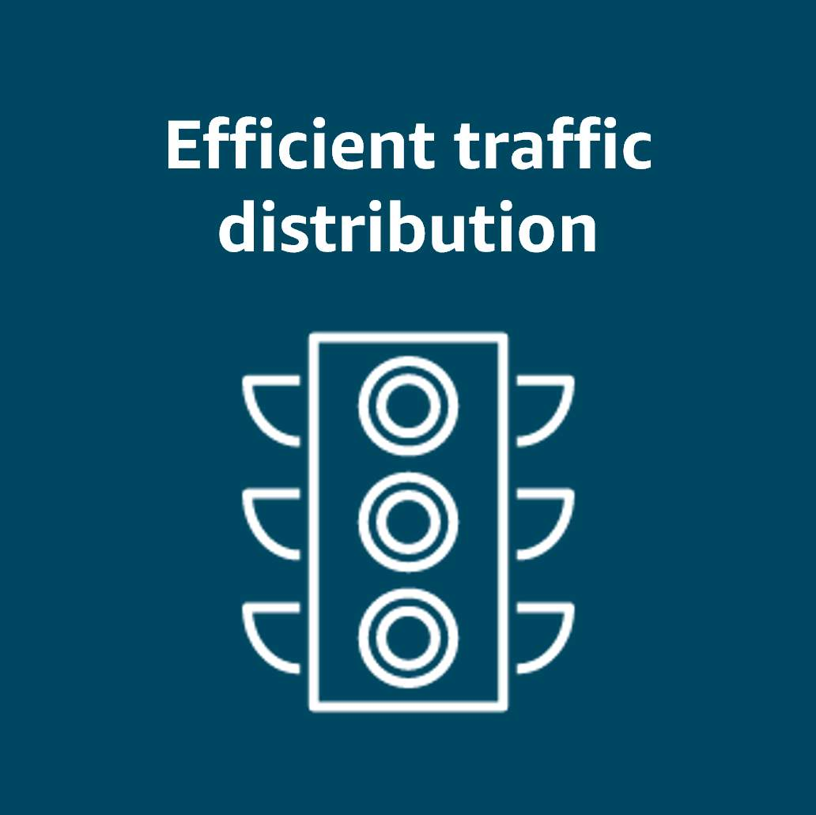
Efficient traffic distribution: ELB evenly distributes traffic across EC2 instances, preventing overload on any single instance and optimizing resource utilization.

Automatic scaling: ELB scales with traffic and automatically adjusts to changes in demand for a seamless operation as backend instances are added or removed.
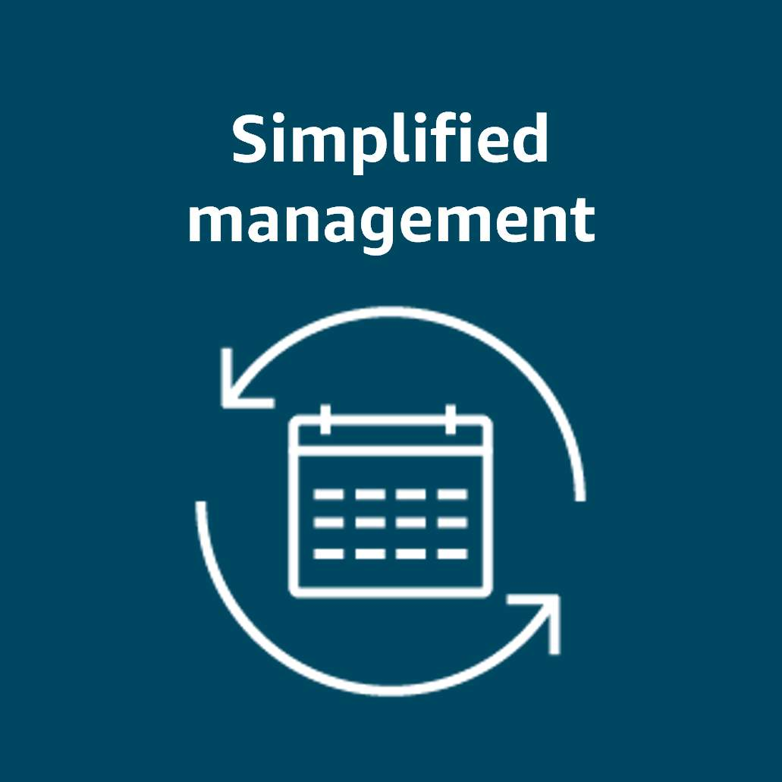
Simplified management: ELB decouples front-end and backend tiers and reduces manual synchronization. It also handles maintenance, updates, and failover to ease operational overhead.
Routing methods
To optimize traffic distribution, ELB uses several routing methods: Round Robin, Least Connections, IP Hash, and Least Response Time. These routing strategies work together for efficient traffic management and optimal application performance.
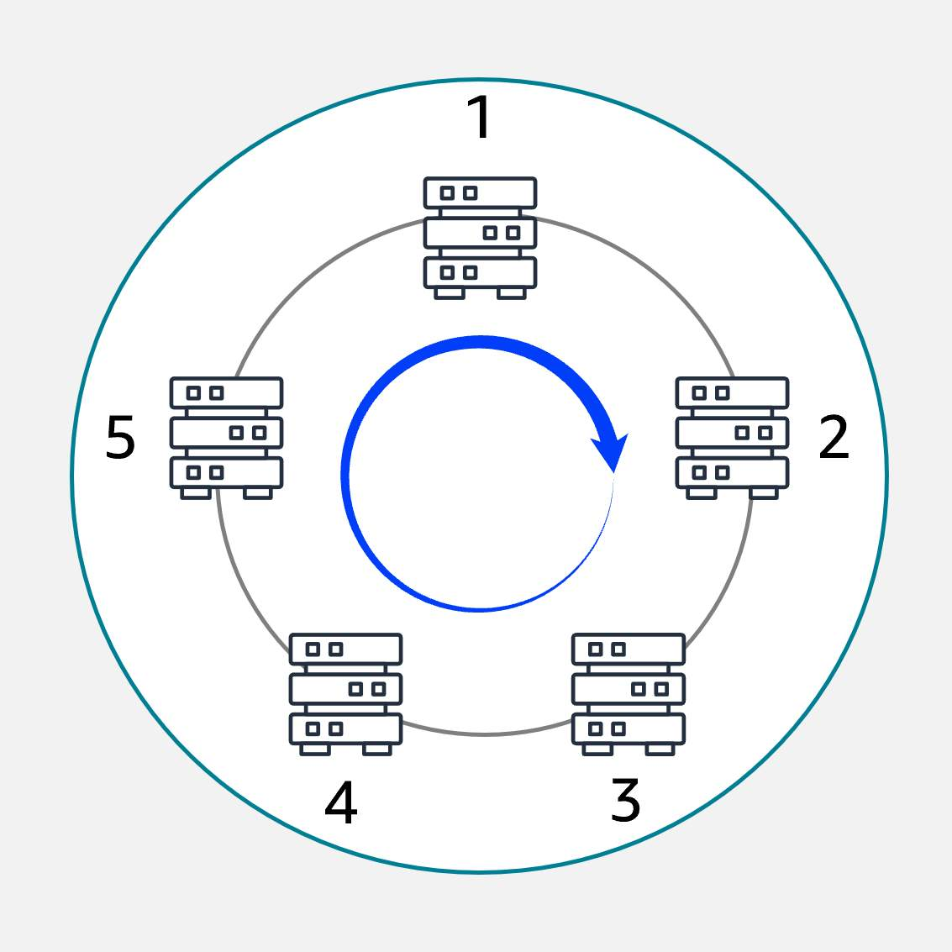
Round Robin Distributes traffic evenly across all available servers in a cyclic manner.

Least Connections Routes traffic to the server with the fewest active connections, maintaining a balanced load.
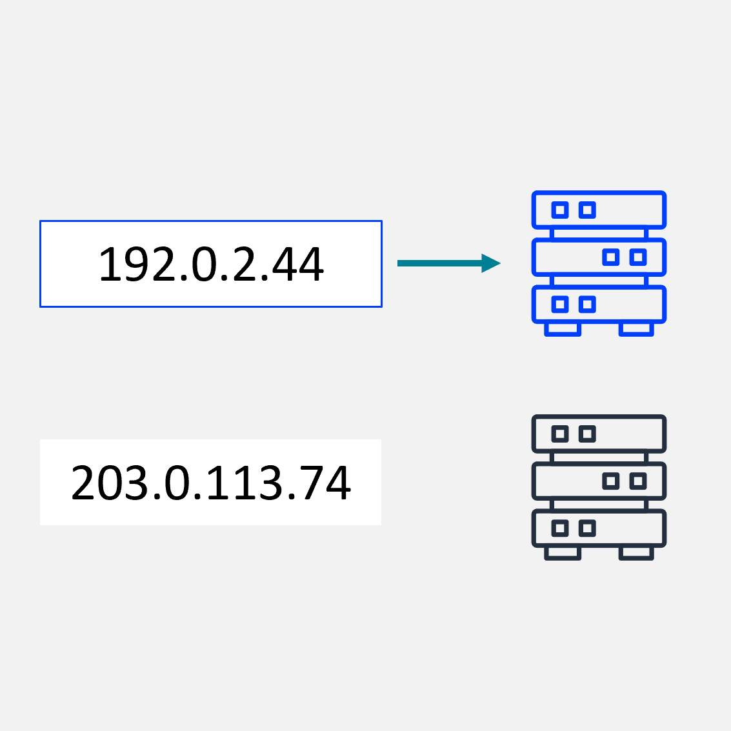
IP Hash
Uses the client’s IP address to consistently route traffic to the same server.
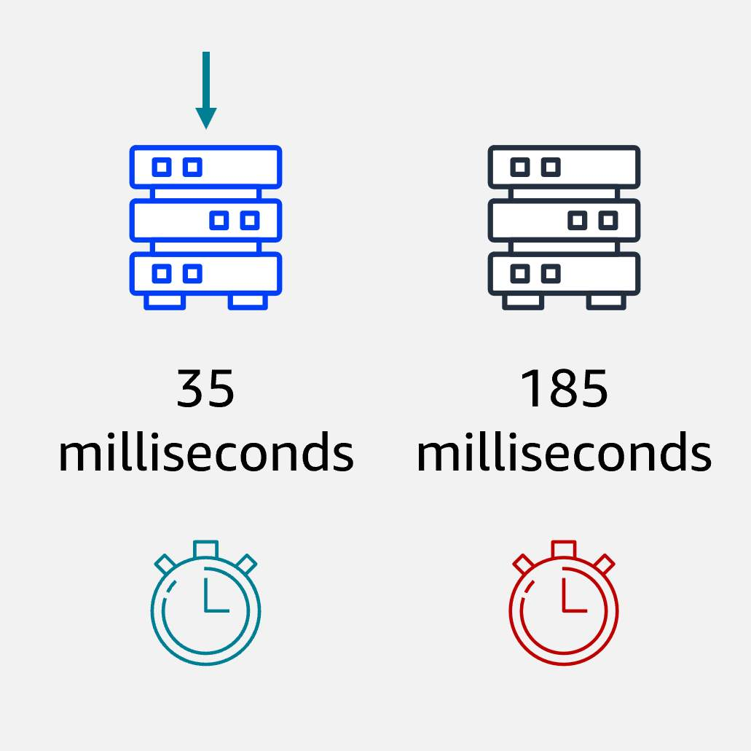
Least Response Time
Directs traffic to the server with the fastest response time, minimizing latency.
Example: Elastic Load Balancing
Let's look at an example to better understand how Elastic Load Balancing works in cloud computing. In the healthcare industry, particularly in hospitals and medical facilities that provide online appointment booking systems or patient portals, website traffic can vary greatly throughout the day.
Low-demand period: At the beginning of the day, only a few patients are accessing the system to book appointments or view medical records. The existing web servers are sufficient to handle the low traffic. This matches the demand, with no need for additional resources at this point.
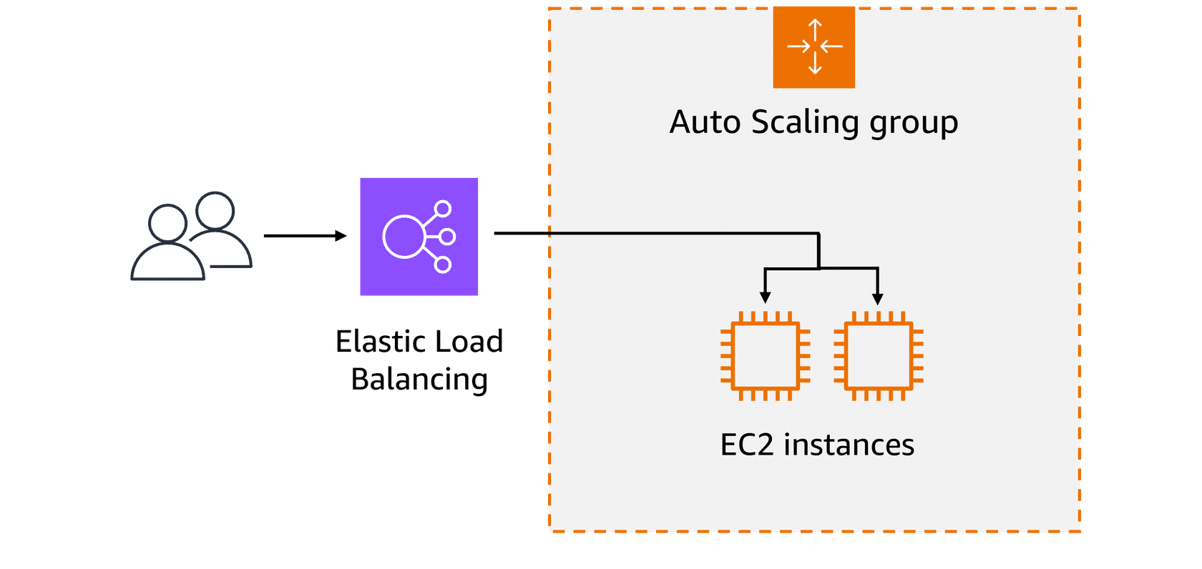
High-demand period: As the day progresses, especially during peak hours, such as early mornings or just before the weekend, more patients access the portal to book appointments, view test results, or contact medical professionals. To handle this surge in demand, the healthcare system automatically scales up the number of servers to help ensure that the system remains responsive and available for all users.
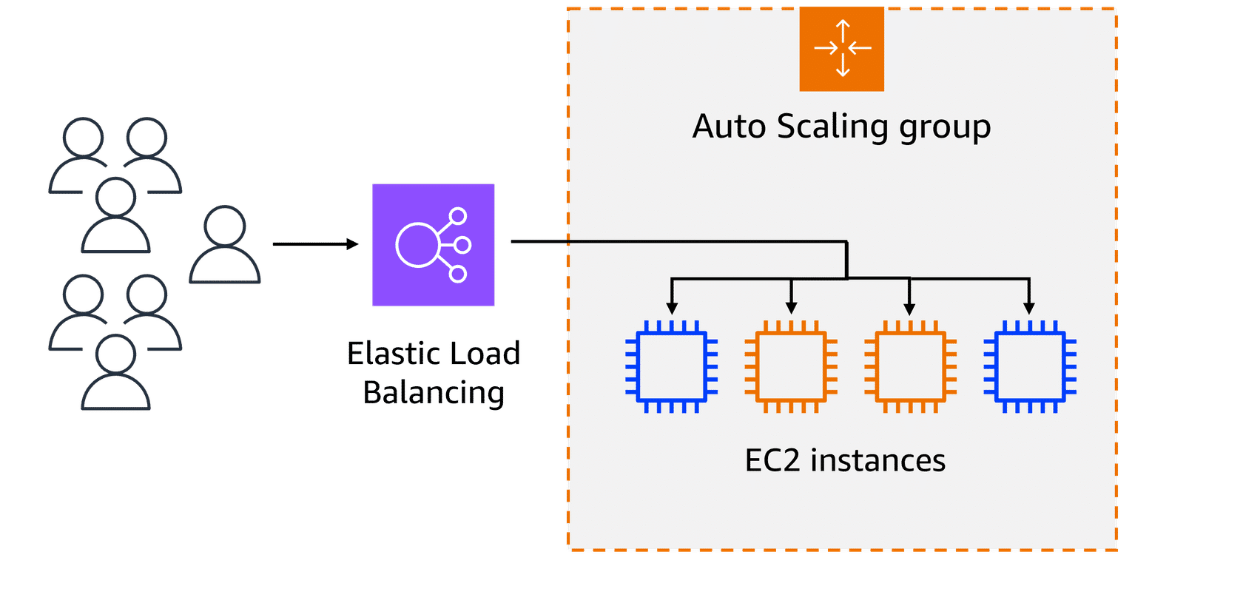
A load balancer directs the incoming traffic to different web servers based on their current load. For instance, if one server starts receiving too many requests, the load balancer will route new requests to a less busy server. This makes sure that no single server becomes overwhelmed. The traffic is evenly distributed across available EC2 instances.
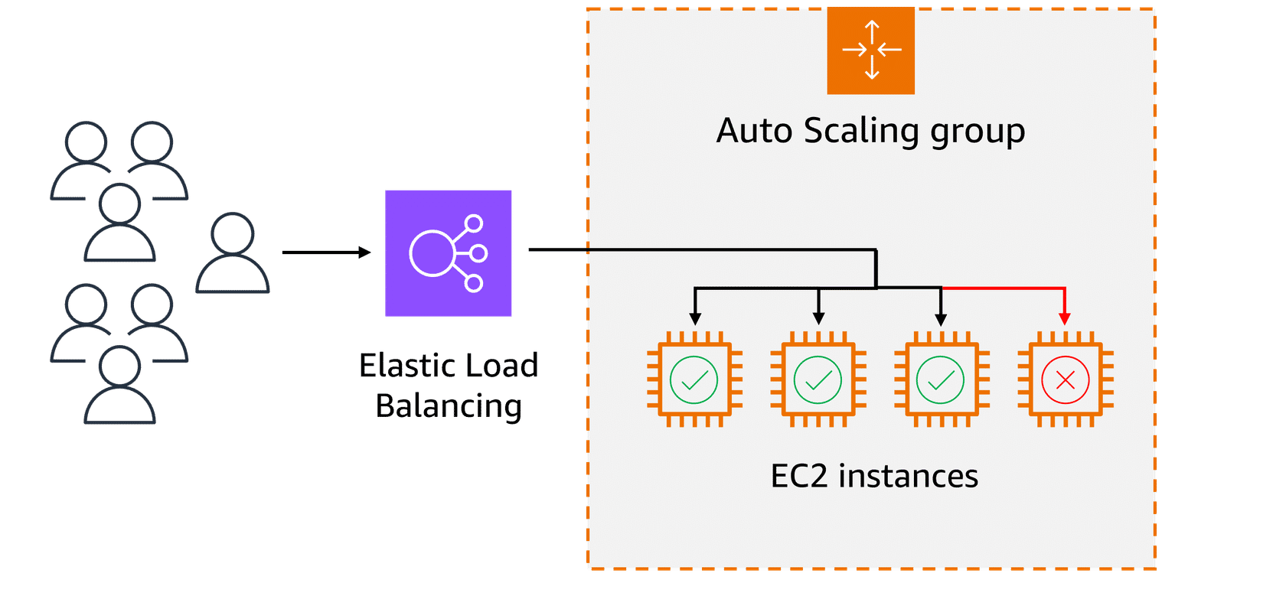
By using Elastic Load Balancing and Auto Scaling, the healthcare industry can efficiently manage the varying levels of patient traffic to online services. This provides reliable access to medical portals even during high-demand periods.

Messaging and Queuing
In this lesson, you will learn how to do the following:
- Describe how Amazon Simple Queue Service (Amazon SQS) facilitates message queuing.
- Explain how Amazon Simple Notification Service (Amazon SNS) uses a publish-subscribe model to distribute messages.
- Identify the difference between tightly coupled and loosely coupled architectures.
- Explain how message queues help improve communication between components.
Ever wonder how busy coffee shops keep everything running smoothly, even when the barista is on break or the cashier is overwhelmed? Well, the same principles apply to software architecture. In this lesson, you will look into how messaging and queuing help prevent slowdowns and failures.
Key takeaways: Decoupling services
In modern application development, reliability and resilience are important. One effective way to achieve this is by adopting a service-oriented approach.
Monolithic applications
Applications consist of multiple components that work together to transmit data, fulfill requests, and keep the application running smoothly. In a traditional approach to application architecture, the components—such as database logic, web application servers, user interfaces, and business logic—are tightly coupled. This means that if one component fails, it can cause the failure of other components, potentially bringing down the entire application.
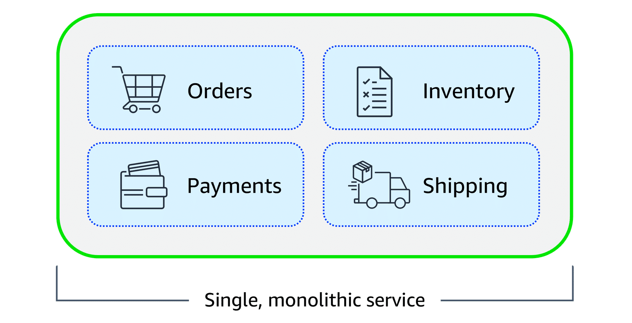
Microservices architecture
To improve application availability and resilience, you can adopt a microservices architecture. In this approach, application components are loosely coupled, meaning that if one component fails, the others continue to function normally. The communication between components remains intact, and the failure of a single component does not impact the entire system. This design promotes greater flexibility and reliability in the application.
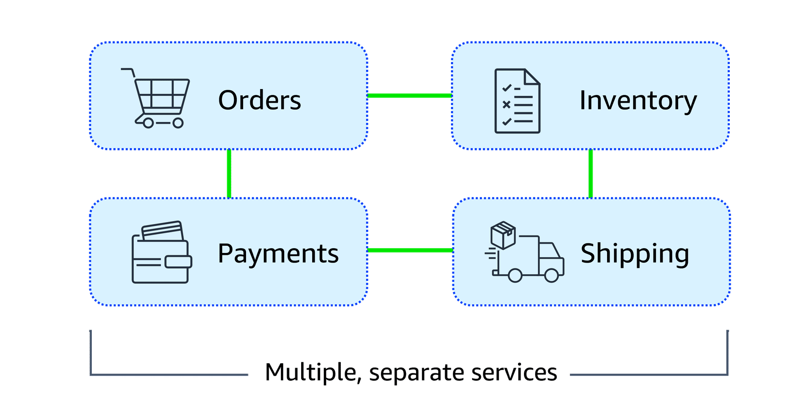
Supporting scalable and reliable cloud communication
Amazon EventBridge, Amazon SNS, and Amazon SQS are AWS services that help different parts of an application communicate effectively in the cloud. These services support building event-driven and message-based systems. Together, they help create scalable, reliable applications that can handle high traffic and can enhance communication between components.

EventBridge
EventBridge is a serverless service that helps connect different parts of an application using events, helping to build scalable, event-driven systems. With EventBridge, you route events from sources like custom apps, AWS services, and third-party software to other applications. EventBridge simplifies the process of receiving, filtering, transforming, and delivering events, so you can quickly build reliable applications.
Example: EventBridge
Customers use an online food delivery service to order meals from local restaurants through a mobile app. When a customer places an order, several steps need to happen simultaneously. To learn more about these steps, review each of the four numbered descriptions below the graphic.
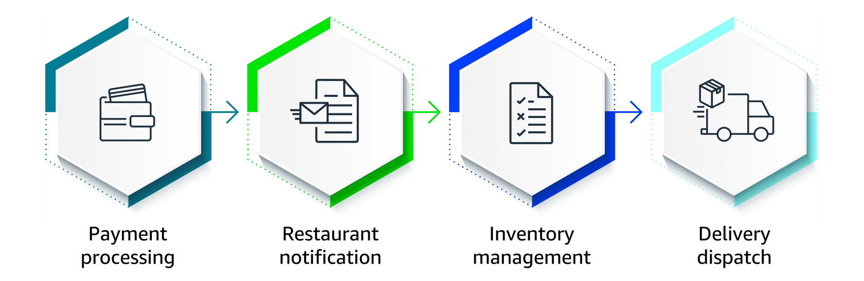
- Payment Processing - The payment service must verify and process the customer's payment.
- Restaurant Notification - The restaurant receives a notification to start preparing the meal.
- Inventory Management - The inventory system checks if the ingredients for the order are available.
- Delivery Dispatch - A delivery driver is notified to pick up and deliver the meal.
How EventBridge helps: EventBridge can route events, like order placed or payment completed, to the relevant services (payment, restaurant, inventory, and delivery). It can handle high volumes of events during peak times, making sure each service works independently. Even if one service fails, EventBridge will store the event and process it as soon as the service is available again. EventBridge helps provide a smooth and reliable operation across the entire system.

Amazon SQS
Amazon SQS is a message queuing service that facilitates reliable communication between software components. It can send, store, and receive messages at any scale, making sure messages are not lost and that other services don't need to be available for processing. In Amazon SQS, an application places messages into a queue, and a user or service retrieves the message, processes it, and then removes it from the queue.
Example: Amazon SQS
As customer support teams grow and the volume of issues increases, traditional workflows can struggle to keep up. Let's consider how a customer support team might tackle this challenge.
SCENARIO: A customer support team consists of a support agent and a technical specialist. The support agent is responsible for receiving customer issues, and the technical specialist works on resolving them. This process works well as long as both the agent and specialist are available and coordinated.
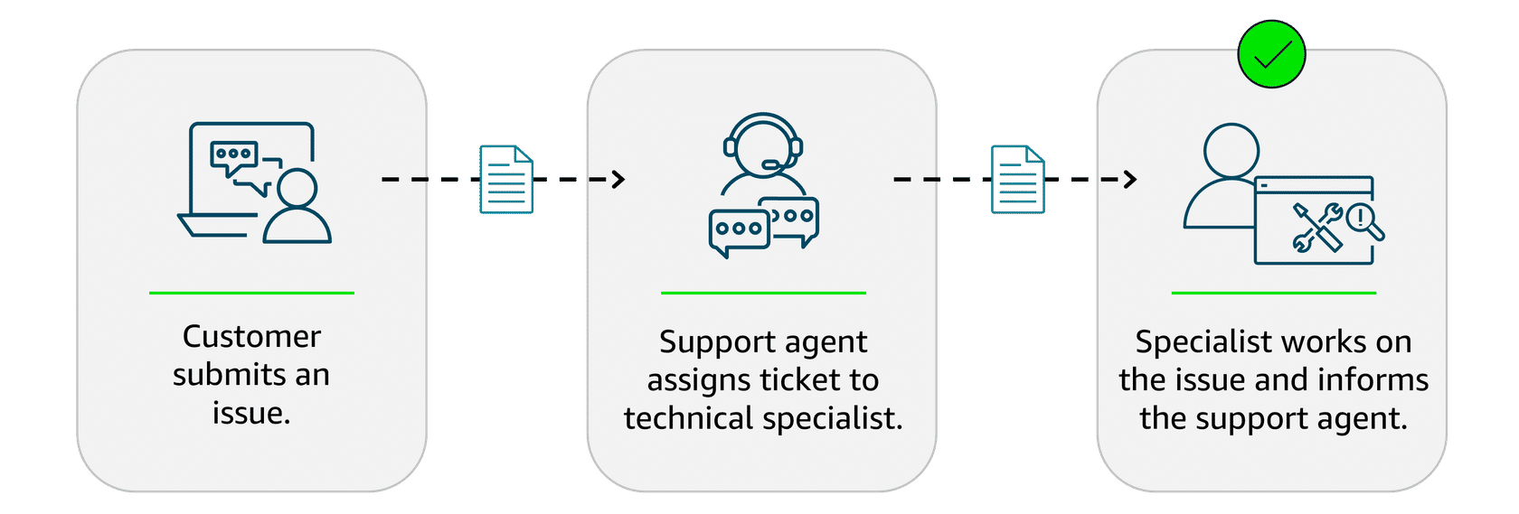
CHALLENGE: However, what happens if the support agent creates a ticket but the technical specialist is busy working on another issue or unavailable? The agent would have to wait until the specialist is free to accept the new ticket, causing delays in resolving customer issues and extending wait times for customers. As the volume of customer issues increases, this process becomes inefficient.
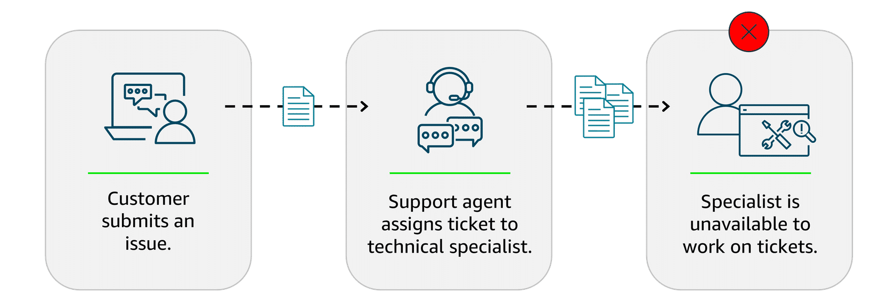
SOLUTION: To improve efficiency, they implement a queue system using Amazon SQS. The support agent adds customer issues to the queue, creating a backlog. Even if the specialist is busy, the agent can continue adding new issues. The specialist checks the queue, resolves issues, and updates the agent. This system provides a smooth workflow and helps handle higher volumes without delays or bottlenecks.
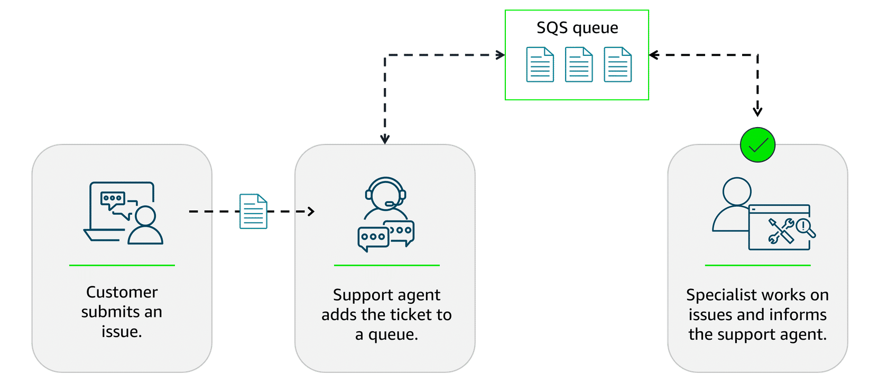

Amazon SNS
Amazon SNS is a publish-subscribe service that publishers use to send messages to subscribers through SNS topics. In Amazon SNS, subscribers can include web servers, email addresses, Lambda functions, and various other endpoints. You will learn about Lambda in more detail later.
Example: Amazon SNS
A company that sells a variety of products is currently sending a single email to all customers with updates on various topics, such as new products, special offers, and upcoming events. Although this method worked initially, customers want to receive only the updates they’re interested in. The current email update is causing customer dissatisfaction and lower engagement.
To learn more about the solution, see the details below.
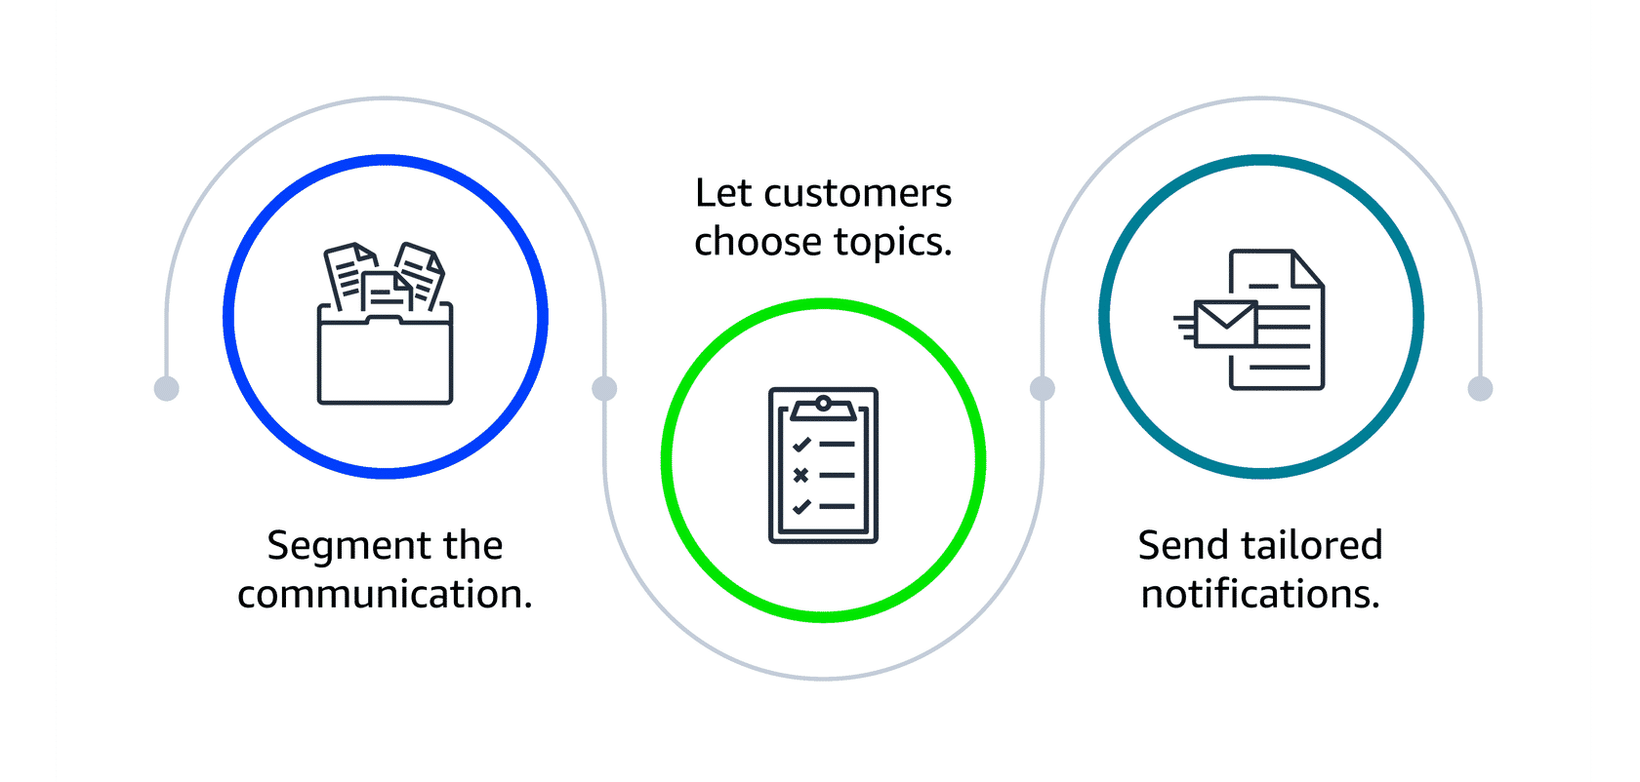
Segment the communication
The company decides to divide the communication into three separate topics, including one for new products, one for special offers, and one for events. Each topic will focus on a specific area of interest.
Let customers choose topics
Customers can subscribe to the topics they care about, such as the following:
- A customer might subscribe only to new product updates.
- Another customer might opt only for event notifications.
- A third customer might choose to subscribe to new product updates and special offers.
Send tailored notifications
With Amazon SNS, the company can send personalized notifications to subscribers based on their specific interests. Amazon SNS makes sure that these notifications are promptly delivered to the right audience, improving the efficiency and relevance of the communication.

