Course : AWS Cloud Practitioner Essentials
Module 5 : Networking
Topic : Introduction to Networking

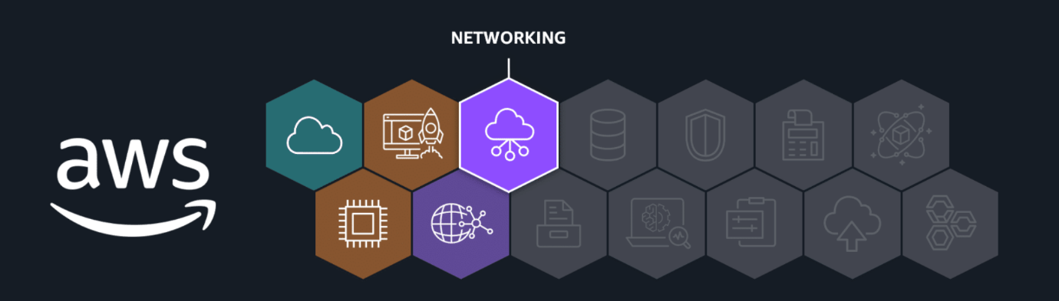
In this lesson, you will learn how to do the following:
- Describe what a virtual private cloud (VPC) is and what it does.
- Describe what a subnet is and what it does.
- Describe the difference between a public and private subnet.
The term networking refers to interconnected devices that can exchange data and resources. Networking in the AWS Cloud consists of the infrastructure and services working together to host your applications, data, and any other resources you might need. Let's get started and learn about the foundational network components used in the AWS Cloud.
Networking components
So far, you've learned about the AWS Cloud, AWS Regions, and Availability Zones. Now you will review two more foundational networking components you will use in the AWS Cloud.
Amazon Virtual Private Cloud (Amazon VPC)
An Amazon VPC lets you provision a logically isolated section of the AWS Cloud where you can launch AWS resources in a virtual network that you define.
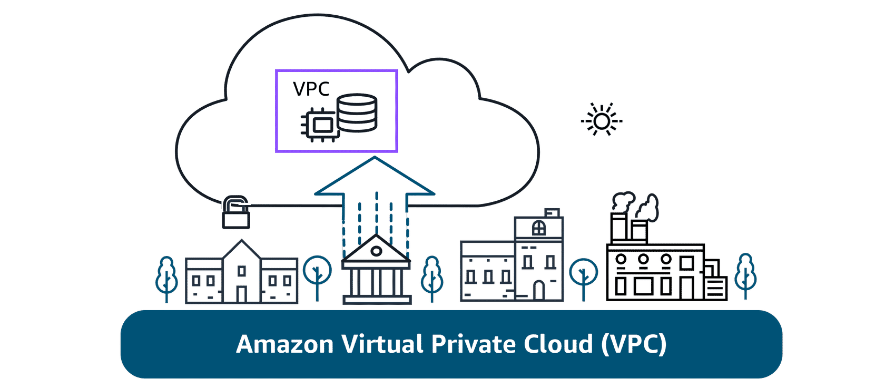
Subnet
Subnets are used to organize your resources and can be made publicly or privately accessible. A private subnet is commonly used to contain resources like a database storing customer or transactional information. A public subnet is commonly used for resources like a customer-facing website.
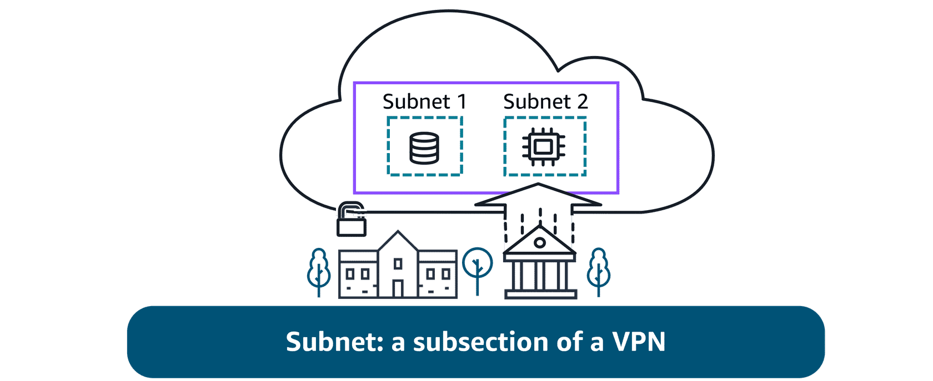
Networking components: Understanding connections through diagrams
If you are new to IT or cloud computing, you might not have worked with architectural diagrams before. A diagram is, simply put, a schematic or map of your network in the AWS Cloud. It can provide a visual of how users or applications access services, resources, or data. A picture is worth a thousand words. With a quick glance, you can see if the network was built for redundancy, security, and even scalability. It can also serve as a blueprint so you don't forget important connections when building your solutions.
To learn more about network diagrams, review the information below.
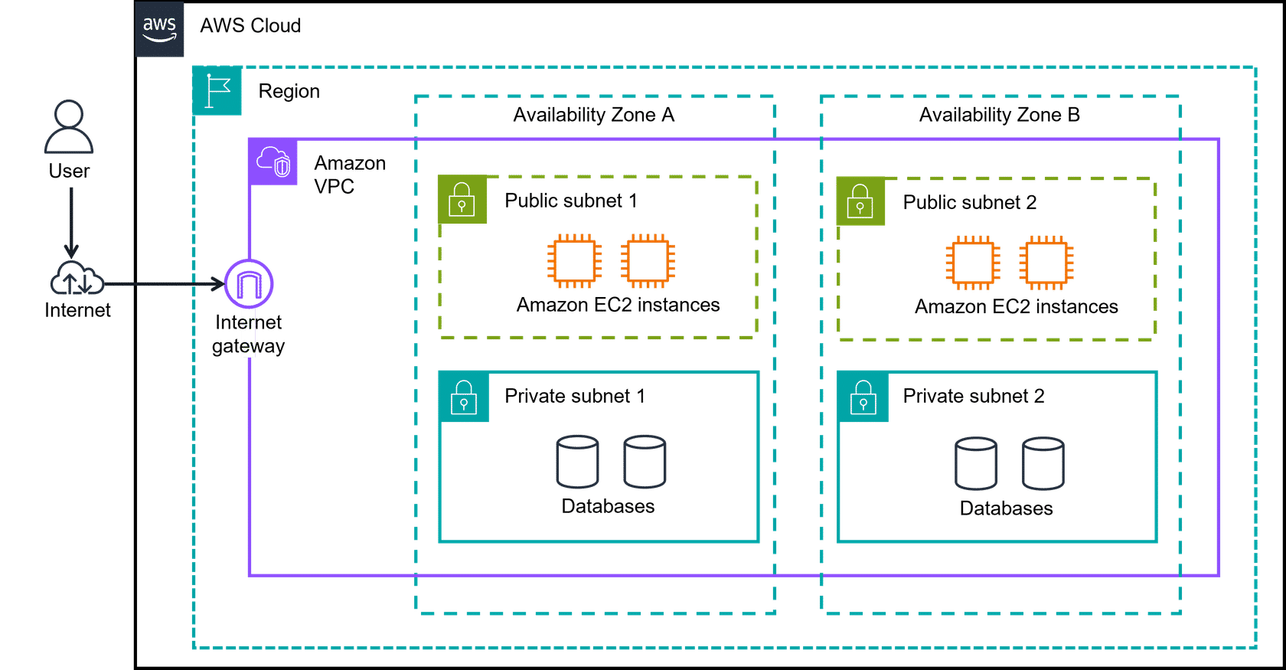
1. AWS Cloud, Regions, Amazon VPC, and AZs
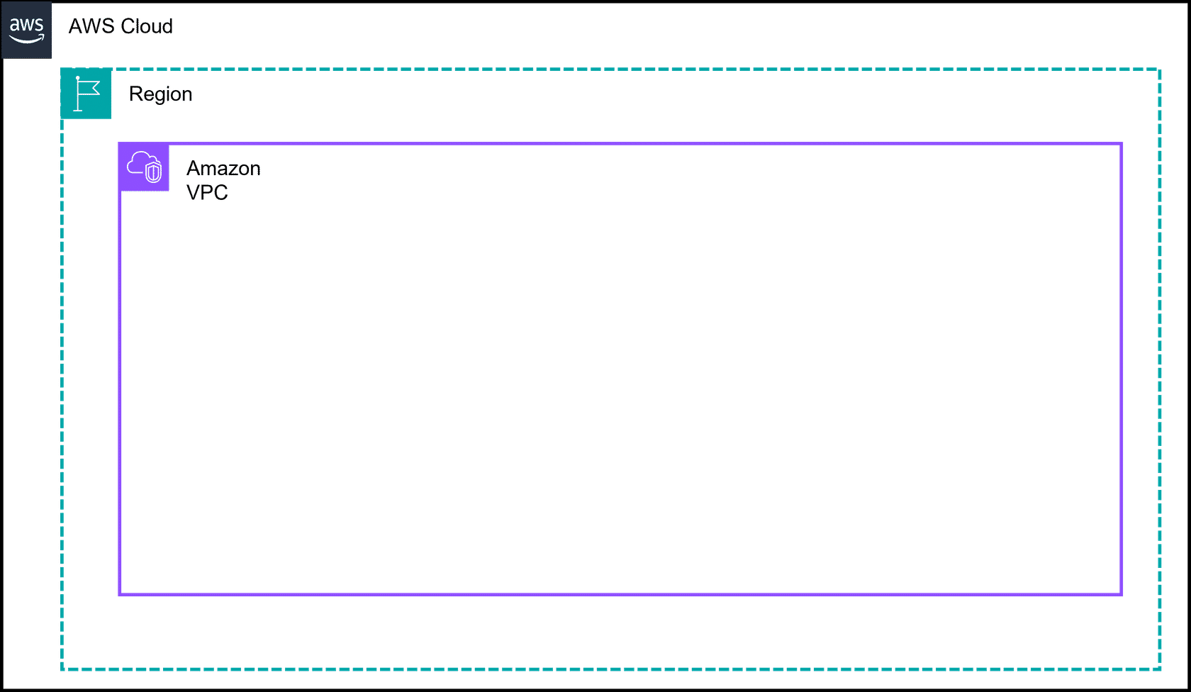
The AWS Cloud is the outermost box in most diagrams.
Region is the next box. AWS Regions are separate geographic areas. You choose your Region based on your users' geographic location for lower latency, compliance and data residency requirements, available services, and cost.
Amazon VPC is a solid box, and it represents your isolated, logically segmented network within AWS. A VPC helps you to control your network resources and security.
Availability Zones are shown as separate boxes across a region. AZs consist of one or more discrete data centers, each with redundant power, networking, and connectivity, and housed in separate facilities. Using multiple AZs can protect your applications from the failure of a single location in the Region.
2. Private subnets
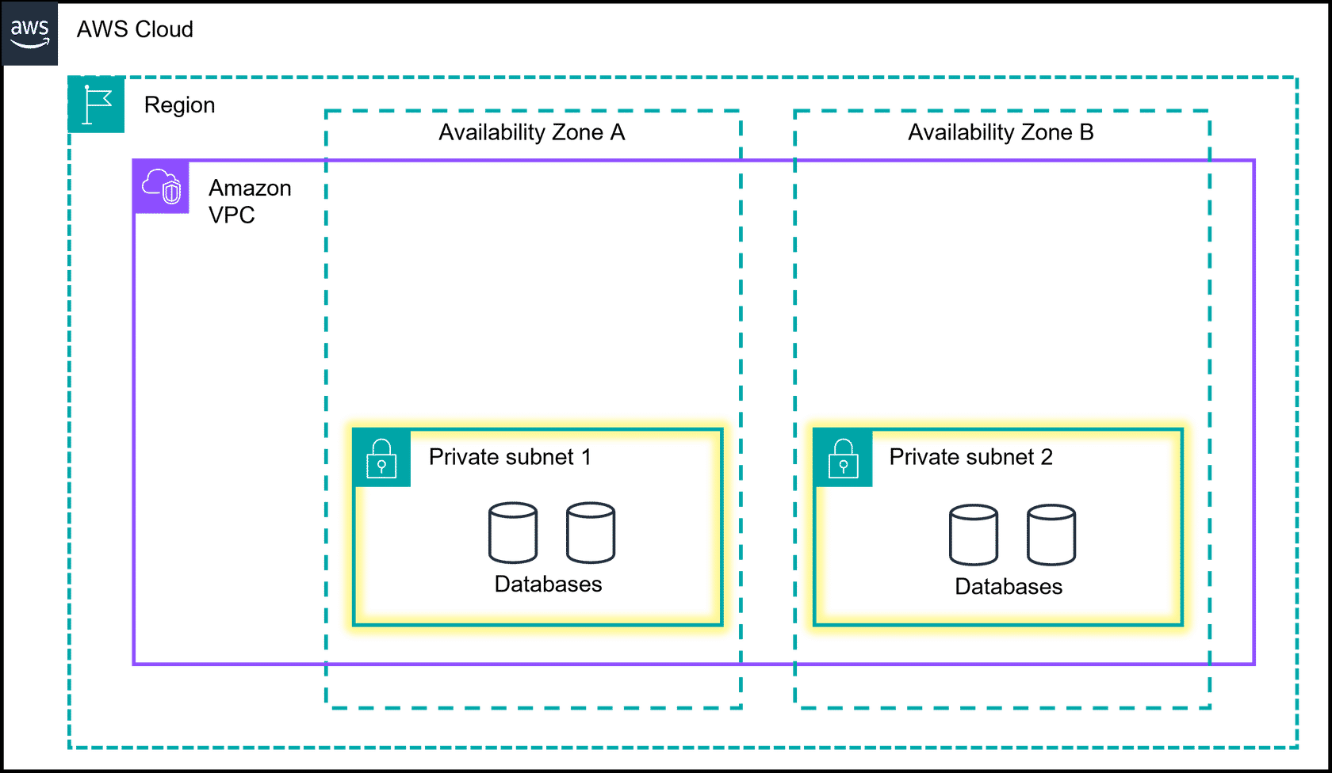
Subnets are essentially segments of your VPC, allowing you to divide your VPC into smaller, manageable sections. A subnet is a range of IP addresses in your VPC.
Private subnets are designed to isolate resources that shouldn't be directly exposed to the public internet. In diagrams, they are illustrated with solid boxes.
3. Public subnets
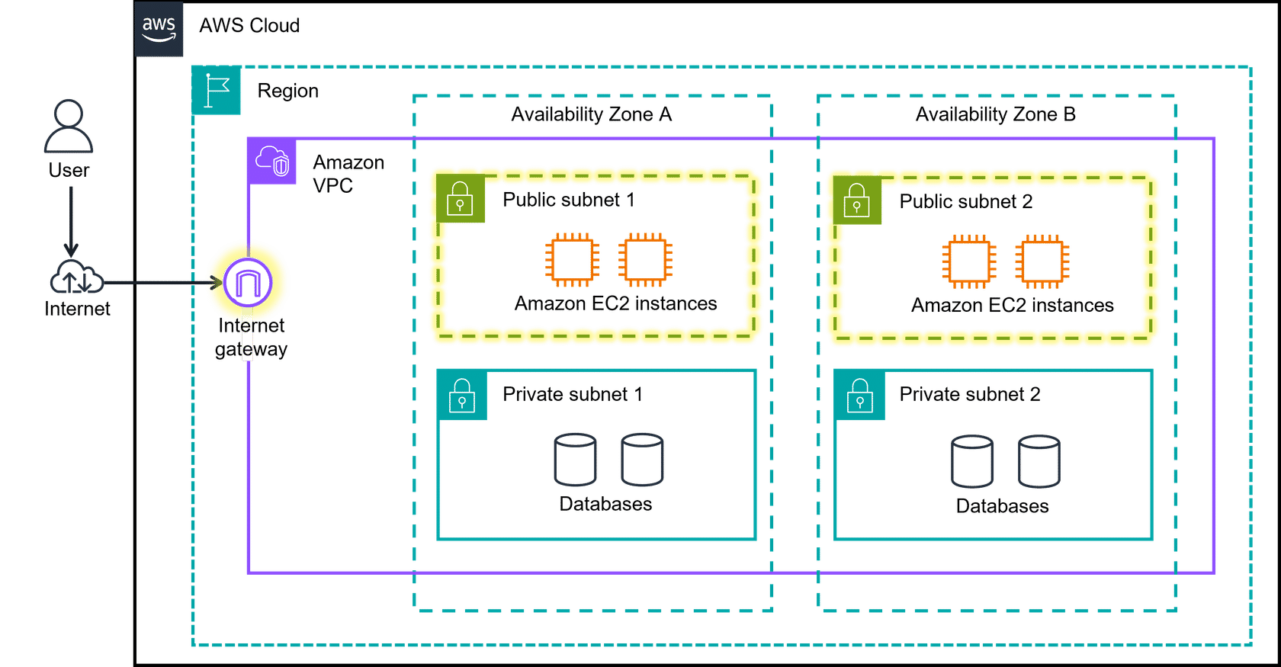
Public subnets are designed to provide direct internet access to resources placed inside them. To allow access, they are connected with an internet gateway. You will learn more about internet gateways in a later lesson. In diagrams, public subnets are drawn with dashed boxes.

Topic : Organizing AWS Cloud Resources

In this lesson, you will learn how to do the following:
- Define what a virtual private gateway is and what it does.
- Identify the core components of a VPC.
- Define an internet gateway and what it does.
In this lesson, you will explore more components in a VPC. Specifically, you will learn more about organizing your resources in the cloud using boundaries and subnets. You will also learn more about controlling access using gateways.
Organizing resources in the AWS Cloud
Imagine the millions of customers who use AWS services. Also imagine the millions of resources that these customers have created, such as Amazon EC2 instances. Without boundaries around all these resources, network traffic can flow between them unrestricted. In the following section you will learn about two components of the AWS Cloud.
- Amazon Virtual Private Cloud (VPC)
- Gateways to connect your resources
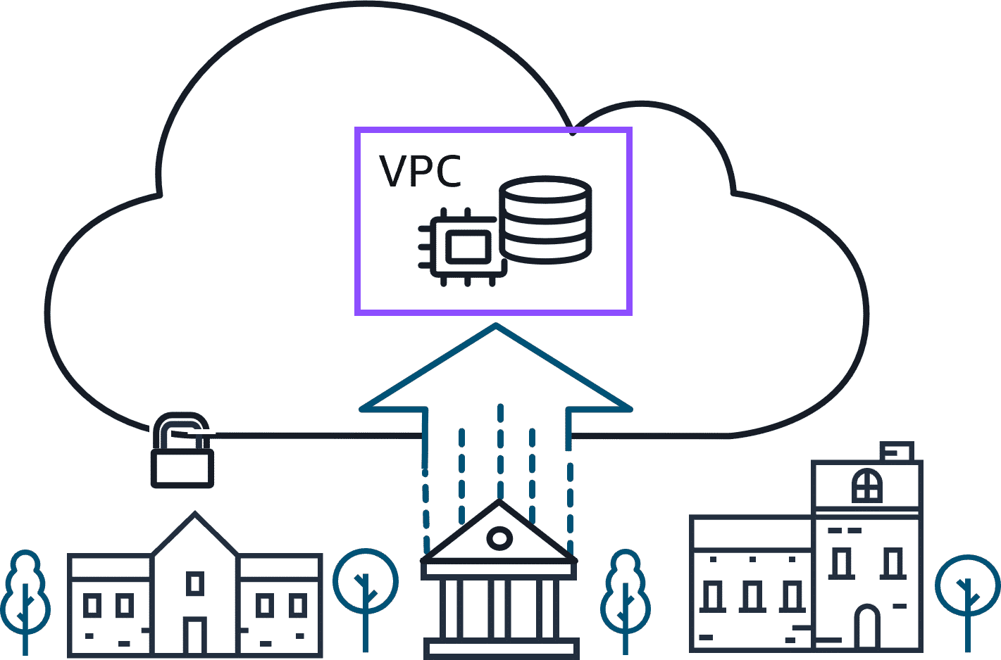
Establishing boundaries around AWS resources
When organizing your resources in the AWS Cloud, you need to be able to group certain functions together and isolate them from the public, or make them available to the public. You've been introduced to what Amazon VPCs do. Next, you will review the benefits.
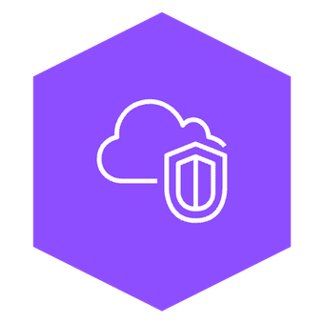
Amazon VPC
With Amazon VPC, you can provision an isolated section of the AWS Cloud. In this isolated section, you can launch resources in a virtual network that you define. It provides three main benefits. It helps increase security because you can secure and monitor connections, screen traffic, and restrict instance access. Amazon VPC gives you full control over your resource placement, connectivity, and security. The convenience of using Amazon VPC means you will spend less time setting up, managing, and validating your virtual network when compared to on-premises network management.
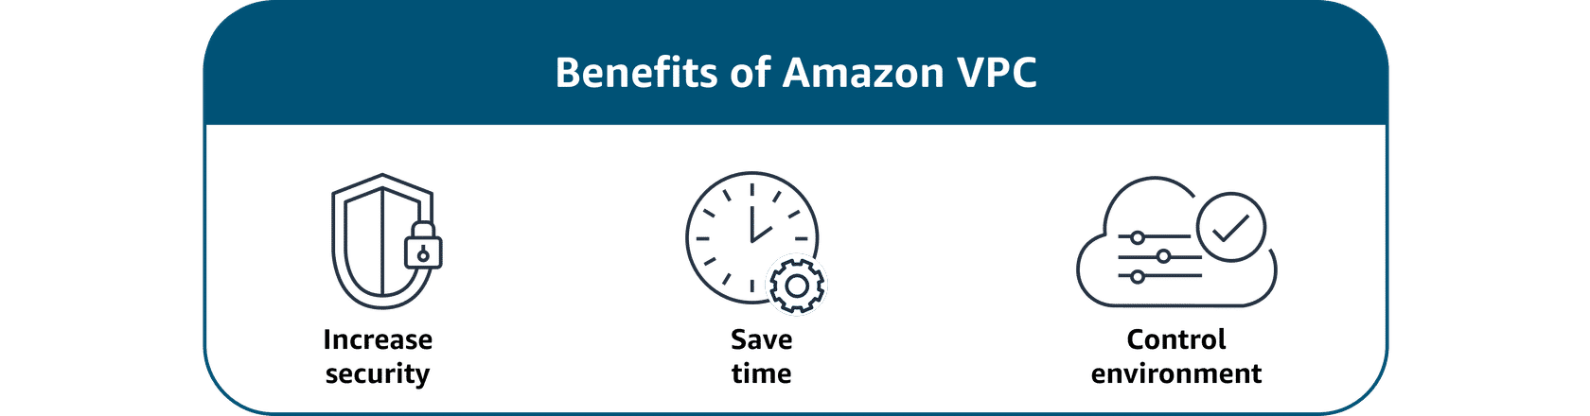
Subnets
Within an Amazon VPC, you can organize your resources into subsections or subnets. A subnet is a section of an Amazon VPC that can contain resources, such as Amazon EC2 instances. You will learn more about subnets in the next lesson.
Connecting your resources with an internet gateway
To allow public traffic from the internet to access your VPC, you attach an internet gateway to the VPC. An internet gateway is a connection between a VPC and the internet. You can think of an internet gateway as being similar to a doorway that customers use to enter the coffee shop. Without an internet gateway, no one can access the resources within your VPC.
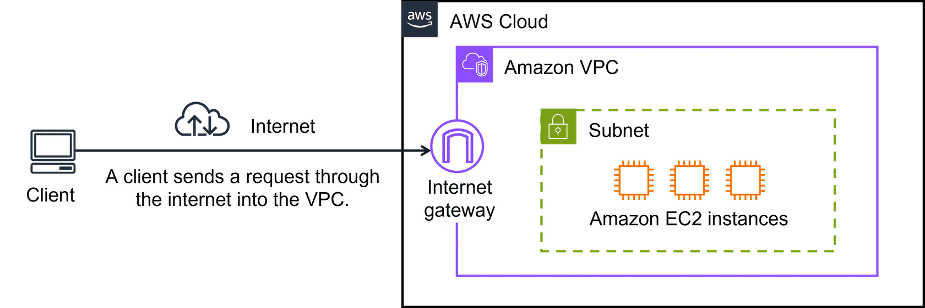
Virtual private gateways
What if you have a VPC that includes only private resources? The following example shows how a virtual private gateway works. You can think of the internet as the road between your home and the coffee shop. It is open and accessible to anyone. You want a way to protect the traffic you send on the internet from the public, internet service providers, and others who might be trying to track or intercept it. This is where a virtual private network (VPN) connection comes in.
VPN creates a connection that is more like a secure tunnel through the internet. Using encryption, it hides and protects everything you send and receive from outside eyes. A virtual private gateway is the component in the AWS Cloud that makes it possible for you to connect this protected traffic to enter the VPC. With a VPN connection, your data travels privately and safely, hidden from others using the same route.
With a virtual private gateway, you can establish a VPN connection between your VPC and a private network, such as an on-premises data center or internal corporate network. A virtual private gateway allows traffic into the VPC only if it is coming from an approved network.
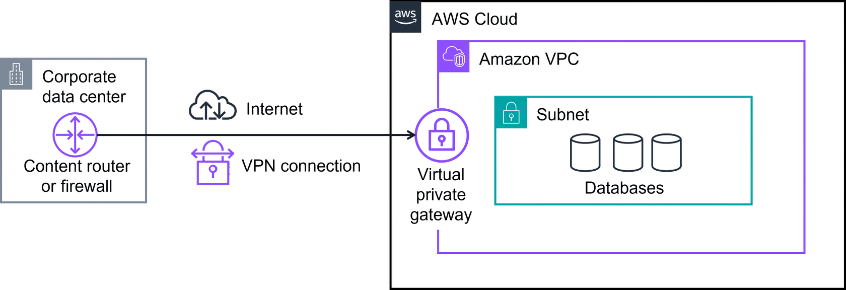
Several of the preceding networking components have similar abbreviations and are often confused. These components are core building blocks that you'll use in many AWS Cloud solutions. To learn the differences between these acronyms, review each of the following flashcards.
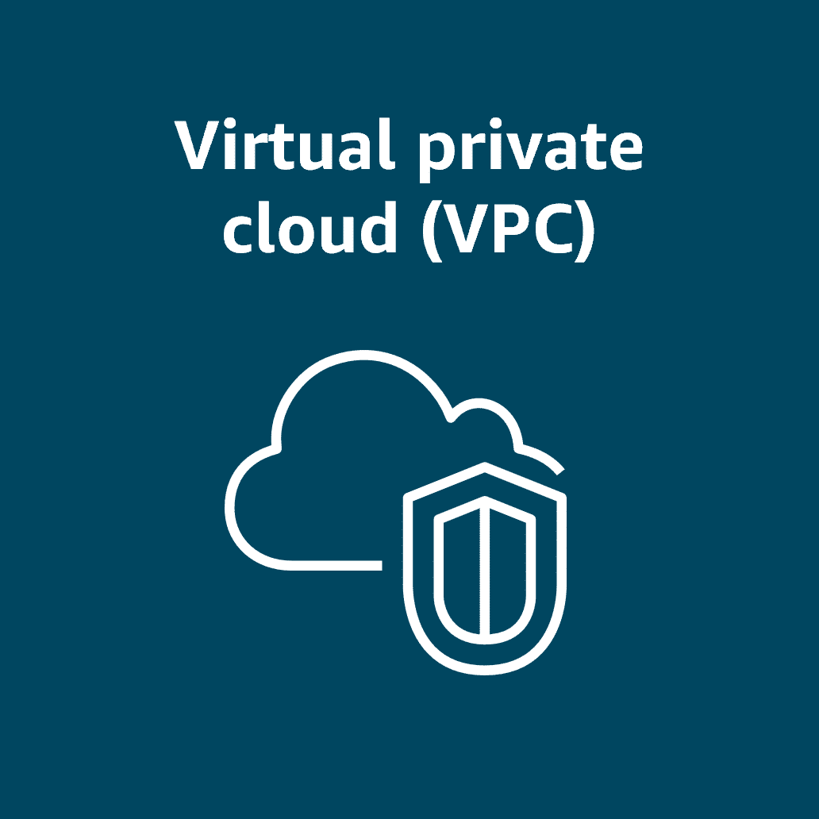
Amazon Virtual Private Cloud
Amazon VPC is used to establish boundaries around your AWS resources.
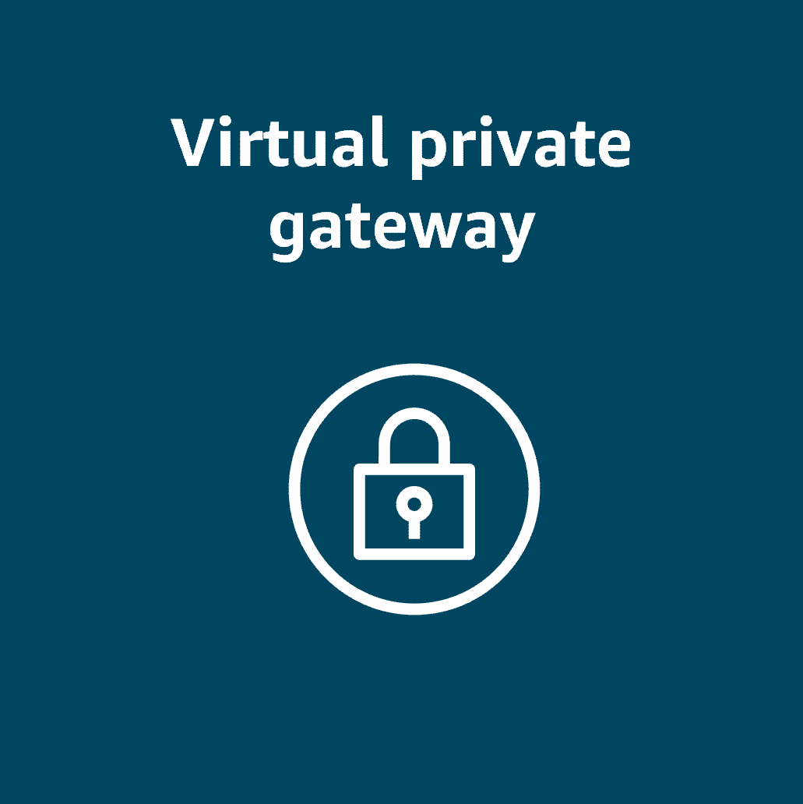
Virtual private gateway
A virtual private gateway allows protected internet traffic to enter into the VPC.
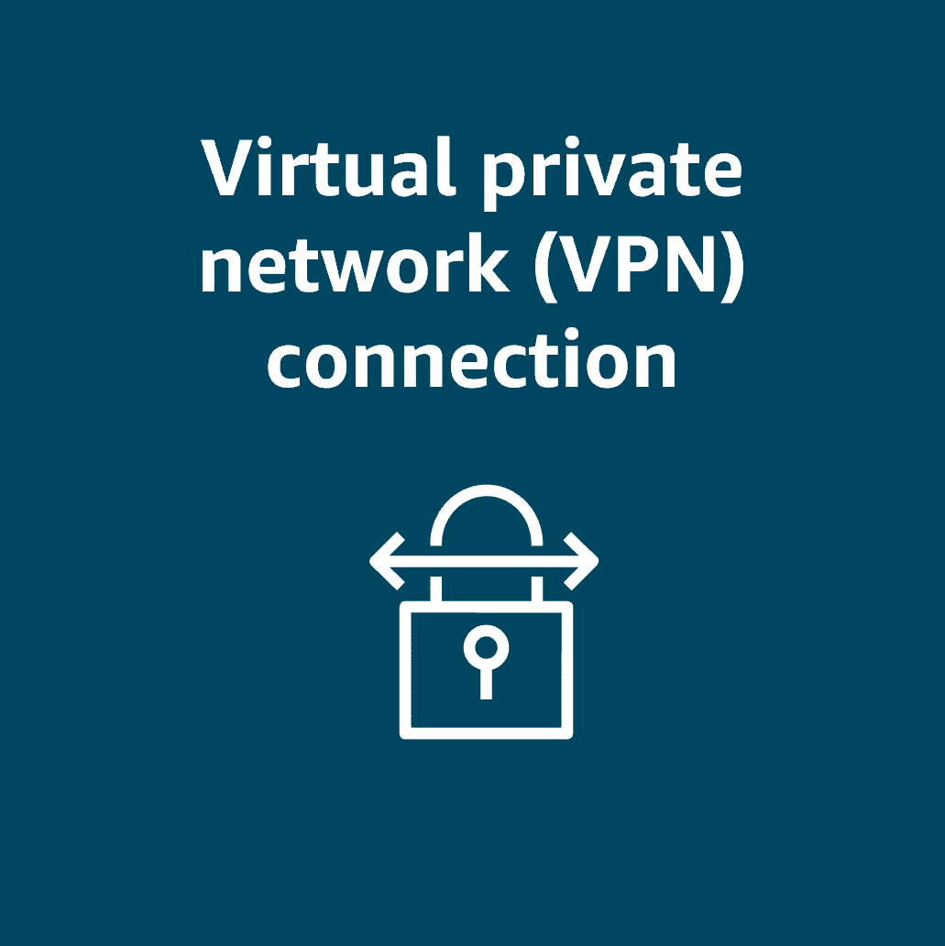
Virtual private network
A VPN encrypts your internet traffic, helping protect it from anyone who might try to intercept or monitor it.

Topic : More Ways to Connect to the AWS Cloud

In this lesson, you will learn how to do the following:
- Describe AWS Client VPN and when to use it.
- Describe AWS Site-to-Site VPN and when to use it.
- Describe AWS PrivateLink and when to use it.
- Describe AWS Direct Connect and when to use it.
You will explore more hybrid cloud connections with the AWS Cloud. Specifically, you'll learn more ways to connect your clients, datacenters, and sites to the AWS Cloud.
Connecting to the AWS Cloud
With so many different types of networks, on-premises datacenters, and remote workers, companies need a wide range of ways to connect to the AWS Cloud. In the following section, you will learn four ways to connect to the AWS Cloud:
- AWS Client VPN
- AWS Site-to-Site VPN
- AWS PrivateLink
- AWS Direct Connect
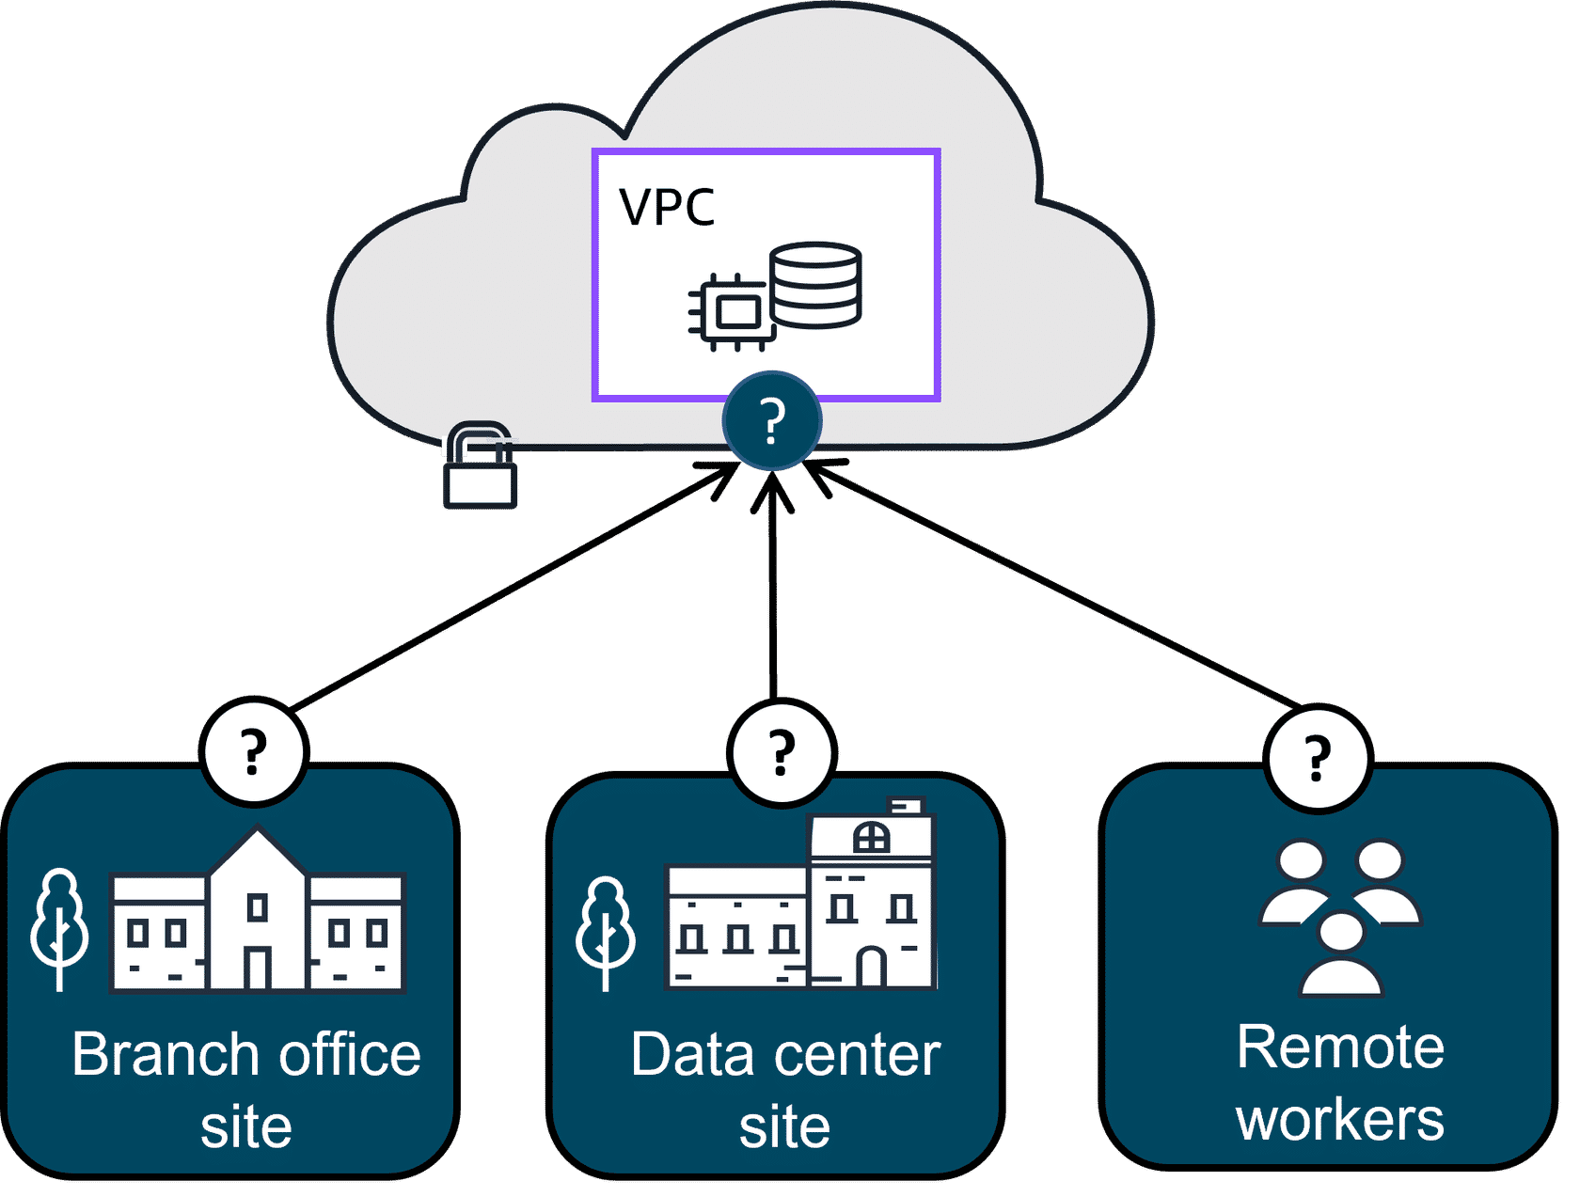
Securely connect a remote workforce to AWS Cloud resources
Imagine a company with a recent acquisition needing to securely connect their new remote workforce to their AWS Cloud resources. Even the largest companies with worldwide remote workers can quickly scale up and connect to the AWS Cloud. That's where AWS Client VPN can help.
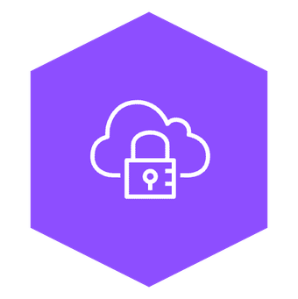
AWS Client VPN
AWS Client VPN is a networking service you can use to connect your remote workers and on-premises networks to the cloud. It is a fully managed, elastic VPN service that automatically scales up or down based on user demand. Because it is a cloud VPN solution, you don’t need to install and manage hardware or try to estimate how many remote users to support at one time.
Benefits: AWS Client VPN provides advanced authentication, remote access. It is elastic and fully managed.
Use case: It can be used to quickly scale remote-worker access.
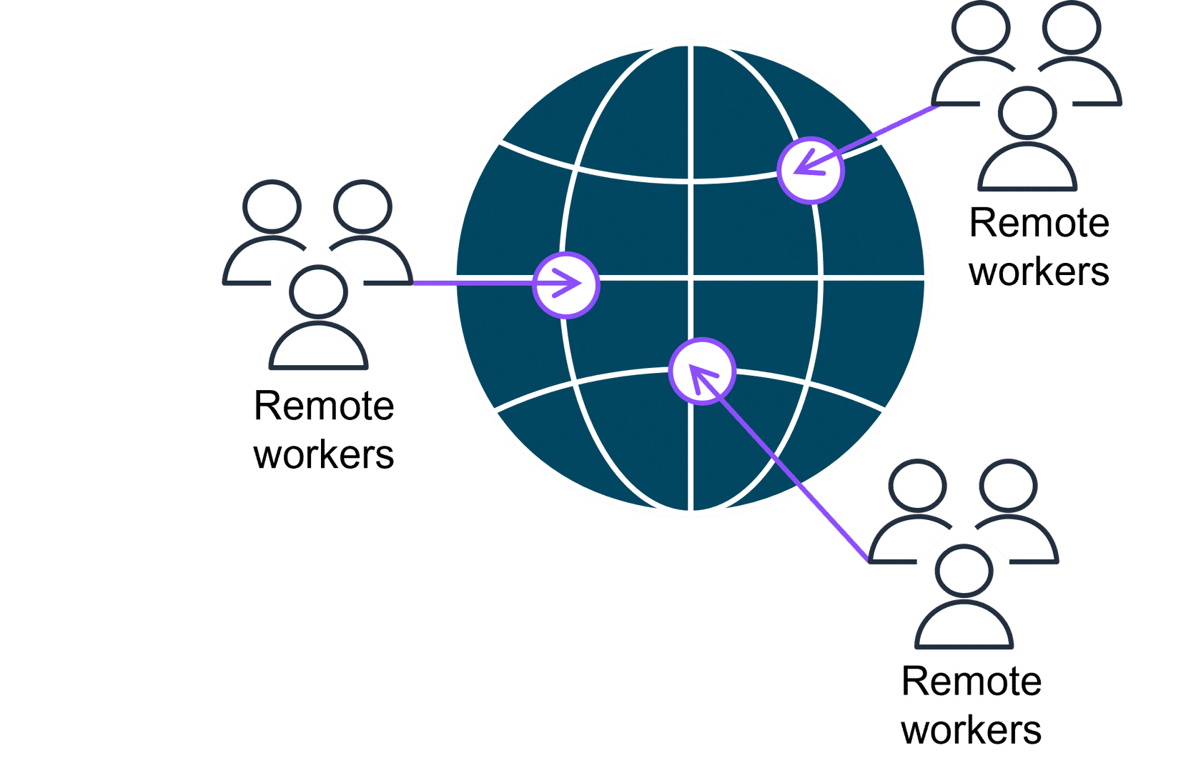
Client VPN, a managed VPN service, provides secure access to AWS resources and on-premises networks from anywhere. It uses an OpenVPN-based client, and it works with global Regions by using the AWS global network.
Securely connect sites to other sites
Some companies might want to establish secure, encrypted connections between their on-premises networks like data centers or branch offices and their resources in their Amazon VPC. That's where Site-to-Site VPN can help.

AWS Site-to-Site VPN
Site-to-Site VPN creates a secure connection between your data center or branch offices and your AWS Cloud resources.
Benefits: Site-to-Site VPN provides high availability, secure and private sessions, and accelerates applications.
Use cases: It can be used for application migration and secure communication between remote locations.
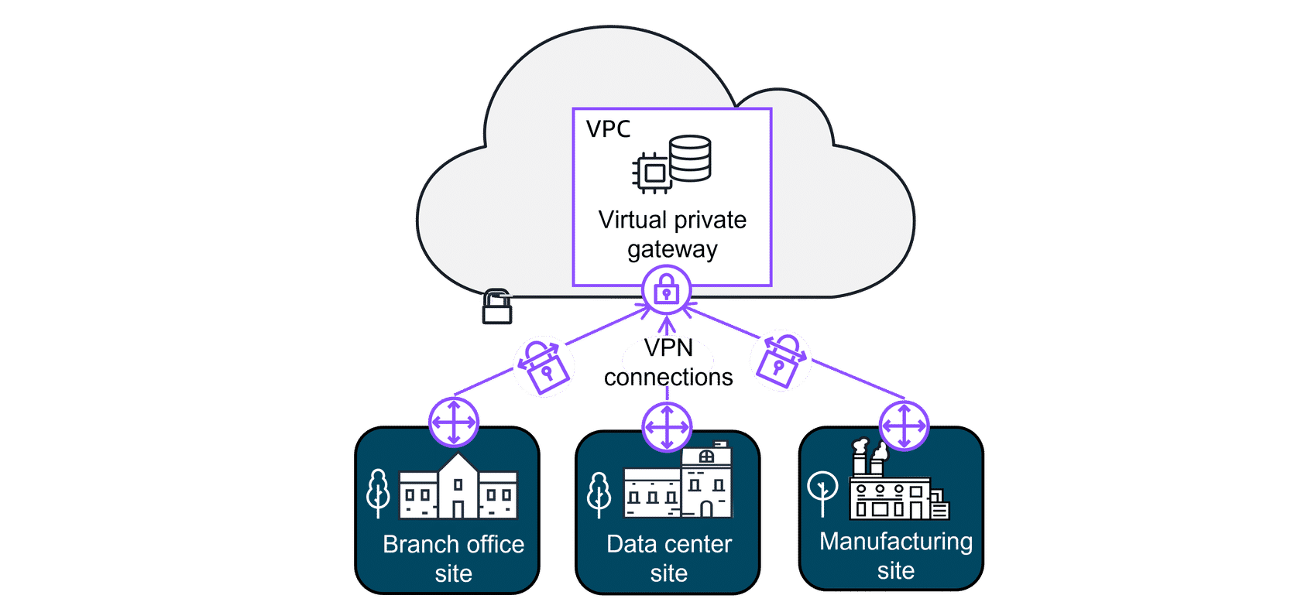
Securely connect resources, even in other VPCs
Other companies sometimes need the flexibility to privately connect to resources in other cloud providers as though they were in their own VPC. They need a way to communicate with these resources and don't want the hassle of setting up gateways or site-to-site VPNs. That's where AWS PrivateLink can help.
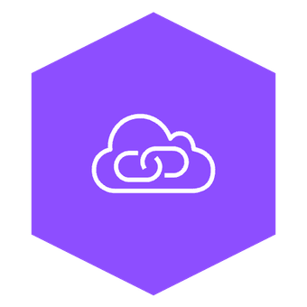
AWS PrivateLink
AWS PrivateLink is a highly available, scalable technology that you can use to privately connect your VPC to services and resources as if they were in your VPC. You do not need to use an internet gateway, NAT device, public IP address, Direct Connect connection, or AWS Site-to-Site VPN connection to allow communication with AWS services or resources from your private subnets. Instead, you control the specific API endpoints, sites, services, and resources that are reachable from your VPC.
Benefits: AWS PrivateLink helps you secure your traffic and connect with simplified management rules.
Use case: It is used for connecting your clients in your VPC to resources, other VPCs, and endpoints.
Even though the preceding connections are highly available and scalable, traffic jams are possible because you’re using the same connection as other clients. That's why for some use cases, you might need a dedicated private connection with a lot of bandwidth.
Dedicated private connections for increased bandwidth
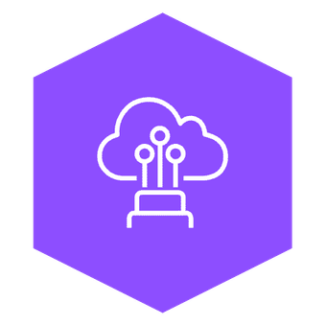
AWS Direct Connect
Direct Connect is a service that makes it possible for you to establish a dedicated private connection between your network and VPC in the AWS Cloud.
Benefits: AWS Direct Connect reduces network costs and increases amount of bandwidth.
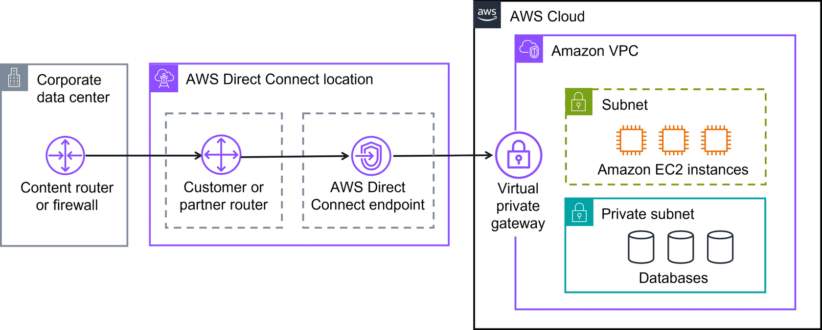
To learn more about Direct Connect, review each of the following three categories.

Latency-sensitive applications:
Direct Connect bypasses the internet and provides a consistent, low-latency network experience. This makes it ideal for applications like video streaming and other real-time applications that require high performance.

Large-scale data migration or transfer:
Direct Connect helps ensure smooth and reliable data transfers at massive scale for real-time analysis, rapid data backup, or broadcast media processing.

Hybrid cloud architectures:
You can use Direct Connect to link your AWS and on-premises networks to build applications that span environments without compromising performance.
Additional gateway services
There are several different types of gateways you can use to connect your AWS resources. Depending on your needs, you might want to learn more about what they are used for and where to go to learn more. To learn more about these additional gateway types, expand each of the following three categories.

AWS Transit Gateway:
AWS Transit Gateway is used to connect your Amazon VPCs and on-premises networks through a central hub. As your cloud infrastructure expands globally, inter-Region peering connects transit gateways together using the AWS Global Infrastructure. To learn more, refer to AWS Transit Gateways.

Network Address Translation (NAT) Gateway:
A NAT gateway is a NAT service. You can use a NAT gateway so that instances in a private subnet can connect to services outside your VPC but external services can't initiate a connection with those instances. To learn more, refer to NAT gateway.

Amazon API Gateway:
You learned about Application Programming Interface (API)s earlier. Quick refresher, an API defines how different software systems can interact and communicate with each other. The Amazon API Gateway is an AWS service for creating, publishing, maintaining, monitoring, and securing APIs at any scale. To learn more, refer to Amazon API Gateway.
In this lesson, you identified services that help you connect your AWS Cloud to your clients, datacenters, and sites. To review the four types of connectivity options, choose each of the following flashcards.
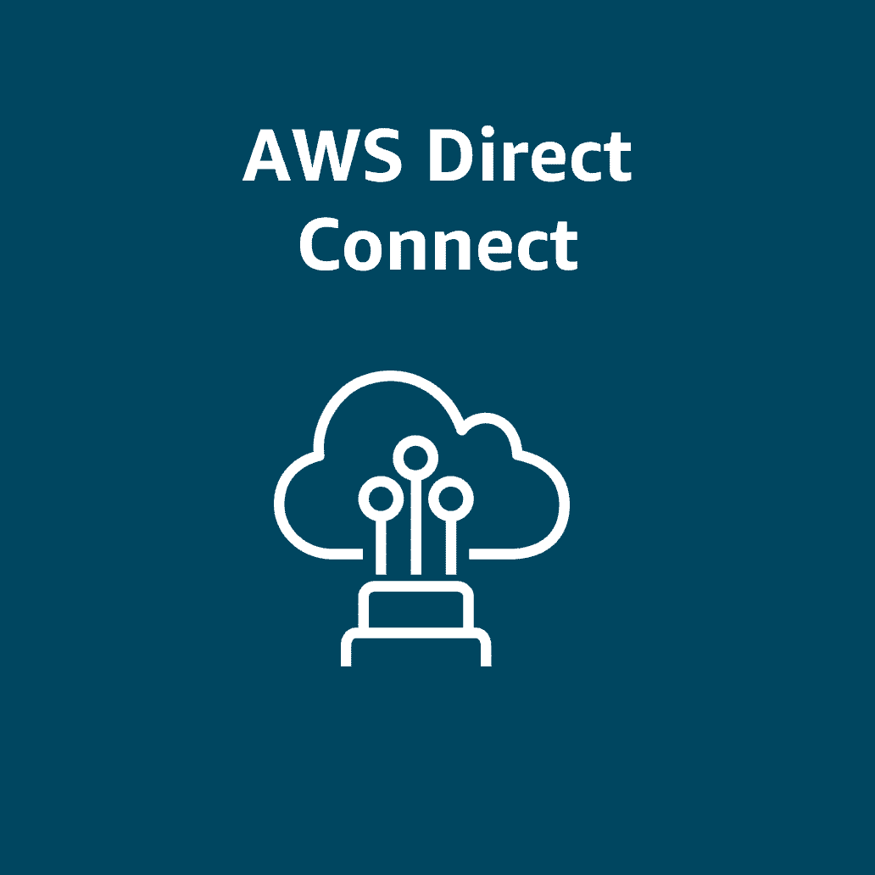
AWS Direct Connect
AWS Direct Connect is a private, dedicated AWS connection to your data center or office.
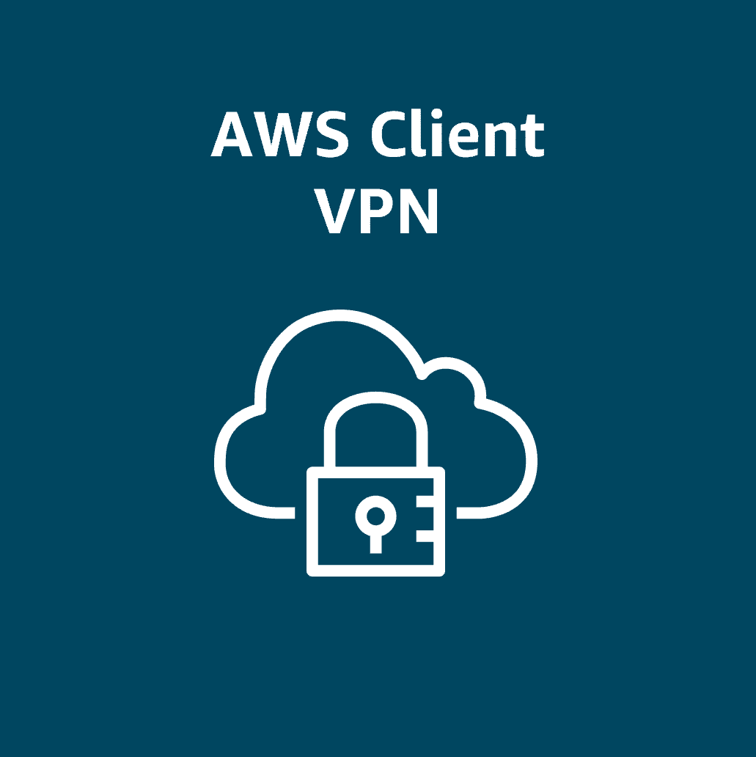
AWS Client VPN
AWS Client VPN connects your remote workforce to AWS or on-premises with a VPN.
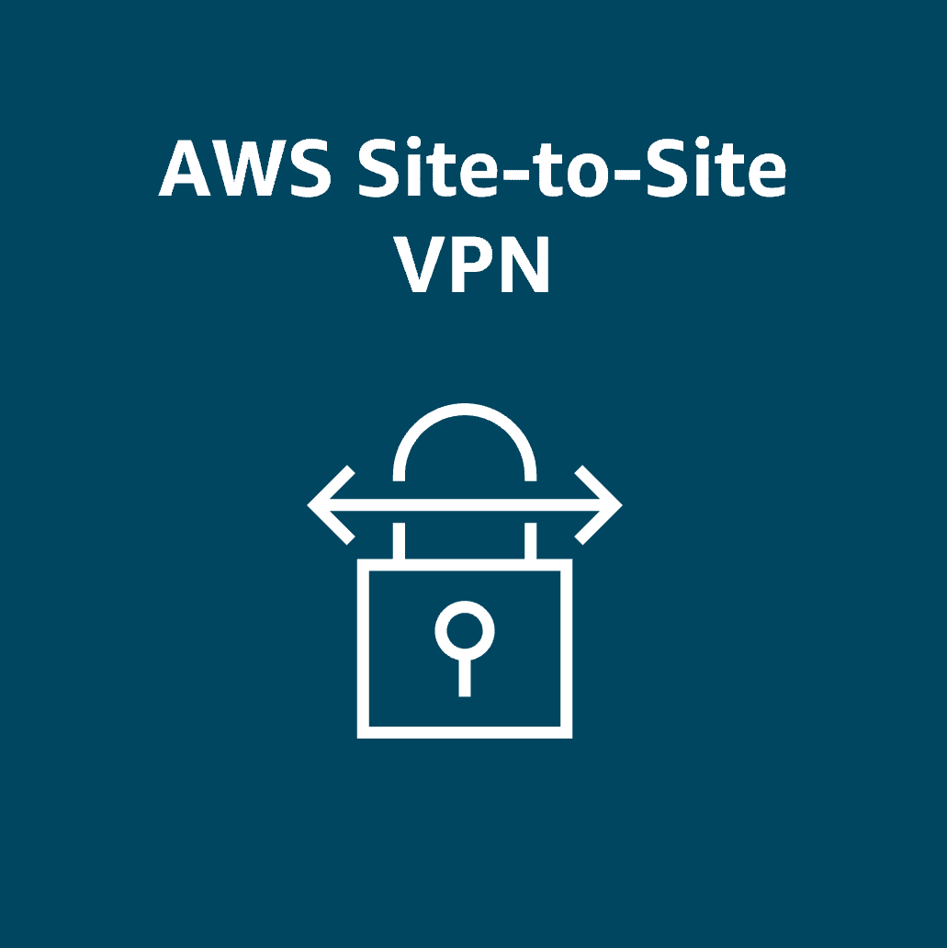
AWS Site-to-Site VPN
AWS Site-to-Site VPN is an encrypted network connection to your Amazon VPCs.
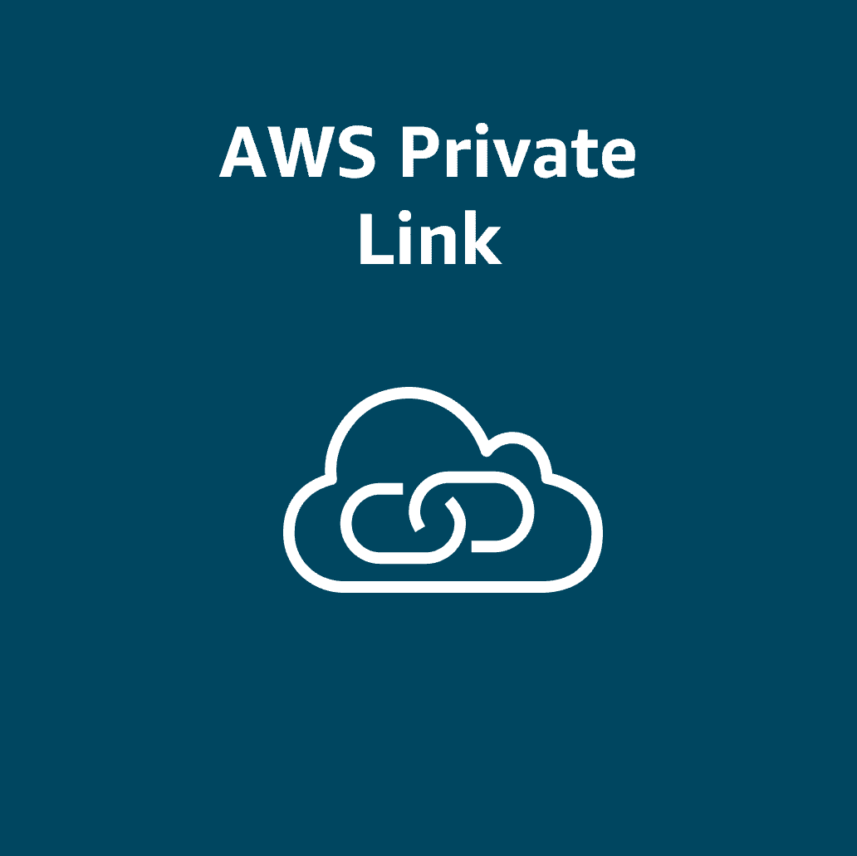
AWS PrivateLink
AWS PrivateLink connects your VPC privately to services and resources as though they were in your VPC.

Topic : Subnets, Security Groups, and Network Access Control Lists

In this lesson, you will learn how to do the following:
- Describe how network traffic works in a VPC.
- Describe how security groups work (stateful).
- Describe how network access control lists (network ACLs) work (stateless).
- Describe who is responsible for securing subnets with security groups and network ACLs according to the AWS Shared Responsibility Model.
Now that you know the basic components of a network, you'll want to start thinking about security. As you get started, you will notice there are many different choices to secure your resources in the AWS Cloud. Two very powerful and flexible ways to control network traffic in your VPC are security groups and network access control lists, or network ACLs. In this lesson, you will learn about defining the rules for your security groups and network ACLs, including how they work. Using these two hardworking security components in your network design will help you to meet your specific application requirements, while also helping to ensure basic network security.
Subnets
A section of a VPC for grouping resources based on security or operational needs
A subnet is a section of a VPC in which you can group resources based on security or operational needs. Subnets can be public or private.
Public subnets contain resources that need to be accessible by the public, such as an online store’s website.
Private subnets contain resources that should be accessible only through your private network, such as a database that contains customers’ personal information and order histories.
In a VPC, you can define rules to allow resources in different subnets to communicate with each other. For example, you might have an application that uses Amazon EC2 instances in a public subnet communicating with databases that are located in a private subnet.
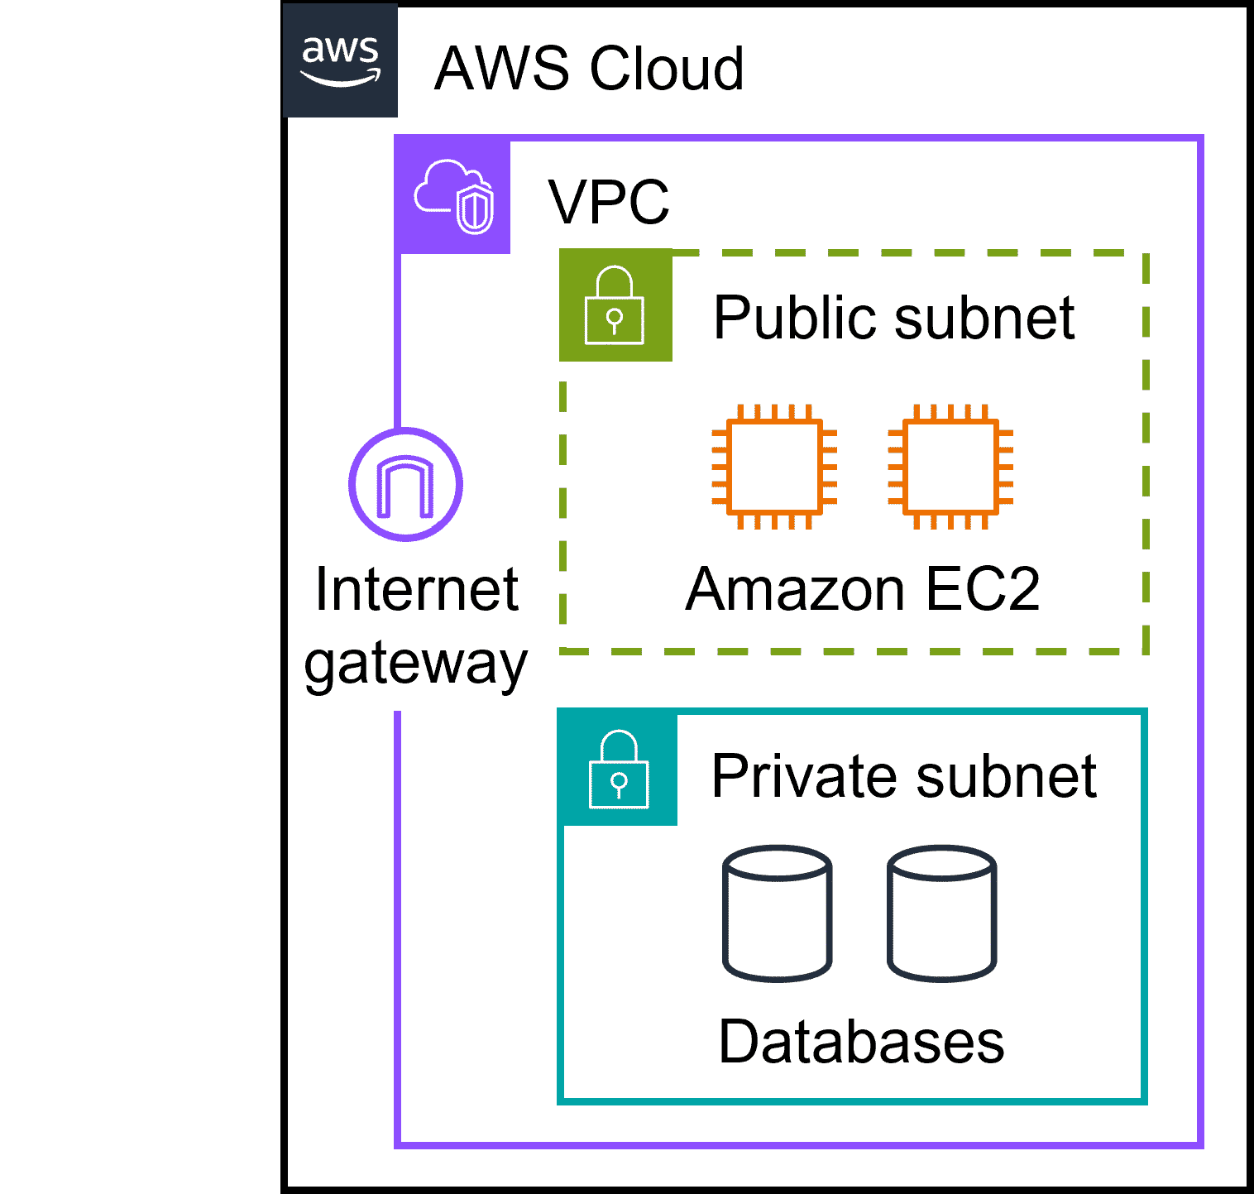
Network traffic in a VPC
The movement of data packets traveling across a network
When a customer requests data from an application hosted in the AWS Cloud, this request is sent as a packet. A packet is a unit of data sent over the internet or a network.
It enters into a VPC through an internet gateway. Before a packet can enter into a subnet or exit from a subnet, it will run into several checks for permissions, one being a network ACL associated with the subnet the packet is being routed to. The permissions defined by the network ACLs indicate what is allowed or denied. It is based on who sent the packet and how the packet is trying to communicate with the resources in a subnet.
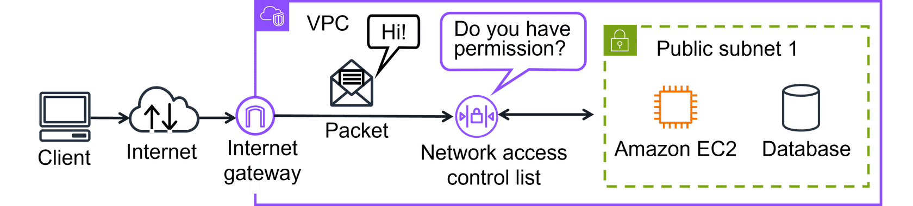
The VPC component that checks packet permissions for subnets is a network ACL.
Network ACLs
Virtual firewall controlling traffic
A network ACL is a virtual firewall that controls inbound and outbound traffic at the subnet level.
For example, imagine that you are at the airport. Travelers are trying to enter into a different country. You can think of the travelers as packets and the passport control officer as a network ACL. The passport control officer checks travelers’ credentials when they are both entering and exiting the country. This is similar to how a network ACL checks permissions every time a packet travels across a subnet boundary.
Each AWS account includes a default network ACL. When configuring your VPC, you can use your account’s default network ACL or create custom network ACLs. By default, your account’s default network ACL allows all inbound and outbound traffic, but you can modify it by adding your own rules.
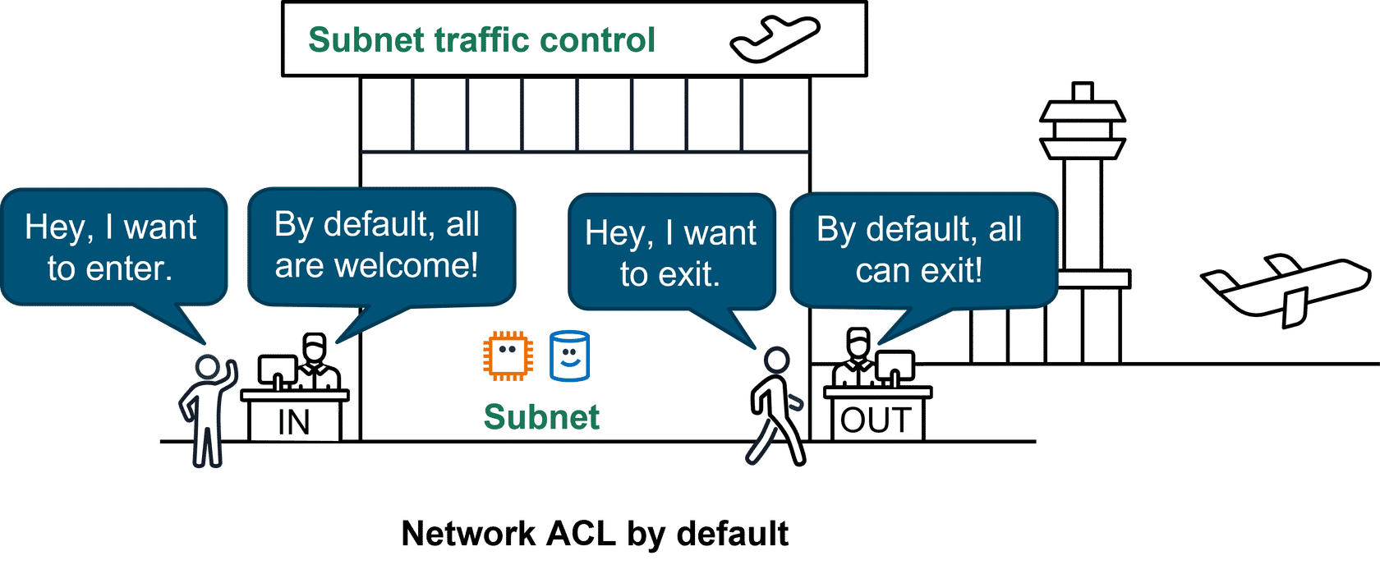
For custom network ACLs, all inbound and outbound traffic is denied until you add rules to specify which traffic to allow. Additionally, all network ACLs have an explicit deny rule. This rule makes sure that if a packet doesn’t match any of the other rules on the list, the packet is denied.
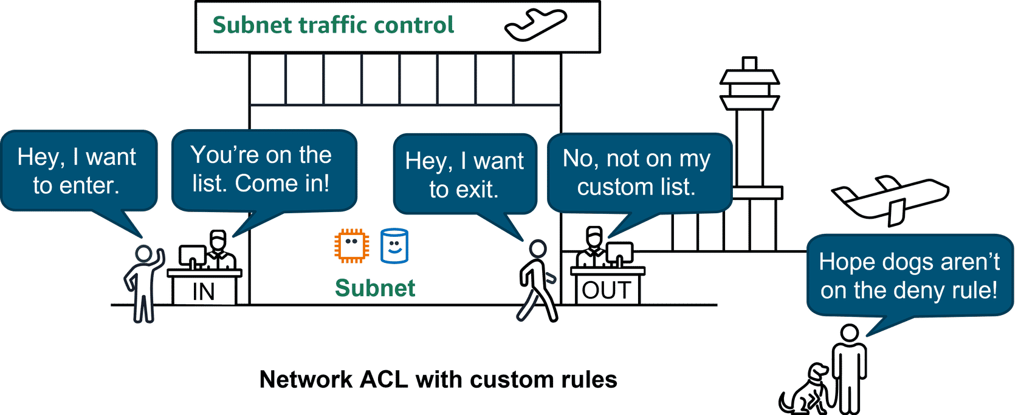
Stateless packet filtering
Network ACLs perform stateless packet filtering. They remember nothing and check packets that cross the subnet border each way: inbound and outbound.
Recall the previous example of a traveler who wants to enter into a different country. This is similar to sending a request out from an Amazon EC2 instance and to the internet.
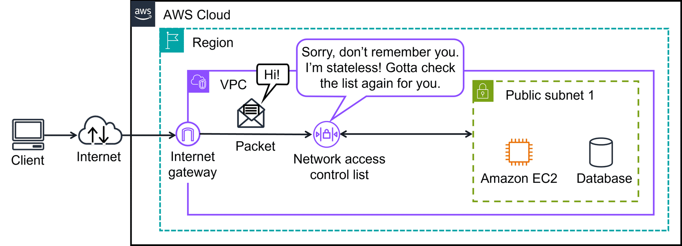
When a packet response for that request comes back to the subnet, the network ACL does not remember your previous request. The network ACL checks the packet response against its list of rules to determine whether to allow or deny.
Security groups: Control inbound and outbound traffic at the resource level
After a packet has entered a subnet, it must have its permissions evaluated for resources within the subnet, such as Amazon EC2 instances. A security group is the VPC component that checks packet permissions for an Amazon EC2 instance. It is a virtual firewall that controls inbound and outbound traffic for specific AWS resources, like Amazon EC2 instances.
By default, a security group denies all inbound traffic and allows all outbound traffic. For this example, suppose that you are at an apartment building with a door attendant who greets guests at the door. You can think of the guests as packets and the door attendant as a security group. With the default settings, the security groups won't let anyone in and allows all outbound traffic out.
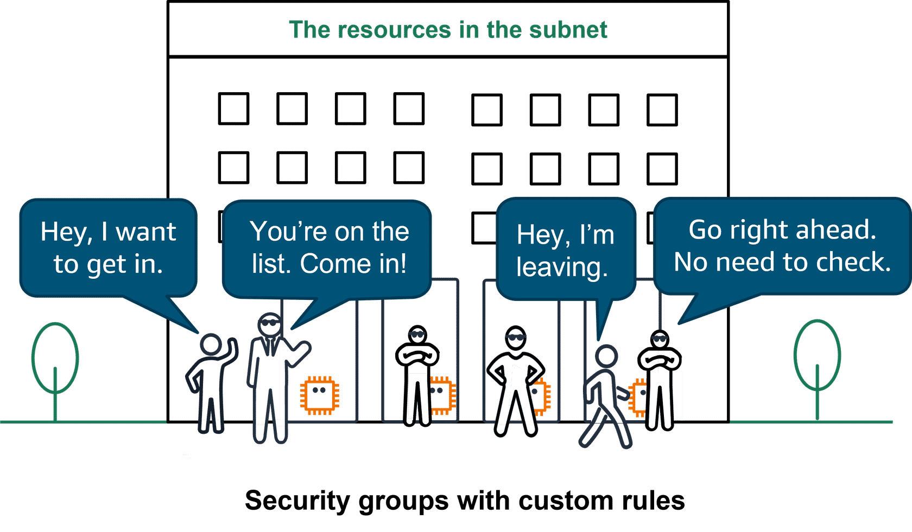
With security groups, you can add custom rules to configure which traffic should be allowed. Any other traffic would then be denied. For example, custom rules can be given separately for inbound and outbound traffic. As guests arrive, the door attendant checks a list to makes sure they can enter the building. However, the door attendant does not check the list again when guests are exiting the building.
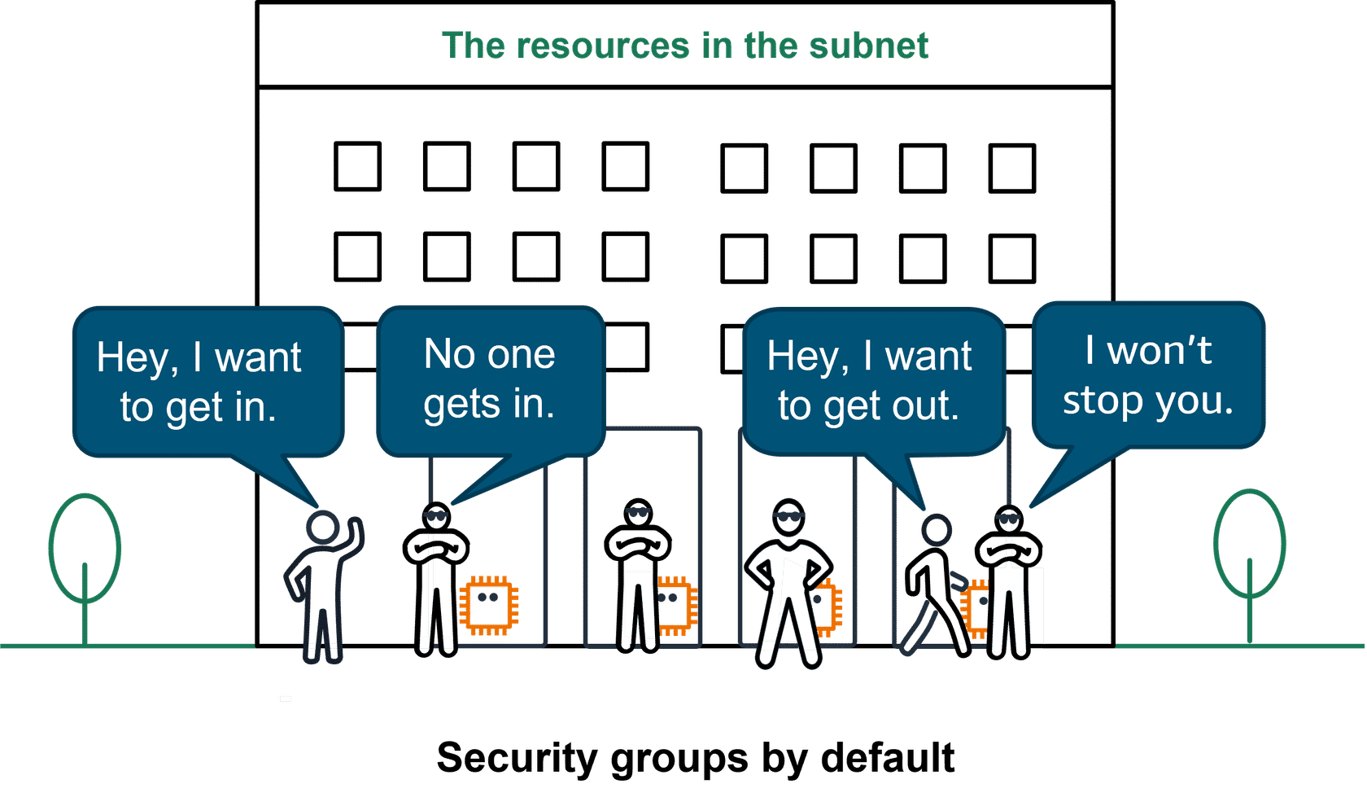
Note: If you have multiple Amazon EC2 instances within the same VPC, you can associate them with the same security group or use different security groups for each instance.
Stateful packet filtering
Security groups perform stateful packet filtering. They remember previous decisions made for incoming packets.
Consider the same example of sending a request out from an Amazon EC2 instance to the internet. When a packet response for that request returns to the instance, the security group remembers your previous request. The security group allows the response to proceed, regardless of inbound security group rules.
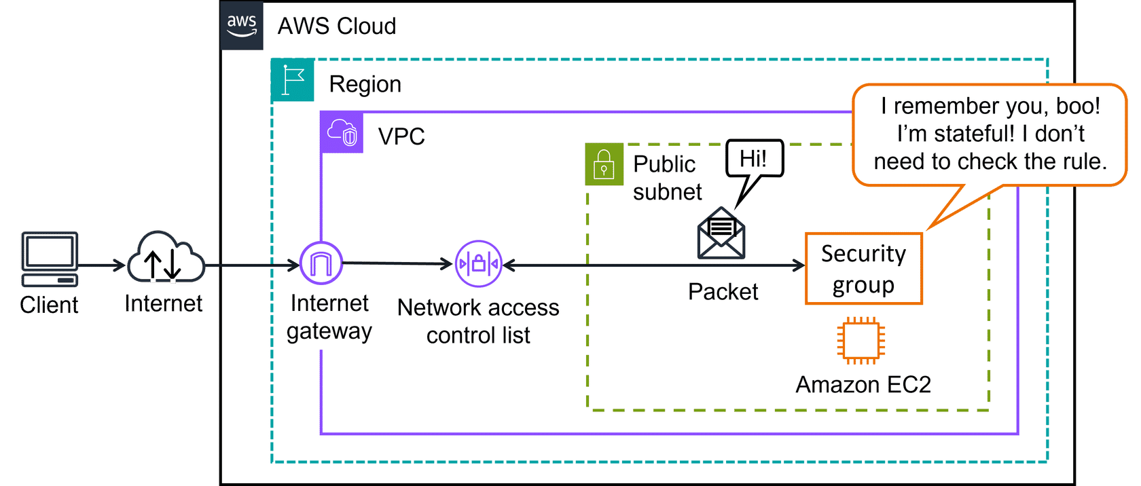
With both network ACLs and security groups, you can configure custom rules for the traffic in your VPC. As you continue to learn more about AWS security and networking, it is important to understand the differences between them. The following table will help you understand which to use.
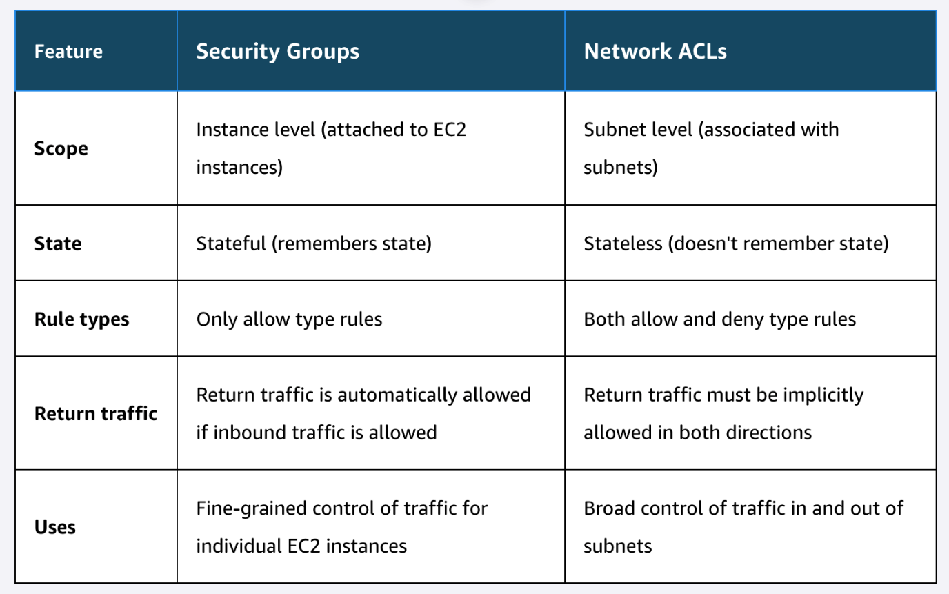
Remember the AWS Shared Responsibility Model? When it comes to securing the subnets and resources in your VPC with network ACLs and security groups, that is your responsibility. These components make up networking traffic protection and are critical defenses in protecting your applications IN the cloud.
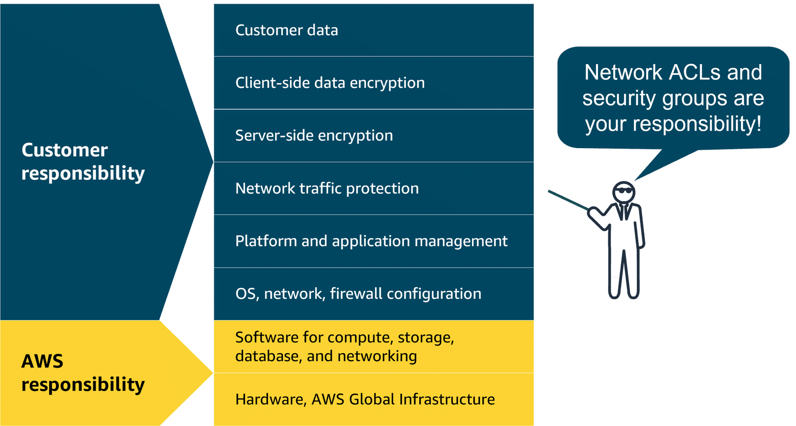

Topic : Amazon VPC Demo

In this lesson, you will learn how to do the following:
- Navigate in the AWS Management Console.
- Review the steps to create a VPC.
- Create both public and private subnets.
- Create and attach an internet gateway.
- Create a route table, add routes, and associate public subnets.
In the previous lessons, you have learned about the Amazon VPC and it's core components. In this demonstration video, you will get to see the steps to bring it to reality. You will learn the steps to create a VPC, public and private subnets in two AZs, an internet gateway, and even routing tables.
Building an Amazon VPC in the AWS Cloud
Core components covered in this demonstration
It's helpful to understand how resources are created using the AWS Management Console. The following is a high-level overview of the resources and core components created in the preceding demonstration.
Create the Amazon VPC
Before you can create resources in the AWS Cloud, the first step is to create your own Amazon VPC. You will also specify the Region best located for your resources.
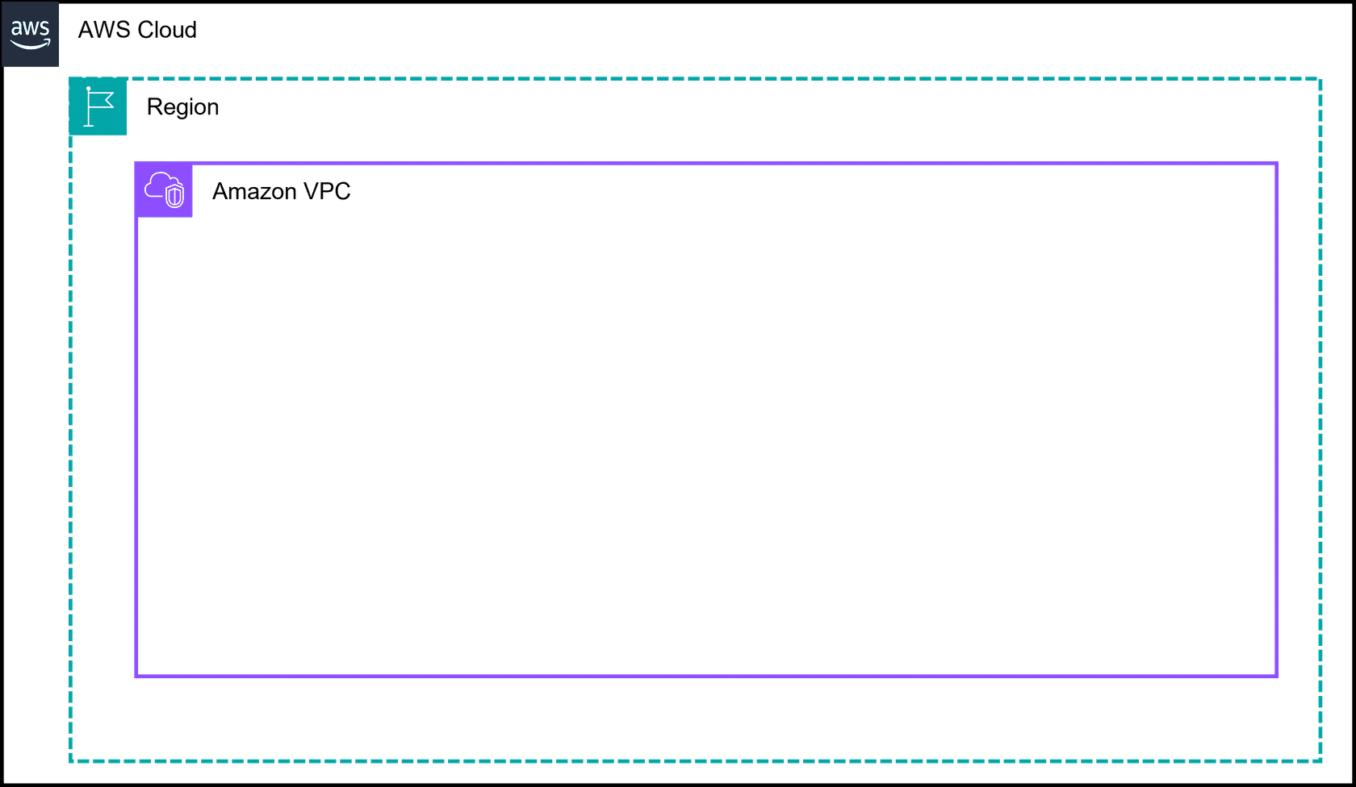
Create the subnets
You will create two public and private subnets across two availability zones. This is a best practice to achieve high availability.
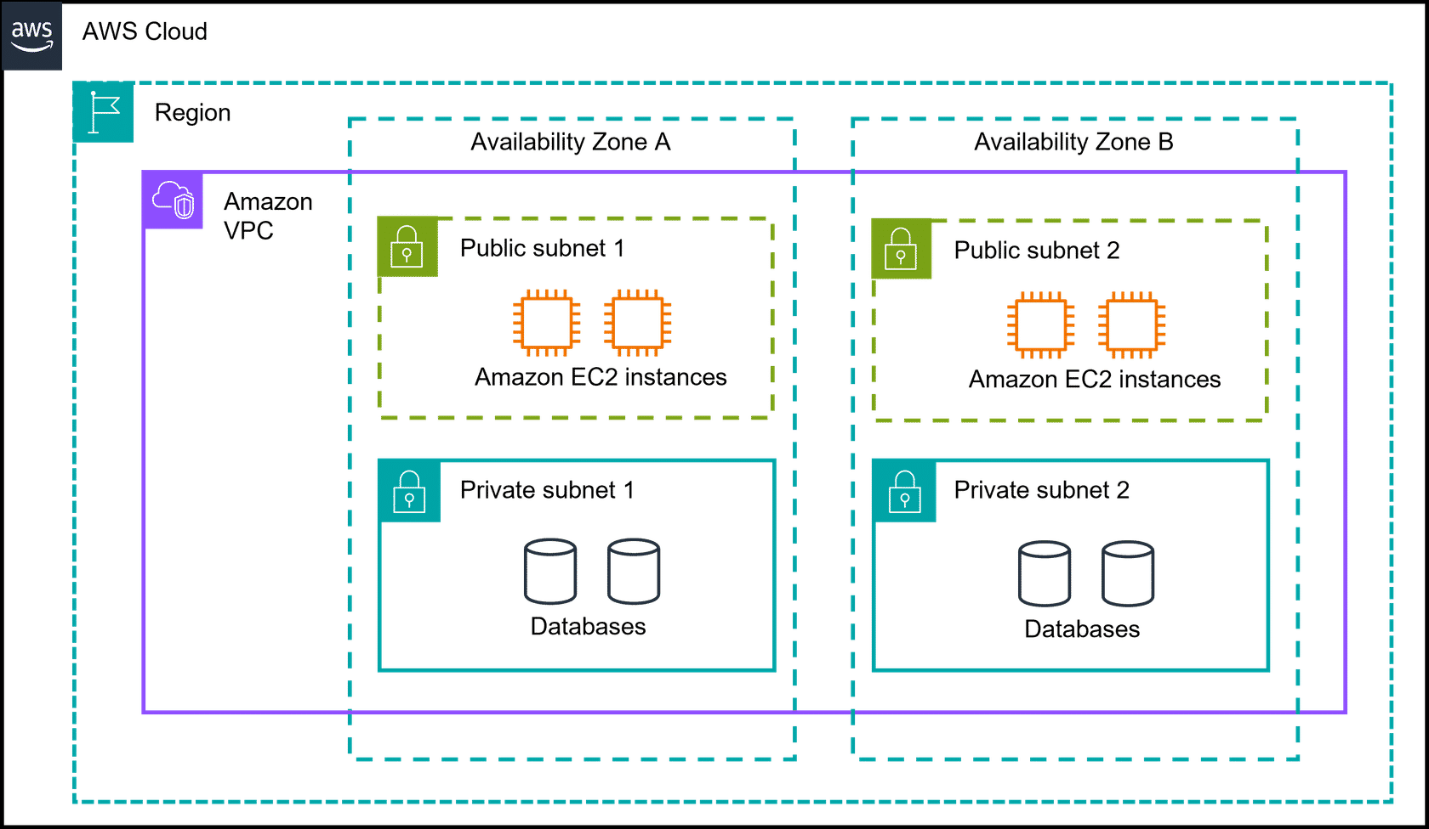
Create an internet gateway and route traffic
Without an internet gateway, your users can't get to your resources. First, you create the internet gateway. Then, you create route tables to route traffic to allow internet traffic in and local traffic out.

You are well on your way to creating your resources in your Amazon VPC. At this point, you would consider what type of security you need and filter the traffic coming in and out. Remember security groups and network ACLs? That's where they come in handy! And finally, you'd be ready to add your resources like EC2 instances or databases in your subnets.

Topic : Global Networking

In this lesson, you will learn how to do the following:
- Define what Domain Name System (DNS) is and what it does.
- Describe benefits and use cases of Amazon Route 53.
- Describe benefits and use cases of Amazon CloudFront.
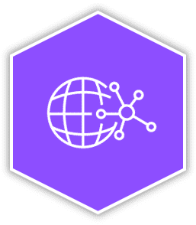
Global networking
You touched on Edge Locations briefly in an earlier lesson. Now you will explore three Edge networking services in more detail. You will identify what edge networking is, why it's important, and learn three AWS Edge services. You will cover what they do, the benefits, and how some of them work together.
Edge networking services
Secure and speedy networking for user-facing application data
Edge networking is the process of bringing information storage and computing abilities closer to the devices that produce that information and the users who consume it. Edge computing is important because organizations often need lower latency access to their data and content. By performing tasks or caching data locally or closer to users, organizations can deliver faster, more responsive experiences while maintaining better control over their infrastructure. There are also many different services that are hosted on the edge, like the DNS service, Amazon Route 53.
Translating domain names to IP addresses with DNS
Suppose that AnyCompany has a website hosted in the AWS Cloud. Customers enter the web address into their browser and they are able to access the website. This happens because of DNS resolution. DNS resolution involves a customer DNS resolver communicating with a company DNS server.
You can think of DNS as being the phone book of the internet. DNS resolution is the process of translating a domain name to an IP address.
To learn more about how DNS works, review each of the three items below.
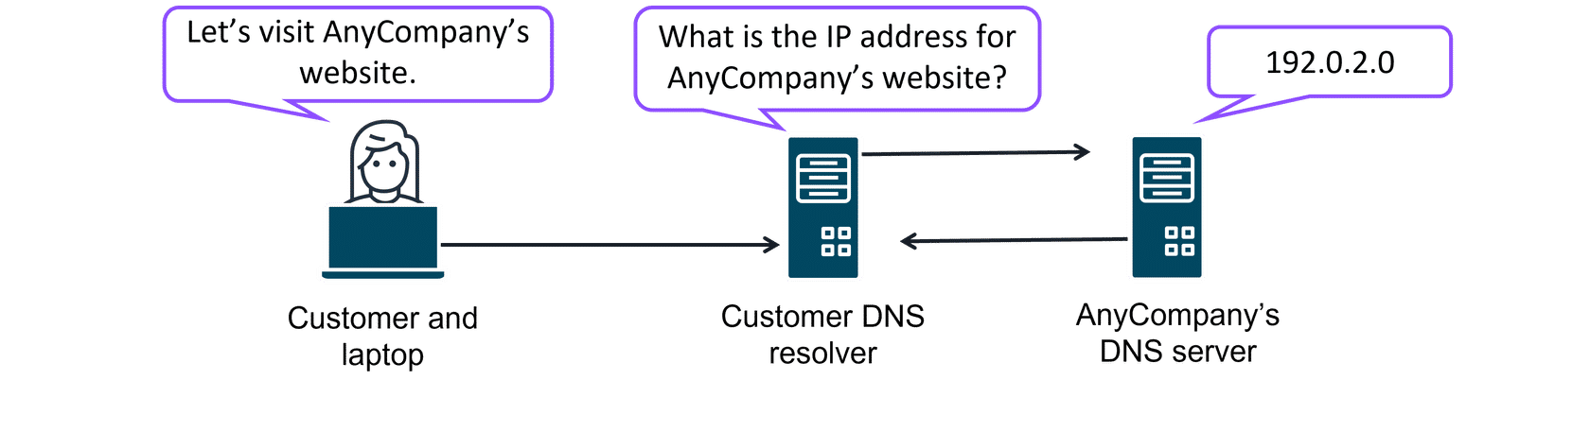
Customer and laptop
When you enter the domain name into your browser, this request is sent to a customer DNS resolver.
Customer DNS resolver
The customer DNS resolver asks the company DNS server for the IP address that corresponds to AnyCompany’s website.
AnyCompany's DNS server
The AnyCompany DNS server responds by providing the IP address for AnyCompany’s website, 192.0.2.0.
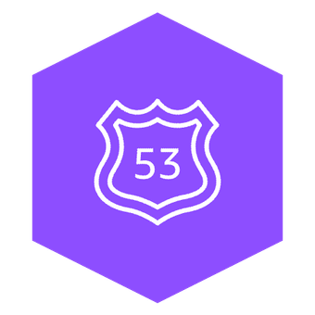
Amazon Route 53
Route 53 is a DNS that provides a reliable and cost-effective way to route end users to internet applications.
Route 53 directs end users to your resources with globally dispersed DNS servers and automatic scaling. It gives developers and businesses a reliable way to route end users to internet applications hosted in AWS. It connects user requests to infrastructure running in AWS, such as Amazon EC2 instances and load balancers. It also routes users to infrastructure outside of AWS.
Another feature of Route 53 is the ability to manage the DNS records for domain names. You can register new domain names directly in Route 53. You can also transfer DNS records for existing domain names managed by other domain registrars. This makes it possible for you to manage all of your domain names within a single location.
Route 53 also works with the next AWS edge networking service, Amazon CloudFront.
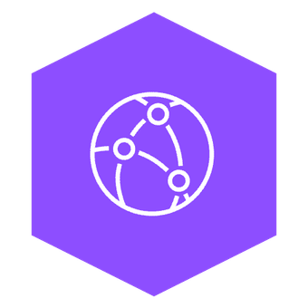
Amazon CloudFront
CloudFront is a content delivery network (CDN) service that delivers your content with faster loading times, cost savings, and reliability.
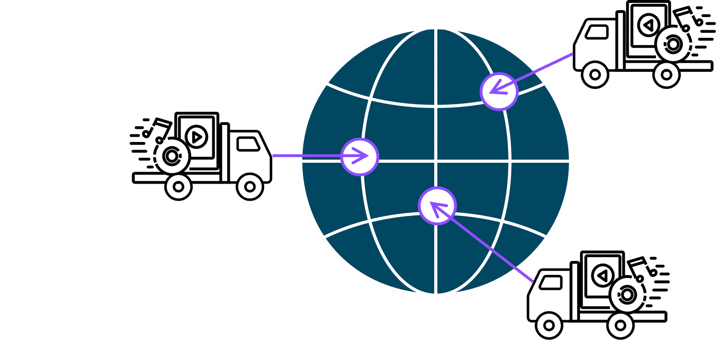
CloudFront is like a global network of delivery trucks that quickly brings web content to users around the world. Instead of all requests traveling back to one central warehouse (your original server), CloudFront stores copies of your content at locations closer to your users. This means websites, videos, images, and applications load much faster, no matter where your customers are located.
To learn more, review each of the following three categories.

Streaming video service:
A company that offers online workout videos uses CloudFront to make sure videos play smoothly without buffering, even during peak exercise times when thousands of users log in simultaneously.

Ecommerce website:
An online store uses CloudFront to deliver product images and web pages quickly during busy shopping seasons. This faster experience keeps customers engaged and reduces abandoned shopping carts.

Mobile app:
A travel app uses CloudFront to deliver map data and images to users' phones quickly to help travelers navigate new cities without frustrating delays.
Now that you know a little more about CloudFront, here is an example of how it can work for customer requests. The following example describes how Route 53 and CloudFront work together to deliver content to customers. To learn more, review each of the following numbered items below the image.
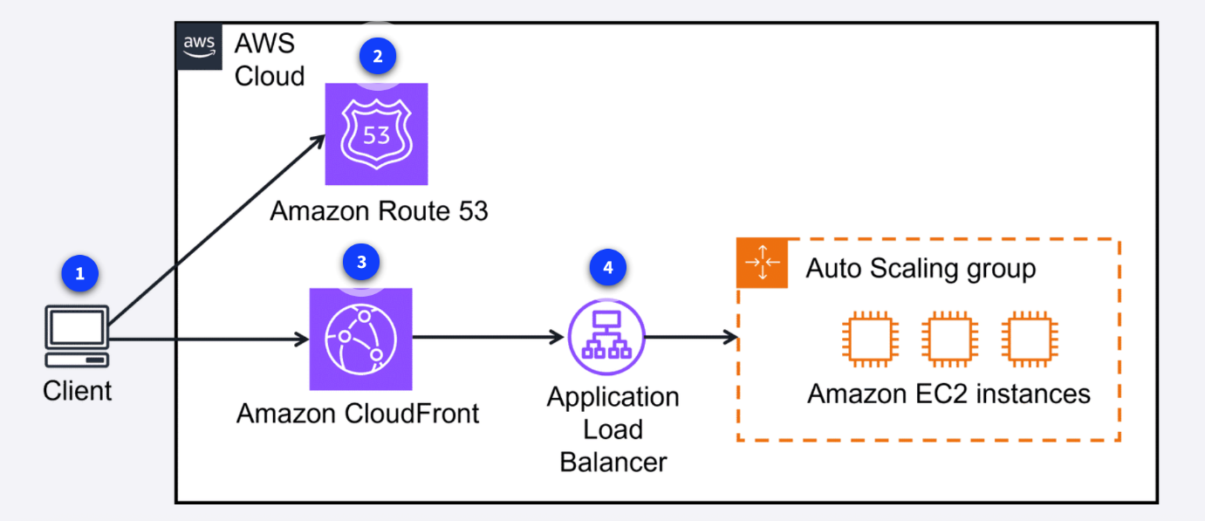
- Customer request: A customer requests data from the application by going to AnyCompany’s website.
- Amazon Route 53: Amazon Route 53 uses DNS resolution to identify AnyCompany.com’s corresponding IP address, 192.0.2.0. This information is sent back to the customer.
- CloudFront: The customer’s request is sent to the nearest edge location through CloudFront.
- Application Load Balancer: Amazon CloudFront connects to the Application Load Balancer, which sends the incoming packet to an Amazon EC2 instance.
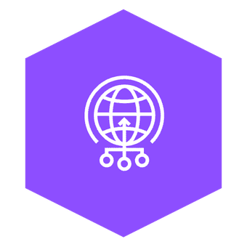
AWS Global Accelerator
Global Accelerator is a service that uses the AWS global network to improve application availability, performance, and security. It uses intelligent traffic routing and fast failover if something goes wrong in one of your application locations.
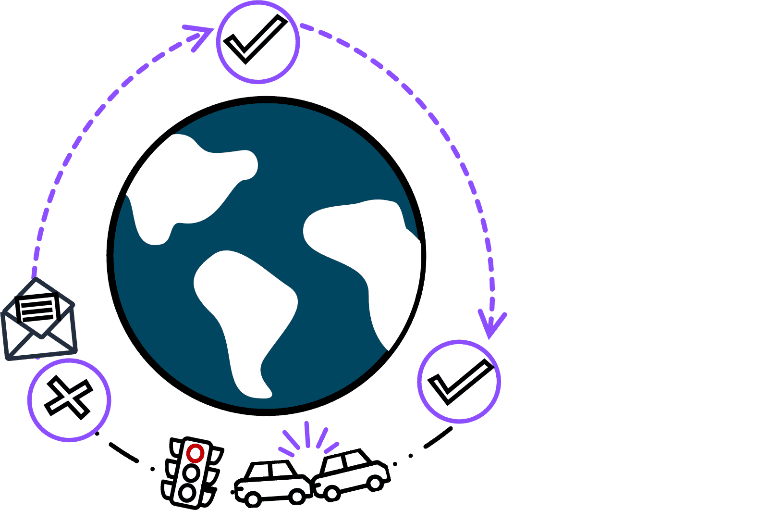
Global Accelerator is a networking service that helps your applications run faster and more reliably across the globe. Think of it like creating express lanes on the internet highway specifically for your application's traffic. Instead of your users' requests taking the regular, sometimes congested internet routes, Global Accelerator directs traffic through the AWS private global network—getting your users to your application faster and more reliably.
To learn more on AWS Global Accelerator, review each of the two example use cases.

Global gaming company:
A gaming company uses Global Accelerator to reduce lag and provide smoother gameplay for players around the world. Players in Tokyo, New York, and London all experience similar, responsive gameplay because their connections are optimized.

Financial services application:
A banking app uses Global Accelerator to ensure their customers always have fast, reliable access to their accounts. Even during peak times or when network conditions in one area are poor, customers can check balances and make transactions without frustrating delays.
Several AWS edge services are similar and are used in global networking solutions. To review these AWS edge services, choose each of the following flashcards.
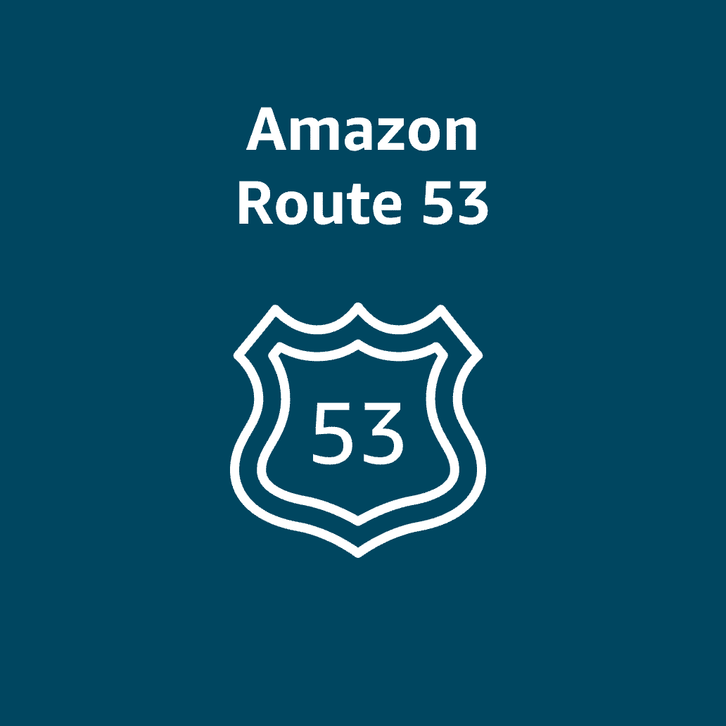
Amazon Route 53
Route 53 is a highly available and scalable cloud DNS service.
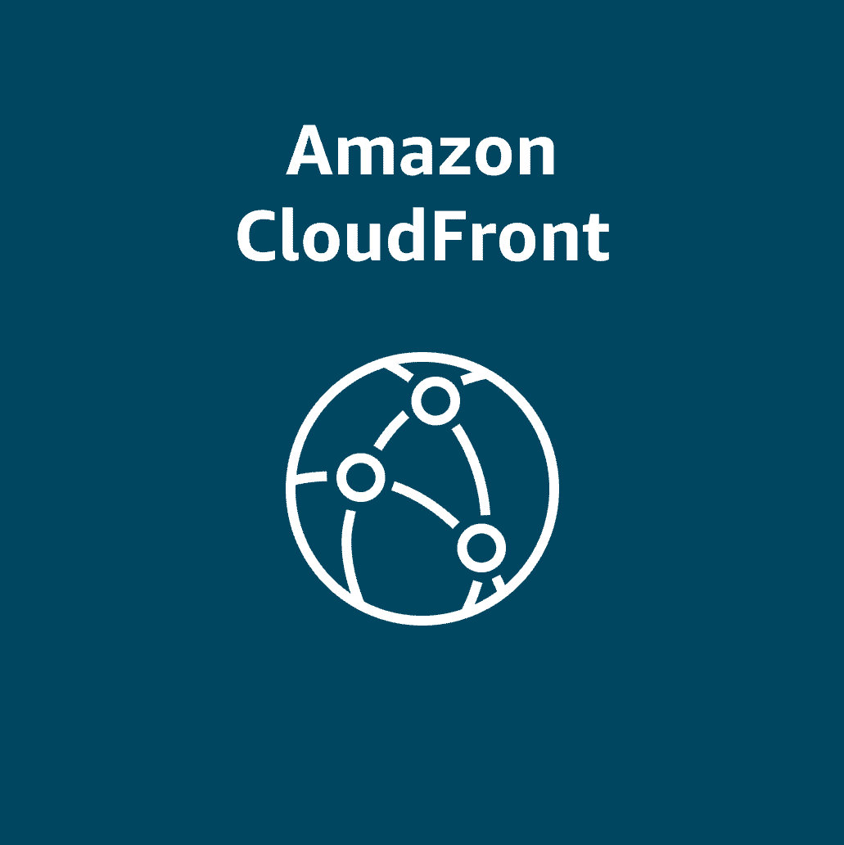
Amazon CloudFront
CloudFront is a CDN service that delivers your content with low latency and high speeds.
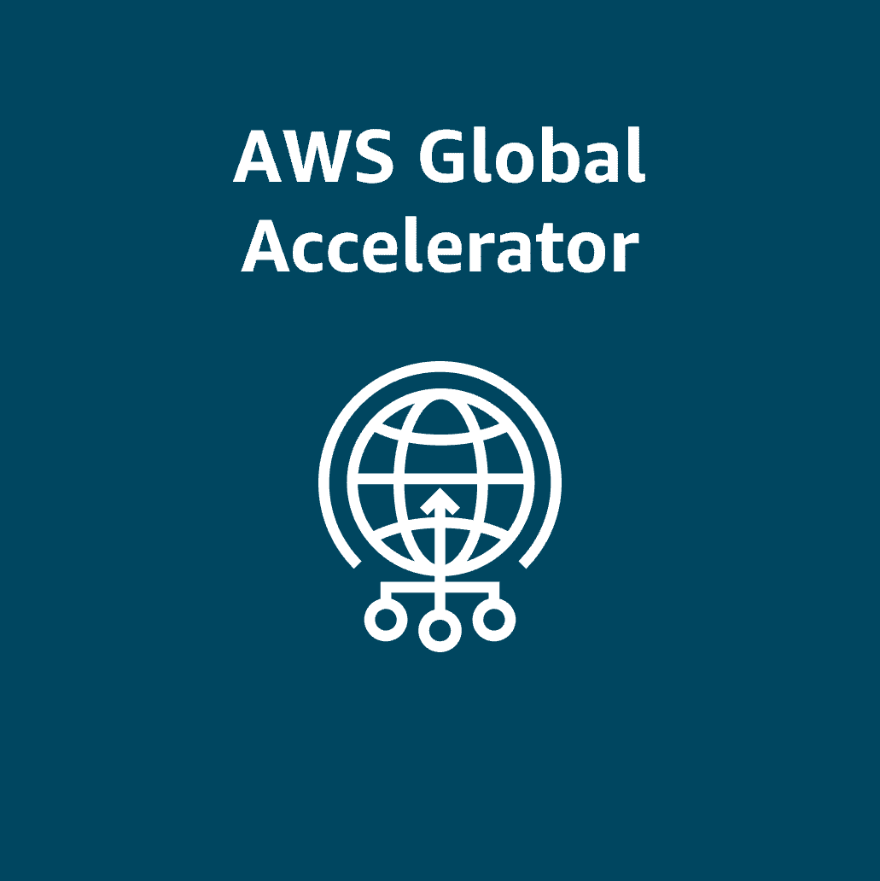
AWS Global Accelerator
Global Accelerator is a service that uses the AWS global network to improve application availability, performance, and security.

Topic : Global Architectures

In this lesson, you will learn how to do the following:
- Identify examples of when to use a VPN or Direct Connect.
- Describe at a high level how a VPC with a virtual private network (VPN) connection and Direct Connect work together.
- Describe how a multi-Region architecture works with CloudFront and Route53.
In the previous video, you reviewed a multi-Region architecture to show how CloudFront, Route 53, Direct Connect, and VPNs all work together.
Cloud in real life: Exploring the examples
Direct Connect failover when you need much higher bandwidth with dedicated lines
You've seen a basic VPN and AWS Direct Connect setup in previous lessons. Here is the video example of a company with clients and servers that demand high bandwidth connections for large data transfers and critical application performance. They chose to access their AWS resources securely with multiple Direct Connect connections for failover.
To learn more about using Direct Connect for failover and to aggregate bandwidth, review each of the following four numbered markers and descriptions below.
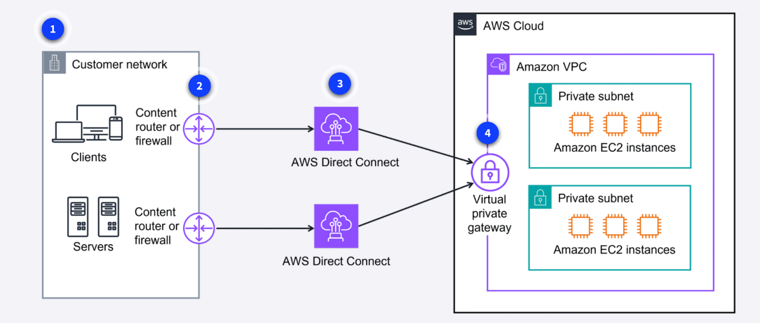
1. Customer network
The customer network clients and servers need a secure, high-bandwidth connection for large data transfers and critical application performance.
2. Content router or firewall
The customer has a content router or firewall connecting their network to Direct Connect.
3. Multiple Direct Connect connections
In addition to fault tolerance, the customer wanted increased bandwidth. They can even combine multiple connections to achieve higher aggregate bandwidth.
4. Virtual private gateway
Using a virtual private gateway, the clients can securely access the private resources in the Amazon VPC.
Delivering content to several different Regions globally
Here is an example of how a company with offices around the world can deliver content with low latency for a seamless experience across multiple Regions.
To learn more about how traffic gets to Regions through CloudFront and Route 53, review each of the following four numbered markers and their details below.
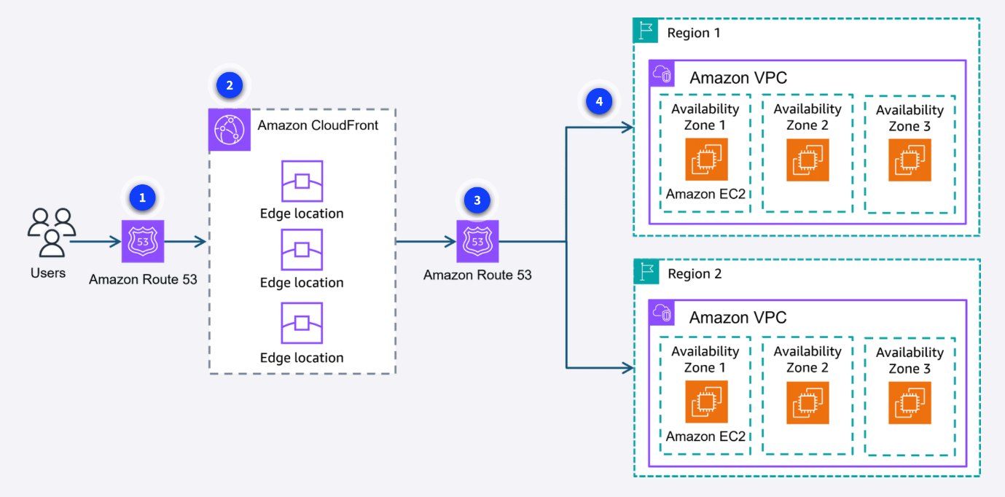
1. Users
The users access the company's website using a custom domain. The request is first sent to a Route 53 DNS record.
2. Routing policy
Route 53 uses a routing policy to determine which Region is closest to the user. Route 53 directs the user to the appropriate CloudFront edge location.
3. Direct to edge locations
Route 53 directs the user to the CloudFront edge location in the appropriate Region.
4. Content in multiple AZs
The content is fetched from the designated origin server in the chosen Region. Also note, the website was built with resources in multiple Availability Zones for high availability.

