Module 7 – Database

Topic : Introduction to Databases

AWS offers a wide range of database services to meet various data storage and management needs. These services are designed to be scalable, reliable, and easy to use for businesses of all sizes. AWS database services include options for relational databases, nonrelational databases, in-memory caches, and purpose-built services for use cases like document management.
In this lesson, you will learn how to do the following:
- Describe how the AWS shared responsibility model applies to AWS database services.
AWS shared responsibility model
The AWS shared responsibility model groups services into three categories based on the ownership of administrative tasks. These categories are fully managed, managed, and unmanaged. The AWS services that you will be exploring in this module are primarily fully managed, with a few managed services, and no unmanaged services.
To learn more about how these categories relate to database services, review the following three categories.
Fully Managed Services: For fully managed services, AWS handles nearly all operational tasks like provisioning, scaling, patching, backups, performance optimization, and security patches. AWS also provides built-in monitoring and metrics. Fully managed AWS database services only require customers to be responsible for designing data structures and managing access controls.
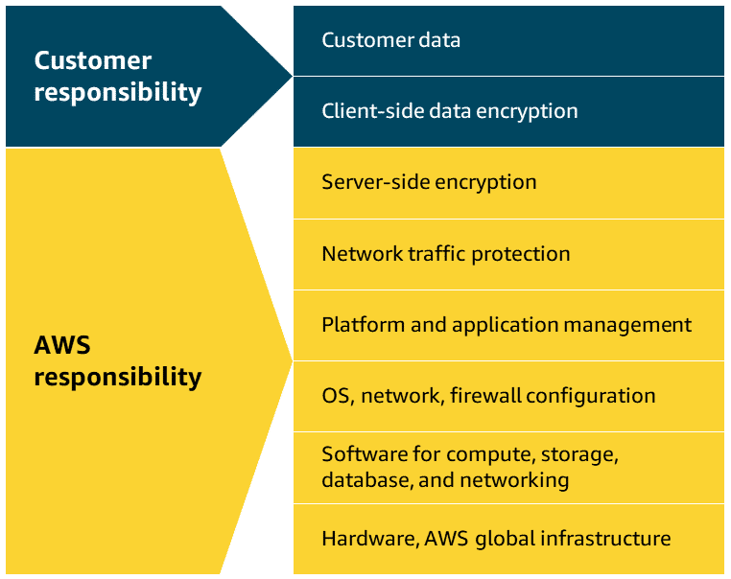
Managed Services: With managed database services, AWS handles routine tasks like backups, patching, and hardware provisioning while customers are responsible for database configuration, query optimization, and performance tuning decisions.
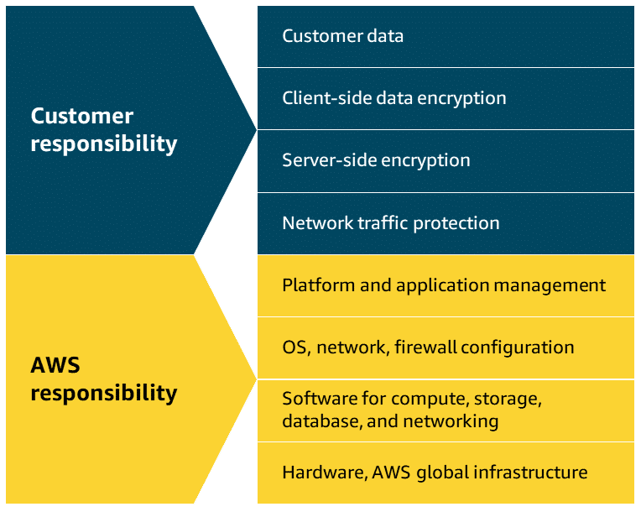
Unmanaged Services: With unmanaged databases, customers are responsible for installation, configuration, patching, maintenance tasks, database security, backups, high availability setup, and performance optimization. An example of an unmanaged database in AWS would be a database management system like MySQL installed directly on an Amazon Elastic Compute Cloud (Amazon EC2) instance.
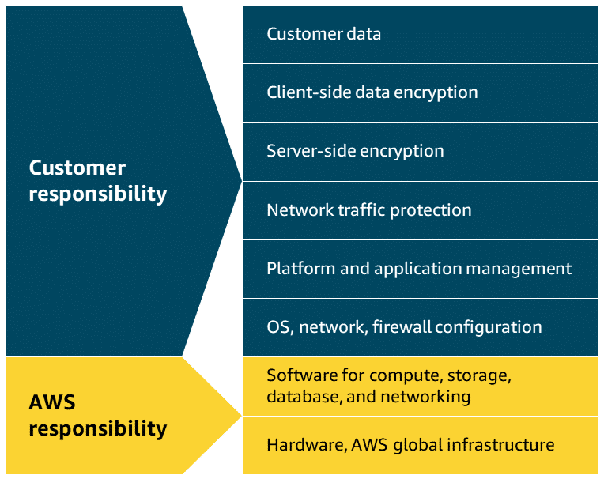

Topic : Relational Database Services
In this lesson, you will learn how to do the following:
- Describe relational databases.
- Describe Amazon Relational Database Service (Amazon RDS), including its benefits and use cases.
- Describe Amazon Aurora, including its benefits and use cases.
Relational databases use a rigid schema that organizes collections of data into tables with rows and columns, where relationships exist between different tables. In this lesson, you will explore the benefits and use cases for AWS relational database services, including Amazon RDS and Amazon Aurora.
Relational databases
Relational databases store data in a way that relates it to other pieces of data, and they use structured query language, or SQL, to manage and query data. This approach stores data in an easily understandable, consistent, and scalable way that works great for applications requiring structured data management.
AWS offers fully managed relational database solutions that remove the burden of database administration while maintaining high availability and security. AWS relational databases support popular database engines like MySQL, PostgreSQL, and Oracle, making it easier to migrate existing databases to AWS.
An example of a relational database would be an inventory management system for a restaurant. Each record in the database includes data for a single item, such as product name, size, price, and so on. The following table shows how this type of data is configured in a relational database.
ID | Product Name | Size | Price
1 | Medium roast ground coffee | 12 oz. | $13.95
2 | Single-origin whole bean coffee | 12 oz. | $21.95

Amazon Relational Database Service (Amazon RDS)
Amazon RDS is a managed relational database service that handles routine database tasks such as backups, patching, and hardware provisioning. Amazon RDS supports multiple database instance class types that optimize for memory, performance, or input/output (I/O).
To improve data resilience, Amazon RDS offers Multi-AZ deployment and automated backups, but you can also manually create backups using DB snapshots. These are full backups of your entire database instance, which can be useful for specific point-in-time recovery or long-term data archiving purposes. Amazon RDS offers security features including network isolation, encryption in transit, and encryption at rest. You can readily scale database resources vertically or horizontally as needed.
Supported database engines
Amazon RDS supports different database engines, including Amazon Aurora, MySQL, PostgreSQL, Microsoft SQL Server, MariaDB, and Oracle Database.
Use cases
Some examples of practical use cases for Amazon RDS are web applications, enterprise workloads, and product inventories for e-commerce platforms.
Benefits
Cost Optimization:
Amazon RDS eliminates the high upfront costs of purchasing and maintaining database hardware infrastructure. You only pay for the compute and storage resources that you consume through a flexible pay-as-you-go model. As a managed service, it also reduces operational expenses by automating time-consuming administrative tasks like backups, patching, and monitoring.

Multi-AZ Deployment:
Amazon RDS improves database reliability through Multi-AZ deployments. It automatically replicates data to a standby instance in a different Availability Zone. During system failures, maintenance, or zone disruptions, Amazon RDS automatically fails over to the standby instance without manual intervention. This ensures continuous database operations with minimal downtime.

Performance Optimization:
Amazon RDS enhances database performance through automated management of resource allocation, monitoring, and optimization tasks. It includes features like automated backups and read replicas that can help offload read traffic from the primary instance. Amazon RDS performance insights provide real-time monitoring and analysis of database load, to help you identify and resolve performance bottlenecks quickly.

Security Controls:
Amazon RDS enhances database security through multiple layers of protection, including VPC isolation as well as encryption at rest and in transit. It leverages automated backups and offers Multi-AZ deployments to provide resiliency against potential system failures.


Amazon Aurora
Aurora is a managed relational database designed to help reduce unnecessary I/O operations. It's compatible with MySQL and PostgreSQL, provides high performance and availability, and automatically scales alongside your workloads. Aurora replicates data across multiple Availability Zones for enhanced durability and fault tolerance, and features automated backups, encryption at rest, and continuous monitoring.
Use cases
Some examples of practical use cases for Aurora are gaming applications, media and content management, and real-time analytics.
Benefits
High performance and availability:
Aurora delivers up to five times the throughput of standard MySQL and three times the throughput of PostgreSQL. It uses a distributed storage system across multiple nodes to provide high performance and availability.
Automated storage and backup mangement:
Aurora automatically grows storage from 10 GB to 128 TB based on your actual data usage, which eliminates guesswork in capacity planning. It also continuously backs up your database to Amazon Simple Storage Service (Amazon S3) to provide point-in-time recovery.
Advanced replication and fault tolerance:
Aurora replicates data across three Availability Zones with six copies of data, and provides 99.99% availability. It automatically detects database failures and redirects traffic to healthy replicas without data loss.

Topic : NoSQL Database Services
In this lesson, you will learn how to do the following:
- Describe NoSQL databases.
- Describe Amazon DynamoDB, including its benefits and use cases.
NoSQL databases use flexible data schemas for storing and retrieving many different types of information. In this lesson, you will explore the benefits and use cases of the NoSQL database service Amazon DynamoDB.
NoSQL databases
NoSQL databases are sometimes referred to as non-relational databases because their structures are different than relational databases like Amazon RDS. Instead of row and column relationships, NoSQL databases build a structure for the data that they contain using key-value pairs instead. With key-value pairs, data is organized into items identified by unique keys.
Each key has one or more associated attributes, or values, that represent various characteristics of the data. You can think of a key as a word entry in a dictionary, and the value as its associated definition. Not every item in the table has to have the same attributes, and you can add or remove attributes at any time.
The following table shows an example of how key-value paired data is stored in NoSQL databases.
Key | Value
1 | Name: John Doe  Address: 123 Any Street  Favorite drink: Medium latte
2 | Name: Mary Major  Address: 100 Main Street  Birthday: July 5, 1994

Amazon DynamoDB
DynamoDB is a fully managed NoSQL database service that provides fast and predictable performance for both document and key-value data structures. It's a powerful and incredibly fast database option for use cases that require a flexible schema, and is ideal for applications that require high performance and seamless scaling.
DynamoDB seamlessly scales alongside your data without impacting performance, which means that you only pay for the resources that you use. It also includes built-in security features for enhanced protection, and automatically spreads your data across multiple servers to handle your workload.
Use cases
Some examples of practical use cases for DynamoDB are gaming platforms, financial service applications, and mobile applications with global user bases.
Benefits
Scalability with provisioned capactiy:
DynamoDB automatically scales throughput up or down based on actual usage, which ensures consistent performance without manual intervention. You can specify target utilization levels, and DynamoDB automatically provisions capacity to maintain those targets. With no practical limits on table size or the amount of data stored, DynamoDB can seamlessly accommodate growing applications.

Consistent high performance:
DynamoDB delivers single-digit millisecond response times at any scale, which makes it ideal for high-performance applications. It maintains consistent performance by automatically distributing data across multiple servers and SSDs.

High acailability and durability:
DynamoDB delivers 99.999% data availability by replicating data across three distinct facilities within each AWS Region. It also maintains multiple copies in separate AWS Regions, to provide built-in fault tolerance and data durability. This ensures continuous operation and protection against data loss even if individual facilities fail.

Data encryption:
DynamoDB offers comprehensive encryption capabilities to protect information both at rest and in transit. All data is automatically encrypted behind the scenes before being written to the storage layer. DynamoDB includes the flexibility to choose between different kinds of encryption keys for customized security control.
Topic : In-Memory Caching Services
In this lesson, you will learn how to do the following:
- Describe in-memory caching as it relates to databases.
- Describe Amazon ElastiCache, including its benefits and use cases.
In-memory caching services are optimized to provide sub-millisecond latency for read and write operations. In this lesson you will learn about in-memory caching services, including the benefits and practical use cases for ElastiCache.
In-memory caches
An in-memory cache is a high-speed storage layer that temporarily stores frequently accessed data in a computer's main memory, or RAM. Retrieving data from RAM provides extremely fast processing and retrieval speeds, often hundreds or thousands of times faster than traditional disk-based storage systems.
When applications need specific information, they first check the cache before requesting it from the original data source. This reduces the load on primary databases and speeds up response times for end users. In-memory caches are ideal for storing session data, API responses, database query results, and other information that applications require repeatedly.


Amazon ElastiCache
ElastiCache is a fully managed in-memory caching service that was built to help reduce the complexity of administering in-memory caching systems. This means that you can continue to use the same Redis, Valkey, or Memcached tools and configurations to scale your workloads. It automatically detects and replaces failed nodes, which makes it ideal for applications that need consistent high performance.
Use cases
Some examples of practical use cases for ElastiCache are session data management, database query enhancement, and gaming leaderboards.
Benefits
High performance for Redis, Valkey or Memcached instances
ElastiCache streamlines the deployment and maintenance of in-memory caching environments, offering high availability for Redis, Valkey, and Memcached by automatically handling hardware provisioning, software patching, and monitoring. ElastiCache offers seamless scalability so you can add or remove nodes as demand changes.
High availability
ElastiCache provides high availability by constantly monitoring primary nodes for potential failures. When issues are detected, it maintains application availability while promoting a replica node to become the new primary without manual intervention. The entire recovery process typically finishes within minutes, which minimizes downtime and preserves operations during infrastructure disruptions.

Replication across multiple Availability Zones
ElastiCache enables automatic replication across multiple Availability Zones to protect against infrastructure failures. You can configure primary and replica nodes across different Availability Zones according to their durability requirements. This helps to ensure that data remains accessible even if one zone experiences an outage.

Data encryption
ElastiCache supports data encryption mechanisms to safeguard sensitive information throughout its lifecycle. At-rest encryption protects data while stored in disk storage and automated backups. In-transit encryption secures data traveling between clients and cache nodes by employing transport layer security, or TLS, for encrypted connections.
Topic : Additional Database Services
In this lesson, you will learn how to do the following:
- Describe Amazon DocumentDB (with MongoDB compatibility), including its benefits and use cases.
- Describe AWS Backup, including its benefits and use cases.
- Describe Amazon Neptune, including its benefits and use cases.
In addition to the services that you have explored so far, there are some specialized AWS database services and their supporting technologies that you should be familiar with. In this lesson, you will explore the use cases and benefits of Amazon DocumentDB, AWS Backup, and Neptune.

Amazon DocumentDB
Amazon DocumentDB (with MongoDB compatibility) is fully managed service designed to handle semistructured data, which is information that doesn't conform to rigid relational schemas. Amazon DocumentDB is a MongoDB-compatible database, so it manages JSON-like documents with dynamic schemas.
Amazon DocumentDB is perfect for applications requiring frequent schema changes and document-oriented data. Unlike relational databases or nonrelational databases, you can quickly iterate without relying on predefined schemas. Amazon DocumentDB can store, query, and index JSON data effortlessly, all while benefiting from automatic scaling, continuous backup, and enterprise-grade security features.
Use cases
Some examples of practical use cases for Amazon DocumentDB are content management systems, catalog and inventory management, and user profile and personalization systems.
Benefits
MongoDB compatibility
Amazon DocumentDB is fully compatible with MongoDB workloads and supports MongoDB APIs, drivers, and tools. This compatibility means that you can use existing MongoDB code and skills without modification. You can also migrate MongoDB applications to Amazon DocumentDB with minimal changes to their application code.
Performance and scalability
Amazon DocumentDB automatically scales storage up to 64 TB in 10 GB increments based on your application needs. It can handle millions of requests per second with consistent performance. It also provides the option to scale compute resources up or down as needed.

Increased read throughput
Amazon DocumentDB improves read throughput for high-volume applications by creating up to 15 replica instances that share underlying storage.

AWS Backup
AWS Backup streamlines data protection across various AWS resources and on-premises deployments by providing a single dashboard for monitoring and managing backups. It eliminates the complexity of managing multiple backup strategies by supporting multiple storage types, including Amazon Elastic Block Store (Amazon EBS) volumes, Amazon Elastic File System (Amazon EFS) file systems, and various databases.
AWS Backup centralizes and automates data protection processes, improving consistency and reducing administrative overhead. It offers flexible scheduling options, encryption capabilities, and cross-Region backup support for enhanced disaster recovery.
Use cases
Some examples of practical use cases for AWS Backup are centralized disaster recovery, consistent backup policies for compliance requirements, and consolidating multiple backup processes through a single interface.
Benefits
Centralized backup management
AWS Backup provides a single dashboard to manage backups across multiple AWS services and accounts. You can monitor backup jobs, restore points, and verify compliance status from one central location to reduce operational complexity and potential configuration errors.
You can create automated backup schedules that align with your business requirements and compliance needs. You can set up backup policies that automatically protect new resources as they're created.

Cross-region backup redundancy
AWS Backup enables automatic replication of backup data across different AWS Regions for disaster recovery purposes. You can quickly restore data from secondary Regions if the primary Region experiences an outage. Cross-Region redundancy helps you meet compliance requirements while guaranteeing data accessibility during Regional failures.

Streamlined regulatory compliance
AWS Backup maintains detailed audit logs and reports to demonstrate compliance with regulatory requirements. You can use it to enforce backup policies across your organization and track backup activities for security and compliance purposes.


Amazon Neptune
Neptune is a fully managed, purpose-built graph database service that manages highly connected data sets, like those used in social networking applications. It excels at understanding complex relationships that are difficult to identify in traditional relational databases like user connections, friend networks, and interaction patterns. Neptune can maintain high performance even as data complexity grows, and offers high availability with automatic failover and backups.
Use cases
Some examples of practical use cases for Amazon Neptune are social network user connection mapping, fraud detection systems, and search and recommendation systems.
Benefits
Purpose-built for complex relationships
Neptune excels at storing and querying highly connected data using graph models. It supports both property graph and resource description framework, or RDF, models making it ideal for relationship mapping and pattern matching applications.

High performance and scalability
Neptune delivers consistent performance at scale, processing billions of relationships in milliseconds. It automatically grows storage up to 64 TB based on your application needs. Its purpose-built engine optimizes graph queries to enable fast traversal of connected data points at scale.

