=>To install truffle
Open command prompt and run
npm install -g truffle

=>To install ganache
Go to
https://archive.trufflesuite.com/ganache/
Click on download
Click next and install
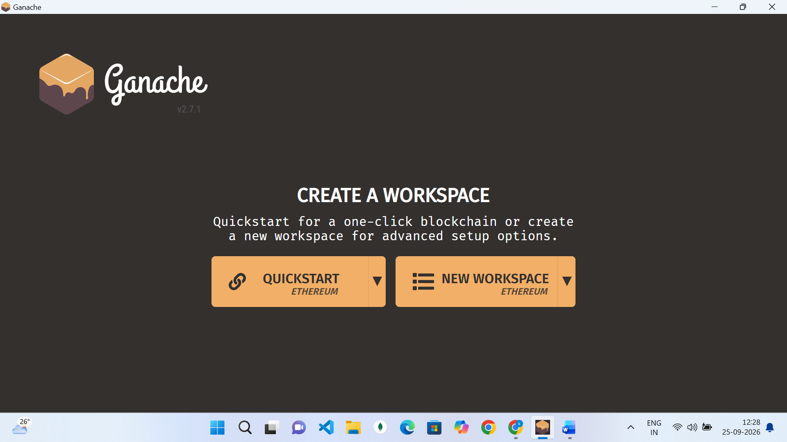

Select quickstart and your ganache is ready

=>To install metamask
=>go to metamask.io
Click on get metamask

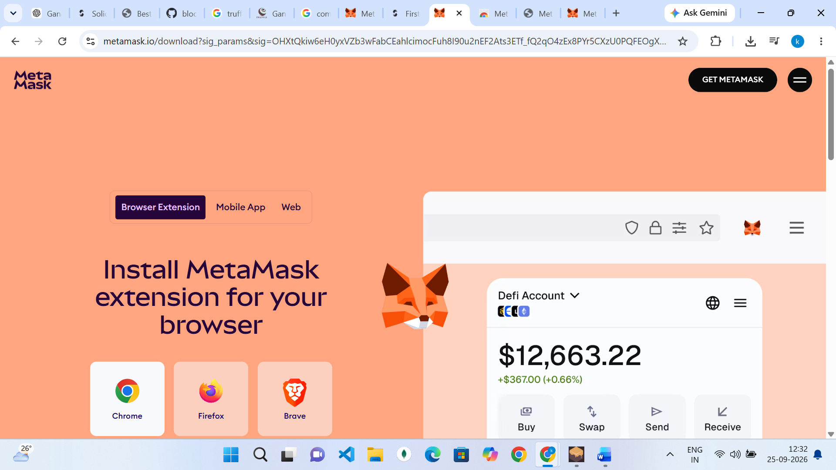

Then select your browser(for example chrome) and add to extension

Then click on the extension and select create a new wallet

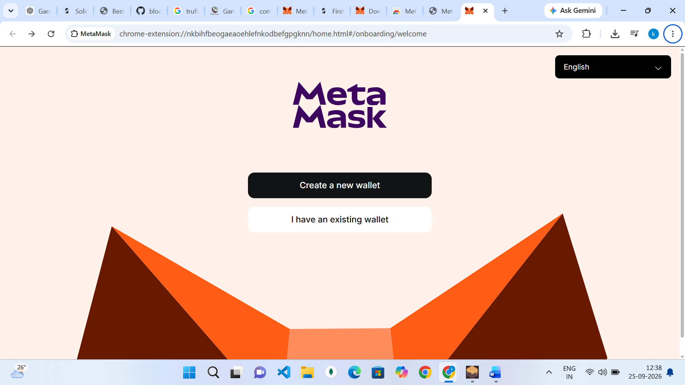

Click on continue with google and select your gmail account and add password
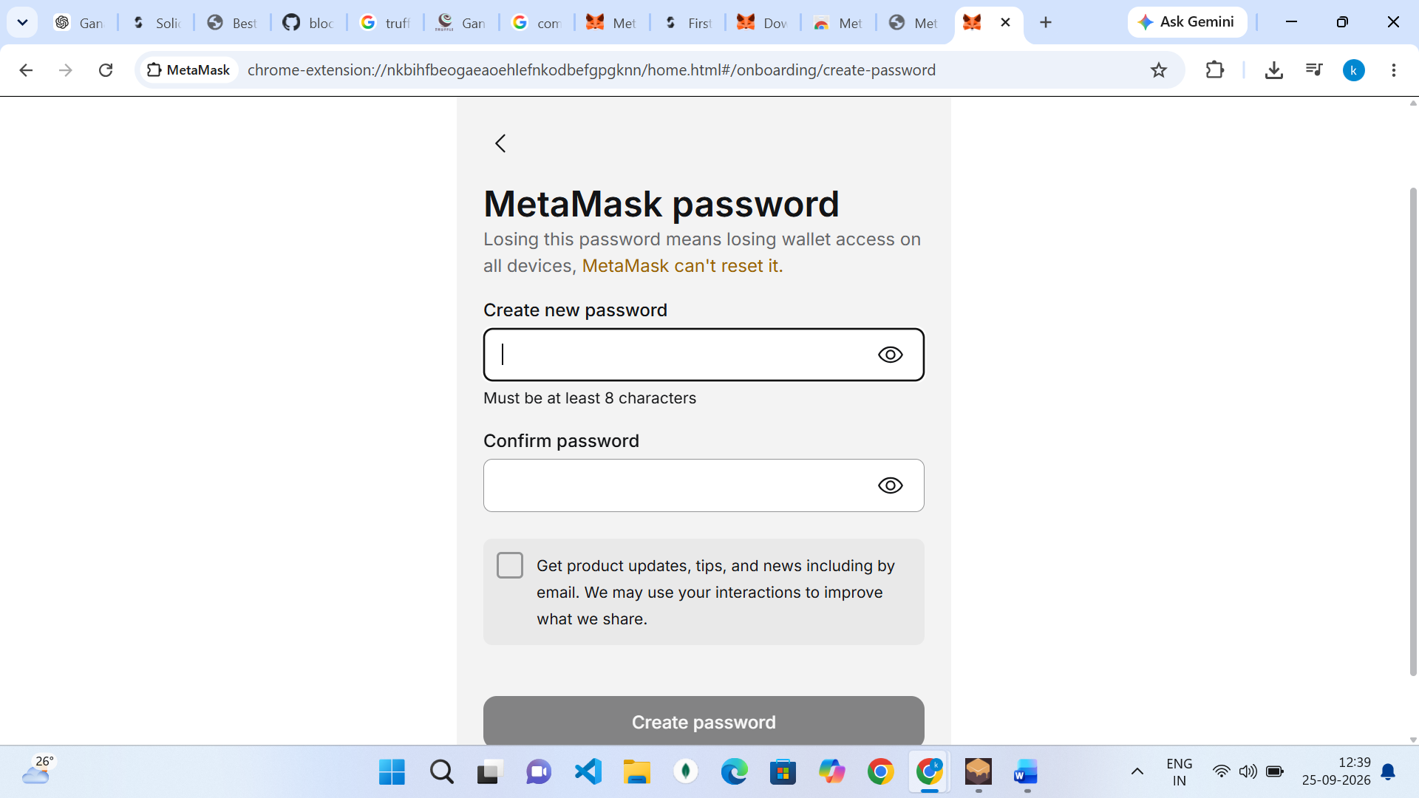

Your account will be ready as shown in the below diagram

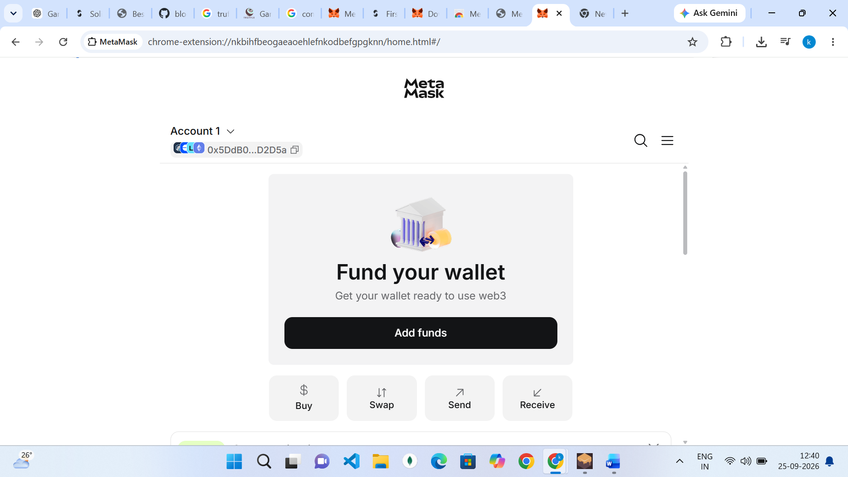

=>To connect ganached to metamask

Open your metamask from the extension open networks and click on add a custom network

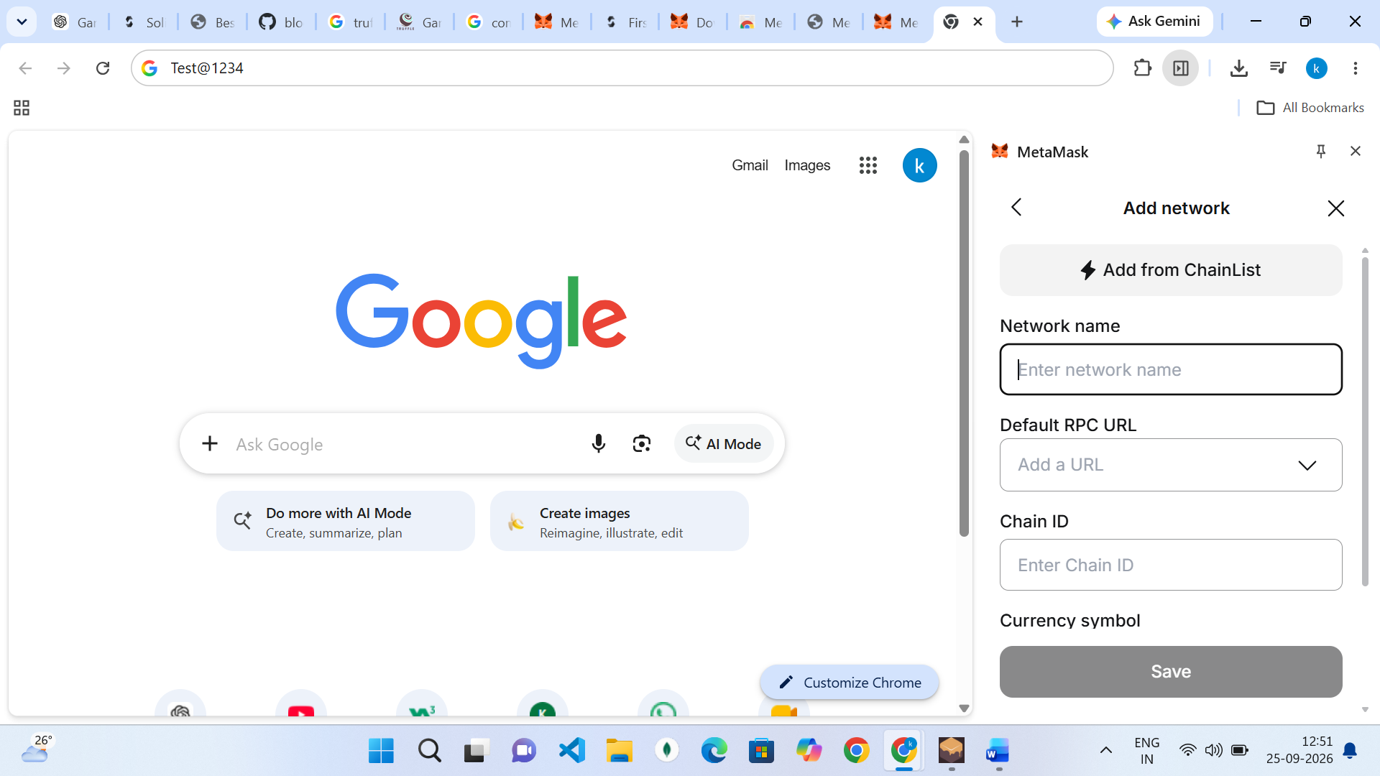

Enter the details shown in the below screenshot
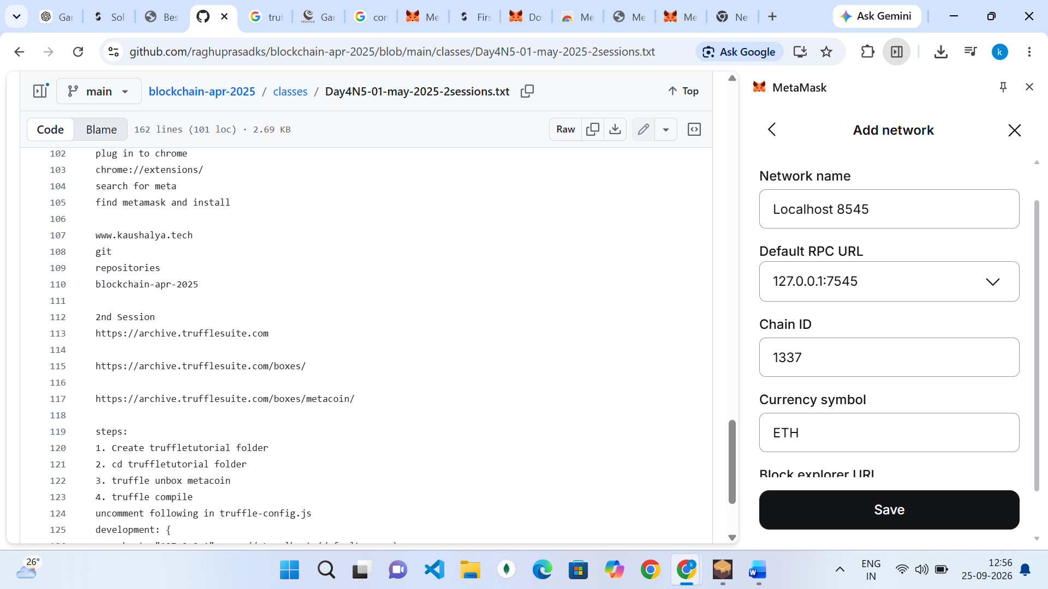

Then change the network to the name you gave like below(localhost 8545) in my case

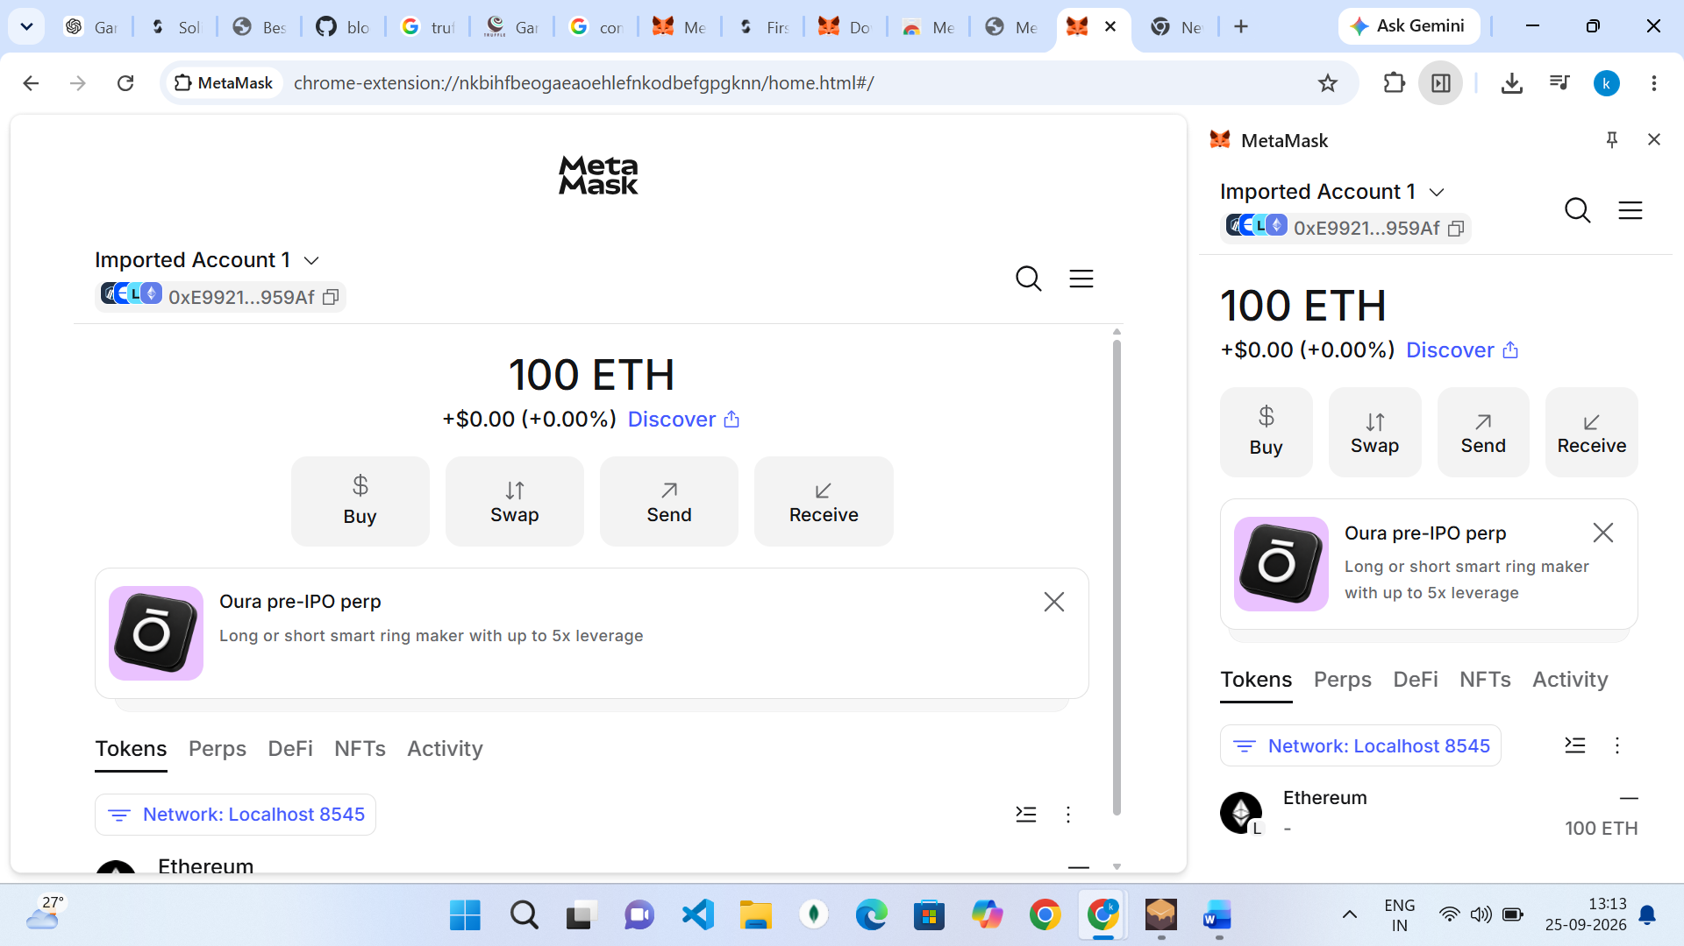

Then click on add wallet

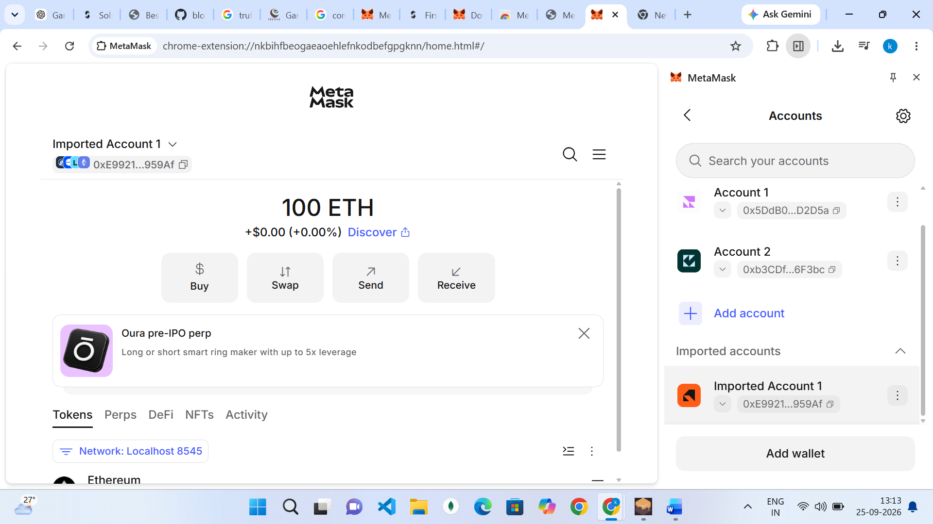

Then import an account via a private key , then paste the private key of one the ganache accounts

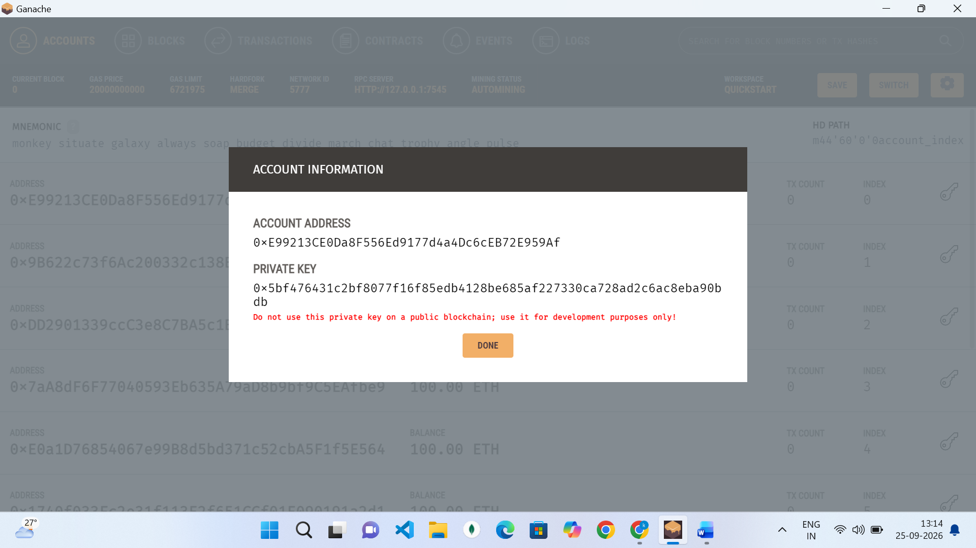

Then you should now be able to see that you will have 100 eth instead of 0

