**Jmeter Beginner Tutorial 11 – How to create HTML Reports from command line**

**Step 1 :** Create Test Plan and save it (and close)

**Step 2 :** Open command line and change directory to jmeter/bin

**Step 3:** Execute command:

Jmeter -n -t “location of the jmeter script” -l “location of result file” -e -o “location of the output folder”

For getting csv file

jmeter -n -t C:\raghu\kaushalya.tech\trainingmaterial\jmeter\jmetertesting\11-ReportGenerationCommandLine.jmx -l C:\raghu\kaushalya.tech\trainingmaterial\jmeter\jmetertesting\result\test11.csv

**Step 4:** For Getting html report

jmeter -n -t C:\raghu\kaushalya.tech\trainingmaterial\jmeter\jmetertesting\11-ReportGenerationCommandLine.jmx -l C:\raghu\kaushalya.tech\trainingmaterial\jmeter\jmetertesting\result\test111.csv -e -o C:\raghu\kaushalya.tech\trainingmaterial\jmeter\jmetertesting\report

If you want to create a report from the existing csv file then

jmeter -n -t C:\raghu\kaushalya.tech\trainingmaterial\jmeter\jmetertesting\11-ReportGenerationCommandLine.jmx -l C:\raghu\kaushalya.tech\trainingmaterial\jmeter\jmetertesting\result\test111.csv -e -o C:\raghu\kaushalya.tech\trainingmaterial\jmeter\jmetertesting\report

jmeter -g “location of the csv file” -o “location of the output file”

jmeter -g C:\raghu\kaushalya.tech\trainingmaterial\jmeter\jmetertesting\result\test111.csv -o C:\raghu\kaushalya.tech\trainingmaterial\jmeter\jmetertesting\report1

**Step 5** : View the reports

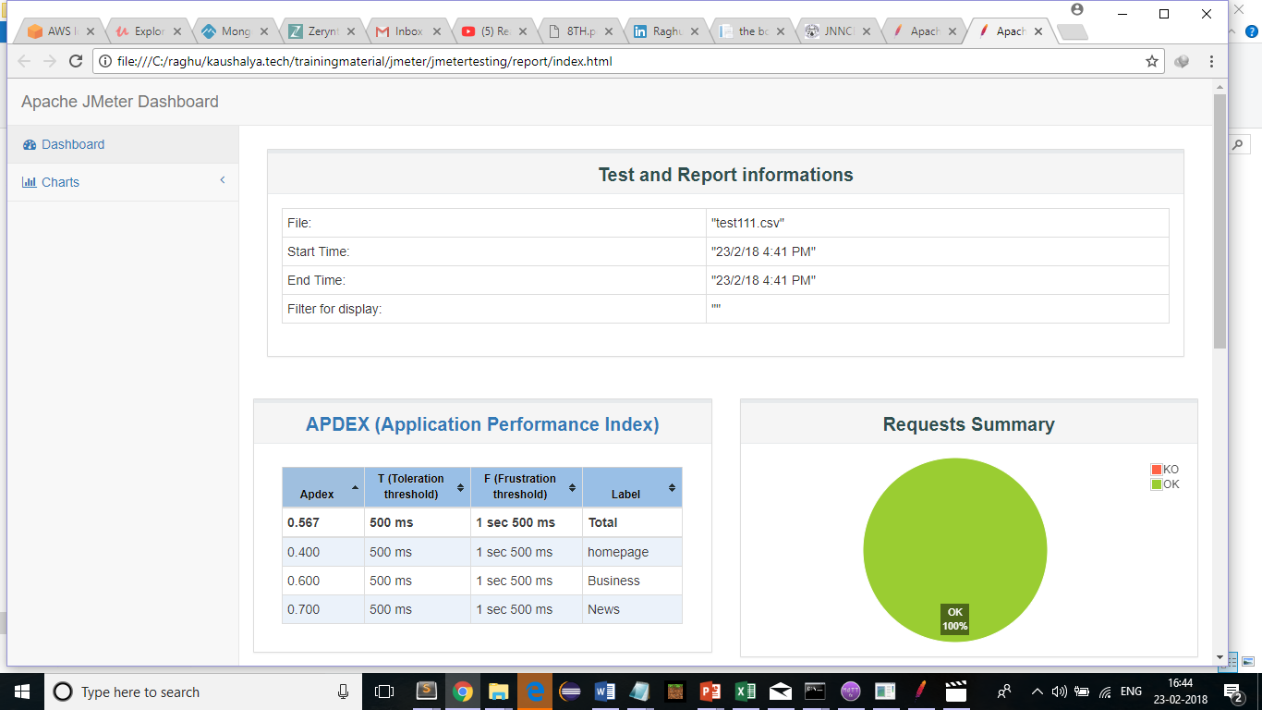

Step 6 : Analyse html report