**Jmeter Beginner Tutorial 9 – Testing Web Services (API)**

API – Application Programming Interface

Restaurant – table 🡨WAITER🡪Kitchen

Waiter is the interface between customer and chef

Travel website MakeMyTrip

Select and search flights - > We get the results

Request has gone to servers of different websites and fetched data.

It should fetch real time data.All airlines have exposed some API’s which can be accessed by MakeMyTrip or other travel portal.

Web Services – Client 🡨API🡪server

REST | SOAP

How to test REST API

**Step 1 :** Add thread group

Step 2 : Add Sampler – HttpRequest

Step 3 : Add RestAPI

<https://openweathermap.org/api>

Step 4 : Sign up for API key

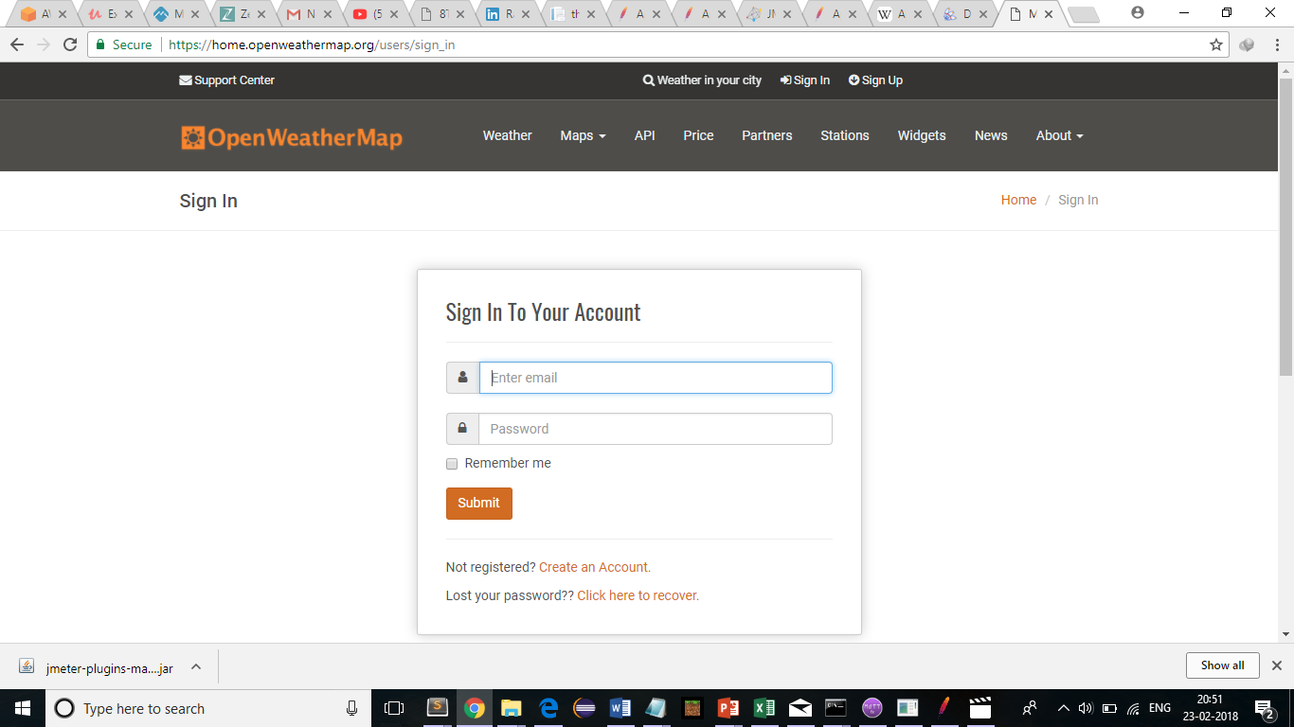

API Keys

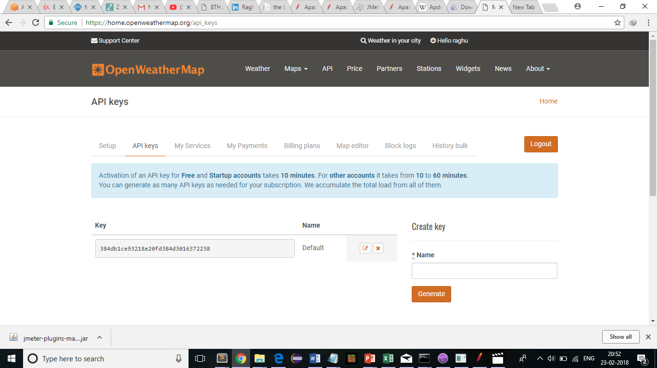

Get API Key - 384db1ce93218e20fd384d3016372238

Step 5 : Make API Call

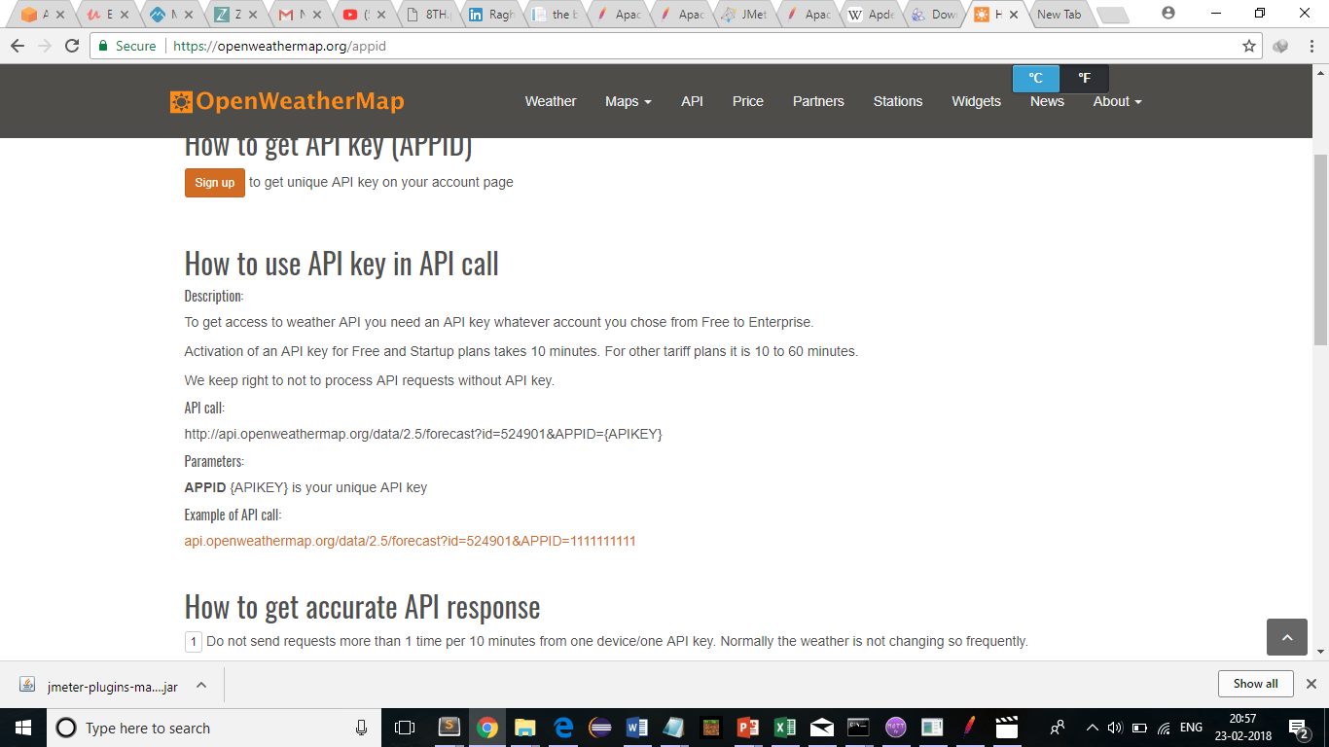

[api.openweathermap.org/data/2.5/weather?q=Bangalore](http://samples.openweathermap.org/data/2.5/weather?q=London,uk&appid=b6907d289e10d714a6e88b30761fae22)&appid=384db1ce93218e20fd384d3016372238

server name/ip : api.openweathermap.org

path : /data/2.5/weather/

Query String (parameters) : appid=384db1ce93218e20fd384d3016372238

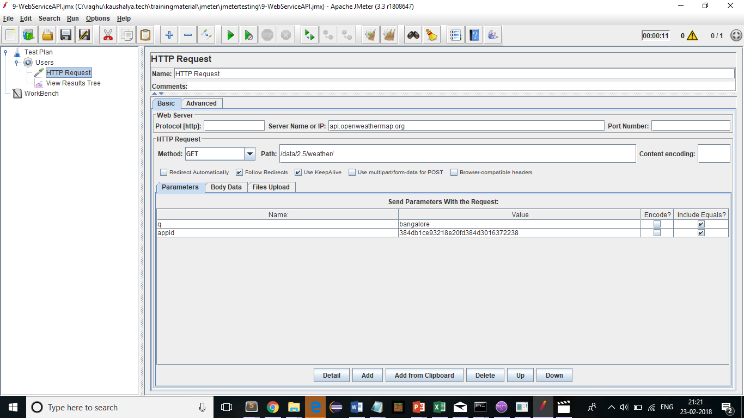

Step 6 : Add view result tree listener and run

