Local SHAP Explanation Report (Single Patient)
This report provides a local SHAP (SHapley Additive exPlanations) explanation for a single patient. It highlights how each health parameter contributed positively or negatively to the model's prediction of diabetes risk.

Waterfall Chart
The waterfall chart below shows the contribution of each feature for this patient. Red bars indicate features that increased the predicted risk, while blue bars indicate features that decreased it.
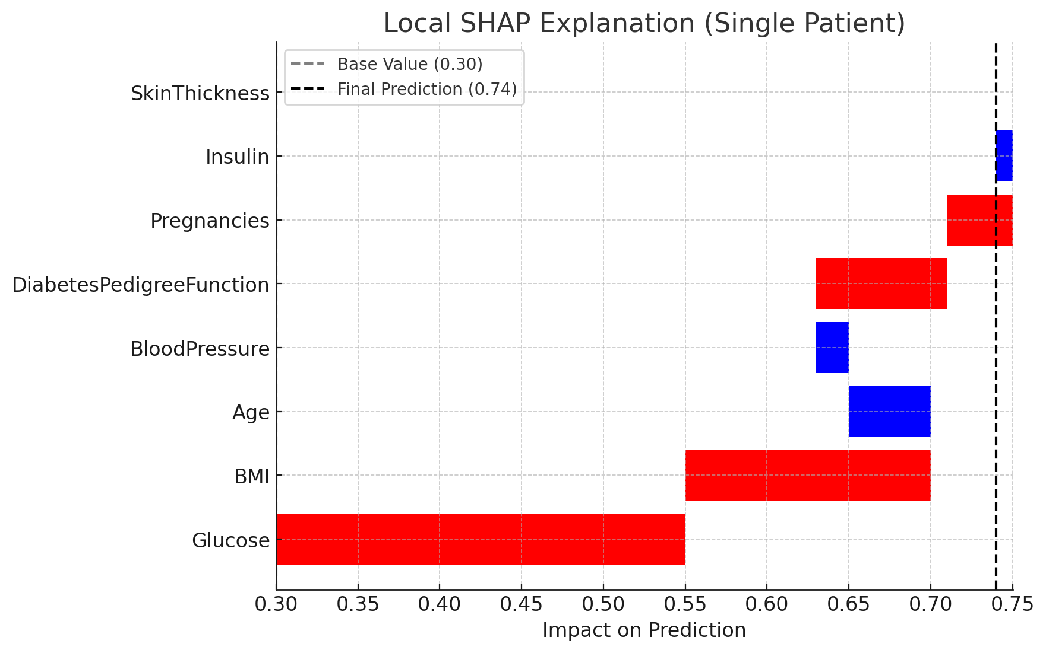

Feature Contributions
- Glucose: Strongly increases risk due to high value.
- BMI (Body Mass Index): High BMI adds to the risk.
- Age: Younger age slightly reduces risk.
- Blood Pressure: Normal value reduces risk slightly.
- Diabetes Pedigree Function: Family history moderately increases risk.
- Pregnancies: Multiple pregnancies add slight risk.
- Insulin: Slightly reduces risk here.
- SkinThickness: No major contribution in this case.

Conclusion
For this patient, high glucose and high BMI are the strongest contributors to elevated diabetes risk. Age and blood pressure provided small protective effects, but overall the model prediction is skewed toward a higher risk outcome.

