Local SHAP Explanation Report (Single Patient)
This report provides a local SHAP (SHapley Additive exPlanations) explanation for a single patient. It highlights how each health parameter contributed positively or negatively to the model's prediction of diabetes risk.

Waterfall Chart
The waterfall chart below shows the contribution of each feature for this patient. Red bars indicate features that increased the predicted risk, while blue bars indicate features that decreased it.
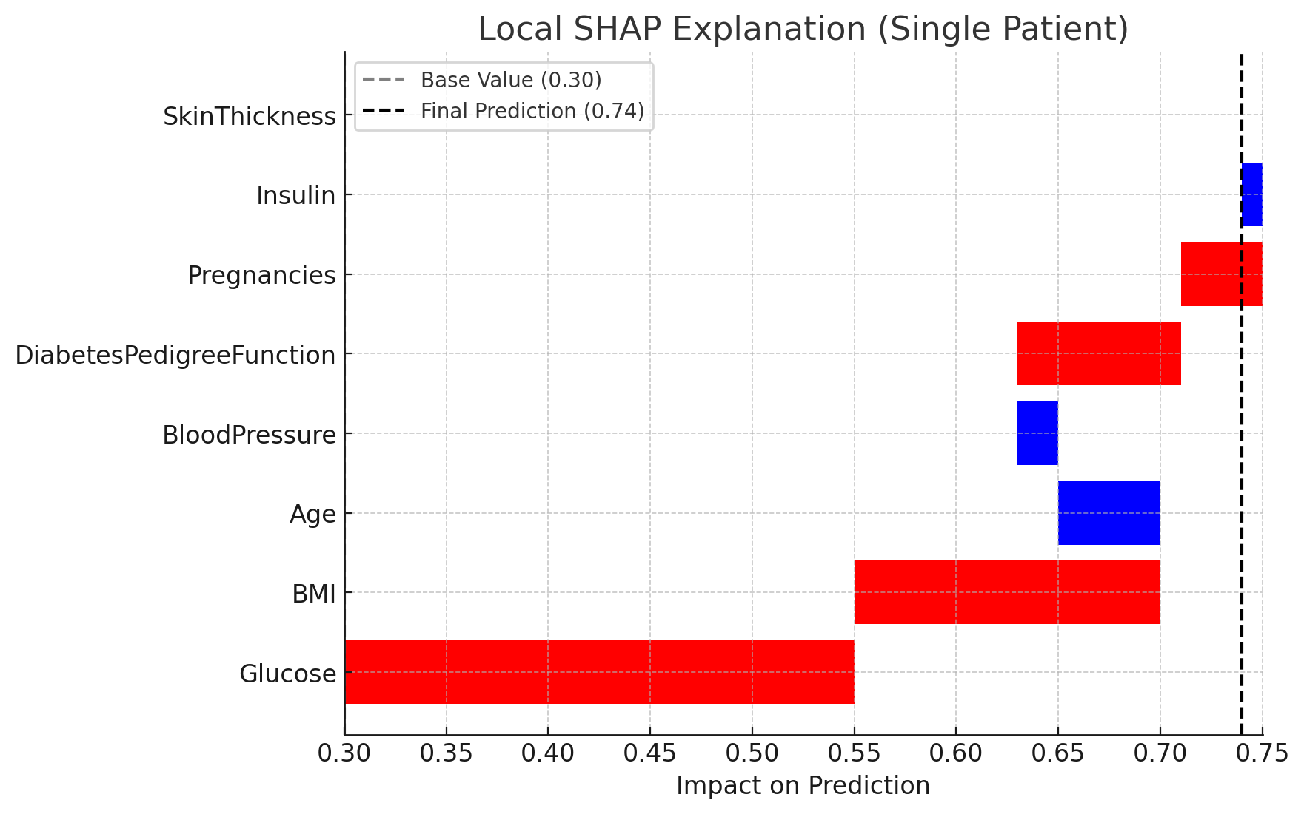

Feature Contributions
- Glucose: Strongly increases risk due to high value.
- BMI (Body Mass Index): High BMI adds to the risk.
- Age: Younger age slightly reduces risk.
- Blood Pressure: Normal value reduces risk slightly.
- Diabetes Pedigree Function: Family history moderately increases risk.
- Pregnancies: Multiple pregnancies add slight risk.
- Insulin: Slightly reduces risk here.
- SkinThickness: No major contribution in this case.

Conclusion
For this patient, high glucose and high BMI are the strongest contributors to elevated diabetes risk. Age and blood pressure provided small protective effects, but overall the model prediction is skewed toward a higher risk outcome.

Understanding the SHAP Base Value
The SHAP base value represents the average model prediction across the entire training dataset. It is the starting point for explanations, showing what the model would predict if it had no information about a specific patient, only the population average.
For an individual patient, the model starts from this base value and then adjusts the prediction by adding or subtracting SHAP values (feature contributions). Mathematically:
Prediction for patient = Base value + Sum(SHAP values for features)
In healthcare, the base value acts as a baseline risk. If the baseline is already high, even small contributions from risk factors can push a patient into a very high predicted risk. If the baseline is low, stronger risk factors are needed to move the prediction upward.
In summary, the base value provides the reference point, while SHAP feature contributions explain why a patient's risk is higher or lower than this baseline.

