Enterprise Observability Strategy
Agentic IT Ticketing Platform on Google Cloud Platform
Leveraging Vertex AI Agent Engine & Datadog

Revision History
Version | Date | Author | Description
1.0 | March 2026 | Enterprise Architecture Team | Initial Board-Level Release

Table of Contents
1. Executive Summary
2. Strategic Objectives
3. Current Challenges
4. Target Architecture Overview
5. Architecture Diagram
6. Observability Layers
7. Business & Operational Metrics
8. SLA & Compliance Model
9. Governance Framework
10. RACI Matrix
11. Security & Data Governance
12. Cost Optimization Strategy
13. Implementation Roadmap
14. Risk Assessment
15. Observability Maturity Model
16. Financial Considerations
17. Final Recommendation
18. Sign-Off

1. Executive Summary
This document outlines the enterprise observability strategy for the Agentic IT Ticketing Platform deployed on GCP. The strategy recommends a Hybrid Observability Model combining real-time operational monitoring through Datadog and long-term analytical, compliance, and SLA measurement capabilities using BigQuery.

2. Strategic Objectives
• Ensure real-time operational visibility for executive oversight.
• Maintain regulatory-grade audit trails.
• Enable SLA compliance measurement and reporting.
• Optimize observability spend at enterprise scale.
• Enable predictive analytics for AI agent behavior.

3. Current Challenges
Agentic systems introduce high-cardinality telemetry, complex workflows, and AI-driven variability. Traditional observability models struggle with cost control, SLA analytics, and compliance traceability.

4. Target Architecture Overview
Telemetry from application and agent layers flows into Cloud Logging. Operational metrics are exported to Datadog for alerting and dashboards. Full-fidelity logs are retained in BigQuery for compliance, SLA reporting, and analytics.

5. Architecture Diagram
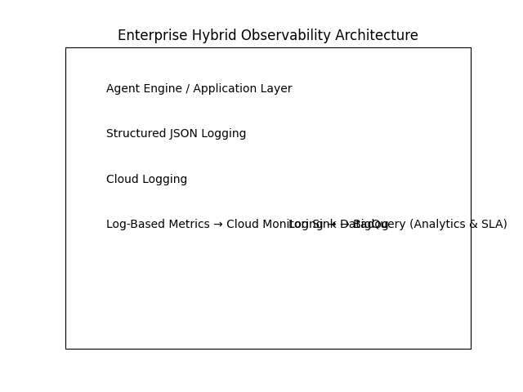

6. Observability Layers
Layer 1: Application Telemetry (Agent latency, tool failures, token usage).
Layer 2: Platform Telemetry (CPU, memory, autoscaling, network latency).
Layer 3: Business Telemetry (MTTR, SLA breach %, approval delays).

7. Business & Operational Metrics
Operational Metrics (Datadog): Error rate, latency percentiles (P95/P99), timeout spikes.
Business Metrics (BigQuery): MTTR, SLA breach %, retry amplification rate.

8. SLA & Compliance Model
SLA calculations are automated in BigQuery using partitioned datasets and scheduled queries. This enables board-level monthly SLA reporting and compliance evidence.

9. Governance Framework
The governance framework defines ownership of metrics, approval of alert thresholds, retention policies, and audit review cycles.

10. RACI Matrix
Activity | Business | SRE | Data Eng | Security
Define SLA | A | C | C | C
Monitor Alerts | I | R | C | C
Log Governance | C | R | A | C
Audit Compliance | A | C | C | R

11. Security & Data Governance
Implements IAM controls, encryption, retention policies, and segregation of duties.

12. Cost Optimization Strategy
Control Datadog cardinality and aggregate metrics.
Use partitioned and clustered BigQuery tables with lifecycle policies.

13. Implementation Roadmap
Phase 1: Structured logging foundation.
Phase 2: Datadog integration & alerting.
Phase 3: BigQuery SLA automation.
Phase 4: Predictive analytics enablement.

14. Risk Assessment
Primary risks include cost overruns, governance drift, and uncontrolled metric growth.

15. Observability Maturity Model
Level 1: Logging → Level 5: AI-driven predictive observability.

16. Financial Considerations
Hybrid model balances Datadog operational spend and BigQuery analytical efficiency.

17. Final Recommendation
Adopt a Hybrid Observability Architecture using Datadog for real-time intelligence and BigQuery as the system of record for compliance and analytics.

18. Sign-Off
Prepared By: ___________________________
Approved By (Client): ___________________________
Date: ___________________________

