We've been busy
Since the template SDK roll out back in April, things have been busy. It's been amazing to see users use template SDK to build out custom IaaS environments on Azure. What's been even more gratifying to see is the level to which templates have made use of the flexibility available in the template syntax. Supporting users with really 'out there' template customization requirements has both been incredibly fun as well as eye opening. To be honest, we were pretty sure that it'd be a long time before developers venture into dynamic template features. Just goes to show how wrong you can be when one of the first feedback emails was someone trying to use liquid filters in their template!
But then, I digress. I wanted to use this post to introduce a bunch of new goodies that are available on Brewmaster. So, without further ado, let's jump in:

Teardown deployed infrastructure.
Deployed an environment using Brewmaster and now want to get rid of it? Absolutely. This has been one of the most asked for features and now you have it now. For any deployment, go to the deployment details page and click the teardown button. 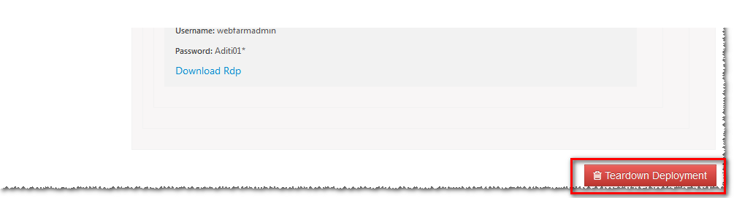
You will see a preview of the infrastructure deployed by the template and you can select resources you'd like to delete. Select and hit 'Proceed'. 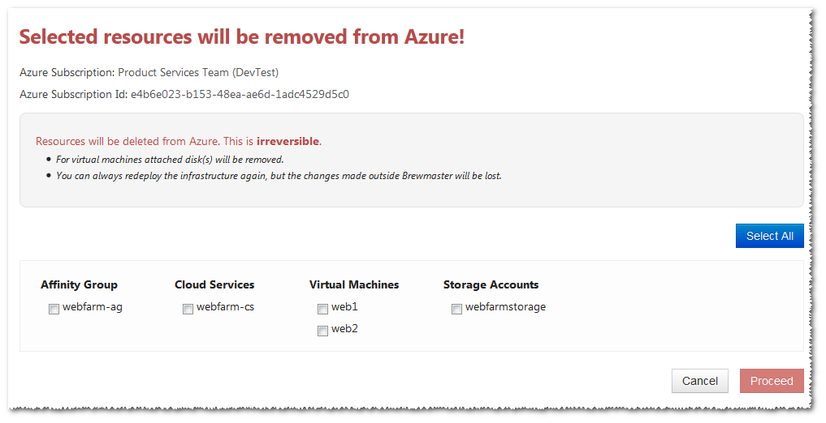
You will be asked to confirm once more and then Brewmaster starts deleting infrastructure from your azure subscription with logs showing up under the deployment.
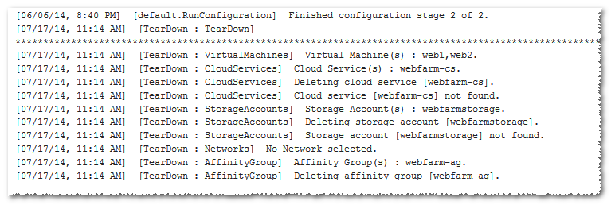

Use a configuration as a template

Use a different commit at deployment
Earlier, when you deploy a registered template, it would default to using the commit used while registering the template. This proved a little problematic when you start a new branch and then realize that to use that branch, you have to register the template again. Not so anymore. Now you when you start a deployment, you have the option to provide a branch name or a commit sha and Brewmaster will pull that revision for the deployment! 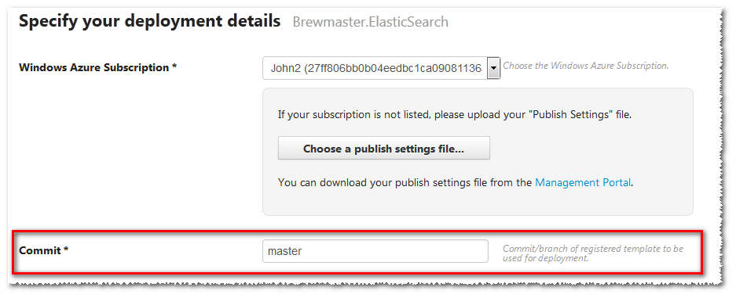

Template validation

Elasticsearch Template
A new Elasticsearch template has been added. You can now have a scalable, Azure aware Elasticsearch instance in minutes. We started using Elasticsearch internally and what better way to show our love than to make a template out of it. The Elasticsearch template deploys into Windows Azure IaaS with automatic node discovery. Just specify the number of Elasticsearch servers and the disk size and Brewmaster will do the rest. 

