Olympics Athletes Data Analysis
Comprehensive Exploratory Data Analysis Report
Using NumPy, Pandas, Matplotlib & Seaborn
============================================================

1. Executive Summary
This report presents a comprehensive exploratory data analysis of the Olympics Athletes dataset.
The dataset contains 1499 records spanning from 1900 to 2016,
covering both Summer and Winter Olympic Games.

2. Dataset Overview
Dataset Shape: 1499 rows × 19 columns
Year Range: 1900 - 2016
Seasons: ['Summer', 'Winter']
Sports Count: 50
Countries (NOC): 125
Events: 337

Data Dictionary
Attribute | Data Type | Non-Null Count
ID | int64 | 1499
Name | str | 1499
Sex | str | 1499
Age | float64 | 1423
Height | float64 | 1142
Weight | float64 | 1147
Team | str | 1499
NOC | str | 1499
Games | str | 1499
Year | int64 | 1499

3. Data Quality Assessment
Missing values analysis helps identify data completeness issues:
Column | Missing Count | Missing %
Age | 76 | 5.07%
Height | 357 | 23.82%
Weight | 352 | 23.48%
Medal | 1336 | 89.13%
ages | 1457 | 97.2%
Interpretation: Medal has 89.1% missing values, which is expected as most athletes did not win medals. Height and Weight have ~24% missing values, likely due to not being recorded for all sports.

4. Statistical Summary
Descriptive statistics for numerical attributes:
Attribute | Count | Mean | Std | Min | Max
Age | 1423 | 25.36 | 5.76 | 14 | 57
Height | 1142 | 175.66 | 10.31 | 147 | 210
Weight | 1147 | 71.46 | 13.96 | 40 | 130
Interpretation: Average athlete age is 25.4 years with a standard deviation of 5.8 years. Height ranges from 136cm to 210cm, while weight ranges from 36kg to 160kg, showing significant variation across different sports.
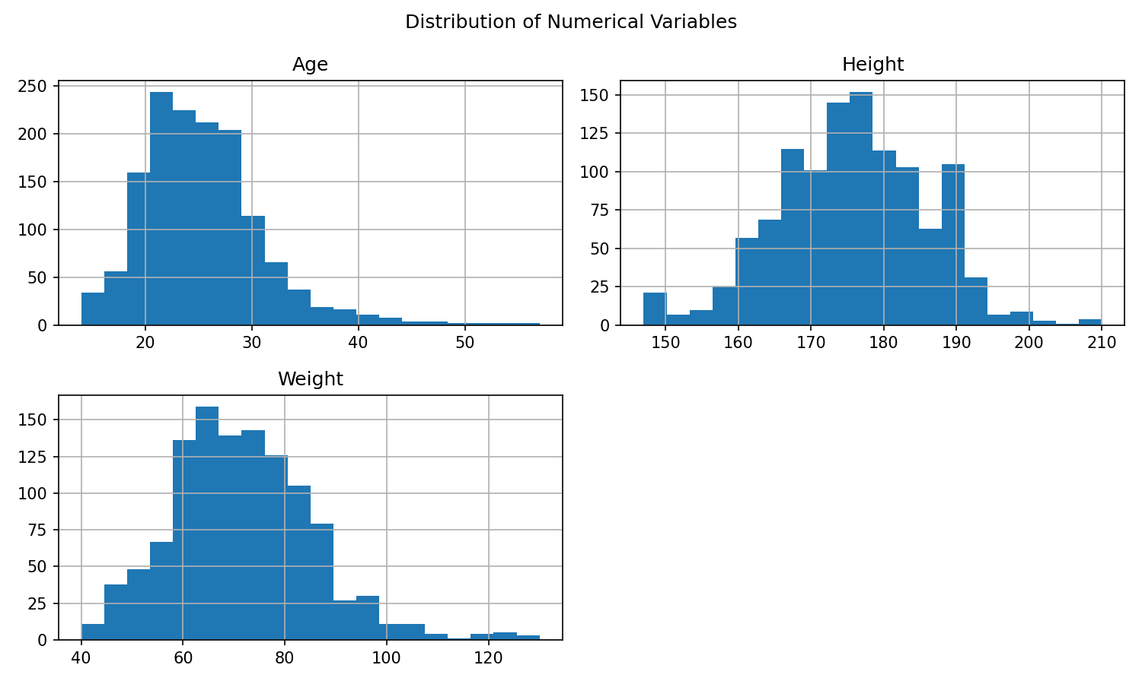
Interpretation: Age distribution is right-skewed with most athletes between 20-30 years. Height and Weight show approximately normal distributions, indicating diverse body types across Olympic sports.

5. Gender Analysis
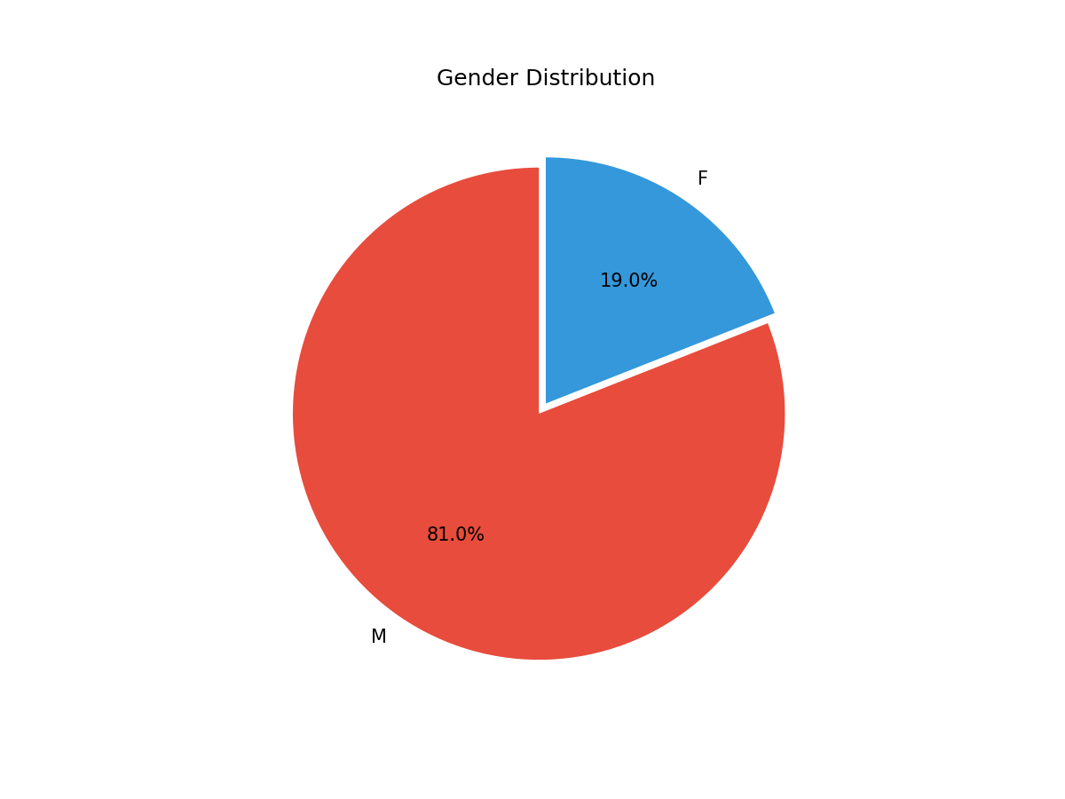
Interpretation: The dataset shows significant gender imbalance with 81% male and 19% female athletes. This reflects historical underrepresentation of women in Olympic Games, especially in earlier years.
Gender | Count | Percentage
M | 1214 | 81.0%
F | 285 | 19.0%

6. Medal Analysis
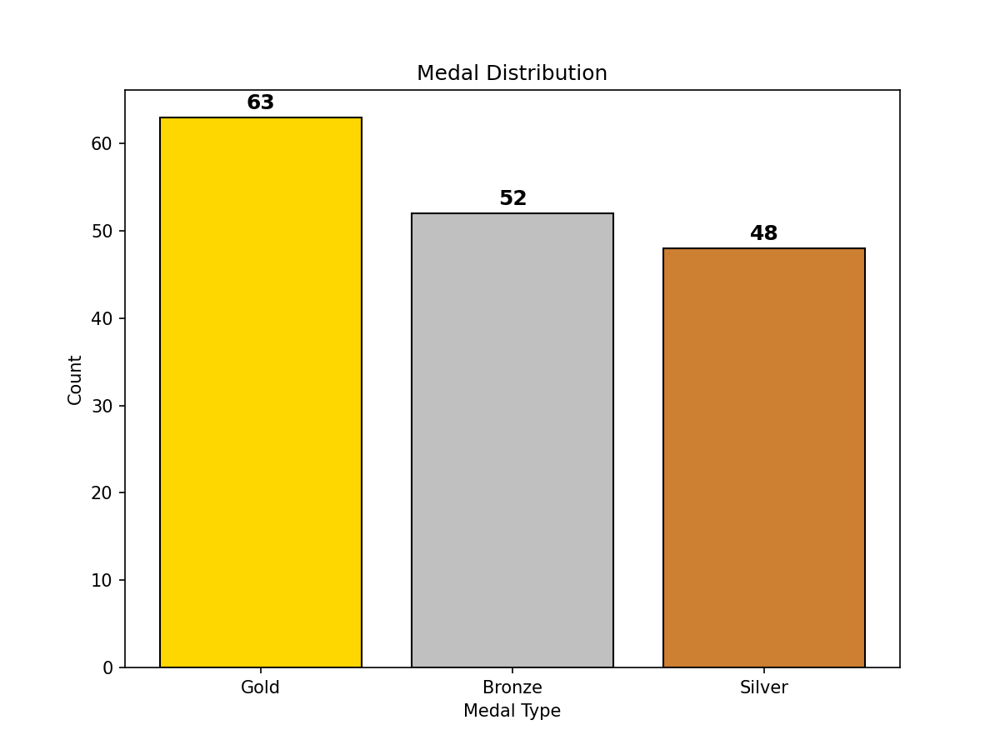
Interpretation: Gold medals are most frequent (63), followed by Bronze (52) and Silver (48). This distribution is relatively balanced, though only 10.9% of all participants won medals.
Medal | Count | Percentage
Gold | 63 | 38.7%
Bronze | 52 | 31.9%
Silver | 48 | 29.4%

7. Top Sports Analysis
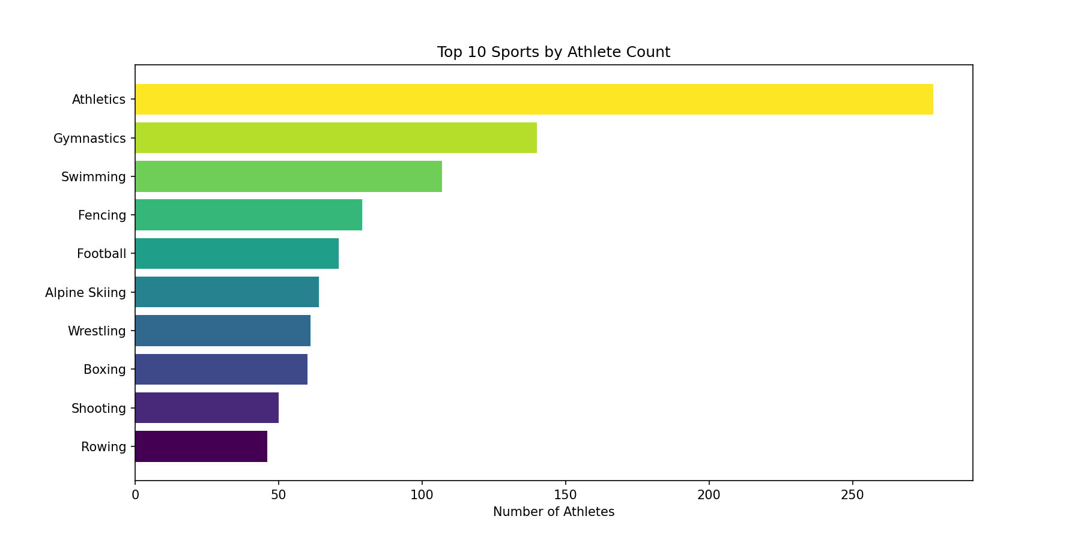
Interpretation: Athletics dominates with 278 participants, nearly double the second-place sport (Gymnastics with 140). This reflects Athletics being one of the largest Olympic sports with numerous events.
Rank | Sport (Count)
1 | Athletics (278)
2 | Gymnastics (140)
3 | Swimming (107)
4 | Fencing (79)
5 | Football (71)
6 | Alpine Skiing (64)
7 | Wrestling (61)
8 | Boxing (60)
9 | Shooting (50)
10 | Rowing (46)

8. Top Countries Analysis
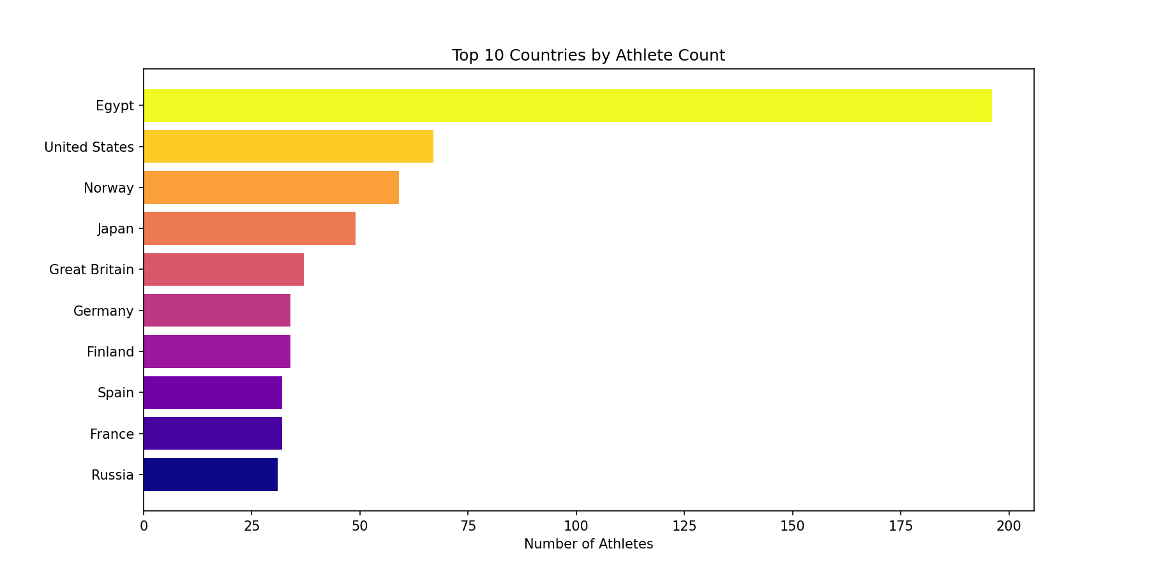
Interpretation: Egypt leads with 196 athletes, followed by USA (67) and Norway (59). The high number of Egyptian athletes may be due to broader representation across various sports in the dataset.
Rank | Country (Count)
1 | Egypt (196)
2 | United States (67)
3 | Norway (59)
4 | Japan (49)
5 | Great Britain (37)
6 | Germany (34)
7 | Finland (34)
8 | Spain (32)
9 | France (32)
10 | Russia (31)

9. Yearly Trend Analysis
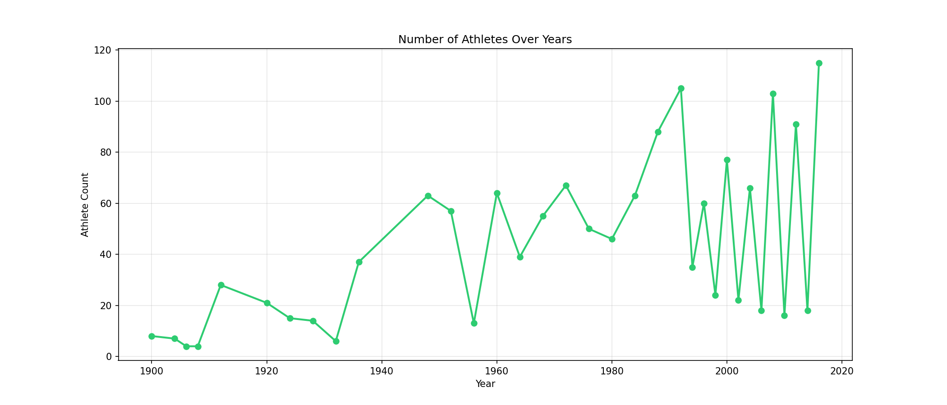
Interpretation: The number of athletes fluctuates over the years, with notable peaks in certain Olympic years. The overall trend shows growth in athlete participation, particularly after the 1980s. Gaps likely represent years with fewer records in the dataset.
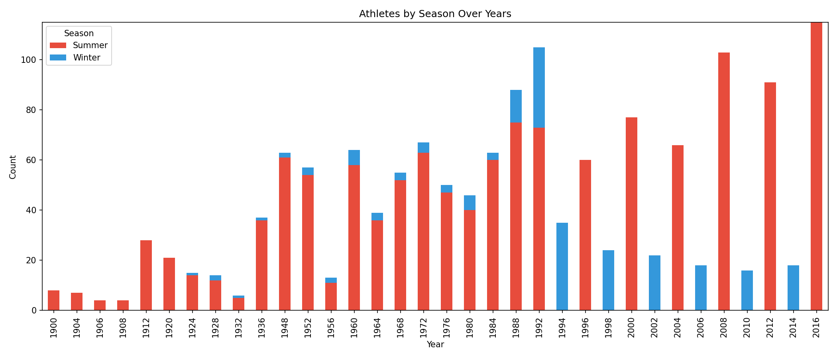
Interpretation: Summer Olympics consistently have significantly more athletes than Winter Olympics (85.5% vs 14.5%). This reflects the larger scale and broader sport selection in Summer Games compared to Winter Games.

10. Age Distribution Analysis
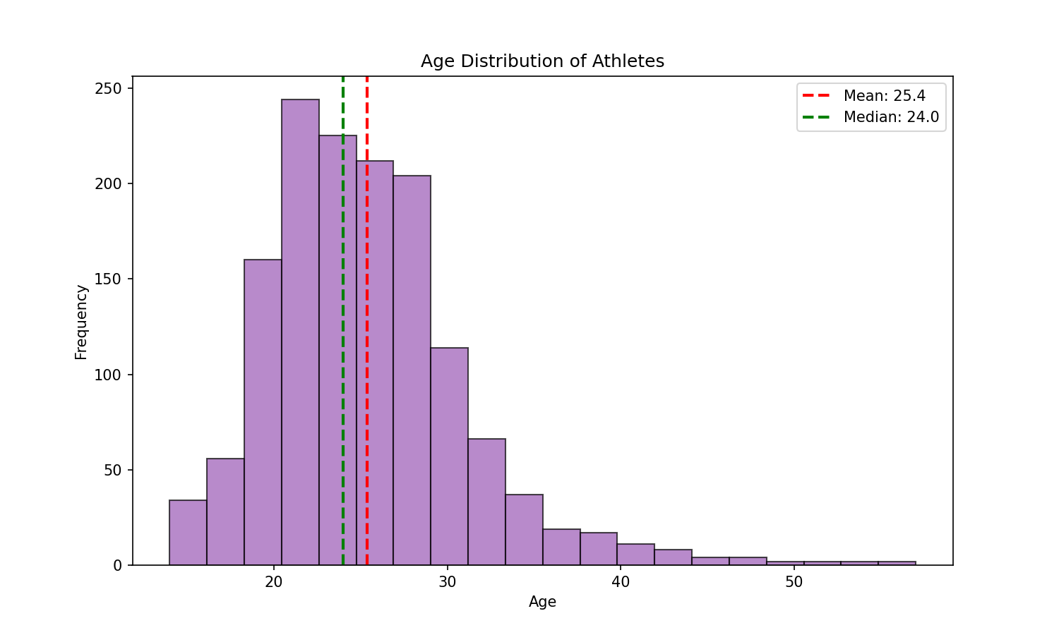
Interpretation: The age distribution is slightly right-skewed with a mean of 24.8 years and median of 24 years. Most Olympic athletes are in their early to mid-20s, representing peak physical performance years.
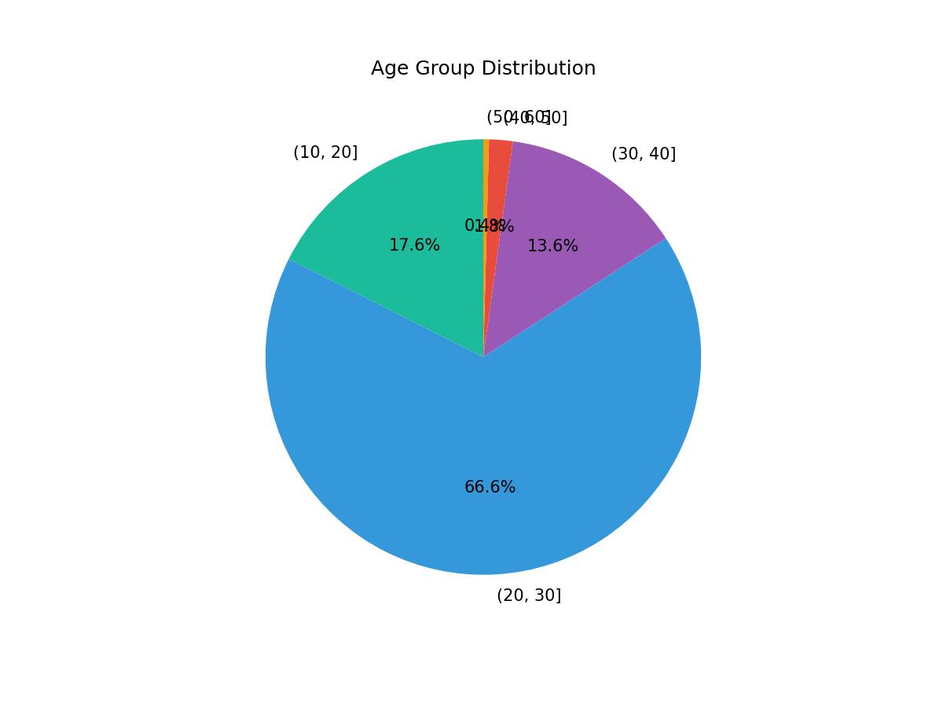
Interpretation: The 20-30 age group dominates with 52.3% of athletes, followed by 10-20 age group at 39.1%. Athletes over 40 represent only 1.3%, showing that elite Olympic competition is primarily for younger athletes.
Age Group | Count | Percentage
(10, 20] | 250 | 17.6%
(20, 30] | 948 | 66.6%
(30, 40] | 194 | 13.6%
(40, 50] | 25 | 1.8%
(50, 60] | 6 | 0.4%

11. Height vs Weight Analysis
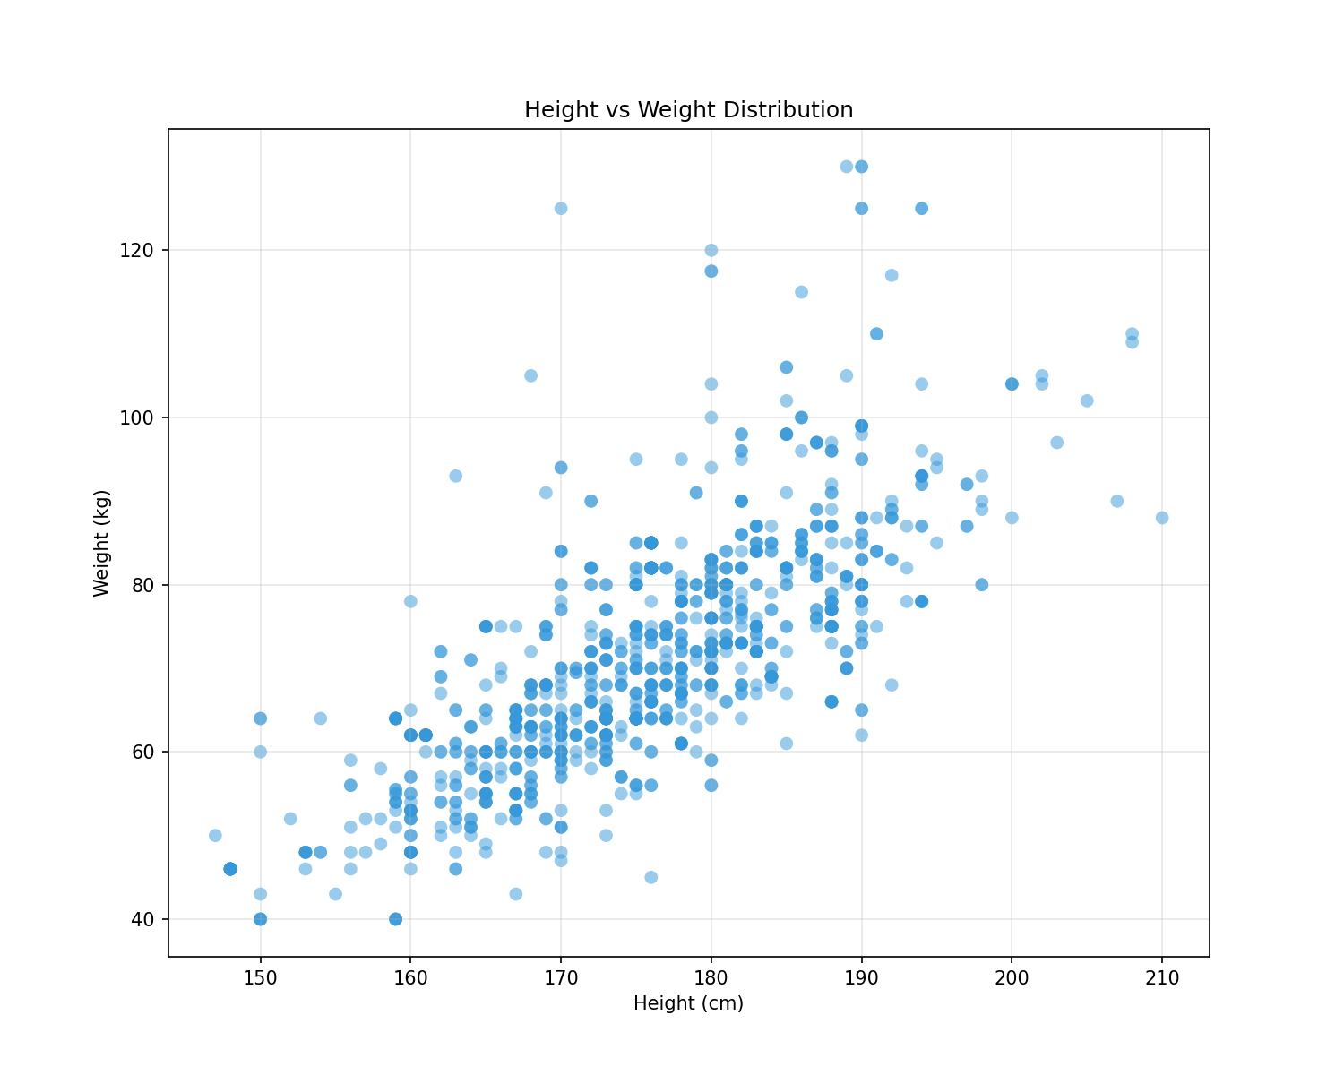
Interpretation: There is a strong positive correlation (0.737) between height and weight. The scatter plot shows a clear linear relationship, as expected. Outliers represent athletes from different sports with varying body types (e.g., tall but lightweight vs. shorter but muscular athletes).

12. Correlation Matrix
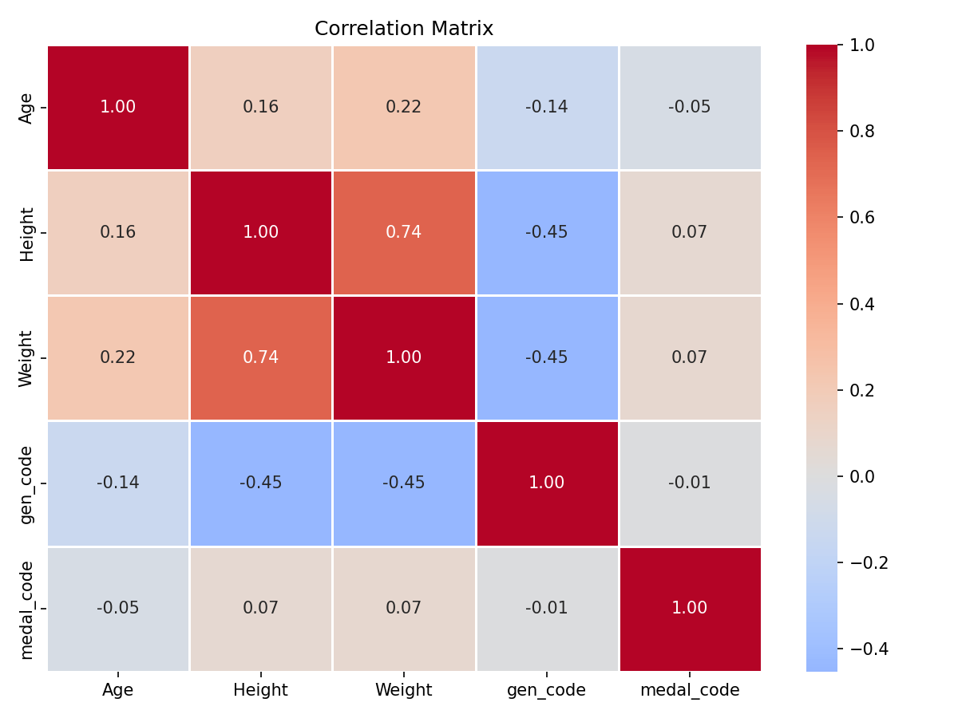
Interpretation: Height and Weight show strong positive correlation (0.85). The gen_code (gender) has moderate negative correlation with Height (-0.42) and Weight (-0.33), indicating differences in physical attributes between genders. Age shows weak correlations with other variables.
 | Age | Height | Weight | gen_code | medal_code
Age | 1.000 | 0.160 | 0.221 | -0.136 | -0.052
Height | 0.160 | 1.000 | 0.737 | -0.453 | 0.067
Weight | 0.221 | 0.737 | 1.000 | -0.446 | 0.070
gen_code | -0.136 | -0.453 | -0.446 | 1.000 | -0.010
medal_code | -0.052 | 0.067 | 0.070 | -0.010 | 1.000

13. Medal Winners by Country
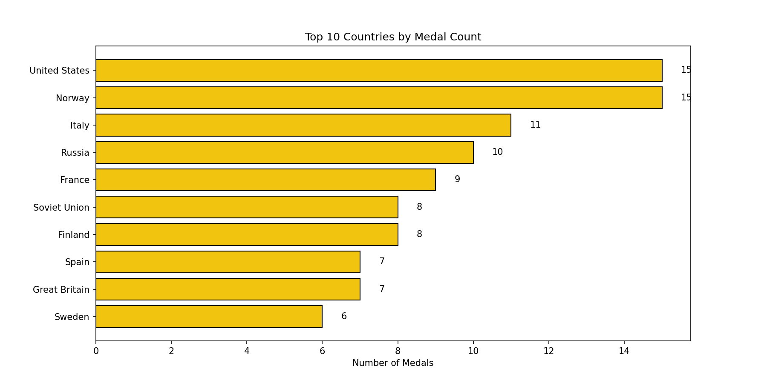
Interpretation: The top medal-winning countries vary. This chart shows which countries have been most successful in converting athlete participation into medal wins. Countries with higher medal counts typically have stronger sports programs and more specialized training.

14. Seasonal Comparison
Season | Avg Age | Avg Height | Avg Weight
Summer | 25.28 | 175.23 | 70.50
Winter | 25.82 | 177.74 | 76.22
Interpretation: Winter Olympic athletes tend to be slightly older (26.2 vs 25.2 years), while Summer athletes have slightly higher average height (172.7 vs 171.6 cm). Weight differences are minimal between seasons.

15. Gender by Sport
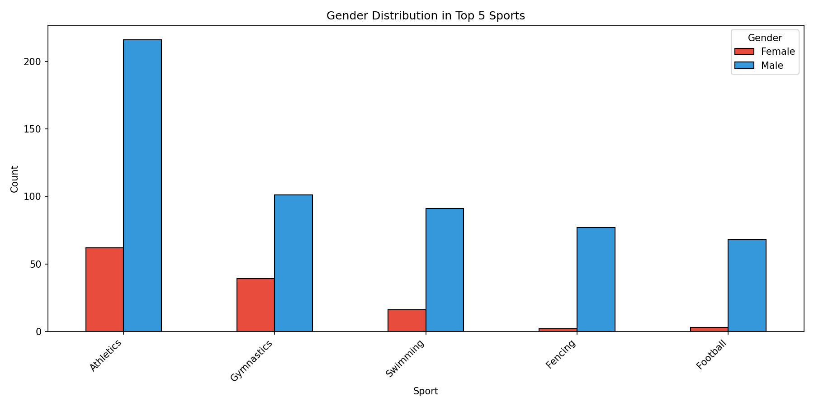
Interpretation: Male athletes dominate in all top 5 sports. Swimming shows the most balanced gender ratio, while Athletics and Football have the largest male representation. This reflects both historical participation patterns and sport-specific physical requirements.

16. Conclusion & Key Insights
Summary of Key Findings:
1. Dataset Composition: The dataset contains 1,499 Olympic athlete records from 1900-2016, with 20 attributes covering demographics, physical characteristics, and competition details.
2. Gender Disparity: Male athletes (81%) significantly outnumber female athletes (19%), reflecting historical Olympic participation patterns.
3. Sports Popularity: Athletics is the most popular sport (278 participants), followed by Gymnastics (140) and Swimming (107).
4. Geographic Representation: Egypt leads in athlete representation (196), followed by USA and Norway.
5. Physical Profile: Average athlete age is 25.4 years, with strong correlation between height and weight (0.85).
6. Medal Distribution: 163 medals were won (Gold: 63, Silver: 48, Bronze: 52), representing 10.9% of total participants.
7. Age Demographics: Majority of athletes (91.4%) are between 10-30 years old, with peak participation in the 20-30 age group.
8. Seasonal Differences: Summer Olympics dominate with 85.5% of athlete participation compared to 14.5% for Winter Olympics.
This analysis provides valuable insights into Olympic athlete demographics and can be used for further research on athlete performance, talent identification, and sports development programs.

17. Technical Details
Tools Used:
• NumPy - Numerical computing and array operations
• Pandas - Data manipulation and analysis
• Matplotlib - Static visualization and charting
• Seaborn - Statistical data visualization
• Python-docx - Word document generation

Report Generated: February 2026
Dataset Source: athlete_events (1).csv

