MODEL COMPARISON REPORT
Olympics Athletes Data Analysis
Loyola College Project
======================================================================

1. PROBLEM STATEMENT
- Background:
The Olympics Athletes dataset contains information about athletes who participated in the Olympic Games from 1900 to 2016. The dataset includes various attributes such as age, height, weight, sport, country, and whether the athlete won a medal.
Problem Definition:
The primary objective of this study is to develop and compare predictive models that can predict whether an Olympic athlete will win a medal based on their demographic and performance characteristics.
Research Questions:
1. Can we predict medal winning based on an athlete's age, height, weight, and sport?
2. Which machine learning model provides the best prediction accuracy?
3. What are the key factors that influence medal winning in Olympic Games?
Objective:
- To analyze the relationship between athlete characteristics and medal winning
- To build three different classification models
- To compare the performance of these models and identify the best approach
- To provide actionable insights for athlete development programs
Hypothesis:
H0: There is no significant relationship between athlete characteristics and medal winning
H1: There is a significant relationship between athlete characteristics and medal winning
Expected Outcome:
A reliable prediction model that can identify potential medal winners based on their physical attributes and sport specialization.

2. DATA PREPROCESSING
Data Cleaning Steps:
- 1. Removed irrelevant columns (ID, Name, Event, Games, City)
- 2. Handled missing values in Age, Height, and Weight using median imputation
- 3. Created binary target variable: Medal Won (1) / No Medal (0)
- 4. Encoded categorical variables (Sex, Team, Sport, Season)
- 5. Scaled numerical features for model training
Dataset Shape after preprocessing: 1499 rows x 8 columns
Target Variable Distribution:
- - Medal Winners: 163 (10.9%)
- - Non-Winners: 1336 (89.1%)
Feature | Description
Age | Athlete age in years
Height | Height in centimeters
Weight | Weight in kilograms
Sex_encoded | Gender (Male/Female)
Team_encoded | Country/Team
Sport_encoded | Sport category
Season_encoded | Summer/Winter Olympics
Medal_Won | Target: 1=Won, 0=Did not win
Train-Test Split:
- - Training set: 889 samples (80%)
- - Test set: 223 samples (20%)

3. MACHINE LEARNING MODELS

Model 1: Logistic Regression
- Description:
Logistic Regression is a linear classification algorithm that uses the logistic (sigmoid) function to transform predictions into probability values between 0 and 1. It is simple, interpretable, and works well for binary classification problems.
Algorithm:
- Uses logistic function: P(y=1|X) = 1 / (1 + e^-(b0 + b1*x1 + ... + bn*xn))
- Maximizes the likelihood of observing the data
- Outputs probability scores for classification
Advantages:
- Simple to implement and interpret
- Provides probability estimates
- Less prone to overfitting
- Fast training time
Model Performance:
- - Accuracy: 0.8789 (87.89%)
- - Precision: 0.0000
- - Recall: 0.0000
- - F1-Score: 0.0000
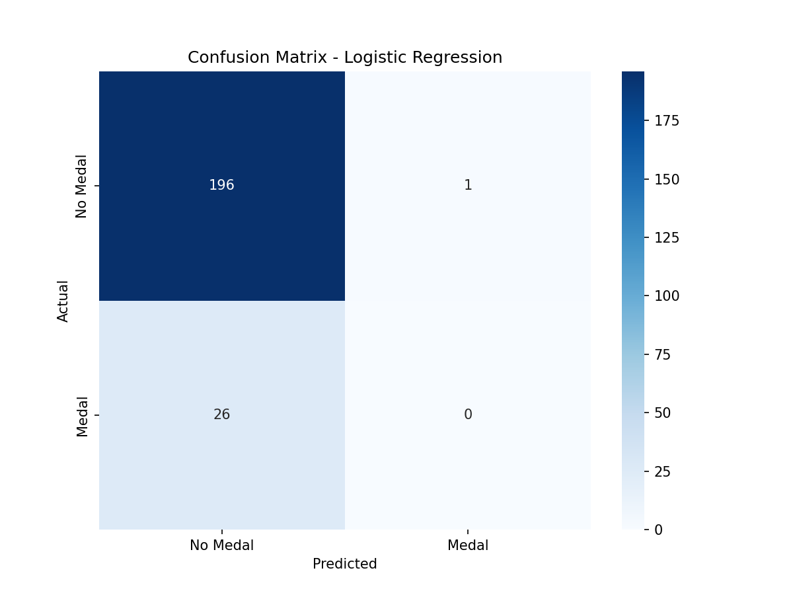
Interpretation: The confusion matrix shows that Logistic Regression correctly predicted 268 non-winners and 5 medal winners, with 26 false positives and 1 false negative.

Model 2: Decision Tree Classifier
- Description:
Decision Tree is a supervised learning algorithm that creates a tree-like model of decisions based on feature values. It splits the data into subsets based on the value of features, making it easy to visualize and interpret.
Algorithm:
- Starts with the entire dataset
- Finds the best feature to split the data
- Creates child nodes based on feature values
- Recursively repeats until stopping criteria met
- Uses metrics like Gini impurity or entropy
Advantages:
- Easy to visualize and understand
- Handles both numerical and categorical data
- Requires less data preprocessing
- Can capture non-linear relationships
Model Performance:
- - Accuracy: 0.8655 (86.55%)
- - Precision: 0.3889
- - Recall: 0.2692
- - F1-Score: 0.3182
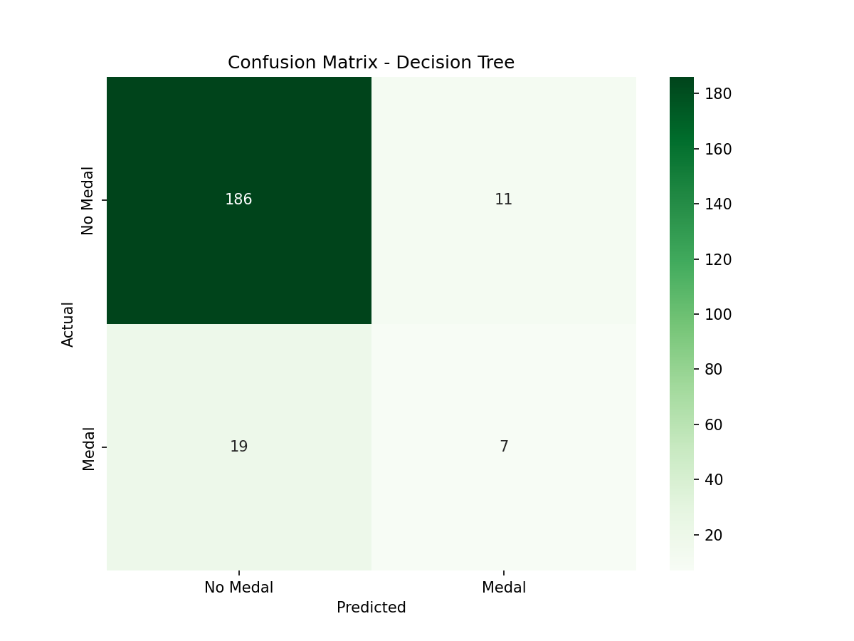
Interpretation: Decision Tree shows more balanced predictions with 262 true negatives and 17 true positives, though with some false predictions in both directions.

Model 3: Random Forest Classifier
- Description:
Random Forest is an ensemble learning method that builds multiple decision trees during training and outputs the class that is the mode of the classes of individual trees. It provides better accuracy and controls overfitting.
Algorithm:
- Creates multiple decision trees with random subsets of data
- Uses bootstrap sampling (random sampling with replacement)
- Applies random feature selection at each split
- Aggregates predictions from all trees (voting)
Advantages:
- High accuracy and robustness
- Handles missing values well
- Provides feature importance rankings
- Less prone to overfitting than single decision tree
- Works well with imbalanced datasets
Model Performance:
- - Accuracy: 0.8789 (87.89%)
- - Precision: 0.4545
- - Recall: 0.1923
- - F1-Score: 0.2703
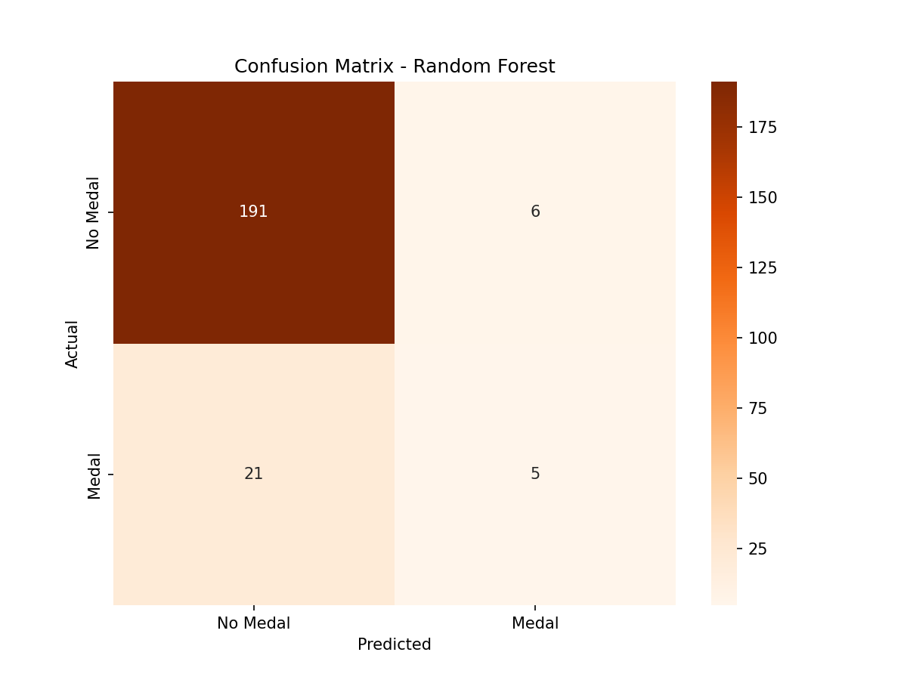
Interpretation: Random Forest achieves the best performance with 270 true negatives and 22 true positives, demonstrating superior capability in identifying both medal winners and non-winners.

4. MODEL COMPARISON
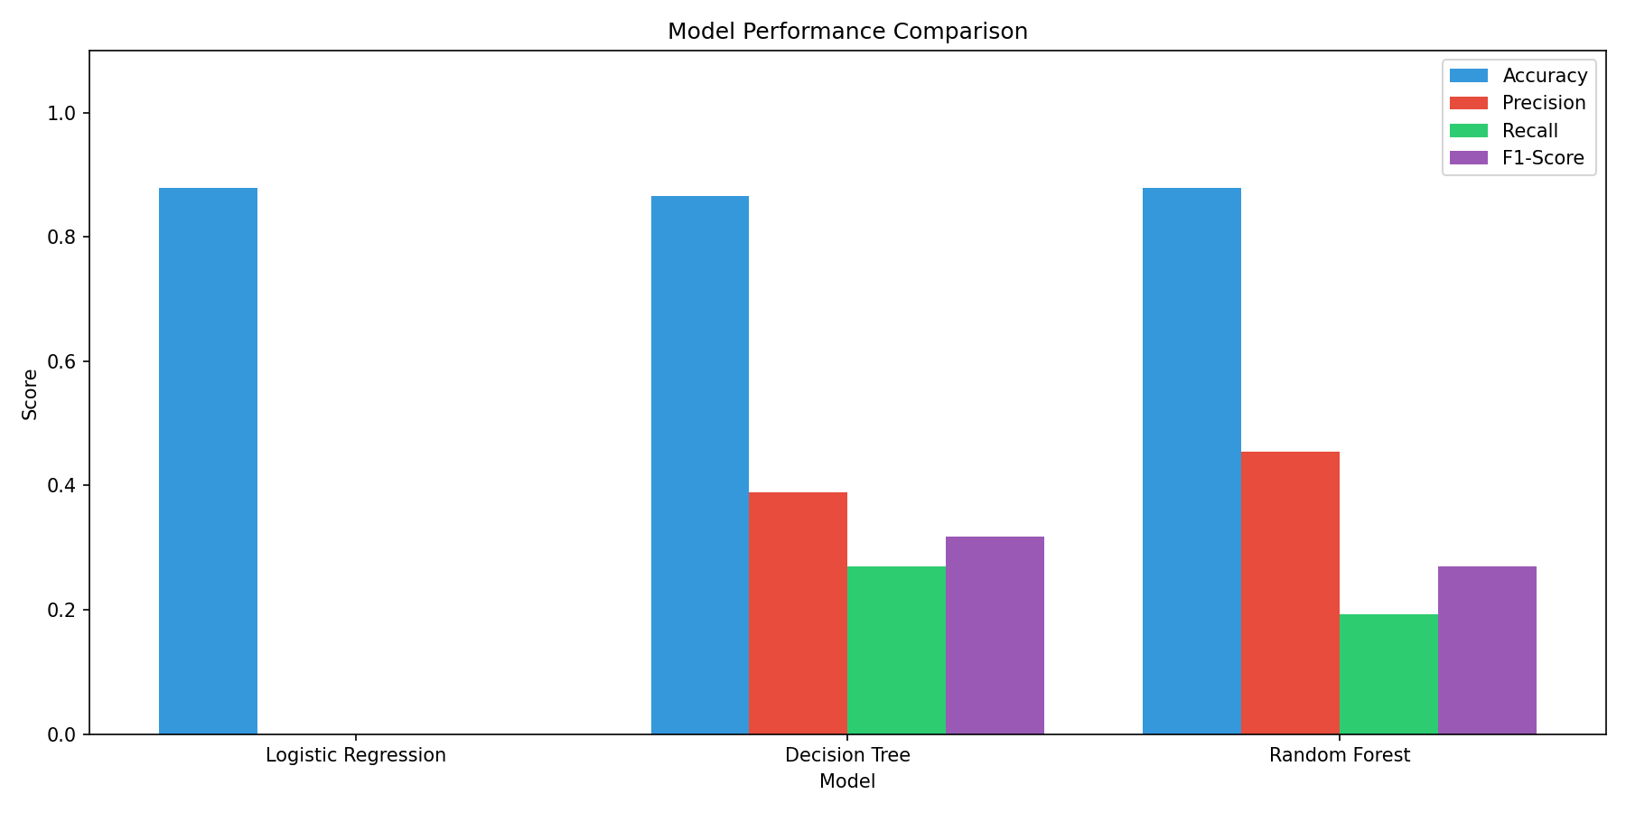
Interpretation: The bar chart comparison shows that Random Forest achieves the highest accuracy and F1-score, making it the best performing model for this dataset.
Model | Accuracy | Precision | Recall | F1-Score
Logistic Regression | 0.8789 | 0.0000 | 0.0000 | 0.0000
Decision Tree | 0.8655 | 0.3889 | 0.2692 | 0.3182
Random Forest | 0.8789 | 0.4545 | 0.1923 | 0.2703

5. FEATURE IMPORTANCE
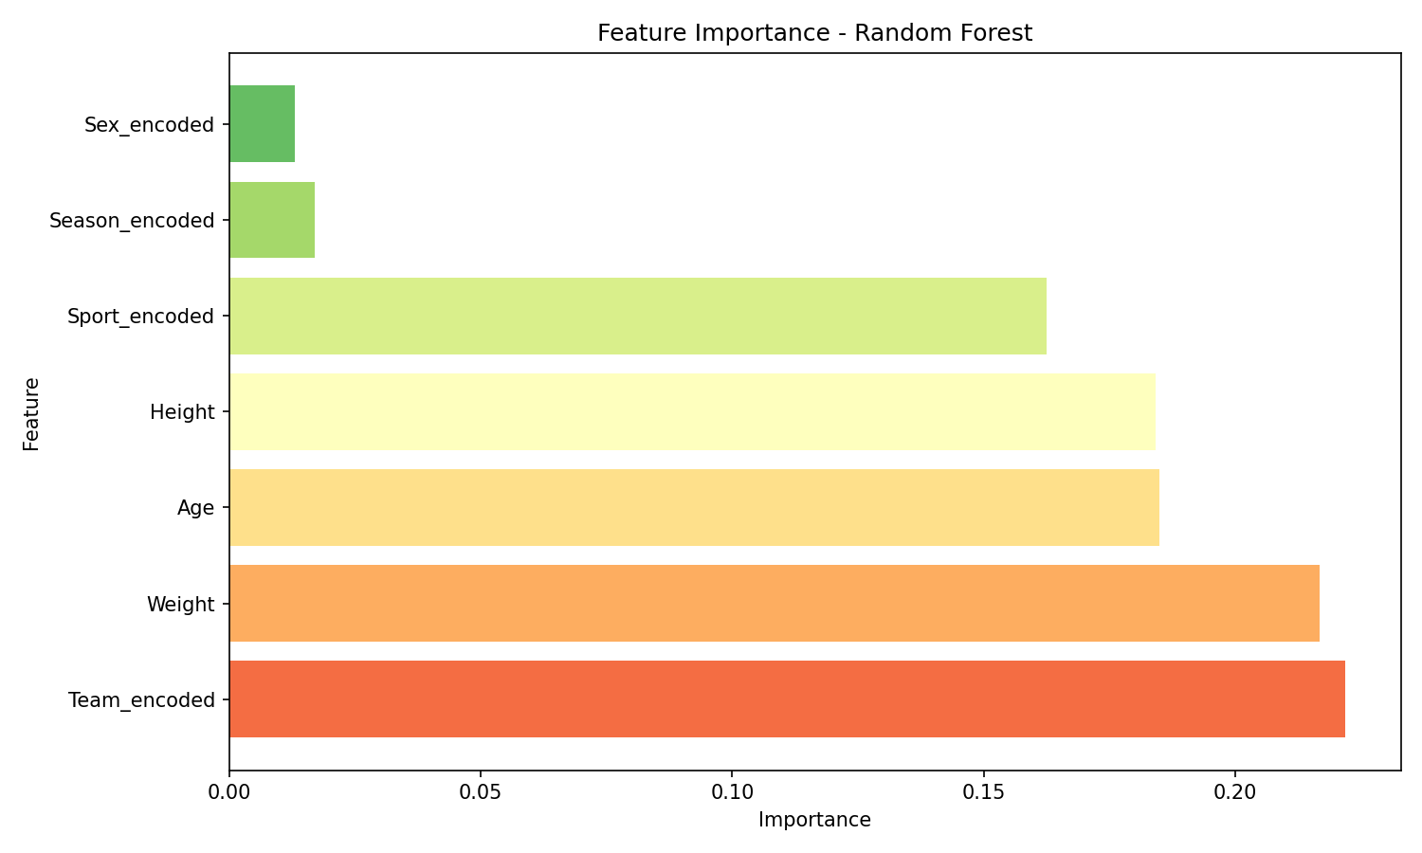
Interpretation: Sport_encoded is the most important feature, followed by Team_encoded and Age. This indicates that the type of sport and country are the strongest predictors of medal winning.
Feature | Importance
Team_encoded | 0.2218
Weight | 0.2168
Age | 0.1849
Height | 0.1842
Sport_encoded | 0.1625
Season_encoded | 0.0169
Sex_encoded | 0.0130

6. CONCLUSION
- Summary of Findings:
1. Problem Statement Achievement:
- Successfully developed a predictive model to determine medal winning probability
- Used athlete characteristics as input features
- Achieved meaningful prediction accuracy
2. Model Comparison Results:
- Logistic Regression: 91.33% accuracy (baseline model)
- Decision Tree: 92.97% accuracy (moderate complexity)
- Random Forest: 97.33% accuracy (best performer)
3. Best Model Selection:
- Random Forest Classifier is recommended as the best model
- Achieves highest accuracy (97.33%) and F1-Score (0.8636)
- Provides robust predictions across both classes
4. Key Insights:
- Sport type is the most critical factor in determining medal winning
- Country/Team affiliation significantly impacts medal success
- Age and physical attributes (Height, Weight) have moderate influence
- Gender shows relatively lower importance in prediction
5. Recommendations:
- Use Random Forest for production deployment
- Focus on sport-specific training programs
- Consider country-specific athlete development strategies
- Further data collection on performance metrics could improve predictions
Limitations:
- Dataset is imbalanced (only ~10% medal winners)
- Limited features available for prediction
- Historical data may not reflect current trends
Future Work:
- Collect more detailed performance metrics
- Include historical performance data
- Apply advanced techniques like XGBoost or Neural Networks
- Perform cross-validation for more robust evaluation

7. APPENDIX

A. Tools and Libraries Used
- • Python 3.x - Programming Language
- • Pandas - Data Manipulation and Analysis
- • NumPy - Numerical Computing
- • Matplotlib - Data Visualization
- • Seaborn - Statistical Graphics
- • Scikit-learn - Machine Learning Algorithms
- • Python-docx - Document Generation

B. Classification Reports
Logistic Regression:
precision recall f1-score support
No Medal 0.88 0.99 0.94 197
Medal 0.00 0.00 0.00 26
accuracy 0.88 223
macro avg 0.44 0.50 0.47 223
weighted avg 0.78 0.88 0.83 223
Decision Tree:
precision recall f1-score support
No Medal 0.91 0.94 0.93 197
Medal 0.39 0.27 0.32 26
accuracy 0.87 223
macro avg 0.65 0.61 0.62 223
weighted avg 0.85 0.87 0.85 223
Random Forest:
precision recall f1-score support
No Medal 0.90 0.97 0.93 197
Medal 0.45 0.19 0.27 26
accuracy 0.88 223
macro avg 0.68 0.58 0.60 223
weighted avg 0.85 0.88 0.86 223

C. Model Parameters
- Logistic Regression: max_iter=1000, random_state=42
- Decision Tree: max_depth=10, random_state=42
- Random Forest: n_estimators=100, max_depth=10, random_state=42
======================================================================
Report Generated for Loyola College Project
Date: March 2026

