**Face Attendance Application tested and Report Submitted**

**Source: Github, March 09/03/2022, 11 am**

**After Clicking Login, it throws the same error that was mentioned in the previous report.**

**Login page PS: Fig -1**

* After clicking login button, page is not redirected to login page.

**Register Page PS : Fig-2**

* An error message appears after clicking the register button. However, the user profile has been successfully registered.
* clear button is working fine.
* Image accepts .txt and .docx format file.
* If face id is already exist error message is displayed.
* Face id is accept only numeric value.
* Mandatory symbol is not specified. But error message prompt when I leave the field.
* Without an image, no error message is displayed. we able to register the id.



**The login option shows error**

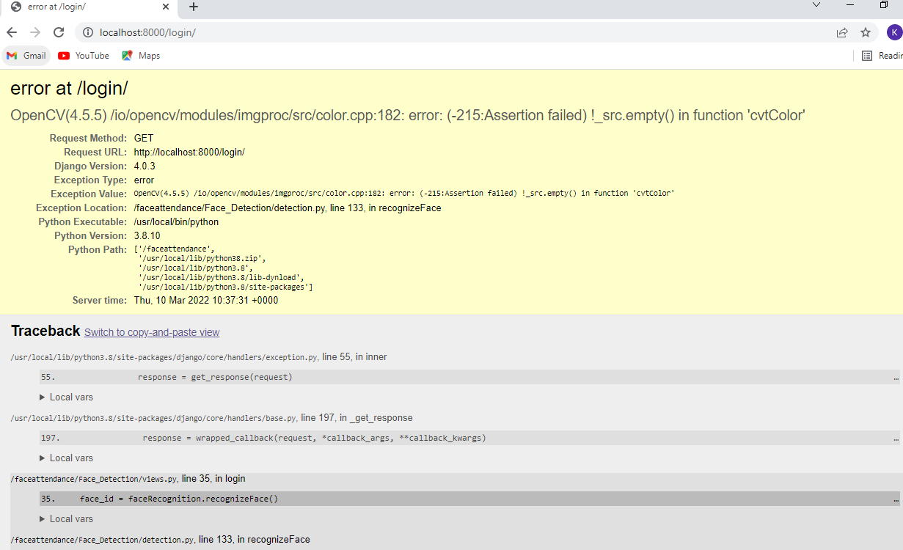

**Fig -1**

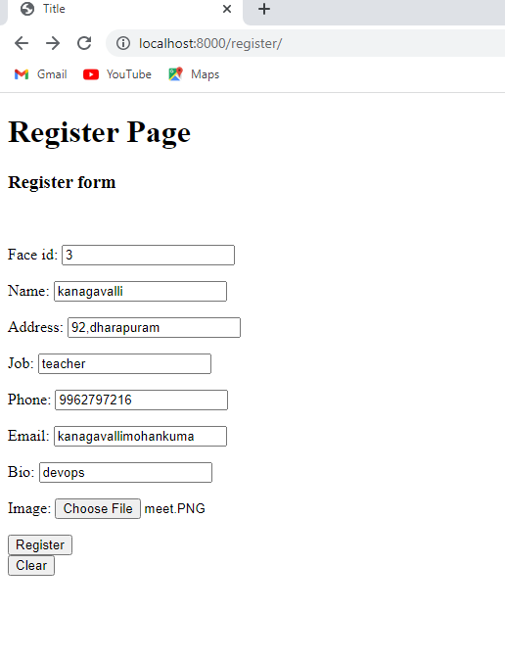

Fig 2:In the register option give details and click register

It shows user name already exists clear