Combined Project Report
GPU Architecture & Design, and DC Motor Monitoring & Control System
Project Report June - July 2026

Author Details
Name | Keerthana Vennela
Role | Electronics Intern
Company | Asquare Infotech Consultancy
Email | keerthanavennela2006@gmail.com

Table of Contents
PART I: GPU ARCHITECTURE, DESIGN & MANUFACTURING
1. Introduction
2. Applications of GPU
3. Architectural Overview
4. Assembly of GPU Components
5. Design of GPU
6. Specifications of Thermal Management System
7. Manufacturing of GPU
8. Conclusion

PART II: DC MOTOR MONITORING & CONTROL SYSTEM
1. Introduction
2. Literature Review
3. Methodology
4. Results
5. Discussion
6. Recommendations for Improvements

PART I
GPU Architecture, Design & Manufacturing

1. Introduction
A Graphics Processing Unit (GPU) is a specialized electronic circuit designed to accelerate the processing of images and videos for output to a display. Owing to their highly parallel architecture, GPUs are now used far beyond graphics rendering, such as in machine learning, scientific computing, and real-time simulation.
This section of the report documents our team's study of GPU architecture, our own from-scratch conceptual GPU design exercise, and the thermal and manufacturing considerations involved in bringing such a design to a physical product.

2. Applications of GPU
- Graphics Rendering (e.g., video games)
- Machine Learning and Artificial Intelligence
- Scientific Computing
- Cryptocurrency Mining
- Medical Imaging
- Autonomous Vehicles
- Video Processing
- Robotics

3. Architectural Overview
The architecture of a GPU is optimized for high throughput and parallelism, enabling it to perform thousands of computations simultaneously. The diagram below summarises how the major functional blocks connect on the die.
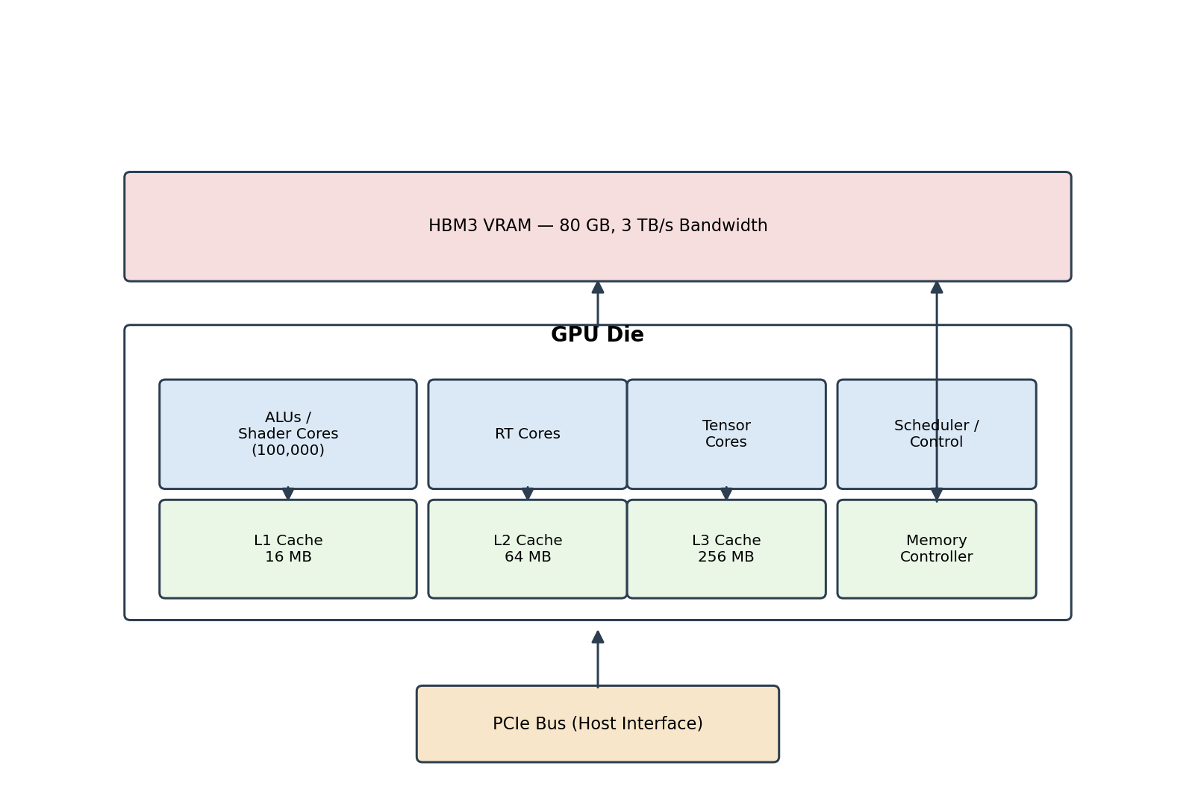
Figure 1: Simplified GPU architecture block diagram.

3.1 Core Processing Units (ALUs)
- Arithmetic Logic Units (ALUs): The heart of the GPU. Each ALU performs basic arithmetic and logical operations. GPUs are designed with hundreds or thousands of ALUs to handle many tasks simultaneously (parallelism).
- Shader Cores: Specialized ALUs for executing shader programs (small programs that compute vertex, pixel, and geometric transformations).

3.2 Memory Hierarchy
- Registers: Fast, small memory located directly in each core, storing intermediate data during computation.
- L1, L2, L3 Caches: Layered cache memory. L1 is closest to the cores and fastest but smallest; L2 and L3 are progressively larger and slower, reducing access time to frequently used data.
- VRAM (Video RAM): The GPU's main memory, storing textures, vertex data, frame buffers, and other graphical assets.
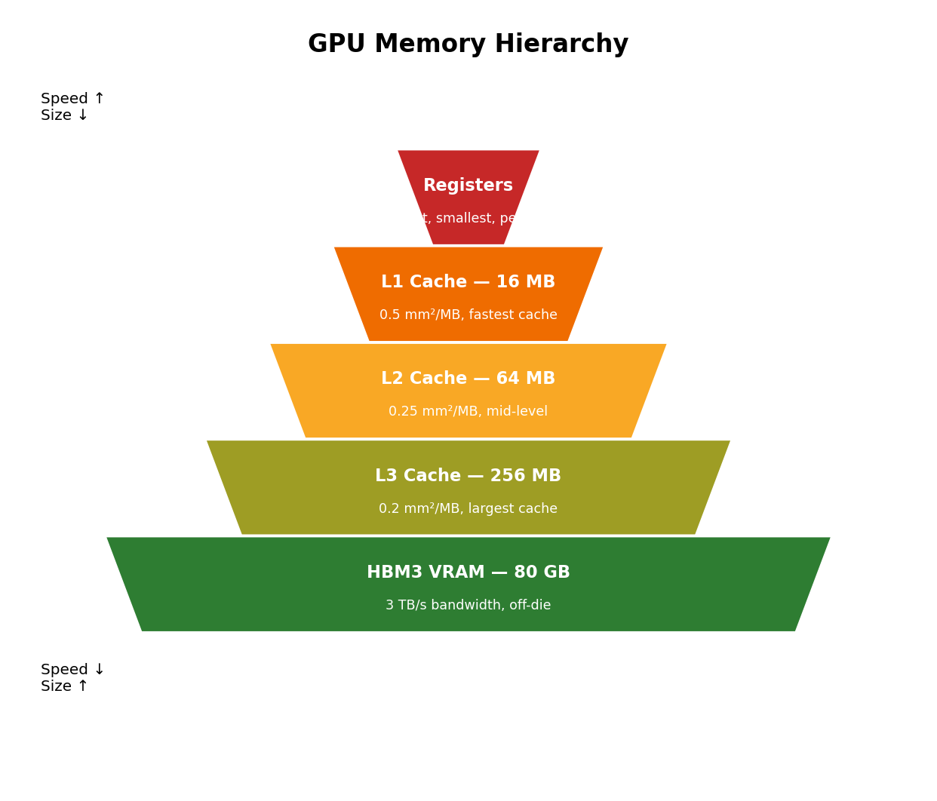
Figure 2: Memory hierarchy, speed vs. capacity trade-off.

3.3 Compute Units (CUs)
GPUs are divided into multiple compute units, each containing several shader cores or ALUs that work together to process large amounts of data concurrently, which is the key parallelism feature that distinguishes GPUs from CPUs. In NVIDIA GPUs these compute units are called Streaming Multiprocessors (SMs), each with its own registers, L1 cache, and shared memory.

3.4 Memory Controllers
Memory controllers manage access to VRAM and other memory structures, handling reads and writes while optimizing for speed and efficiency.

3.5 Interconnects and Buses
- PCIe Bus: Connects the GPU to the CPU and system memory, at slower speeds than internal GPU memory.
- NVLink (NVIDIA): A high-speed interconnect used in multi-GPU NVIDIA systems, allowing GPUs to share memory and workloads.

3.6 Graphics Pipeline
- Vertex Processing: Transforms 3D vertices into 2D space, applying transformations, lighting, and perspective corrections.
- Rasterization: Converts vertices into pixel fragments, determining which pixels need to be drawn.
- Fragment Shading: Computes colour, texture, and other attributes of each pixel fragment.
- Output Merging: Combines pixel fragments into the final rendered image, stored in the framebuffer.

3.7 Shader Units
- Vertex Shaders: Transform 3D coordinates into 2D screen space and compute lighting effects.
- Pixel/Fragment Shaders: Handle per-pixel operations such as texturing, shading, and blending.
- Geometry Shaders: Take entire shapes as input and can create new shapes, enabling complex rendering tasks.

3.8 Specialized Hardware
- Ray-Tracing Cores (RT Cores): Present in modern GPUs (e.g., NVIDIA RTX series), dedicated to real-time ray tracing for realistic lighting and shadows.
- Tensor Cores: Designed for AI workloads, accelerating the matrix multiplications critical to deep learning.

3.9 Control and Scheduling
Dedicated scheduling units manage the large number of threads running on the cores, allocating resources and keeping GPU cores busy by distributing tasks efficiently.

3.10 Thermal and Power Management
- Dynamic Voltage and Frequency Scaling (DVFS): Dynamically adjusts clock speed and voltage to balance performance and power consumption.
- Power States (P-states): The GPU operates in different power states depending on workload, reducing energy use during lighter tasks.
- Thermal Sensors: Monitor component temperature; the GPU adjusts fan speed and power draw to maintain safe operating temperatures.

4. Assembly of GPU Components
The physical layout below reflects how the major components are arranged on the printed circuit board (PCB).
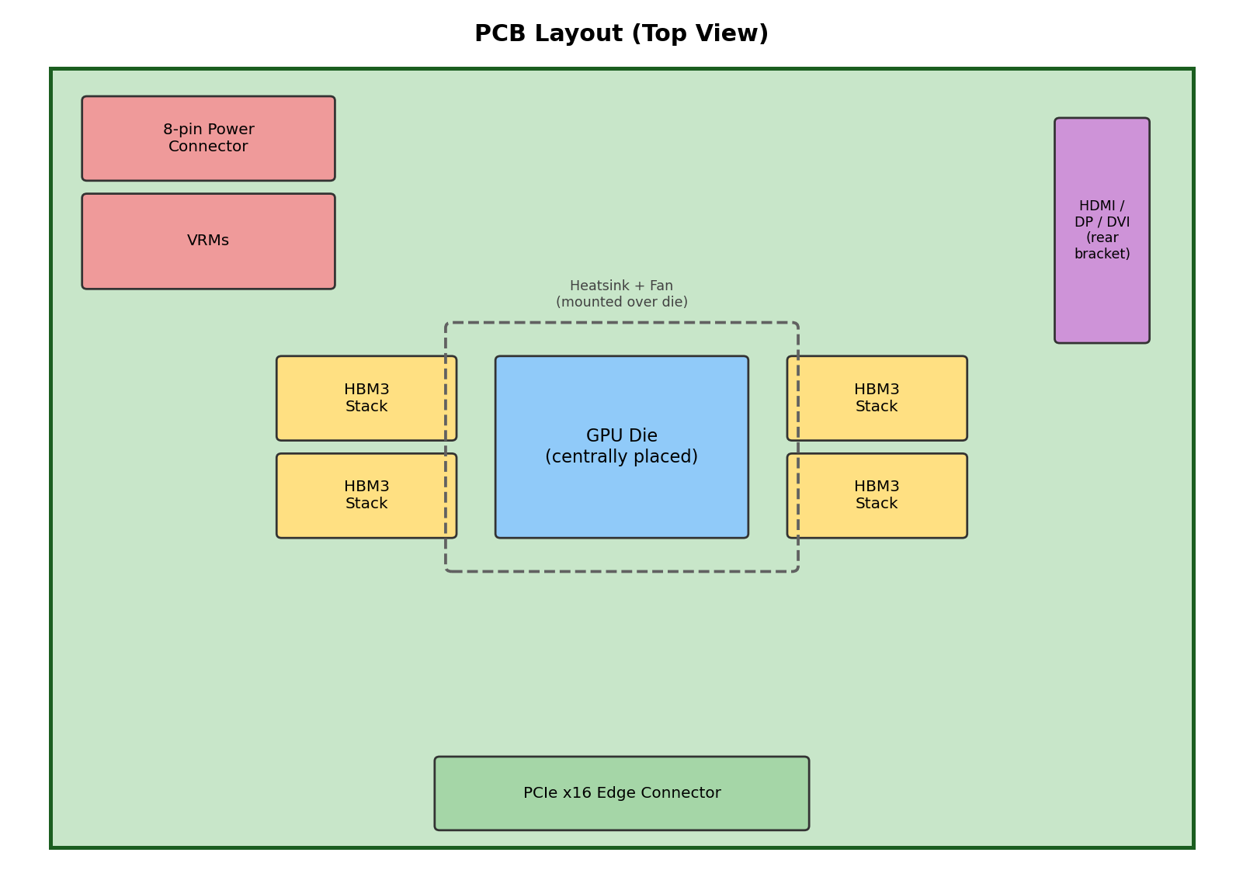
Figure 3: PCB component layout.
Component | Function | Typical Location
Printed Circuit Board (PCB) | Foundation that mechanically supports and electrically connects all components | Base layer
GPU Die | Contains ALUs/shader cores, RT cores, and tensor cores — the computational brain | Centrally placed
Memory Interface & Controller | Manages data transfer between GPU die and VRAM chips | Integrated within die
VRAM | Stores textures, frame buffers, vertex data, and other graphical assets | Surrounding the die
VRMs & Power Connectors | Regulate and supply power to die and components | Near PCB edge
Cooling System | Heatsink, heat pipes, fans, and thermal paste/pads to manage temperature | Directly on die
Display Outputs | HDMI, DisplayPort, DVI ports for monitor connections | Rear bracket
PCIe Interface | Connector interfacing with the motherboard's PCIe slot | Bottom edge of PCB
Drivers & Firmware | Software (not physical) essential for GPU operation | Onboard/system storage

5. Design of GPU

5.1 Initial Design: Memory Hierarchy
Memory Level | Size | Area Density | Total Area | Notes
L1 Cache | 2 MB | 0.5 mm²/MB | 1 mm² | SRAM (6T cells) — fast access for frequently used data
L2 Cache | 4 MB | 0.25 mm²/MB | 1 mm² | SRAM — mid-level cache balancing speed and size
L3 Cache | 16 MB | 0.2 mm²/MB | 3.2 mm² | SRAM — largest on-die cache
DRAM (VRAM) | 512 MB | 0.05 mm²/MB | 25.6 mm² | 1T-1C DRAM cells

Initial Total Area Estimation
Component | Area
ALUs | 100 mm²
SRAM Cache (L1+L2+L3) | 5.2 mm²
DRAM | 25.6 mm²
Registers & Clock Distribution | 10 mm²
Total Estimated Area | 140.8 mm²

5.2 Challenges: Comparison with a High-Capacity GPU (NVIDIA H100, Reference)
The H100 figures below are used purely as an external reference point to benchmark the scale of our conceptual design, rather than as a claim of equivalence.
Aspect | Our Initial Design | NVIDIA H100 (Reference)
Computational Throughput | Our initial design offers modest parallelism at small scale | Far higher raw throughput at data-centre scale
Memory Capacity | 512 MB on-die DRAM | Up to 80 GB HBM3, ~3.35 TB/s bandwidth
Power Draw | Lower, but also lower absolute performance | 700 W TDP class
Rendering Capacity | Fewer TMUs/ROPs, lower pixel fill rate | Full modern rendering pipeline
Architecture | Good general-purpose starting point | Includes dedicated RT & Tensor cores at scale

5.3 Improvements Identified
- Enhancing Computational Capacity: increase ALU count.
- Improving Memory Architecture: expand on-die cache and integrate high-bandwidth off-die memory.
- Clock Speed and Parallelism: raise clock speed with adequate cooling and power delivery to avoid thermal throttling.
- Introduce Specialized Cores: add Tensor Cores for AI/deep-learning matrix operations.
- Thermal Management: use adaptive power gating for idle units plus real-time thermal sensing.

5.4 Optimized Design
Building on the improvements above, the optimized design scales up computational and memory resources as follows:
Memory Level | Capacity | Notes
L1 Cache | 16 MB | 0.5 mm²/MB
L2 Cache | 64 MB | 0.25 mm²/MB
L3 Cache | 256 MB | 0.2 mm²/MB
HBM3 VRAM | 80 GB @ 3 TB/s | off-die, high-bandwidth workloads (AI training, 8K rendering)

Optimized Area & Power Estimate
Component | Area
ALUs (100,000 units) | ~100 mm²
SRAM Cache (L1+L2+L3) | ~67.2 mm²
HBM3 VRAM interface | ~80 mm²
Registers & Clock Distribution | ~15 mm²
Total Estimated Die Area | ~262.2 mm²

5.5 Performance Estimation (Worked Example)
To make the throughput figure traceable rather than asserted, we estimate performance using the standard peak-FLOPS formula:
Peak FLOPS = ALU count × Clock speed × FLOPs per cycle (FMA = 2)
With 100,000 ALUs at an assumed 1.2 GHz clock, theoretical peak throughput is approximately 240 TFLOPS. In practice, sustained throughput is far lower because ALUs stall waiting on memory: with a 512 MB / on-die-DRAM initial design, memory bandwidth, rather than compute capacity, is the bottleneck. Assuming realistic utilization under memory-bound conditions, sustained performance for the initial design is estimated at roughly 15 TFLOPS.
This gap is the main justification for the optimized design's move to HBM3 (3 TB/s): higher bandwidth raises achievable utilization and closes the distance between theoretical peak and sustained real-world throughput.

Power Consumption
TDP is estimated at approximately 350 to 450 W. This is scaled down from the initial (unscaled) 500 to 700 W estimate to stay internally consistent with an ALU count and memory bandwidth that remain below H100-class hardware, a lower TDP is the more defensible figure for a design of this scale.

Power Efficiency and Thermal Management
- Low-Power Transistors: Use of multi-threshold CMOS (MTCMOS) to reduce static power consumption.
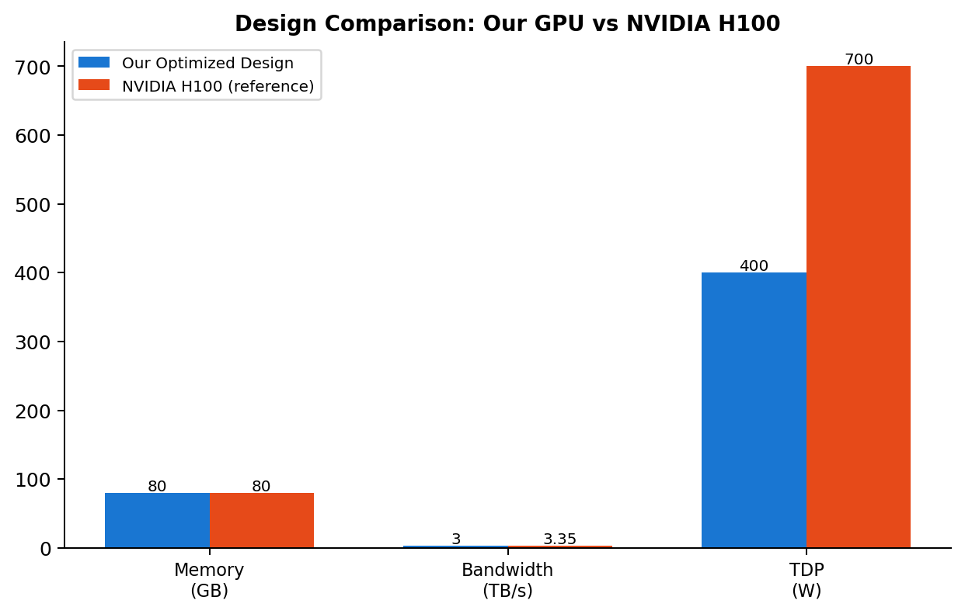
Figure 4: Optimized design vs. NVIDIA H100 (reference) across key metrics.

6. Specifications of Thermal Management System

6.1 Cooling Fans
Parameter | Specification
Diameter | 40–120 mm (80 mm typical balance; 120 mm for higher airflow)
Thickness | 25 mm standard for axial fans
Airflow (CFM) | 30–100 CFM; 30–50 for smaller GPUs, 70–100 for high-performance/overclocked designs
Bearing Type | Sleeve, ball, or fluid-dynamic — affects noise and longevity
Control | PWM-controlled, adjusting speed dynamically with GPU temperature

6.2 Thermal Pads
Parameter | Specification
Common Sizes | 120 mm × 120 mm (broad coverage); 12 mm × 12 mm (memory chips/VRMs); custom-cut for precise fit
Thickness | 0.5–3 mm, matched to the gap being filled
Thermal Conductivity | Minimum 5 W/mK; higher-performance pads offer 10–14.8 W/mK
Material | Often graphite or metal-oxide blends for enhanced conductivity
Matching pad thickness to the original specification is critical: too thin and the pad won't fill the gap; too thick and it may not compress enough, both leading to inefficient heat transfer.

6.3 Heatsinks
Parameter | Specification
Height | 20–50 mm (20–30 mm for compact GPUs; 40–50 mm for high-performance designs)
Width/Length | 40–100 mm typical; over 100 mm in enthusiast-grade cards
Thickness | 10–20 mm (thinner for slim/low-profile GPUs, thicker for higher thermal loads)
Material | Aluminium (lightweight, good conductivity), often combined with copper for high-performance designs
Mounting | Screws or clips directly onto the GPU, with thermal paste/pads for contact
Design Innovations | Heat pipes / vapour chambers for even heat spread; anodizing for corrosion resistance

7. Manufacturing of GPU

7.1 Overview of GPU Architecture in Manufacturing Context
- Core Processing Units: thousands of cores enabling parallel computation for gaming, video rendering, and machine learning.
- Memory Subsystem: high-bandwidth memory (e.g., GDDR6/HBM3) crucial for fast data access.
- Interconnect Network: connects cores, memory, and other components for efficient data flow.

7.2 Voltage Regulator Selection
- High efficiency minimizes energy loss, lowering power consumption and heat generation.
- Stability ensures consistent power delivery, preventing fluctuations that could affect performance or damage the chip.
- Low thermal dissipation is critical for maintaining optimal operating temperature and extending GPU lifespan.

7.3 Voltage Regulator Modules (VRMs)
A VRM is a critical part of the GPU's power delivery system, converting the 12 V supply-rail output to a lower voltage (typically 1.1 V to 3.3 V) required by the GPU's internal circuitry. It is implemented as a buck converter, a switching regulator that steps down voltage efficiently. While the topology is conceptually simple, careful component selection is required to ensure stable, efficient power delivery capable of handling currents reaching hundreds of amps while maintaining tight output regulation.

7.4 Importance of Efficient Power Management
- Reduced Energy Consumption: Minimizes energy waste, lowering operating costs and environmental footprint.
- Enhanced Performance: Dynamic power management adjusts delivery to workload demand.
- Increased Longevity: Reducing heat and component stress prolongs GPU lifespan.

7.5 Manufacturing Processes and Techniques
- Wafer Fabrication: Silicon wafers manufactured with precise tolerances through lithography, etching, and deposition.
- Die Packaging: Individual GPU dies packaged in specialized carriers with heat spreaders and thermal interface materials.
- Assembly and Testing: Dies mounted on circuit boards, interconnected, and tested for functionality and reliability.

7.6 Quality Assurance and Testing
- Functionality Tests: Verify core functionality, proper operation, and performance metrics.
- Thermal Stress Tests: Subject GPUs to extreme temperatures to evaluate thermal performance and stability under demanding conditions.

8. Conclusion
A GPU is a specialized electronic circuit designed primarily for image and video processing, but its highly parallel architecture has expanded its use into machine learning, scientific computing, and beyond. Modern GPUs combine core processing units, a layered memory hierarchy, compute units, memory controllers, and interconnects to handle large-scale parallel workloads, representing the key distinction from traditional CPUs.
Working through our own conceptual design, spanning from an initial 140.8 mm² estimate to an optimized ~262.2 mm² design with HBM3 integration, clarified how compute capability, memory bandwidth, power draw, and thermal management are tightly coupled trade-offs rather than independent choices. The gap between our design's theoretical peak throughput (~240 TFLOPS) and its realistic sustained throughput (~15 TFLOPS) was the most instructive finding: it demonstrated concretely why memory bandwidth, not raw ALU count, is usually the binding constraint in real GPU performance.
Designing and manufacturing a GPU involves intricate processes, from architectural design to power management and thermal solutions, culminating in wafer fabrication, die packaging, and rigorous testing. In summary, GPUs have evolved into versatile computational engines, and building even a simplified model of one requires a working understanding of both hardware architecture and power/thermal engineering trade-offs.

PART II
DC Motor Monitoring & Control System

1. Introduction
DC motors used in industrial and prototyping settings commonly fail silently; bearing wear, shaft imbalance, and thermal stress typically go undetected until a breakdown occurs. Manual periodic inspection does not scale and cannot catch developing faults between checks.
This project set out to build a self-protecting DC motor controller around an Arduino UNO that would continuously monitor an RS775 DC motor's speed (RPM), temperature, and vibration while displaying live status on an LCD and logging every reading to a PC for later analysis.

1.1 Project Status
Due to time constraints, this project was not completed end-to-end. The full hardware circuit, comprising power delivery, motor driver wiring, and all three sensor circuits (Hall-effect RPM, DS18B20 temperature, and ADXL345 vibration) along with the LCD, was fully assembled and wired as designed. The Arduino firmware and the PC-side Python logger, however, were left incomplete: core sensor-reading routines were started, but RPM smoothing, fault-protection logic, LCD display cycling, and the full serial communication and CSV logging pipeline were not finished or tested end-to-end.
The remainder of this report is written in two registers: Sections 2 and 3 describe the system as designed (the intended architecture and methodology), while Section 4 (Results) reports honestly on what was actually completed versus what remains outstanding.

1.2 Objectives
- Drive an RS775 DC motor with controllable speed and direction via PWM.
- Continuously measure RPM, temperature, and 3-axis vibration in real time.
- Display live status on a 16×2 LCD without requiring a connected PC.
- Log every reading to a timestamped CSV file with derived metrics (duty cycle %, estimated wattage, alert flags).
- Automatically stop the motor if temperature or vibration exceeds safe limits, and safely resume after a fault-hold period.
In one sentence: a self-protecting motor controller intended to monitor RPM, temperature, and vibration in real time, display it on an LCD, and log everything to a PC. The circuit is fully built, but the software layer still in progress at the time of this report.

2. Literature Review

2.1 DC Motor Speed Control
Brushed DC motor speed is conventionally controlled via Pulse Width Modulation (PWM) delivered through an H-bridge driver stage. Dual-BTS7960 half-bridge modules are widely used in hobbyist and light-industrial applications for their high current rating and built-in current-sensing/thermal-protection features. Soft-start and ramp techniques, which gradually increase the duty cycle rather than stepping directly to full speed, reduce inrush current and mechanical shock on the motor shaft and coupling.

2.2 Condition-Based Monitoring in Rotating Machinery
Speed, temperature, and vibration are the standard "vital signs" used in condition-based maintenance of rotating equipment. Vibration severity standards such as ISO 10816 / ISO 20816 define acceptable vibration velocity ranges for various machine classes, providing an industry reference point for what constitutes a fault condition, even though this project uses simplified fixed thresholds rather than a full standards-compliant classification.

2.3 Shaft Vibration Sensing
Vibration in a rotating shaft system is most commonly captured using MEMS accelerometers, which measure acceleration along three orthogonal axes. The ADXL345 used in this project is a low-cost, digital-output (I2C/SPI) 3-axis accelerometer capable of resolving both dynamic (vibration) and static (tilt/orientation) acceleration.
Vibration signatures carry diagnostic meaning depending on which axis is affected relative to the shaft's axis of rotation:
- Radial vibration (X/Y, perpendicular to the shaft): typically indicates rotor imbalance or bearing wear.
- Axial vibration (Z, along the shaft): typically indicates misalignment or coupling faults.
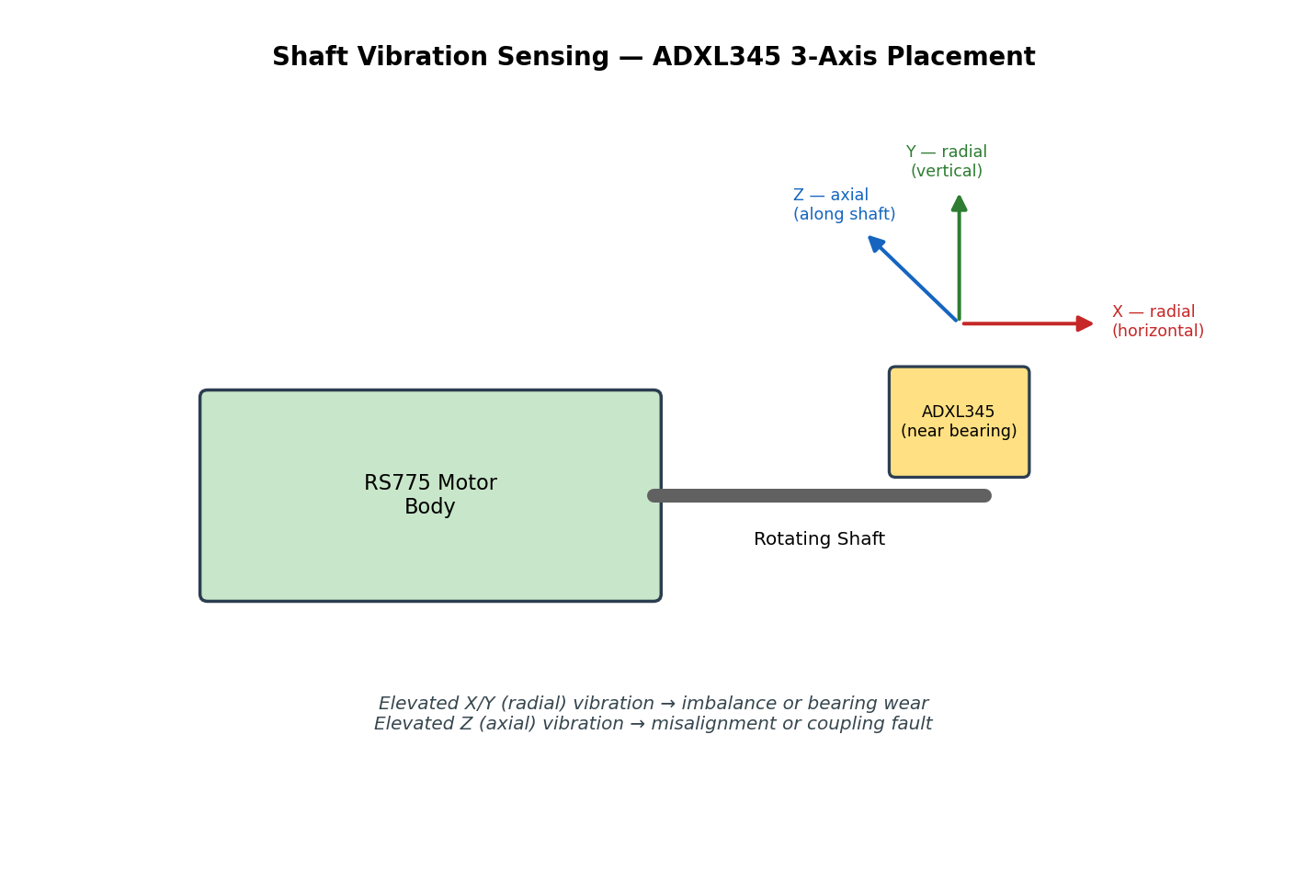
Figure 5: ADXL345 axis orientation relative to the motor shaft, and the fault types each axis is sensitive to.
Two broad analysis approaches exist for vibration data:
- Time-domain analysis: computing RMS or peak acceleration magnitude over a sampling window, which is computationally cheap and well-suited to a microcontroller with limited resources. This is the approach used in this project.
- Frequency-domain analysis (FFT): decomposing the vibration signal into its constituent frequencies, which can pinpoint specific fault types (e.g., bearing defect frequencies) but requires substantially more processing power and memory than an Arduino UNO provides.

2.4 Hall-Effect RPM Sensing
Non-contact speed measurement using a Hall-effect sensor (such as the A3144) and a magnet mounted on the rotating shaft is a standard, low-cost technique. The sensor produces a digital pulse each time the magnet passes, and RPM is derived either by counting pulses over a fixed time window or by measuring the time interval between pulses; a smoothing filter (e.g., moving average) is typically applied to reduce jitter from mechanical or electrical noise.

2.5 Digital Temperature Sensing
The DS18B20 is a widely used digital temperature sensor communicating over the 1-Wire protocol, allowing multiple sensors to share a single data line. Its ability to operate reliably over a long cable run (in this project, 1 metre) makes it well suited to placement close to the motor housing while keeping the controller electronics at a safe distance.

2.6 Serial Data Logging and Local Display
Streaming sensor data from a microcontroller to a host PC over USB serial, combined with local feedback via a character LCD, is a standard pattern in embedded monitoring systems: the LCD provides at-a-glance status without a connected computer, while the PC-side logger enables long-term data retention, post-hoc analysis, and remote command issuance.

2.7 Gap Addressed by This Work
Most hobbyist and educational DC motor controllers implement open-loop speed control only, without integrated health monitoring. This project combines speed control, three independent sensing modalities (RPM, temperature, vibration), local display, PC logging, and automatic fault protection into a single low-cost, Arduino-based platform.

3. Methodology
The system was designed around an Arduino UNO as the central controller, with a Python-based host application for logging and command issuance. The overall architecture is shown below. As noted in Section 1.1, the hardware described in this section was fully built; the firmware logic described alongside it reflects the intended design, and its actual implementation status is summarised in Section 4.
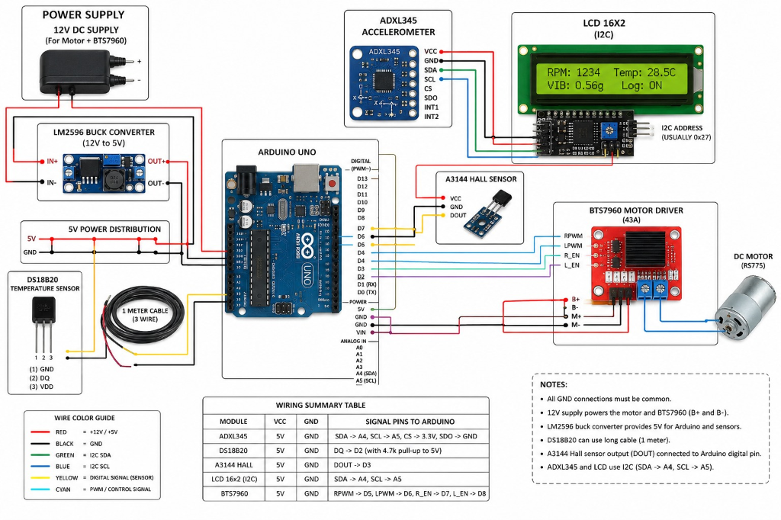
Figure 6: System wiring and schematic diagram.

3.1 Power Delivery Design
- A 12 V DC supply drives the RS775 motor directly through the BTS7960 driver (rated 43 A), providing ample headroom for the motor's operating current.
- An LM2596 buck converter steps the same 12 V rail down to a regulated 5 V supply for the Arduino and all sensors, avoiding the need for a second external supply.

3.2 RPM Measurement Pipeline
- The A3144 Hall-effect sensor detects a magnet mounted on the motor shaft, generating one pulse per revolution.
- The Arduino counts pulses via an interrupt routine and computes RPM from the pulse interval.
- A smoothing filter (moving average) is applied to the raw RPM reading to reduce noise before display and logging.

3.3 Temperature Measurement Pipeline
- The DS18B20 sensor, mounted on a 1-metre cable near the motor housing, is read over the 1-Wire protocol.
- Readings are taken continuously in degrees Celsius and compared against a configurable safe-operating threshold.

3.4 Vibration Measurement Pipeline (Shaft Vibration)
- The ADXL345 accelerometer is mounted near the motor bearing housing and read over I2C, providing raw acceleration values on the X, Y, and Z axes.
- A vibration magnitude metric is computed from the combined X/Y/Z readings each sampling cycle.
- The computed magnitude is compared against a configurable threshold; sustained excursions beyond the threshold are flagged as a vibration fault, distinguishing radial (imbalance/bearing) from axial (misalignment) trends where the dominant axis is identifiable.
This shaft vibration channel is the system's early-warning mechanism for mechanical degradation, representing the same class of fault that, left undetected, leads to the bearing wear and imbalance failures described in Section 2.3.

3.5 LCD Display Logic
The 16×2 LCD cycles through RPM, temperature, vibration level, and logging status, giving an operator a local at-a-glance view of motor health without needing a connected PC.

3.6 Motor Control Logic
- Direction control and PWM-based speed control are implemented through the BTS7960 driver.
- A soft ramp gradually increases duty cycle on start-up and on speed changes, reducing mechanical shock and inrush current, consistent with the soft-start practice described in Section 2.1.

3.7 Fault Protection Logic
If temperature or vibration exceeds its configured safe limit, the Arduino immediately cuts motor drive (auto-stop), holds the fault state for a fixed cool-down period, and then automatically attempts to resume, preventing both immediate damage and unnecessary permanent shutdown for transient events.

3.8 Python Logger and Command Interface
- The Python logger receives the Arduino's serial data stream and writes every reading to a timestamped CSV file, with derived columns for duty cycle (%), estimated wattage, and alert flags.
- A keyboard command interface allows the operator to change speed, reverse direction, and reset faults directly from the PC, sent back to the Arduino over the same serial link.
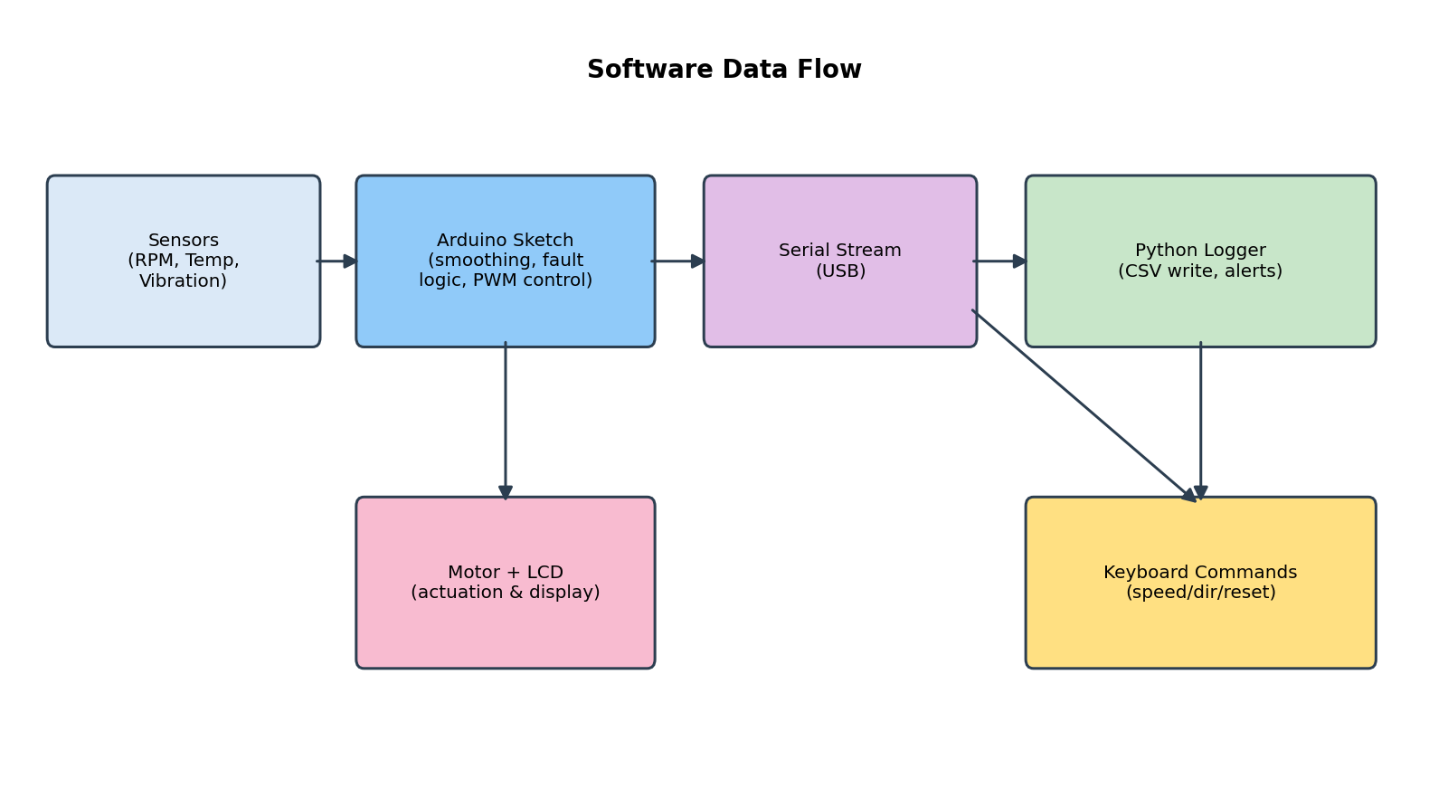
Figure 7: Software data flow between sensors, Arduino, serial link, and the Python logger.

4. Results
This project was not completed within the available project timeline. The results below are reported honestly against what was actually finished, split by hardware and software.

4.1 Hardware: Completed
- The full circuit was assembled and wired: 12 V supply to the BTS7960 motor driver and RS775 motor, and the LM2596 buck converter supplying a regulated 5 V rail to the Arduino and all sensors.
- All three sensor circuits were wired and powered correctly: the A3144 Hall-effect sensor positioned at the shaft magnet, the DS18B20 temperature sensor on its 1-metre cable near the motor housing, and the ADXL345 accelerometer mounted near the bearing housing.
- The 16×2 LCD was wired and confirmed to power on and accept display commands.
- Continuity and power-rail checks confirmed correct voltage levels at the Arduino, sensor supply pins, and motor driver inputs.

4.2 Software: Incomplete
- Basic sensor read routines (raw pulse counting for RPM, raw temperature reads from the DS18B20, and raw X/Y/Z reads from the ADXL345) were started in the Arduino sketch, but were not fully integrated or validated together.
- RPM smoothing/filtering, the vibration magnitude calculation, and the fault-protection logic (auto-stop and cool-down/retry behaviour) described in Sections 3.2 to 3.4 and 3.7 were designed but not implemented in code.
- LCD display cycling through RPM/temperature/vibration/logging status (Section 3.5) and the motor's soft-ramp speed control (Section 3.6) were not implemented.
- The Python logger and keyboard command interface (Section 3.8), including CSV writing, derived columns, and serial command handling, were not started.
As a result, no end-to-end performance data (RPM accuracy, temperature response, vibration fault detection, or logging integrity) is available for this report. The hardware is ready to accept the remaining firmware without any rework.

5. Discussion

5.1 Why the Project Was Not Completed
The primary constraint was time: the hardware design, component sourcing, and full circuit assembly and verification consumed the majority of the available project window, leaving insufficient time to write, integrate, and test the firmware and host-side logging software. Because the circuit was verified electrically sound before time ran out, the remaining work is purely a software task rather than a hardware redesign.

5.2 Limitations
- Incomplete firmware: the Arduino sketch lacks RPM smoothing, vibration magnitude calculation, fault-protection (auto-stop/cool-down/retry), LCD cycling, and soft-ramp motor control (detailed in Section 4.2).
- No host-side software: the Python logger, CSV output, and keyboard command interface were not started, so there is no logging or remote-command capability yet.
- No end-to-end validation: because the software layer is incomplete, none of the sensing or protection behaviour described in the Methodology has been tested under real operating conditions.
- Time-domain-only vibration analysis (as designed): even once completed, the system would detect elevated vibration magnitude but not distinguish specific fault types the way an FFT-based frequency-domain analysis could, see Section 2.3.
- Fixed (not adaptive) fault thresholds are the intended design, and would need to be tuned once the system is operational.

5.3 What Remains vs. What Was Achieved
The achieved outcome of this project is a fully assembled and electrically verified motor control and sensing circuit, ready to run the intended firmware without further hardware changes. The unachieved outcome is the software layer described in Sections 3.2 to 3.8, which would need to be written and tested before any of the monitoring or fault-protection claims in the original objectives (Section 1.2) could be demonstrated.

5.4 Intended Benefit over Manual Monitoring (Aspirational)
Manual periodic inspection can only catch a fault if it happens to be visible or audible at the moment of inspection, and provides no continuous record. Once completed, this system is intended to monitor continuously, hold a full historical CSV record for post-hoc analysis, and react to fault conditions within one sampling cycle rather than at the next scheduled inspection. This remains the design goal rather than a demonstrated result, pending completion of the software described in Section 4.2.

6. Recommendations for Improvements

6.1 Complete the Firmware and Host Logger (Immediate Priority)
The most urgent next step is finishing the Arduino sketch (RPM smoothing, vibration magnitude calculation, fault-protection logic, LCD cycling, soft-ramp control) and the Python logger and command interface described in Sections 3.2 to 3.8, since the hardware is already complete and ready to support it. This should precede any of the enhancements below.

6.2 Frequency-Domain Vibration Analysis
Adding an FFT stage (potentially offloaded to a more capable microcontroller such as an ESP32 or a companion PC-side analysis step) would allow the system to identify specific bearing defect frequencies rather than only flagging elevated overall vibration magnitude, substantially improving diagnostic specificity.

6.3 Closed-Loop PID Speed Control
Using the existing RPM feedback to drive a PID control loop would allow the motor to maintain a target speed under varying load, rather than running open-loop at a fixed duty cycle.

6.4 Wireless Telemetry
Replacing the wired USB serial link with an ESP32-based Wi-Fi/Bluetooth telemetry stage would allow remote monitoring without a tethered PC connection.

6.5 Real-Time Data Visualization
A live plotting dashboard (e.g., a simple web front-end reading the same serial/CSV stream) would make trends in RPM, temperature, and vibration easier to interpret than reviewing raw CSV rows after the fact.

6.6 Multi-Motor / Multi-Channel Scaling
Extending the logger and dashboard to handle multiple motors concurrently would allow the same platform to monitor a small fleet of motors from a single PC.

6.7 Adaptive Fault Thresholds
Replacing fixed temperature/vibration thresholds with statistically learned, motor- and load-specific baselines would reduce both false alarms and missed early-stage faults compared to the current fixed-limit approach.

