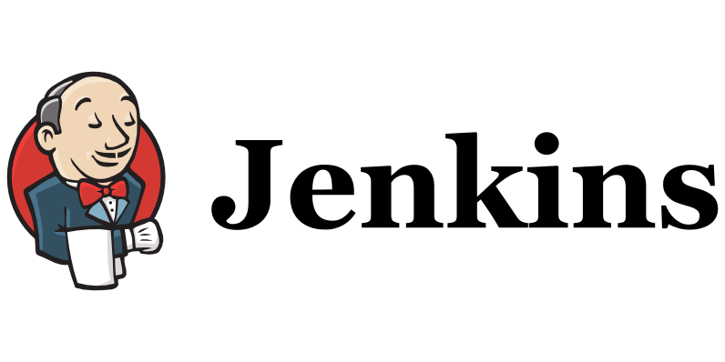

**What is Jenkins?**

* Jenkins is an open-source automation tool that allows continuous integration (CI) and continuous delivery (CD) of projects, regardless of the platform you are working on.
* It is used to build(compile, test) code and deploy it to the production

**What is Continuous Integration?**

* Continuous Integration is a development practice in which the developers are required to commit changes to the source code in a shared repository several times a day or more frequently.
* Every commit made in the repository is then built.
* This process allows to identify errors as early as possible.

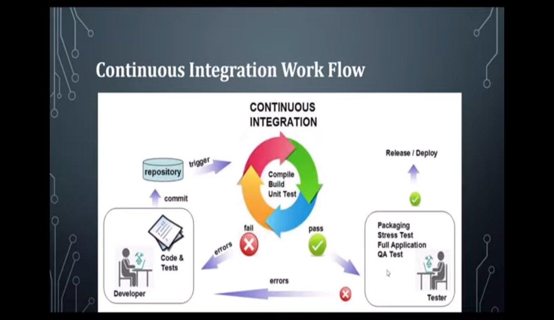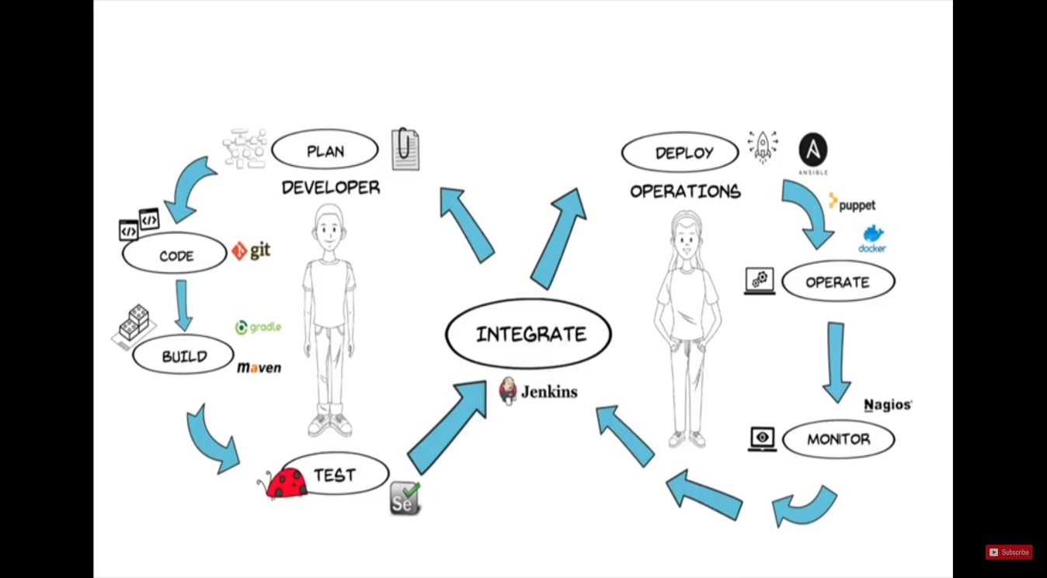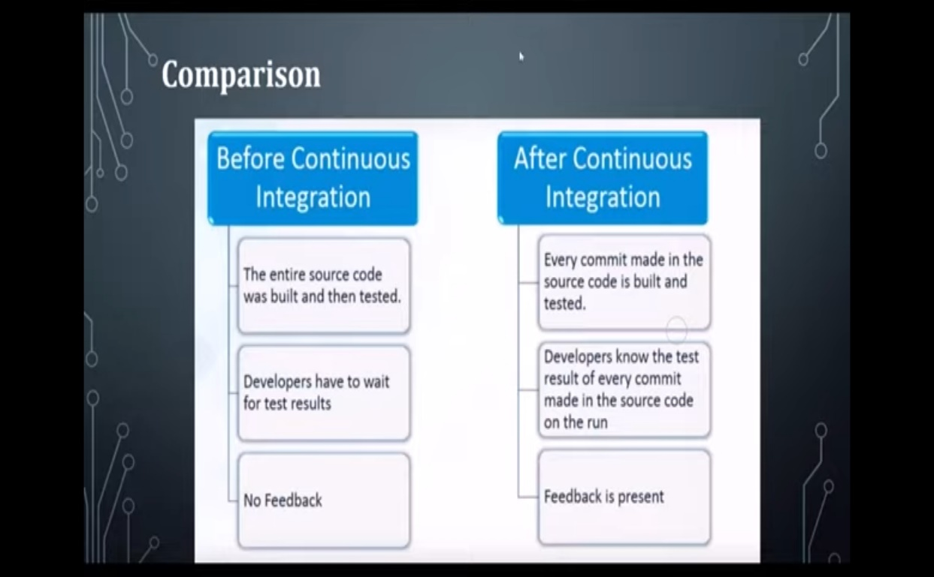

* It provides hundreds of plugin's to support building, deploying and automating any project.
* Jenkins is used to build and test your software projects continuously making it easier for developers to integrate changes to the project, and making it easier for users to obtain a fresh build.
* With Jenkins, organizations can accelerate the software development process by automating it.
* It is a server-based system that runs in servlet containers such as Apache Tomcat. It supports version control tools like SVN, Git to automate build.
* You can set up Jenkins to watch for any code changes in places like GitHub, Bitbucket or GitLab and automatically do a build a with tools like Maven and Gradle.

**Advantages of Jenkins include:**

* It is an open source tool with great community support.
* It is easy to install.
* It has 1000+ plugins to ease your work. If a plugin does not exist, you can code it and share with the community.
* It is free of cost.
* It is built with Java and hence, it is portable to all the major platforms

**Jenkins Pipeline**

* In Jenkins, a pipeline is a collection of events or jobs which are interlinked with one another in a sequence.
* It is a combination of plugins that support the integration and implementation of **continuous delivery pipelines** using Jenkins.
* Each job contains some processing inlet and outlets.
* Build-Deploy-Test-Release

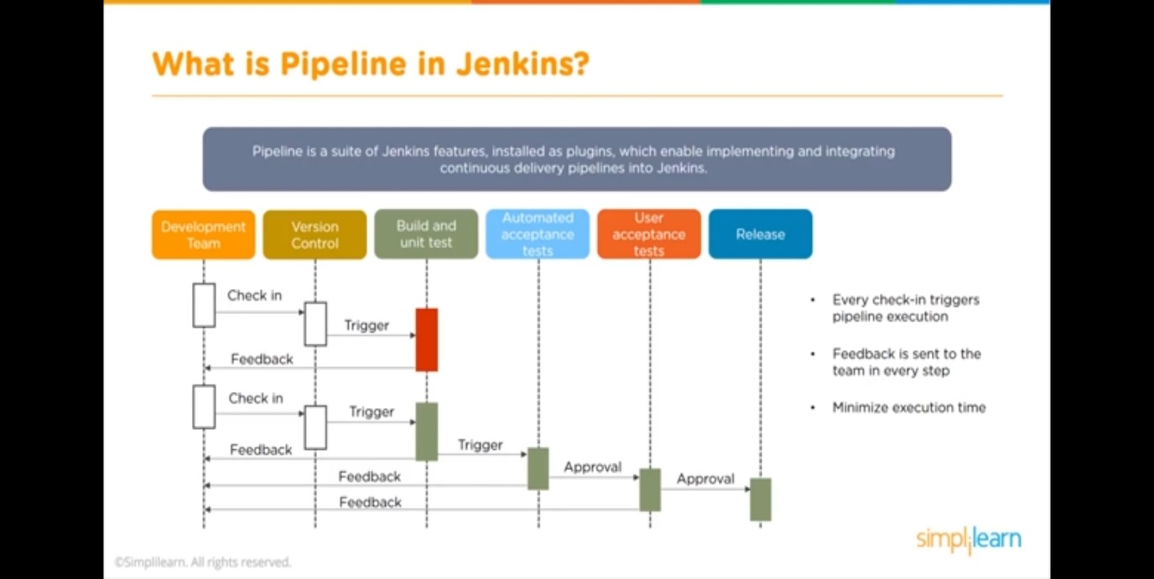

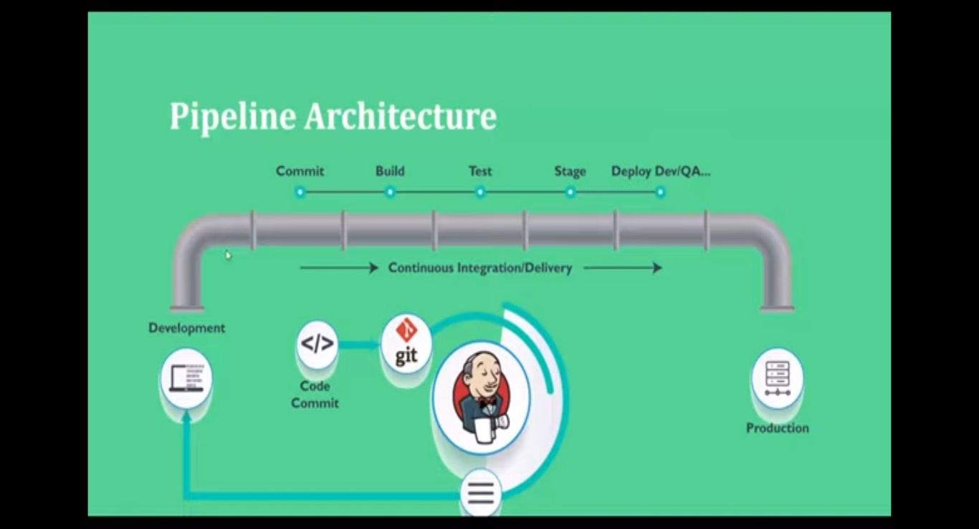

**Types of Pipelines:**

* Build Plugin Pipeline
* Declarative pipeline
* Scripted pipeline
* If your application have less job to execute then go for build plugin pipeline
* If your application have multiple jobs like development, Code review, Unit Test, Coverage Test, Load Test, Integration Test, Packaging, Build etc.. then go for Declarative or Scripted Pipeline
* Incase of Declarative pipelines, we need to write Jenkins files as part of our code and we can commit it to git and we can re-use it.
* Incase of Scripted pipelines, In Jenkins configure section we need to add scripts and those scripts are written in groovy syntax