Pushing code to github:
- if you don’t have a github account , Create a account.Create a repository for storing and managing the folders.
- Create a repository to manage a project or files at any time.

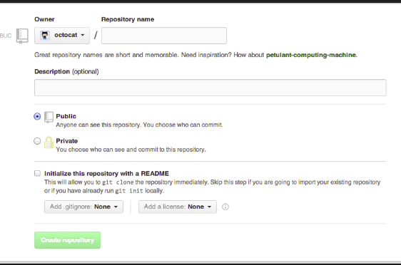
- Create a .gitignore file in your project folder to ignore the specific files and mention which files you want to ignore. In below screenshot we can see the example “*.pyc” it ignores all .pyc files in your project while commit to GitHub .
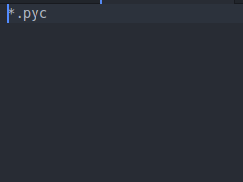

Then follow the following commands to push the projects to repository:
- git init.
- git add “your project name/”.
- Git status.
- git commit -m "first commit".
- git remote add origin “your git repository path”.

- git push -u origin master.

Aws Instance: An EC2 instance is a virtual server in Amazon's Elastic Compute Cloud (EC2) for running applications on the AWS.

How to launch a AWS Instance:

- Click on launch Instance to launch the instance.

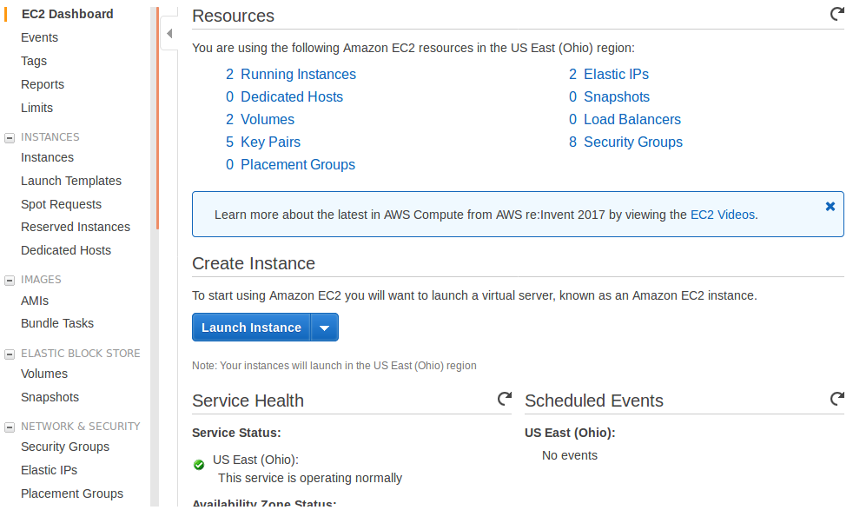

- Select an ubuntu server 16.04 AMI in below screenshot.

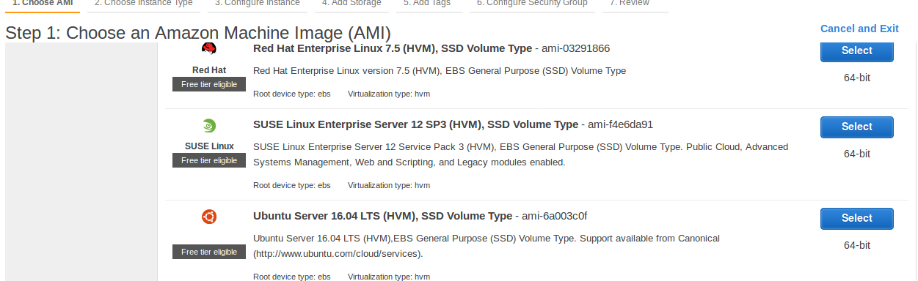

- Select an instance type t2.micro and Click on review and launch .

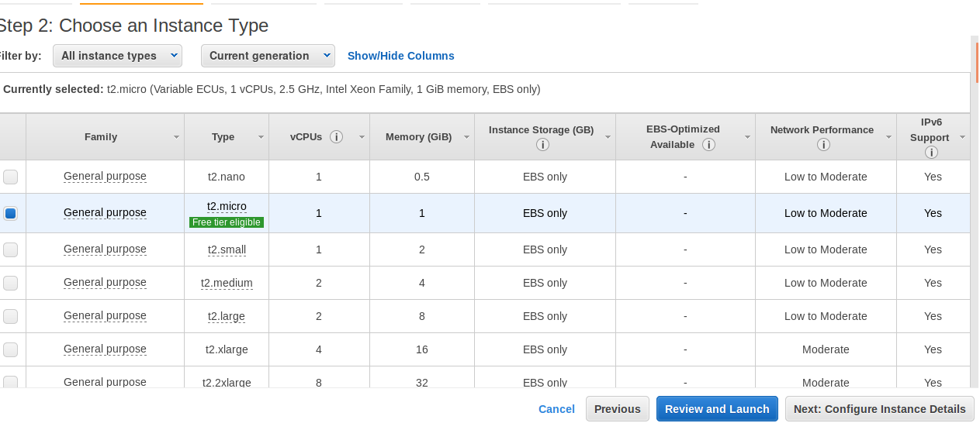

- Click on launch.

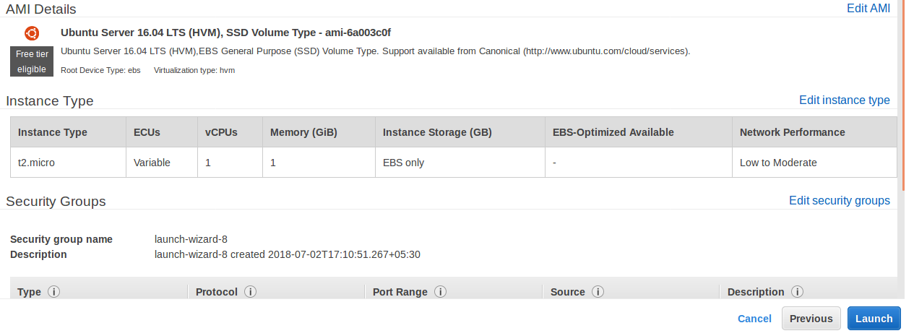

- Select a create new key pair and give a name in key value pair , and click on
download key-value pair and click on launch to launch the instance.

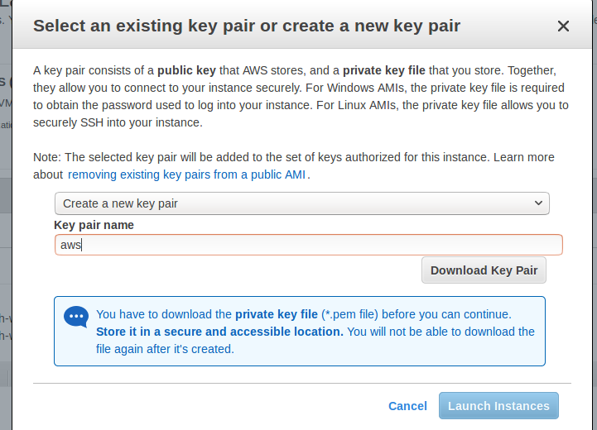

- Click on running instances to see the instance is running or not.

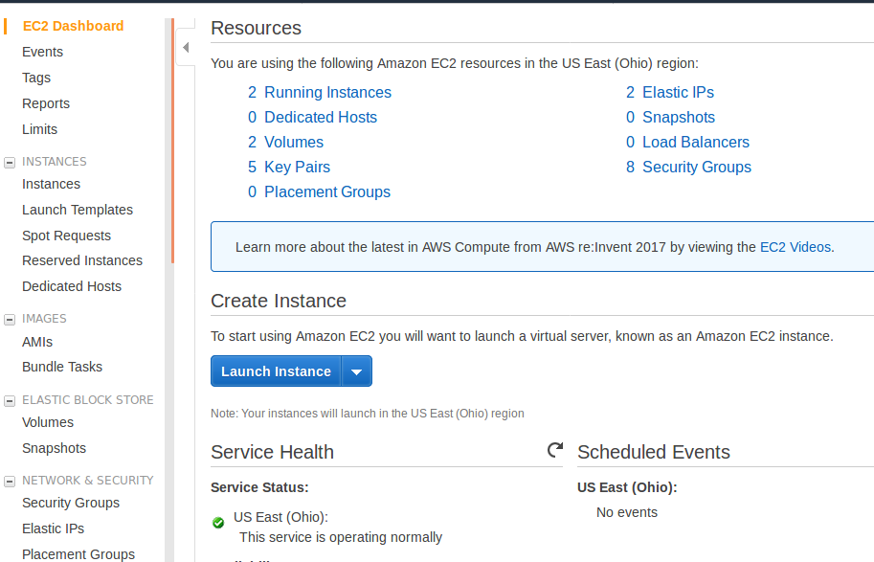

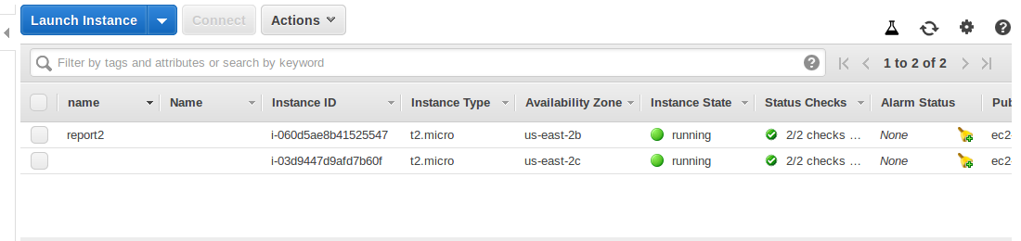

- select a instance and click on Elastic ip in network&security to set the static ip.

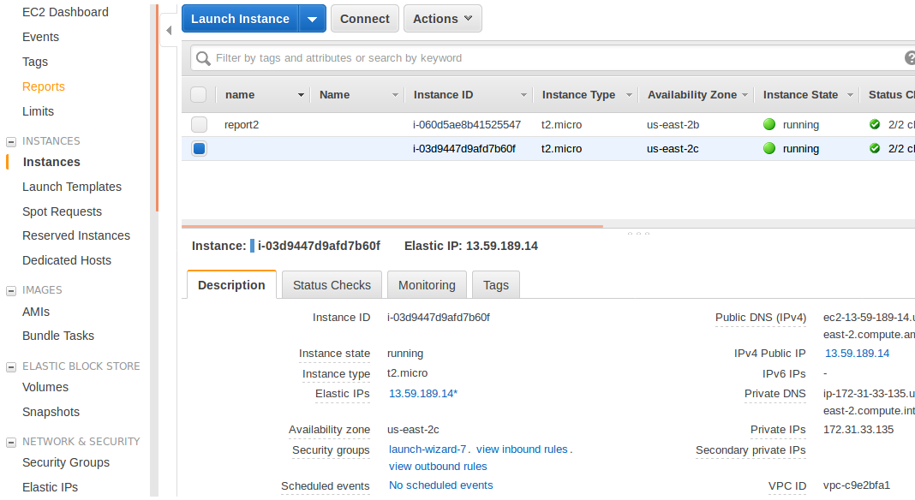

- click on allocate new adress.

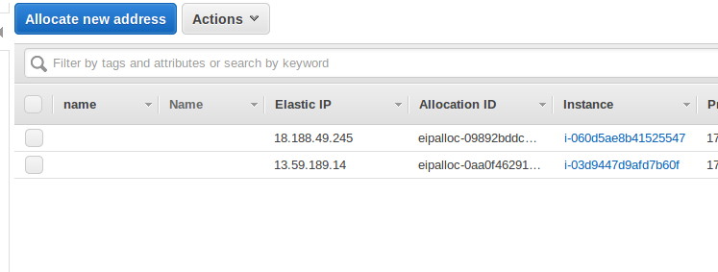

- Click on allocate.

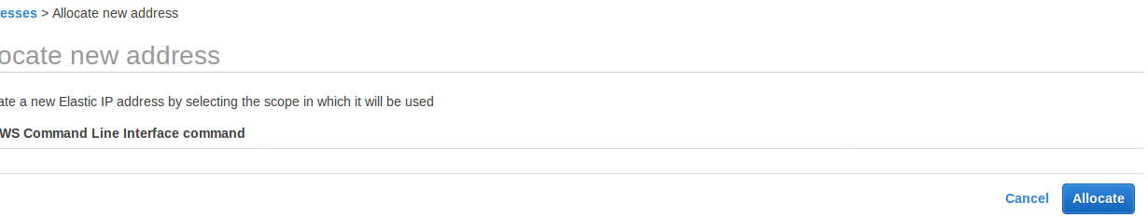
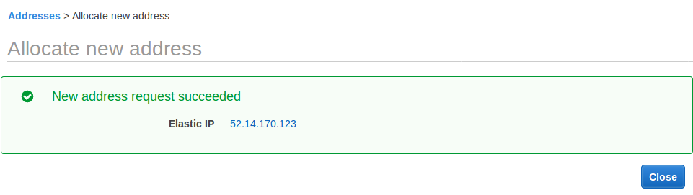
- You can get the new ip adress and click on close.

- Select appropriate ip adress , Click on actions and click on associate adress.

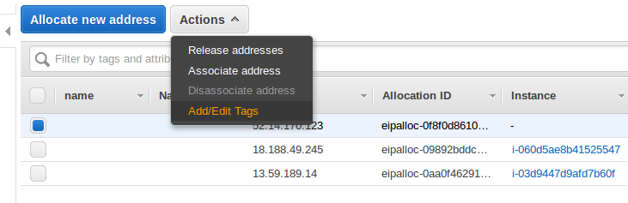

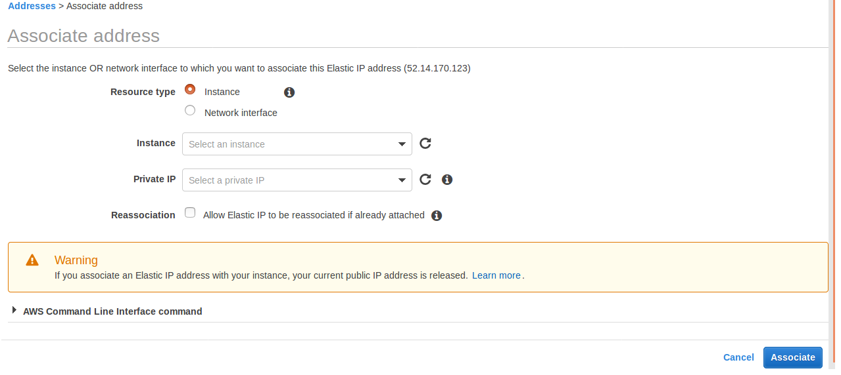
- Select your running instance and select private ip ,Click on associate.

- See whether the ip adress is associated with instance or not.

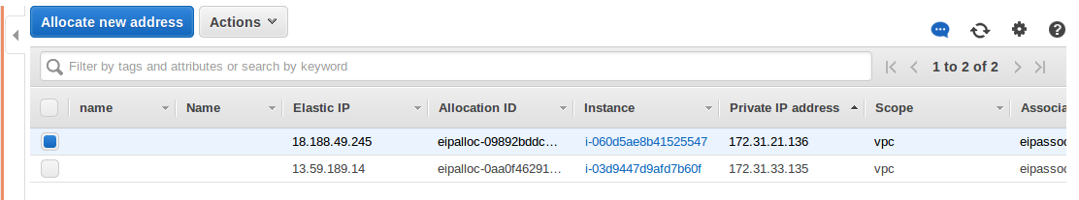

- click on instances.

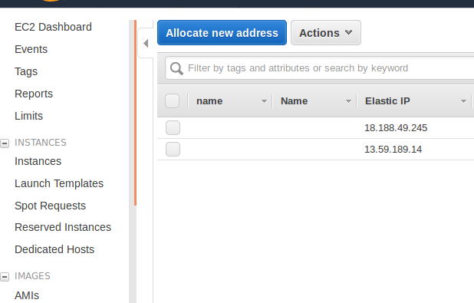

- Select instance and click on security groups.

- select your instance group, Click on actions and click on edit inbound rules.

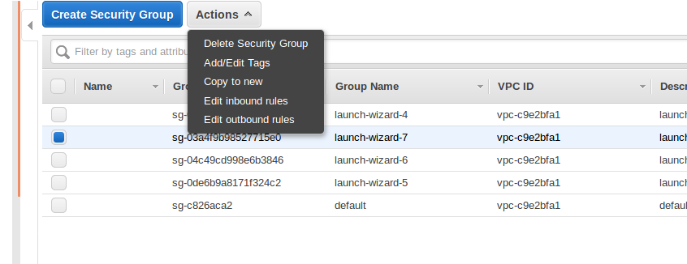

- By default it has 22 port and remaining port ranges and types you have to set like below mentioned in the screen shot and click on save.

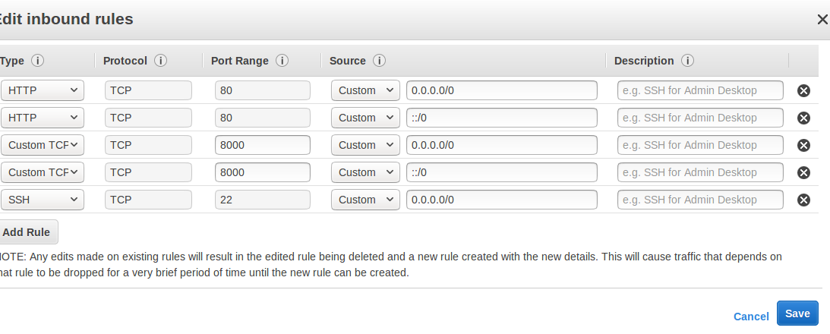
- Click on instances.

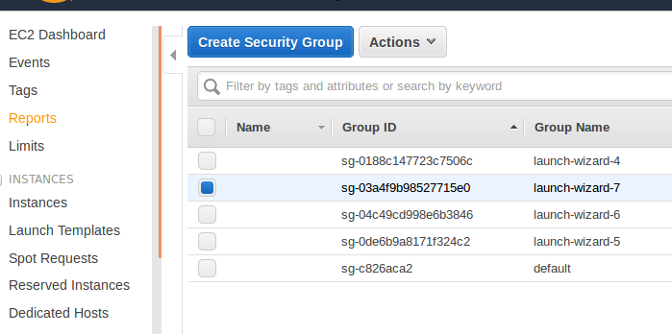

- Select appropriate instance and click on connect.

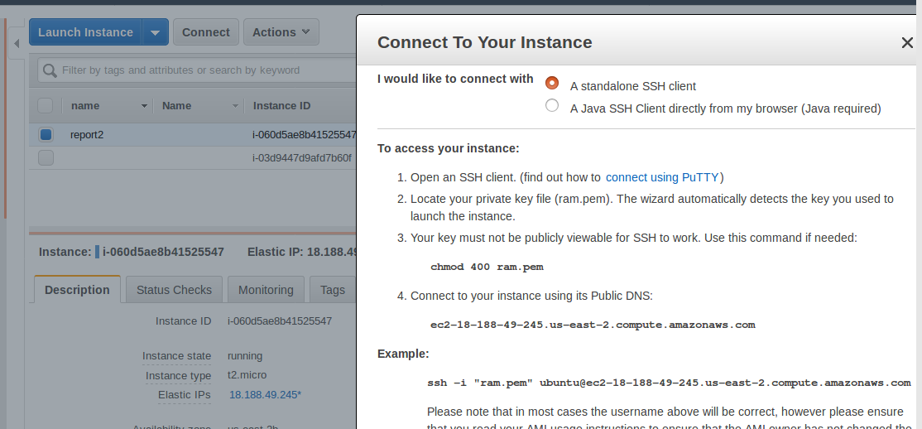

- U can get the dialogue box like this by this .
- you can connect in your instance in your system.

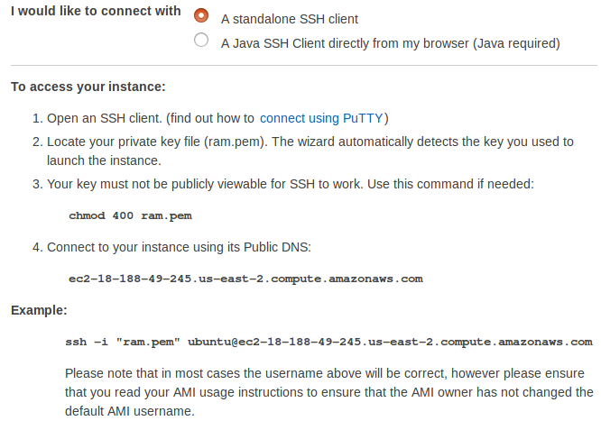

Follow the steps:
- Open terminal and change the directory to where you downloaded the .pem file .

$cd downloads.

- Copy and paste the below “ chmod 400 ram.pem ”in terminal.
- Next copy the line just below the example its like ssh-i command .

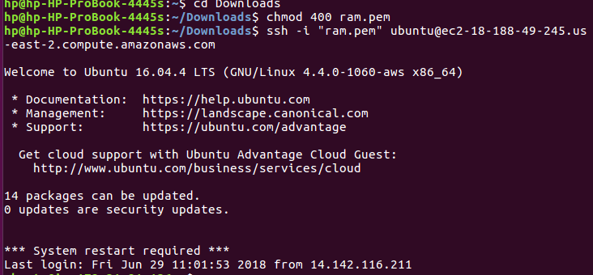
- you can login like this
- you have to install virtual,mysql,pip

git cloning a particular folder:

- $ git clone --depth 1 https://github.com/raghurammanyam/my-projects.git countsquares(project folder which you have to clone)
- $ Cd countsquares (change the directory to which the folder you want)
- $ git filter-branch --prune-empty --countsquares-filter countsquares HEAD

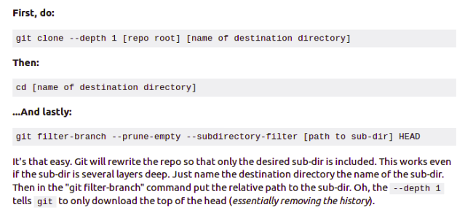

What is Nginx?

Nginx is one of the most popular webserver for its load balancing,reverseproxy and security. It hosts some of the largest traffic sites on the internet.

Installation Steps:

- we have to update local package index , so that we can install recent packages.

$ sudo apt-get update
- install nginx

$ sudo apt-get install nginx

- Adjusting the firewall: To configure our firewall to allow acess to the service.

$ sudo ufw app list
- You should get a listing of the application profiles:
Output:
Available applications:
Nginx Full
Nginx HTTP
Nginx HTTPS
OpenSSH
- As you can see, there are three profiles available for Nginx:
- Nginx Full: This profile opens both port 80 (normal, unencrypted web traffic) and port 443 (TLS/SSL encrypted traffic)
- Nginx HTTP: This profile opens only port 80 (normal, unencrypted web traffic)
- Nginx HTTPS: This profile opens only port 443 (TLS/SSL encrypted traffic)
- You can enable this by typing:
$ sudo ufw allow 'Nginx HTTP'
- you can verify the change by seeing the status
$ sudo ufw status
- you can see the HTTP traffic allowed.
Output:
Status: active

To Action From
-- ------ ----
OpenSSH ALLOW Anywhere
Nginx HTTP ALLOW Anywhere
OpenSSH (v6) ALLOW Anywhere (v6)
Nginx HTTP (v6) ALLOW Anywhere (v6)
- In case status is inactive follow these steps:
$ sudo ufw enable
$ sudo ufw default deny
$ sudo ufw iptables -L
$ sudo ufw status
- Check the Nginx service is active or not.
$ systemctl status nginx
- you can see the status like this:
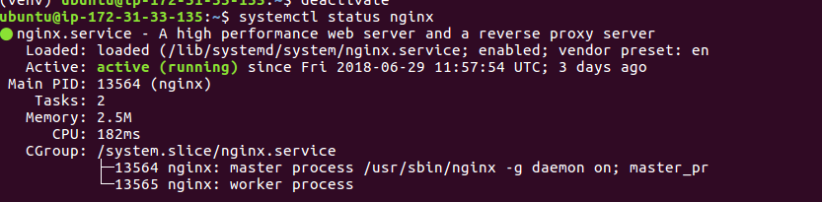

UWSGI: it is an application server which can communicate with applications through interface called wsgi.

UWSGI Installion Steps:

- Install uwsgi by using pip

$ sudo -H pip install uwsgi

- For instance, we can tell it to serve our first project by typing:

$ uwsgi --http :8080 --home /home/sammy/Env/firstsite --chdir /home/sammy/firstsite -w firstsite.wsgi

- create a directory to store configure files.

$ sudo mkdir -p /etc/uwsgi/sites

- create a file for your project and open in a text editor.

$ sudo nano /etc/uwsgi/sites/firstsite.ini

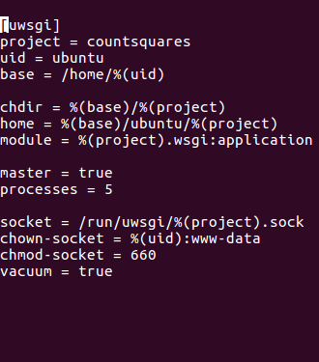

in above screenshot you type mention project = “your projectname” , uid = “your system id”

- Create a systemd file to automate the uwsgi.

$ sudo nano /etc/systemd/system/uwsgi.service
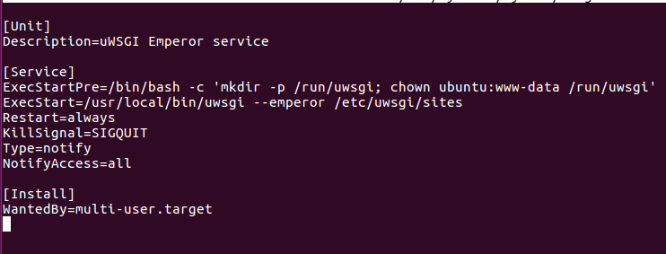

- Create a server block configuartion file where our project can access.

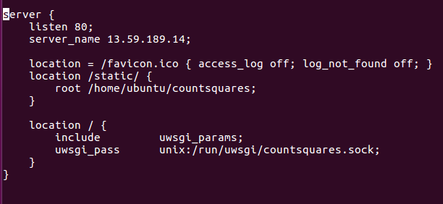

- link your configuration

