Steps to integrate CI & CD using AWS CodeDeploy

Step 1: Create two IAM roles one for instance purpose and another for service purpose.

IAM roles one for Instance Purpose :

Go to IAM roles, click on Create New Role, Enter Role Name as you like ex: “Cdinstancerole” , Click on Next step. In AWS Service Roles select amazon EC2
add or attach the following policy :
1)amazonEC2RoleforAWSCOdeDeploy
2)AutoScalingNotificationAccessrole

Click on Next button, review your information and click on “Create Role”

IAM roles one for Service Purpose :

Go to IAM roles, click on Create New Role, Enter Role Name as you like ex: “Cdservicerole” , Click on Next step. In AWS Service Roles select amazon EC2
add or attach the following policy :
1) AwsCodeDeployRole
Click on Next button, review your information and click on “Create Role”

Click on the service role, go to trust relationship, click on edit trust relationship and replace the following code “ "Service": "ec2.amazonaws.com" ” to “ "Service": "codedeploy.amazonaws.com" ”

Step 2: Attach “instancerole” to Amazon EC2 Instance

While creating a EC2 instance, Under Configure Instance Details, in IAM role select “Cdinstancerole” and create instance.

Step 3: Install CodeDeploy Agent in EC2 Instance
After creating instace, Need to add CodeDeploy Agent in the newly created server. login as root user and crete a codedeploy.sh file and add the below content and run the file ./codedeploy.sh or bash codedeploy.sh

For Linux Instance :
yum -y update
yum install ruby wget -y
yum install httpd
cd /home/ec2-user
wget https://aws-codedeploy-us-east-1.s3.amazonaws.com/latest/install
chmod +x ./install
./install auto

For Ubuntu Instance :

sudo apt-get update
sudo apt-get install apache2
sudo apt-get install python-pip
apt-get install -y ruby2.0
sudo apt-get install wget
cd /home/ubuntu
wget https://aws-codedeploy-us-east-1.s3.amazonaws.com/latest/install
chmod +x ./install
sudo ./install auto

Note: change “us-east-1” as per your avalibility zone

To verify the AWS CodeDeploy agent is running In Amazon Linux or RHEL or Ubuntu
sudo service codedeploy-agent status
or
ps -ef | grep code*

If you see a message like error: No AWS CodeDeploy agent running, start the service and run the following two commands, one at a time:

sudo service codedeploy-agent start
sudo service codedeploy-agent status

Step 4: Creating codedeploy application

Go to codedeploy click on Get Started Now if you are using this services 1st time. Select Custom Deployment and click on Skip Walkthough

Under Create New Application add Applicaiton Name & Deployment Gruop name as your wish
ex: Application Name : CDstageapp
Deployment Group Name: Cdstageappgroup

Under Add Instances > Search by Tags select Amazon EC2 for Tag Type, Name as Key, Your Instance as Value

Under Deployment Configuration select “CodeDeployDefault.OneAtATime”

Under Service Role select “Cdservicerole” which we created in step 1

Under Rollbacks enable Roll back when a deployment fails (Optional)

finally click on “Create Application”

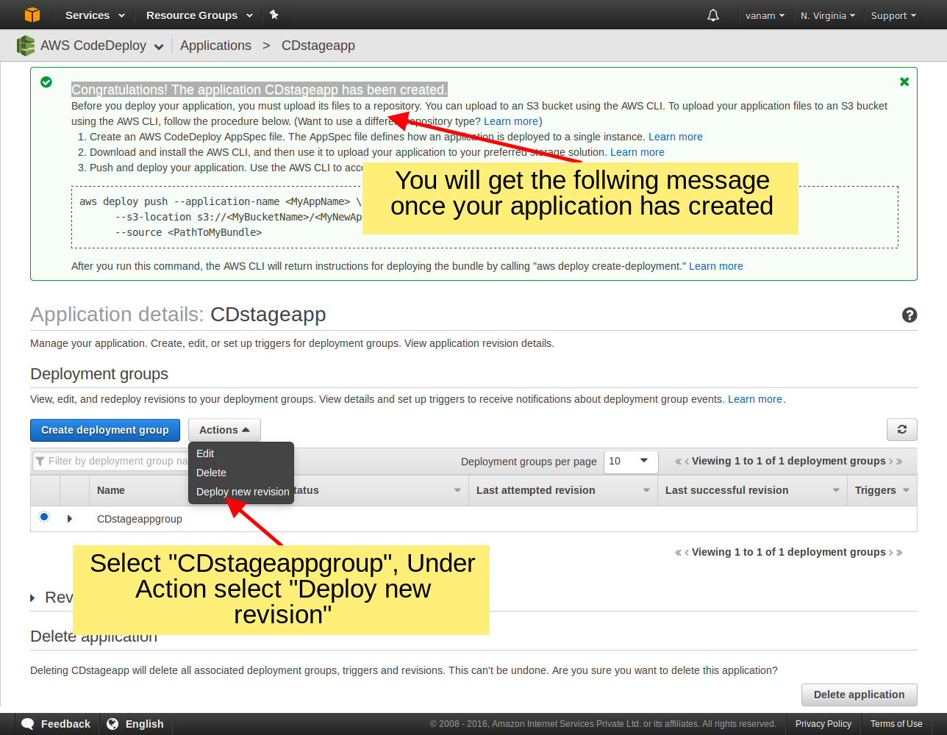

Step 5: Create a new Deployment

Create a new deployment from your existing resources. Select “Cdstageapp” as Application, “Cdstageappgroup” as Deployment Group, Select github as Revision Type and connect with github with your github credentials. Enter the repository name from your github as username/projectname Ex: sandyvanam/AWS_CODE_DEPLOY, latest Commit ID from github, “CodeDeployDefault.OneAtATime” as Deployment Config and click on Deploy Now

You will get Success message if build is successful, Failed messsage if buid is fail, troubleshoot based on the error message.

Step 6 : Triggering Deployment automatically using aws code pipeline

In developers tool go to aws code pipeline service, Click on “ Get Started ”.
Step i : Name
Enter the pipeline name, ex: CD_Pipeline .
Step ii: Source
Select your source provider i.e github or s3 or Aws CodeCommit and click on next. For now select github, connect to github with your credentials, select your Repository and select your branch
Step iii : Build
For php projects select build provider as “ No Build”
Step iV: Beta
choose Deployment Provider as “Aws Code Deploy” as we already configured this step 4. Select appropriate application name and Deployment Group.
Step V : Service Role.
Create a service role as “ AWS-CodePipeline-Service”
Step Vi: Review
Review your pipeline and click on Create Pipeline

Pipeline will trigger the build automatically once the code is pushed to branch you selected in setp ii.

