Apache and Tomcat Integration(Mod_Proxy):-

(Pre-Requisites--> Apache,Tomcat,DB(MySql),Application(petclinic)war file,JAVA,MySql connector jar file.)

STEP 1:- Create a Security Groups for EC2 Instances (Apache and Tomcat-DB).:-

==> First Create a Security Group for Apache (EC2-Instance).

---> Goto AWS Console---> Select Serivces-->Select EC2--> Left Side Panel Select Security

Group--> Selcet Create Security Group-->

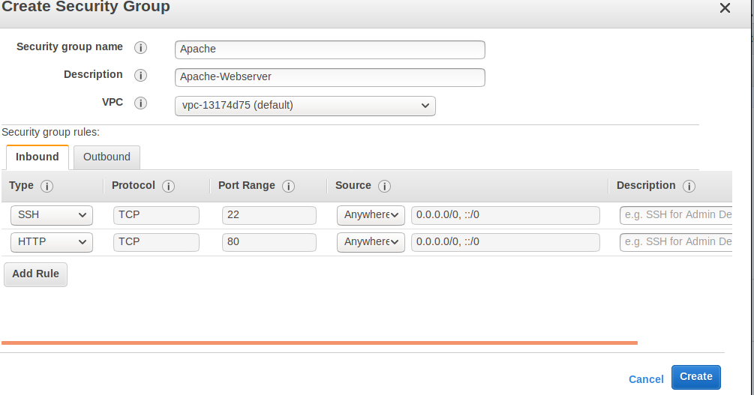
SSH-22-->for connect remote(linux) host

HTTP-80--> for Apache

---> Next Select Create.

==> Create A Secuiry Group for Tomcat-DB (EC2-Instance).

---> Goto AWS Console---> Select Serivces-->Select EC2--> Left Side Panel Select Security

Group--> Selcet Create Security Group-->

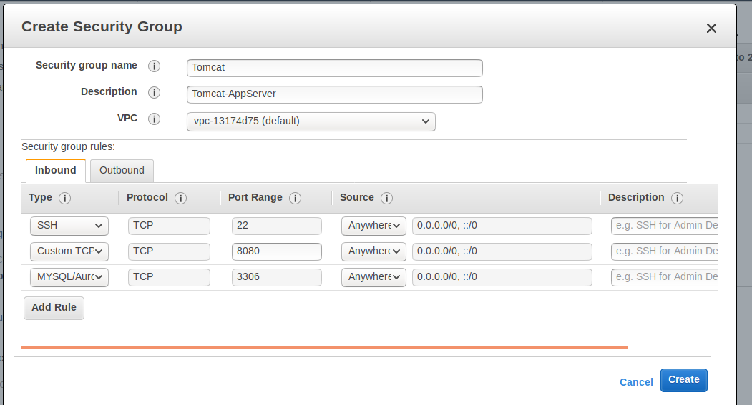

SSH-22-->for connect remote(linux) host

Custom TCP Rule--8080--> for Tomcat

MYSQL/Aurora-->3306--> for MySQL Database.

---> Next Select Create.

----> After created Security Groups.

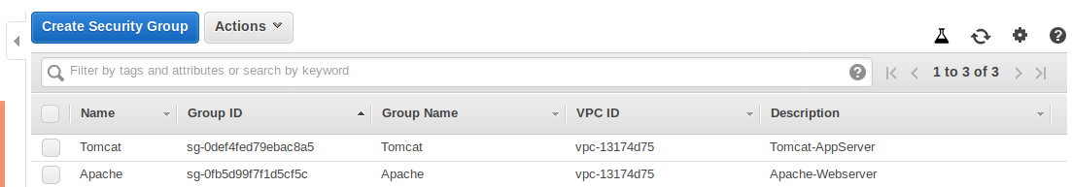

STEP 2:- Create EC2-Instances.

---> Create 2 EC2-Instances--->1 for Apache and 1 for Tomcat and Mysql.

---> Goto AWS Console---> Select Serivces-->Select EC2--> Select Launch Instance-->Choose

Amazon Machine Image (AMI)-->

---> After created instances like below,

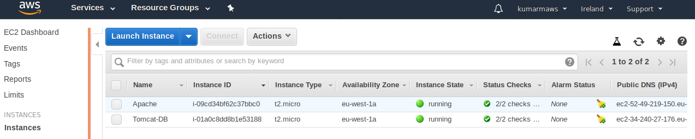

STEP 3:- Connect EC2 Instances

==> Connect EC2-Instance(Apache)-->

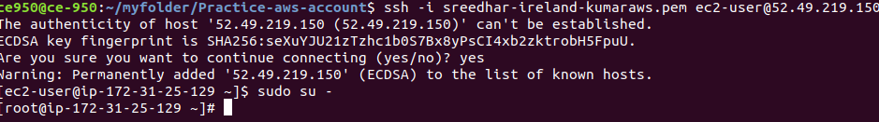
---> Install Apache (the below command)

yum install httpd -y

--->Install Apache bootup level (the below command)

systemctl enable httpd

---> Start Apache (the below command)

systemctl start httpd

---> To check Apache Status (the below command)

systemctl status httpd

---> To check apche is running or not outside.

IP:80

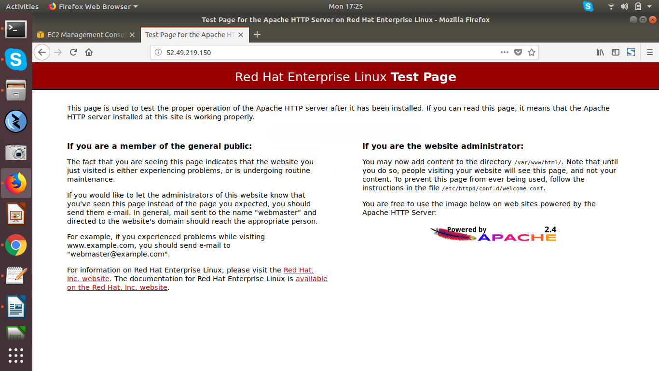

==>Connect EC2-Instance(Tomcat-DB)

--->(Pre-Requisites JAVA,Tomcat, DB(MySQL),Application(Petclinic),MySql-Connectors-Jar file)

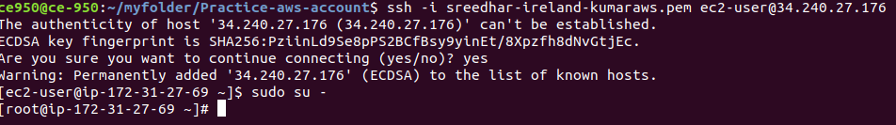
---> Downlaod JAVA.

--->Goto Google Crome--> Oracle java download--->

http://www.oracle.com/technetwork/java/javase/downloads/jdk8-downloads-2133151.html

--->Before dowloading JAVA -->Select Accept License Agreement.

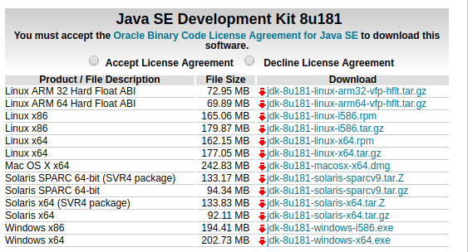

--->Download RPM package for linux to EC2-Instance.

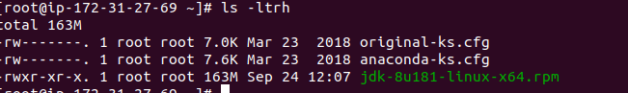
--->After Downloading JAVA linux RPM Package, Run below command to install JAVA.

rpm -ivh jdk-8u181-linux-x64.rpm

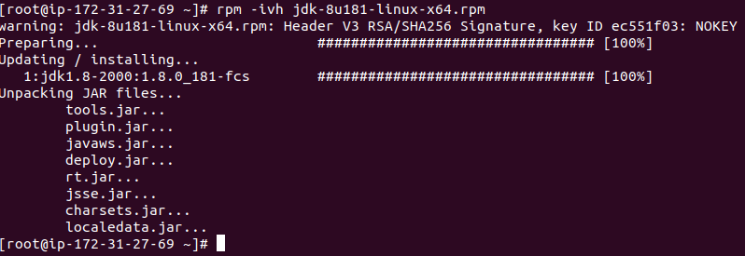
--->To check JAVA which Version Installed run below commad.

java -version

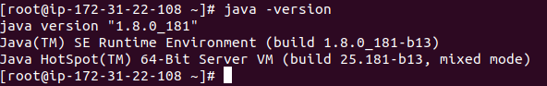

---> Download Tomcat.

--->Goto Browser---> Search Downlaod Tomcat -->

https://tomcat.apache.org/download-80.cgi

(Here i am download Tomcat8.)

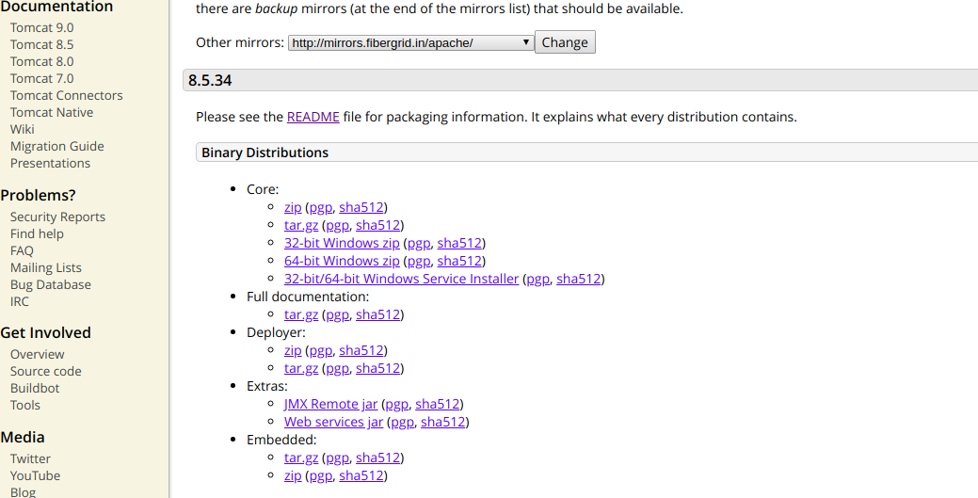

--->Before Download Tomcat Package Select README

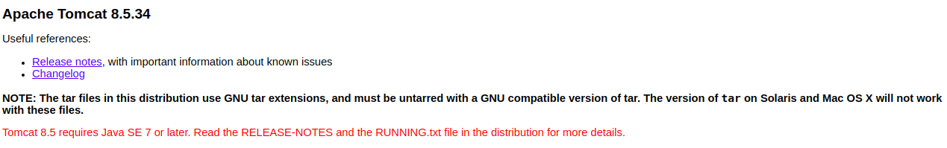
--->Select 64 bit-Windows.zip (Right click Select Copy link Address).

--->After downloading Tomcat Zip file will come like below

apache-tomcat-8.5.34-windows-x64.zip

--->unzip Tomcat Zip file.

unzip apache-tomcat-8.5.34-windows-x64.zip

--->after unzip tomcat zip file--> apache-tomcat-8.5.34 directory will come, like below,

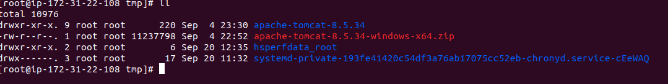
--->change Tocmat Directory permissions to 775.

chmod -R 775 apache-tomcat-8.5.34

--->Next Copy Tomcat to /opt

cp -R apache-tomcat-8.5.34 /opt

--->Goto tomcat bin and start tomcat.

/opt/apache-tomcat-8.5.34/bin

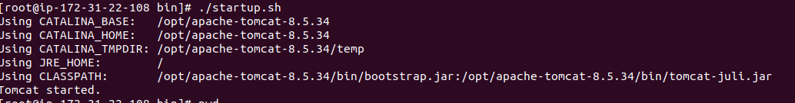
--->Goto browser search IP:8080

--->Tomcat Page will come like below,

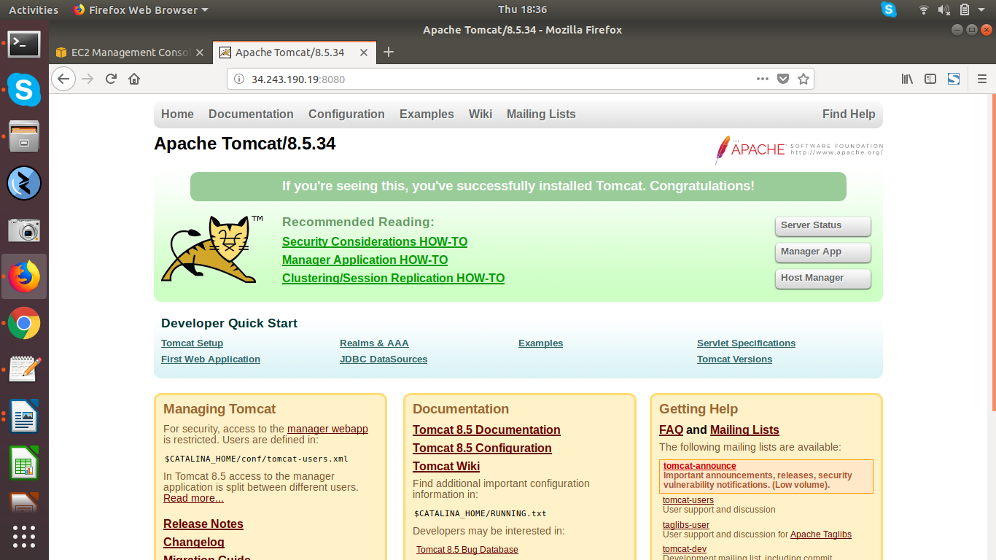
--->Tomcat is started and running.

---> Install DB(MySQL)

---> To install mysql (the below command)

yum install mysql-server*

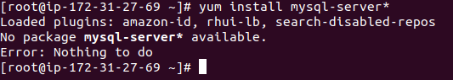

---> If you get error like above,Then try with below link as it is.

yum localinstall https://dev.mysql.com/get/mysql57-community-release-el7-11.noarch.rpm

---> Now , try the below command will work

yum install mysql-server*

---> to check mysql is installed or not/Version (the below command)

---> Start mysql and check mysql status, (the below commands)

service mysqld start

service mysqld status

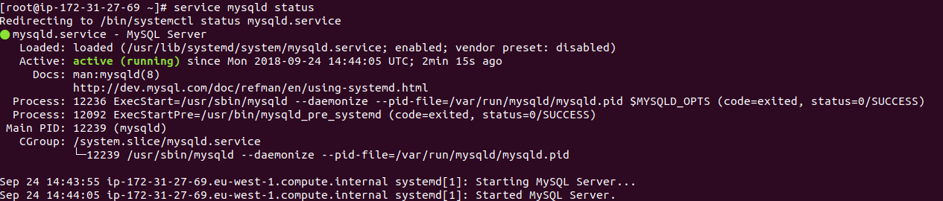
netstat -anlp | grep ":8080"

---> To get the default root password for Mysql (the below command)

grep 'temporary password' /var/log/mysqld.log

nfMXues50f!9

---> Reset MySql Default root Password.

(first connect Mysql with default root Password)

mysql -h localhost -u root -p

Enter password:

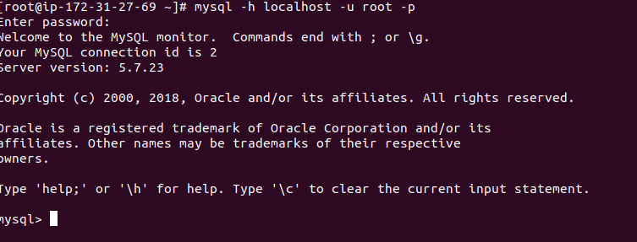
--->Change mysql default password with own password(the below command)

--->SET PASSWORD FOR 'root'@'localhost' = PASSWORD('MyNewPass');

--->Create a petclinic db in mysql(the below command)

CREATE DATABASE petclinic;

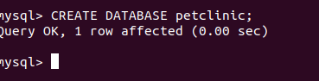

---> Give all Previliges to Peticlinc DB( the below commands)

GRANT ALL PRIVILEGES ON petclinic.* TO root@localhost IDENTIFIED BY 'Login@123';

FLUSH PRIVILEGES;

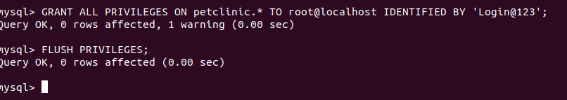
---> Check Petclinic DB created or not (the below command)

show databases;

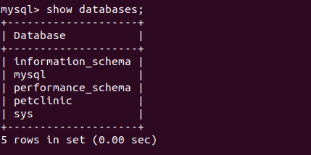

---> Download Petclinic War file.

link:-http://cliqr-appstore.s3.amazonaws.com/petclinic/petclinic.war

wget http://cliqr-appstore.s3.amazonaws.com/petclinic/petclinic.war

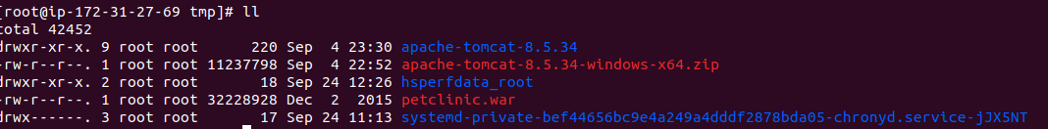
==> Deploy Petclinic.war to Tomcat Webapps.

cp petclinic.war /opt/apache-tomcat-8.5.34/webapps/

---> Once Deployed Petclinic war to Tomcat webapps--> Petclinic directory will create

automatically-->

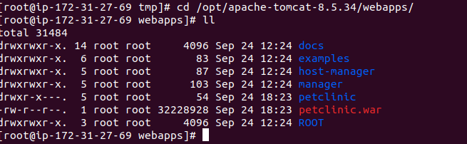
---> Download mysql connector jar file.

---> Download mysql connector for connect application and database.

---> goto browser search download mysql connector jar

http://www.java2s.com/Code/Jar/m/Downloadmysqlconnectorjar.htm

---> After downloadig mysql-connector-java-5.1.45 jar---> copy to tomcat/lib-->

cp mysql-connector-java-5.1.45-bin.jar /opt/apache-tomcat-8.5.34/lib/

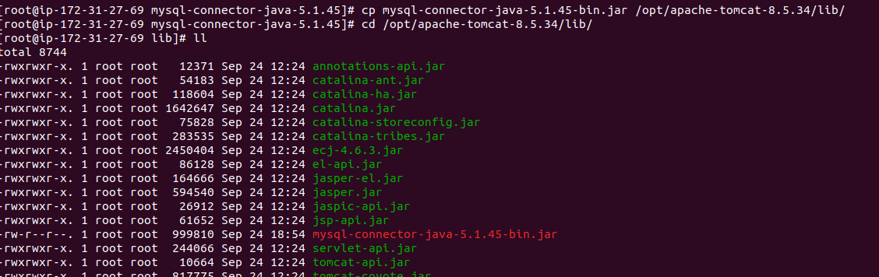

---> Next Restart tomcat.

Goto tomcat bin directrory.

./shutdown.sh

./startup.sh

---> Goto Tomcat and change init DB.sql configuration like below

/opt/apache-tomcat-8.5.34/webapps/petclinic/WEB-INF/classes/db/mysql

vi init DB.sql

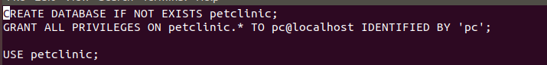
--->give username and password petclinic database, like below

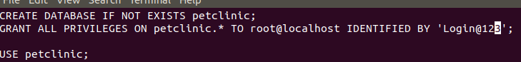

---> Goto Tomcat--> Webapps-->Petclinic directory-->

/opt/apache-tomcat-8.5.34/webapps/petclinic/WEB-INF/classes/spring-->here

---> goto vi data-access.properties, (remove all HQL and MS-SQL. ( keep only mysql lines and remove #(comments)))

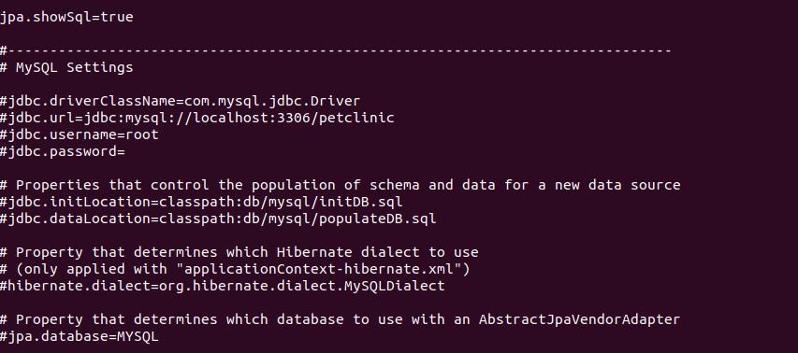
--->give password and romove # tags like below

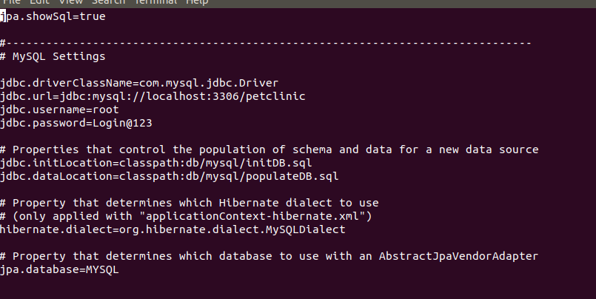

--> Goto Browser-->give Tomcat-DB:8080/petclinic

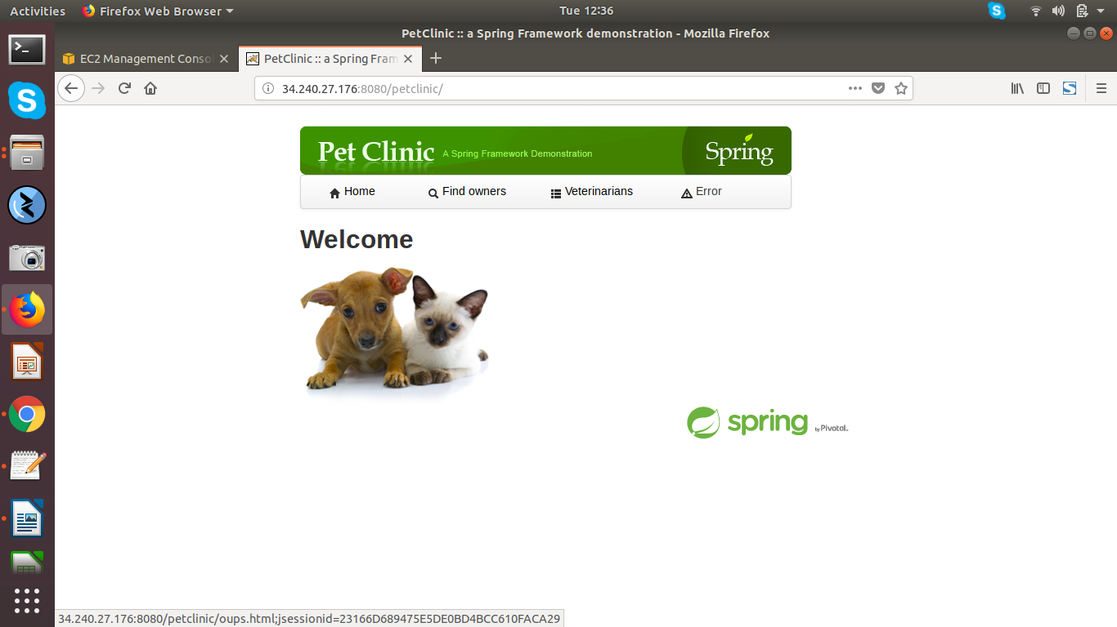

STEP 4:- Apache to Tomcat Integration(Proxy_Pass):-

---> Connect to Apache server--> past the proxy pass configuration in httd.conf file-->

--> cd /etc/httpd/conf/

---> vi httpd.conf

---> goto last line past the below ProxyPass Synt ax code (172.31.22.71--> tomcat server private

ip:8080/application name.

<VirtualHost *:80>
ProxyRequests Off
ProxyPreserveHost On
RedirectMatch ^/$ /petclinic
ProxyPass /petclinic http://172.31.22.71:8080/petclinic
ProxyPassReverse /petclinic http://172.31.22.71:8080/petclinic

</VirtualHost>

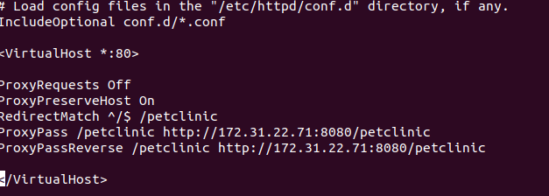
---> If did any changes in Apache Configure file (httpd.conf)--> Apache restart is mandatory

systemctl stop httpd

systemctl start httpd

or

systemctl restart httpd

---> goto browser --> search with Apache pubile IP-->

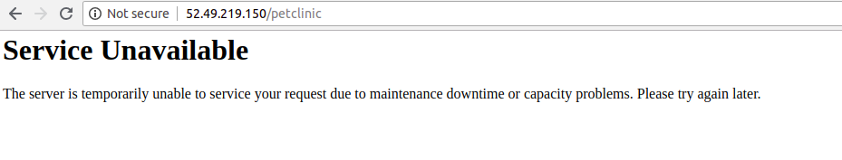
---> If you get error like above --> In Apache by defult Selinux is enabled-->

goto --> Apache server and disable the Selinux

----> Getenforce (if enforcing means Selinux is enabled)

----> setenforce 0 (means disabling the selinux)

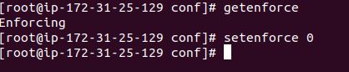

---> Goto Browser Search with Apache server Public IP:--

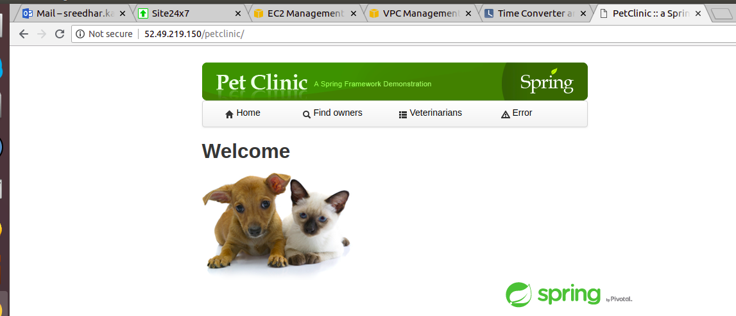

---> Conclusion:--Now we are giving request to Apache.

--->Through Apache its connecting to Tomcat appliation/webapps/Petclinic application.

---> Apache--> Tomcat (Petclinic application)--> DB(MySql).

