Setting up a sample Jenkins job
##############################################
Step:1
install required plugin to build and deploy Sample Project:

Mange Jenkins-->Manage Plugins--> select avaliable plugins and install without restart

required plugins: Dploy to container, github

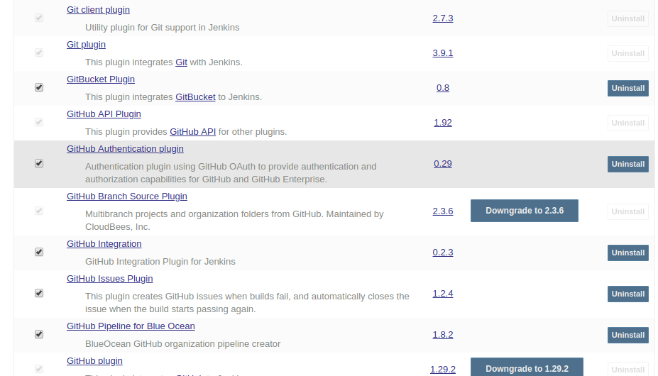

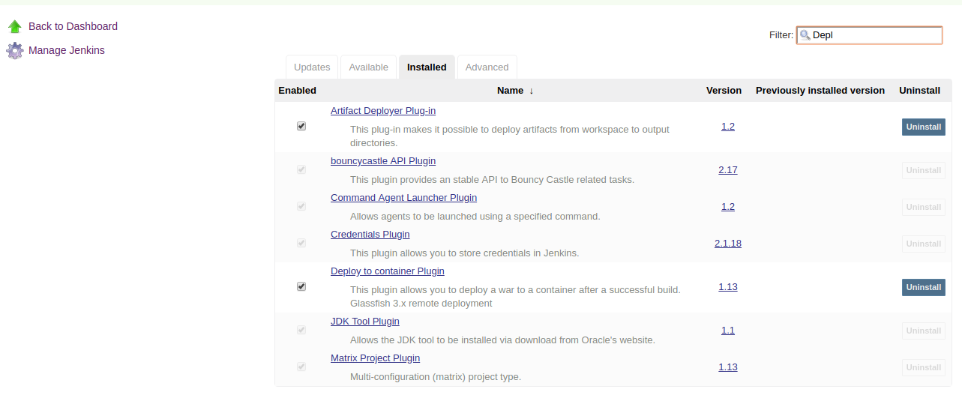

Step:2
Click on new item--> Enter project name --> select free style project--> click next
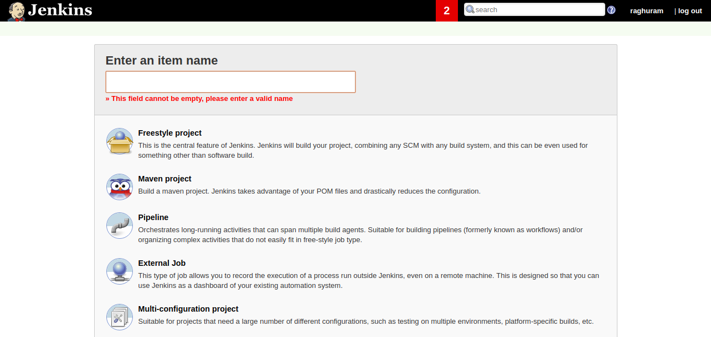

Step:3
click on configure
Configure how the source code can be retrieved. for example using Git, enter the URL to the Git repository. If the repository is not public, you may also need to configure the credentials.

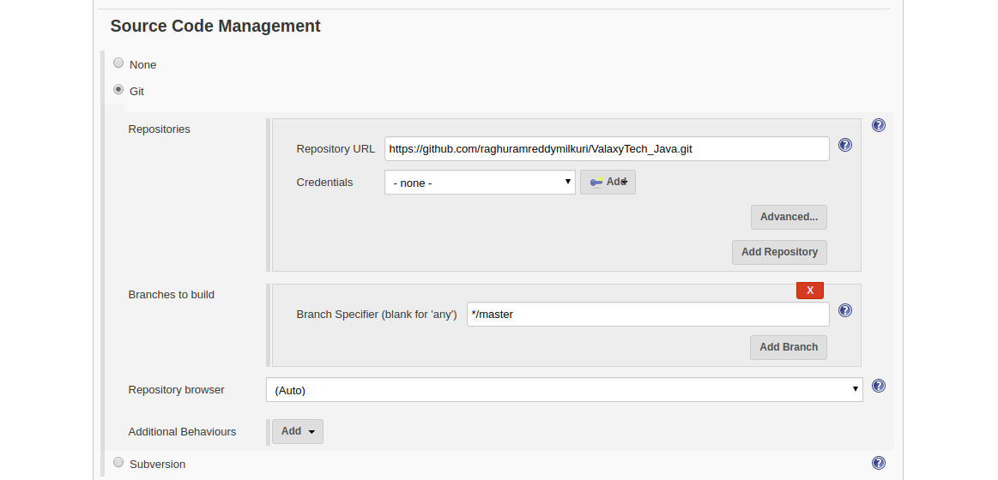

Step:4
Specify when and how your build should be triggered. Git repository every
min. It triggers a build, if something has changed in the repo.

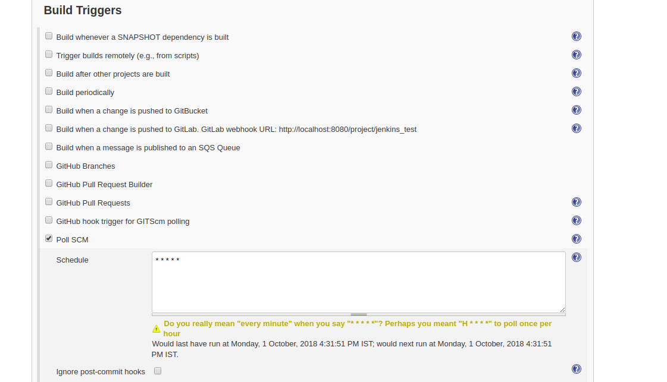

Post steps: select Goals and maven project version:

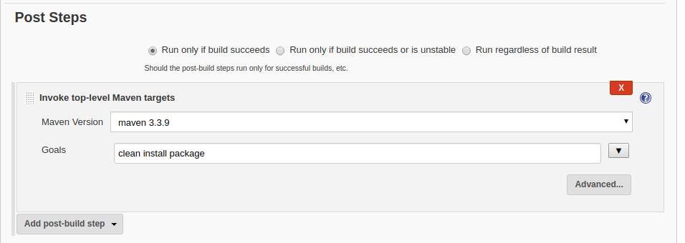

Step:5
Post-Build-Actions: Provide taget sever details and server login details --> click on save

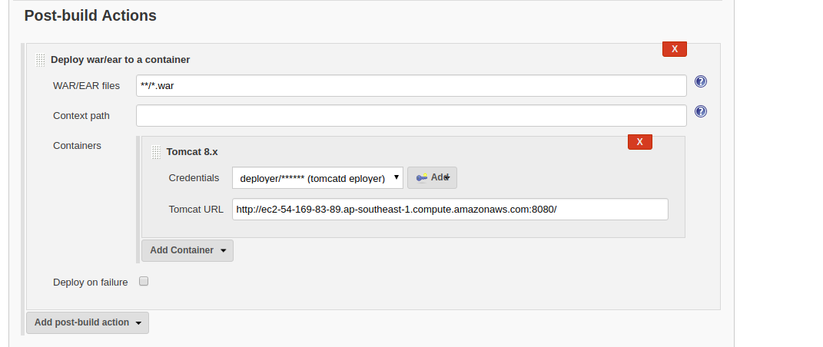

After click on build now

Step:6
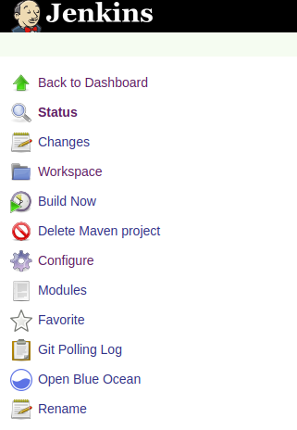

Step:7
If build sucess Deployment done in tomcat server

