Creating Hosted Zone and hosting a domain in Amazon Route53:-

(PreRequisites-->Domain name)

STEP 1:- Register Domain Name

---> Register domain name from any of domain providers like Godaddy,Amazon,Symantec..etc.

---> first create a account for any of above domain providers like Godaddy,Amazon,Symantec..etc

----> Domain name should be unique.

----> Created account in Godaddy--> Registeted Domain Name.

ex: cloudengineers.org

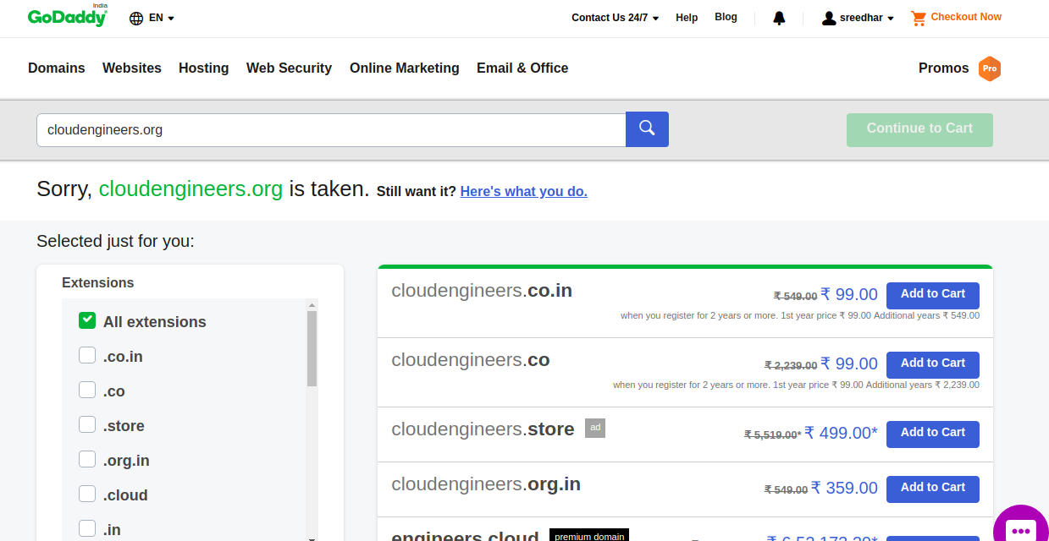
---> you can choose what ever you want with extentions.. like .com,.org,.net, .in....etc.

---> here registered domain name : cloudengineers.org

STEP 2:- Create a Hosted Zone for Domain.

---> Here Creating hosted Zone in AWS.

--->Goto AWS Console-->Select Services--> Select Route53-->

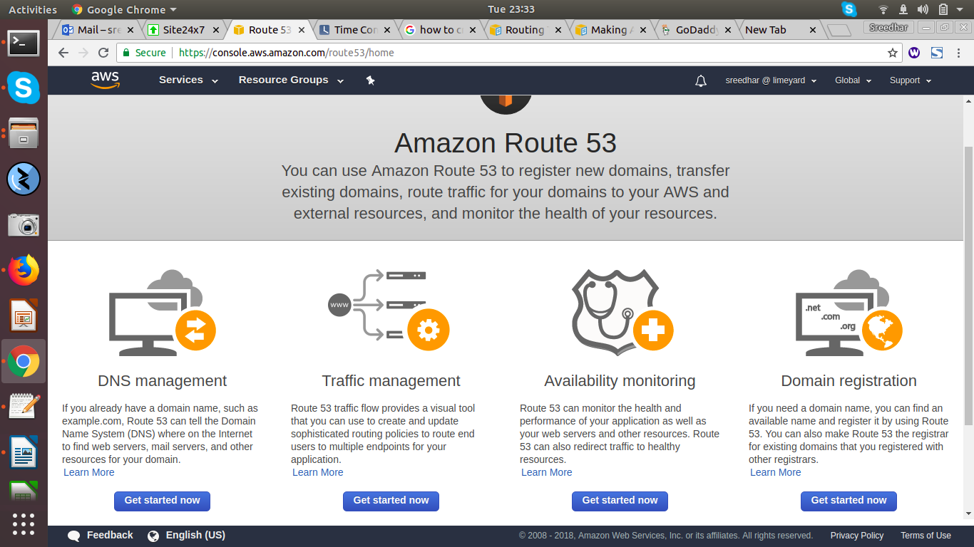

---> Select DNS Management-->Select Get Started Now--->Select Create a Hosted Zone -->

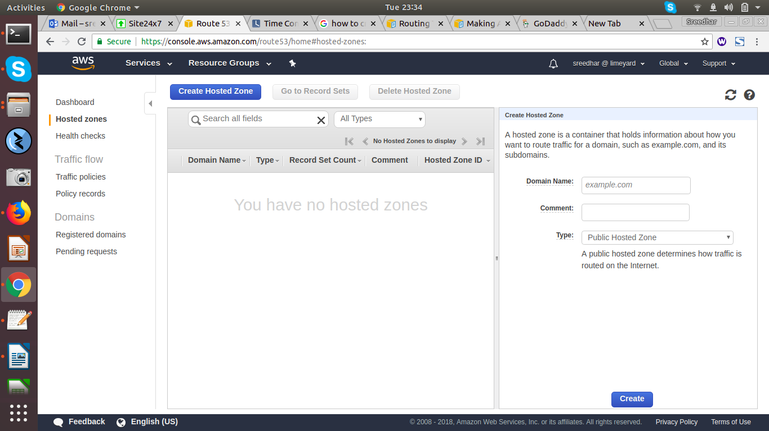

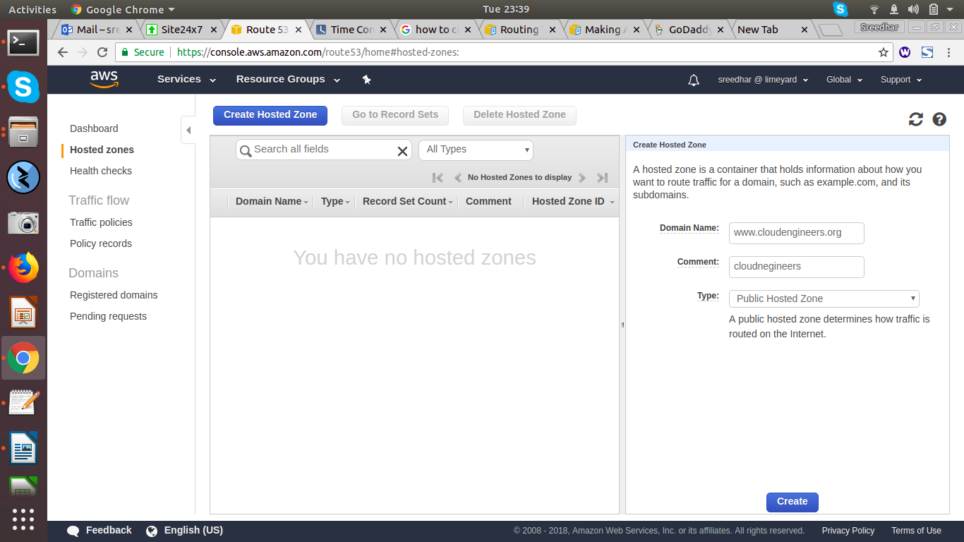
---> Next Create.

---> Next Select Created Hosted Zone --->

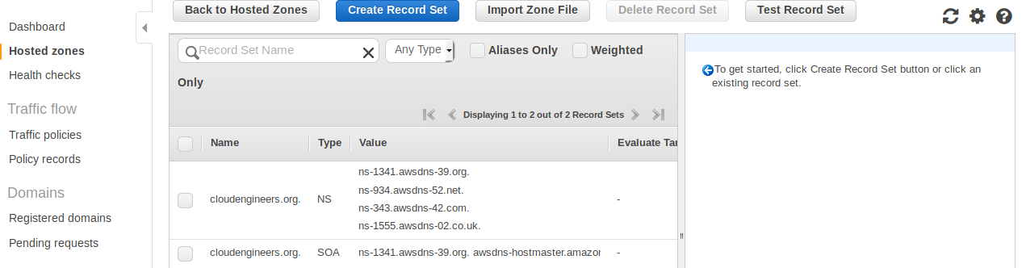
---> Selcect Name Servers (NS)---> Register these Name servers into Godaddy Account--->

Ex:

ns-459.awsdns-57.com
ns-737.awsdns-28.net
ns-1109.awsdns-10.org
ns-1718.awsdns-22.co.uk

==> Login into Godaddy Account.

---> Select Domain name---> in the list below to go to ---> Select Manage DNS--->

----> By Default Godaddy name servers will be there --> change to custom---> paste

AWS Name Servers here

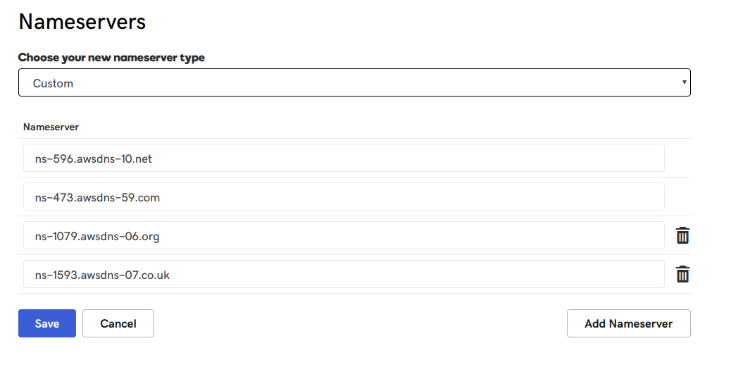

--> Select Save.

----> After updating your nameservers, allow 4 to 8 hours for other networks to access information for .com and .net domain names, and allow 24 to 48 hours for other networks to access information for all other domain extension.

STEP 3:- Create EC2-Instance and install Apache and sample static content.

---> Goto AWS Console--> Select Services---> Select EC2--> Select Launch Instance---> Create a

Instance for Apache.

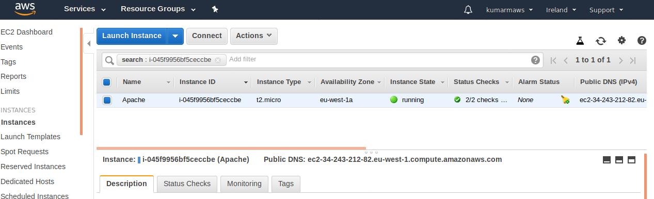
---> Install Apache and write a Sample static content in Document Root (Directory Index Path)

Ex: Cd /var/www/html(Document root Path) vi Index.html(Direcory Index)

---> Goto browser search with Pubic IP.

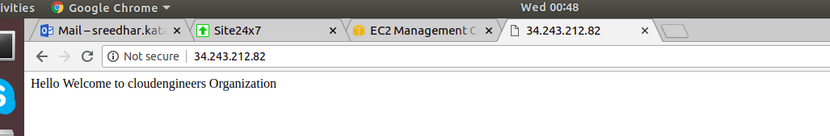
STEP 4:- Create a Record set in Amazon Route 53

----> Goto AWS Console ---> Select Services--> Select Route 53--> under DNS Mangement select

already created hosted zones-->

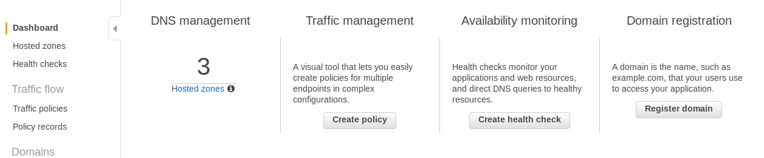

---> Select Hosted Zone (Any of created )---> Select Goto Record Sets--->

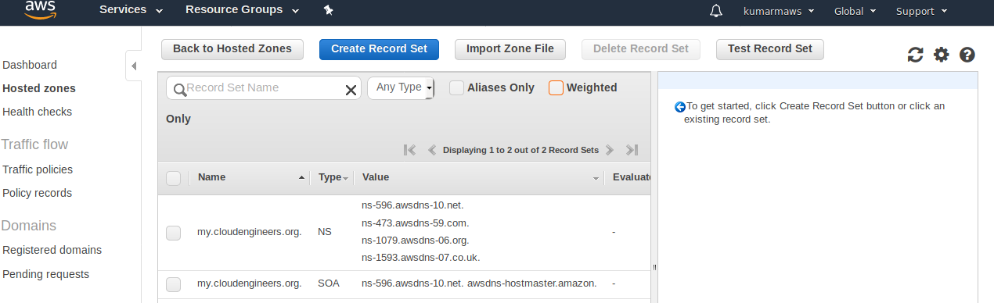
---> Select Aliases or Weighted--> Any one--> Select Create Record Set-->

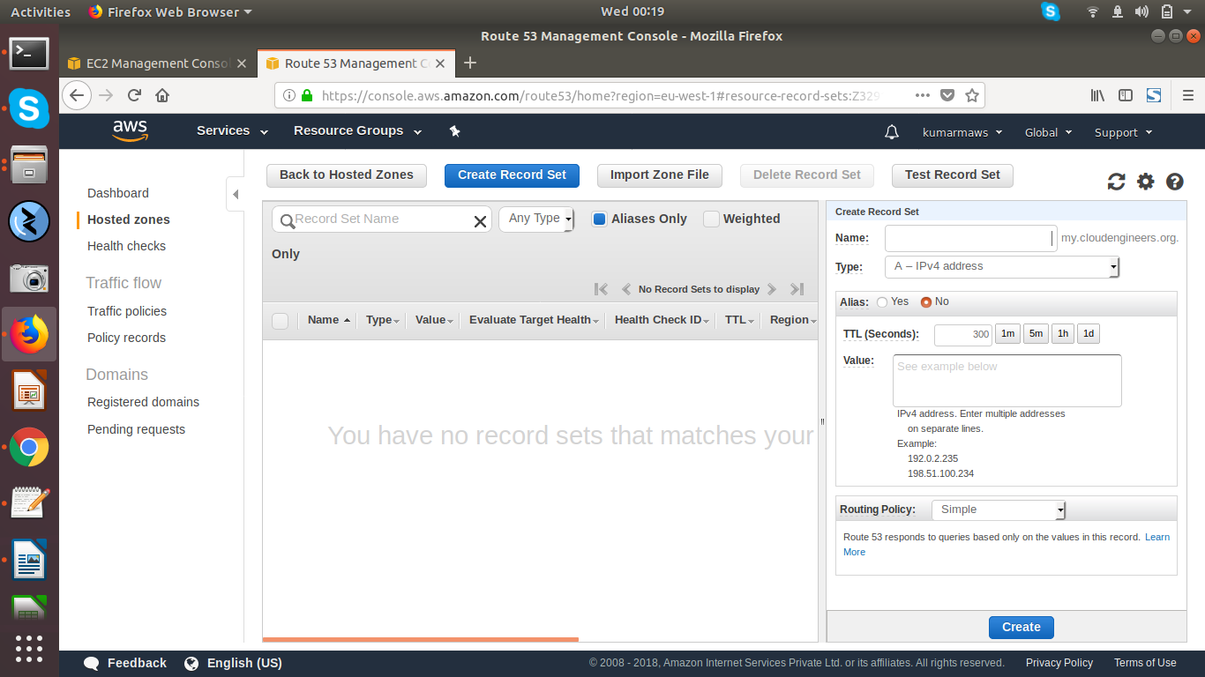

---> Right Side Session fill the details.

Name: test.my.cloudengineers.org

Type: A-IPV4-Address

Aliases: Select No for IP addresses

Aliases: Select yes for Lod Balancer IP’s

Value: Apache Server Public IP.

Routing Policy: Sample

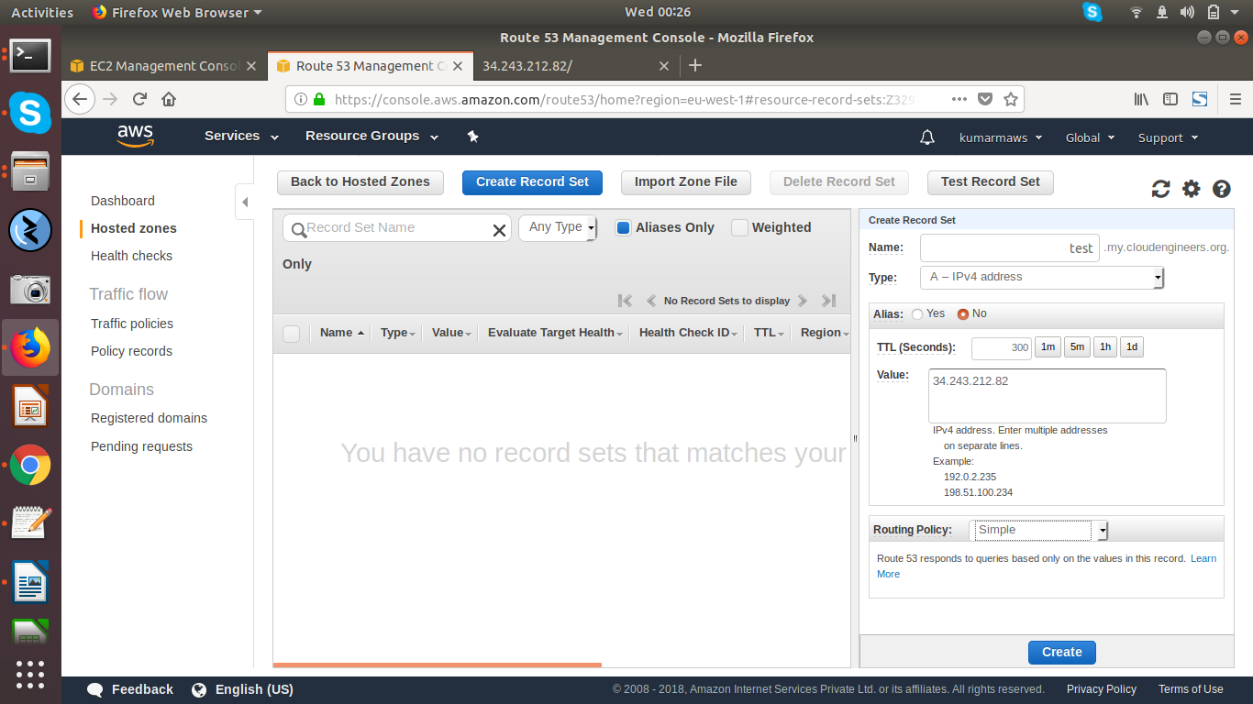

---> Select Create.

---> Next it will come like below,

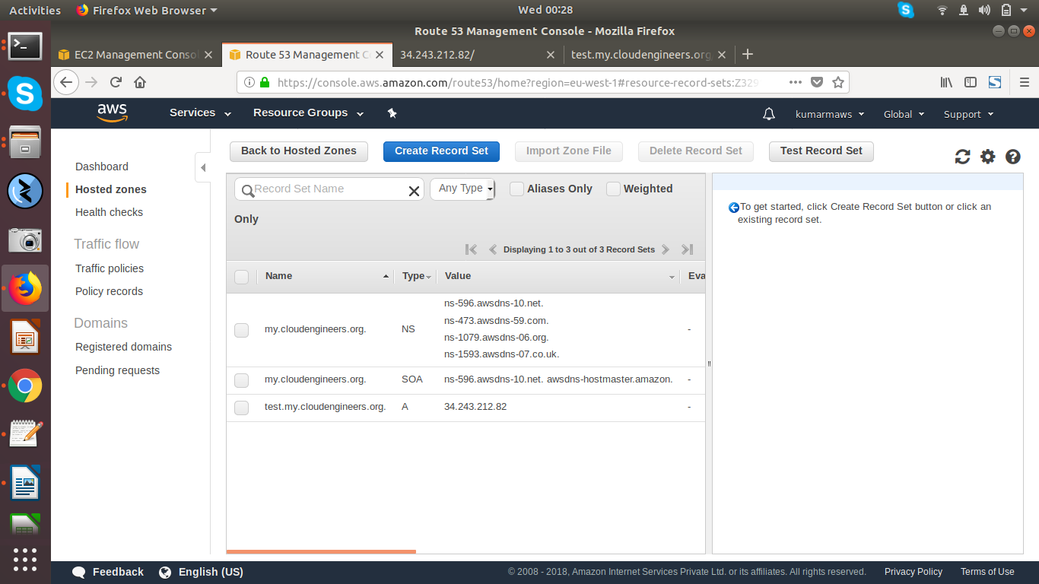

---> Goto browster ---> Search test.my.cloudengineers.org

