EFS(Elastic File System):-

(Creating EFS File System and mounting to EC2 Instances)

STEP 1:- FirstCreate a Security Group for EC2 and EFS.

==> (Create a Security Group for EC2)

Goto AWS Cosole-->Choose EC2-->Choose Security Groups-->Select Create Security Group-->

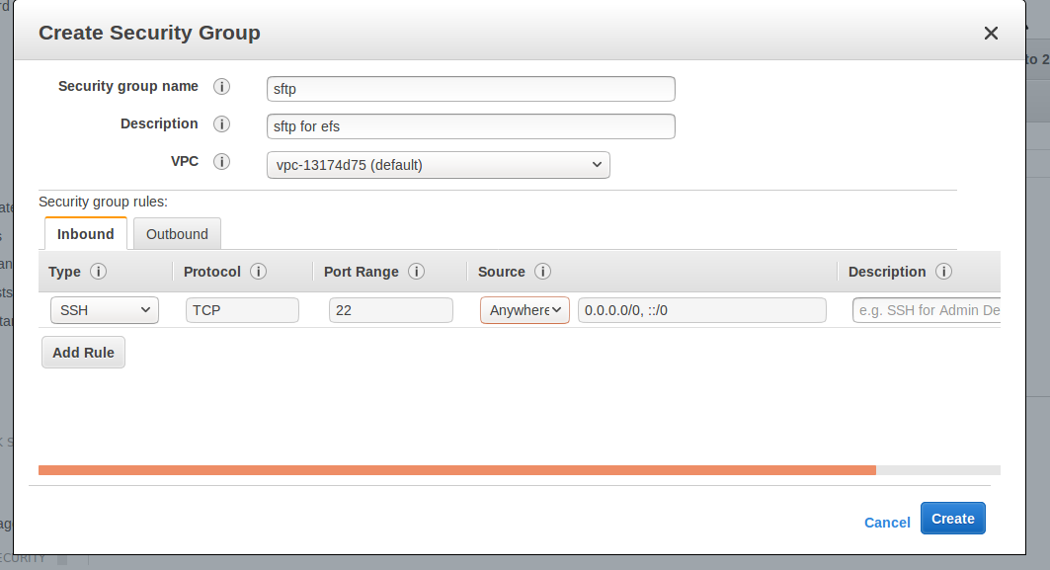
Next Click Create.

SFTP (EC2-Level)Security Group Created like below

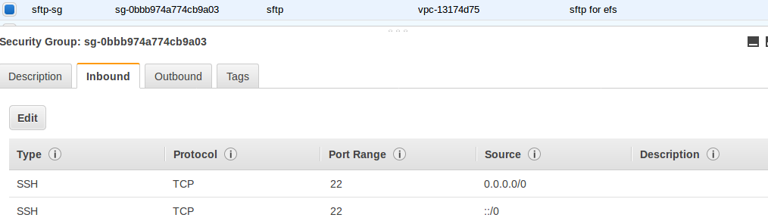

Sftp-sg-ID =sg-0bbb974a774cb9a03

==> (Create a Security Group for EFS)

Goto AWS Cosole-->Choose EC2-->Choose Security Groups-->Select Create Security Group-->

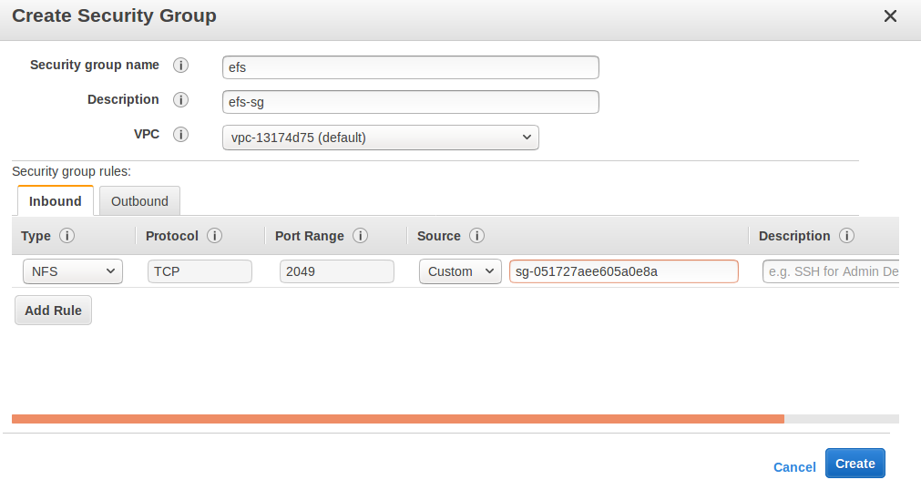
==> Here Choose Security Group Source is Custom-Sg-0bbb974a774cb9a03(sftp-sg)

EFS Security Group Created like below

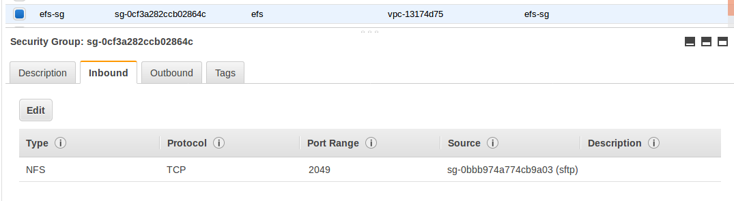

EFS-Sg-ID= sg-0cf3a282ccb02864c

STEP 2:- Create a EFS File System.

Goto AWS Cosole-->Choose EFS-->Select Create File System-->

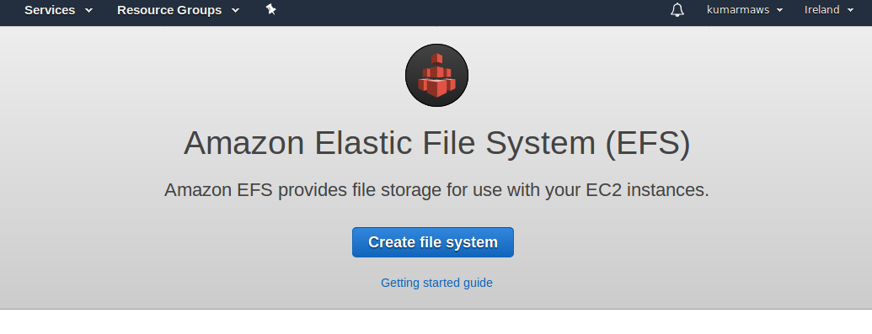
Select Create File System

Choose VPC form VPC dropdown

Select the Checkboxes for All the Availability Zones. Make Sure That they all have the default subnets, automatic IP addresses.

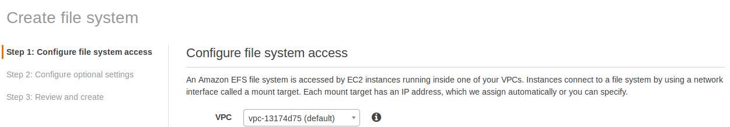

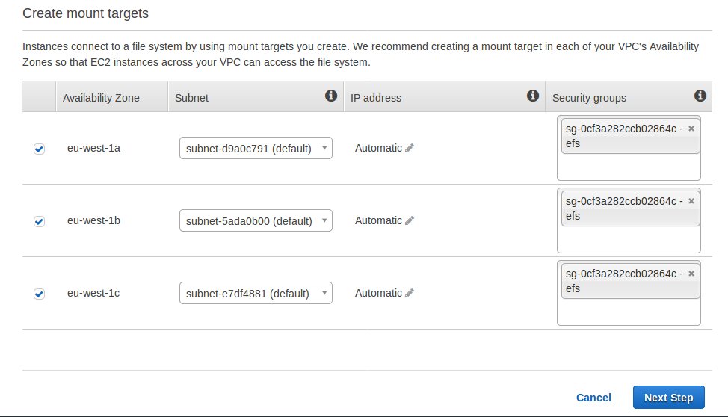
Select Next Step.

Here add Tag name for EFS “TEST-SFTP-MYOWN”

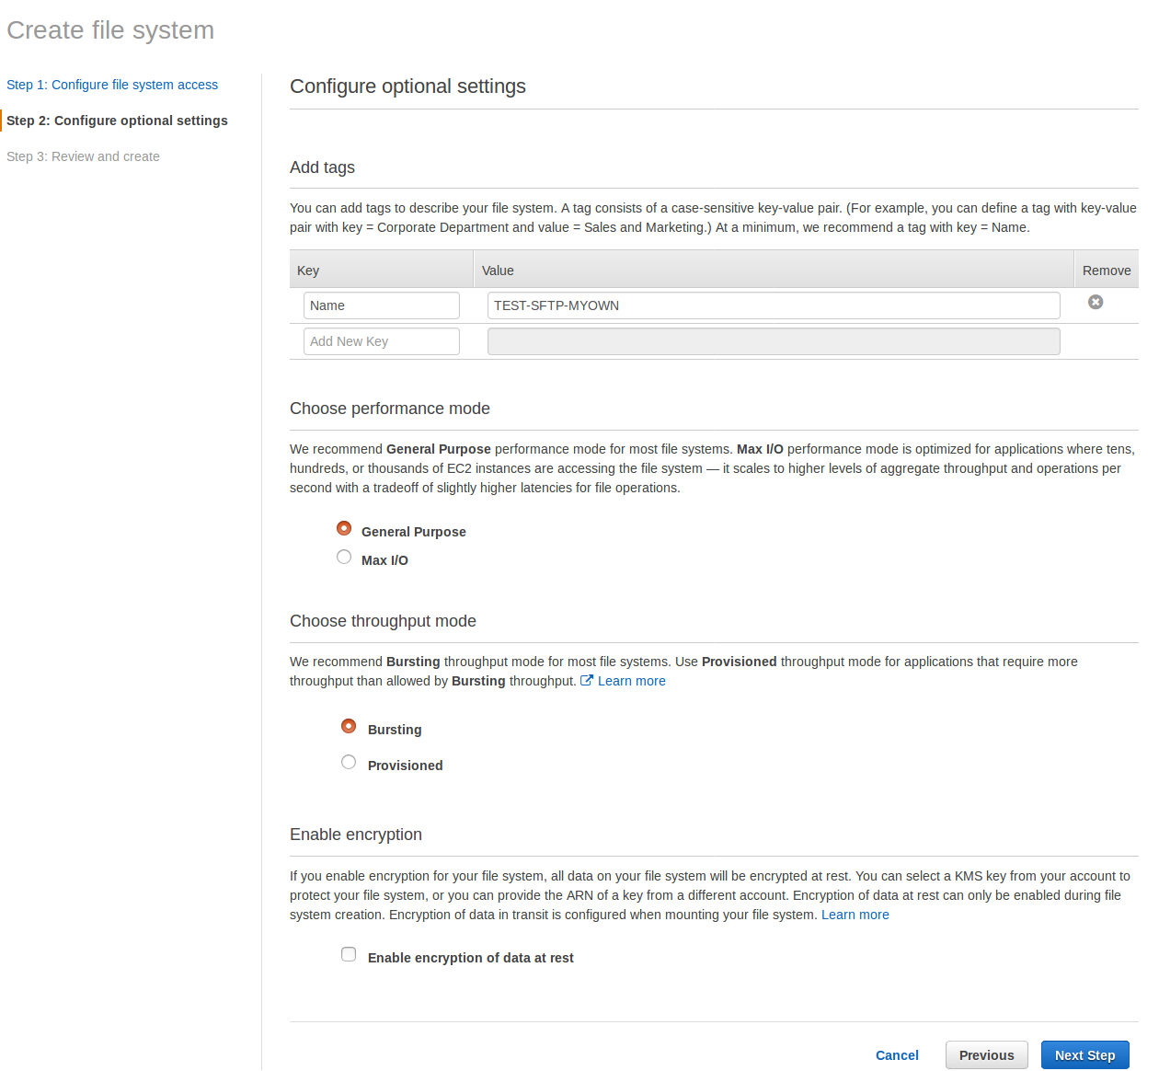
Select Next Step.

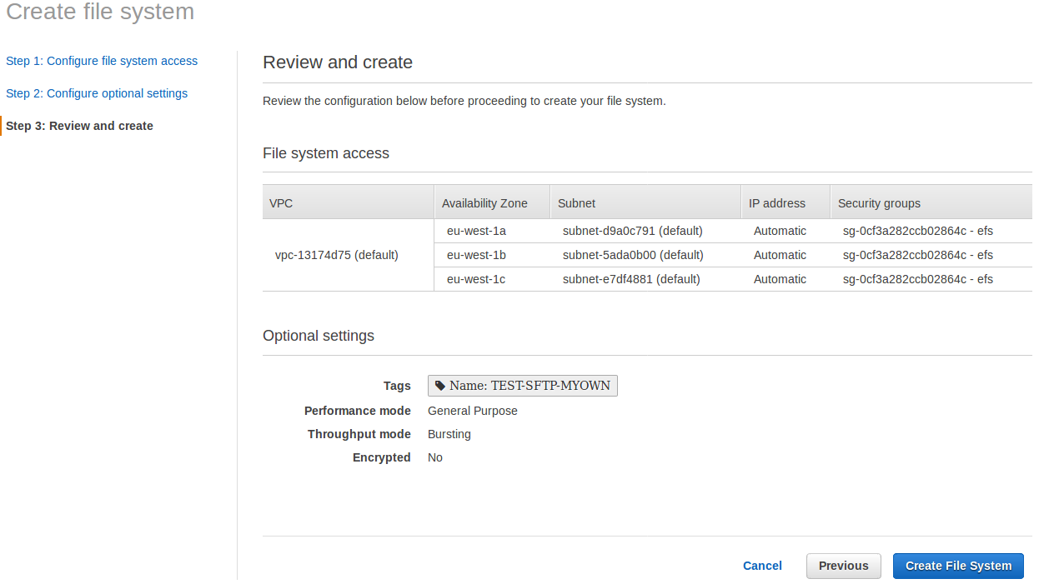
Select Create File System.

EFS File System Created like below

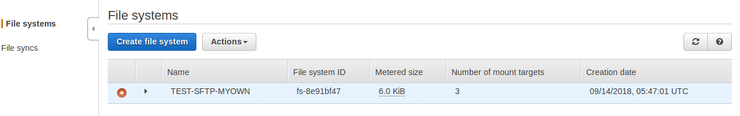

Expand and see EFS all Availabilty Zones(AZ’s) Available now

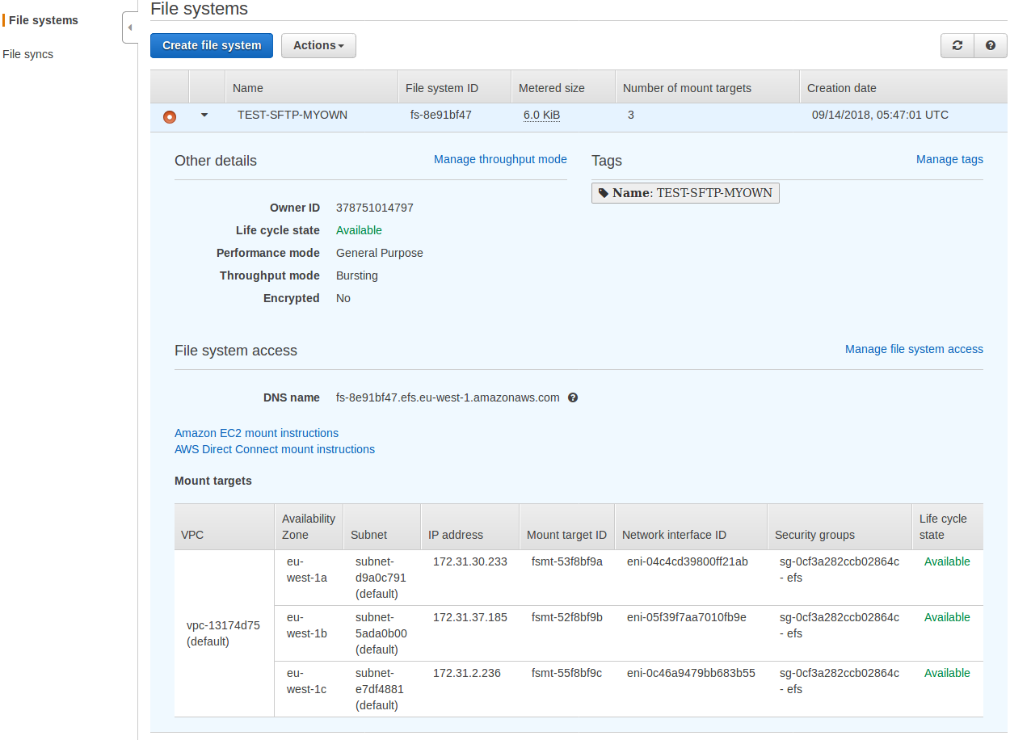

STEP 3:- Create 3 EC2 Instances in different Availabilty Zones.

Goto AWS Cosole-->Choose EC2-->Select Launch Instance-->

Choose which ever AMI want to launch.

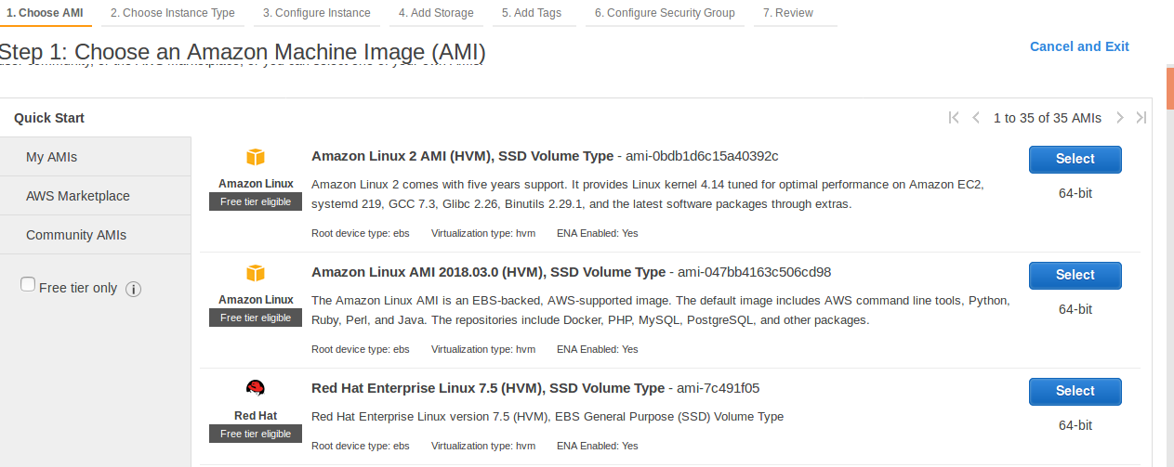

EC2 Isnstances up and running.

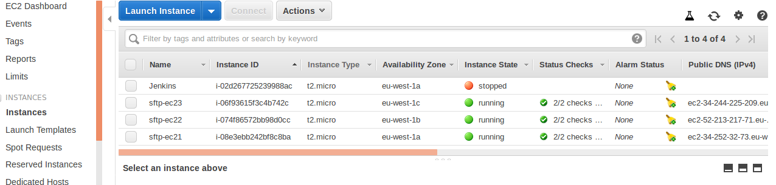

Connect to each EC2 Instance.

ssh -i sreedhar-ireland-kumaraws.pem ec2-user@34.244.225.209

Warning: Permanently added '34.244.225.209' (ECDSA) to the list of known hosts.
[ec2-user@ip-172-31-2-64 ~]$ sudo su -
[root@ip-172-31-2-64 ~]# useradd sreedhar
[root@ip-172-31-2-64 ~]# passwd sreedhar
Changing password for user sreedhar.
New password:
BAD PASSWORD: The password contains the user name in some form
Retype new password:
passwd: all authentication tokens updated successfully.
[root@ip-172-31-2-64 ~]# passwd
Changing password for user root.
New password:
BAD PASSWORD: The password contains the user name in some form
Retype new password:
passwd: all authentication tokens updated successfully.
[root@ip-172-31-2-64 ~]# visudo
[root@ip-172-31-2-64 ~]# su - sreedhar
[sreedhar@ip-172-31-2-64 ~]$ sudo su -
Last login: Fri Sep 14 06:54:22 UTC 2018 on pts/0
[root@ip-172-31-2-64 ~]# vi /etc/ssh/sshd_config
[root@ip-172-31-2-64 ~]# service sshd restart
Redirecting to /bin/systemctl restart sshd.service
[root@ip-172-31-2-64 ~]# exit
logout
[sreedhar@ip-172-31-2-64 ~]$ exit
logout
[root@ip-172-31-2-64 ~]# exit
logout
[ec2-user@ip-172-31-2-64 ~]$ exit
logout
Connection to 34.244.225.209 closed.

STEP 4:- Mount EC2 instances to EFS.

Goto EFS Console

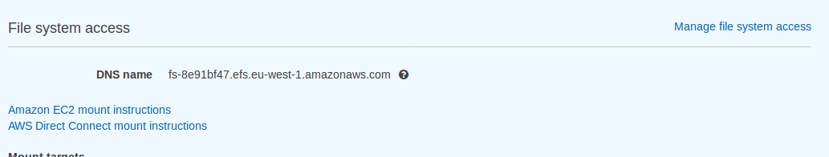

Click Amazon EC2 mount instructions

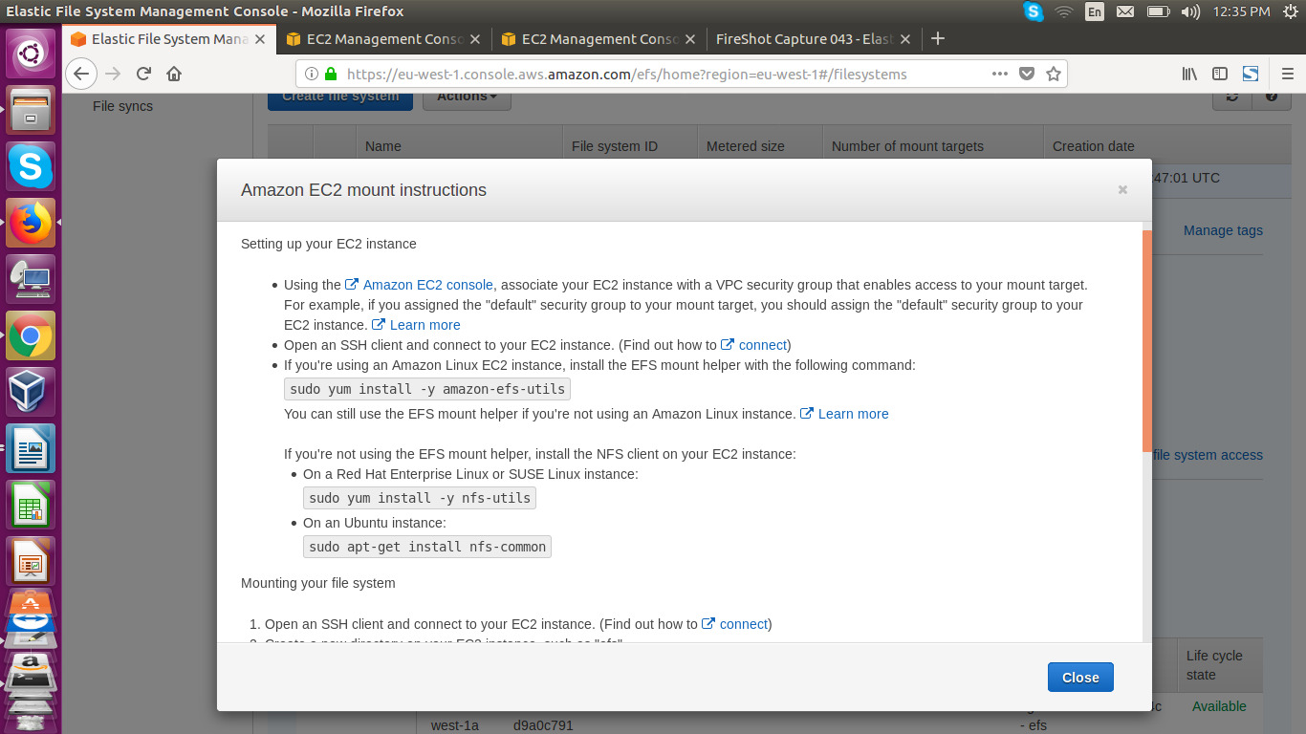

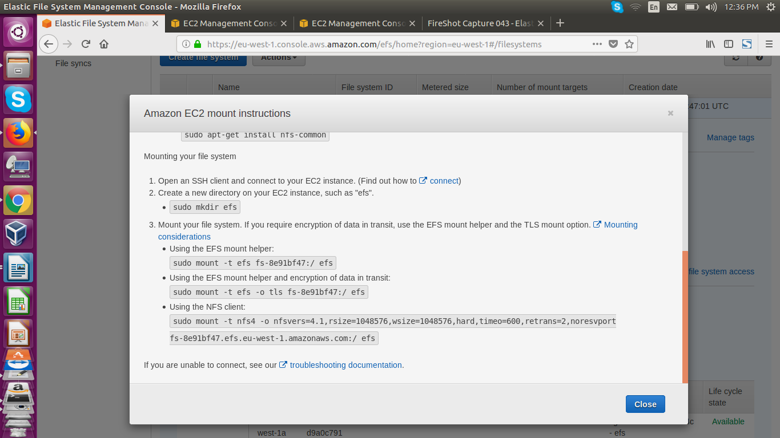

Next ==> Connect to EC2 Instances and follow the above instructions based on AMI.

Here first EC2 Instance (sftp-ec21)

After connected to EC2 Instance(Redhat AMI)

ce950@ce-950:~/myfolder/Practice-aws-account$ ssh sreedhar@34.252.32.73
sreedhar@34.252.32.73's password:
Last login: Fri Sep 14 06:49:18 2018 from 1.186.213.137
[sreedhar@ip-172-31-28-164 ~]$ sudo su -
Last login: Fri Sep 14 06:48:53 UTC 2018 on pts/0
[root@ip-172-31-28-164 ~]#

-->Run the below command for Redhat Linux AMI

sudo yum install -y nfs-utils

-->Create a new directory on your EC2 instance , such as “efs”

sudo mkdir efs (here i customized like below efs replace)

[root@ip-172-31-28-164 ~]# sudo mkdir -p /root/sreedhar-test/sreedhar_efs

-->Permanently mount add entry in /etc/fstab

fs-8e91bf47.efs.eu-west-1.amazonaws.com

-->Add entry in fstab for permanent mount

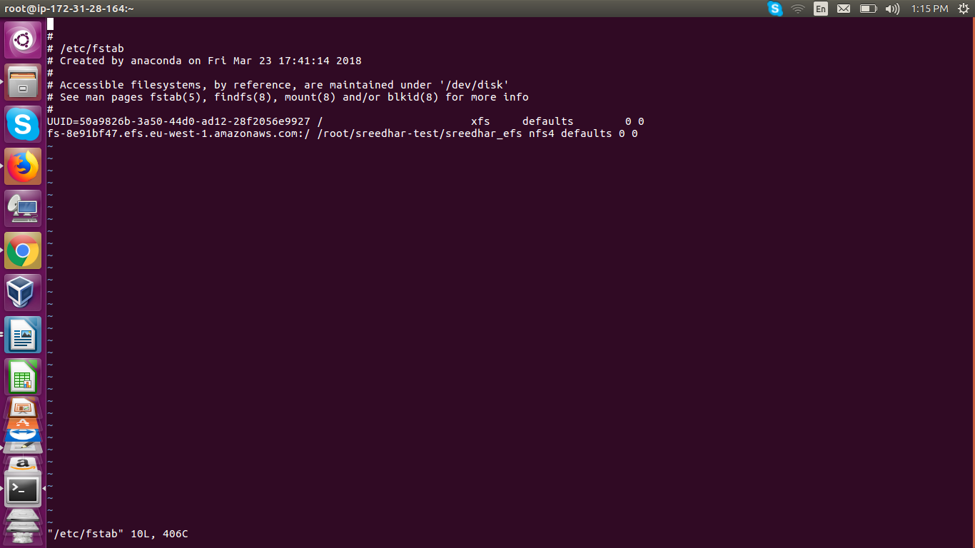

[root@ip-172-31-28-164 ~]# vi /etc/fstab
[root@ip-172-31-28-164 ~]# mount -a
[root@ip-172-31-28-164 ~]# df -h
Filesystem Size Used Avail Use% Mounted on
/dev/xvda2 10G 1.3G 8.8G 13% /
devtmpfs 474M 0 474M 0% /dev
tmpfs 496M 0 496M 0% /dev/shm
tmpfs 496M 13M 483M 3% /run
tmpfs 496M 0 496M 0% /sys/fs/cgroup
tmpfs 100M 0 100M 0% /run/user/1001
fs-8e91bf47.efs.eu-west-1.amazonaws.com:/ 8.0E 0 8.0E 0% /root/sreedhar-test/sreedhar_efs
[root@ip-172-31-28-164 ~]#

--> Same like other two instances(sftp-ec22,sftp-ec23 follow the same like EC2 Instance (sftp-ec21).

