Jenkins (Installation and Configuration) + Creating new user+Manage and Assign Roles+

Jobs(Sample and Chain Job)

Method 1:-

STEP 1:- First Spin-up EC2-Instance.

==> Create a security group for EC2-Instance.

--->Goto AWS Console-->Selece EC2 --> Select Security Group--> Select Create Security Group

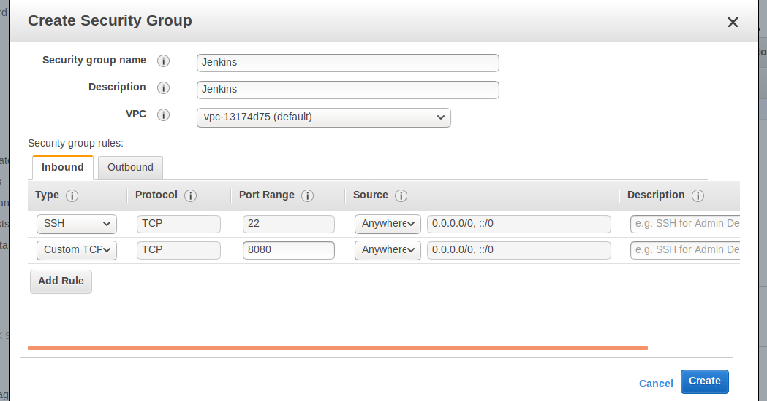
SSH-22---> for remote login

Custom TCP Rule -8080 ---> for jenkins (default port for jenkins)

Select Create.

--->Goto AWS-Console--> Select EC2---> Select Launch Instance-->

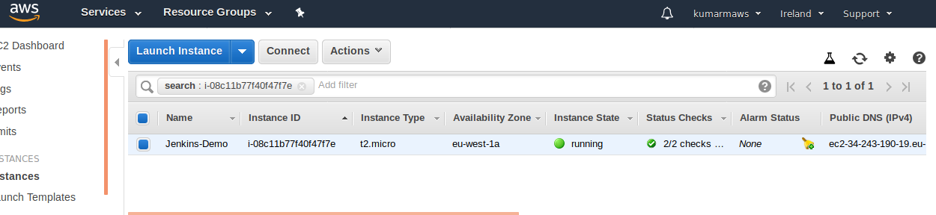

--->EC2-Instance is up and running.

STEP 2:- Connect to EC2-Instance.

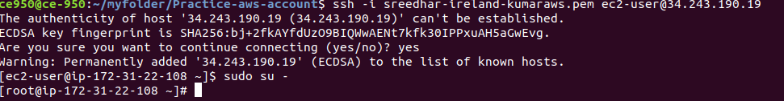

==> Download java

( Jenkins running on Java, java 1.7 or 1.8 and above is required)

--->Goto Google Crome--> Oracle java download--->

http://www.oracle.com/technetwork/java/javase/downloads/jdk8-downloads-2133151.html

--->Before dowloading JAVA -->Select Accept License Agreement.

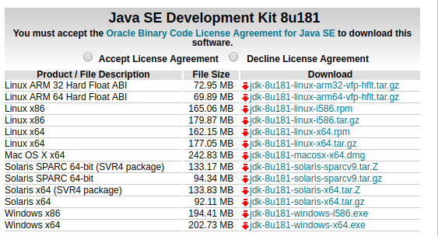

--->Download RPM package for linux to EC2-Instance.

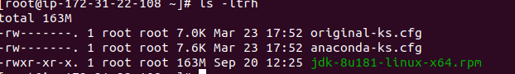

--->After Downloading JAVA linux RPM Package, Run below command to install JAVA.

rpm -ivh jdk-8u181-linux-x64.rpm

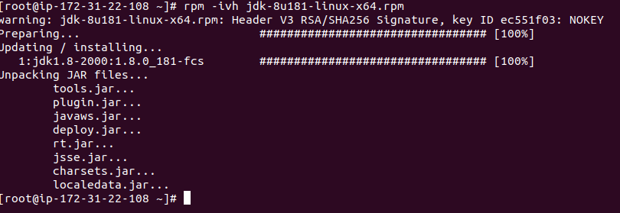

--->To check JAVA which Version Installed run below commad.

java -version

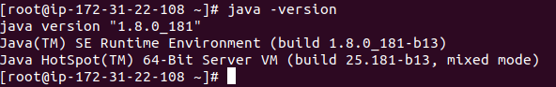
==> Download Tomcat.

--->Goto Browser---> Search Downlaod Tomcat -->

https://tomcat.apache.org/download-80.cgi

(Here i am download Tomcat8.)

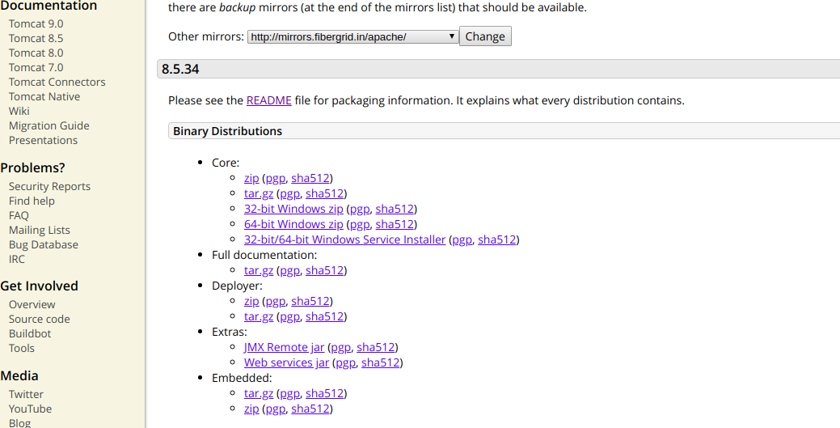

--->Before Download Tomcat Package Select README

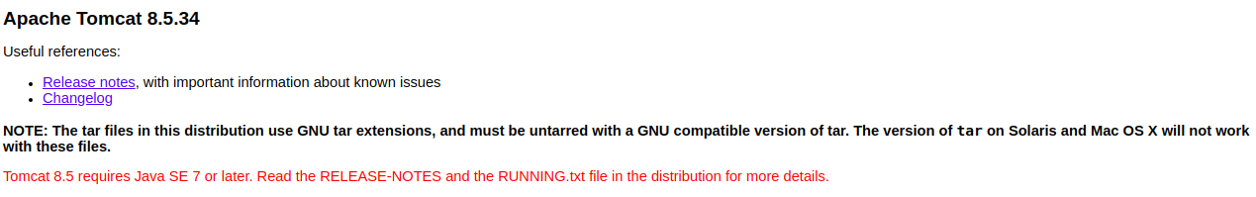

--->Select 64 bit-Windows.zip (Right click Select Copy link Address).

--->After downloading Tomcat Zip file will come like below

apache-tomcat-8.5.34-windows-x64.zip

--->unzip Tomcat Zip file.

unzip apache-tomcat-8.5.34-windows-x64.zip

--->after unzip tomcat zip file--> apache-tomcat-8.5.34 directory will come, like below,

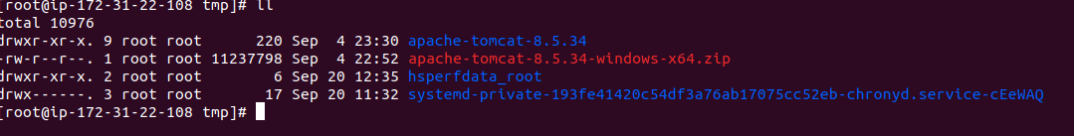

--->change Tocmat Directory permissions to 775.

chmod -R 775 apache-tomcat-8.5.34

--->Next Copy Tomcat to /opt

cp -R apache-tomcat-8.5.34 /opt

--->Goto tomcat bin and start tomcat.

/opt/apache-tomcat-8.5.34/bin

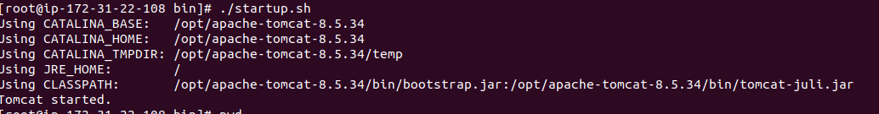

--->Goto browser search IP:8080

--->Tomcat Page will come like below,

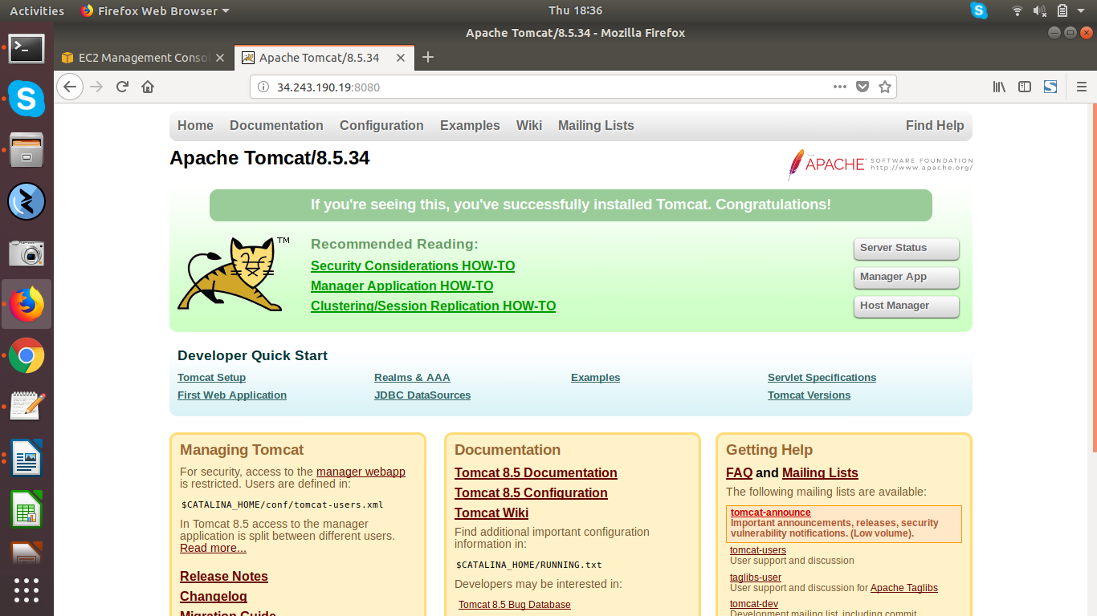

--->Tomcat is started and running.

==> Download Jenkins.war file

--->Goto browser--> Search jenkins war download-->

https://updates.jenkins-ci.org/download/war/

--->page will come like below

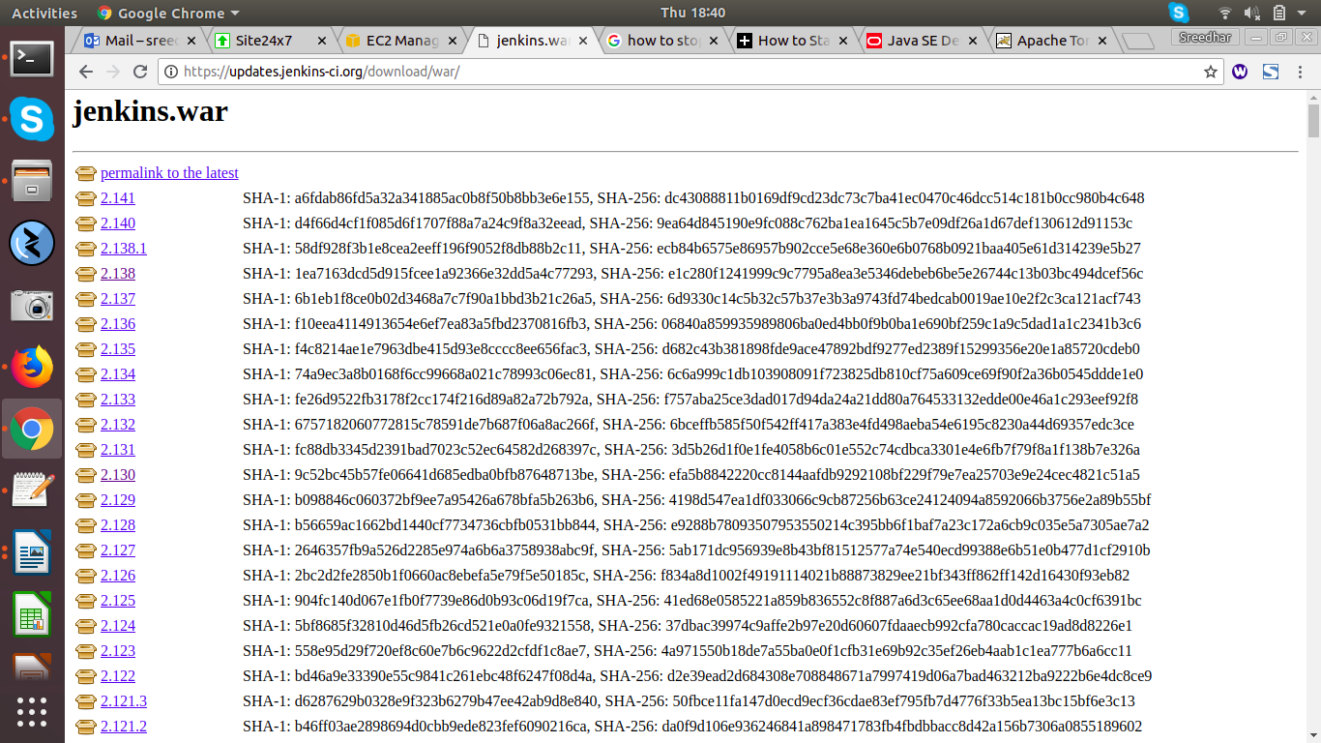

--->Now Downlaod package from here to EC2 Instance.

(here i am downloading 2.130)

--->Select 2.130 --> Right Click-->Copy link Address.

--->After downlaoded jenkins.war file will come

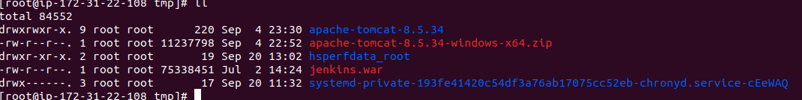
--->Copy Jenkins.war file to tomcat webapps directory.

cp jenkins.war /opt/apache-tomcat-8.5.34/webapps/

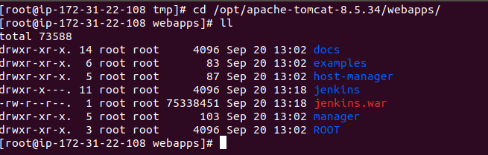
--->After copieng Jenkins.war file to Tomcat Webapps--> Jenkins Directory will create
automatically.

--->goto browser search with IP:8080/jenkins

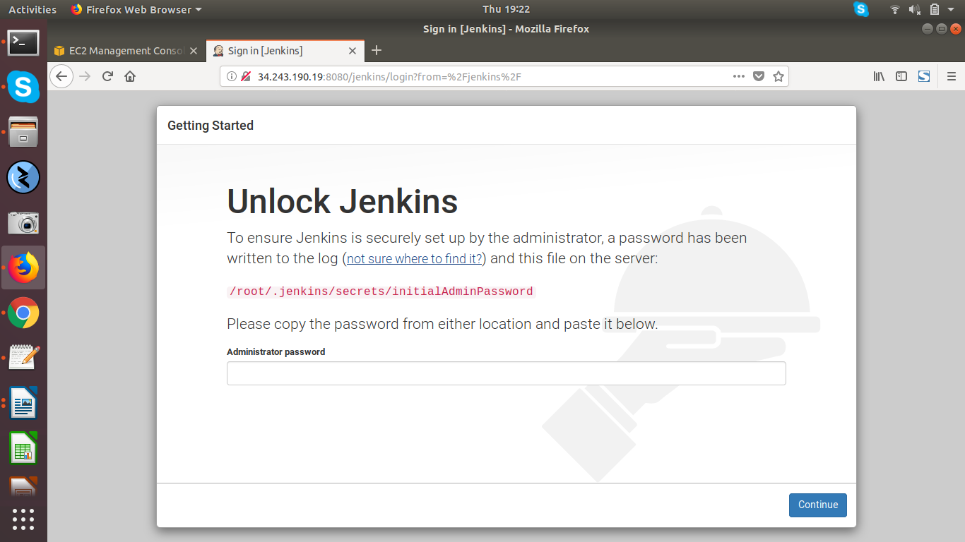

--->Get Administration Password from Jenkins home directory.

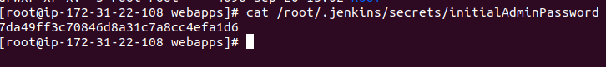
--->Admin Password: 7da49ff3c70846d8a31c7a8cc4efa1d6

--->After giving password it will ask like below

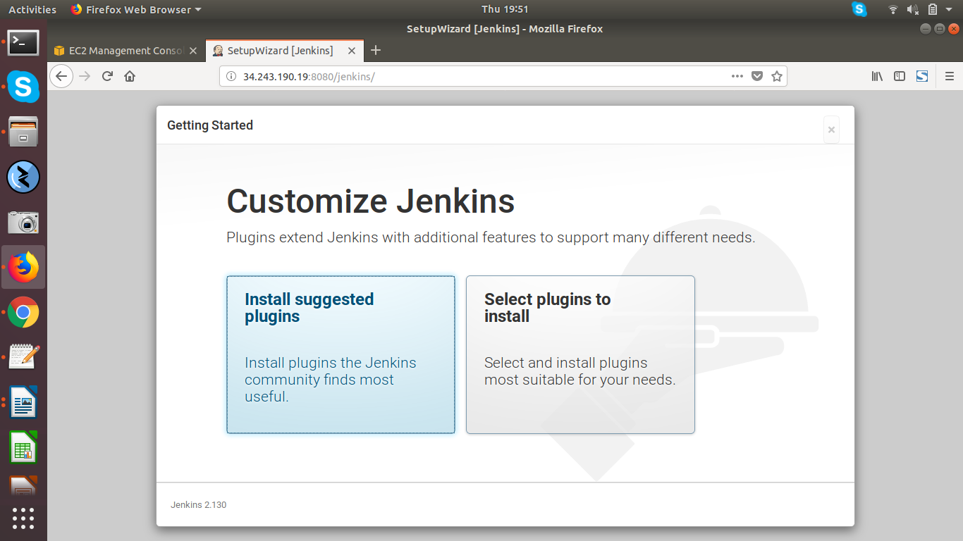

--->Install Suggested Plugins

--->Next it will come like below,

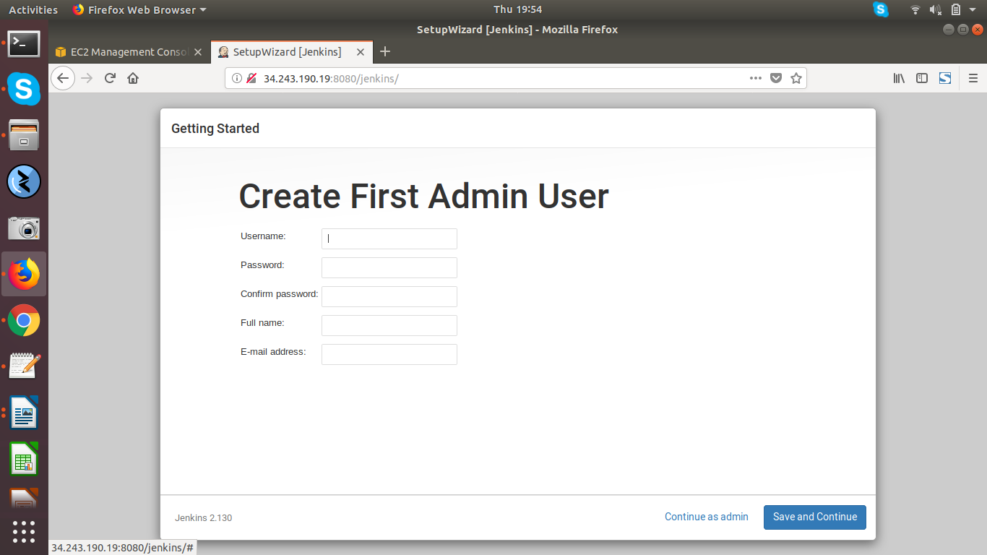

--->Select Continue as admin.

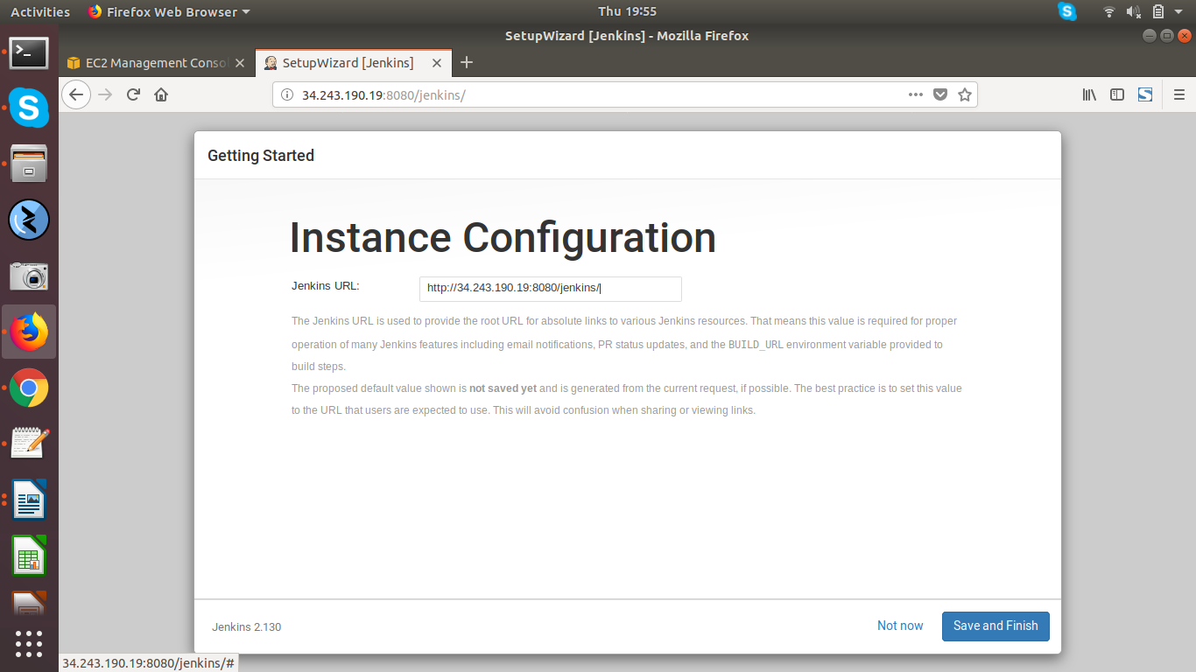
--->Select Save and Finish.

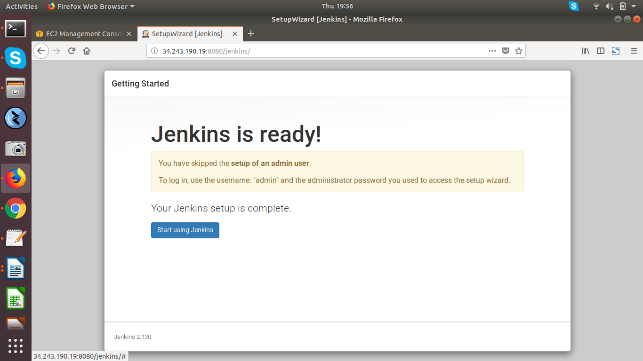
--->Select Start Using Jenkins.

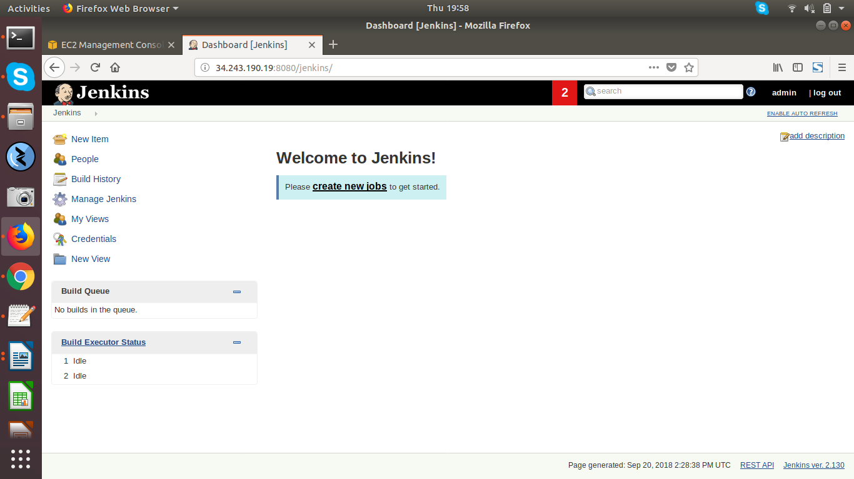
--->The above image is jenkins Console.

Method 2:-

STEP 1:- First Spin-up EC2-Instance.

==> Create a security group for EC2-Instance.

--->Goto AWS Console-->Selece EC2 --> Select Security Group--> Select Create Security Group

SSH-22---> for remote login

Custom TCP Rule -8080 ---> for jenkins (default port for jenkins)

Select Create.

--->Goto AWS-Console--> Select EC2---> Select Launch Instance-->

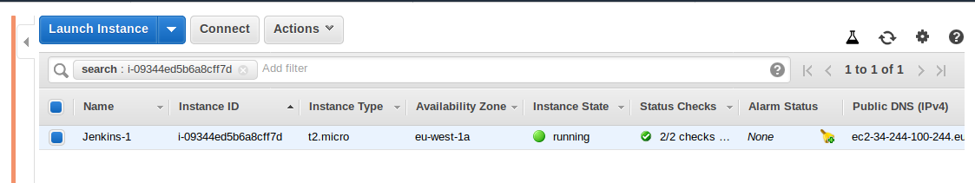

--->EC2-Instance is up and running.

STEP 2:- Connect to EC2-Instance.

==> Download java

( Jenkins running on Java, java 1.7 or 1.8 and above is required)

--->Goto Google Crome--> Oracle java download--->

http://www.oracle.com/technetwork/java/javase/downloads/jdk8-downloads-2133151.html

--->Before dowloading JAVA -->Select Accept License Agreement.

--->Download RPM package for linux to EC2-Instance.

--->After Downloading JAVA linux RPM Package, Run below command to install JAVA.

rpm -ivh jdk-8u181-linux-x64.rpm

--->To check JAVA which Version Installed run below commad.

java -version

==> Download Jenkins.war file

--> got-o browser--> Search jenkins war download-->

https://updates.jenkins-ci.org/download/war/

--->page will come like below

--->Now Downlaod package from here to EC2 Instance.

(here i am downloading 2.130)

--->Select 2.130 --> Right Click-->Copy link Address.

--->After downlaoded jenkins.war file will come

--->Copy Jenkins to /Opt

cp jenkins.war /opt

--->goto jenkins.war file location.

cd /opt

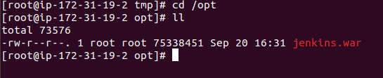
--->run the jenkins with below command

nohup java -jar jenkins.war &

(jenkins run in the background)

--->goto browser check with IP:8080

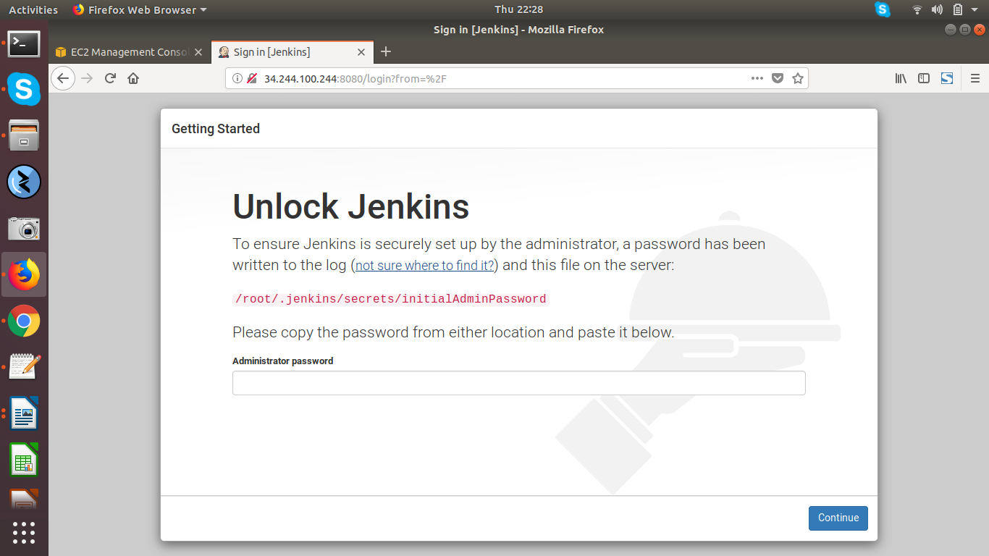

--->Get Administration Password from Jenkins home directory.

--->Admin Password: 016c17e07bb8467d9efd63e3f55dbb74

--->After giving password it will ask like below

--->Install Suggested Plugins

--->Next it will come like below,

--->select Continue as admin.

--->select Save and Finish.

--->Select Start Using Jenkins.

--->The above image is jenkins Console.

Creating New User in Jenkins:-

--->Goto Jenkins Console

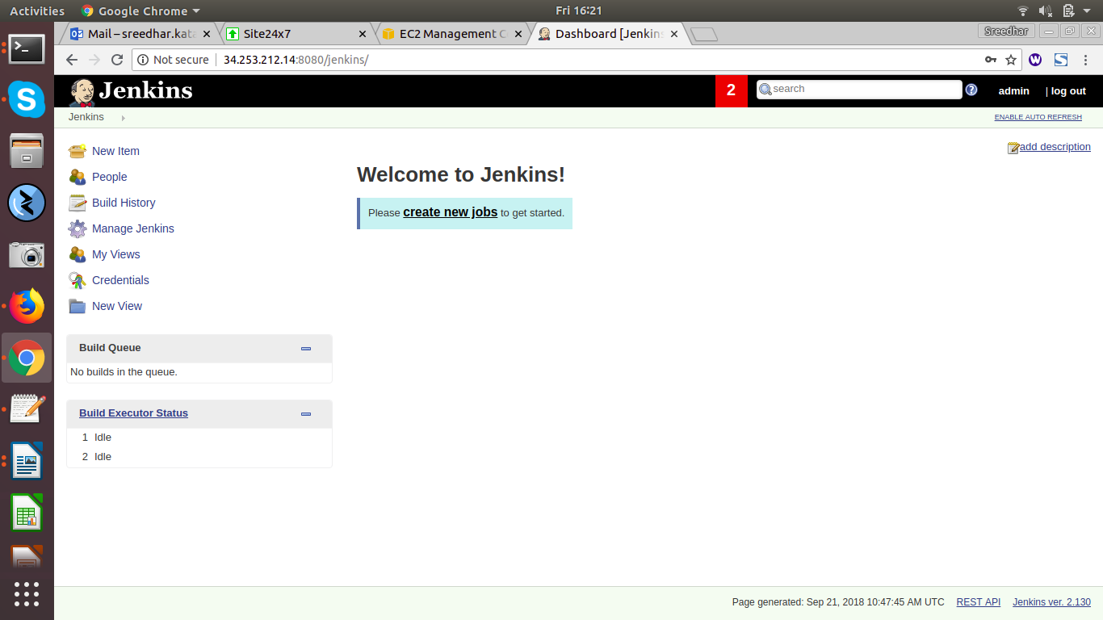
-->left side panel Select Manage Jenkins-->go drop down Select ManageUsers--->

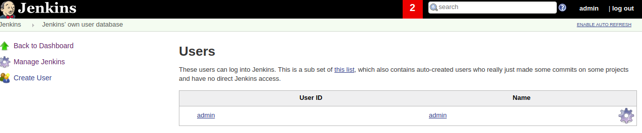
---> Select Create User --> and enter new user details like below

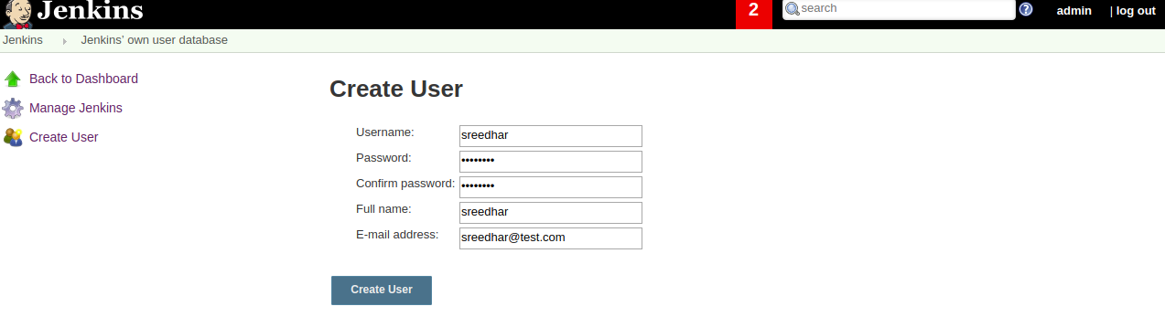
---> and Select Create User --->

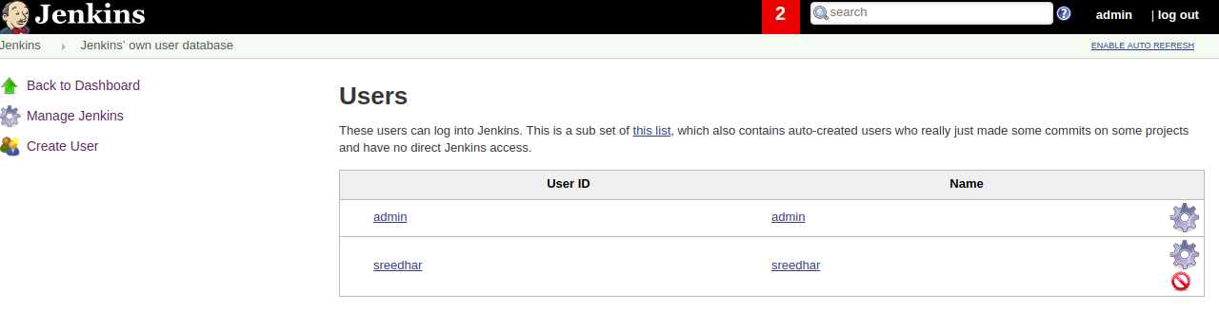
---> Now logout with Admin user and login with new user.

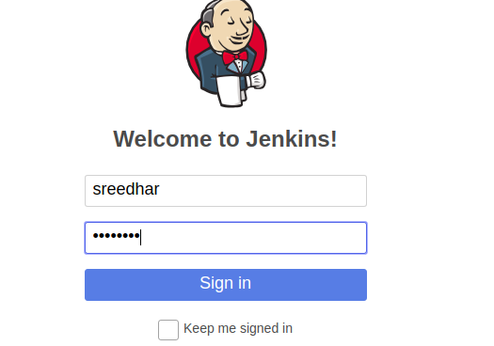
---> New User Jenkins Console will come like below,
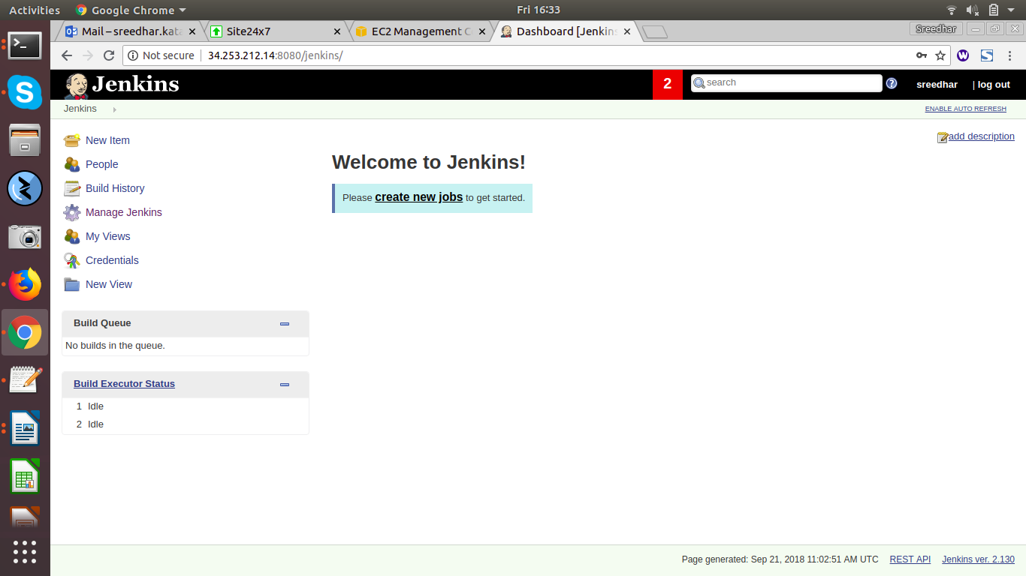

Creating Manage and Assign Roles:-

--->Pre-requisites:-

--->Create and Manage Users role to do that Roles Strategy Plugin is required.

--->Goto Jenkins Console-->Manage Jenkins--> Select Manage Plugins--> Select Available-->

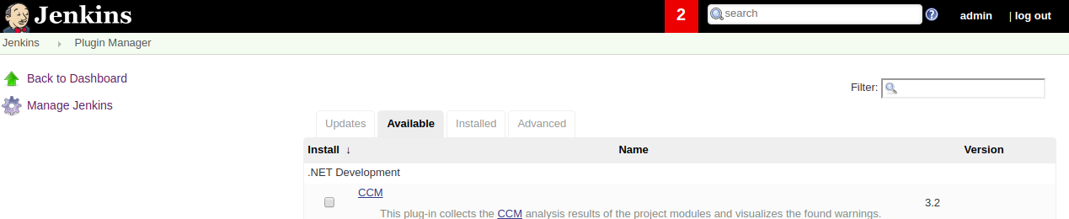

--->Here Search Role Based Authorization Strategy Plugin.

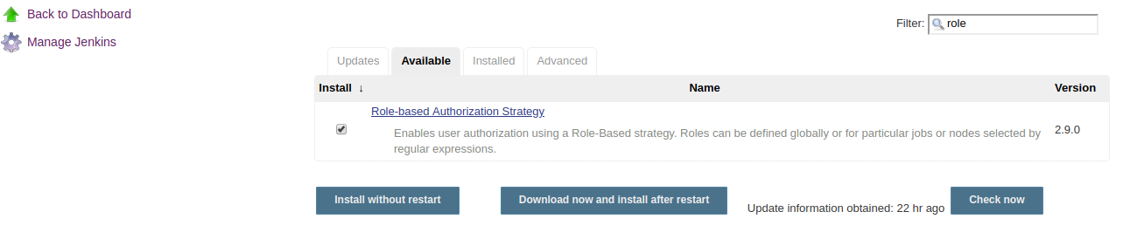

--->After Installed Role Based Authorization Strategy plugin jenkins restart is required.

(Role Based Authorization Strategy)

---> After that make sure enable Enable Security and inside Authorization Section find and Select

Role-Based Strategy(this option will come only after plugin installed and jenkins is restarted)

. For that goto Jenkins Console -->Manage Jenkins--> Select Configure

Global Security--->

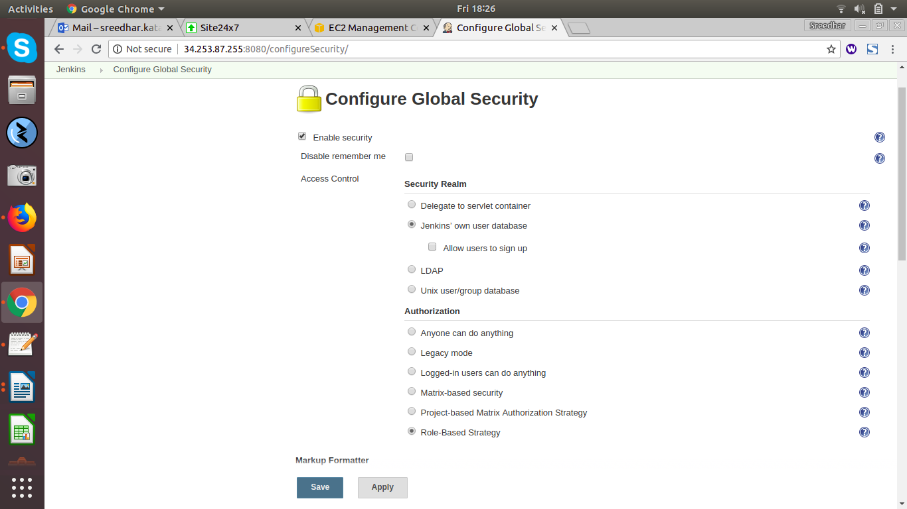
---> Next Apply and Save.

----> For Creating roles-->

---> Goto Jenkins-->Manage Jenkins--> Select Manage and Assign Roles( you will get this option

only after select role based strategy)

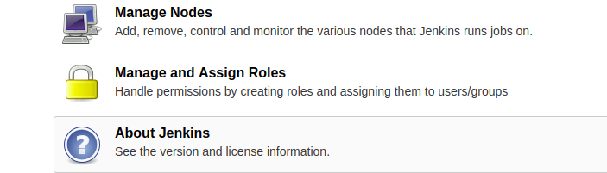

--->After Select Manage and Assign role,

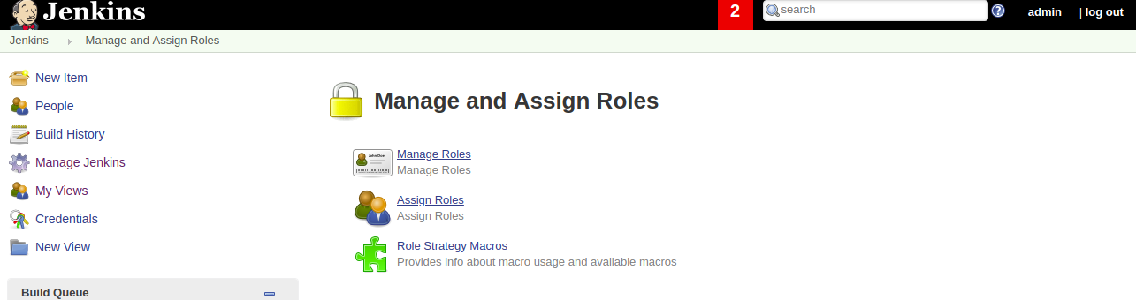
---> To Create a Manage Roles:-

---> Select Manage Role-->

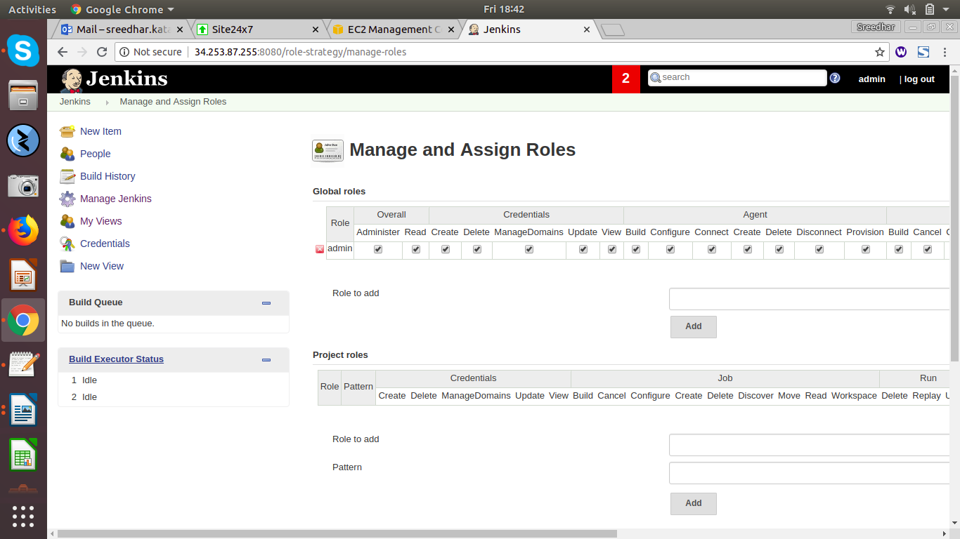
---> Create a global role-->

--->Here I am creating Global and Project Roles

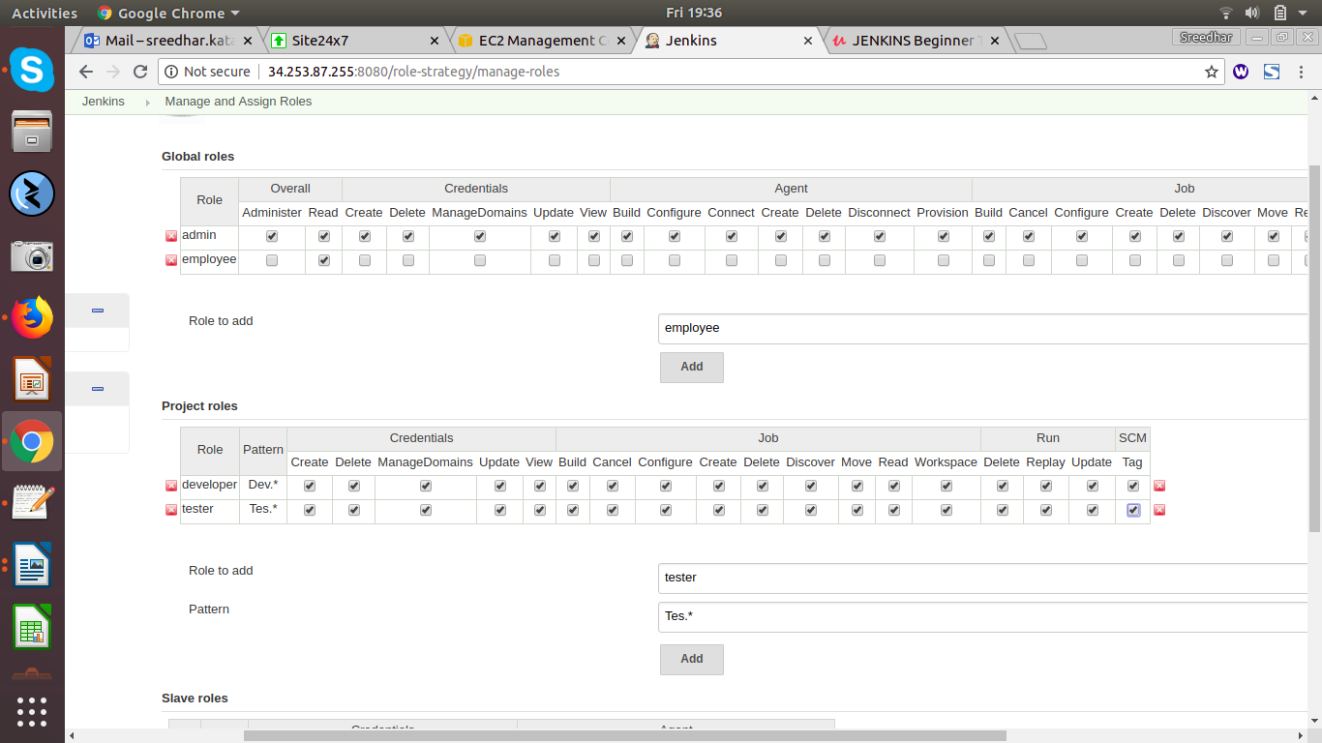

--->Here employee is a Global role and Devloper and Tester as a Project roles

---> Global role “employee” giving read and view access only

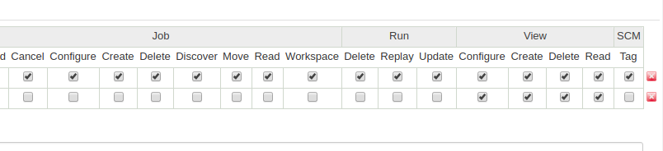
---> Developer and Tester are Project Roles, giving full access to them.

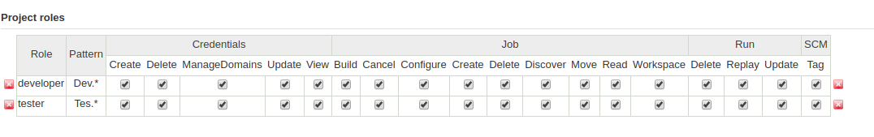
---> Next Apply and Save.

---> Now assigning roles to users.

--->For that goto Jenkins-->Manage Jenkins-->Select Manage and Assign roles-->Select Assign

Roles-->
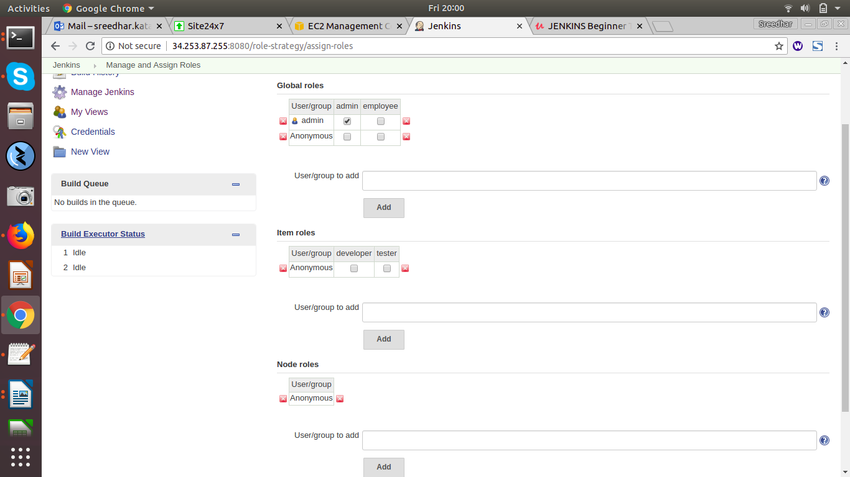

---> I will add users (test1,test2) to Global roles .

---> I will add users (test1,test2) to Project roles .

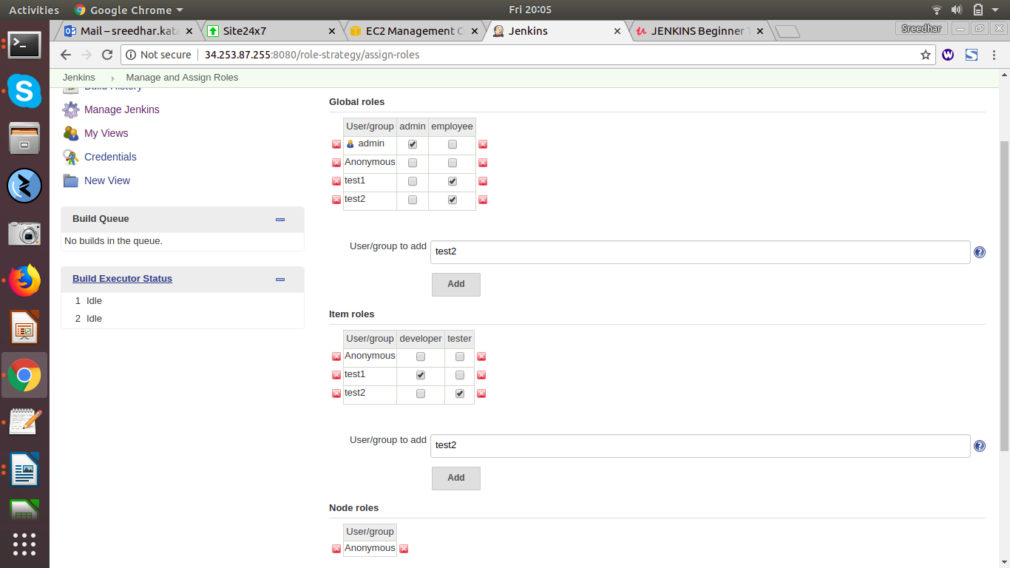

---> In Project Role Test1 user as a Develoer and Test2 user as a tester.

--> Next Apply and Save.

---> Create Two sample projects:-(DevProject and TestProject)

--> Go Jenkins Console-->Select New Item --> Enter an Item) name(DevProject)-Select
freestyle Project-->and select OK-->next Apply and Save.

--> Go Jenkins Console-->Select New Item --> Enter an Item) name(TestProject)-Select
freestyle Project-->and select OK-->next Apply and Save.

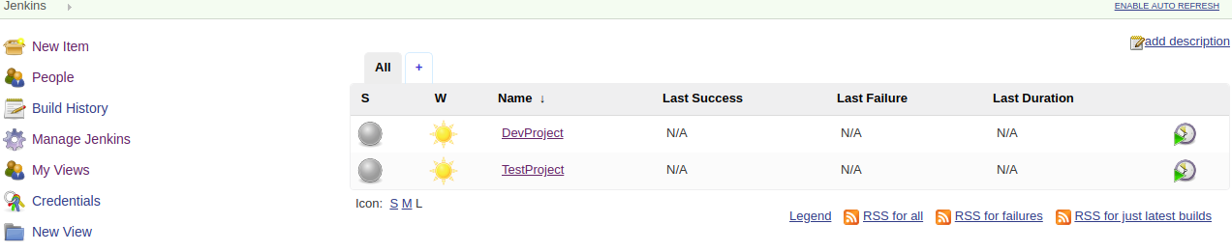

--->Developer can access the project which starts with Dev and same like Tester can access the

project which starts with “Tes”.

---> Now login as a user (Test1)--> can able to access only Dev Project.

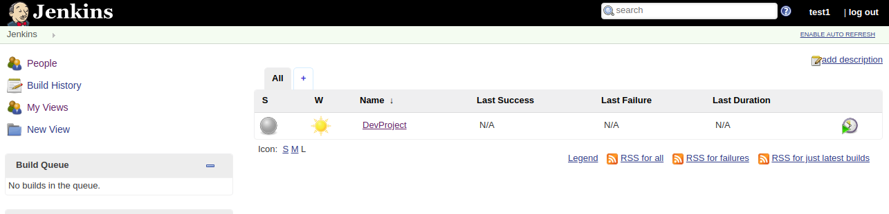
---> Now login as a user (Test2)--> can able to access only Tes Project.

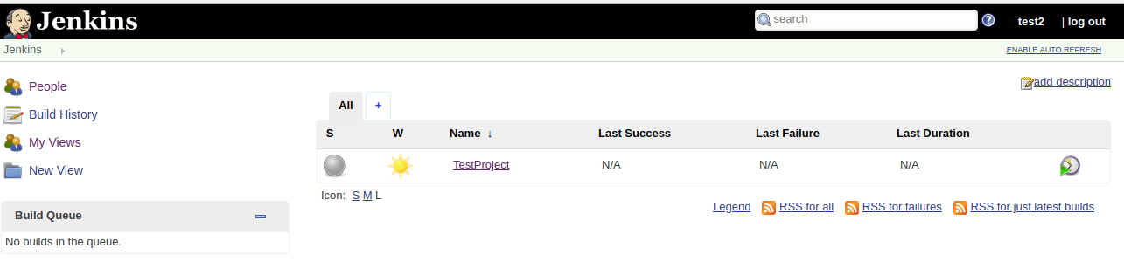

==>Build Jobs:-

--> Creatinig Sample build Job

---> Goto Jenkins Console--> Select New Item-->Enter an Item Name (sample-job)--> Select

FreeStyle Project-->Select OK.

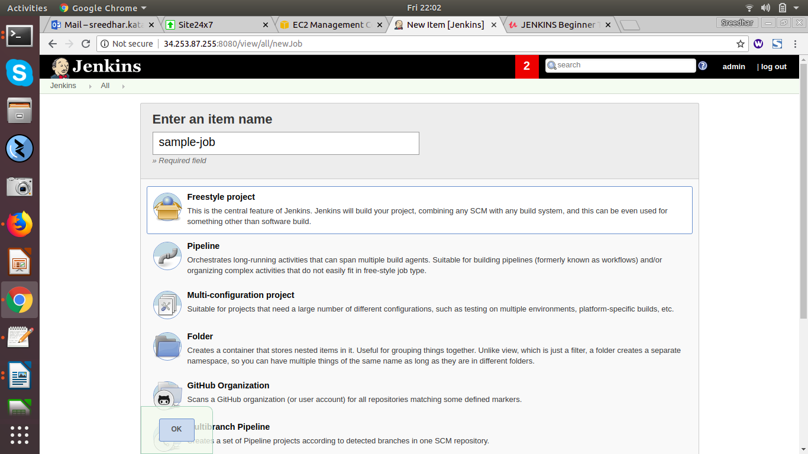

--> Next it will come 5 sessions below are the list-->

General
Source Code Management
Build Triggers
Build Environment
Build
Post-build Actions

---> Selcet Build-->

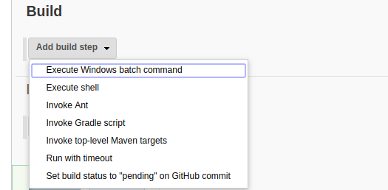

---> Select Excute shell--> and give sample shell commands (ex:date and pwd)

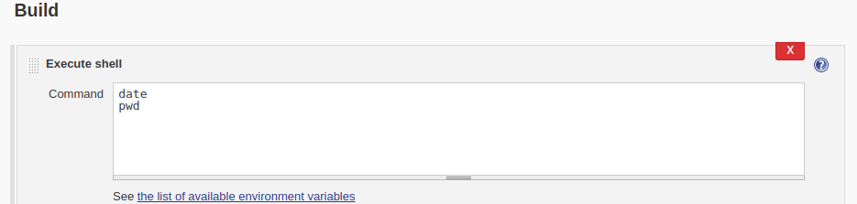
--->next Apply and Save.

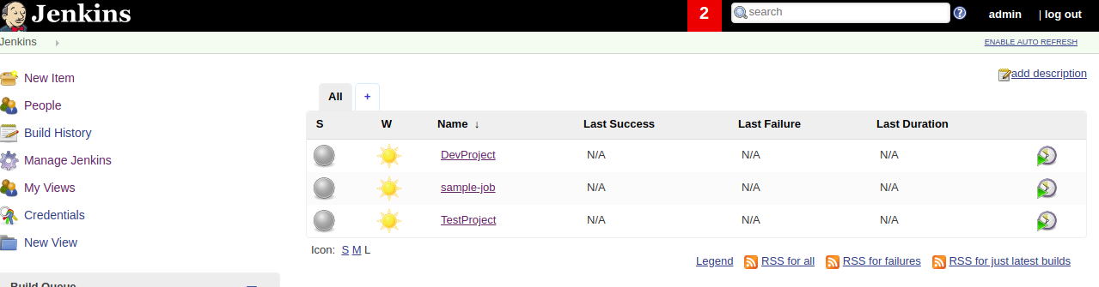
---> Select Sample-Job-->Select Build Now --> Select Build history--> Select Console Output-->

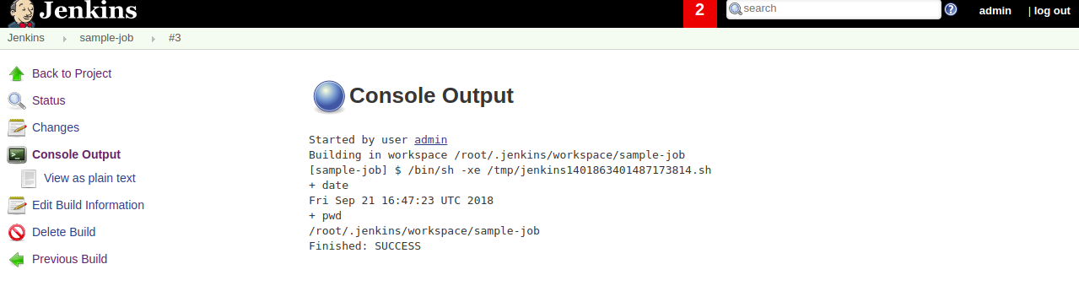

==>Chain Job Executions:-

--->Here we Create Three Sample Projects like (Project1, Project2, Project3)

---> Go Jenkins Console-->Select New Item --> Enter an Item name(Project1)-Select

freestyle Project-->and select OK-->---> Selcet Build-->Select Excute shell--> and give

sample shell commands (ex: date)

---> Go Jenkins Console-->Select New Item --> Enter an Item name(Project2)-Select

freestyle Project-->and select OK-->---> Selcet Build-->Select Excute shell--> and give

sample shell commands (ex: pwd)

---> Goto Jenkins Console-->Select New Item --> Enter an Item name(Project3)-Select

freestyle Project-->and select OK-->---> Selcet Build-->Select Excute shell--> and give

sample shell commands (ex: who)

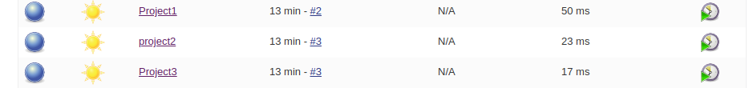

---> Goto Jenkins Console--> Select Project2--> Select Configure-->Select Build Triggers-->

Choose Build after other projects are built and select Project1--> drop down choose Trigger

only if build is stable.

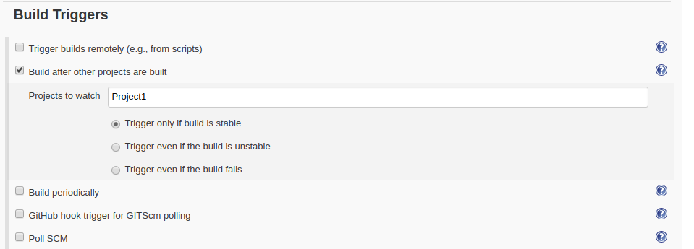

--> Next Select Post-build Actions--> Select Projects to build and select Project3-->drop down

Select Trigger only if builds are stable.

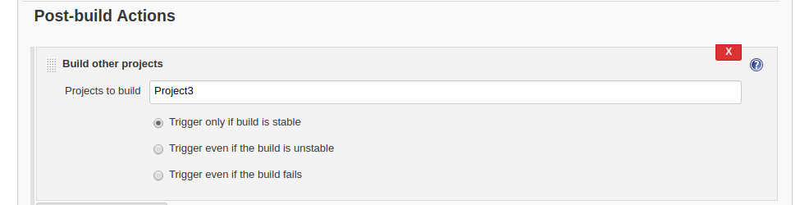

--> Next Apply and Save.

---> Next goto Jenkins Console and Select Project1--> Select Build-->

here jobs build first project1-->project2-->project3.



