First Step before any in place or SQL Server upgrade is the assessment. Below are the steps.

Timeline ( 1-3 Days based on number and size of Databases)

First Install Necessary .NET Framework on all SQL Server tools to be installed as Pre-Req.

**Installation**

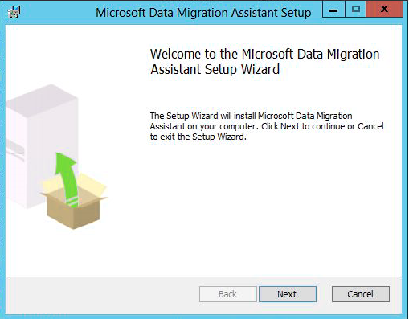

Click on next button.

Read the terms and accept them then click on Next button.

Then you must agree the privacy policy and finally click on the Install button.

If the installation is successful, you will get following pane. You can choose to either launch Database Migration Assistant or not when you click on the “Finish” button.

**Using Database Migration Assistant**

Here is how the interface looks like at startup:

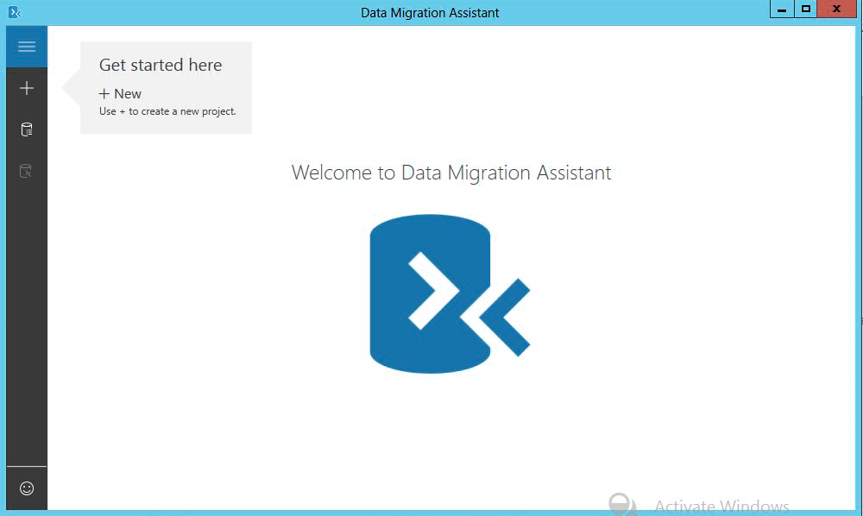

Let’s try it out and click on the “+” button on the left hand sidebar pointed out by the “Get started here” area.

A form will appear letting us choose between an assessment and a migration task. No matter the chosen option, we can see that a project name is absolutely necessary:

**Using Database Migration Assistant to plan a migration**

Let’s first choose the assessment project type and try to plan a SQL Server to SQL Server migration.

One every parameter is set; we can push the “create” button.

Once this button has been clicked, the tool will ask us more and more questions, starting with the target environment. We have following choices:

As I don’t have any SQL Server 2016 or 2017 available at the moment, let’s choose SQL Server 2014.

By default, there is an option that will give advices on the new features that we would add benefits to the current situation.

Once we set everything as we want, we can click on the next button to provide information about the source database(s).

Here is the screen where we provide source servers. We are directly on a form to add a new source where we can specify connection properties like server name, authentication type or connection properties like encryption usage.

Notice the “SQL Server permissions” section on the screen that tells you what permissions are mandatory for the login used for connection.

Once you provided correct credentials with appropriate permissions and clicked on the connect button, you will be shown a list of databases existing on the source server instance. You can select one or more databases and click on the “Add” button to actually add them as source databases for migration process. These databases will be analyzed to check if they can be migrated as is to the destination version of SQL Server.

For instance:

Once we added all the databases, we get a summary with database names and sizes and we can click on a “Start assessment” button.

We will have to wait a moment before getting back the results of this assessment in Database Migration Assistant. While waiting, we can notice that the report will either show compatibility issues or feature recommendations and that we will be able to look for a particular database. These filters can be found on the left part of the report pane:

Once everything is done, we see that an assessment report is divided in multiple parts:

First, there is an icon that visually tells you directly if the database can be migrated (orange rectangle in following screen capture). Then, we see that the tool will run an assessment task for each compatibility level option from current one to the one corresponding to destination’s SQL Server version (zone rounded in purple on following screen capture). Furthermore, for each compatibility level, we will see what the tool discovers in terms of breaking changes, behavior changes and depreciated features and we can click on each discovery to get a full explanation of the discoveries, and which objects are impacted (rounded in green in following screen capture). Finally, we can see there are three actions in Database Migration Assistant that we can perform:

* Restart the assessment
* Delete assessment results
* Export assessment report (to JSON or CSV)

](https://www.sqlshack.com/wp-content/uploads/2018/03/atisources-dba-jel-documents-a-classer-dma-untit-13.png)

*From <*[*https://www.sqlshack.com/an-overview-of-sql-server-database-migration-tools-provided-by-microsoft/*](https://www.sqlshack.com/an-overview-of-sql-server-database-migration-tools-provided-by-microsoft/)*>*

Migration\Upgrade Pre-steps from SQL Server 2019 to SQL Server 2022 Checklist ( Similar for any version to version )

Source SQL Server Checklist

|  |  |  |  |
| --- | --- | --- | --- |
| Task No | Task | Completion Status | Timeline (Overall 1-5 days to document) |
| 0.1 | All recommendations from DMA before upgrade have to be identified and remediated by appropriate DBA or developer. |  | The number of errors and new development needed will increase or decrease migration time significantly. |
| 1. | Identify databases you would like to migrate |  |  |
| 2. | Backup all user databases |  |  |
| 3. | Script out all the existing login |  |  |
| 4. | Script out all the server Roles if applicable |  |  |
| 5. | Script out all the Audit and Audit Specifications if applicable |  |  |
| 6. | Script out backup devices if Applicable |  |  |
| 7. | Script out server level triggers if applicable |  |  |
| 8. | Script out Replication along with Configuration if Applicable |  |  |
| 9. | Script out Mirroring if Applicable |  |  |
| 10. | Script out Data Collection if applicable |  |  |
| 11. | Script out Resource Governor’s objects if applicable |  |  |
| 12. | Script out Linked Server if Applicable |  |  |
| 13. | Script out Log shipping if Applicable |  |  |
| 14. | Script out all SQL Server Agent Jobs |  |  |
| 15. | Script out all DB Mail objects such as Profile and its settings |  |  |
| 16. | Script out All Proxy accounts and credentials if Applicable |  |  |
| 17. | Script out all Operators if Applicable |  |  |
| 18. | Script out all alerts if applicable |  |  |
| 19. | Save SQL Server, Server configuration in a file |  |  |
| 20. | Data Encryption Keys |  |  |
| 21. | Monitor OS usage CPU , Memory , Disk IO and document findings |  |  |
| 22. | Monitor Disk Usage Patterns Size and Load and document findings |  |  |
| 23 | Document all App Users to Servers , ports , Users |  |  |
| 23 | Work with the App team to check no Software \Vendor specific issues for upgrade |  |  |
| 24 | Come to agreement on App test procedure after SQL upgrade with all stakeholders |  |  |

Destination SQL Server Pre - Checklist (This can be same Server for In-Place Upgrade)

|  |  |  |
| --- | --- | --- |
| Task No | Task | Overall Timeline ( 1-3 days) |
| 1. | Based on memory OS usage make increases as needed |  |
| 1. | Based on disk usage. Increase present disk sizes and add disk as needed. Datafiles , Log Files , TempDB and Backups should have their own dedicated drives |  |
| 2. | DBA Source SQL Server Check list is completed |  |
| 3. | Enough Space should be available for storing Backup and source scripts and all of them should be stored in preferably 2 locations for redundancy and precaution |  |
| 4. | Patch OS to latest level recommended since new installation is happening, it will save downtime in future. |  |
| 5. | Specific to Side by Side, Targeted SQL Server version has to be installed with latest patch level to save downtime later |  |
| 6 | Make sure all ports are opened , connectivity is tested during Server setup process |  |

**SQL Server Side-Side Install Actual Steps**

|  |  |  |  |
| --- | --- | --- | --- |
| Task No | Task | Overall Time-Line |  |
| 1 | Make Sure SQL Server is installed with latest patch |  |  |
| 2 | Apply all the Server level configurations previously documented in 3-20 in the pre-steps  This take care of Logins , Server configurations , linked Servers , operators , etc |  |  |
| 3 | 1 and 2 also can be done prior to side by side upgrade and make sure no more changes made with change control, so it will save downtime |  |  |
| 4 | Restore all the databases from the latest last backups after just after source Server database App usage is stopped. |  |  |
| 5 | For Huge database Full , Diff Backups can be restored by no recovery. Then log backups can be applied at cutover time with recovery. |  |  |
| 6 | Make Sure database owner is set correctly |  |  |
| 7 | Make sure compatibility level is changed to latest compatibility level |  |  |
| 8 | Make sure no errors are reported in Windows , SQL , Install logs during this process |  |  |
| 9 | Run Update Statistics , DBUsage after restore is complete |  |  |
| 10 | It is recommended to run the DBCC CheckDB to check database integrity. |  |  |
| 11 | Perform App Connectivity and Use testing as agreed previously. |  |  |
| 12 | If no errors release for production use |  |  |

**In Place Upgrade Not recommended as prone to errors and difficult fixes ( Time 1-3 days)**

In place upgrade documentation

Pre-Steps

* Back up all database files from the instance to be upgraded, so that you can restore them, if it is required.
* Run the appropriate Database Console Commands (DBCC) on databases to be upgraded to ensure that they are in a consistent state.
* Estimate the disk space that is required to upgrade SQL Server components, in addition to user databases. For disk space that is required by SQL Server components
* Ensure that existing SQL Server system databases - master, model, msdb, and tempdb - are configured to auto grow, and ensure that they have sufficient hard disk space.
* Ensure that all database servers have logon information in the master database. This is important for restoring a database, as system logon information resides in master.
* Disable all startup stored procedures, as the upgrade process will stop and start services on the SQL Server instance being upgraded. Stored procedures processed at startup time might block the upgrade process.
* Upgrade target servers before you upgrade master servers. If you upgrade master servers before target servers
* Quit all applications, including all services that have SQL Server dependencies. Upgrade might fail if local applications are connected to the instance being upgraded.
* Make sure that Replication is current and then stop Replication.  
  For detailed steps for performing a rolling upgrade in a replicated environment.

Actual in Place Upgrade

1. Insert the installation media, and from the root folder, double-click Setup.exe. To install from a network share, move to the root folder on the share, and then double-click Setup.exe.
2. The Installation Wizard starts at the Installation Center. To upgrade an existing instance of click **Installation** in the left-hand navigation area, and then click **Upgrade from...** previous versions.
3. On the Product Key page, click an option to indicate whether you are upgrading to a free edition of or whether you have a PID key for a production version of the product.
4. On the License Terms page, review the license agreement and, if you agree, select the **I accept the license terms** check box, and then click **Next**.
5. In the Global Rules window, the setup procedure will automatically advance to the Product Updates window if there are no rule errors. **Not Recommended disable**
6. An update page will appear next if the Update check box in Control Panel\All Control Panel Items\Windows Update\Change settings is not checked. Putting a check in the Update page will change the computer settings to include the latest updates when you scan for Windows Update.
7. On the Product Updates page, the latest available product updates are displayed. If you don't want to include the updates, clear the **Include product updates** check box. If no product updates are discovered, Setup does not display this page and auto advances to the **Install Setup Files** page.
8. On the Install Setup Files page, Setup provides the progress of downloading, extracting, and installing the Setup files. If an update for Setup is found, and is specified to be included, that update will also be installed. **If OS box has no internet connection CUs can be updated later manually by transferring files**
9. In the Upgrade Rules window, the setup procedure will automatically advance to the Select instance window if there are no rule errors.
10. On the Select Instance page, specify the instance of upgrading. To upgrade Management tools and shared features, select **Upgrade shared features only**.
11. On the Select Features page, the features to upgrade will be preselected. A description for each component group appears in the right pane after you select the feature name.
12. On the Instance Configuration page, specify the Instance ID for the instance of

**Instance ID** - By default, the instance name is used as the Instance ID. This is used to identify installation directories and registry keys for your instance. This is the case for default instances and named instances. For a default instance, the instance name and instance ID would be MSSQLSERVER. To use a non-default instance ID, provide a value for the **Instance ID** textbox.

All service packs and upgrades will apply to every component of an.

**Installed instances** - The grid will show instances of that are on the computer where Setup is running. If a default instance is already installed on the computer, you must install a named instance.

1. On the Server Configuration - Service Accounts page, the default service accounts are displayed for services. The actual services that are configured on this page depend on the features that you are upgrading.

Authentication and login information will be carried forward from the previous instance. You can assign the same login account to all services, or you can configure each service account individually. You can also specify whether services start automatically, are started manually, or are disabled.

1. The Feature Rules window will automatically advance if all rules pass.
2. The Ready to Upgrade page displays a tree view of installation options that were specified during Setup. To continue, click **Install**. Setup will first install the required prerequisites for the selected features followed by the feature installation.
3. During installation, the progress page provides status so that you can monitor installation progress as Setup continues.
4. After installation, the Complete page provides a link to the summary log file for the installation and other important notes. To complete the installation process, click **Close**.
5. If you are instructed to restart the computer, do so now. It is important to read the message from the Installation Wizard when you have finished Setup.
6. In the Setup Bootstrap log, you will have all installation log info.