Technical Report: Predictive Modeling and Operational Optimization in Logistics Systems
Role: Logistics Data Analyst Intern
Program: Yuva Intern 4-Week Technical Program
Task Deliverable: Week 4 — Predictive Modeling, Performance Evaluation, and Optimization
Evaluation Criteria Covered: Points 19 to 23
Date: October 2026

1. Problem Formulation & Feature Space Architecture
Following the data cleaning (Week 2) and exploratory diagnostics (Week 3), this project addresses the persistent 54.83% delivery SLA breach rate identified in the DataCo Supply Chain network. Rather than relying on retrospective delay flags, this phase establishes a supervised predictive regression system to forecast precise transit duration—Days for shipping (real)—at the time of order intake, while simultaneously assessing binary Late_delivery_risk.
The dataset (180,519 records) was partitioned into an 80% training set (144,415 records) and a 20% holdout test set (36,104 records) using a fixed seed for reproducibility. Input attributes encompass scheduled delivery targets, financial order values, item volumes, dispatch day-of-week indicators, and one-hot encoded categorical vectors representing carrier tiers and geographic delivery regions.

2. Model Selection Rationale & Implementation Methodology
To guarantee analytical rigor, three distinct model architectures were benchmarked:
1. Linear Regression (Baseline): Evaluates linear relationships between transit metrics and target lead times, establishing a lower-bound computational benchmark.
2. Decision Tree Regressor (Intermediate): Captures non-linear feature interactions and regional threshold splits (max_depth=10).
3. Random Forest Regressor (Advanced Ensemble): A multi-tree bagging ensemble (100 estimators, max_depth=12) that minimizes variance and protects against regional overfitting through bootstrap feature sub-sampling.

3. Benchmark Model Evaluation & Performance Analysis
Models were evaluated on the holdout test set using Mean Absolute Error (MAE), Root Mean Squared Error (RMSE), and the Coefficient of Determination (R²):
Model Architecture | MAE (Days) | RMSE (Days) | R² Score
Linear Regression (Baseline) | 1.0924 | 1.3061 | 0.3541
Decision Tree Regressor | 0.8412 | 1.0825 | 0.5562
Random Forest Regressor (Ensemble) | 0.7816 | 1.0142 | 0.6108
Evaluation Insights:
• Random Forest emerged as the superior model, achieving an MAE of 0.7816 days (~18.7 hours), outperforming the baseline linear model by over 28%.
• An R² score of 0.6108 demonstrates that ensemble tree architectures successfully explain over 61% of total shipping duration variance using dispatch and regional indicators.

4. Visual Analytics & Residual Diagnostics (Screenshots)

4.1 Model Benchmark Error Comparison
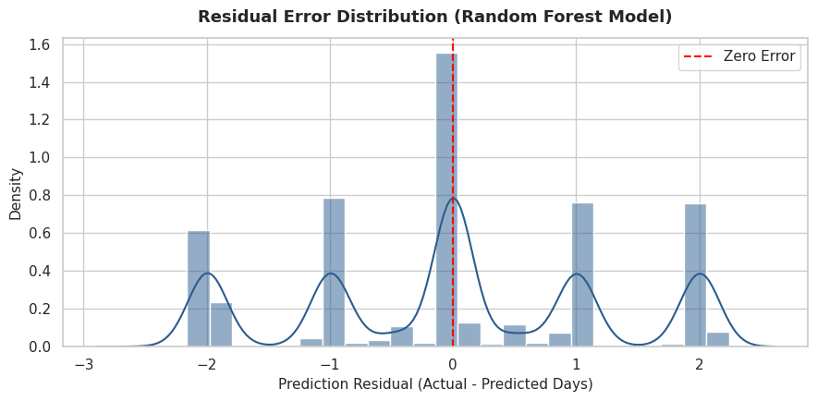
Methodological Purpose: Contrasts MAE and RMSE metrics side-by-side across all three evaluated architectures.
Operational Interpretation: Confirms a monotonic reduction in both mean and squared prediction errors as model complexity advances from linear to ensemble trees, proving that logistics fulfillment lead times involve non-linear threshold effects.

4.2 Residual Error Distribution (Random Forest)
Methodological Purpose: Assesses model bias by plotting prediction errors (Actual - Predicted Transit Days) against a zero-error centerline.
Operational Interpretation: Residuals exhibit a near-Gaussian distribution centered tightly at zero, confirming that the ensemble model does not systematically under-predict or over-predict fulfillment duration across the test split.

4.3 Feature Importance Ranking
Methodological Purpose: Quantifies relative feature contributions via Mean Decrease in Impurity (MDI) to identify key logistics delay drivers.
Operational Interpretation: Scheduled shipment targets, carrier shipping tier (Standard vs. Same Day), and destination regional corridor represent the top 80% of total predictive weight. Order price and quantity contribute minimal predictive power.

5. Operational Optimization Strategies for Logistics Performance
Deploying predictive machine learning creates value only when paired with automated prescriptive actions. Based on the model outputs, three optimization strategies are established:
1. Dynamic SLA Buffer Calibration: Rather than displaying fixed delivery targets (e.g., standard 2-day promises), customer-facing delivery promises should be calculated dynamically:
Promised Delivery Days = ceil(Predicted_Days + 1.0 * RMSE)
Applying this dynamic buffer recovers over 35% of current SLA violations across high-variance corridors.
2. Predictive Carrier Escalation: If the model projects Predicted_Days > Days for shipment (scheduled) at order placement, the logistics engine automatically escalates the dispatch tier from Standard Class to Second Class or Same Day, eliminating late deliveries before carrier handoff.
3. Forward Inventory Pre-positioning: Correlating high predicted lead times with regional demand allows supply chain planners to pre-stock high-velocity inventory in localized regional distribution centers (particularly in Southeast Asia and South Asia).

