Cue
Developer guide
Every feature and how it flows, the architecture, data model, background jobs, testing and deploy.
As of 14 October 2026 · migration 0058
Source: docs/DEVELOPER.md in the repository (this file is generated from it)

Everything a developer needs to work on Cue: what it does, how it is built, how each feature flows from the screen to the database and back, and how it is tested and shipped. It is written against the code as of 14 Oct 2026 (migration 0058). File links are relative to this folder, so they work on GitHub and in an editor.

Contents
1. What Cue is
2. Architecture at a glance
3. Running it locally
4. Configuration
5. House rules
6. The server
7. Data model
8. Core flows
9. The web client
10. Languages: English and Hindi
11. Push notifications
12. The Android app
13. Testing
14. Database migrations
15. CI, deploy and production
16. Security and privacy, as enforced in code
17. Recipes
18. Known gaps and loose ends

1. What Cue is
Cue is a personal assistant for anyone with a lot to remember: say a thing once — typed, dictated, shared from another app, or found in your email — and Cue turns it into a plan with the right reminders, and keeps at you until it is done. It is built for India first: Hinglish and Hindi lines are understood, the whole app is in English and Hindi, and rupees, UPI, IRCTC, FASTag and PUC are all known.
It is generic on purpose. What a person picks they use Cue for (personal life, office work, sales, hiring, freelance, a job search, studies) only decides which sections they see first; every feature is open to everyone.
It runs at https://cue.vitelio.in/ — in any phone's browser, installed to the home screen, or as an Android app (in.vitelio.cue).
What it does, by area
- Capture — one box understands plain sentences in English, Hinglish and Hindi: plans, repeating plans, trips, wishes ("when I'm in Pune…"), bills, expenses, money owed, parcels, bookings, job/hiring/deal updates. An optional AI reading helps only with lines the rules are unsure of.
- Plans and nagging — every plan gets reminders that escalate until it is done, snoozed or moved; overdue items are triaged, moved into real free slots, or let go.
- The day's rhythm — morning brief, meeting prep, after-meeting follow-ups, focus blocks, an evening nudge that plans tomorrow, a daily report for whoever you report to, and a Friday weekly review.
- Your inbox and calendar, read for you — Gmail/Outlook (read-only) give tickets, hotel stays, parcels, bills, insurance, PUC, service dates, FASTag and challans; Google/Microsoft calendars and ICS feeds are mirrored.
- Trips — assembled from bookings and plans in other cities, with packing lists and "while I'm there" wishes.
- People — contacts, keep-in-touch cadences, birthdays and greetings, who you are waiting on, money owed with UPI reminders.
- Work — job hunt, hiring and deal boards; companies and their stages; weekly targets.
- Money — bills and renewals, expenses and claims, parcels with cash on delivery.

A demo, no sign-up. "Try the demo" on the website opens a 24-hour account with a sample week, in the language the visitor was reading.

2. Architecture at a glance
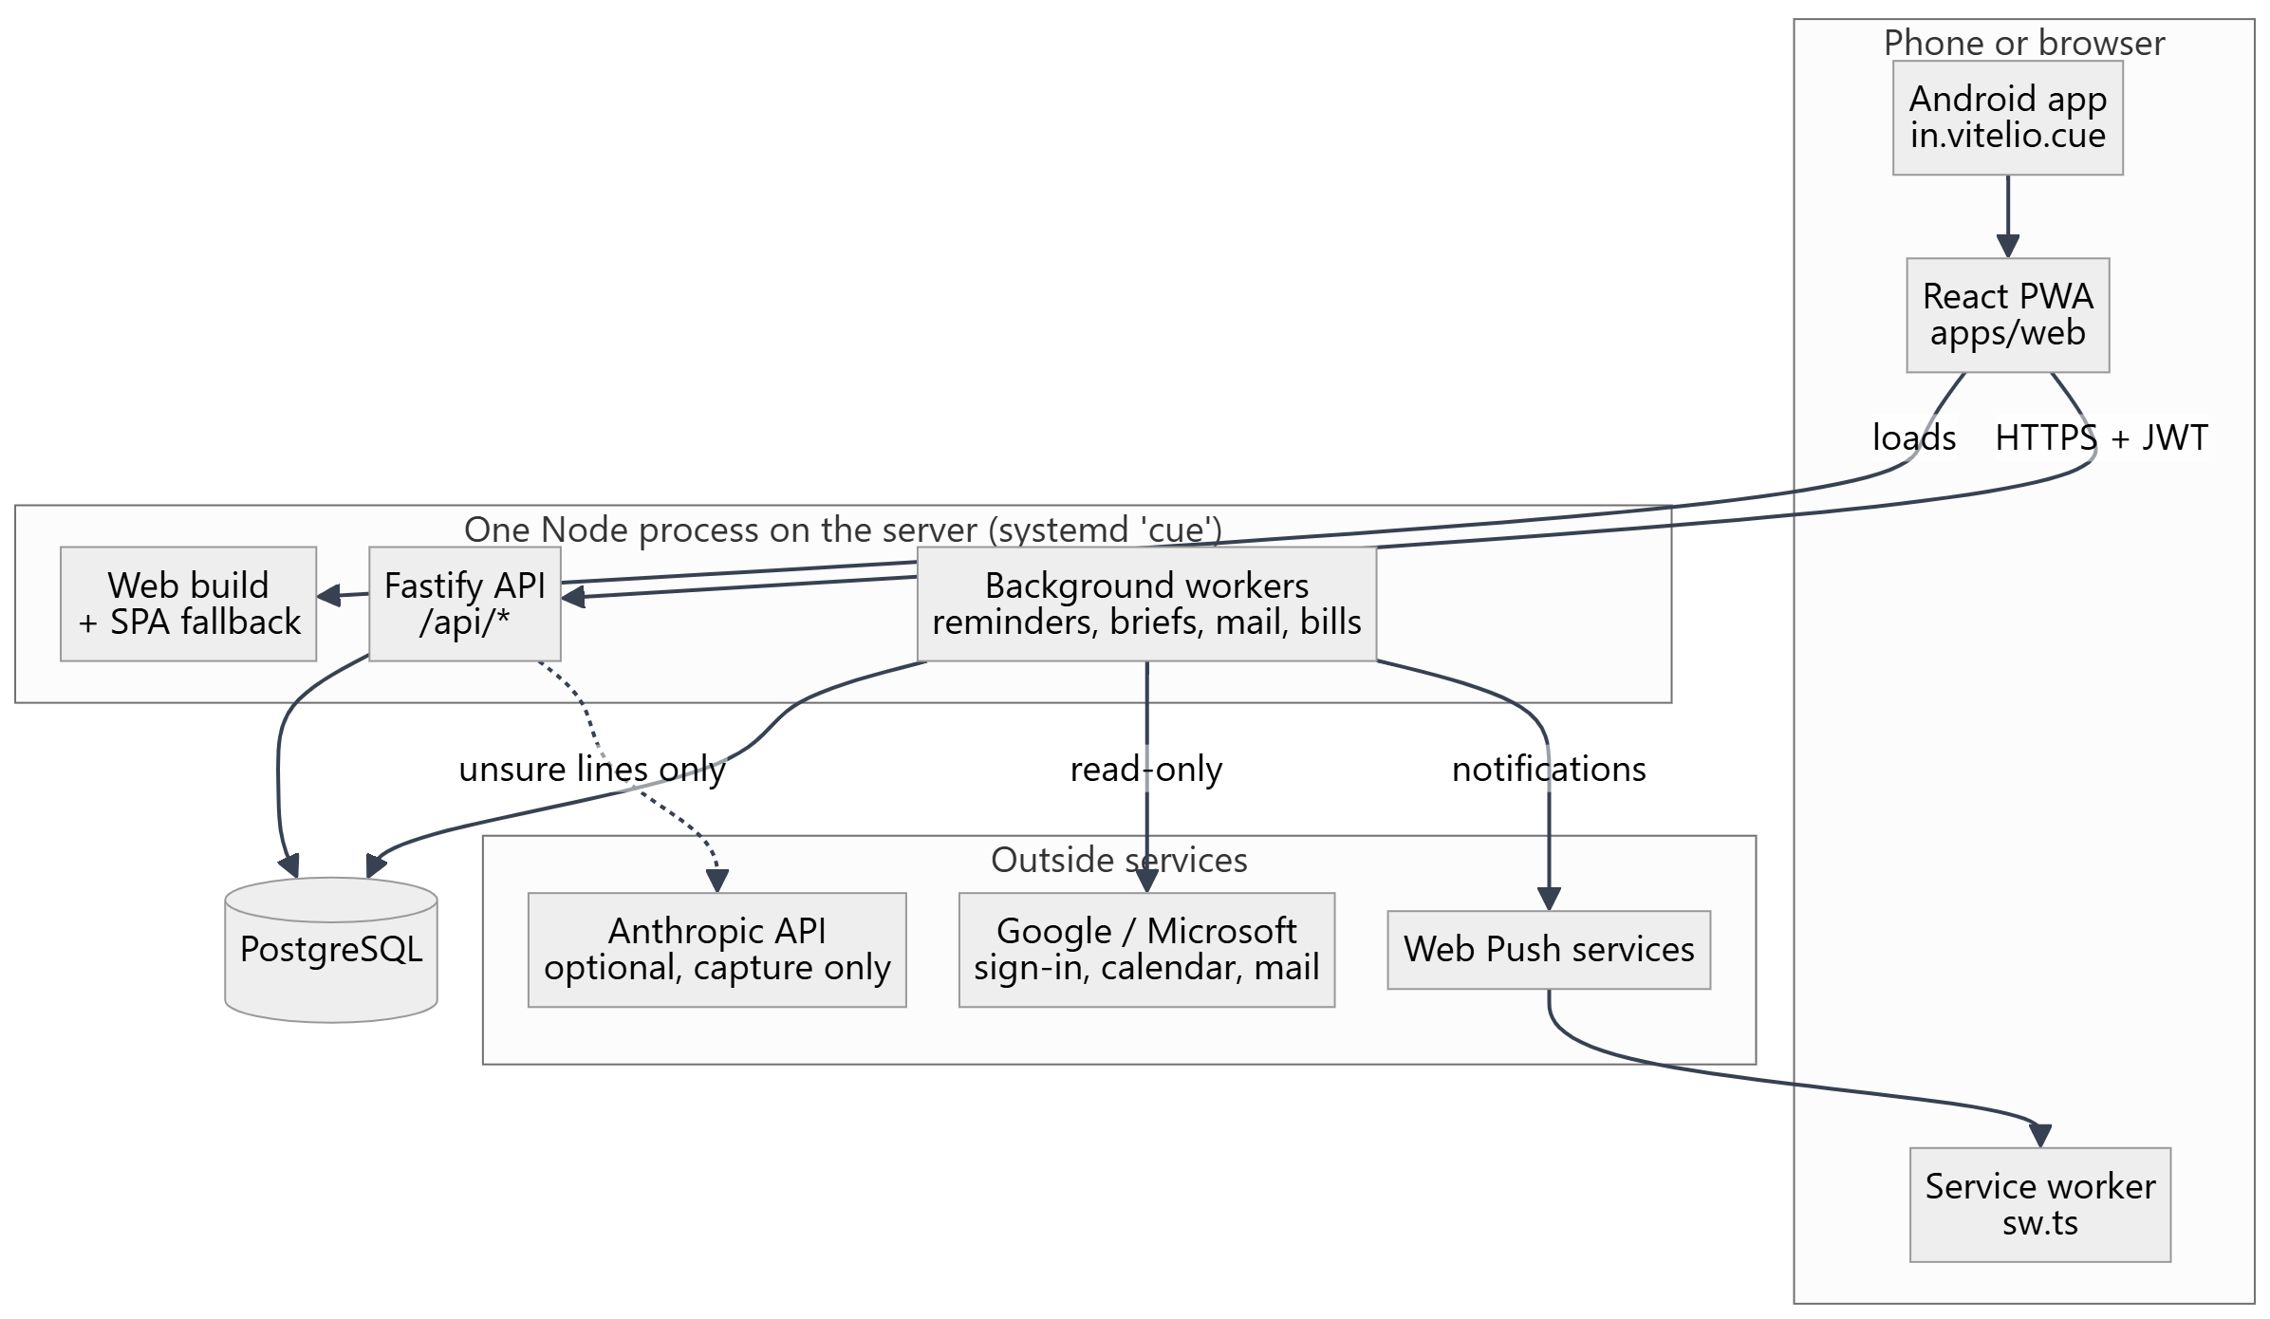
Monorepo (npm workspaces, Node ≥ 22, ES modules, TypeScript everywhere):
Path | What it is
apps/api | Fastify 5 API, run as TypeScript through tsx (no build step). Drizzle ORM over postgres.js. Hand-written SQL migrations.
apps/web | React 18 + react-router 7 + Vite 6 PWA (vite-plugin-pwa, injectManifest). One global stylesheet.
packages/shared | @cue/shared: zod input schemas, DTO types, and all the pure logic both sides need — the sentence parsers, recurrence rules, Hindi tables. Consumed as TS source.
android | Bubblewrap TWA definitions and Play Store listings for both apps.
scripts | setup-db.ps1 (Windows local Postgres).
.github/workflows | deploy.yml (check + deploy), android.yml (build an app).

Why it is shaped this way
- One process, one port, one URL. The API serves the built web app, so production is a single systemd unit behind Caddy; the same origin means no CORS in production and the service worker scope is the whole site.
- Logic in shared. Parsers and rules are pure functions with unit tests; the server calls them to save, the web calls some of them to preview or label.
- Everything is a commitment. A plan, a repeating plan's day, a mirrored calendar event, a booking and a bill reminder all end up as rows in commitments, so Today, the calendar, search and the reminder engine work for all of them without knowing where they came from.

Tech stack (installed versions)
Area | Stack
Runtime | Node 22, tsx 4.23, TypeScript 5.9 (strict, noUncheckedIndexedAccess)
API | fastify 5.12, @fastify/jwt 9, @fastify/cors 10, @fastify/static 8, zod 3.25, bcryptjs, web-push 3.6, nodemailer, pdfjs-dist 6.3 (pinned)
DB | PostgreSQL 14+ (CI 16, local 18), postgres.js 3.4, drizzle-orm 0.38
Web | react 18.3, react-router-dom 7, vite 6.4, vite-plugin-pwa 0.21, workbox 7.4
Tests | node:test + node:assert/strict via tsx --test; API tests against real Postgres

3. Running it locally
Prerequisites: Node 22+, a local PostgreSQL (14 or newer). No Docker.
npm install
- Create a database. On Windows npm run db:setup creates the cue role and database (it asks for the Postgres superuser password). On other systems, create a database by hand.
- Create .env at the repo root (both the API and Vite read it from there). The minimum is DATABASE_URL and JWT_SECRET; see §4. Never point a local .env at the production database.
- Migrate. On a brand-new, empty database the first run needs the guard lifted once:
CUE_NEW_DATABASE=1 npm run db:migrate

After that, always plain npm run db:migrate. (Do not use npm run db:push: drizzle-kit push is broken against PostgreSQL 18, and the migrations folder is the source of truth.)
- Run.
npm run dev # API on :3002 (tsx watch) + Vite on :5173

Or build the web app and let the API serve it on one port, as in production:
npm run build
PORT=3002 npm start -w @cue/api
- Optional pieces
  - Push: npm run vapid prints a key pair for VAPID_PUBLIC_KEY / VAPID_PRIVATE_KEY.
  - Google/Microsoft: client id/secret plus ENCRYPTION_KEY; npm run check:oauth prints what the server derives (never secrets).
  - Capture AI: ANTHROPIC_API_KEY.
  - npm run seed creates a local demo tenant; or press "Try the demo" on the website, which makes a 24-hour demo account with a sample week.

A throwaway database for tests. API tests create and drop their own schemas, but they still need a database to do it in. The simplest safe set-up is a private cluster on its own port with trust auth:
initdb -D <scratch>/pgdata -U postgres --auth=trust
pg_ctl -D <scratch>/pgdata -o "-p 5499 -c listen_addresses=localhost" -l <scratch>/pg.log start
createdb -h localhost -p 5499 -U postgres cue
DATABASE_URL=postgres://postgres@localhost:5499/cue npm run db:migrate # with CUE_NEW_DATABASE=1 the first time
DATABASE_URL=postgres://postgres@localhost:5499/cue npm run test:api

4. Configuration
All server configuration is environment variables, read once in apps/api/src/env.ts from the repo-root .env.
Variable | Default | Purpose
DATABASE_URL | required | Postgres URL (?sslmode=require for managed hosts)
JWT_SECRET | required | Signs session tokens
PORT / HOST | 3002 / 0.0.0.0 | Listen address; use HOST=127.0.0.1 behind a proxy
WEB_ORIGIN | http://localhost:5173 | CORS origin, base for reset links and OAuth returns
APP_TIMEZONE | Asia/Kolkata | Sets process.TZ for the whole server (day boundaries)
VAPID_PUBLIC_KEY, VAPID_PRIVATE_KEY, VAPID_SUBJECT | empty | Web push
ENCRYPTION_KEY | empty | AES-256-GCM for OAuth tokens, ICS URLs and own-key AI keys. Without it, Google/Microsoft count as not configured
GOOGLE_CLIENT_ID, GOOGLE_CLIENT_SECRET, GOOGLE_REDIRECT_URI | empty / derived | Google Calendar and Gmail
MICROSOFT_CLIENT_ID, MICROSOFT_CLIENT_SECRET, MICROSOFT_TENANT, MICROSOFT_REDIRECT_URI | empty / common / derived | Outlook calendar and mail
PLACE_LOOKUP_PROVIDER, GOOGLE_PLACES_API_KEY | auto / empty | Businesses near a point: Google if a key, else OpenStreetMap
SMTP_HOST, SMTP_PORT, SMTP_USER, SMTP_PASSWORD, SMTP_FROM | empty / 587 | Password-reset email only
ANTHROPIC_API_KEY, CAPTURE_AI_MODEL | empty / claude-haiku-5-5 | Capture AI; empty means rules only
CAPTURE_AI_DAILY_LIMIT, CAPTURE_AI_DEMO_LIMIT | 40 / 8 | AI readings per user per day
AI_DEFAULT_MODEL | claude-haiku-5-5 | An org's own-key extraction
ANDROID_PACKAGE, ANDROID_CERT_SHA256 | in.vitelio.cue / none | Digital Asset Links for the Cue app
TRAVEL_SPEED_KMH | 45 | Travel-time estimates between places
REMINDER_POLL_MS, ESCALATION_MINUTES, MAX_ESCALATIONS | 20000 / 15 / 4 | The nag engine
CUE_NEW_DATABASE | unset | 1 only for the very first migrate of an empty database

Web build-time: VITE_API_URL (leave blank in production so the browser calls its own origin), WEB_PORT (Vite dev port, 5173).

5. House rules
These are decisions, not accidents. Keep them.
- Every user-visible string has Hindi. Web text goes through t(), msg() or rich() with an entry in apps/web/src/lib/hi/*.ts; server text through t(lang, …) with an entry in apps/api/src/hi/*.ts. Tests fail otherwise (§10). Policies are kept in pairs.
- Email is never sent to any AI service. The privacy policy promises it. The mail path has no AI call; keep it that way.
- Sections appear because they are wanted. The defaults are People, Trips, Repeating and History; anything else shows because the person picked a use that leads to it or already has something in it (§8.12).
- Migrations are hand-written SQL, forward-only and idempotent. schema.ts is kept in step by hand. The migrate script refuses a database with no history unless told it is new.
- Tests run against a real Postgres. Never against production.
- Comments explain why, in plain words. The code base reads like a description of the product; match it.

6. The server

6.1 Bootstrap
apps/api/src/index.ts:
- Fastify with pino logging at info. A ZodError becomes 400 {error:'invalid_input', issues}; other errors become {error: message} with their status (≥500 logged).
- CORS for WEB_ORIGIN; JWT auth (registerAuth); static serving of apps/web/dist with an SPA fallback (404 JSON for /api* and non-GET).
- Unprefixed: GET /health → {ok, push} (does not touch the DB); GET /.well-known/assetlinks.json (built from the ANDROID_* variables).
- Every route module registered under /api (§6.3).
- Start-up checks: select 1, the time zone, OAuth redirect sanity, VAPID presence.
- Starts the workers (§6.4); on SIGINT/SIGTERM stops them and closes Fastify.

6.2 Auth and tenancy
- Sessions are JWTs (@fastify/jwt, 30 days) with {sub: userId, orgId, email}. app.authenticate guards routes; scope(req) returns the claims. Tenant ids come from the token, never from a request body, and every query filters by them.
- Sign-up creates an org ("<name>'s account") and the user as owner. bcrypt cost 10. Login failures are a single invalid_credentials.
- Password reset: a 32-byte token stored as a SHA-256 hash, single use, one hour; /auth/forgot answers the same whether or not the address exists.
- Demo accounts: POST /auth/demo {language?: 'en'|'hi'} makes org "Demo" with user "Asha" and a sample week (sampleDay.ts), in that language from the start; 5 per address per hour, 120 per hour overall; deleted after 24 hours. Demos cannot connect Google/Microsoft and get a smaller AI allowance.
- Account deletion needs the password (not for demos), revokes OAuth grants first, then deletes the user — or the whole org if they were alone.

6.3 Route catalogue
All under /api, all authenticated unless noted. Files are in apps/api/src/routes.
File | Endpoints | For
auth.ts | POST /auth/register, /login, /demo, /forgot, /reset, /change-password; GET/DELETE /auth/me; avatar POST/DELETE /auth/avatar, GET /auth/avatar/:id; PATCH /auth/profile | Accounts
me.ts | GET /me/filled; GET/PATCH /me/preferences; POST /me/preferences/test-brief, test-nudge, test-report | Preferences, sections with something in them, "send it now"
quickAdd.ts | GET /quick/suggestions; POST /quick/preview; POST /quick; DELETE /quick/:kind/:id | The capture box (§8.1)
commitments.ts | GET /commitments/range, /agenda, /queue; POST /commitments, /check-conflicts, /suggest-slots; GET/PATCH/DELETE /commitments/:id; POST /:id/done, /cancel, /snooze, /reschedule, /wrap-up; GET /:id/slots, /:id/prep; GET /people/summary, /people/:id/overview, /accounts/overview | Plans
checklist.ts | GET/POST /commitments/:id/checklist; PATCH/DELETE /checklist/:itemId | Lists on plans
recurrences.ts | GET/POST /recurrences; GET/PATCH/DELETE /recurrences/:id; POST /recurrences/:id/detach/:commitmentId | Repeating plans
schedules.ts | GET/POST /schedules; DELETE /schedules/:id | Step schedules (e.g. child vaccinations)
focus.ts | POST /focus; POST /focus/:id/end | Focus blocks
insights.ts | GET /insights; POST/DELETE /sample-day; GET/POST /plan/tomorrow; GET/POST /triage | Today's insights, planning tomorrow, triage
review.ts | GET /review/week; POST /review/week/done, /test | Weekly review
report.ts | GET /report/day | Daily report / stand-up
availability.ts | GET /availability | Free times to send someone
search.ts | GET /search, /history, /people/match; DELETE /history/:kind/:id | Search and history
trips.ts | GET/POST /trips; GET/PATCH/DELETE /trips/:id; POST /trips/:id/packing | Trips
intentions.ts | GET/POST /intentions, POST /intentions/batch, /nearby; PATCH/DELETE /intentions/:id; POST /intentions/:id/schedule; POST /commitments/:id/attach-wishes; POST /trips/:id/plan-wishes | Wishes ("while I'm there")
places.ts | GET/POST /places; POST /places/lookup, /match; GET /places/:id, /places/:id/suggestion | Places
visits.ts | POST/GET /visits; GET/PATCH/DELETE /visits/:id | Logged visits (offline-safe by clientId)
voiceNotes.ts | POST/GET /voice-notes; GET /voice-notes/:id/audio; PATCH/DELETE /voice-notes/:id | Voice notes
calls.ts | POST /calls | A call just made, and what came of it
contacts.ts | GET/POST /contacts, GET /contacts/organizations, POST /contacts/import; GET/PATCH/DELETE /contacts/:id; POST /contacts/:id/touched, /touch-later; GET /people/keep-in-touch | People
occasions.ts | GET /occasions/upcoming; GET/POST /greetings; GET /greetings/:id; POST /greetings/:id/sent | Birthdays, festival greetings
owed.ts | GET/POST /owed; POST /owed/status, /owed/asked; DELETE /owed/:id; PUT /expenses/:id/shares | Money owed to you
templates.ts | GET/POST /templates; POST /templates/starters; PATCH/DELETE /templates/:id; POST /templates/:id/used | Quick messages
accounts.ts | GET/PUT /accounts; POST /accounts/rename | Companies and their stages
trackers.ts | GET /trackers; GET/POST /trackers/:board; GET/PATCH/DELETE /tracker-items/:id | Jobs, hiring, deals boards
targets.ts | GET /targets/week; PUT /targets | Weekly targets
expenses.ts | GET /expenses, /unclaimed, /claimed; POST /expenses, /claim; PATCH/DELETE /expenses/:id; receipt GET/POST/DELETE /expenses/:id/receipt | Expenses and claims
bills.ts | GET/POST /bills; PATCH/DELETE /bills/:id; POST /bills/:id/paid, /undo-paid; GET /bills/:id/payments | Bills and renewals
deliveries.ts | GET /deliveries; PATCH/DELETE /deliveries/:id | Parcels
calendarFeeds.ts | GET/POST /calendar-feeds; POST /calendar-feeds/upload; POST /calendar-feeds/:id/sync; PATCH/DELETE /calendar-feeds/:id | Calendars Cue reads
oauth.ts | GET /oauth/status; POST /oauth/:provider/connect; GET /oauth/:provider/callback (no auth); GET/POST /oauth/accounts/:id/calendars; POST /oauth/accounts/:id/setup; DELETE /oauth/accounts/:id | Google / Microsoft
mail.ts | GET /mail/found; POST /mail/check; POST /oauth/accounts/:id/mail-off | Mail reading
push.ts | GET /push/public-key (no auth); POST /push/subscribe, /unsubscribe, /test | Web push
ai.ts | GET/PATCH /ai/settings; POST /ai/ollama-models, /ai/test, /ai/extract | An org's own AI key (owner only)

6.4 Background workers
All run inside the API process. Each runs once at start, then on its interval, with a guard so ticks never overlap. Per-user schedules are judged in the user's time zone (users.timezone), and each records the local date it last sent, so a restart cannot send twice.
Worker | File | Every | Does
Reminders | worker/reminders.ts | 20 s | Claims due reminders (FOR UPDATE SKIP LOCKED), pushes, escalates (§8.2)
Morning brief | services/morningBrief.ts | 5 min | At morningBriefHour (8): today's shape; nothing on an empty day
Evening nudge | services/dailyNudge.ts | 5 min | At dailyNudgeHour (19): "did you log everything?", and tomorrow planned
Daily report | services/dailyReport.ts | 5 min | Opt-in, at reportHour (18): "your report is ready"
Weekly review | services/weeklyReview.ts | 10 min | Friday at weeklyReviewHour (17)
Meeting prep | services/meetingPrep.ts | 2 min | 15 min before a meeting with things open from last time
Follow-ups | services/wrapUp.ts | 2 min | A one-off meeting that just ended: "anything to follow up?"
Focus | services/focus.ts | 2 min | Closes finished focus blocks (no push)
Bills | services/bills.ts | 15 min | Days before, on the day, the day after (09:00–21:00 local)
Deliveries | services/deliveries.ts | 15 min | "Arriving today", with cash on delivery
Mail | services/mailReader.ts | 15 min | Reads connected mailboxes (§8.5)
Demo clean-up | services/demo.ts | 1 h | Deletes demo orgs older than 24 h
Recurrence sweep | services/recurrence.ts | 1 h | Keeps 120 days of repeating plans written ahead
Calendar sync | services/calendarFeed.ts | 30 min | Re-reads ICS, Google and Microsoft calendars
Voice-note purge | routes/voiceNotes.ts | 1 h | Removes audio never attached to a visit

7. Data model
The types live in apps/api/src/db/schema.ts (Drizzle); the truth is the SQL in apps/api/migrations. The diagram shows how plans hang together; the table after it lists every table.
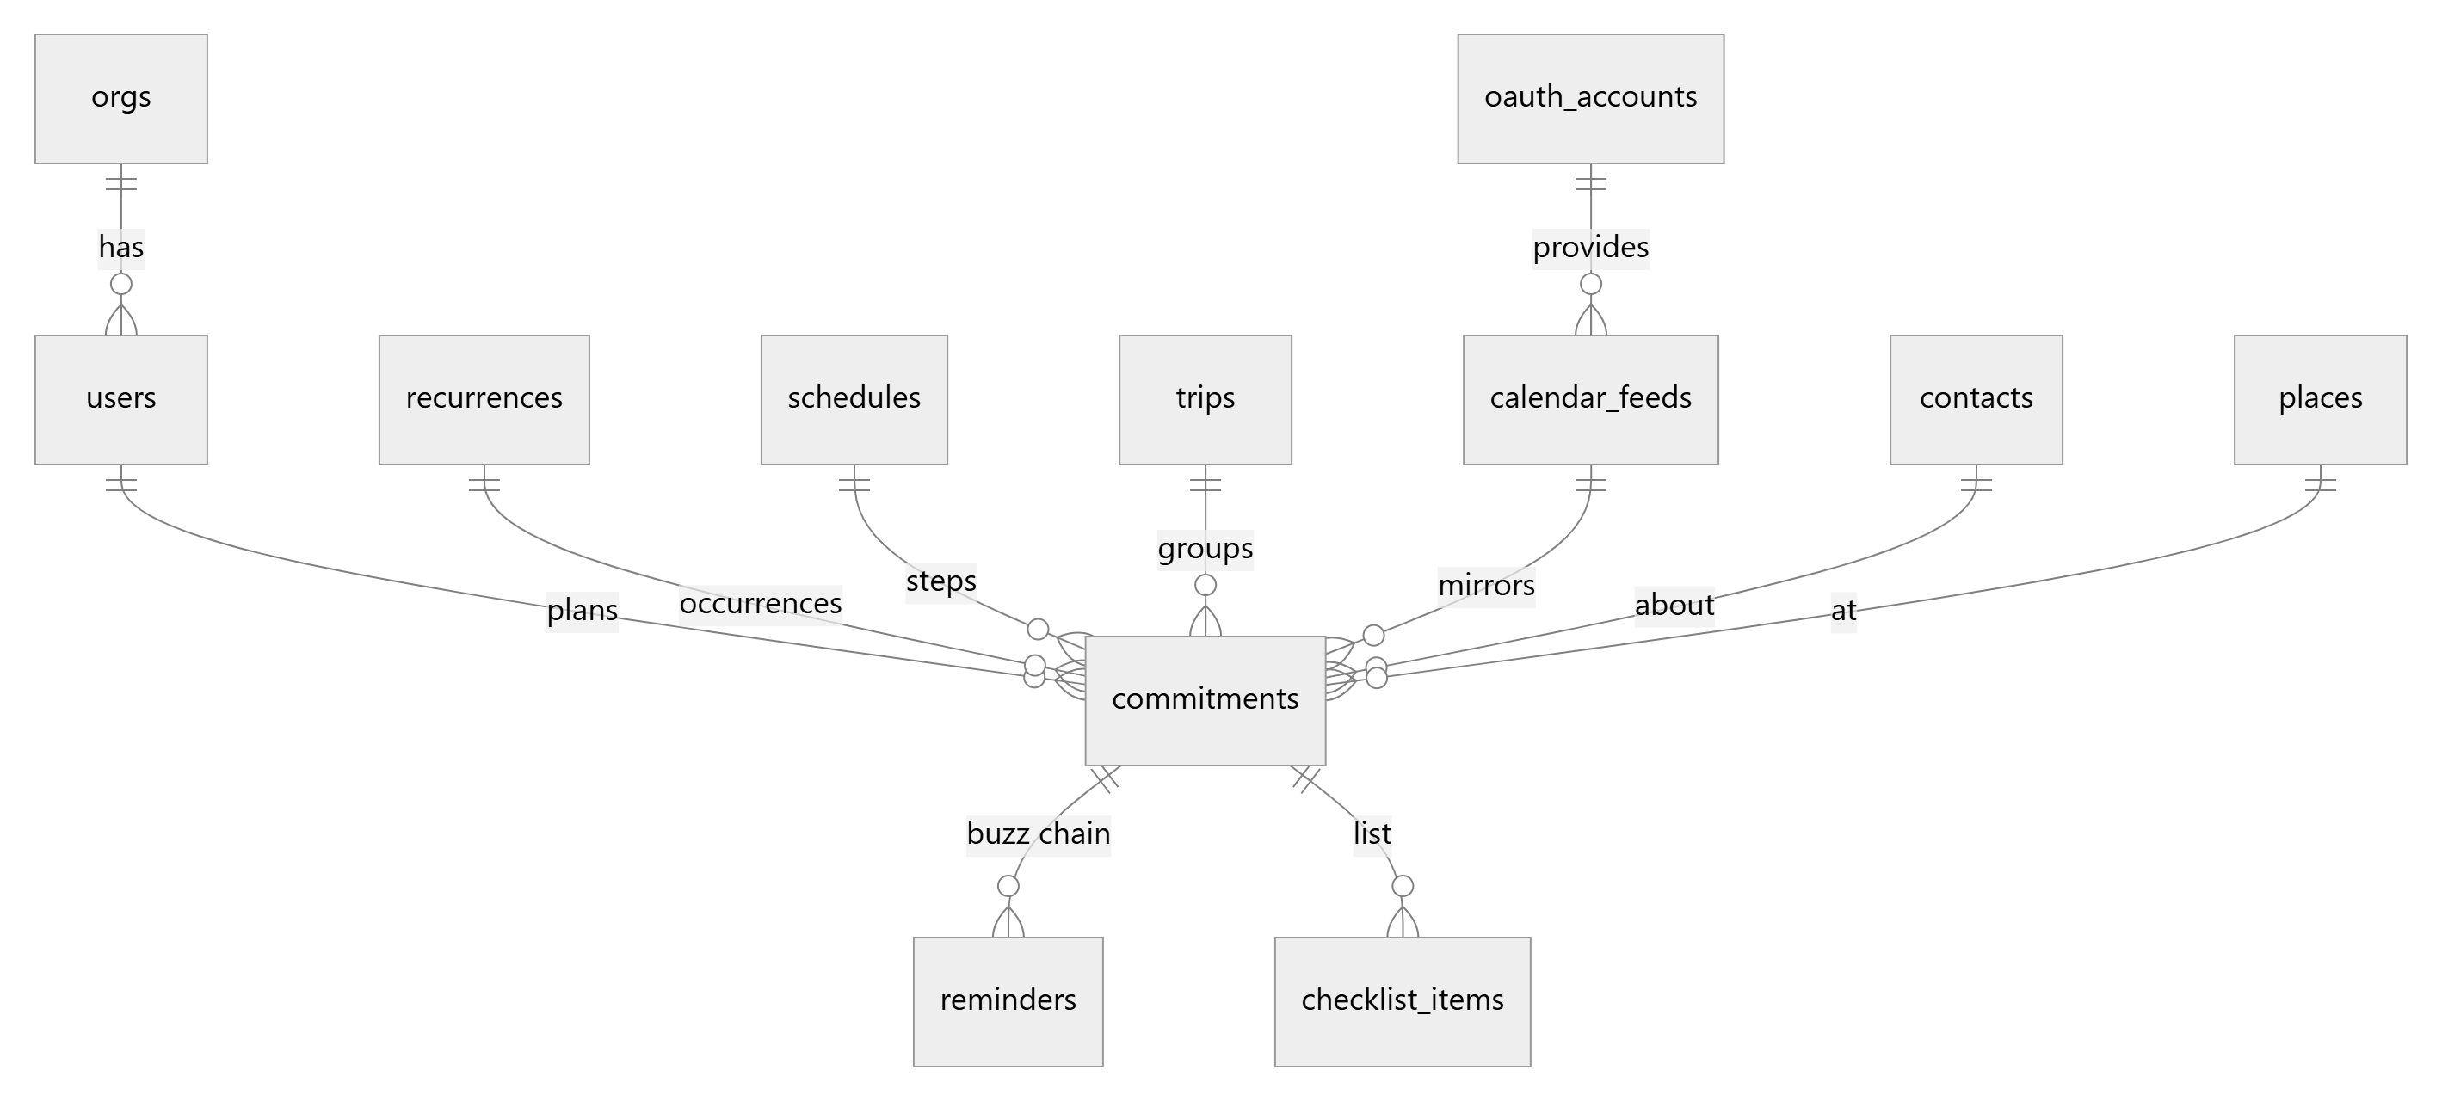
Group | Tables
Accounts | orgs (tenant; own-key AI settings), users (credentials, role, timezone, language, notification preferences and last-sent dates, uses, home city, UPI id, is_demo), password_resets, oauth_states, oauth_accounts (encrypted tokens, mail on/off), push_subscriptions
Plans | commitments (the core: kind callback/meeting/task/followup/focus, status pending/done/cancelled/deleted, due_at, duration, flexibility, priority, waiting_on, booking jsonb, sphere, links to contact/place/trip/feed/recurrence), reminders (fire_at, status, attempt, held), checklist_items, recurrences, schedules, interactions (visits, calls), voice_notes
Calendars and mail | calendar_feeds (ICS URL, upload, Google or Microsoft calendar), mail_seen (message ids read and a one-line summary of what was found — never the content)
People | contacts (phone, organization, birthday/anniversary MM-DD, keep-in-touch), accounts (a company's stage and notes, matched by name), message_templates, greeting_runs, greeting_sends, money_owed
Places and trips | places (lat/lng/radius), trips, intentions (wishes), geocode_cache
Money | bills, bill_payments, expenses (paise; receipts as bytea), deliveries
Work | tracker_items, tracker_events (jobs, hiring, deals)

8. Core flows

8.1 Capture: the one box
Typed or dictated (the browser transcribes; the server only ever sees text) or shared in from another app. Files: routes/quickAdd.ts, services/captureAi.ts, parsers in packages/shared/src.
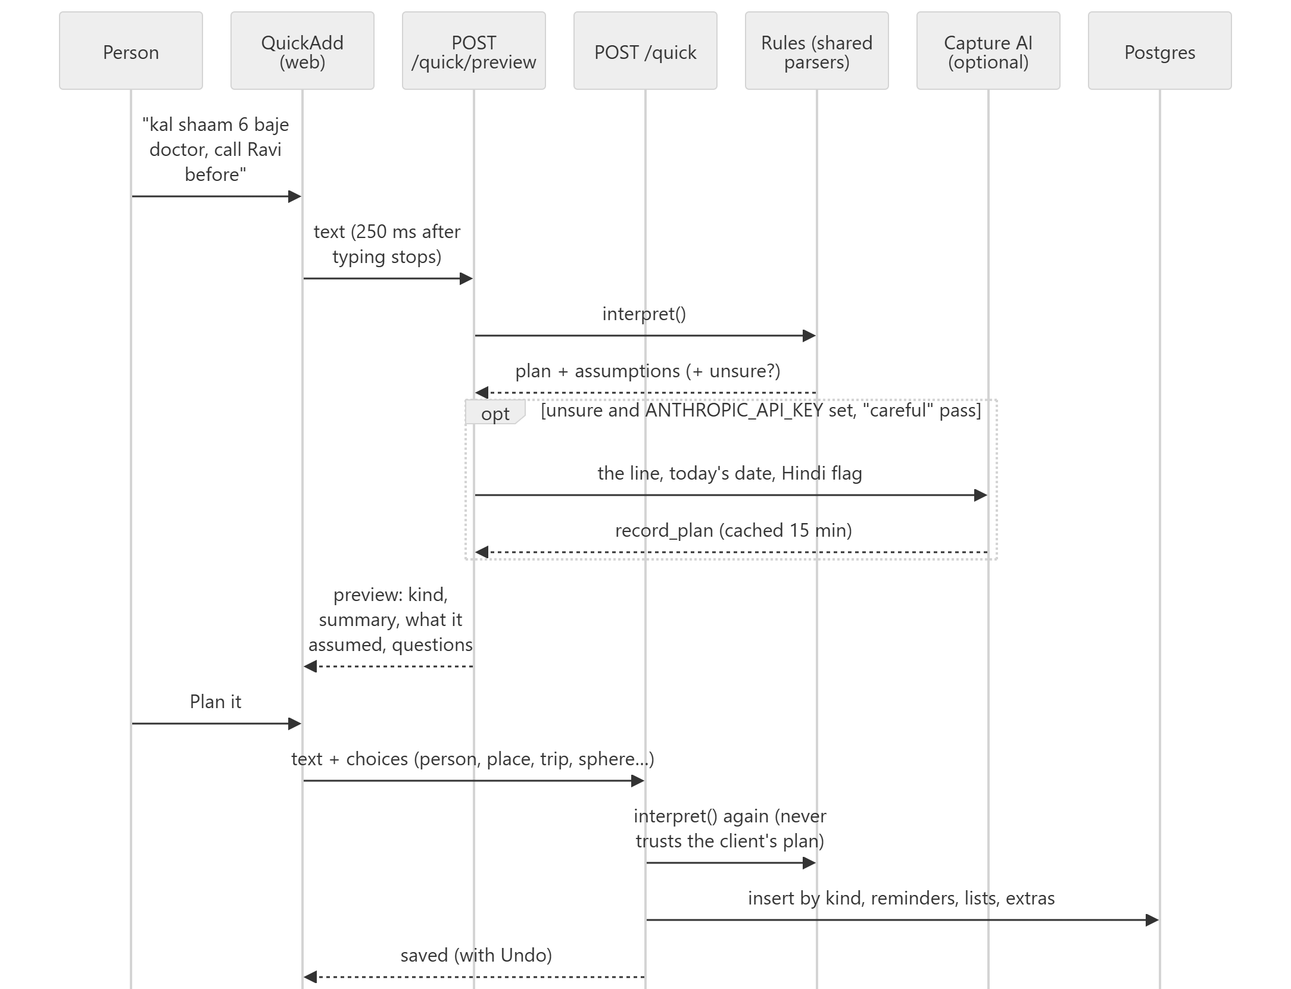
interpret() tries readers in this order; the first that matches wins:
- parseChecklist — a colon introduces a list ("pack for Pune: charger, tickets").
- normalizeHinglish — Roman and Devanagari time words become English (kal, parso, subah, shaam ko, baje…); nothing else changes.
- parseDelivery → delivery.
- parseChallan → bill (vehicle).
- parseFastag (low balance) → a "Recharge FASTag" to-do.
- parseVehicleNotice (PUC) → renewal bill.
- parseBooking / a service notice → commitment with a booking.
- parseWishList → several wishes.
- parseInsurance → yearly bill.
- parseBill → bill (rent, EMI, passport expiry…).
- parseTrackerLine → tracker item (jobs, hiring, deals).
- parseOwed → money owed.
- parseExpense (unless it starts "pay/send/book…") → expense.
- A pronoun with no name ("call him") → ask who.
- parseIntention → wish.
- parseTrip → trip.
- parseRecurrence / a birthday or anniversary → repeating plan (one series per clock time).
- parseRelative ("after standup") → anchored plan, or ask when.
- extractRoles (kind, person, place, subject) → plan, or ask who / when.
- parseWhen → a dated plan; with no date, a learned habit hour, an appointment question, or a flexible item for today marked unsure.

Then enrich() links a certain person, place, company or trip (a plan in another city offers a trip), and withSuggestions() offers extras: move after a trip, start early, a prep focus block, book a cab, a yearly gift reminder. Errors on save: 422 unclear, 428 needs a time, 300 needs a person, 409 a time clash (the client offers "book it anyway"). DELETE /quick/:kind/:id is the Undo.
Capture AI (captureAi.ts) is used only when the rules are unsure or Hindi is left in the title, and only with ANTHROPIC_API_KEY set. It sends the line, today's date and a Hindi flag — no names, contacts or account data — with a forced tool (record_plan), an 8 s timeout and a daily cap. What is saved is the cached reading the person saw.

8.2 Plans, reminders and the nag engine
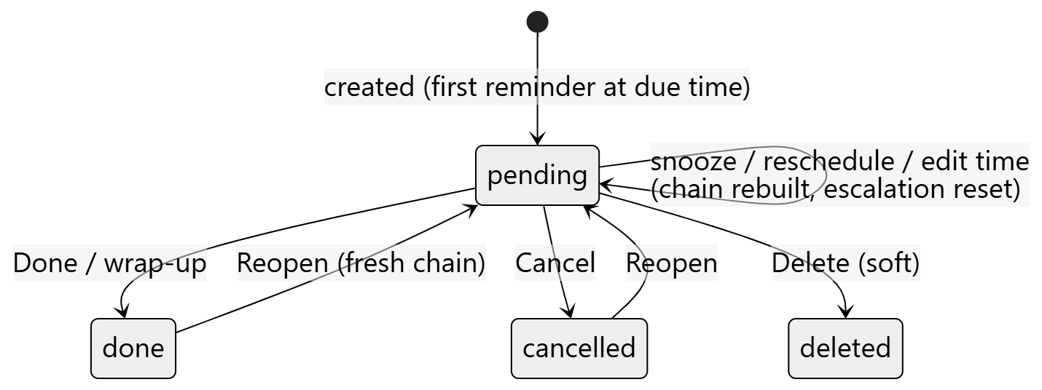
- scheduleFirstReminder queues attempt 0 at the due time. The worker (worker/reminders.ts) claims due reminders, and for each:
  - cancels it if the plan is no longer pending;
  - focus hold — during an active focus block, anything not critical is re-queued for the block's end (held);
  - keep apart — for people with a working life who chose it, a nagging personal reminder waits for the end of the work day and a work one for the next work day (services/workLife.ts); times the person chose, and critical items, always ring;
  - pushes the right words: focus starting, waiting-on check-in, a booking's "leaves in 45 min", a mirrored event's "starting now", or "due now" then "still open — 30 min overdue";
  - queues the next attempt ESCALATION_MINUTES later, up to MAX_ESCALATIONS buzzes.
- Never chased: mirrored calendar events, waiting-on items, focus blocks, bookings.
- Overdue (services/overdue.ts canBeOverdue) excludes calendar history, all-day mirrored events, meetings awaiting their wrap-up (7 days), waiting-on, focus and bookings. Chased-out items surface in Triage (services/triage.ts): done, reschedule, someday or drop. Move it offers three real free slots (services/freeSlots.ts).
- Clashes (services/scheduling.ts checkConflicts) block a save with 409 and suggestions unless allowed; location clashes (a plan during a trip elsewhere, not enough travel time) warn but never block.

8.3 Repeating plans
- Rules (shared/recurrence.ts): freq daily/weekly/monthly/yearly, interval, byWeekday (0 = Sunday), byMonthDay, byMonth (0 = January), setPos ("second Tuesday"), until, count, exdates. describeRecurrence words them in either language.
- Occurrences are written ahead as ordinary commitments (recurrence_id, occurrence_on) for 120 days by materialise; a unique index makes it idempotent. The hourly sweep tops them up. So the nag engine, Today and search need to know nothing about recurrence.
- Editing a rule regenerates future untouched occurrences; stopping (stopSeries) removes them; "just this one" detaches an occurrence.
- Repeating shows the next date from written occurrences, or — past the 120-day window, e.g. a yearly reminder months off — from the rule.

8.4 Calendars
- Three sources into calendar_feeds: an ICS URL (stored encrypted; SSRF guard: https/webcal only, no private addresses, no redirects, 8 MB, 20 s), an uploaded .ics, or a Google/Microsoft calendar via OAuth.
- syncFeed → reconcile: one-off events become meeting commitments keyed by feed_id + external_uid; repeating events become recurrences; events that vanished are removed only if future, pending and untouched. Window: historyDays back (365) to 400 days ahead.
- Mirrored events are read-only and never written back, announced once ("starting now") only if the feed has reminders on, never chased, and events before the connect date are history, not overdue.

8.5 Reading email
services/mailReader.ts. Read-only scopes (gmail.readonly, Graph Mail.Read), consented separately from the calendar.
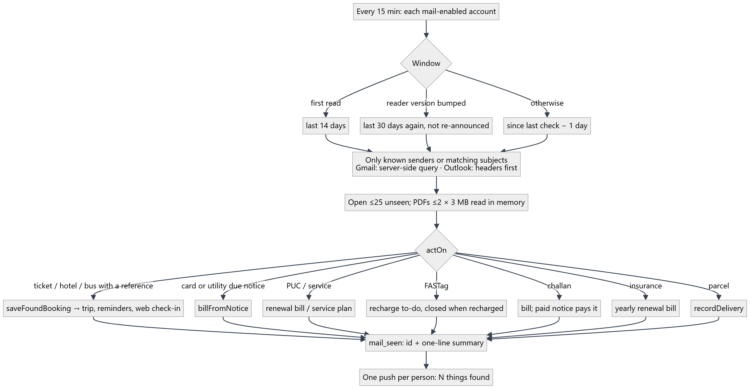
- Never stored: message content. Never sent to AI: anything.
- A booking needs a reference (a sale email is not a flight); parcels need an order reference, item or tracking link; older notices never overwrite newer dates; a time the person set is never overwritten.
- A misread email: add a redacted sample to services/mailCorpus.ts, fix the reader, bump READER_VERSION so the last 30 days are read again.

8.6 Trips and wishes
- Trips come from typing ("Pune 12–14 Oct"), the Trips page, a plan in another city (offered), or bookings (services/tripAssembly.ts tripForBooking): a hotel stretches the trip to check-out, a journey from an away city ends it, the way home joins it, a journey to a new city starts one. Home is users.home_city.
- Trip detail is day by day with "leave by" times; packing makes a "Pack for X" task the evening before with a list from shared/packing.ts.
- Wishes ("when I go to Jaipur, eat at LMB") are intentions; they are offered when a trip there is made (also in a push for trips made from email), when nearby (40 km, only while the app is open), and can be planned onto a trip day or attached to a plan's list.

8.7 The day's rhythm
Moment | What | File
Morning | Brief: meetings and tasks, journeys with leave-by, parcels and cash, bills due, longest free stretch, check-ins, wrap-ups, overdue, keep-in-touch, targets behind, birthdays | morningBrief.ts
Before a meeting | What is still open from related meetings | meetingPrep.ts
After a meeting | "Anything to follow up?" → follow-ups become tasks or "waiting on X" items | wrapUp.ts
Any time | Focus block: reminders held, closed when time is up | focus.ts
Evening | Daily report for your manager (opt-in), then the nudge that plans tomorrow (planTomorrow.ts) | dailyReport.ts, dailyNudge.ts
Friday | Weekly review: done, slipped, waiting, gone quiet, next week, targets | weeklyReview.ts

8.8 People
- Contacts with organization (which defines companies), birthday and anniversary (MM-DD, no year), phone import from the Contacts Picker (fills gaps, never overwrites a number).
- Keep in touch: last touch is the latest of "talked today", a visit or call, a meeting held, or a finished plan mentioning them; due = last touch + cadence; snooze with "later".
- Waiting on: commitments.waiting_on; never overdue, never chased; the push opens a nudge with a pre-filled WhatsApp/email.
- Money owed: "Ravi owes me ₹500", "lent 2000 to Priya", expense shares; the reminder message (with your UPI id) is composed on the phone — the server sends nothing to the other person.
- Greetings: festival rounds sent one person at a time; each send counts as contact.

8.9 Work: boards, companies, targets
- Boards (shared/trackers.ts BOARDS): jobs (saved → applied → interview → offer → accepted/rejected/withdrawn), hiring, deals. Each stage has a "gone quiet after" day count. Lines like "applied to Infosys for data analyst" create items; a later plan mentioning one links to it and can move it to interview.
- Companies come from contacts' organization; stages prospect → talking → proposal → customer/lost; 14 days without contact is "gone quiet".
- Targets: calls, conversations, visits, meetings, done, new contacts — counted from what is logged, paced over the working week.

8.10 Money: bills, expenses, parcels, vehicles, insurance
- Bills: bill or renewal; repeat none/weekly/monthly/quarterly/ half-yearly/yearly; reminder days ahead (3, renewals 30); autopay. Paying moves to the next due date; undo reverses the last payment.
- Expenses in paise, categories (travel, fuel, food, parking, phone, stay, supplies, other), claim status, receipt photo, linked to the trip on that date.
- Deliveries: status only ever moves forward; matched by order reference, then store and item.
- Vehicles: PUC → renewal bill by registration number; service → a booking-style plan; FASTag → recharge to-do; challan → bill, paid by a paid notice. Insurance → yearly bill matched by vehicle number.

8.11 Places and location
Saved places have a radius (150 m). "Log a visit" matches the phone's fix to saved places in SQL, or looks up businesses nearby (services/placeLookup.ts: Google if keyed, else OSM Overpass; cached ~10 min). Geocoding is Nominatim, cached in geocode_cache. There is no background location: nearby wishes are checked while the app is open.

8.12 Sections: who sees what
packages/shared/src/uses.ts:
- Uses: personal, office, sales, hiring, freelance, job_search, student.
- Sections: people, history, trips, repeating, expenses, jobs, hiring, deals, bills.
- EVERYONE = people, trips, repeating, history — what anyone sees.
- LEADS[use] — each use's sections in priority order (e.g. job_search → jobs, people, history, repeating).
- sectionsFor(uses, available, filled) = EVERYONE ∪ the picked uses' LEADS, plus any filled section (services/sections.ts filledSections: has trips, expenses, bills, or a board item). So "applied to Infosys" makes Jobs appear for someone who never picked it.
- tabsFor deals up to 4 main tabs round-robin across the picked uses; the rest go in More.
- hasWork, hasClients, hasCompanies switch work-only features (work/personal split, report, targets, companies).

9. The web client

9.1 Shell and routing
apps/web/src/main.tsx registers the service worker, catches a shared item (catchShare) before routing, and renders BrowserRouter > AuthProvider > App. App.tsx:
- Signed out: / website (Home), /login, /register, /reset, /privacy, /terms.
- Signed in: / Today, /history, /trips, /repeating, /people, /places (URL only), /expenses, /jobs /hiring /deals (one Tracker component), /bills.
- The shell holds the demo banner, nav, sync status, the Add sheet, Search and Settings modals; <div className="app" key={language()}> remounts everything when the language changes. Keyboard: Ctrl/Cmd+K or / search, n add.
- Tabs: Today first, then up to four from tabsFor, then More (grouped; "What I use Cue for…" at the end). Bottom bar on phones, top bar from 900 px.

9.2 Pages
Page | Shows and does
Home | Public site, in English or Hindi: a cycling capture demo; what arrives from email; how it works; a day with Cue (morning brief → meeting prep → follow-ups → reminders → evening plan → Friday review); who it is for; every feature in detail (eight areas); privacy; the demo
Login, ResetPassword | Sign in / up / forgot; reset link
Today | Capture box, uses picker (first time), connect-mail card, search; aside: nearby wishes, parcels, day brief, calendar, install and push banners; main: List/Week/Month, Work/Personal, follow-ups due, waiting on others, now, overdue (Move it), today, whenever, coming up, closed today. Many deep links (?review=1, ?day=1, ?nudge=id, ?action=done&id=…)
History | Visits and plans done, cancelled or let go; edit or forget
Trips | New trip, trips by time, trip detail (days, packing, wishes), the wishlist
Repeating | Repeating plans and step schedules; stop
People | Contacts (or companies), birthdays, keep in touch, greetings, import from phone
Expenses | Month view, categories, claims, money owed
Bills | Due this week, later, overdue, renewals; one-tap paid with undo
Tracker | Jobs / hiring / deals stage boards
Legal | Privacy and terms in English and Hindi (English prevails)

9.3 Components worth knowing
QuickAdd (the box: preview, questions, clash handling, undo), CommitmentSheet / CommitmentEditor (a plan), Checklist, DayBrief, YourDay, WeeklyReview, DailyReport, Targets, Triage, MoveIt, PlanTomorrow, WrapUp, Nudge, FocusStart, CalendarView, Deliveries, NearbyIntentions, AddPanel (Add sheet: upcoming, past visit, repeating, schedule, share availability), Search, Settings, UsesPicker, ConnectMailCard, Integrations, CalendarFeeds, PersonSheet, Greetings, QuickMessage, Owed, TripDetail, Modal (portal; Escape closes the top one), InfoTip, DictateButton.

9.4 Client libraries
File | Role
lib/api.ts | api<T>() with the Bearer token (cue.token), JSON, ApiError(status, code, data); a 401 clears the token; apiSendFile for raw uploads
lib/auth.tsx | useAuth(): me (uses, filled, isDemo, isAdmin, language), login/register/demo/logout, saveUses, saveLanguage; refreshes filled after changes while a section is hidden
lib/changes.ts | announceChange() / useOnChange() — the app-wide "something was saved, reload" event
lib/i18n.tsx, lib/hi/* | Language and Hindi (§10)
lib/share.ts | Sharing text in from other apps
lib/push.ts | Subscribing to push
lib/outbox.ts, idb.ts, online.ts, cache.ts | Offline: visits queued in IndexedDB and replayed idempotently; places and contacts cached
lib/time.ts | Day bounds, labels; YYYY-MM-DD parsed as local midnight
lib/addSheet.ts, reopen.ts, calls.ts, dictation.ts, audio.ts, geo.ts, deviceContacts.ts | Opening Add from anywhere, reopening, call tracking, speech, recording, location, contact picker

9.5 First visit
- Website (Home), optionally switched to Hindi.
- Sign up, sign in or Try the demo (a 24-hour account with a sample week). The site's language is carried into the account.
- Today asks once what you use Cue for (UsesPicker) — tabs change at once — then offers to connect Google/Microsoft (ConnectMailCard).
- The browser's time zone is saved; the outbox sync loop and push re-registration start.

9.6 Offline and the PWA
- Workbox precaches the app shell; navigations fall back to index.html except /api/*; API responses are never cached.
- Visits logged offline (with voice clips) go to an IndexedDB outbox keyed by a client id and replay idempotently when back online.
- The manifest is generated by Vite (shortcuts: speak, add, log a call; share target GET /share).

9.7 Sharing into Cue
- Text (WhatsApp messages, SMS, links): /share?title&text&url → stored for 15 minutes in sessionStorage → Today opens with the box filled.

9.8 Styling
One plain stylesheet, styles.css: tokens on :root (--bg, --surface, --text, --muted, --accent, --warn, --good, --danger…), redefined under prefers-color-scheme: dark; mobile-first; wide layouts from 900/1000 px; reduced motion respected. Shared vocabulary: .card, .stack, .row, .chip, .tile, .tag, .primary, .ghost, .small-btn, .link.

10. Languages: English and Hindi
The whole of Cue is in English and Hindi, chosen per person (users.language).
Web
- lib/i18n.tsx: the language is module state (stored in cue.language, else the device's); t('English line', {vars}) looks the line up in the Hindi dictionary and falls back to English; msg() marks constants; rich() handles inline tags.
- Dictionaries by area in lib/hi (common, today, add, money, people, settings, plans, work, site); common.ts describes the house style for Hindi.
- Policies: PrivacyEn/PrivacyHi, TermsEn/TermsHi, checked for parity.

Server
- apps/api/src/i18n.ts: t(lang, en, vars), langOf(userId), localeOf(lang); dictionaries in apps/api/src/hi (notify.ts, capture.ts).
- Push payloads carry lang, so the service worker labels its buttons.
- Plan titles from parsing stay as written (later emails are matched against them).

The checks (part of the test suites):
- apps/web/scripts/i18n-check.ts — every t()/msg()/rich() string has Hindi with the same {placeholders} and tags, no unused entries, no conflicting translations across areas. npx tsx apps/web/scripts/i18n-check.ts --leftovers <file> finds unwrapped English.
- apps/api/src/i18n.test.ts — the same for the server.
- legal.test.ts, sharedLabels.test.ts — policy parity, shared labels.

11. Push notifications
- VAPID keys in .env; /health reports push: true when set.
- push.ts sendToUser(userId, payload) sends to every device (urgency: high, TTL 6 h), prunes dead endpoints (404/410), returns how many were delivered. Payload: title, body, tag, url, commitmentId, phone, lang.
- Client: enablePush() on Today asks permission, fetches the public key, subscribes and posts it; resyncPush() re-registers silently on every launch. iOS needs the app on the home screen first.
- The service worker shows a sticky notification with Call, Mark done, Snooze 15m when it is about a plan; tapping opens the app at ?action=…&id=… and the page does the action (the worker has no token).
- Background jobs mark something sent before sending, so a failure can never loop or double-send.

12. The Android app
A Trusted Web Activity generated by Bubblewrap, host cue.vitelio.in: package in.vitelio.cue, manifest android/twa-manifest.json, start URL /, text shared in through GET /share, store listing in android/store/.
- Build: GitHub Actions → "Android app"; release signs with the upload key from secrets, otherwise a throwaway key.
- Digital Asset Links are served by the API at /.well-known/assetlinks.json from ANDROID_CERT_SHA256 — put both the Play app-signing and upload-key fingerprints in /srv/cue/.env and restart, or the app shows a browser bar.

13. Testing
Suite | Command | What
Shared | npm run test:unit | ~40 files of parser and rule tests, no database
Web | npm run test:web | Hindi coverage, policy parity, the share target, shared labels
API | npm run test:api | ~70 files; most are *.db.test.ts against real Postgres, run one at a time
Types | npm run typecheck | API and web (shared is checked through them)
All | npm test | Shared, web, API

Writing an API test — apps/api/src/testing/harness.ts:
let h: Harness
before(async () => {
h = await createTestDb('my_feature') // a fresh schema, all migrations applied
process.env.DATABASE_URL = h.url // before importing anything that touches the DB
const svc = await import('./myFeature.ts')
const who = await seedUser(h.sql, 'asha@test.local')
// …or build a Fastify app, registerAuth, register the routes, app.inject()
})
after(() => h.close()) // drops the schema
Pass now into services rather than relying on the clock, and inject send (the push function) where a service accepts it — most notification code does. Old test_* schemas are swept after two hours.

14. Database migrations
- Add apps/api/migrations/NNNN_name.sql (next number after the latest), written to be safe to run twice (if not exists), and make the same change in schema.ts.
- npm run db:migrate applies files in name order, each in its own transaction, recording them in _migrations. It refuses a database whose _migrations is missing or empty unless CUE_NEW_DATABASE=1 — the guard added after the production tables were dropped on 9 Oct 2026. Never set it against an existing database.
- Deploys run the migrate step on the server before restarting.

15. CI, deploy and production
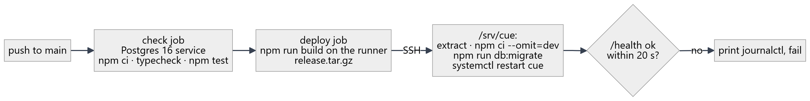
- deploy.yml runs on every push and PR (deploys only from main). Secrets/variables: DEPLOY_SSH_KEY, DEPLOY_HOST, DEPLOY_USER, DEPLOY_PATH (default /srv/cue).
- Production: one systemd unit cue running the API (which serves the web build) on 127.0.0.1:3002, Caddy in front for TLS (HTTPS is required for the service worker, push, location and the microphone). Logs: journalctl -u cue. The production .env lives at /srv/cue/.env.
- After changing /srv/cue/.env, restart: sudo systemctl restart cue.

16. Security and privacy, as enforced in code
- Tenancy: org and user come from the JWT; every query filters by them; undo and delete are scoped to the owner in the same statement.
- Secrets at rest: OAuth tokens, ICS URLs and own-key AI keys are AES-256-GCM encrypted (secrets.ts); providers are not offered without ENCRYPTION_KEY; only masked hints are ever returned.
- OAuth: PKCE S256, single-use state (10 min); read-only scopes; mail is its own consent; disconnecting and deleting the account revoke the grant.
- Email: only listed senders/subjects opened; content never stored; PDFs read in memory with limits; no AI.
- Capture AI: off without a key; only unsure lines; only the line and the date; capped; sanitised; nothing saved without the person's tap.
- Uploads have size caps (avatar 512 KB, receipt 3 MB, voice 5 MB, ICS 8 MB).
- Passwords: bcrypt; reset tokens hashed, one hour, single use; the same answer whether or not an address exists.

17. Recipes
A new notification — write a compose…(data, lang) that returns {title, body, url} or null when there is nothing to say; pass every string through t(lang, …) and add the Hindi to apps/api/src/hi/notify.ts; add a users preference and a "last sent on" date in a migration; a run… that selects due users in their own time zone, marks the date, then sends; a start…Worker in index.ts; a switch and a "send now" in Settings; a *.db.test.ts with an injected send. services/weeklyReview.ts is a complete example.
A new thing the box understands — a pure parser in packages/shared with unit tests, called from interpret() in routes/quickAdd.ts at the right point in the order (§8.1); save it in the save switch; add Hinglish/Hindi examples to the tests.
A new section — add it to Section, LEADS and (if data can make it appear) FILLABLE in shared/uses.ts, to filledSections, to SECTION_LINKS in App.tsx, and a page.
A new web string — t('Your words'), then the Hindi in the right lib/hi/*.ts area; run npx tsx apps/web/scripts/i18n-check.ts.
A misread email — §8.5.

18. Known gaps and loose ends
- Production waits on configuration: ANTHROPIC_API_KEY (capture AI), the Android certificate fingerprint, and the Play account.
- No global rate limiter or security headers in the app (no helmet/CSP); Fastify trustProxy is unset, so behind Caddy req.ip is the proxy.
- /health does not check the database.
- README drift: its deploy section describes an older git-pull deploy and "two test suites"; this guide reflects deploy.yml as it is. scripts/setup-db.ps1 still suggests db:push; use the migrate step.
- schema.ts's header mentions a db/scope.ts that does not exist; CORS still allows capacitor:// origins from an older Android plan.
- A shared comment says the nag engine sets status snoozed; nothing does.

