- Can’t implement file input in chat using webembed bcoz its only supporting string.
- Google Font CDN Customization:
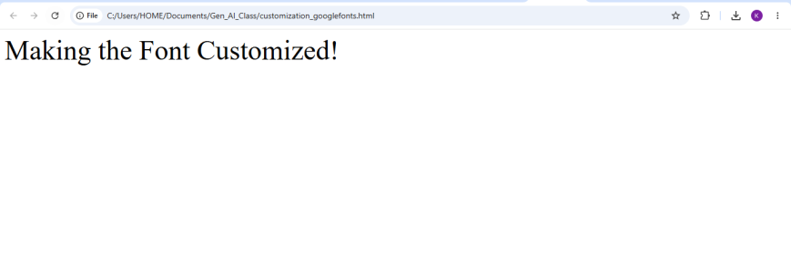
- Implementation of TC Generator using md file with export option:
