TS-6315 Visteon :: Darwinbox - Willis Tower Watson (USA) Employee Master Integration BRD

|  |  |  |
| --- | --- | --- |
| **Client** | {{r client }} | |
| **Vendor** | {{r vendor }} |  |
| **Version** | {{r version }} | |
| **Doc Owner** | @{{r doc_owner }} | |
| **Functional Lead** | @{{r functional_lead }} | |
| **Status** | **{{r status }}** | **{{r list_of_statuses }}** |
| **Last updated by** | **@{{r last_updated_by }}** | |
| **Last date updated** | {{r last_date_updated }} | |
| **Client Approved By [Name, Designation]** | {{r client_approved_by }} | |
| **Client Approved Date** | {{r client_approved_date }} | |
| **Mode of Integration** | **{{r mode_of_integration }}** | {{r list_of_integration_modes }} |
| **Modules** | {{r modules }} | |
| **Direction** | **{{r direction }}** | {{r list_of_directions }} |
| **Frequency** | **{{r frequency }}** | |
| **Data Load** | {{r data_load }} | |
| **Client email for error/success response** | {{r client_emails }} | |
| **File Format** | {{r file_format }} | |
| **File naming convention** | {{r file_naming_convention }} | |
| **Encryption** | **{{r encryption }}** | |
| **Integration Approach** | **{{r integration_approach }}** | |
| **Employee Selection Criteria** | {{r employee_selection_criteria }} | |

|  |  |
| --- | --- |
|  |  |
| **Data Exclusion Logic** | {{r data_exclusion_logic }} |
| **Date Format** | {{r date_format }} |

## Purpose/**Justiifiication**

{{r purpose }}

## Integration Description and Overview

{{r integration_description }}

# Integration Flow Diagram

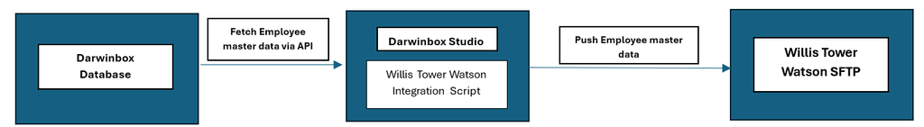

**Darwinbox Technical Design Specifications** 

{{r darwinbox_technical_design_specifications }}

## Data Mapping Table:

The following table enumerates and briefly describes the fields that are being provided with the integration:

|  |  |  |  |  |  |  |  |
| --- | --- | --- | --- | --- | --- | --- | --- |
| [**S**.**n**](http://s.no/)[**o**](http://s.no/) | **Field Type** | **Mandato ry(Y/N)** | **Required fields** | **DB Field** | **Custom Field** | **Logic** | **Sample** |

|  |  |  |  |  |  |  |  |
| --- | --- | --- | --- | --- | --- | --- | --- |
| {% for row in field_mapping %} |  |  |  |  |  |  |  |
| {{r row.sno }} | {{r row.field_type }} | {{r row.is_mandatory }} | {{r row.required_field }} | {{r row.db_field }} | {{r row.custom_field }} | {{r row.logic }} | {{r row.sample }} |
| {% endfor %} |  |  |  |  |  |  |  |

## Assumptions

{{r assumptions }}

# Dependencies

{{r dependencies }}

# Error Handling Logic

{{r error_handling_logic }}

***List of Darwinbox APIs:*** 

|  |  |
| --- | --- |
| **Employee Master API** | **Endpoint** - [https://subdomain.darwinbox.com](https://onlinehr.darwinbox.com/)/[masterapi/employee](https://bsvgroup.darwinbox.in/masterapi/employee) |