**Amazon Sales Analysis Report**

Prepared by: Raghu Varma Uppalapati

Date: June 2025

Data: 2022



# 1. Objectives

This analysis distills Amazon’s 2022 sales performance into clear, actionable takeaways to support marketing, operations, and customer-experience strategies. We aim to:

* Evaluate overall revenue trends and seasonal peaks.
* Uncover customer preferences by product category, size, and purchase volume.
* Benchmark fulfillment methods for efficiency and delivery success.
* Map regional demand at state and city levels.
* Deliver targeted recommendations to boost sales, optimize inventory, and elevate service.

# 2. Data Preparation

To ensure reliability and precision, the raw dataset underwent rigorous cleaning and enhancement:

* Deduplication & Null Handling: Removed duplicate entries and imputed or discarded blank fields.
* Date Harmonization: Unified all date values into a single format and extracted Day, Month, Year, and Weekday.
* Categorical Standardization: Consolidated delivery statuses and service levels into uniform categories.
* Column Pruning: Eliminated irrelevant fields (e.g., pin code, currency) to improve processing efficiency.
* Feature Engineering: Created helper columns such as Weekday Name, month, and Fast-Delivery Flag for deeper insights.

# 3. Key Insights from Analysis

## 3.1 Sales Performance Overview

* Total Revenue: ₹7.85 Cr across 1.29 L orders.
* Peak Month: April delivered ₹2.05 Cr—over 53% driven by t-shirt sales.
* Seasonal Decline: Sales tapered steadily from July through December.
* Weekday Wins: Tuesdays drive the most orders, followed by Saturdays and Sundays.
* Average Order Value: ₹648.64, signaling robust per-order spend.
* Lowest Month: December’s post-festival lull saw the smallest revenue.

**Monthly sales for different products**

## 3.2 Product Performance

* Top Categories: T-shirts, shirts, and blazers account for 91% of revenue.
* Size Breakdown: M and L sizes represent 34.2% of units sold.
* Seasonal Shifts: Perfumes peak in May; t-shirt demand soars in April–June.
* Underperformers: Watches recorded only one sale—prime candidate for promotion or phase-out.

**Category vs. Quantity Bar Chart**

## 3.3 Fulfillment & Delivery Efficiency

* Fulfillment Share: Amazon handles 70% of orders with 85% on-time delivery.
* Merchant Challenges: Merchant-fulfilled orders see a 37% return/cancellation rate.
* Delivery Preference: Expedited shipping chosen in 69% of orders, especially in metros.
* Regional Variation: Tier-2 cities favor standard delivery.

**Fulfillment Efficiency Stacked Chart**

## 3.4 Geographic Demand

* Leading States: Maharashtra, Karnataka, and Telangana drive 48% of total orders.
* City Hotspots: Bengaluru (11.8k orders) and Hyderabad top the city leaderboard.
* Urban vs. Rural: Urban centers outperform rural markets by 3× in both volume and revenue.
* Category Clusters: Maharashtra shows strong affinity for t-shirts and shirts.

**Sales from different states**

## 

## 3.5 Customer Segmentation

* B2C Dominance: Business-to-consumer transactions make up 99.3% of orders.
* Metro Behavior: Urban customers overwhelmingly select expedited delivery options.

**Delivery preference for top metro cities**

# 4. Strategic Recommendations

## Sales Optimization

* Regional Promotions: Launch targeted campaigns in Maharashtra, Karnataka, and Telangana during peak months.
* Seasonal Bundles: Offer summer bundles for t-shirts and shirts to capitalize on April–June momentum.
* Underperformer Strategy: Introduce discounts or bundles for watches to revive sales.

## Inventory Management

* Size-Based Stocking: Prioritize inventory for M, L, and XL sizes in high-velocity categories.
* Localized Warehousing: Position stock in regional hubs (e.g., Bengaluru, Hyderabad) to accelerate expedited delivery.
* Lean SKUs: Phase out or minimize slow-moving items to free up capital.

## Customer Experience

* Merchant Enablement: Provide training and performance incentives to reduce merchant-return rates.
* Express Incentives: Offer discounts for expedited shipping in under-performing areas to boost uptake.
* Fulfillment Monitoring: Implement dashboard alerts for spikes in Amazon-fulfilled cancellations.

# 5. Conclusion

The 2022 sales data underscores distinct seasonal peaks, concentrated product preferences, and clear geographic hotspots. T-shirts and shirts commanding over half of revenue, coupled with a strong customer insistence on fast delivery in urban areas, pinpoint where marketing and logistics efforts should focus. Meanwhile, merchant-fulfillment issues highlight an opportunity for operational enhancements. By executing the recommendations above—targeted promotions, size-guided inventory, and fulfillment excellence—Amazon can drive sustainable growth and superior customer satisfaction in 2023 and beyond.

# Appendix

**Dashboard image:**

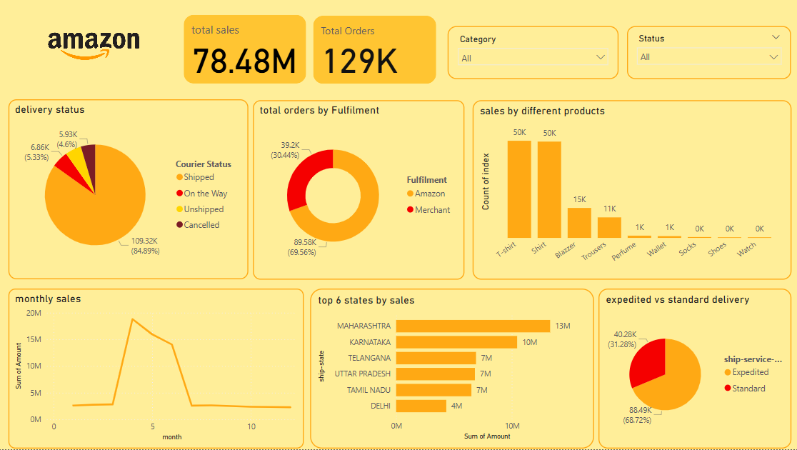

**Pivot Tables Used:**

- Sales by Category & Order Count

- Quantity by Size Distribution

- Fulfillment Method vs. Delivery Status

- Expedited vs. Standard Delivery Split

- Sales by Month & Seasonality

- Sales by Weekday Pattern

- State-Level Sales Heatmap

- Top 20 Cities by Order Volume

- B2C vs. B2B Order Breakdown

- Preferred Delivery Type in Major Cities