LAB – 5

* Instruction to run the programs

To execute all programs you can use the same command as following

mpiexec -np 4 --use-hwthread-cpus python3 file.py

I used this command since my laptop does have enough number of processors so I made you of this command ( made use of threads)

The outputs of the programs -

1) sum of matrixes

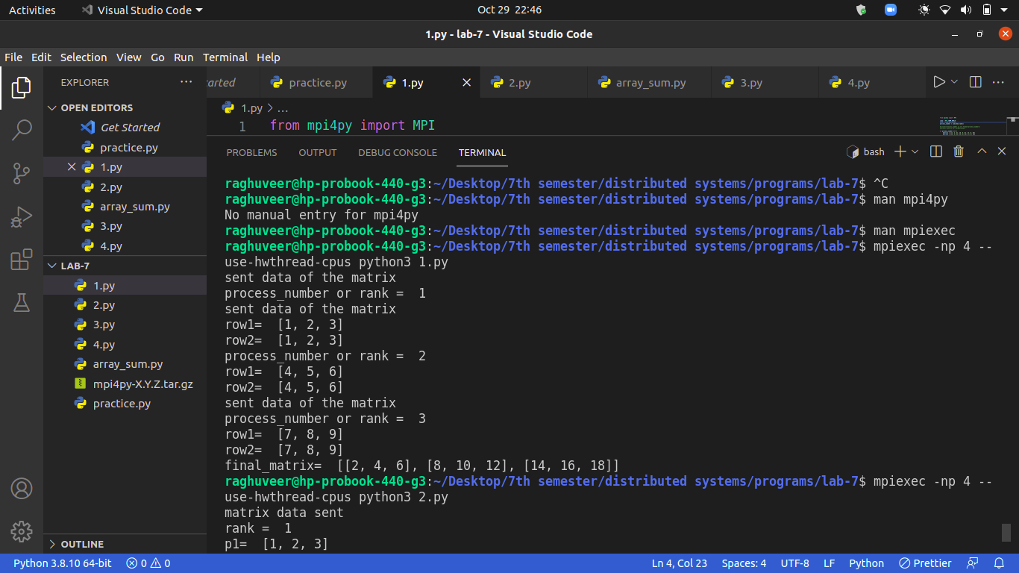

2) Matrixes multiplication

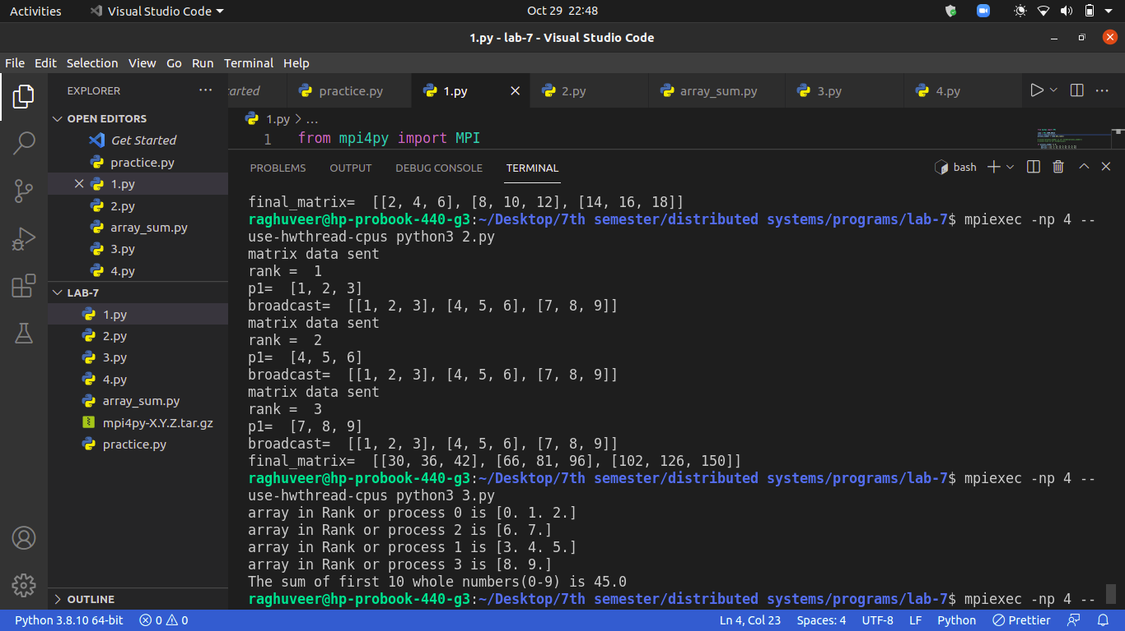

3) sum of array using reduce operations

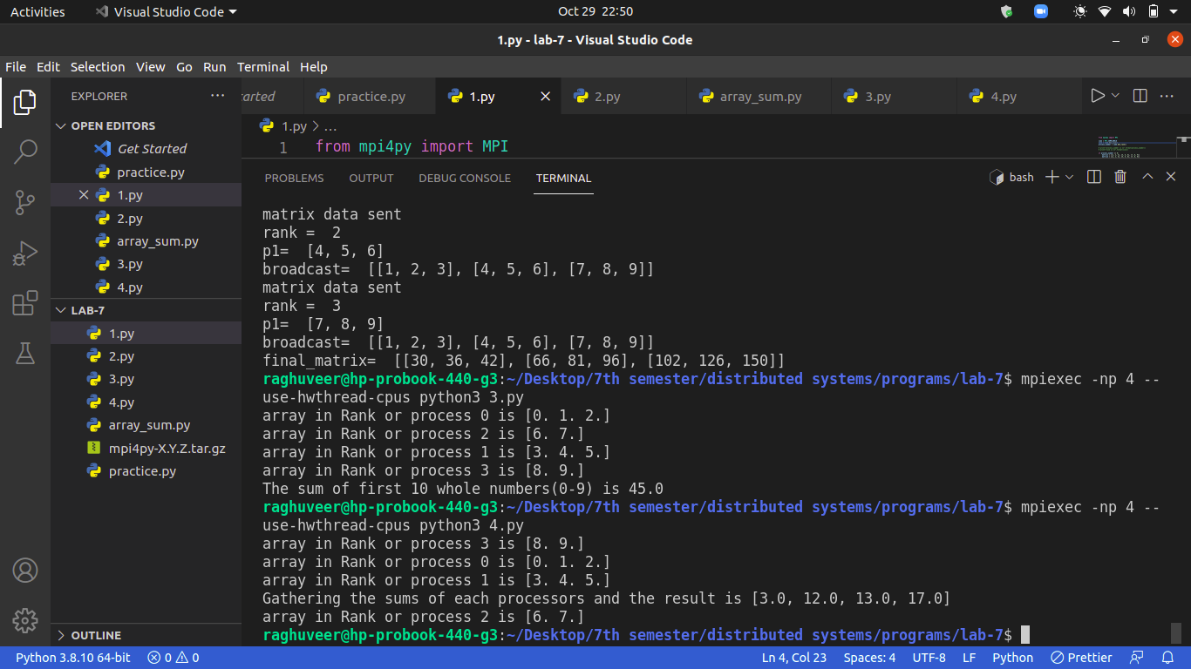

4) Exploring scatter and gather operations in MPI. I used the same code as for sum of the array instead of reduce operation I used gather operation. And I used Scatter operation is there in both 3 and 4 th problem

