**D.S.Raghuveer**

**18XJ1A0518**

**Assignment – 4**

**Plot –1**

which has the number of clusters on the x-axis, and the value of Objective function and the number of iterations for convergence on the two y-axes

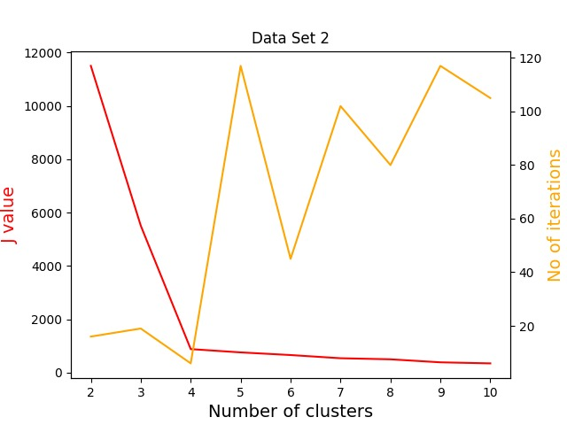

**Plot –2**

**Clustters -**

