Topic - Develop a standalone console-based Python application which will manage various Colleges across the state.

Coding approach

1) Programming language – python (Version -3.8)

2) Code Editor – Sublime text.

3) Object oriented Approach with College as class and Initializing a constructor and created object of the class college and passing all the parameter by calling the constructor.

4) Prompting the user to enter the details using the global variables and passing the global variable in the constructor while defining the object of the class college.

5) Defining the Modules and performing the various Task like adding,searching and deleting the college data.

Functions Defined-

This is a basic python console-based application which consists of the following functions:

1. Add Function
2. Search Function
3. Delete function

Main Page for console Application:

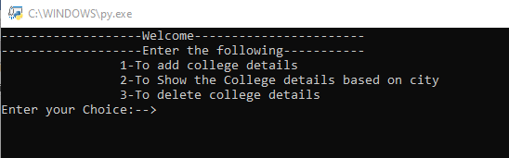

Figure 1: Main Page

1) Add Function:

This Add module takes the college object values from the user consisting the basic college details like college id, college name etc. and adds the college details to an excel file “college.csv”. This module is implemented with functionalities such as no 2 colleges can have the same college Id, even if a user tries to add a college with the same Id, the application will print “college Id already exists” and will not allow user to add college with same Id.

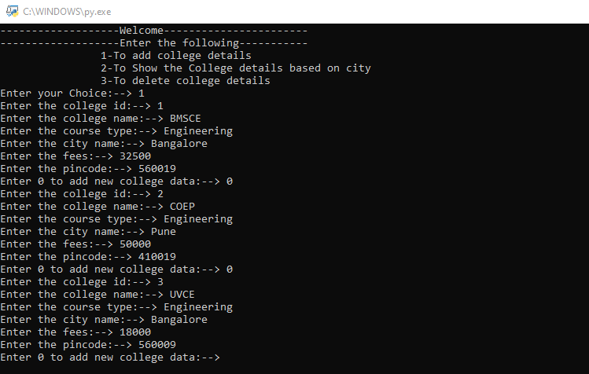

Figure 2: Add college details

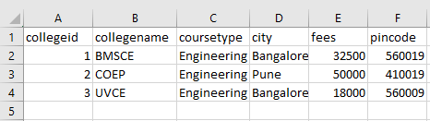

Figure 3: csv records after adding colleges

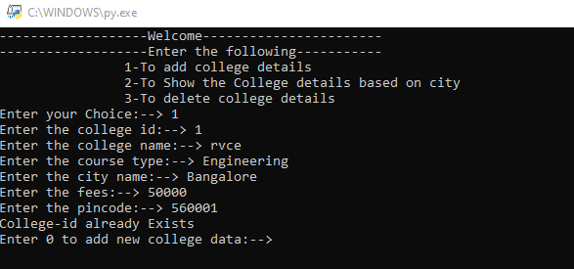

Figure 4: Ignoring duplicate college id entries

2) Search Function:

This function takes a user input for the college city from the user and displays all the records for that particular college city on the console.

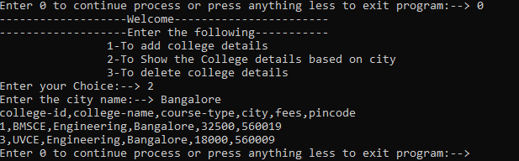

Figure 5: Search for a particular city record

3) Delete Function:

If the user needs to delete record, the user can call the delete module and pass college Id as a parameter and the module will search for the records having that particular college Id and delete it from the records store.

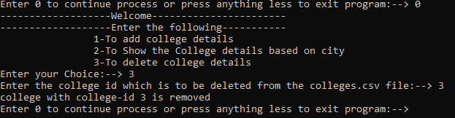

Figure 6: Delete operation for college Id NO-3

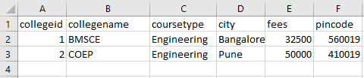

Figure 7: csv file records after deleting college Id NO- 3

Source Code –



**Source Code File, Double Click Icon to open in the .txt format and save the it to (.py) Extension in new file**



**Source code in .zip format, double click to Extract and the Run the program.**