Dear Dr. Sinosh Skariyachan,

We are pleased to submit our manuscript entitled "PEARL: Parameter-Efficient Adaptation with Retrieval-Augmented Learning for Molecular Property Prediction" for consideration as an original research article in Computers in Biology and Medicine.

Computational drug discovery faces three persistent bottlenecks: sequence-based chemical language models lack explicit three-dimensional geometric inductive biases; full finetuning of large molecular models remains computationally prohibitive for many biomedical research groups; and reported gains over graph-based baselines are rarely re-validated under an identical, leakage-free protocol. PEARL addresses all three through systematic Low-Rank Adaptation (LoRA) benchmarking across three CLM families - ChemBERTa, MolFormer, and the geometric SE(3)-equivariant Uni-Mol - across seven ADMET and MoleculeNet property-prediction datasets spanning classification and regression, achieving 76-97% parameter reduction while matching or exceeding full finetuning.

Crucially, PEARL also introduces Retrieval-Augmented Feature Enhancement (RAFE): rather than relying solely on what a model has learned, RAFE enriches predictions with the physicochemical neighbourhood of each query molecule i.e. its logP, QED, and synthetic accessibility distributions via a database of ZINC-250k neighbours retrieved via GPU-accelerated FAISS indices. This label-free, leakage-free signal captures where a molecule sits in chemical space, providing an interpretable and orthogonal complement to learned representations that no amount of finetuning alone can supply. Beyond RAFE, every reported gain is benchmarked against in-house Chemprop, GCN, and PC-only baselines trained under the identical scaffold split and evaluation protocol - rather than cited from prior papers - and screened against a stricter statistical-overlap criterion, directly addressing the reproducibility gap common in computational drug-discovery benchmarking. This openly released, rigorously validated computational pipeline for ADMET and molecular-property prediction sits squarely within the scope of Computers in Biology and Medicine, which prioritises validated computational methods and tools for biomedical and life-science applications. Figure 1 illustrates the PEARL workflow.

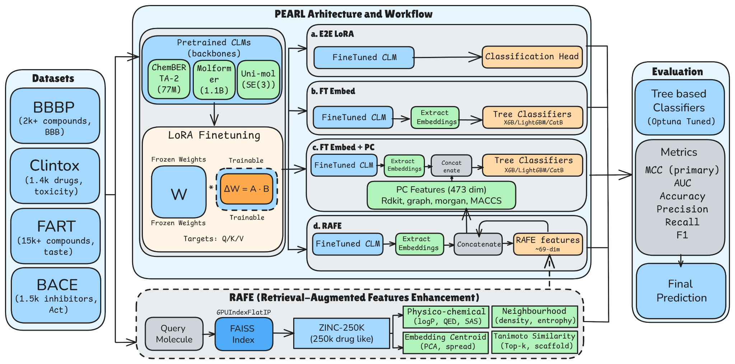
Figure 1: PEARL workflow. Molecules are processed by one of three CLM families (ChemBERTa, MolFormer, Uni-Mol) with LoRA adapters. Task-specific embeddings are fused with molecular PC features and ZINC-250k retrieval features, then passed to tree-based classifiers. Uni-Mol additionally encodes 3D ETKDGv3 conformers via SE(3) representation.

Our key contributions include:

• LoRA across three CLM families: 76-97% parameter reduction across seven ADMET/MoleculeNet datasets spanning classification and regression, matching or exceeding full finetuning.
• 3D geometry advantage: Uni-Mol LoRA achieves MCC = 0.623 on BACE inhibitor classification (8% absolute gain over the best SMILES-based model) - the only result where the CLM ladder statistically clears a strong PC-only baseline.
• RAFE: the top point-estimate result on BBBP (MCC = 0.798) and DILI (MCC = 0.790), enriching predictions with interpretable ZINC-250k chemical-neighbourhood context.
• Rigorous, identically-protocoled benchmarking: in-house Chemprop, GCN, and PC-only baselines - rather than externally cited numbers - show PC-only remains statistically competitive with the full CLM ladder on five of seven datasets, a transparently reported finding.
• Full reproducibility: code and pipelines released at https://github.com/raghvendra5688/PEARL.

We firmly believe this manuscript will be of strong interest to the readers of Computers in Biology and Medicine, particularly those developing and validating computational methods, algorithms, and tools for drug discovery, ADMET property prediction, and biomedical data science. This manuscript has not been published previously and is not under consideration elsewhere. Please do not hesitate to contact us if you require any additional information.

With regards,

Dr. Raghvendra Mall (Corresponding Author)
Qatar Center for Artificial Intelligence, QCRI, Hamad Bin Khalifa University, Doha, Qatar
Email: raghvendramall@ieee.org | ramall@hbku.edu.qa

